Table S1. Use of nucleos(t)ide analogues after LT in the study population

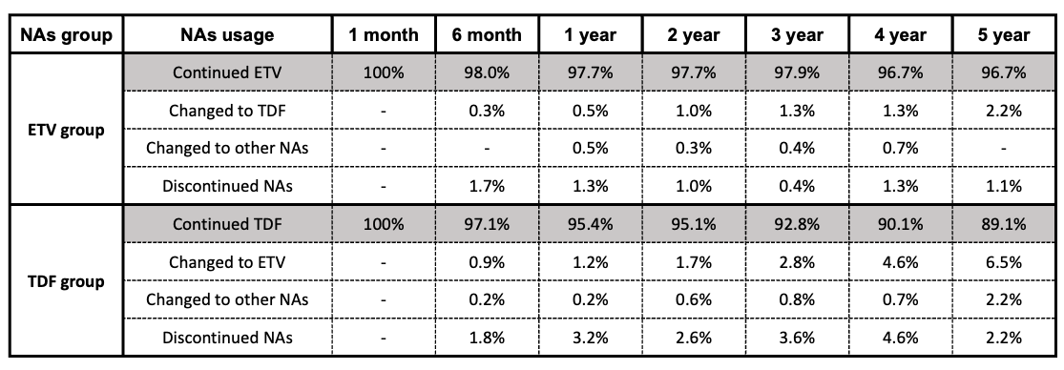

Figure S1. Density plot for the time from LT to HCC recurrence

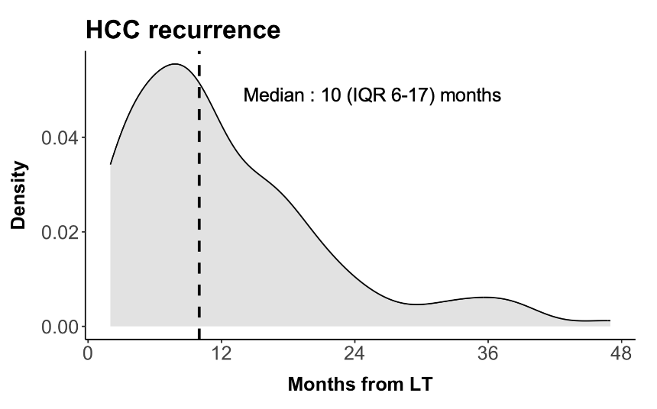

Table S2. Full results of multivariable Cox regression for HCC recurrence
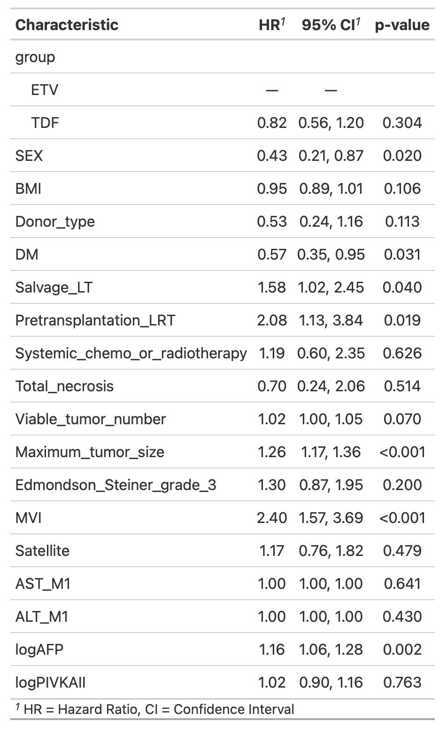

Table S3. Full results of multivariable Cox regression for overall death
