Supplementary Information

Trimesic acid anchored electrocatalysts of bioinspired design: Unique static and dynamic compatibility enhanced water oxidation

Xiaojing Lin, Zhaojie Wang*, Shoufu Cao, Yuying Hu, Siyuan Liu*, Xiaodong Chen, Hongyu Chen, Xingheng Zhang, Shuxian Wei, Hui Xu, Zhi Cheng, Qi Hou, Daofeng Sun, and Xiaoqing Lu*

X. Lin, Z. Wang, S. Cao, Y. Hu, S. Liu, X. Chen, X. Zhang, H. Xu, Z. Cheng, Q. Hou, D. Sun, X. Lu
School of Materials Science and Engineering,
China University of Petroleum,
Qingdao 266580, P. R. China
E-mail: wangzhaojie@upc.edu.cn; lsy@upc.edu.cn; luxq@upc.edu.cn

H. Chen, S. Wei
College of Science
China University of Petroleum,
Qingdao 266580, P. R. China

Experimental details
Preparation of SU-NiFe-LDH(TA)@cp. In a typical procedure, the electrochemical-deposition was carried out in a standard three-electrode system using Pt electrode and an Ag/AgCl electrode (saturation KCl) as a counter electrode and a reference electrode, respectively. A piece of carbon paper(cp) in 1 × 2 cm² was used as the working electrode. Before electrodeposition, carbon paper was cleaned by ultrasonication in acetone and diluted HCl solution for 15 min in turn to remove the impurities. It was rinsed with water and ethanol before being dried in an oven at 60°C. Then, a piece of carbon paper was transferred into the electrochemical-deposition solution containing 3 mmol Fe(NO₃)₃‧9H₂O, 4.5 mmol Ni(NO₃)₂‧6H₂O, 0.6 mmol trimesic acid, 20 mL deionized water and 10 mL DMF. The catalyst was prepared by a constant-voltage method at -1.0 V. The high quality subsize and ultrathin thickness NiFe layered double hydroxide nanosheet modified by trimesic acid ligand (SU-NiFe-LDH(TA)@cp) can be obtained after 1000 s electrochemical-deposition. After deposition, the SU-NiFe-LDH(TA)@cp electrode was rinsed with ethanol and deionized water, and then dried in air at 70°C.
Preparation of NiFe-LDH@cp and NiFe-LDH(TA)@cp. The NiFe layered double hydroxide nanosheet array (NiFe-LDH@cp) was synthesized by a similar procedure for SU-NiFe-LDH(TA)@cp. The distinction is the electrochemical-deposition solution containing 3 mmol FeSO₄‧7H₂O, 4.5 mmol Ni(NO₃)₂‧6H₂O, 20 mL deionized water and 10 mL DMF. The NiFe-LDH nanosheets modified by trimesic acid lidands were prepared by adding additional 0.6 mmol trimesic acid on the basis of NiFe-LDH@cp preparation.
Characterization
The crystalline structure of the fabricated samples was characterized by X-ray diffraction (XRD, Philips X-Pert diffractometer) with Cu Kα radiation. The morphology and structure were investigated by field-emission scanning electron microscopy (FE-SEM, Hitachi S-480 equipped with an energy dispersive X-ray spectrometer), and high-resolution Transmission electron microscopy (HRTEM, JEM-2100F microscope with Cs-corrector). The surface composition was investigated using X-ray photoelectron spectroscopy (XPS, a Thermo Fisher K-alpha 250Xi). Fourier transform infrared spectra (FTIR) was performed on the IRTracer-100. The dissolved metal ions in OER electrolyte were measured by inductively coupled plasma massspectrometry (ICP-MS, Agilent 7700E). Raman spectra were measured by DXR Microscope (HORIBA HR Evolution). Contact angles of ultrapure water on as-prepared electrodes were analyzed via a dynamic contact angle determinator (JC2000C1) at room temperature. The bubble adhesion and desorption behaviors on the surfaces of composite electrodes were observed by Axioplan2 imagingE coupled with CHI 660E electrochemistry workstation
Electrochemical Measurements
Electrochemical measurements were tested on CHI 660E electrochemistry workstation in alkaline medium (1 M KOH) using a traditional three electrode configuration. Electrochemical measurements at large current densities were carried out on a workstation with KA3005P programmable DC power supply. Linear sweep voltammetry (LSV) was measured at a scan rate of 5 mV s⁻¹ with 90% iR compensation unless otherwise stated. The slopes of the curves were calculated by the Tafel equation: η = b × log (j/j₀). The electrochemical impedance spectroscopy (EIS) analysis were conducted with a frequency range of 10⁵-0.01 Hz. ECSA was determined by the double layer capacitance (C_{dl}). Potentials described in this work were calibrated with the reversible hydrogen electrode (RHE), according to Nernst equation: E(RHE) = E(Ag/AgCl) + 0.0591 × pH + 0.197.
Density functional theory (DFT) calculation
All calculations were carried out by spin-polarized density functional theory (DFT) as implemented in Vienna Ab initio Simulation Package (VASP) 6.1.0¹ with Perdew-Burke-Ernzerhof (PBE)² generalized gradient approximation (GGA). The cutoff energy was set as 420 eV after cutoff testing and the k-points were 2 × 2 × 1 for the geometry optimization. The k-points for electronic densities of states calculation were set as 11 × 11 × 1. For densities of states analysis, the 3d orbitals were calculated based on Ni and Fe atoms while the 2p orbitals of O were calculated based on two O atomsin trimesic acid. The electronic energy and forces were converged to 10⁻⁵ eV and 0.02 eV/Å, respectively. The van der Waals interaction was considered by the method of the Grimme (DFT+D3).
Changes of Gibbs free energy were calculated by the computational hydrogen electrode (CHE) model³, in which the reaction: H⁺(aq) + e⁻ = 1/2 H₂(g) is equilibrated at 0 V vs the reversible hydrogen electrode at all pH values. the change of Gibbs free energy (∆G) for each elementary step was defined as follows,
$$\text{∆}\text{G}\text{ = ∆}\text{E}\text{ + ∆}{\text{E}}_{\text{ZPE}} ‒ \text{T}\text{∆}\text{S}\text{ + ∆}{\text{G}}_{\text{U}}$$
where ∆E, ∆E_{ZPE} and ∆S are the reaction energy, the zero-point energy (ZPE) and the entropy difference between the products and the reactants at room temperature (T = 298.15 K), respectively. ∆G_{U} is the contribution of the applied electrode potential (U) to ∆G, which is set as 0V in our work.

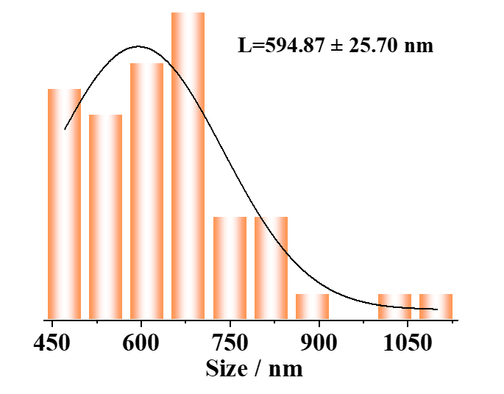
Figure S1. The particle size distribution of NiFe-LDH@cp.

Figure S2. XRD patterns of NiFe-LDH@cp, NiFe-LDH(TA)@cp, and SU-NiFe-LDH(TA)@cp.

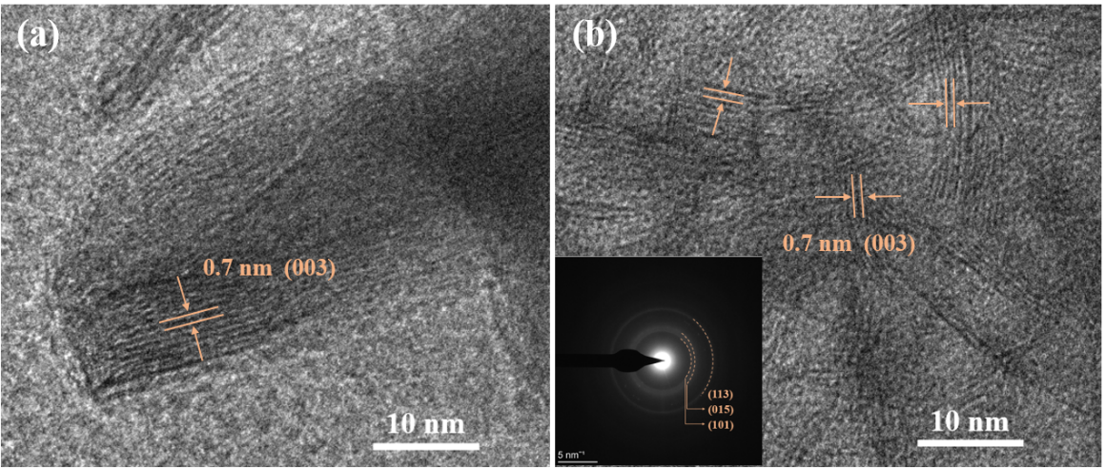
Figure S3. HRTEM images of a) NiFe-LDH@cp, b) SU-NiFe-LDH(TA)@cp, and the inset present SAED pattern of SU-NiFe-LDH(TA)@cp.

Figure S4. The particle size distribution of SU-NiFe-LDH(TA)@cp.

Figure S5. TEM images of a) NiFe-LDH@cp, and b) SU-NiFe-LDH(TA)@cp.

Figure S6. FTIR spectrum of NiFe-LDH@cp and SU-NiFe-LDH(TA)@cp.

Figure S7. Raman spectra of Trimesic acid, NiFe-LDH@cp, NiFe-LDH(TA)@cp, and SU-NiFe-LDH(TA)@cp.

Figure S8. High resolution XPS spectrum of a) Ni 2p, b) Fe 2p, c) C 1 s, and d) O 1 s for NiFe-LDH(TA)@cp.

Figure S9. The CV curves of a) NiFe-LDH@cp, b) NiFe-LDH(TA)@cp, and c) SU-NiFe-LDH(TA)@cp at different scanning rates.

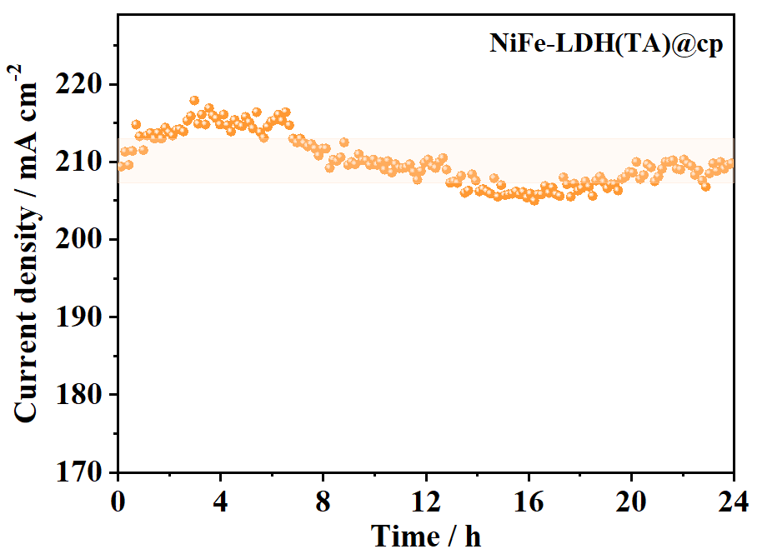

Figure S10. Chronoamperometric curve of NiFe-LDH(TA)@cp in 1M KOH.

Figure S11. Comparison of Chronoamperometric curves for NiFe-LDH@cp and SU-NiFe-LDH(TA)@cp in 1M KOH.

Figure S12. High resolution XPS spectrum of a) Ni 2p, b) Fe 2p, c) C 1 s, and d) O 1 s for p-SU-NiFe-LDH(TA)@cp.

Figure S13. a) The photos of SU-NiFe-LDH(TA) on different basements, including carbon paper (cp), nickel foam (nf), and carbon cloth (cc). b) LSV curves of SU-NiFe-LDH(TA)@cp, SU-NiFe-LDH(TA)@nf, and SU-NiFe-LDH(TA)@cc with iR compensation.

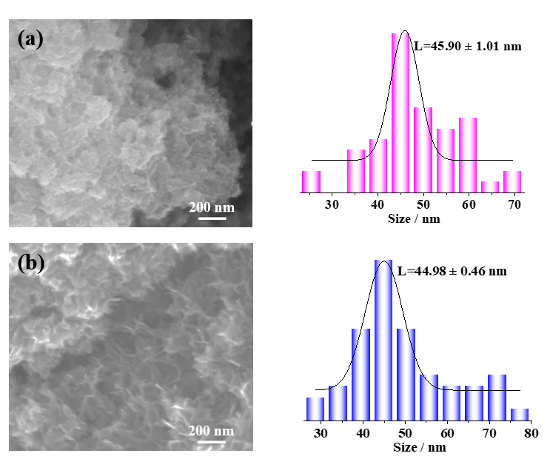
Figure S14. a) SEM image (left) and the particle size distribution (right) of SU-NiFe-LDH(TA)@nf. b) SEM image (left) and the particle size distribution (right) of SU-NiFe-LDH(TA)@nf after continuous operation for 1300 h at 1500 mA cm⁻² current density.

Figure S15. The contact angle of ultrapure water on carbon paper.

Figure S16. The contact angle of ultrapure water on a) NiFe LDH@cp, b) NiFe-LDH(TA)@cp, and c) SU-NiFe-LDH(TA)@cp after 0.1 s.

Figure S17. The digital photography of O₂ releasing behavior on a) NiFe LDH@cp, b) NiFe-LDH(TA)@cp, and c) SU-NiFe-LDH(TA)@cp at 200 mA cm⁻².

Figure S18. FTIR spectrum of SU-NiFe-LDH(TA)@cp and p-SU-NiFe-LDH(TA)@cp.

Figure S19. Model for NiFe-LDH. Green balls: Ni atoms; Orange balls: Fe atoms; Red balls: O atoms; Brown balls: C atoms; White atoms: H atoms.

Figure S20. The optimized structures of *OH, *O, and *OOH adsorbed at Fe_{b} active site on a) NiFe-LDH and b) SU-NiFe-LDH(TA) models.

Figure S21. The optimized structures of *OH, *O, and *OOH adsorbed at Ni_{b} active site on a) NiFe-LDH and b) SU-NiFe-LDH(TA) models.

Figure S22. Free energy diagrams of NiFe-LDH and SU-NiFe-LDH(TA) models for Fe_{b} sites.

Table S1 The Ni and Fe ions content in electrolyte for NiFe LDH@cp, NiFe-LDH(TA)@cp and SU-NiFe-LDH(TA)@cp samples after 24 h stability test at 200 mA cm⁻².
Working electrode | Testing time | Element content / ng mL⁻¹
Working electrode | Testing time | Ni | Fe
NiFe-LDH@cp | 24 h | 290.751 |  | 365.659
NiFe-LDH(TA)@cp | 24 h | 18.206 |  | 20.713
SU-NiFe-LDH(TA)@cp | 24 h | 7.462 |  | 19.115

Table S2 Comparison of the OER performance and tafel between the SU-NiFe-LDH(TA) catalyst and other recently reported LDH-based OER electrocatalysts in 1 M KOH electrolyte.
Electrocatalysts | η at 10 mA cm⁻² | Tafel / mV dec⁻¹
SU-NiFe-LDH(TA) | 219 | 31.1
Co₉S₈@NiFe LDH⁴ | 220 | 52.0
PM-NiFe-LDH⁵ | 230 | 47.0
Ni-Fe-Ce-LDH⁶ | 242 | 39.3
NiFe LDH-0.20 M⁷ | 243 | 50.0
Co₁Fe_{0.2} LDH ⁸ | 256 | 40.0
ultrathin NiFe LDH ⁹ | 270 | 48.6
NiCo LDH@ZIF-67¹⁰ | 290 | 58.0
GDY@NiFe LDH ¹¹ | 260 | 95.0
2D CoCo-LDH¹² | 319 | 42.0

Table S3 Comparison of the stability between the SU-NiFe-LDH(TA) catalyst and other recently reported LDH-based OER electrocatalysts in 1 M KOH electrolyte.
Electrocatalysts | Current density / mA cm⁻² | Time / h
SU-NiFe-LDH(TA) | 1500 | 1300
FeNiW-LDH¹³ | 300 | 120
LDH-Bir¹⁴ | 100 | 160
P-V-NiFe LDH NSA¹⁵ | 40 | 1000
Zn-(Ni/FeOOH) ¹⁶ | 1000 | 1000
NiFeOOH/NiFe/Ni ¹⁷ | 500 | 100
Ni_{x}Fe_{1-x}-AHNA ¹⁸ | 500 | 24

Table S4 Comparison of the stability between the SU-NiFe-LDH(TA) catalyst and other recently reported advanced OER electrocatalysts in 1 M KOH electrolyte.
Electrocatalysts | Current density / mA cm⁻² | Time / h
SU-NiFe-LDH(TA) | 1500 | 1300
(NiCo)₃Se₄¹⁹ | 1000 | 500
Ni₃N@2M-MoS₂ ²⁰ | 1000 | 300
MnCoP ²¹ | 100 | 240
Ni₃S₂ ²² | 100 | 100
Co₉S₈@Fe₃O₄ ²³ | 500 | 120
Ni₃Fe_{0.5}V_{0.5} ²⁴ | 100 | 60

Table S5 The O-H bond length in *OH and *OOH of NiFe-LDH and SU-NiFe-LDH(TA) models at different adsorption sites (Ni_{b} and Fe_{b}).
Catalysts | Adsorption sites | Intermediate | O-H bond length / Å
NiFe-LDH | Ni_{b} | *OH | 0.979
NiFe-LDH | Ni_{b} | *OOH | 0.982
NiFe-LDH | Fe_{b} | *OH | 0.973
NiFe-LDH | Fe_{b} | *OOH | 0.980
SU-NiFe-LDH(TA) | Ni_{b} | *OH | 0.979
SU-NiFe-LDH(TA) | Ni_{b} | *OOH | 1.020
SU-NiFe-LDH(TA) | Fe_{b} | *OH | 1.043
SU-NiFe-LDH(TA) | Fe_{b} | *OOH | 0.992

References for SI
1. G. Kresse et al. Efficient iterative schemes for ab initio total-energy calculations using a plane-wave basis set. PhRvB 54, 11169-11186 (1996).
2. J. P. Perdew et al. Generalized gradient approximation made simple. Phys. Rev. Lett. 77, 3865-3868 (1996).
3. J. K. Nørskov et al. Origin of the overpotential for oxygen reduction at a fuel-cell cathode. J. Phys. Chem. B 108, 17886-17892 (2004).
4. Feng, X. et al. Revealing the effect of interfacial electron transfer in heterostructured Co₉S₈@NiFe LDH for enhanced electrocatalytic oxygen evolution. J. Mater. Chem. A 9, 12244-12254 (2021).
5. Zhang, X. et al. A simple synthetic strategy toward defect-rich porous monolayer NiFe-layered double hydroxide nanosheets for efficient electrocatalytic water oxidation. Adv. Energy Mater. 9, 1900881 (2019).
6. Xu, H. et al. Fabrication of layered double hydroxide microcapsules mediated by cerium doping in metal–organic frameworks for boosting water splitting. Energy Environ. Sci. 13, 2949-2956 (2020).
7. Wu, C. et al. NiFe layered double hydroxides with unsaturated metal sites via pre-covered surface strategy for oxygen evolution reaction. ACS Catal. 10, 11127-11135 (2020).
8. Bai, X. et al. Unveiling the active sites of ultrathin Co-Fe layered double hydroxides for the oxygen evolution reaction. Chinese J. Catal. 43, 2240-2248 (2022).
9. Suliman, M. et al. Growth of ultrathin nanosheets of nickel iron layered double hydroxide for the oxygen evolution reaction. Int. J. Hydrogen Energy 47, 23498-23507 (2022).
10. Chen, W. et al. Ni–Co hydroxide nanosheets on plasma-reduced Co-based metal–organic nanocages for electrocatalytic water oxidation. J. Mater. Chem. A 7, 4950-4959 (2019).
11. Shi, G. et al. Graphdiyne-supported NiFe layered double hydroxide nanosheets as functional electrocatalysts for oxygen evolution. ACS Appl. Mater. Interfaces 11, 2662-2669 (2019).
12. Wang, H. et al. Recent progress on layered double hydroxides: comprehensive regulation for enhanced oxygen evolution reaction. Mater. Today Energy 27, 101036 (2022).
13. He, J. et al. Promoting electrocatalytic water oxidation through tungsten-modulated oxygen vacancies on hierarchical FeNi-layered double hydroxide. Nano Energy 80, 105540 (2021).
14. Chen, Z. et al. TM LDH meets birnessite: A 2D-2D hybrid catalyst with long-term stability for water oxidation at industrial operating conditions. Angew. Chem. Int. Ed. Engl. 60, 9699-9705 (2021).
15. Tang, Y. et al. Activating the hydrogen evolution and overall water splitting performance of NiFe LDH by cation doping and plasma reduction. Appl. Catal. B: Environ. 266, 118627 (2020).
16. Zhang, X. et al. In situ reconstructed Zn doped Fe_{x}Ni_{(1-x)}OOH catalyst for efficient and ultrastable oxygen evolution reaction at high current densities. Small, e2203710 (2022).
17. Wu, Y. et al. Ultrastable NiFeOOH/NiFe/Ni electrocatalysts prepared by in-situ electro-oxidation for oxygen evolution reaction at large current density. Appl. Surf. Sci. 564, 150440 (2021).
18. Liang, C. et al. Exceptional performance of hierarchical Ni-Fe oxyhydroxide@NiFe alloy nanowire array electrocatalysts for large current density water splitting. Energy Environ. Sci. 13, 86-95 (2020).
19. Abed, J. et al. In situ formation of nano Ni-Co oxyhydroxide enables water oxidation electrocatalysts durable at high current densities. Adv. Mater. 33, e2103812 (2021).
20. Wu, T. et al. Engineering metallic heterostructure based on Ni₃N and 2M-MoS₂ for alkaline water electrolysis with industry-compatible current density and stability. Adv. Mater. 34, e2108505 (2022).
21. Fu, W.-Y. et al. Sepaktakraw-like catalyst Mn-doped CoP enabling ultrastable electrocatalytic oxygen evolution at 100 mA·cm⁻² in alkali media. Rare Metals 41, 3069-3077 (2022).
22. Zhao, C.X. et al. An anionic regulation mechanism for structural reconstruction of sulfide electrocatalysts under oxygen evolution conditions. Energy Environ. Sci. 15, 3257-3264 (2022).
23. Ji, Q. et al. Operando identification of active species and intermediates on sulfide interfaced by Fe₃O₄ for ultrastable alkaline oxygen evolution at large current density. ACS Catal. 12, 4318-4326 (2022).
24. Jiang, J. et al. Atomic-level insight into super-efficient electrocatalytic oxygen evolution on iron and vanadium Co-doped nickel (oxy)hydroxide. Nat. Commun. 9, 2885 (2018).

