Supporting Information
The Binding Behaviors between Cyclopentanocucurbit[6]uril and Three Amino Acids in the Solid and the Solution Phases
Si Yuan Cheng,ª Wei Wei Zhao,^{a,co} Xi Nan Yang,ª Lian Tong Wei,^{b} Zhu Tao,ª Pei Hua Ma*^{,c}
ªKey Laboratory of Macrocyclic and Supramolecular Chemistry of Guizhou Province, Guizhou University, Guiyang 550025, China
^{b}Guiyang Bewg Water Co., Ltd., Guiyang, 550001, China
^{co} Co-First author
＊Corresponding author. Email: phma@gzu.edu.cn.

Table S1 Crystallographic parameters of complexes 1-4
 | 1 | 2 | 3 | 4
Empirical formula | C₅₈H₇₂CdCl₄N₂₆O₁₆ | C₆₀H₇₈Cd₂Cl₈N₂₆O₁₄ | C₆₀H₇₄Cl₆N₂₅O₁₇Zn₂ | C₆₀H₇₄Cl₈N₂₅O₂₅Zn₂
Formula weight | 1643.61 | 1895.88 | 1760.88 | 1959.78
Crystal system | triclinic | monoclinic | triclinic | monoclinic
Space group | P -1 | P 21/c | P 1 | C 2
a[Å] | 12.263(3) | 15.9260(18) | 11.9881(10) | 27.042(3)
b[Å] | 12.710(2) | 17.703(2) | 12.1637(11) | 17.771(3)
c[Å] | 24.619(5) | 19.055(2) | 15.2288(13) | 18.421(2)
α[°] | 82.780(6) | 90 | 85.950(2) | 90
β[°] | 75.926(6) | 125.562(4) | 73.241(2) | 93.564(5)
γ[°] | 82.318(5) | 90 | 63.402(2) | 90
V[Å³ ] | 3671.2(13) | 4370.3(9) | 1896.9(3) | 8835.5(18)
Z | 2 | 2 | 1 | 4
D_{calcd}.[g cm ⁻³ ] | 1.487 | 1.441 | 1.541 | 1.473
T[K] | 296.15 | 296.15 | 296.15 | 296.15
μ[mm ⁻¹ ] | 0.525 | 0.800 | 0.926 | 0.868
Parameters | 980 | 543 | 983 | 986
R_{int} | 0.0396 | 0.0978 | 0.0862 | 0.0897
R[I > 2σ(I)]^{[a]} | 0.0547 | 0.0871 | 0.0686 | 0.0665
wR[I > 2σ(I)]^{[b]} | 0.1337 | 0.2267 | 0.1690 | 0.1612
R(all data) | 0.0897 | 0.1033 | 0.0994 | 0.1237
wR(all data) | 0.1485 | 0.2371 | 0.1860 | 0.1945
GOF on F² | 1.029 | 1.051 | 1.053 | 1.025
[a] Conventional R on Fhkl: ∑||F_{o}| - |F_{c}||/∑|F_{o}|.
[b] Weighted R on |Fhkl|²: ∑[w(F_{o}² - F_{c}²)²]/∑[w(F_{o}²)²]^{1/2}.

Table S2 Hydrogen bonding parameters of compounds 1-4
complexes | bond | bond length/Å |  |  | bond angle/°
complexes | X-H···Y | X-H | H···Y | X···Y | X-H···Y
1 | N26-H26C···O3 | 0.890 | 2.100 | 2.751 | 129.27
 | N26-H26D···O4 | 0.890 | 2.150 | 3.035 | 173.38
 | O6-H6···O5 | 0.820 | 1.763 | 2.576 | 170.82
 | N13-H13D···O11 | 0.890 | 2.045 | 2.901 | 160.91
 | N13-H13E···O14 | 0.890 | 2.044 | 2.806 | 143.05
 | N13-H13C···Cl1 | 0.890 | 2.356 | 3.228 | 166.16
 | O16-H16···O15 | 0.820 | 1.760 | 2.572 | 170.55
2 | N1-H1A···O6 | 0.890 | 2.471 | 3.062 | 124.26
 | N1-H1C···O4 | 0.890 | 1.693 | 2.334 | 126.40
 | N1-H1C···O7 | 0.890 | 2.672 | 3.048 | 106.61
 | O2-H2···O7 | 0.820 | 1.941 | 2.755 | 171.41
 | N2-H2A···O6 | 0.890 | 2.432 | 2.952 | 117.65
3 | O13—H13···O1 | 0.820 | 1.818 | 2.629 | 169.67
 | N25—H25C···O9 | 0.890 | 2.509 | 2.890 | 106.88
 | N25—H25D···O5 | 0.890 | 2.327 | 2.851 | 117.67
 | N25—H25E···O7 | 0.890 | 2.158 | 2.740 | 122.36
4 | O14—H14···O1 | 0.820 | 1.818 | 2.602 | 139.44
 | N25—H25D···O5 | 0.891 | 2.131 | 2.878 | 140.98
 | N25—H25D···O5 | 0.891 | 2.224 | 2.674 | 110.86
 | N25—H25E···O7 | 0.889 | 1.969 | 2.850 | 170.79

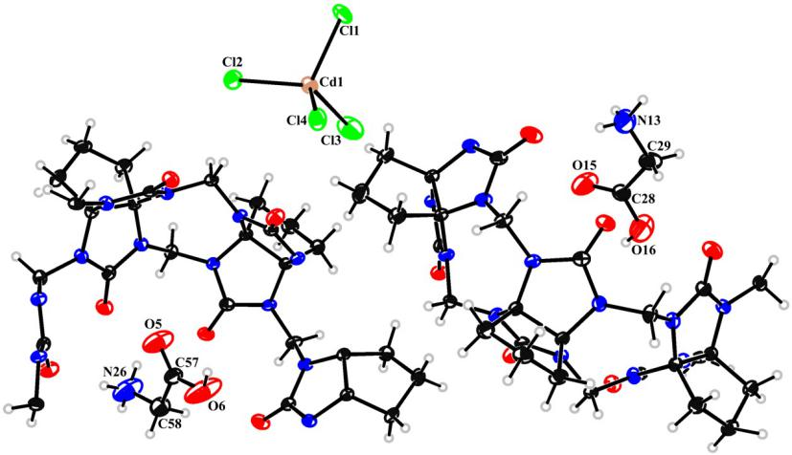

Fig. S1 ORTEP of the asymmetric unit of compound 1 (30% probability level) C = Black, H = Gray, O = Red，N = Blue, Cl = Green, Cd = Tan, Zn = Scarlet
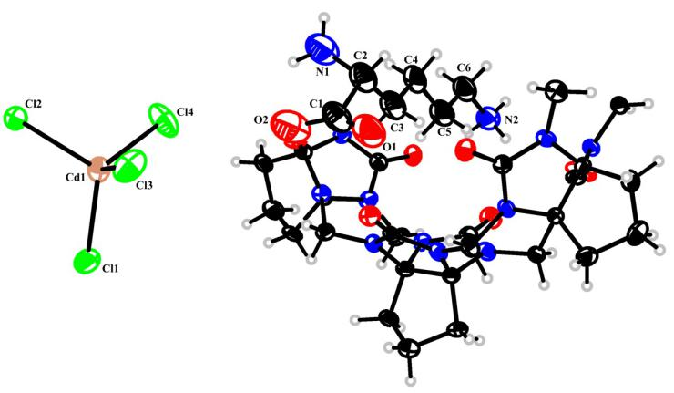
Fig. S2 ORTEP of the asymmetric unit of compound 2 (30% probability level) C = Black, H = Gray, O = Red，N = Blue, Cl = Green, Cd = Tan.
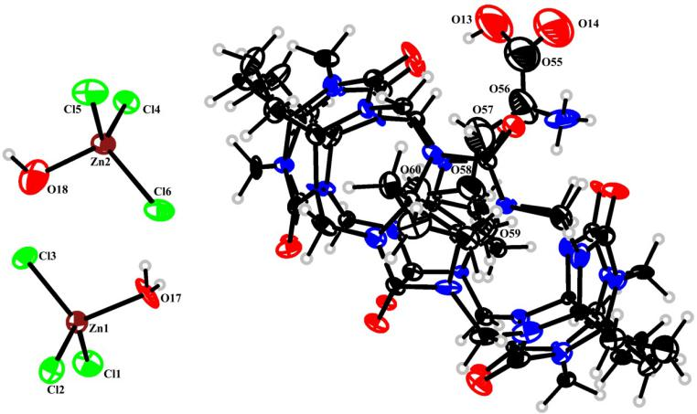

Fig. S3 ORTEP of the asymmetric unit of compound 3 (30% probability level) C = Black, H = Gray, O = Red，N = Blue, Cl = Green, Zn = Scarlet

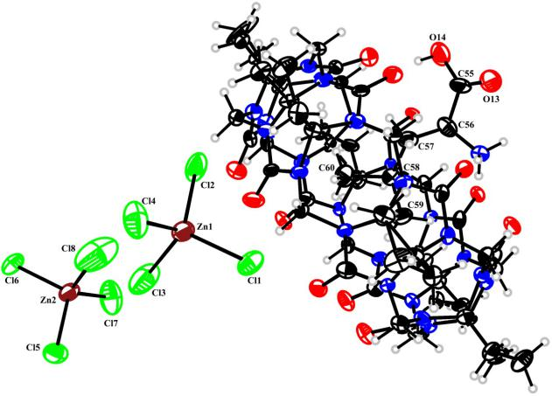

Fig. S4 ORTEP of the asymmetric unit of compound 4 (30% probability level)C = Black, H = Gray, O = Red，N = Blue, Cl = Green, Zn = Scarlet

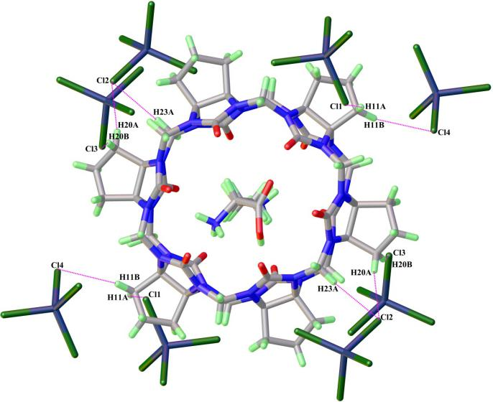

Fig. S5 Dipolar interaction between the counter ion and the cucurbituril in complex 2

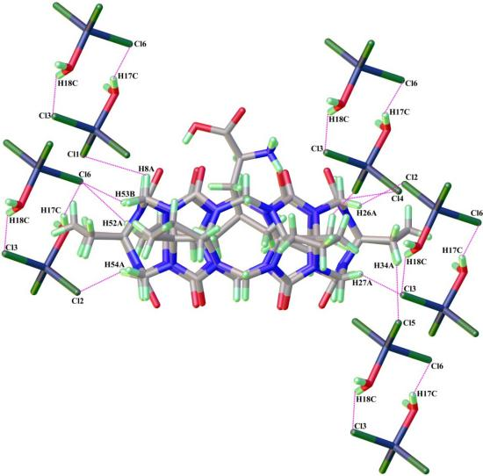

Fig. S6 Dipolar interaction between the counter ion and the cucurbituril in complex 3

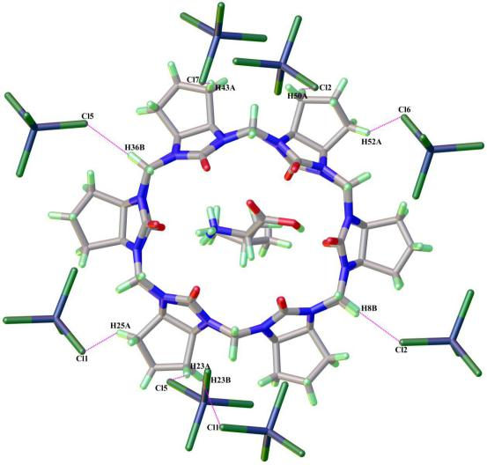

Figure S7 Dipolar interaction between the counter ion and the cucurbituril in complex 4

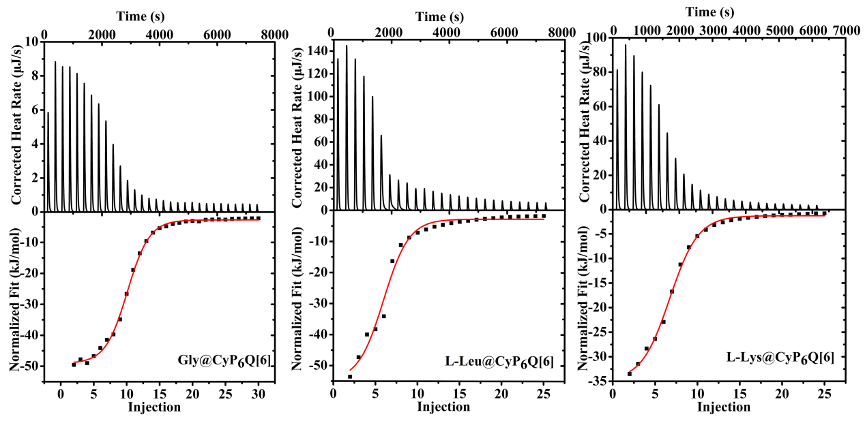
Fig. S8 Isothermal titration calorimetry of CyP₆Q[6] with three amino acids under 298.15K

