Supplementary data

Inland water quality dynamic and influencing factors of human-driven economic activities in Hainan, China

Table S1 The grade of water quality
COD | NH4 +-N | DO | Grade
COD≤ 2.0 mg/L | NH4 +-N≤0.15 mg/L | DO≥7.5 mg/L | I
2.0 mg/L＜COD≤ 4.0 mg/L | 0.15 mg/L＜NH4 +-N≤ 0.5 mg/L | 6.0 mg/L＜DO≤ 7.5 mg/L | II
4.0 mg/L＜COD≤ 6.0 mg/L | 0.5 mg/L＜NH4 +-N≤ 1.0 mg/L | 5.0 mg/L＜DO≤ 6.0 mg/L | III
6.0 mg/L＜COD≤ 10.0 mg/L | 1.0 mg/L＜NH4 +-N≤ 1.5 mg/L | 3.0 mg/L＜DO≤ 5.0 mg/L | IV
10.0 mg/L＜COD≤ 15.0 mg/L | 1.5 mg/L＜NH4 +-N≤2.0 mg/L | 2.0 mg/L＜DO≤ 3.0 mg/L | V

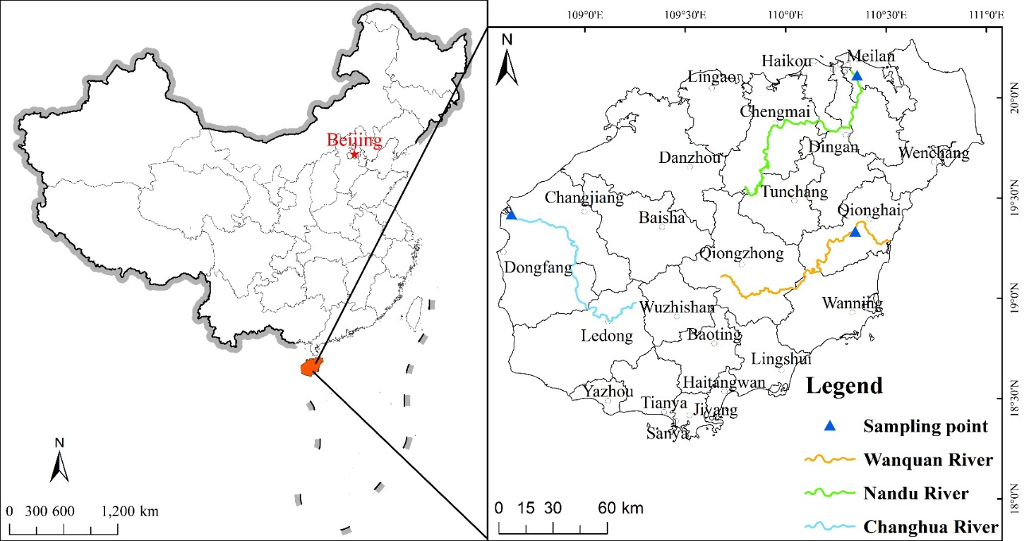
Fig S1. Sampling information in the Nandu River, Changhua River and Wanquan River.

Fig. S2 The output value of GOV of agriculture, GOV of Fishery, Total AABM and GOV of Animal Husbandry

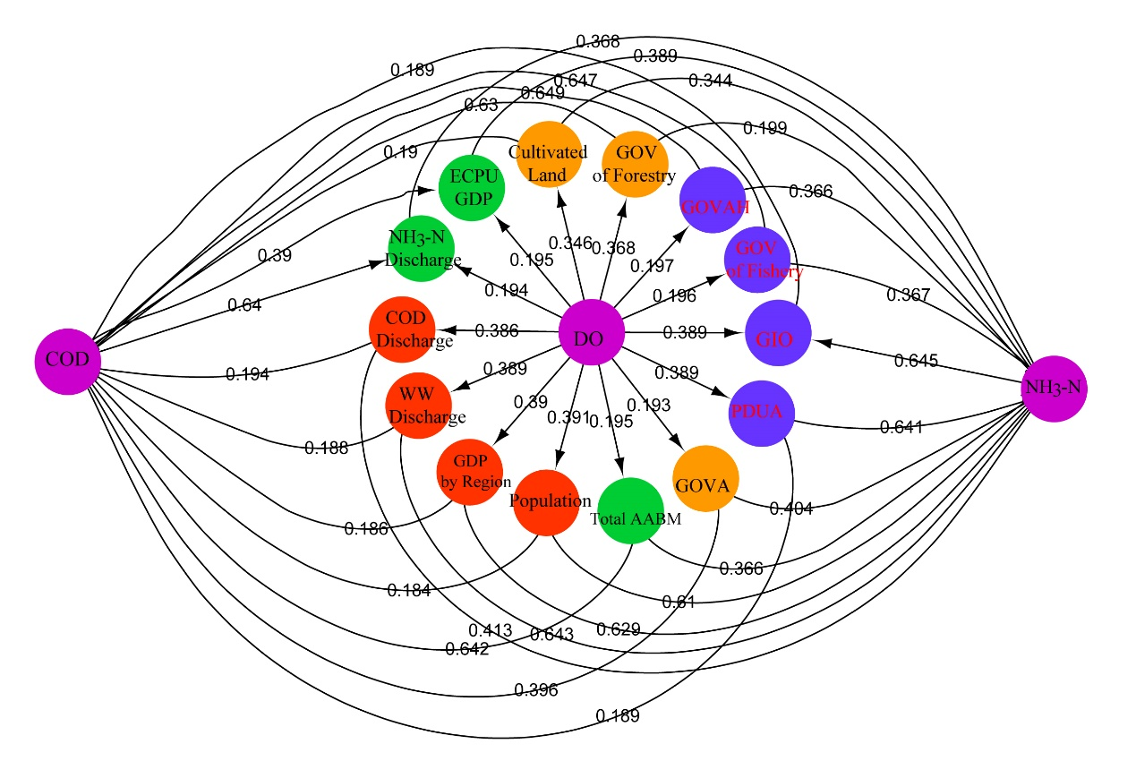
Fig. S3 Bayesian static graph in Wanquan River for predicting water quality
Fig. S4 The output value of GOV of agriculture, GOV of Fishery, Total AABM and GOV of Animal Husbandry
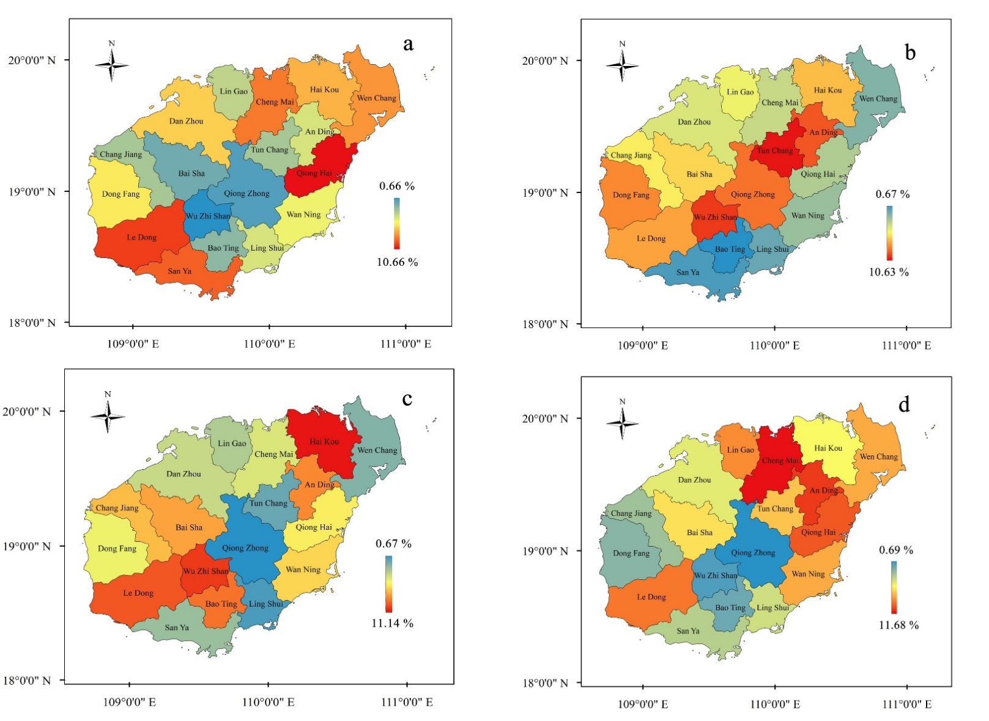
Fig. S5 Gross value of AO in 2012 (a), 2013 (b), 2014 (c) and 2015 (d).

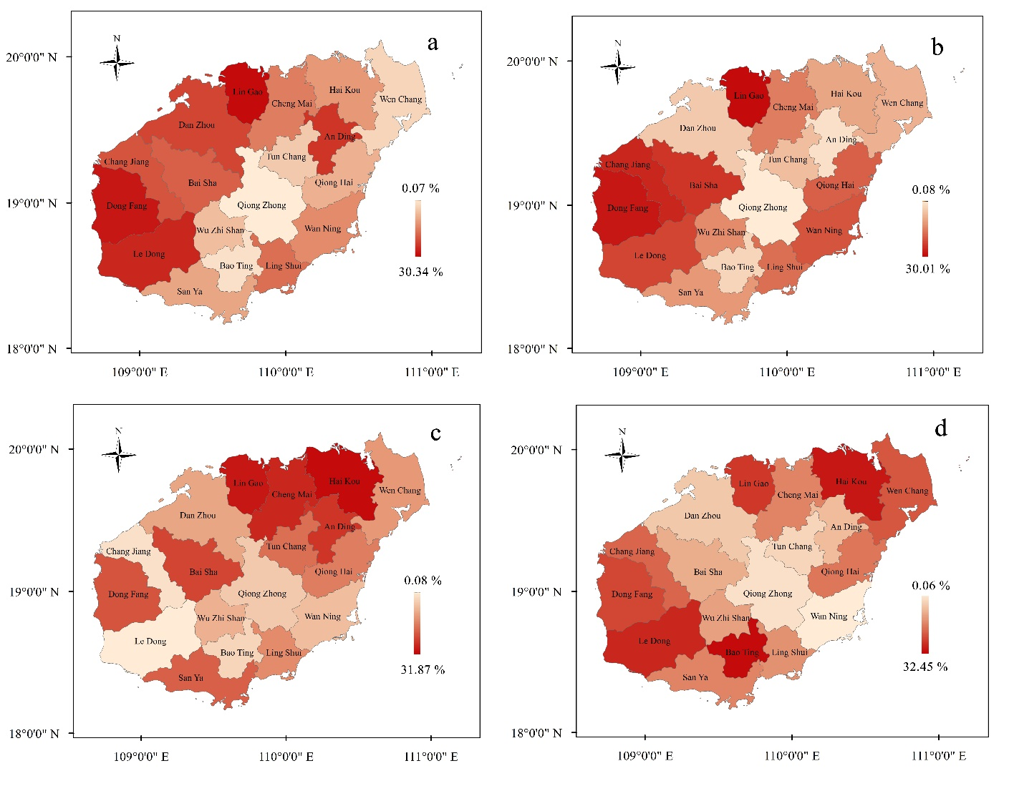
Fig. S6 Gross value of fishery in 2012 (a), 2013 (b), 2014 (c) and 2015 (d).

Fig. S7 The relationship between predicted and experimental values.

