Appendix

Appendix A: Catalog
Table 1 Event catalog during observation
Event Start time  (UTC) | longitude  (°) | latitude  (°) | Magnitude | depth  (m) | Epicenter distance  (m)
2021-12-29T17:39:17.457 | 25.093 | 123.268 | 4.5 | 12440 | 530036
2021-12-29T17:58:34.108 | 25.07 | 123.325 | 4.7 | 10000 | 535469
2021-12-29T18:25:51.844 | -7.546 | 127.576 | 7.3 | 164280 | 3687740
2021-12-30T06:47:09.128 | 23.95 | 122.491 | 5.3 | 23700 | 452320
2022-01-01T07:27:57.146 | 25.017 | 123.406 | 4.6 | 10000 | 543009
2022-01-01T08:14:51.854 | 25.106 | 123.475 | 4.8 | 10000 | 550946
2022-01-02T07:02:13.934 | 27.793 | 100.727 | 5.4 | 37690 | 1772024
2022-01-03T09:46:35.666 | 23.994 | 122.26 | 6.2 | 19000 | 428363
2022-01-03T21:08:51.270 | 27.145 | 141.572 | 5.8 | 43410 | 2371820
2022-01-03T23:17:28.926 | 24.035 | 122.192 | 5 | 26490 | 420912
2022-01-04T20:55:46.858 | -4.806 | 125.081 | 6 | 544000 | 3325361
2022-01-05T13:09:03.262 | 23.913 | 122.452 | 4.3 | 22680 | 448985
2022-01-05T13:11:35.849 | 23.903 | 122.495 | 4.5 | 22670 | 453480
2022-01-05T21:53:50.208 | 26.019 | 125.707 | 4.2 | 72300 | 788217
2022-01-06T00:27:20.268 | -6.063 | 127.84 | 4.2 | 406230 | 3538794
2022-01-07T17:45:30.799 | 37.825 | 101.282 | 6.6 | 13000 | 2175097
2022-01-07T17:55:20.954 | 37.811 | 101.163 | 5.2 | 10000 | 2182399
2022-01-07T21:12:17.590 | 24.26 | 120.776 | 4.6 | 10000 | 275137
2022-01-09T21:59:05.758 | 1.489 | 127.867 | 5.6 | 10000 | 2751370
2022-01-10T00:06:30.834 | -33.782 | 179.574 | 6.2 | 7000 | 9156877
2022-01-10T04:46:00.470 | 24.854 | 122.448 | 4.2 | 10000 | 445025
2022-01-10T19:18:49.272 | 36.223 | 140.784 | 4.3 | 84740 | 2533728
2022-01-11T01:07:48.091 | 35.233 | 31.947 | 6.6 | 21000 | 8153884
2022-01-11T11:35:46.156 | 52.656 | -167.917 | 6.8 | 22320 | 6819059
2022-01-11T12:39:31.515 | 52.605 | -168.155 | 6.6 | 11230 | 6803309
2022-01-12T00:43:22.701 | 24.472 | 122.279 | 4.4 | 66110 | 426402
2022-01-12T00:37:03.855 | 54.016 | 160.388 | 4.2 | 10000 | 4791955
2022-01-12T10:20:43.155 | 37.682 | 101.405 | 5.1 | 10000 | 2156775
2022-01-14T09:05:41.461 | -6.857 | 105.286 | 6.6 | 33000 | 3731899
2022-01-14T22:16:34.738 | 23.911 | 122.606 | 4.1 | 25400 | 464525
2022-01-16T08:07:15.011 | 51.868 | 170.57 | 4.1 | 10000 | 5353836
2022-01-16T08:15:41.930 | 24.185 | 122.264 | 5.2 | 52670 | 426432
2022-01-18T19:10:06.069 | 21.279 | 122.013 | 4.7 | 193580 | 536047
2022-01-21T16:08:37.265 | 32.744 | 132.043 | 6.3 | 39000 | 1643820
2022-01-22T02:26:13.317 | 3.675 | 126.658 | 6 | 21000 | 2477258
2022-01-22T05:17:04.896 | 53.24 | -166.682 | 6.2 | 29000 | 6897581
2022-01-23T02:21:19.948 | 38.467 | 97.346 | 5.6 | 10000 | 2498080
2022-01-25T14:17:25.353 | -3.125 | 147.952 | 4.5 | 10000 | 4445261
2022-01-25T14:35:53.224 | 24.642 | 121.99 | 4.5 | 64490 | 397358
2022-02-03T04:47:13.554 | 19.91 | 121.572 | 4.9 | 49600 | 619459
2022-02-05T10:59:16.988 | -3.64 | 146.784 | 4.1 | 10000 | 4395492
2022-02-05T11:04:47.279 | 3.709 | 127.165 | 4.3 | 10000 | 2494510
2022-02-05T11:16:22.952 | 16.277 | 122.171 | 4.4 | 50990 | 1001463
2022-02-07T10:58:25.027 | 24.379 | 122.044 | 5.1 | 36430 | 402820
2022-02-08T16:36:31.700 | 26.84 | 126.525 | 5.6 | 10000 | 888535
2022-02-08T22:41:46.104 | 26.804 | 126.343 | 5.1 | 10000 | 870034
2022-02-10T09:38:32.995 | 23.957 | 122.303 | 4.6 | 24830 | 433266
2022-02-11T12:51:28.636 | 23.988 | 122.343 | 4.9 | 28590 | 436822
2022-02-11T16:43:10.201 | 23.981 | 122.284 | 5.3 | 10000 | 430979
2022-02-11T17:47:45.381 | 23.968 | 122.323 | 4.5 | 21910 | 435109
2022-02-11T18:19:30.383 | 23.96 | 122.335 | 4.5 | 24350 | 436443
2022-02-12T00:41:07.197 | 20.127 | 121.389 | 5.2 | 26040 | 588800
2022-02-12T03:09:33.483 | 23.927 | 122.357 | 4.4 | 10000 | 439190
2022-02-13T04:36:17.787 | 19.13 | 121.173 | 5.5 | 28220 | 671346
2022-02-13T20:29:46.308 | 11.784 | 144.29 | 6 | 15000 | 3100249
2022-02-16T05:41:57.391 | 23.854 | 121.549 | 4.5 | 10000 | 359528
2022-02-16T20:21:06.737 | -23.768 | 179.998 | 6.8 | 535000 | 8550419
2022-02-20T10:49:41.629 | 23.893 | 122.559 | 4.5 | 25880 | 460090
2022-02-20T18:29:27.263 | 6.007 | 126.645 | 5.5 | 58120 | 2237826
2022-02-21T20:52:32.563 | 26.861 | 126.436 | 5.6 | 11590 | 880639
2022-02-25T01:39:26.723 | 0.214 | 100.09 | 6.1 | 4940 | 3309664
2022-02-25T08:50:53.881 | 26.737 | 126.464 | 5.3 | 10000 | 879702
2022-02-26T06:15:53.561 | 5.705 | 126.285 | 5.2 | 119180 | 2253270
2022-03-02T00:18:48.927 | 35.804 | 95.781 | 4.8 | 10000 | 2480084
2022-03-02T12:52:07.343 | -30.076 | -177.728 | 6.6 | 24000 | 9130054
2022-03-03T04:49:15.071 | 26.811 | 126.533 | 4.6 | 10000 | 888454
2022-03-04T21:03:47.961 | 39.637 | 143.5 | 4.7 | 10000 | 2915341
2022-03-04T22:29:45.329 | 39.608 | 143.721 | 5.1 | 10000 | 2930698
2022-03-05T14:43:04.599 | 22.344 | 101.684 | 4.5 | 10000 | 1690473
2022-03-06T01:13:33.571 | 28.094 | 130.011 | 5 | 10000 | 1257878
2022-03-06T03:51:56.569 | 24.837 | 122.229 | 4.4 | 113490 | 422809
2022-03-09T12:22:14.402 | 23.283 | 121.423 | 5.2 | 31640 | 365167
2022-03-13T18:28:47.062 | 22.737 | 114.982 | 3.8 | 10000 | 368572
2022-03-13T21:05:49.364 | 14.086 | 119.373 | 6.4 | 11000 | 1156230
2022-03-13T21:06:00.000 | 14.1 | 119.4 | 6.7 | 33000 | 1155029
2022-03-13T21:09:22.000 | -0.63 | 98.629 | 6.7 | 28000 | 3479618
2022-03-14T14:12:08.676 | -0.543 | 98.551 | 5.3 | 15950 | 3476907
2022-03-14T14:31:54.334 | 14.15 | 119.379 | 4.8 | 10000 | 1149271
2022-03-14T14:40:47.749 | 14.145 | 119.334 | 5.2 | 10000 | 1149267
2022-03-14T15:15:23.995 | 14.171 | 119.439 | 4.5 | 10000 | 1147732
2022-03-14T15:22:53.896 | 14.131 | 119.516 | 5 | 10000 | 1153158
2022-03-15T06:40:15.628 | 26.841 | 126.376 | 4.8 | 10000 | 874299
2022-03-15T12:12:31.279 | -0.551 | 98.566 | 5.2 | 36590 | 3476643
2022-03-16T00:09:30.321 | 14.117 | 119.285 | 5.2 | 10000 | 1151767
2022-03-16T00:34:48.618 | 22.155 | 120.825 | 4.3 | 10000 | 379837
2022-03-16T14:36:33.000 | 37.702 | 141.587 | 7.3 | 59850 | 2669221

Appendix B: Data cleaning
K-means cluster analysis is an example of a clustering algorithm. In this work, we used the K-means method to perform cluster analysis on the hourly HVSR spectra calculated by each station and judged the clustering effect according to the elbow rule. The algorithm used in this work comes from the SciPy module. Fig. 1 shows the HVSR spectrum of seismic data from the top floor of the high-rise building as an example to illustrate the process of data cleaning.
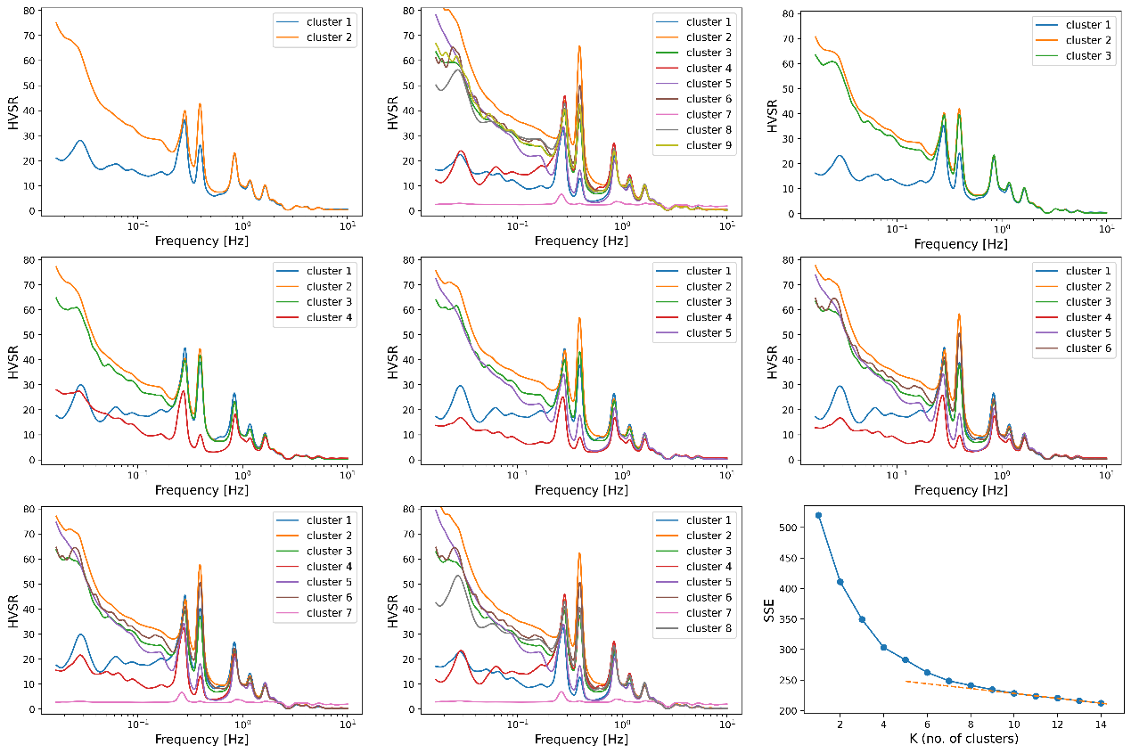
Fig. 1 Clustering analysis results using the K-means method. The first 8 subgraphs represent the classification results under different numbers of clusters, the curves represent the average HVSR spectrum of the corresponding clusters, and the last subplot is the SSE plot (squared error and SSE and number of clusters K).
As shown in Fig. 1, when the number of classifications is greater than 7, the HVSR spectrum of the pink class (cluster 7) appears to be significantly lower than the normal value. After verification, these are the poor HVSR spectra of some data due to severe drift, pulse interference, instrument switching and other factors, which need to be cleaned. According to the elbow rule, in the last subplot of Figure 1, after K=8, the SSE (sum of squared errors) begins to decrease in a linear manner (orange dotted line). Therefore, k=8 is chosen as the optimal number of clusters, and the pink data will be clear.

