Table 1: Two- dimensional structure of Furanone derivatives
S.no. | Ligand name | Ligand structure
1. | 2(3H) – Furanone, dihydro- 3,3- dimethyl- 5- methylene (Compound 1) | 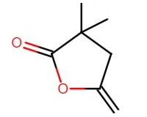
2. | 3-phenyl-2H-furan-5-one (Compound 2) | 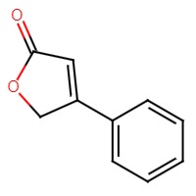
3. | 4,4-dimethyl-5-methylenedihydro-2(3H)-furanone (Compound 3) | 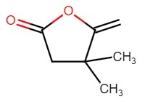
4. | 5-phenyl-3H-furan-2-one (Compound 5) | 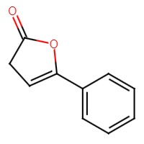
5. | 5-Benzylidenedihydrofuran-2-one (Compound 6) | 