Expression and clinical significance of IL7R, NFATc2 and RNF213 in familial and sporadic multiple sclerosis patients

Seyedeh Zahra Hosseini Imani¹, Zohreh Hojati^{1*}, Fariba Dehghanian¹, Sheyda Khalilian¹, Majid Kheirollahi², Mehdi Khorrami², Vahid Shaygannejad³, Omid Mirmosayyeb³

- Division of Genetics, Department of Cell and Molecular Biology and Microbiology, Faculty of Biological Sciences and Technologies, University of Isfahan, Isfahan, Iran.
- Research Institute for Primordial Prevention of Non-Communicable Disease and Department of Genetics and Molecular Biology, School of Medicine, Isfahan University of Medical Sciences, Isfahan, Iran.
- Isfahan Neuroscience Research Center, Isfahan University of Medical Sciences, Isfahan, Iran.

* Correspondence: Dr. Zohreh Hojati
Postal Code: 81746-73441
Email: z.hojati@sci.ui.ac.ir

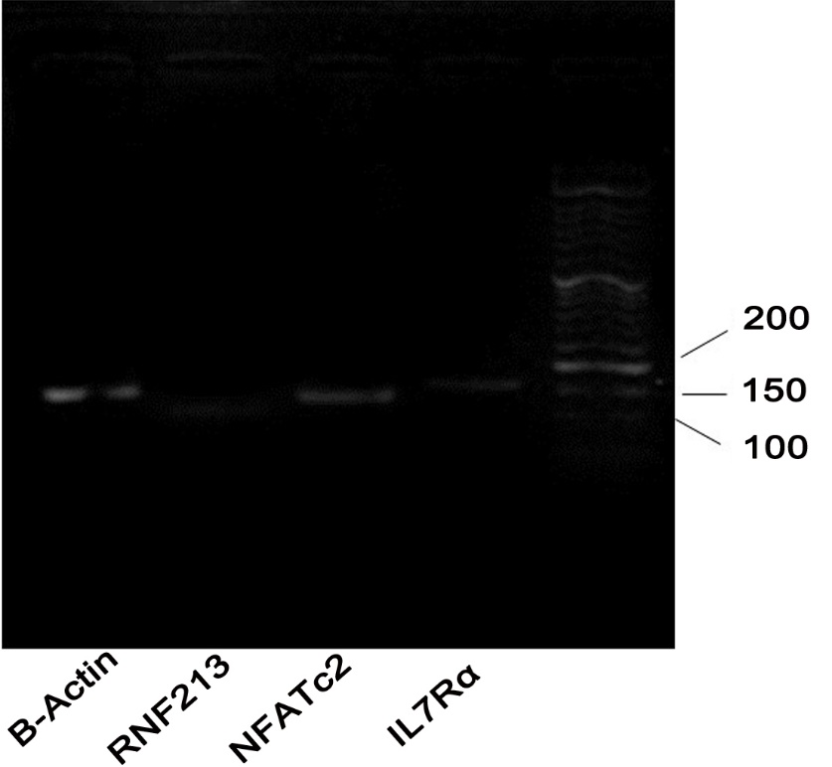

Supplementary Fig. 1 DNA gel electrophoresis for validation of gene amplification in RT-PCR. A patient sample run on a 2% agarose gel stained with Ethidium Bromide. The first line accommodates a 50 base bp ladder. Amplicon size of IL7R = 150 bp, NFATc2 = 133 bp, RNF213 = 106 bp, ACTB =151 bp

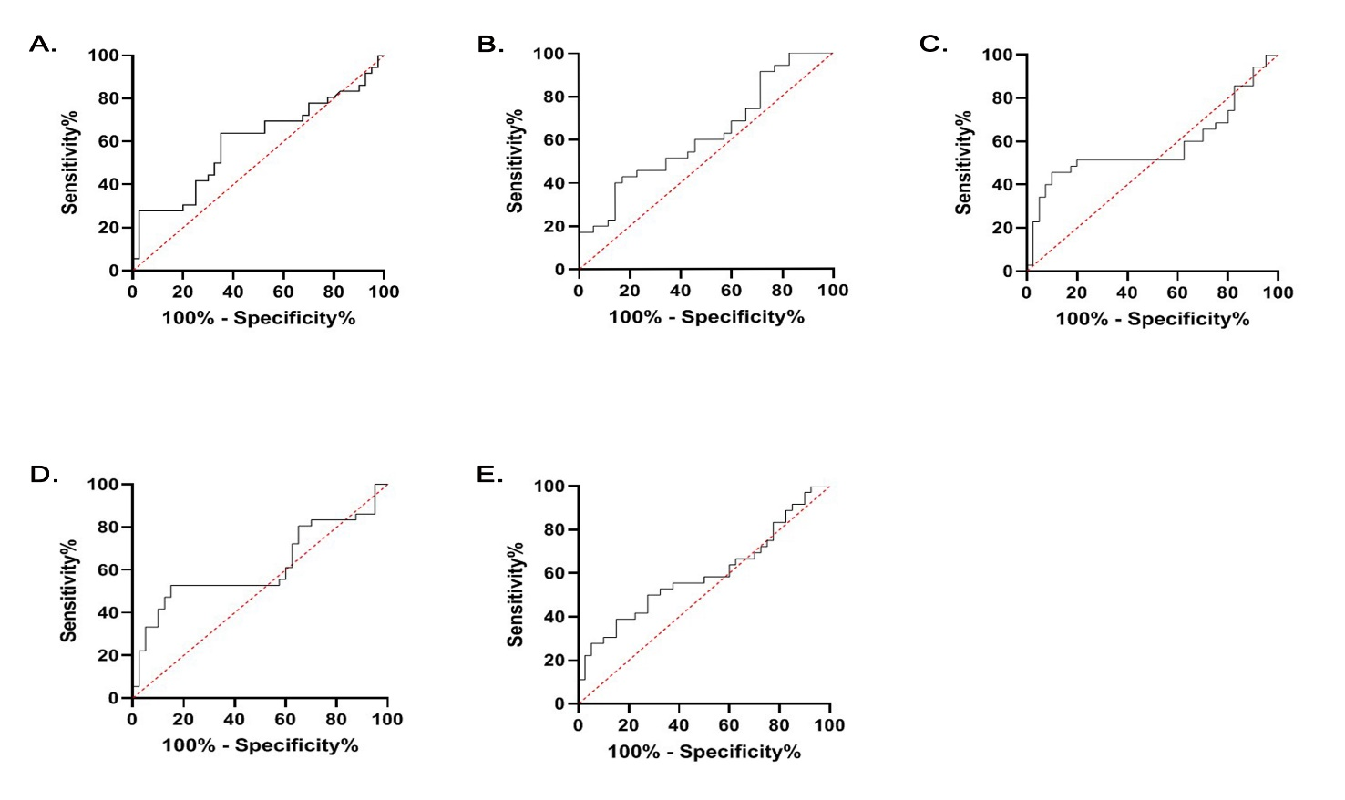
Supplementary Fig. 2 ROC curves for IL7R, NFATc2 and RNF213. A) ROC curve of sporadic and Familial patients analyzed for relative expression level of IL7R (AUC: 0.59, p value: 0.14). B) ROC curve of Sporadic patients and FDR groups analyzed for relative expression level of NFATC2 (AUC: 0.62, p value: 0.08).C) ROC curve of sporadic patients and healthy controls analyzed for relative expression level of NFATC2 (AUC: 0.58, p value: 0.22). D) ROC curve of Familial patients and healthy controls analyzed for relative expression level of NFATC2 (AUC: 0.61, p value: 0.07). E) ROC curve of Familial patients and healthy controls analyzed for relative expression level of RNF213 (AUC: 0.59, p value: 0.15).

