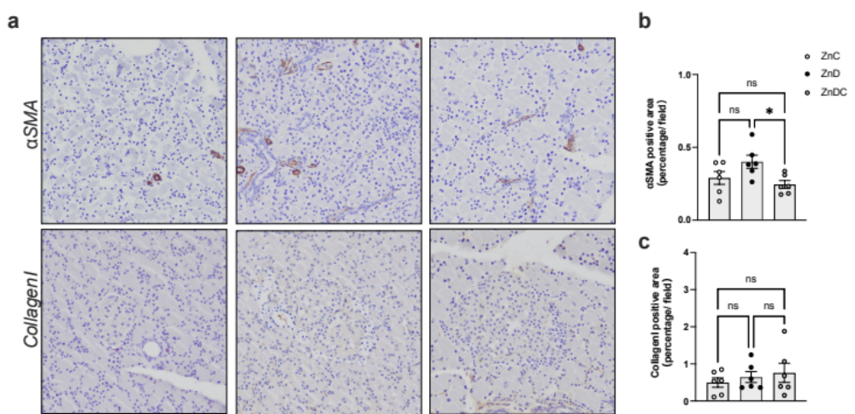

Supplementary figure
(a-c) Immunohistochemical analysis of the rats used in Figure 1. (a) Histological analysis of αSMA, Collagen1, and Cd11b/c. (b and c) Quantification of each marker using WinROOF software. Data were reported as mean ± SEM. Statistical differences were determined by Student’s t-test using Graph Pad Prism 9. Statistical significance is displayed as follows: *p < 0.05, **p <0.01, ***p<0.001 ZnC vs ZnD. And ns stands for not statistically significant.

