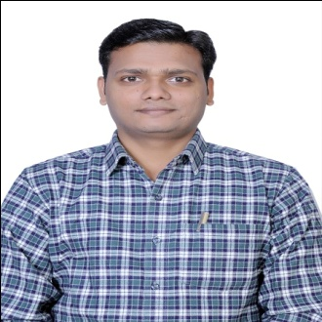
Dr. Tayyab Khan received the Engineering degree in Computer Science & Engineering from Gautam Buddh Technical University, UP, India. He has completed his M.Tech. and Ph.D. in Computer Science & Engineering from the School of Computer and Systems Sciences, JNU New Delhi, India in October 2016 and 2021 respectively. He has published more than 20 research papers in the reputed journals and good Conference. His primary research interests are in the Trust modeling, wireless sensor networks, Body sensor networks, Network security, Multicast communication. He organized the workshops, International conference sessions, and training.

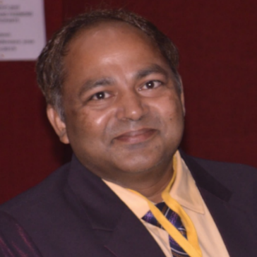
Dr. Karan Singh (SMIEEE) is working with the School of Computer & Systems Sciences, Jawaharlal Nehru University, New Delhi. He works as a proctor and many committee members at Gautam Buddha University. He is member of Admission and placement committee at school level. His primary research interests are in computer network, computer network security, Multicast communication, Internet of Things, Blockchain, and Wireless Sensor Networks. He supervised twenty Ph.D. scholars and fifty-four M.Tech. Students. He is reviewer of IEEE & Elsevier conferences and reviewer of International Journals & IEEE Transactions TIIS, CN, IoT etc.. He is an Editorial Board Member of Journal of Communications and Network (CN), USA. He published Hundred fifty plus research papers in journal (SCI, SCIE, Scopus and Transactions) and good conferences. He organized of various workshop, Session, Conference and training. Dr. Singh worked as General Chair of International conference (Qshine) in year 2013 at Gautam Buddha University. He organized as Chair the International Conference “NetCrypt 2019, 2020” at JNU, New Delhi. He was nominated for Who’s who in World in year 2008. Dr. Singh has been joined as Professional member Association for Computing Machinery (ACM), New York, Computer Science Teachers Association (CSTA) U.S.A, Computer Society of India(CSI), Secunderabad, India, Cryptology Research Society of India (CRSI), Kolkata, India, Institute of Electrical and Electronics Engineers (IEEE), USA, International Association of Computer Science and Information Technology (IACSIT), Singapore, Institute for Computer Sciences, Social-Informatics and Telecommunications Engineering (ICST), America, International Association of Engineers (IAENG), Hong Kong, Association of Computer Electronics and Electrical Engineers (ACEEE), India, Internet Society(ISOC), USA and Academy & Industry Research Collaboration Center (AIRCC), India.

