Supplementary Materials for

Inflammatory memory restrains intestinal stem cell regeneration
Dongchang Zhao¹, Visweswaran Ravikumar², Emma Lauder^{1,3}, Lu Li¹, Yaping Sun¹, Katherine Oravecz-Wilson³, Michael Brooks³, Evan T. Keller⁴, Fengju Chen¹, Laure Maneix¹, Ana Eva Santibanez¹, Chad J. Creighton¹, Arvind Rao², Pavan Reddy^{1,3*}

Corresponding author: pavan.reddy@bcm.edu

The PDF file includes:

Materials and Methods
Figs. S1 to S7
Tables S1 to S2
References

Materials and Methods
Mice
C57BL/6 (B6, H-2Kb) and BALB/c (H-2Kd) were purchased from Charles River Laboratories. Lgr5-eGFP-IRES-CreERT2 (B6-GFP-Lgr5) (H-2Kb), C3H.SW (H-2Kb) were purchased from the Jackson Laboratory. The Sdha^{floxp/floxp} mice (1) were bred with GFP-Lgr5 mice to create Lgr5-cre Sdha^{floxp/floxp} (SdhaΔ/ISC) mice upon tamoxifen administration. Female mice aged 8 to 12 weeks old were used for experiments. All mice were kept under specific pathogen-free conditions and cared for according to regulations reviewed and approved by the University of Michigan or Baylor College of Medicine Committee on the Use and Care of Animals, which are based on the University of Michigan or Baylor College of Medicine Laboratory Animal Medicine guidelines.
Methods
Bone marrow transplantation
BMTs were performed as previously described (2). Syngeneic (B6→B6 or B6-GFP-Lgr5) and allogeneic (BALB/c→B6 or B6-GFP-Lgr5 or C3H.SW→B6) BMT recipients received lethal irradiation. In the special BMT (Fig. 3e-i), recipients of SdhaΔ/ISC mice were treated with tamoxifen (KO) or diluent (WT) for five days before receiving irradiation. 14 days after initial tamoxifen treatment, B6, or B6-GFP-Lgr5 or SdhaΔ/ISC mice received a single dose of 1,000 cGy on day -1. On day 0, donor splenic CD90.2⁺ T cells were enriched with MACS Columns Separator (Miltenyi Biotec) and 2.5-5.0x 10⁶ of donor T cells with 5.0 x10⁶ of donor bone marrow cells were transferred to B6 or B6-GFP-Lg5 or SdhaΔ/ISC recipients. All recipients were monitored survival daily and determined recipient body weight and GVHD clinical scores weekly, as described previously (2).
In vivo tamoxifen treatment
To delete sdha in lgr5⁺ISCs, adult SdhaΔ/ISC mice were intraperitoneal (i.p.) injected with tamoxifen suspended in corn oil at a concentration of 10 mg/ml, 10µl per g of body weight daily for five days (3). SdhaΔ/ISC mice were intraperitoneal (i.p.) injected with corn oil only as control.
In vivo EdU incorporation assay
Lgr5⁺ISCs proliferation was determined using 5-ethynyl-2’-deoxyuridine (EdU) incorporation into DNA as previously reported (2). Lgr5-EGFP strains mice were injected intraperitoneally with 200μL of 5mM EdU solution in PBS 2h before sacrifice. Small intestinal samples were collected for EdU staining. EdU was detected with the EdU Flow Cytometry Assay kit according to the manufacturer's instructions.
Intestinal crypt isolation and crypts-derived organoids culture
Intestinal crypts-derived organoids culture was adapted from previously reports (4, 5). In brief, small intestines were collected and flushed with ice-cold PBS, cut longitudinally into roughly 2-mm-long pieces, incubated in 10 mM EDTA at 4 °C for 40 minutes. Tissues were transferred to cold PBS. Crypts were mechanically separated from tissues by pipette up and down and then filtered through a 70-mm cell strainer. To get purified crypts, tissues were repeated to this mechanical separation for 3-5 times. Isolated crypts were counted and embedded in Matrigel and culture media (1:1) at 2-5 crypts per µl. Unless otherwise noted, crypt culture media consists of Advanced DMEM that was supplemented with EGF 40 ng/ml, Noggin 200 ng/ml, R-spondin 500 ng/ml, N2 (1X), B27 (1X), 10uM γ-27632, 100 U/ml penicillin, and 100µg/ml streptomycin. Intestinal crypts in10-50µl droplets of Matrigel and culture media were plated onto a flat bottom of Seahorse 96-well cell culture plate, or Corning 48-well and 24-well plate and allowed to solidify for 15-30 minutes in a 37°C incubator. One hundred fifty microliters to five hundred microliters of crypt culture medium per well were then overlaid onto the Matrigel according to different culture plate. Crypt culture medium were changed every three days and maintained at 37°C in fully humidified chambers containing 5% CO2. For the serial organoid culture, primary organoids were removed from Matrigel and mechanically dissociated into single-crypt domains with 20-gauge needle, and then transferred to fresh Matrigel. Passage was performed every 7-10 days with a 1:5 split ratio (5).
Single intestinal stem cells-derived organoids culture
Sorted single intestinal stem cells-derived organoids culture was performed as previously described (5, 6). In brief, 1000 cells of Lgr5⁺ISCs per well in 10 µl droplets of Matrigel and ISCs culture media (1:1) were plated onto a flat bottom of Seahorse 96-well cell culture plate and allowed to solidify for 15-30 minutes in a 37°C incubator. One hundred fifty microliters of ISCs culture medium were then overlaid onto the Matrigel. ISCs culture medium were changed every two days and maintained at 37°C in fully humidified chambers containing 5% CO2. ISCs culture media consists of IntestiCult™ Mouse Organoid Growth Medium supplemented with 1µM JAG1 protein, 100 U/ml penicillin, and 100µg/ml streptomycin. Organoids numbers and organoid formation-crypts were counted per well 4-9 days after initiation of cultures.
Dimethyl succinate or dimethyl malonate treatment organoids
Three days after initial intestine organoids culture, indicated concentration of dimethyl succinate or dimethyl malonate were add to cultures in standard organoids culture media for seventy-two hours. Organoids numbers and their formation-crypts were counted and imaged. Then, the organoids were harvested for further experiments.
Succinate quantification
Organoids were harvested on indicated culture time, washed twice use cold PBS, and then dissociated to single cells with TrypLE express for five minutes at 37°C. Then, cells were processed and analyzed using the Succinate Assay Kit according to the manufacturer’s protocol (1).
Global DNA methylation assay
Organoids were harvested on indicated culture time, washed twice use cold PBS, and dissociated to single cells with TrypLE express for five minutes at 37°C. Then, cells were compiled for genomic DNA isolation using the Quick-DNA Miniprep Kit. The Global DNA methylation levels were obtained utilizing the Global DNA Methylation (5-mC) ELISA Easy Kit according to the manufacturer’s instructions.
Flow cytometry analysis
lamina propria lymphocytes (LPL) analysis was performed as previously reported (2). In brief, isolated cells were further incubated with Cell Stimulation Cocktail for 4 hours, and subsequently stained with LIVE/DEAD™ Fixable Near-IR Dead Cell Stain Kit and surface-stained with 1:200-CD4, 1:200-CD8, and 1:200-TCRβ antibodies. For detection of cytokines, cells were incubated overnight at 4°C in 400 µl of Fix/Perm solution, and then stained with 1:100-IFN-γ and 1:100-IL-17A antibodies. For detection of T regulatory lymphocytes, surface-stained cells were fixed with Foxp3/Transcription Factor Staining Buffer Set at 4°C overnight, and then stained with 1:200-Foxp3 antibody. For quantification of Lgr5⁺ISCs, or Annexin V⁺ISCs, isolated intestinal crypt single cells were surface-stained with 1:400-CD326 antibody or 1:50-Annexin V according to the manufacturer’s instruction. For quantification of Ki67⁺ISCs, SDHA⁺ISCs, or EdU⁺ISCs, isolated intestinal crypt single cells were stained with LIVE/DEAD™ Fixable Near-IR Dead Cell Stain Kit and CD326 antibody. We then fixed the cells with True-Phos™ Perm Buffer overnight for intracellular staining with 1:100-Ki67 antibody, 1:1000-primary SDHA antibody, or EdU antibody with EdU assay kits according to the manufacturer’s instruction. We used secondary antibody to satin SDHA with 1-500-PE Goat anti-Rabbit IgG, and to stain GFP-Lgr5 with 1:50-Alexa Fluor® 488 anti-GFP. Cell samples were run on an Attune NxT flow cytometer and analyzed using FlowJo v10.2.
RNA isolation and RT–PCR

Total RNA from sorted-ISCs or dissociated-organoids was isolated using the RNeasy Kit and reverse transcribed into cDNA using the High-Capacity cDNA Reverse Transcription Kit. RT-qPCR analysis was performed with QuantStudio 5 Real-Time PCR Systems using the SYBR Green Master Mix and specific primers. Signals were normalized to GAPDH levels within each sample and normalized data were used to calculate relative levels of gene expression using ΔΔC_{t} analysis.
In vitro EdU incorporation assay
Lgr5⁺ISCs proliferation in vitro was determined using EdU incorporation into DNA. Organoids cultured as described above were pulsed with 10 µM EdU in the standard culture media for 1h at 37 °C, 5% CO2 condition. Then, organoids were harvested, washed twice use cold PBS, and then dissociated to single cells with TrypLE express for ten minutes at 37°C. The isolated single cells were ready for further flow cytometry analysis.
Organoid measurement and image
Organoid measurement was performed as previously report (3). All organoid numbers and its crypts on indicated culture time manually were counted, and their images were recorded by an Olympus IX50 Inverted Microscope. Unless otherwise specified in the figure legends or method details, organoid assays 3-6 wells per group with at least 3 different mice were analyzed.
Seahorse assay
Seahorse assay on organoids were performed as an adaptive method (1, 7, 8). In brief, on the assay day, removed the culture medium from culture plate, washed organoids twice with pre-warmed Seahorse assay medium supplement with 17.5mM glucose, 1mM sodium pyruvate, 2mM glutamine, and 100 U/ml penicillin, and 100µg/ml streptomycin adjusted to pH 7.4, and then incubated organoids with Seahorse assay medium in an incubator without CO2 at 37°C for 40 minutes. Oxygen consumption rate (OCR) was assessed via Seahorse platform as sequentially exposed to 7.5µM oligomycin, 10µM Carbonyl cyanide-4 (trifluoromethoxy) phenylhydrazone (FCCP), and 2µM rotenone as well as 2µM antimycin A. Seahorse Wave Desktop Software was used for data analysis. After the Seahorse assay, removed medium from wells, and the organoids were stored at -20°C.
Intestinal crypts single cell isolation and ISCs sorting
Isolation of intestinal crypts and the dissociation of cells were performed as previously described (3). In brief, small intestines were collected and flushed with ice-cold PBS, cut longitudinally into roughly 2-mm-long pieces, incubated in 10 mM EDTA at 4°C for 40 minutes, shaken in ice-cold PBS for 3 minutes, filtered with the 70-μm cell strainer to get the enriched crypts. The isolated crypts were incubated in TrypLE express supplemented with DNase I (800U/ml) at 37°C for 20 minutes, then filtered with the 40-μm-mesh cell strainer to get the crypts single cells. The crypts single cells isolated from GFP-Lgr5 mice and stained with PE-CD45/CD31/Ter119, and APC-CD326 antibodies. Lg5⁺ISCs were sorted as EGFP^{high}CD326⁺CD45⁻CD31⁻Ter119⁻DAPI⁻ with a Sony SH800 cell sorter.
Singe cell RNA sequencing of intestinal crypt cells
Singe cell RNA sequencing (scRNA-seq) of intestinal crypt cells was performed as previously described (9, 10). In brief, there were approximately 8000-10000 cells each independently biology samples, which were pooled 3-4 mice together. The viability of cells was between 85-90%, as confirmed with 0.2% Trypan Blue staining. The samples were performed on the 10x Genomics Chromium platform following the user guide manual CG00053 Rev C and Single Cell 3’ Reagent Kit. The resulting libraries were sequenced on Illumina’s NovaSeq.
Assay of transposase-accessible chromatin sequencing of intestine stem cells
Assay of transposase-accessible chromatin sequencing (ATAC-seq) of intestine stem cells was performed as previously reported (11). In brief, we FACS sorted 50000 Lgr5⁺ISCs each independently biology samples, which were pooled 3-4 mice together from Lgr5-GFP allogeneic or syngeneic recipients. Cell samples were sent to the University of Michigan Epigenomics Core for ATAC-Seq library preparation as the protocol (11). The samples were then quantitated with the Qubit HS dsDNA kit, and their quality was assessed using a TapeStation HS D1000 kit. The final libraries were cleaned using Qiagen MinElute columns and AMPure XP beads. The libraries were pooled and quantitated by qPCR using KAPA’s Illumina Library quantitation kit before PE-150 sequencing on a shared flowcell on the NovaSeq6000 at the Advanced Genomics Core.
Analysis of scRNA-seq data
Single cell raw counts data for four samples (two biological replicates each from allogeneic and syngeneic transplantation conditions) output by the cell ranger program are analyzed using scVI tools (12, 13) in python with default settings for the neural networks. Cells with fewer than 200 detected genes and over 20% mitochondrial gene content are filtered out. We also exclude genes expressed by fewer than 3 cells from analysis. We train a variational auto-encoder to correct for batch effects between samples. We use the latent scVI representation to build a neighborhood graph for cells, that is used for clustering and visualization. We cluster the data using the Leiden community detection algorithm using a resolution of 1.
In order to annotate cell types, we find cluster-specific marker genes and use the gseapy package (14) to perform an enrichment analysis against cell-type specific markers from the CellMarker (15) and PanglaoDb databases (16) with the enrichr API (17). Guided by the enrichment results and previously described marker genes (10), we identify the different intestinal cell subtypes. To focus on Lgr5⁺ intestine stem cells (Lgr5⁺ISCs) within crypt stem cells crypt-base columnar cells (CBCs), we used a cut-off of 0.5 and obtained a total of 1128 Lgr5⁺ISCs (760 syngeneic condition and 368 allogeneic condition).
We identify genes differentially expressed in Lgr5⁺ISCs between Allogeneic condition versus Syngeneic condition using the t-test in scanpy (18). Differential genes with an FDR cutoff of 0.05 and log2 fold change cutoff of 1 were used to identify biological pathways that are significantly different between conditions. Dotplots for differential enrichment of gene ontology pathways were created using the ClusterProfiler package (19) in R.
Analysis of ATAC-seq data
ATAC peak calls output by the Michigan Bioinformatics core are analyzed in R using the DiffBind package (20). We identify consensus peaks across the samples and extract peak counts from the BAM files. The peak counts are normalized, and we obtain differential peaks between Allogeneic and Syngeneic conditions using functionalities in the package. For downstream annotation of the differential peaks, we use the ChIPpeakAnno package (21) in R.
Statistical analysis of biological data
Statistical analysis was performed, and graphs were generated using Prism software (GraphPad). Data are presented as mean and SEM for the different groups. Survival curves were plotted using Kaplan-Meier estimates and compared by using the log-rank test. For comparison of two groups, an unpaired t-test for parametric data. Differences were considered significant when the P value was <0.05. Unless otherwise specified, all studies for which data are presented are representative of at least two independent experiments.

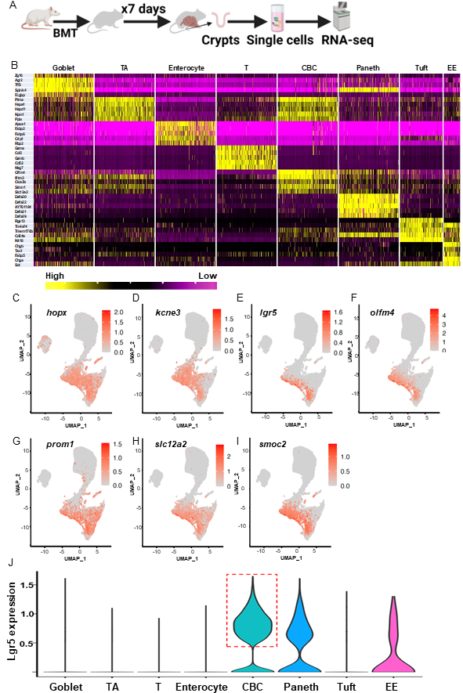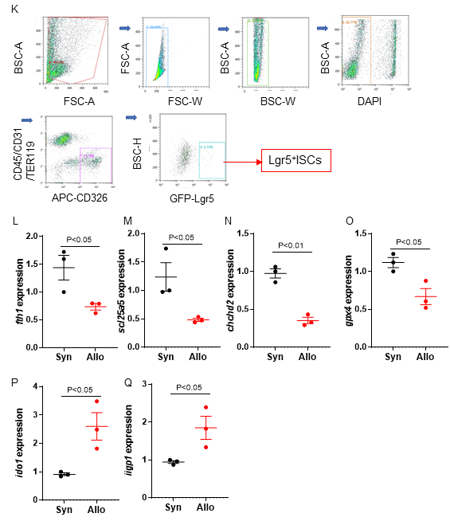
Figure S1. Analysis of Lgr5 positive stem cells by scRNA-seq.
(A-J) Small intestine crypts single cells were isolated from Allo (BALB/c→C57BL/6) and Syn (C57BL/6→C57BL/6) transplant 7 days after BMT, and then barcoded with the 10x Chromium technique for scRNA-seq. n = 2 independent biology samples each group. (A) Schematic of study design; (B) Heatmap of cell-type signature genes; (C-I) UMAP plots highlighting of ISCs signature genes; (J) lgr5 single gene expression in subtype of crypts epithelial cells and T lymphocytes, Lgr5⁺ISCs are clustered to show within box of red dash line. Goblet, goblet cells; TA, transient amplifying cells; Enterocyte, absorb enterocytes; T, T lymphocytes; CBC, crypt-base columnar cells; Paneth, Paneth cells; EE, enteroendocrine cells; Tuft, tuft cells. (K-Q) Validation of scRNA gene expression on Lgr5⁺ISCs. GFP-Lgr5⁺ISCs (Lgr5⁺ISCs) of small intestine crypts were sorted from Allo (BALB/c→B6-GFP-Lgr5) and (Syn) (B6→ B6-GFP-Lgr5) recipients 7 days after BMT and validated the differentially expressed genes by qPCR. (K) Lgr5⁺ISCs sorting strategy; (I-Q) Gene fth1, scl25a5, chchd2, gpx4, id01, and iigp1 expression on Lgr5⁺ISCs.
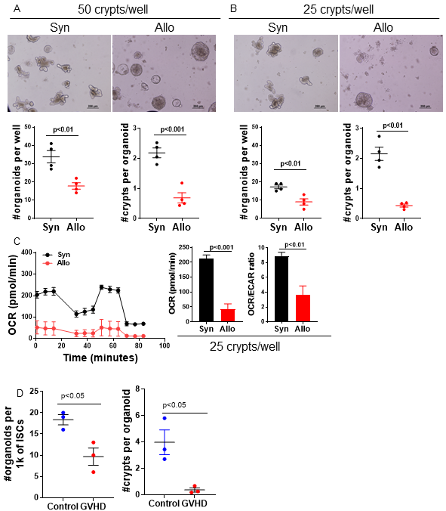
Figure S2. Lgr5⁺ISCs from GVHD demonstrate metabolic alteration.
Small intestinal crypts or their sorted Lgr5⁺ISCs from allogeneic (Allo) (BALB/c→B6 or B6-GFP-Lgr5) or (C3H.SW→B6) and syngeneic (Syn) (B6→B6 or B6-GFP-Lgr5) transplant 7 days after BMT were cultured for organoids formation for five to nine days and then organoids were sequentially exposed to oligomycin, Carbonyl cyanide-4 (trifluoromethoxy) phenylhydrazone (FCCP), and rotenone as well as antimycin A for analyzing oxygen consumption rates (OCRs) via Seahorse platform. (A) Representative organoid images per 50 crypts per well cultured for four days and quantification of organoids formation, Scale bar, 200 µm; (B) Representative organoid images per 25 crypts per well cultured for four days and quantification of organoids formation, Scale bar, 200 µm; (C) Seahorse assay for OCR, Basal OCR, and OCR/ECAR ratio on organoids per 25 crypts per well cultured for five days, n = 4 Allo (BALB/c→B6), 4 (Syn) (B6→ B6) mice. (D) Lgr5⁺ISCs of small intestine crypts were sorted from Allo (BALB/c→B6-GFP-Lgr5) and (Syn) (B6→ B6-GFP-Lgr5) recipients 7 days after BMT as gated in Figure S1K and cultured in 96-well plate with 1000 cells per well for 4-9 days and quantification of organoids formation, n = 3 Syn (B6→B6-GFP-Lgr5), 3 Allo (BALB/c→B6-GFP-Lgr5) independent biology samples. See also Figure 2E.

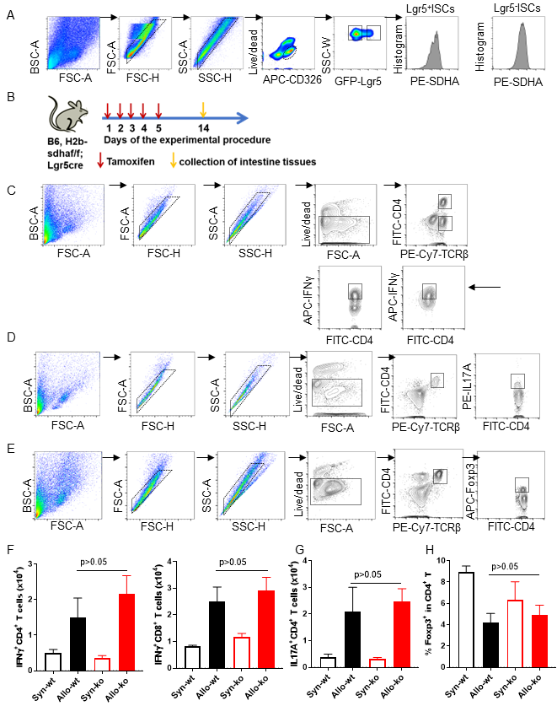Figure S3. Intrinsic alteration in SDHA dependent OXPHOS in ISCs.
(A) SDHA protein analysis strategy. See also Figures 3A-3D. (B) Schematic of deletion of SDHA protein in the Lgr5⁺ISCs of SdhaΔ/ISC mice with tamoxifen treatment. See also Figures 3C-3D. (C-H) SdhaΔ/ISC mice treated with tamoxifen (KO) or diluent (WT) for five days, 14 days after initial treatment, animals received 10-Gy total body irradiation followed by 2.5 × 10⁶ T cells and 5 × 10⁶ BM cells from either syngeneic B6 or allogeneic BALB/c donors. Seven days after BMT, animals were euthanized, and small intestine were harvested for isolating lamina propria lymphocytes. n = 3 independent biology samples each group. (C) Strategy of quantification of IFNγ production in CD4 andCD8 T lymphocytes. (D) Strategy of quantification of IL17A production in CD4 T lymphocytes. (E) Strategy of quantification of Foxp3 expression in CD4 T lymphocytes. (F) IFNγ production, (G) IL17A production, and (H) Foxp3 expression in lymphocytes of intestinal lamina propria.

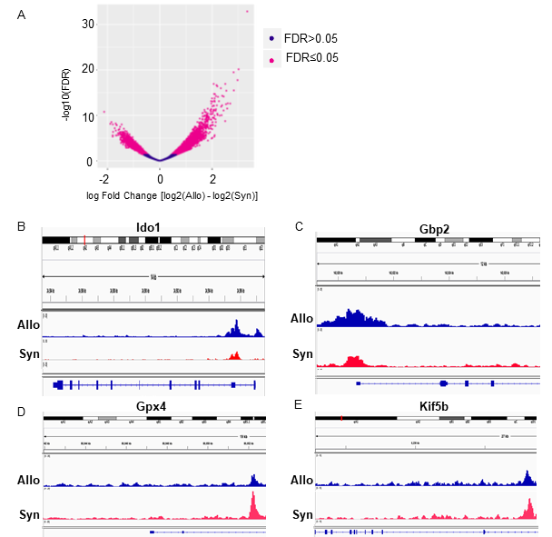Figure S4. ISCs epigenome is altered in context of GI GVHD.
Lgr5⁺ISCs were sorted as Figure S1K from Allo (BALB/c→B6-GFP-Lgr5) and Syn (B6→B6-GFP-Lgr5) transplant 7 days after BMT and performed for ATAC-seq, n = 3 Syn (B6→B6-GFP-Lgr5), 4 Allo (BALB/c→B6-GFP-Lgr5) independent biology samples. ATAC-seq data were analyzed for the peaks of chromatin accessibility. (A) Volcano plot of differential peaks. Representative genomic region showing chromatin changes of Lgr5⁺ISCs between Allo- and Syn-recipients, (B) Ido1, (C) Gbp2, (D) Gpx4, and (E) Kif5b.

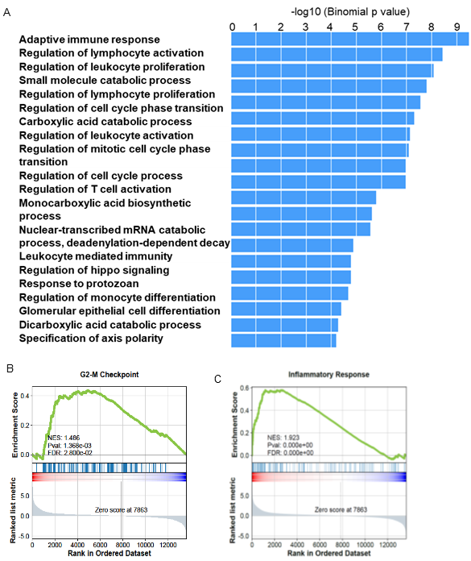Figure S5. Integration of transcriptomics and epigenomics analysis of ISCs.
(A) Lgr5⁺ISCs were sorted as Figure S1K from Allo (BALB/c→B6-GFP-Lgr5) and Syn (B6→B6-GFP-Lgr5) transplant 7 days after BMT and performed for ATAC-seq, n = 3 Syn (B6→B6-GFP-Lgr5), 4 Allo (BALB/c→B6-GFP-Lgr5) independent biology samples. Pathway enrichment analysis for genes with high fold changes of chromatin accessibility peaks via Genomic Regions Enrichment of Annotations Tool (GREAT). (B, C) Small intestine crypts single cells were isolated from Allo (BALB/c→ C57BL/6) and Syn (C57BL/6→C57BL/6) transplant 7 days after BMT, and then barcoded with the 10x Chromium technique for scRNA-seq sorted as Figure 1, n = 2 independent biology samples each group. Lgr5⁺ISCs were clustered I Figure 1D and its gene sets enrichment analysis on (B) G2-M check point and (C) inflammation response pathways. See also Figures 1 and Figure S1.

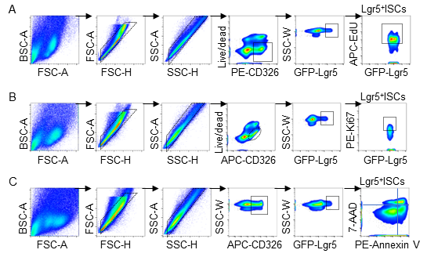
Figure S6. Quantification of Lgr5⁺ISCs proliferation and apoptosis by flow cytometry.
Single cells were isolated in small intestine crypts or intestine organoids from GFP-Lg5 mouse and then surface-stained with CD326 antibody or Annexin V or intracellular-stained for Ki67 or EdU. (A) Quantification of EdU⁺Lgr5⁺ISCs strategy. (B) Quantification of Ki67⁺Lgr5⁺ISCs strategy. (C) Quantification of Annexin V⁺Lgr5⁺ISCs strategy.

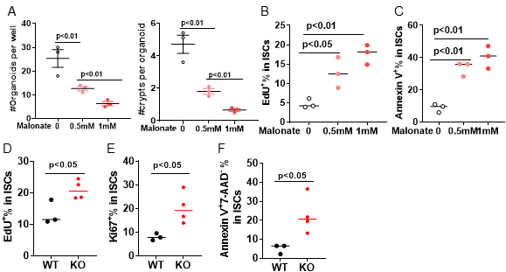
Figure S7. Metabolic deficit in SDHA regulates ISC function.
(A-C) Primary intestine organoids cultured for three days from naïve GFP-Lgr5 mice were treated with malonate or diluent control for seventy-two hours and quantified for organoids formation and labeled EdU for quantification EdU⁺Lgr5⁺ISCs as in methods, n = 3 each mice group. Quantification of organoids formation per 50 crypts per well (A), Quantification of EdU⁺Lgr5⁺ISCs (B) and Annexin V⁺Lgr5⁺ISCs (C) in organoids. (D-F) SdhaΔ/ISC mice treated with tamoxifen (KO) or diluent (WT) for five days as in Figure S3B. Fourteen days after initial treatment, animals were pulsed EdU for 2 hours and then harvested small intestine to analyze EdU⁺Lgr5⁺ISCs by FACS as in Figure S6A, n = 4 each mice group. (D) Quantification of EdU⁺Lgr5⁺ISCs; (E) Quantification of Ki67⁺Lgr5⁺ISCs; (F) Quantification of Annexin V⁺Lgr5⁺ISCs. See also Figures S6B-6C.

Supplementary Table 1. Primer sequences for RT-qPCR

Primer | Forward | Reverse
fth1 | 5′-CAGACCGTGATGACTGGGAG-3 | 5′-CTCAATGAAGTCACATAAGTGGGG-3′
chchd2 | 5′-ATGGCCCAGATGGCTACC-3′ | 5′-CTGGTTCTGAGCACACTCCA-3′
slc25a5 | 5′- ACACGGTTCGCCGTCGTATGAT-3′ | 5′- AAAGCCTTGCTCCCTTCATCGC-3′
gpx4 | 5′- ACACGGTTCGCCGTCGTATGAT-3′ | 5′- AAAGCCTTGCTCCCTTCATCGC-3′
ido1 | 5′-GCAGACTGTGTCCTGGCAAACT-3′ | 5′-AGAGACGAGGAAGAAGCCCTTG-3′
iigp1 | 5′-GGGGCAATAGCTCATTGGTA-3′ | 5′-ACCTCGAAGACATCCCCTTT-3′
gapdh | 5’-AGG TCG GTG TGA ACG GAT TTG-3’ | 5’-TGT AGA CCA TGT AGT TGA GGT CA-3’

Supplementary Table 2. Antibodies for flow cytometry

Antibody/Fluorochrome | Clone | Company | Dilution
PE anti-mouse CD45 | 30-F11 | Biolegend | 1:200
PE anti-mouse CD31 | 390 | Biolegend | 1:200
PE Anti- mouse Ter-119 | Ter-119 | Sigma-Aldrich | 1:200
FoxP3-APC | FJK-163 | eBioscience | 1:200
APC anti-mouse CD326 | G8.8 | Biolegend | 1:500
PE anti-mouse CD326 | G8.8 | Biolegend | 1:500
Anti-mouse CD90.2 MicroBeads | 130-121-278 | Miltenyi Biotec | 1:50
FITC Anti-mouse CD4 | RPA-T4 | Biolegend | 1:200
FC-blocker-CD16/32 | 2.4G2 | BD Biosciences | 1:100
CD24-PE-Cy7 | M1/69 | eBioscience | 1:200
FITC Anti-mouse CD8 | 53-6.7 | Biolegend | 1:200
APC Anti-mouse IFNγ | XMG1.2 | Biolegend | 1:100
PE-Anti-mouse IL17A | TC11-18H10.1 | Biolegend | 1:100
PE-Cy7 Anti-mouse TCRβ | H57-597 | Biolegend | 1:400
Annexin V-PE | N/A | eBioscience | 1:20
DAPI (10μg/ml) | N/A | Sigma-Aldrich | 1:600
7-AAD | N/A | eBioscience | 1:20
Live/Dead viability dye-Near IR | N/A | ThermoFisher | 1:1000
Rabbit monoclonal to SDHA | Epr9043-B | Abcam | 1:1000
PE Goat anti-Rabbit IgG Secondary Antibody | N/A | ThermoFisher | 1:500
Alexa Fluor® 488 anti-GFP | FM264G | Biolegend | 1:50

References
1. H. Fujiwara et al., Mitochondrial complex II in intestinal epithelial cells regulates T cell-mediated immunopathology. Nat Immunol 22, 1440-1451 (2021).
2. D. Zhao et al., Survival signal REG3alpha prevents crypt apoptosis to control acute gastrointestinal graft-versus-host disease. J Clin Invest 128, 4970-4979 (2018).
3. C. W. Cheng et al., Ketone Body Signaling Mediates Intestinal Stem Cell Homeostasis and Adaptation to Diet. Cell 178, 1115-1131 e1115 (2019).
4. O. H. Yilmaz et al., mTORC1 in the Paneth cell niche couples intestinal stem-cell function to calorie intake. Nature 486, 490-495 (2012).
5. T. Sato et al., Single Lgr5 stem cells build crypt-villus structures in vitro without a mesenchymal niche. Nature 459, 262-265 (2009).
6. M. M. Mihaylova et al., Fasting Activates Fatty Acid Oxidation to Enhance Intestinal Stem Cell Function during Homeostasis and Aging. Cell Stem Cell 22, 769-778 e764 (2018).
7. M. C. Ludikhuize, M. Meerlo, B. M. T. Burgering, M. J. Rodriguez Colman, Protocol to profile the bioenergetics of organoids using Seahorse. STAR Protoc 2, 100386 (2021).
8. M. C. Ludikhuize et al., Mitochondria Define Intestinal Stem Cell Differentiation Downstream of a FOXO/Notch Axis. Cell Metab 32, 889-900 e887 (2020).
9. A. Ayyaz et al., Single-cell transcriptomes of the regenerating intestine reveal a revival stem cell. Nature 569, 121-125 (2019).
10. A. L. Haber et al., A single-cell survey of the small intestinal epithelium. Nature 551, 333-339 (2017).
11. M. R. Corces et al., An improved ATAC-seq protocol reduces background and enables interrogation of frozen tissues. Nat Methods 14, 959-962 (2017).
12. R. Lopez, J. Regier, M. B. Cole, M. I. Jordan, N. Yosef, Deep generative modeling for single-cell transcriptomics. Nat Methods 15, 1053-1058 (2018).
13. T. Stuart et al., Comprehensive Integration of Single-Cell Data. Cell 177, 1888-1902 e1821 (2019).
14. Z. Fang, X. Liu, G. Peltz, GSEApy: a comprehensive package for performing gene set enrichment analysis in Python. Bioinformatics 39, (2023).
15. X. Zhang et al., CellMarker: a manually curated resource of cell markers in human and mouse. Nucleic Acids Res 47, D721-D728 (2019).
16. O. Franzen, L. M. Gan, J. L. M. Bjorkegren, PanglaoDB: a web server for exploration of mouse and human single-cell RNA sequencing data. Database (Oxford) 2019, (2019).
17. M. V. Kuleshov et al., Enrichr: a comprehensive gene set enrichment analysis web server 2016 update. Nucleic Acids Res 44, W90-97 (2016).
18. F. A. Wolf, P. Angerer, F. J. Theis, SCANPY: large-scale single-cell gene expression data analysis. Genome Biol 19, 15 (2018).
19. G. Yu, L. G. Wang, Y. Han, Q. Y. He, clusterProfiler: an R package for comparing biological themes among gene clusters. OMICS 16, 284-287 (2012).
20. R. Stark, G. Brown. (2012).
21. L. J. Zhu et al., ChIPpeakAnno: a Bioconductor package to annotate ChIP-seq and ChIP-chip data. BMC Bioinformatics 11, 237 (2010).

