Supplemental Material 5

Figure 1. Correlation and Bland-Altman plots for MPT.

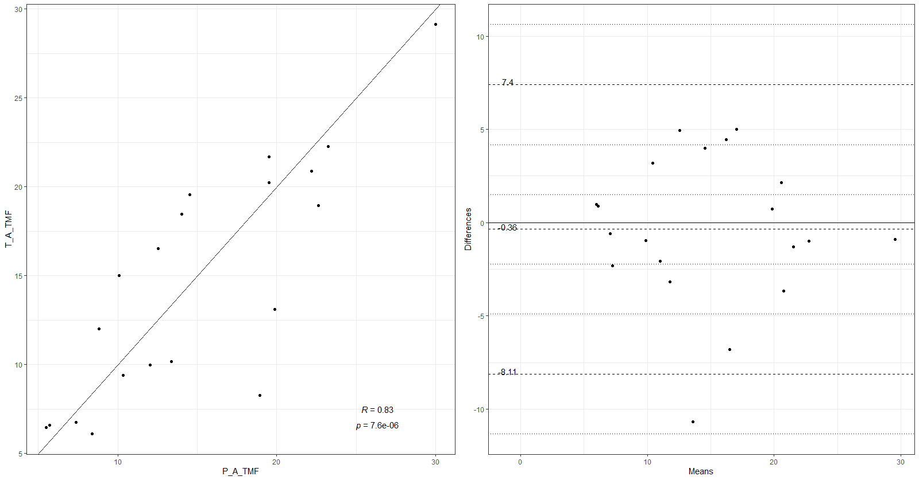

Figure 2. Correlation and Bland-Altman plots for PTK_nsyll.

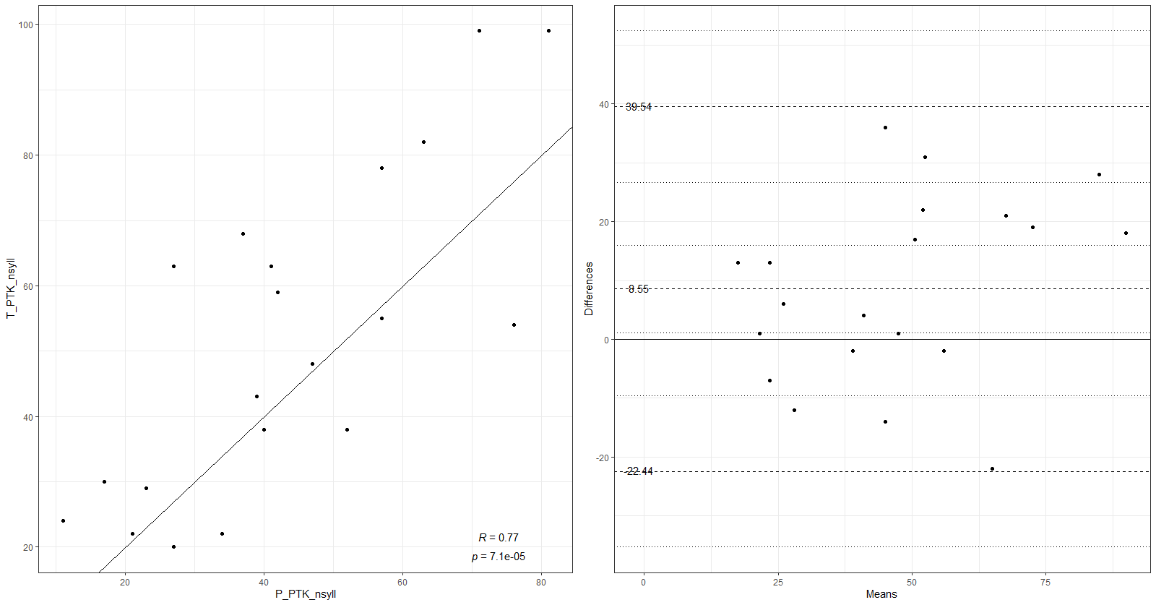

Figure 3. Correlation and Bland-Altman plots for PTK_phonation_time.

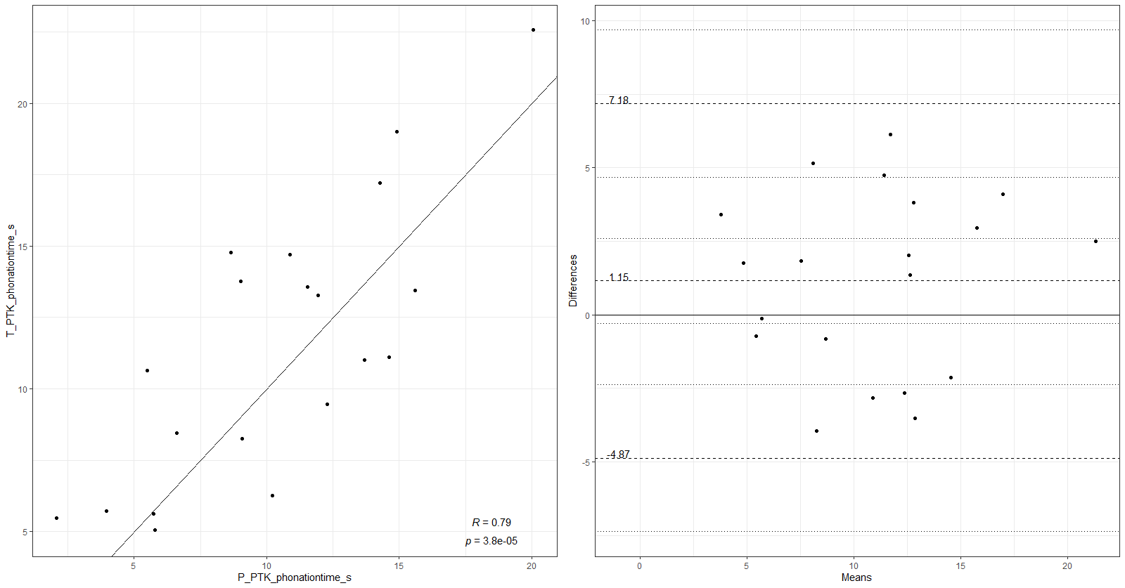

Figure 4. Correlation and Bland-Altman plots for Int_F0_min.
