Supplemental Material

Early childhood exposure to phenols/parabens, phthalates, organophosphate pesticides, and trace elements in association with attention deficit hyperactivity disorder (ADHD) symptoms in the CHARGE study

Jiwon Oh, Kyoungmi Kim, Kurunthachalam Kannan, Patrick J. Parsons, Agnieszka Mlodnicka, Rebecca J. Schmidt, Julie B. Schweitzer, Irva Hertz-Picciotto, Deborah H. Bennett

Table of Contents

Table S1. List of items for Aberrant Behavior Checklist (ABC) hyperactivity subscale and two subdomains.
Table S2. Chemical names and abbreviations of 62 analytes.
Table S3. Limit of detection (LOD), percent detection above the LOD, and distribution of specific gravity (SG)-uncorrected concentrations (ng/mL) of phenols/parabens, phthalate metabolites, pesticide metabolites, and trace elements in urine samples of 574 CHARGE children.
Table S4. Specific gravity (SG)-corrected concentrations of representative compounds by characteristics of 574 CHARGE children.
Table S5. Covariate-adjusted associations between individual chemicals and ABC subscale/subdomain scores and p-values with and without FDR correction for multiple testing among all children (n = 574).
Table S6. Covariate-adjusted associations between individual chemicals and ABC subscale/subdomain scores and p-values with and without FDR correction for multiple testing among children with ASD (n = 232).
Table S7. Covariate-adjusted associations between mixtures of each chemical class and ABC subscale/subdomain scores among children with ASD or DD.
Table S8. Covariate-adjusted associations between mixtures and ABC hyperactivity subscale and two subdomain scores, stratified by child’s sex.
Figure S1. Directed acyclic graph for associations of child urinary chemical concentrations with attention deficit hyperactivity disorder (ADHD) symptoms.
Figure S2. Estimated weight distributions of urinary total chemicals from 100 repetitions of weighted quantile sum (WQS) regression for (A) hyperactivity/impulsivity subdomain and (B) inattention subdomain, restricted to children with ASD.
Figure S3. Estimated weight distributions of urinary phthalate metabolites from 100 repetitions of weighted quantile sum (WQS) regression for (A) hyperactivity subscale and (B) hyperactivity/ impulsivity subdomain, restricted to children with ASD/DD.
Figure S4. Estimated weight distributions of urinary phthalate metabolites from 100 repetitions of weighted quantile sum (WQS) regression for (A) hyperactivity subscale and (B) hyperactivity/impulsivity subdomain, stratified by child’s sex.
Table S1. List of items for Aberrant Behavior Checklist (ABC) hyperactivity subscale and two subdomains.
Hyperactivity subscale | Hyperactivity/  impulsivity subdomain | Inattention subdomain
1. Excessively active at home, school, work, or elsewhere | O
7. Boisterous (inappropriately noisy and rough) | O
13. Impulsive (acts without thinking) | O
15. Restless, unable to sit still | O
18. Disobedient; difficult to control
21. Disturbs others | O
24. Uncooperative
31. Disrupts group activities | O
38. Does not stay in seat (e.g., during lesson or training periods, meals, etc.) | O
39. Will not sit still for any length of time | O
48. Constantly jumps or runs around the room | O
54. Tends to be excessively active | O
28. Does not pay attention to instructions |  | O
44. Easily distractible |  | O
51. Pays no attention when spoken to |  | O
56. Deliberately ignores directions
Note: Item no. 18, 24, and 56 were not used to create subdomains.
Table S2. Chemical names and abbreviations of 62 analytes.
Abbreviation | Chemical name
Phenols/Parabens
BP1 | 2,4-dihydroxybenzophenone
BP2 | 2,2′,4,4′-tetrahydroxybenzophenone
BP3 | 2-hydroxy-4-methoxybenzophenone
BP8 | 2,2′-dihydroxy-4-methoxybenzophenone
BPA | Bisphenol A; 2,2-bis(4-hydroxyphenyl)propane
BPAF | 4,4′-(hexafluoroisopropylidene)-diphenol
BPAP | 4,4′-(1-phenylethylidene)bisphenol
BPB | 2,2-bis(4-hydroxyphenyl)butane
BPF | Bisphenol F; 4,4′-dihydroxydiphenylmethane
BPP | 4,4′-(1,4-phenylenediisopropylidene)bisphenol
BPS | Bisphenol S; 4,4′-sulfonyldiphenol
BPZ | 4,4′-cyclo-hexylidenebisphenol
BUPB | Butyl paraben
BZPB | Benzyl paraben
DCP24 | 2,4-dichlorophenol
DCP25 | 2,5-dichlorophenol
DHB34 | 3,4-dihydroxy benzoic acid
ETPB | Ethyl paraben
HB4 | 4-hydroxybenzoic acid
HEPB | Heptyl paraben
MEPB | Methyl Paraben
OH4BP | 4-hydroxybenzophenone
OHETP | Ethyl-protocatechuic acid
OHMEP | Methyl-protocatechuic acid
PCP | Pentachlorophenol
PRPB | Propyl paraben
TCC | Triclocarban
TCP245 | 2,4,5-trichlorophenol
TCP246 | 2,4,6-trichlorophenol
TCS | Triclosan
Phthalate metabolites
MBZP | Mono-benzyl phthalate
MCHP | Monocyclohexyl phthalate
MCHPP | Mono(7-carboxyheptyl)phthalate
MCINP | Mono-carboxy isononyl phthalate
MCIOP | Mono-carboxy isooctyl phthalate
MCMHP | Mono-2-(carboxymethyl) hexyl phthalate
MCPP | Mono (3-carboxypropyl) phthalate
MECPP | Mono-(2-ethyl-5-carboxypentyl) phthalate
MEHHP | Mono (2-ethyl-5-hydroxyhexyl) phthalate
MEOHP | Mono (2-ethyl-5-oxohexyl) phthalate
MEP | Monoethyl phthalate
MHPP | Mono-2-heptyl phthalate
MHXP | Mono-hexyl phthalate
MIBP | Mono-isobutyl phthalate
MINP | Mono-isononyl phthalate
MIPP | Mono-isopropyl phthalate
MMP | Mono-methyl phthalate
MNBP | Mono-n-butylphthalate
MOP | Mono-n-octyl phthalate
MPEP | Mono-pentyl phthalate
Pesticide metabolites
DEDP | Diethyldithiophosphate
DEP | Diethylphosphate
DETP | Diethylthiophosphate
DMDP | Dimethyldithiophosphate
DMP | Dimethylphosphate
DMTP | Dimethylthiophosphate
Trace elements
As | Arsenic
Be | Beryllium
Cd | Cadmium
Mo | Molybdenum
Tl | Thallium
U | Uranium

Table S3. Limit of detection (LOD), percent detection above the LOD, analysis results of 15 blinded duplicate samples, and distribution of specific gravity (SG)-uncorrected concentrations (ng/mL) of phenols/parabens, phthalate metabolites, pesticide metabolites, and trace elements in urine samples of 574 CHARGE children.
Chemical | LOD | % above LOD | # of valid pairs ª | RPD ^{b} median (%) | 5th Percentile | 25th Percentile | Median | 75th Percentile | 95th Percentile
Phenols/parabens
BP1 | 0.05 | 100 | 15 | 11 | 1.3 | 4.5 | 13.8 | 55.6 | 7109.0
BP2 | 0.2 | 11.7 | 1 | 35 | <LOD | <LOD | <LOD | <LOD | 0.5
BP3 | 0.5 | 100 | 15 | 14 | 4.7 | 15.5 | 49.8 | 196.8 | 1597.0
BP8 | 0.02 | 81.4 | 11 | 21 | <LOD | 0.1 | 0.2 | 0.8 | 11.6
BPA | 0.05 | 98.6 | 13 | 17 | 0.3 | 1.1 | 2.2 | 4.3 | 12.5
BPAF | 0.05 | 0.7 | 0 | - | <LOD | <LOD | <LOD | <LOD | <LOD
BPAP | 0.1 | 89.4 | 14 | 46 | <LOD | 0.2 | 0.3 | 0.5 | 1.1
BPB | 0.05 | 50.0 | 5 | 43 | <LOD | <LOD | 0.0 | 0.1 | 0.3
BPF | 0.5 | 89.2 | 13 | 12 | <LOD | 1.3 | 2.9 | 7.2 | 20.9
BPP | 0.01 | 76.1 | 14 | 44 | <LOD | 0.0 | 0.1 | 0.2 | 0.7
BPS | 0.05 | 94.4 | 15 | 13 | <LOD | 0.2 | 0.4 | 0.9 | 3.8
BPZ | 0.05 | 1.2 | 0 | - | <LOD | <LOD | <LOD | <LOD | <LOD
BUPB | 0.05 | 92.5 | 15 | 26 | <LOD | 0.1 | 0.4 | 1.0 | 11.9
BZPB | 0.1 | 15.0 | 4 | 32 | <LOD | <LOD | <LOD | <LOD | 0.3
DCP24 | 0.02 | 95.1 | 15 | 17 | 0.1 | 1.2 | 2.6 | 5.7 | 13.7
DCP25 | 0.02 | 88.2 | 10 | 17 | <LOD | 1.5 | 3.4 | 6.7 | 72.0
DHB34 | 0.2 | 100 | 15 | 8 | 32.6 | 85.8 | 152.0 | 271.5 | 524.6
ETPB | 0.02 | 99.0 | 15 | 15 | 0.2 | 0.6 | 1.2 | 3.1 | 55.0
HB4 | 1 | 100 | 15 | 5 | 396.4 | 976.5 | 1460.0 | 2390.0 | 6388.0
HEPB | 0.1 | 0.3 | 0 | - | <LOD | <LOD | <LOD | <LOD | <LOD
MEPB | 0.05 | 99.8 | 15 | 8 | 3.6 | 12.7 | 42.5 | 210.8 | 2670.5
OH4BP | 0.2 | 99.0 | 15 | 13 | 0.5 | 1.1 | 1.7 | 3.0 | 12.5
OHETP | 0.1 | 64.8 | 10 | 9 | <LOD | <LOD | 0.3 | 1.1 | 4.5
OHMEP | 0.1 | 95.8 | 12 | 11 | 0.2 | 1.5 | 4.4 | 14.9 | 112.0
PCP | 0.05 | 96.2 | 12 | 21 | 0.1 | 0.5 | 1.0 | 1.9 | 4.9
PRPB | 0.1 | 98.4 | 15 | 18 | 0.4 | 1.9 | 5.9 | 26.3 | 377.1
TCC | 0.1 | 7.5 | 2 | 8 | <LOD | <LOD | <LOD | <LOD | 0.3
TCP245 | 0.1 | 49.8 | 6 | 35 | <LOD | <LOD | 0.1 | 0.2 | 0.6
TCP246 | 0.02 | 99.8 | 15 | 6 | 0.4 | 0.9 | 1.5 | 2.5 | 7.0
TCS | 0.1 | 96.7 | 14 | 8 | 0.3 | 2.5 | 7.5 | 25.9 | 201.8
Phthalate metabolites
MBZP | 0.02 | 99.5 | 14 | 5 | 4.0 | 14.1 | 30.8 | 74.5 | 285.4
MCHP | 0.5 | 8.0 | 0 | - | <LOD | <LOD | <LOD | <LOD | 0.8
MCHPP | 0.1 | 26.8 | 4 | 5 | <LOD | <LOD | <LOD | 0.1 | 15.5
MCINP | 0.01 | 98.4 | 15 | 11 | 0.9 | 3.2 | 5.5 | 10.4 | 32.1
MCIOP | 0.01 | 99.8 | 15 | 6 | 3.3 | 10.1 | 19.9 | 40.1 | 114.4
MCMHP | 0.02 | 98.6 | 15 | 25 | 1.8 | 8.0 | 16.0 | 33.3 | 94.3
MCPP | 0.05 | 99.8 | 15 | 7 | 1.0 | 2.8 | 5.5 | 10.4 | 25.7
MECPP | 0.02 | 99.7 | 15 | 8 | 5.9 | 17.5 | 34.0 | 68.4 | 220.5
MEHHP | 0.2 | 100 | 15 | 7 | 7.2 | 22.3 | 45.4 | 97.7 | 282.2
MEOHP | 0.01 | 100 | 15 | 9 | 2.7 | 9.2 | 19.5 | 40.5 | 124.6
MEP | 0.1 | 100 | 15 | 5 | 9.3 | 21.4 | 42.7 | 78.2 | 315.8
MHPP | 0.5 | 74.0 | 8 | 38 | <LOD | <LOD | 1.3 | 3.0 | 16.3
MHXP | 0.5 | 56.4 | 6 | 14 | <LOD | <LOD | 0.7 | 12.7 | 162.4
MIBP | 0.01 | 100 | 15 | 9 | 3.3 | 10.6 | 19.4 | 34.0 | 86.8
MINP | 0.01 | 0.0 | 0 | - | <LOD | <LOD | <LOD | <LOD | <LOD
MIPP | 0.5 | 2.4 | 0 | - | <LOD | <LOD | <LOD | <LOD | <LOD
MMP | 5 | 40.9 | 5 | 36 | <LOD | <LOD | <LOD | 7.9 | 27.6
MNBP | 0.2 | 99.8 | 15 | 7 | 7.2 | 21.6 | 40.6 | 72.8 | 187.4
MOP | 0.5 | 1.2 | 0 | - | <LOD | <LOD | <LOD | <LOD | <LOD
MPEP | 1 | 2.3 | 0 | - | <LOD | <LOD | <LOD | <LOD | <LOD
Pesticide metabolites
DEDP | 0.05 | 3.7 | 0 | - | <LOD | <LOD | <LOD | <LOD | <LOD
DEP | 0.1 | 99.1 | 15 | 8 | 0.5 | 1.6 | 3.6 | 8.6 | 28.5
DETP | 0.02 | 98.4 | 15 | 13 | 0 | 0.2 | 0.5 | 1.2 | 5
DMDP | 0.02 | 91.6 | 13 | 8 | <LOD | 0.1 | 0.3 | 1 | 7.2
DMP | 0.05 | 99.5 | 15 | 8 | 0.9 | 3.3 | 8.2 | 20.3 | 71
DMTP | 0.05 | 95.3 | 15 | 8 | 0.1 | 1 | 3.4 | 11.8 | 49.3
Trace elements
As | 0.059 | 100 | 15 | 1 | 2.7 | 6.4 | 10.8 | 17.1 | 44.5
Be | 0.022 | 7.1 | 1 | 27 | <LOD | <LOD | <LOD | <LOD | 0.0
Cd | 0.006 | 72.5 | 11 | 21 | <LOD | <LOD | 0.0 | 0.0 | 0.1
Mo | 0.45 | 100 | 15 | 1 | 24.1 | 58.6 | 95.8 | 147.8 | 292.1
Tl | 0.005 | 100 | 15 | 3 | 0.1 | 0.1 | 0.2 | 0.3 | 0.5
U | 0.0007 | 99.7 | 15 | 3 | 0.0 | 0.0 | 0.0 | 0.0 | 0.1
ª Number of blinded duplicate pairs where both were ≥LOD
^{b} Relative percent differences (RPD) = |sample result – repeat result|/(sample result + repeat result)*100
Table S4. Specific gravity (SG)-corrected concentrations of representative compounds by characteristics of 574 CHARGE children.
Characteristics ª | Phenols/parabens |  | Phthalate metabolites |  | Pesticide metabolites |  | Trace elements
Characteristics ª | MEPB |  | MIBP |  | DEP |  | U
 | Median (25th, 75th) | p ^{b} | Median (25th, 75th) | p ^{b} | Median (25th, 75th) | p ^{b} | Median (25th, 75th) | p ^{b}
Sex |  | 0.25 |  | 0.14 |  | 0.96 |  | 0.57
Male | 50.1 (13.2, 253.0) |  | 19.3 (11.1, 35.4) |  | 3.9 (1.7, 8.2) |  | 0.010 (0.006, 0.020)
Female | 43.2 (13.2, 169.1) |  | 20.1 (10.9, 29.8) |  | 3.7 (1.7, 9.5) |  | 0.010 (0.006, 0.020)
Child’s birth year |  | 0.26 |  | 0.19 |  | <0.001 |  | 0.05
2000-2004 | 53.3 (16.8, 238.3) |  | 18.2 (10.2, 34.9) |  | 2.7 (1.2, 6.2) |  | 0.010 (0.006, 0.020)
2005-2008 | 53.2 (13.6, 253.0) |  | 19.3 (11.5, 31.2) |  | 4.0 (1.8, 8.3) |  | 0.012 (0.007, 0.023)
2009-2013 | 38.3 (11.7, 186.0) |  | 20.3 (11.6, 35.9) |  | 4.8 (2.6, 11.3) |  | 0.009 (0.006, 0.016)
Preterm birth (< 37 weeks) |  | 0.18 |  | 0.47 |  | 0.48 |  | 0.15
No | 44.3 (12.8, 211.1) |  | 19.7 (11.1, 34.0) |  | 3.8 (1.7, 8.2) |  | 0.010 (0.006. 0.020)
Yes | 96.9 (19.3, 313.4) |  | 20.0 (11.3, 32.4) |  | 4.4 (1.7, 9.6) |  | 0.012 (0.009, 0.022)
Child’s race/ethnicity |  | 0.06 |  | 0.40 |  | 0.83 |  | 0.10
White (non-Hispanic) | 33.9 (11.5, 168.8) |  | 18.3 (10.3, 31.3) |  | 4.0 (1.7, 9.0) |  | 0.010 (0.006, 0.018)
Non-White (non-Hispanic) | 73.5 (15.7, 447.4) |  | 20.3 (10.6, 36.5) |  | 3.6 (1.9, 9.0) |  | 0.010 (0.006, 0.018)
Hispanic (any race) | 54.5 (16.0, 226.2) |  | 21.3 (12.0, 36.2) |  | 3.9 (1.7, 7.5) |  | 0.013 (0.00,7 0.023)
Mother’s age at delivery |  | 0.42 |  | 0.92 |  | 0.76 |  | 0.70
< 30 years | 38.3 (13.1, 223.9) |  | 20.8 (11.6, 32.9) |  | 4.0 (1.8, 9.1) |  | 0.011 (0.007, 0.021)
30-34 years | 52.7 (12.2, 183.6) |  | 18.3 (10.1, 34.8) |  | 3.5 (1.7, 7.5) |  | 0.009 (0.006, 0.017)
≥ 35 years | 55.7 (14.2, 332.0) |  | 18.0 (10.8, 37.4) |  | 4.5 (1.8, 8.8) |  | 0.010 (0.006, 0.021)
Maternal metabolic conditions |  | 0.45 |  | 0.26 |  | 0.37 |  | 0.68
Healthy weight/overweight  and no metabolic conditions | 46.6 (13.1, 175.1) |  | 20.6 (11.6, 34.4) |  | 4.0 (1.9, 9.0) |  | 0.010 (0.006, 0.020)
Obese or hypertensive  disorder/gestational diabetes | 53.8 (12.9, 317.7) |  | 18.4 (10.3, 32.8) |  | 3.8 (1.5, 7.5) |  | 0.010 (0.006, 0.020)
Parity |  | 0.03 |  | 0.14 |  | 0.17 |  | 0.09
1 | 59.8 (15.6, 346.2) |  | 18.7 (10.2, 33.3) |  | 4.5 (1.8, 9.1) |  | 0.009 (0.006, 0.019)
≥ 2 | 38.5 (11.7, 199.9) |  | 20.1 (11.6, 34.4) |  | 3.4 (1.6, 7.3) |  | 0.011 (0.006, 0.020)
Highest education in household |  | 0.75 |  | 0.04 |  | 0.91 |  | <0.001
High school/GED or less | 54.1 (13.0, 588.8) |  | 22.2 (12.1, 36.0) |  | 4.3 (1.5, 9.8) |  | 0.014 (0.007, 0.029)
Some college credit | 51.2 (13.2, 232.5) |  | 17.4 (9.9, 31.4) |  | 4.3 (1.7, 8.9) |  | 0.013 (0.007, 0.025)
Bachelor’s degree or higher | 48.7 (13.1, 185.0) |  | 20.2 (11.6, 35.1) |  | 3.6 (1.8, 8.2) |  | 0.009 (0.006, 0.016)
Homeowner |  | 0.16 |  | 0.39 |  | 0.32 |  | 0.04
No | 58.9 (16.8, 247.5) |  | 19.2 (10.6, 31.7) |  | 3.6 (1.7, 7.2) |  | 0.012 (0.007, 0.022)
Yes | 42.1 (12.8, 232.5) |  | 19.8 (11.4, 34.9) |  | 4.1 (1.8, 8.4) |  | 0.010 (0.006, 0.019)
Diagnostic groups |  | <0.001 |  | 0.29 |  | <0.001 |  | 0.003
ASD | 64.9 (14.4, 319.0) |  | 20.9 (11.5, 37.3) |  | 5.3 (2.5, 12.4) |  | 0.012 (0.006, 0.024)
DD | 88.2 (23.4, 382.1) |  | 19.6 (11.2, 31.0) |  | 2.9 (1.3, 6.0) |  | 0.011 (0.008, 0.025)
TD | 28.9 (11.1, 136.8) |  | 17.4 (10.6, 33.1) |  | 3.1 (1.6, 6.9) |  | 0.010 (0.006, 0.017)
 | r_{sp} ^{c} | p ^{d} | r_{sp} ^{c} | p ^{d} | r_{sp} ^{c} | p ^{d} | r_{sp} ^{c} | p ^{d}
Child’s age at assessment | -0.08 | 0.06 | 0.08 | 0.05 | 0.11 | 0.007 | 0.07 | 0.08
ª Missing (n): preterm birth (11), child’s race/ethnicity (5), maternal metabolic condition (16), parity (19), homeowner (21)
^{b} P-values from the Wilcox rank-sum test for binary variables and the Kruskal-Wallis test for categorical variables with more than two levels.
^{c} Spearman’s rank correlation coefficients between child’s age and each chemical concentrations.
^{d} P-values from the Spearman’s rank correlation test.
Table S5. Covariate-adjusted associations between individual chemicals and ABC subscale/subdomain scores and p-values with and without FDR correction for multiple testing among all children (n = 574).
Chemical | Hyperactivity subscale |  |  | Hyperactivity/impulsivity subdomain |  |  | Inattention subdomain
Chemical | IRR (95% CI) | Unadj.  p-value | FDR-corrected p-value | IRR (95% CI) | Unadj.  p-value | FDR-corrected p-value | IRR (95% CI) | Unadj.  p-value | FDR-corrected p-value
Phenols/parabens
BP1 | 0.98 (0.90, 1.08) | 0.711 | 0.868 | 0.98 (0.89, 1.09) | 0.724 | 0.910 | 1.01 (0.94, 1.08) | 0.823 | 0.971
BP3 | 0.99 (0.90, 1.09) | 0.785 | 0.868 | 0.99 (0.90, 1.09) | 0.794 | 0.910 | 1.01 (0.94, 1.09) | 0.782 | 0.971
BP8 | 0.94 (0.86, 1.04) | 0.232 | 0.734 | 0.95 (0.86, 1.05) | 0.306 | 0.824 | 0.97 (0.90, 1.05) | 0.485 | 0.971
BPA | 1.02 (0.93, 1.11) | 0.649 | 0.868 | 1.01 (0.92, 1.11) | 0.815 | 0.910 | 1.00 (0.94, 1.07) | 0.941 | 0.971
BPAP | 0.98 (0.89, 1.08) | 0.728 | 0.868 | 0.96 (0.87, 1.06) | 0.428 | 0.845 | 1.00 (0.94, 1.07) | 0.967 | 0.971
BPF | 0.96 (0.87, 1.06) | 0.443 | 0.845 | 0.95 (0.85, 1.05) | 0.339 | 0.824 | 0.99 (0.92, 1.07) | 0.833 | 0.971
BPP | 0.98 (0.89, 1.08) | 0.747 | 0.868 | 0.98 (0.89, 1.09) | 0.721 | 0.910 | 1.05 (0.97, 1.13) | 0.240 | 0.971
BPS | 1.02 (0.92, 1.12) | 0.738 | 0.868 | 1.01 (0.91, 1.12) | 0.833 | 0.910 | 0.98 (0.91, 1.07) | 0.699 | 0.971
BUPB | 0.92 (0.84, 1.00) | 0.077 | 0.536 | 0.93 (0.85, 1.02) | 0.139 | 0.824 | 0.97 (0.91, 1.05) | 0.481 | 0.971
DCP24 | 1.02 (0.93, 1.13) | 0.611 | 0.868 | 1.04 (0.94, 1.15) | 0.443 | 0.845 | 0.99 (0.91, 1.08) | 0.807 | 0.971
DCP25 | 1.04 (0.94, 1.16) | 0.400 | 0.839 | 1.03 (0.93, 1.14) | 0.577 | 0.910 | 1.01 (0.93, 1.09) | 0.880 | 0.971
DHB34 | 0.89 (0.81, 0.98) | 0.016 | 0.335 | 0.90 (0.81, 0.99) | 0.026 | 0.537 | 0.98 (0.91, 1.05) | 0.552 | 0.971
ETPB | 0.95 (0.87, 1.03) | 0.237 | 0.734 | 0.97 (0.89, 1.06) | 0.559 | 0.910 | 0.98 (0.91, 1.05) | 0.519 | 0.971
HB4 | 0.95 (0.87, 1.03) | 0.274 | 0.734 | 0.96 (0.87, 1.05) | 0.344 | 0.824 | 0.97 (0.90, 1.04) | 0.348 | 0.971
MEPB | 0.95 (0.87, 1.03) | 0.236 | 0.734 | 0.96 (0.87, 1.05) | 0.353 | 0.824 | 1.00 (0.93, 1.08) | 0.971 | 0.971
OH4BP | 0.98 (0.88, 1.09) | 0.686 | 0.868 | 0.99 (0.89, 1.11) | 0.867 | 0.910 | 1.00 (0.92, 1.08) | 0.924 | 0.971
OHMEP | 1.01 (0.91, 1.10) | 0.905 | 0.950 | 1.00 (0.91, 1.10) | 0.996 | 0.996 | 1.03 (0.96, 1.12) | 0.405 | 0.971
PCP | 1.00 (0.92, 1.08) | 0.982 | 0.982 | 1.01 (0.92, 1.10) | 0.808 | 0.910 | 0.97 (0.90, 1.04) | 0.343 | 0.971
PRPB | 0.95 (0.87, 1.04) | 0.280 | 0.734 | 0.95 (0.87, 1.05) | 0.325 | 0.824 | 1.03 (0.96, 1.11) | 0.379 | 0.971
TCP246 | 1.05 (0.95, 1.16) | 0.355 | 0.829 | 1.05 (0.95, 1.17) | 0.316 | 0.824 | 0.99 (0.91, 1.07) | 0.752 | 0.971
TCS | 0.91 (0.82, 1.00) | 0.038 | 0.401 | 0.95 (0.85, 1.05) | 0.263 | 0.824 | 0.89 (0.83, 0.96) | 0.002 | 0.045
Phthalate metabolites
MBZP | 0.98 (0.90, 1.07) | 0.675 | 0.835 | 1.01 (0.92, 1.10) | 0.829 | 0.829 | 0.99 (0.92, 1.07) | 0.811 | 0.885
MCINP | 1.07 (0.97, 1.18) | 0.116 | 0.278 | 1.09 (0.98, 1.19) | 0.086 | 0.192 | 1.06 (0.99, 1.14) | 0.095 | 0.422
MCIOP | 1.01 (0.92, 1.10) | 0.783 | 0.835 | 1.04 (0.94, 1.14) | 0.449 | 0.539 | 1.00 (0.94, 1.07) | 0.930 | 0.930
MCMHP | 1.02 (0.93, 1.10) | 0.717 | 0.835 | 1.04 (0.95, 1.13) | 0.423 | 0.539 | 1.02 (0.95, 1.09) | 0.614 | 0.885
MCPP | 1.01 (0.92, 1.10) | 0.835 | 0.835 | 1.03 (0.93, 1.13) | 0.548 | 0.597 | 0.99 (0.93, 1.06) | 0.745 | 0.885
MECPP | 1.11 (1.02, 1.22) | 0.019 | 0.209 | 1.16 (1.04, 1.28) | 0.003 | 0.041 | 1.06 (0.99, 1.14) | 0.106 | 0.422
MEHHP | 1.11 (1.01, 1.22) | 0.035 | 0.209 | 1.13 (1.02, 1.25) | 0.018 | 0.106 | 1.06 (0.99, 1.14) | 0.083 | 0.422
MEOHP | 1.09 (0.99, 1.20) | 0.077 | 0.275 | 1.10 (1.00, 1.22) | 0.057 | 0.170 | 1.05 (0.97, 1.12) | 0.220 | 0.423
MEP | 1.01 (0.92, 1.11) | 0.830 | 0.835 | 1.05 (0.95, 1.16) | 0.363 | 0.539 | 1.01 (0.94, 1.09) | 0.745 | 0.885
MHPP | 1.09 (0.99, 1.19) | 0.092 | 0.275 | 1.09 (0.99, 1.20) | 0.096 | 0.192 | 1.05 (0.98, 1.13) | 0.185 | 0.423
MIBP | 1.05 (0.96, 1.15) | 0.278 | 0.476 | 1.07 (0.97, 1.18) | 0.154 | 0.263 | 1.05 (0.98, 1.13) | 0.189 | 0.423
MNBP | 1.07 (0.97, 1.16) | 0.184 | 0.369 | 1.11 (1.01, 1.22) | 0.035 | 0.141 | 1.04 (0.97, 1.12) | 0.247 | 0.423
Pesticide metabolites
DEP | 1.02 (0.94, 1.11) | 0.695 | 0.868 | 1.03 (0.94, 1.13) | 0.512 | 0.640 | 1.01 (0.94, 1.08) | 0.782 | 0.922
DETP | 1.06 (0.97, 1.16) | 0.214 | 0.814 | 1.06 (0.97, 1.17) | 0.228 | 0.640 | 1.05 (0.97, 1.13) | 0.210 | 0.922
DMDP | 1.00 (0.91, 1.10) | 0.954 | 0.954 | 1.02 (0.92, 1.13) | 0.686 | 0.686 | 0.99 (0.92, 1.06) | 0.684 | 0.922
DMP | 1.03 (0.95, 1.12) | 0.488 | 0.814 | 1.04 (0.95, 1.13) | 0.416 | 0.640 | 0.99 (0.92, 1.06) | 0.720 | 0.922
DMTP | 1.04 (0.95, 1.14) | 0.359 | 0.814 | 1.04 (0.94, 1.14) | 0.470 | 0.640 | 1.00 (0.94, 1.08) | 0.922 | 0.922
Trace elements
As | 1.01 (0.92, 1.10) | 0.870 | 0.944 | 1.00 (0.91, 1.11) | 0.941 | 0.941 | 1.04 (0.97, 1.12) | 0.298 | 0.744
Cd | 0.99 (0.90, 1.08) | 0.804 | 0.944 | 1.01 (0.91, 1.11) | 0.900 | 0.900 | 1.00 (0.94, 1.08) | 0.894 | 0.744
Mo | 1.04 (0.95, 1.14) | 0.425 | 0.944 | 1.04 (0.95, 1.15) | 0.360 | 0.941 | 1.05 (0.98, 1.12) | 0.205 | 0.894
Tl | 1.00 (0.90, 1.10) | 0.944 | 0.944 | 0.99 (0.90, 1.10) | 0.908 | 0.941 | 1.01 (0.94, 1.08) | 0.816 | 0.894
U | 1.04 (0.95, 1.15) | 0.396 | 0.944 | 1.05 (0.95, 1.16) | 0.319 | 0.900 | 0.99 (0.92, 1.06) | 0.755 | 0.894

Table S6. Covariate-adjusted associations between individual chemicals and ABC subscale/subdomain scores and p-values with and without FDR correction for multiple testing among children with ASD (n = 232).
Chemical | Hyperactivity subscale |  |  | Hyperactivity/impulsivity subdomain |  |  | Inattention subdomain
Chemical | IRR (95% CI) | Unadj.  p-value | FDR-corrected p-value | IRR (95% CI) | Unadj.  p-value | FDR-corrected p-value | IRR (95% CI) | Unadj.  p-value | FDR-corrected p-value
Phenols/parabens
BP1 | 1.04 (0.95, 1.15) | 0.376 | 0.706 | 1.05 (0.94, 1.17) | 0.407 | 0.895 | 1.06 (0.98, 1.15) | 0.118 | 0.354
BP3 | 1.03 (0.94, 1.13) | 0.575 | 0.805 | 1.03 (0.93, 1.14) | 0.598 | 0.895 | 1.05 (0.97, 1.14) | 0.216 | 0.505
BP8 | 1.01 (0.92, 1.11) | 0.815 | 0.899 | 1.02 (0.91, 1.13) | 0.784 | 0.915 | 1.04 (0.95, 1.13) | 0.385 | 0.596
BPA | 1.06 (0.98, 1.14) | 0.152 | 0.706 | 1.07 (0.98, 1.17) | 0.117 | 0.895 | 1.03 (0.97, 1.11) | 0.354 | 0.596
BPAP | 1.05 (0.95, 1.15) | 0.322 | 0.706 | 1.02 (0.92, 1.13) | 0.686 | 0.895 | 1.04 (0.97, 1.12) | 0.269 | 0.514
BPF | 0.96 (0.87, 1.05) | 0.391 | 0.706 | 0.94 (0.84, 1.04) | 0.242 | 0.895 | 1.00 (0.93, 1.09) | 0.945 | 0.990
BPP | 0.99 (0.90, 1.09) | 0.801 | 0.899 | 0.97 (0.87, 1.08) | 0.559 | 0.895 | 1.07 (0.98, 1.16) | 0.116 | 0.354
BPS | 1.01 (0.91, 1.12) | 0.858 | 0.899 | 1.00 (0.88, 1.12) | 0.953 | 0.953 | 1.01 (0.92, 1.11) | 0.897 | 0.990
BUPB | 1.04 (0.93, 1.16) | 0.448 | 0.706 | 1.03 (0.91, 1.17) | 0.600 | 0.895 | 1.04 (0.95, 1.13) | 0.397 | 0.596
DCP24 | 1.06 (0.94, 1.18) | 0.383 | 0.706 | 1.07 (0.93, 1.21) | 0.362 | 0.895 | 1.04 (0.94, 1.17) | 0.462 | 0.646
DCP25 | 0.99 (0.90, 1.09) | 0.899 | 0.899 | 0.98 (0.88, 1.09) | 0.725 | 0.895 | 1.00 (0.92, 1.09) | 0.990 | 0.990
DHB34 | 1.08 (0.97, 1.19) | 0.176 | 0.706 | 1.07 (0.95, 1.21) | 0.239 | 0.895 | 1.08 (0.99, 1.17) | 0.105 | 0.354
ETPB | 1.07 (0.97, 1.19) | 0.163 | 0.706 | 1.07 (0.96, 1.20) | 0.238 | 0.895 | 1.06 (0.97, 1.15) | 0.178 | 0.468
HB4 | 1.04 (0.94, 1.15) | 0.470 | 0.706 | 1.05 (0.94, 1.19) | 0.377 | 0.895 | 1.00 (0.91, 1.09) | 0.937 | 0.990
MEPB | 1.04 (0.94, 1.14) | 0.470 | 0.706 | 1.04 (0.94, 1.17) | 0.438 | 0.895 | 1.05 (0.97, 1.14) | 0.253 | 0.514
OH4BP | 1.08 (0.97, 1.21) | 0.177 | 0.706 | 1.08 (0.96, 1.22) | 0.205 | 0.895 | 1.09 (1.00, 1.20) | 0.057 | 0.354
OHMEP | 1.07 (0.95, 1.21) | 0.239 | 0.706 | 1.05 (0.92, 1.20) | 0.461 | 0.895 | 1.11 (1.00, 1.23) | 0.044 | 0.354
PCP | 0.99 (0.91, 1.07) | 0.849 | 0.899 | 0.99 (0.90, 1.08) | 0.878 | 0.922 | 0.99 (0.92, 1.06) | 0.694 | 0.857
PRPB | 1.05 (0.95, 1.16) | 0.351 | 0.706 | 1.04 (0.93, 1.17) | 0.499 | 0.895 | 1.09 (1.00, 1.18) | 0.049 | 0.354
TCP246 | 0.98 (0.89, 1.08) | 0.670 | 0.879 | 0.99 (0.89, 1.11) | 0.837 | 0.922 | 0.98 (0.90, 1.06) | 0.593 | 0.779
TCS | 0.94 (0.83, 1.07) | 0.327 | 0.706 | 0.97 (0.84, 1.12) | 0.679 | 0.895 | 0.92 (0.84, 1.01) | 0.070 | 0.354
Phthalate metabolites
MBZP | 1.10 (1.01, 1.20) | 0.044 | 0.150 | 1.15 (1.03, 1.28) | 0.012 | 0.048 | 1.05 (0.97, 1.15) | 0.220 | 0.330
MCINP | 1.09 (1.00, 1.18) | 0.050 | 0.150 | 1.11 (1.01, 1.21) | 0.036 | 0.086 | 1.05 (0.98, 1.14) | 0.180 | 0.330
MCIOP | 1.05 (0.97, 1.13) | 0.236 | 0.279 | 1.08 (0.99, 1.18) | 0.077 | 0.116 | 1.02 (0.96, 1.09) | 0.524 | 0.571
MCMHP | 1.06 (0.99, 1.14) | 0.138 | 0.236 | 1.07 (0.99, 1.15) | 0.109 | 0.131 | 1.06 (0.99, 1.14) | 0.125 | 0.300
MCPP | 1.05 (0.97, 1.13) | 0.255 | 0.279 | 1.08 (0.99, 1.18) | 0.084 | 0.116 | 1.01 (0.95, 1.09) | 0.699 | 0.699
MECPP | 1.12 (1.04, 1.20) | 0.003 | 0.033 | 1.17 (1.07, 1.28) | 0.000 | 0.004 | 1.06 (0.99, 1.13) | 0.106 | 0.300
MEHHP | 1.11 (1.02, 1.21) | 0.014 | 0.081 | 1.14 (1.04, 1.26) | 0.006 | 0.037 | 1.06 (0.99, 1.14) | 0.103 | 0.300
MEOHP | 1.08 (0.99, 1.17) | 0.098 | 0.195 | 1.10 (1.00, 1.21) | 0.061 | 0.116 | 1.04 (0.96, 1.11) | 0.327 | 0.436
MEP | 1.04 (0.95, 1.15) | 0.418 | 0.418 | 1.07 (0.96, 1.19) | 0.232 | 0.232 | 1.03 (0.95, 1.12) | 0.493 | 0.571
MHPP | 1.06 (0.97, 1.15) | 0.219 | 0.279 | 1.07 (0.97, 1.17) | 0.182 | 0.199 | 1.05 (0.97, 1.13) | 0.219 | 0.330
MIBP | 1.07 (0.97, 1.17) | 0.164 | 0.246 | 1.09 (0.99, 1.20) | 0.087 | 0.116 | 1.08 (1.00, 1.17) | 0.047 | 0.300
MNBP | 1.08 (1.00, 1.16) | 0.080 | 0.191 | 1.12 (1.02, 1.23) | 0.019 | 0.056 | 1.08 (1.00, 1.17) | 0.058 | 0.300
Pesticide metabolites
DEP | 0.98 (0.90, 1.06) | 0.666 | 0.867 | 1.01 (0.92, 1.10) | 0.853 | 0.998 | 0.96 (0.89, 1.02) | 0.193 | 0.758
DETP | 0.98 (0.89, 1.07) | 0.664 | 0.867 | 1.00 (0.90, 1.11) | 0.998 | 0.998 | 0.99 (0.92, 1.06) | 0.758 | 0.758
DMDP | 1.01 (0.92, 1.10) | 0.867 | 0.867 | 1.00 (0.90, 1.11) | 0.951 | 0.998 | 1.02 (0.95, 1.10) | 0.639 | 0.758
DMP | 1.02 (0.93, 1.12) | 0.592 | 0.867 | 1.03 (0.92, 1.14) | 0.600 | 0.998 | 1.03 (0.96, 1.12) | 0.393 | 0.758
DMTP | 0.99 (0.90, 1.08) | 0.743 | 0.867 | 1.01 (0.90, 1.12) | 0.905 | 0.998 | 0.98 (0.91, 1.06) | 0.673 | 0.758
Trace elements
As | 1.02 (0.93, 1.11) | 0.700 | 0.875 | 1.01 (0.91, 1.11) | 0.883 | 0.949 | 1.04 (0.96, 1.12) | 0.357 | 0.824
Cd | 1.08 (0.99, 1.18) | 0.090 | 0.448 | 1.10 (0.99, 1.21) | 0.067 | 0.335 | 1.06 (0.98, 1.14) | 0.126 | 0.632
Mo | 1.00 (0.92, 1.09) | 0.940 | 0.940 | 1.00 (0.90, 1.10) | 0.949 | 0.949 | 1.02 (0.95, 1.10) | 0.625 | 0.824
Tl | 0.96 (0.88, 1.06) | 0.409 | 0.750 | 0.97 (0.87, 1.07) | 0.477 | 0.795 | 0.98 (0.91, 1.06) | 0.660 | 0.824
U | 1.04 (0.95, 1.14) | 0.450 | 0.750 | 1.05 (0.95, 1.16) | 0.370 | 0.795 | 1.00 (0.93, 1.08) | 0.933 | 0.933

Table S7. Covariate-adjusted associations between mixtures of each chemical class and ABC subscale/subdomain scores among children with ASD or DD.
Outcome | Mixture | ASD/DD (n = 326)
Outcome | Mixture | Mean IRR ª | 2.5 PCT | 97.5 PCT
Hyperactivity subscale | Phenols/Parabens | 0.99 | 0.87 | 1.14
Hyperactivity subscale | Phthalate metabolites | 1.09 | 0.99 | 1.18
Hyperactivity subscale | Pesticide metabolites | 0.98 | 0.91 | 1.04
Hyperactivity subscale | Trace elements | 1.02 | 0.93 | 1.17
Hyperactivity subscale | Total mixture | 1.05 | 0.93 | 1.16
Hyperactivity/  impulsivity subdomain | Phenols/Parabens | 1.00 | 0.84 | 1.15
Hyperactivity/  impulsivity subdomain | Phthalate metabolites | 1.15 | 1.03 | 1.28
Hyperactivity/  impulsivity subdomain | Pesticide metabolites | 0.98 | 0.92 | 1.05
Hyperactivity/  impulsivity subdomain | Trace elements | 1.05 | 0.93 | 1.22
Hyperactivity/  impulsivity subdomain | Total mixture | 1.11 | 0.97 | 1.22
Inattention subdomain | Phenols/Parabens | 1.02 | 0.92 | 1.14
Inattention subdomain | Phthalate metabolites | 1.04 | 0.96 | 1.12
Inattention subdomain | Pesticide metabolites | 0.99 | 0.93 | 1.06
Inattention subdomain | Trace elements | 1.02 | 0.92 | 1.15
Inattention subdomain | Total mixture | 1.02 | 0.91 | 1.11
ª WQS regression models were adjusted for child’s sex, birth year, and age at assessment, parity, parental education, and maternal metabolic conditions.
Table S8. Covariate-adjusted associations between mixtures and ABC hyperactivity subscale and two subdomain scores, stratified by child’s sex.
Outcome | Mixture | Male (n = 460) |  |  | Female (n = 114)
Outcome | Mixture | Mean IRR ª | 2.5 PCT | 97.5 PCT | Mean IRR ª | 2.5 PCT | 97.5 PCT
Hyperactivity subscale | Phenols/Parabens | 0.87 | 0.43 | 1.98 | 0.78 | 0.47 | 1.31
Hyperactivity subscale | Phthalate metabolites | 1.37 | 1.02 | 2.65 | 1.10 | 0.98 | 1.23
Hyperactivity subscale | Pesticide metabolites | 1.11 | 0.81 | 2.20 | 1.36 | 0.83 | 2.24
Hyperactivity subscale | Trace elements | 0.99 | 0.75 | 1.77 | 1.07 | 0.73 | 1.58
Hyperactivity subscale | Total mixture | 1.26 | 0.78 | 4.36 | 1.13 | 0.54 | 2.36
Hyperactivity/  impulsivity subdomain | Phenols/Parabens | 0.87 | 0.49 | 1.62 | 0.82 | 0.47 | 1.43
Hyperactivity/  impulsivity subdomain | Phthalate metabolites | 1.43 | 1.01 | 3.34 | 1.21 | 0.81 | 1.82
Hyperactivity/  impulsivity subdomain | Pesticide metabolites | 1.11 | 0.80 | 2.53 | 1.38 | 0.93 | 2.05
Hyperactivity/  impulsivity subdomain | Trace elements | 0.98 | 0.71 | 2.75 | 1.20 | 0.70 | 2.06
Hyperactivity/  impulsivity subdomain | Total mixture | 1.29 | 0.74 | 5.15 | 1.33 | 0.53 | 3.32
Inattention subdomain | Phenols/Parabens | 0.84 | 0.57 | 1.26 | 0.84 | 0.52 | 1.35
Inattention subdomain | Phthalate metabolites | 1.25 | 0.99 | 2.05 | 0.95 | 0.57 | 1.57
Inattention subdomain | Pesticide metabolites | 0.95 | 0.66 | 1.61 | 1.14 | 0.60 | 2.15
Inattention subdomain | Trace elements | 0.99 | 0.75 | 1.41 | 1.01 | 0.72 | 1.43
Inattention subdomain | Total mixture | 1.10 | 0.82 | 1.73 | 0.84 | 0.36 | 1.94
ª WQS regression models were adjusted for child’s birth year and age at assessment, parity, parental education, and maternal metabolic conditions.
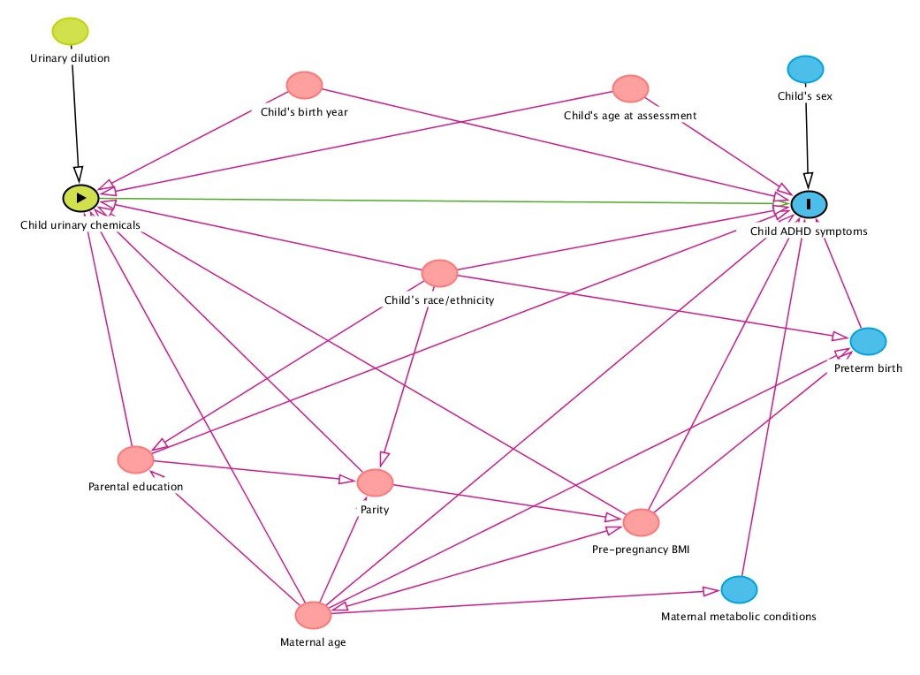
Figure S1. Directed acyclic graph for associations of child urinary chemical concentrations with attention deficit hyperactivity disorder (ADHD) symptoms. Green circles indicate ancestors of the exposure, blue circles indicate ancestors of the outcome, and pink circles indicate ancestors of both exposure and outcome.
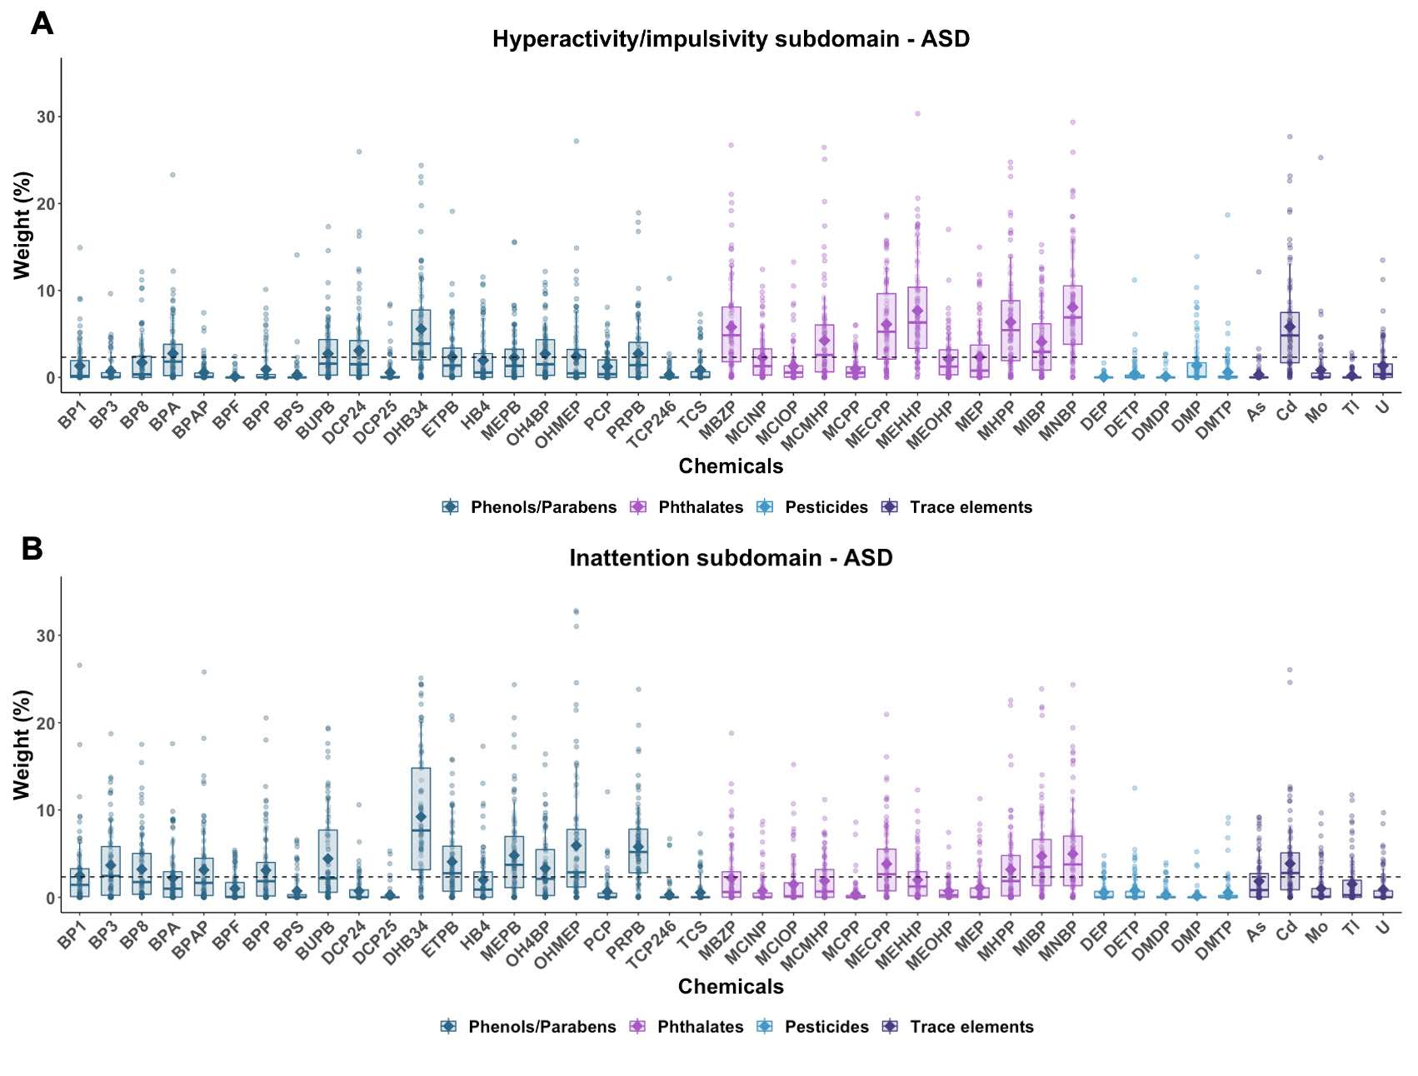
Figure S2. Estimated weight distributions of urinary total chemicals from 100 repetitions of weighted quantile sum (WQS) regression for (A) hyperactivity/impulsivity subdomain and (B) inattention subdomain, restricted to children with ASD. Boxes indicate 25th, 50th, and 75th percentiles, and diamonds indicate mean, and whiskers indicate 10th and 90th percentiles of weights. Dashed line indicates a threshold (1/# of chemicals in the mixture).

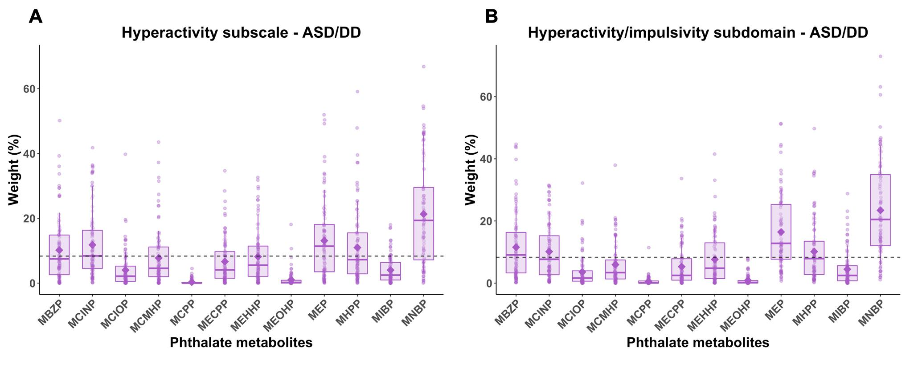
Figure S3. Estimated weight distributions of urinary phthalate metabolites from 100 repetitions of weighted quantile sum (WQS) regression for (A) hyperactivity subscale and (B) hyperactivity/ impulsivity subdomain, restricted to children with ASD/DD. Boxes indicate 25th, 50th, and 75th percentiles, and diamonds indicate mean, and whiskers indicate 10th and 90th percentiles of weights. Dashed line indicates a threshold (1/# of chemicals in the mixture).
z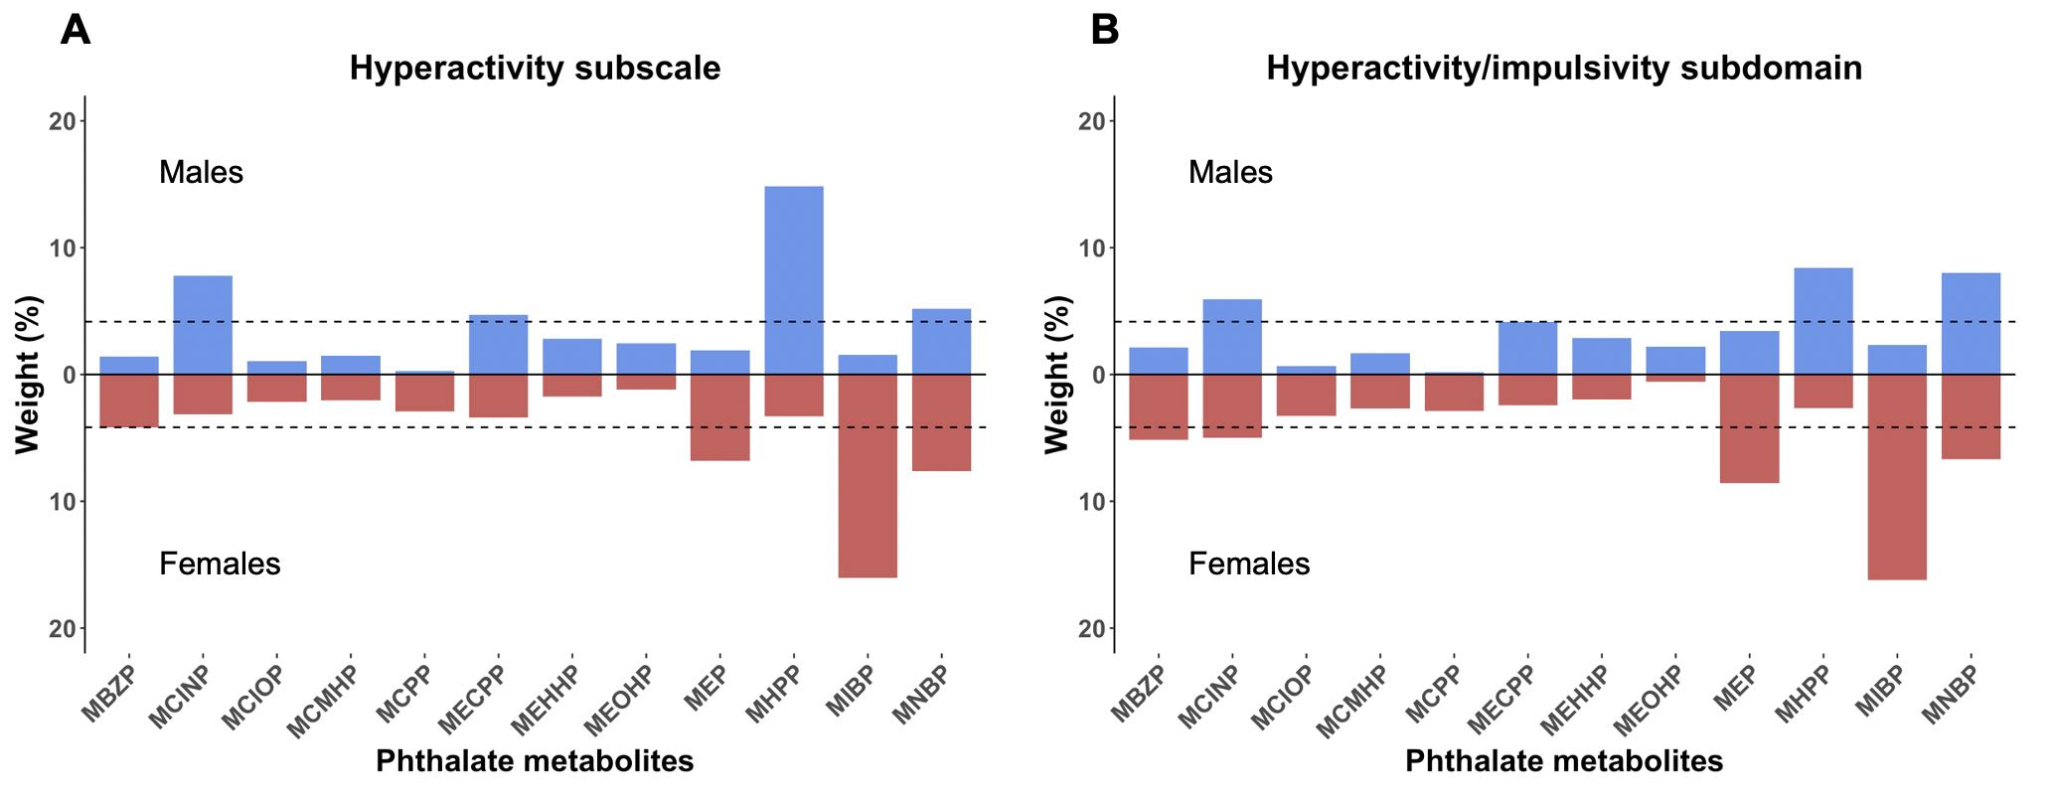
Figure S4. Estimated weight distributions of urinary phthalate metabolites from 100 repetitions of weighted quantile sum (WQS) regression for (A) hyperactivity subscale and (B) hyperactivity/impulsivity subdomain, stratified by child’s sex. Boxes indicate 50th percentiles of weights. Dashed line indicates a threshold (1/# of chemicals in the mixture).

