Quantitative analysis of cellular morphology during in vitro decidualization
Luciana Ant¹, François Le Dily² , Miguel Beato^{2,3}, Patricia Saragüeta^{1*}.

¹ Instituto de Biología y Medicina Experimental (IBYME-CONICET), Buenos Aires, Argentina.
² Centro de Regulación Genómica (CRG), Barcelona, Spain
³ Universitat Pompeu Fabra (UPF) Barcelona

Supplementary Materials and Methods

The specific methods followed in this work can be found thoroughly explained in the corresponding scripts

Supplementary Figures.
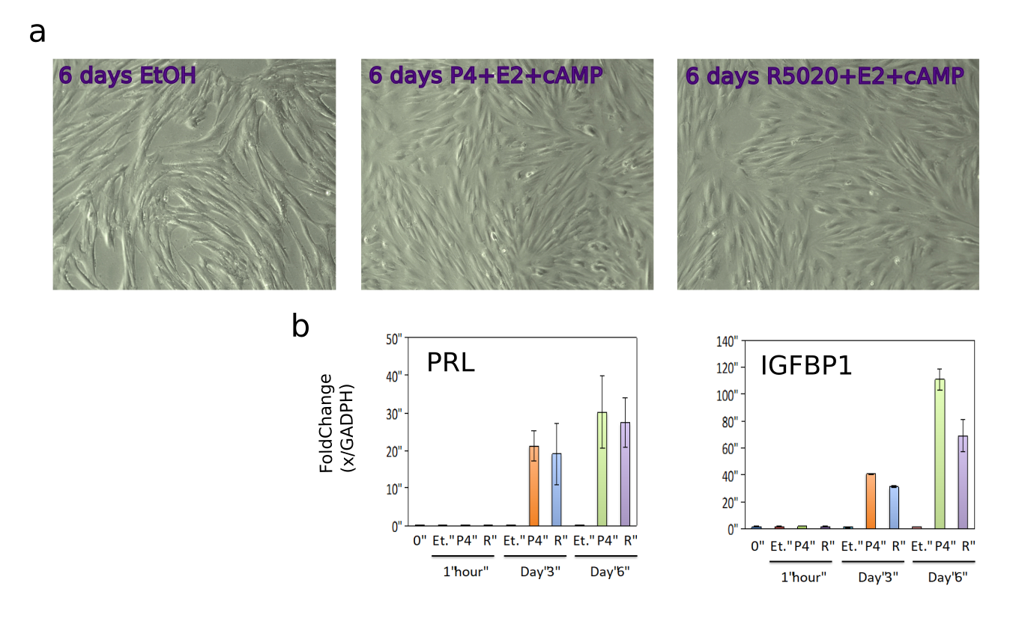
Fig. S1: a. Representative TLM images of the THESCs at six days after treatment with OH, P4+E2+cAMP and R5020+E2+cAMP. b. Expression of decidualization markers PRL and IGFBP1 at T0, 1h and 3 and 6 days after treatment.
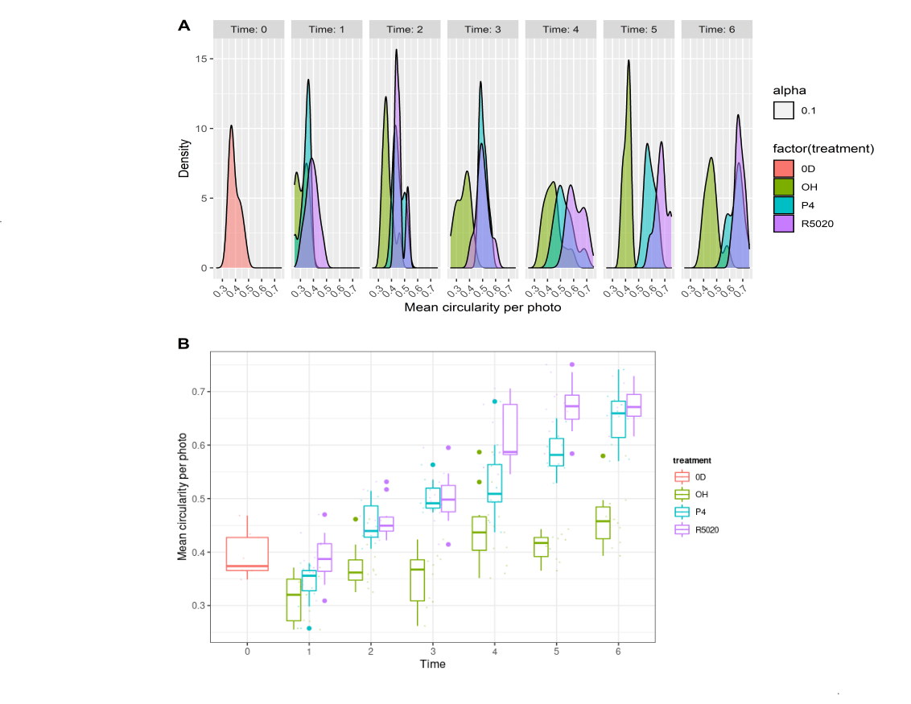

Fig. S2 Exploratory Analysis. a. Distribution of mean circularity per photo for each combination of treatment and day, depicting a normal distribution. b. Boxplot of mean circularity per photo.

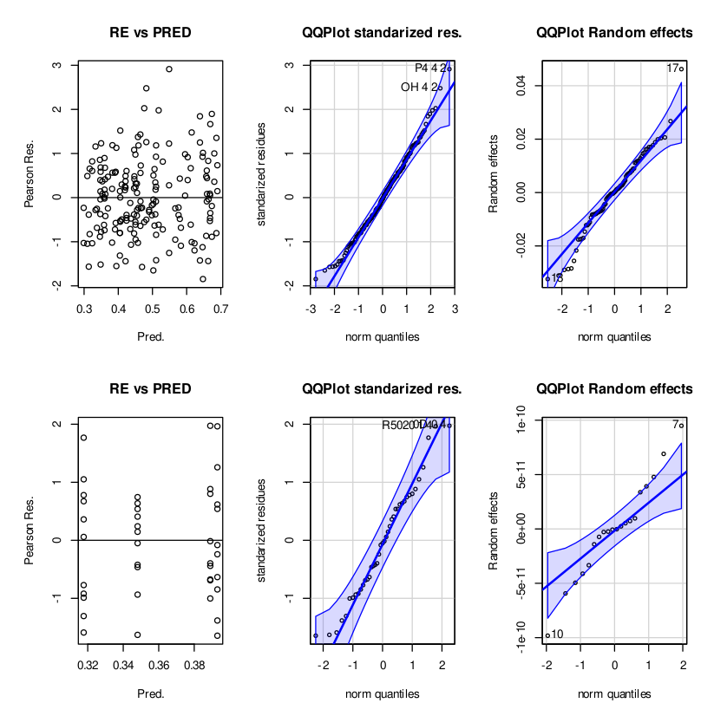
Fig S3 Graphical validation of the assumptions for the two final models, the conditional model (top panels) and the mT0 model (bottom panels). Shapiro-Wilk tests did not show evidence of non-normality (p-value > 0.05) for either of the models.

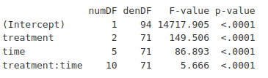

Table S1: Anova for the selected conditional model (m1). A p-value < 0.01 is considered significant.

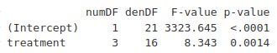

Table S2: Anova for the simple model comparing T0 and Day1. A p-value < 0.01 is considered significant.

