Table 1. CONSORT Flow Chart
Evaluated for eligibility (n=148 couples)
148 parents (female-male

Accepted the study (n=93)

Inclusion criteria:
(1) No communication problem,
(2) having a child aged 0-24 months,
(3) refusing to vaccinate his/her child.

Randomization

Control group (n=44)
Experiment group (n=49)

PRE-TEST(IIF, PACV)

4-WEEK SOLUTION-FOCUSED THERAPY

Refused to participate, unreachable (n=21)
Refused to participate (n= 2),
Left due to COVID-19 (n=2),
due to family reasons (n=1)
unwillingness to communicate (n=1)

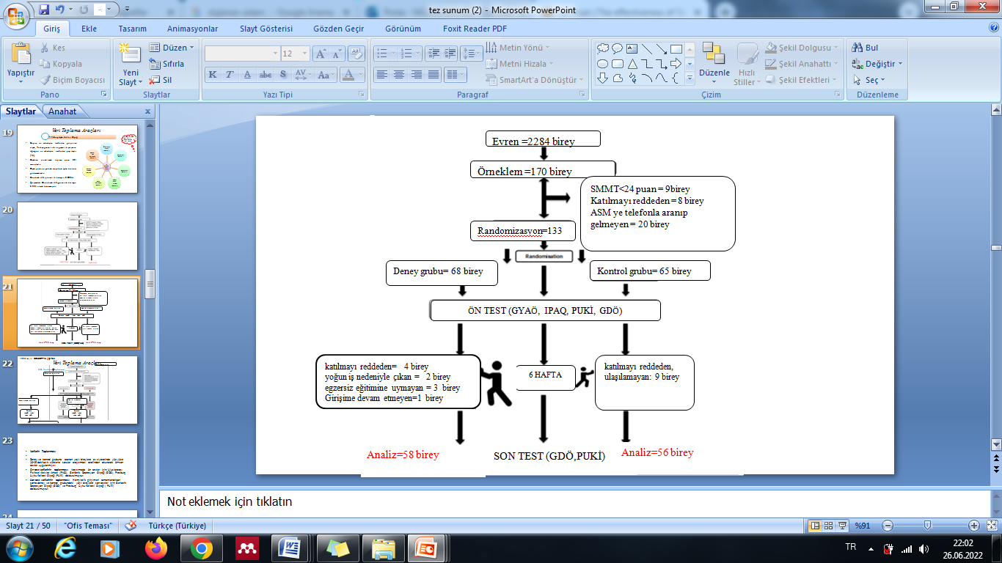

Control Group (n=23)
Experiment group (n=43)
END TEST(IIF, PACV)

