Supplementary information

Scattered trees as crucial elements in maintaining urban diversity: a case study with canopy ants in a biodiversity hotspot

Renata Graziele Mendonça-Santos^{1,2}*, Reuber Antoniazzi³, Flávio Camarota⁴, Yana Teixeira dos Reis¹, Arleu Barbosa Viana-Junior⁵

Fig S1 - Study area map with geographical position (yellow points) of all trees marked (in left) and in detail a numbered metal tag on the tree trunk (in right).
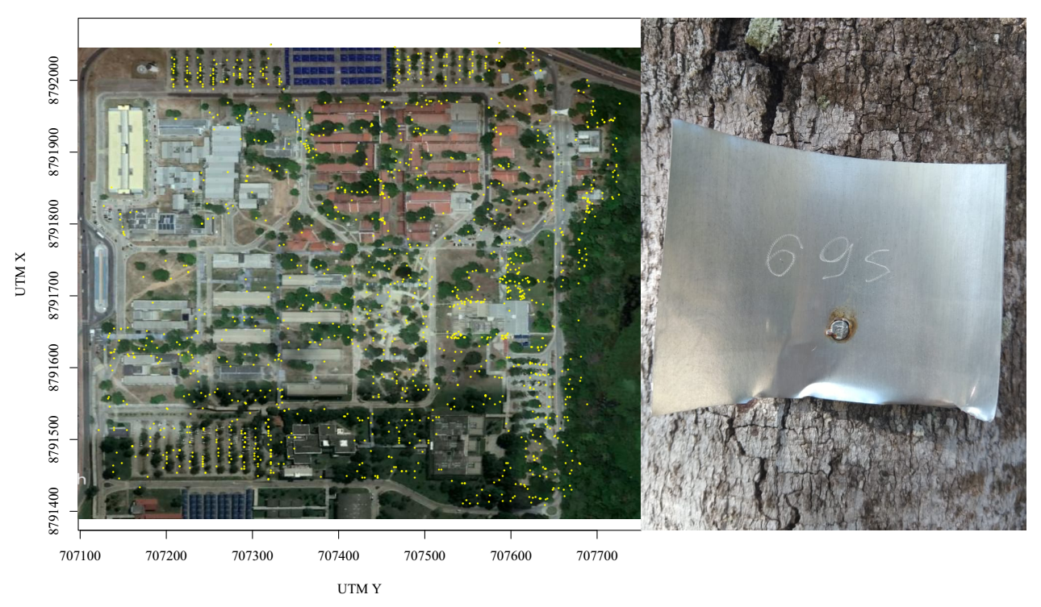

Fig. S2 - Detail of the arboreal bait line technique proposed by Leponce et al. (2019) and used in the present study.

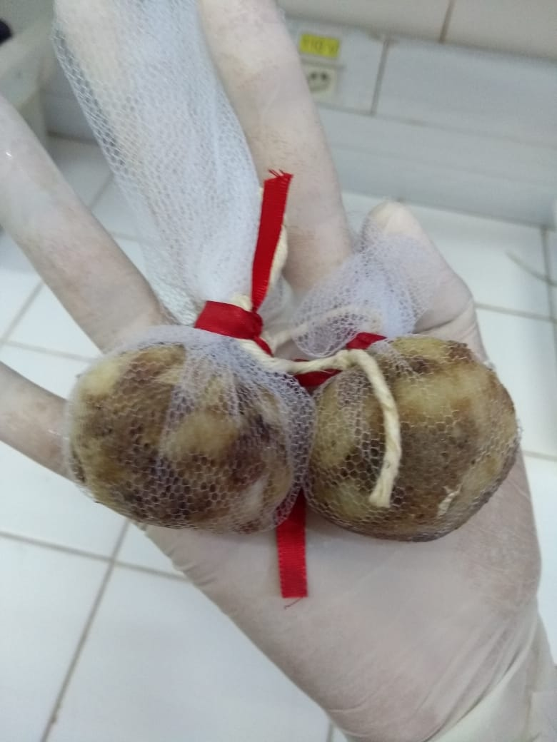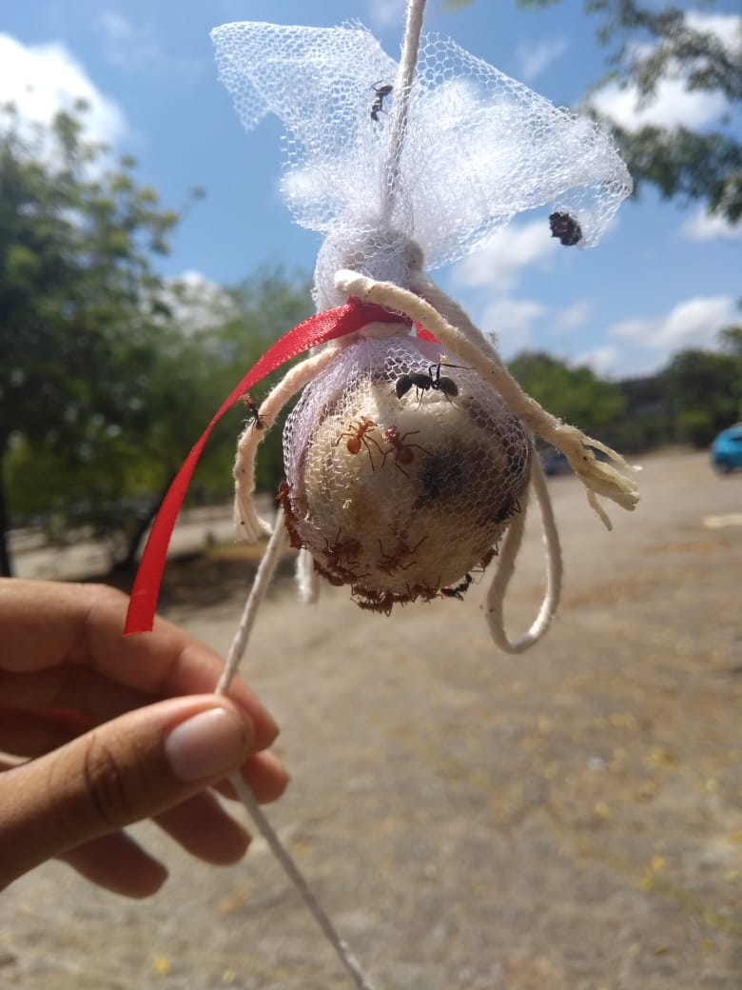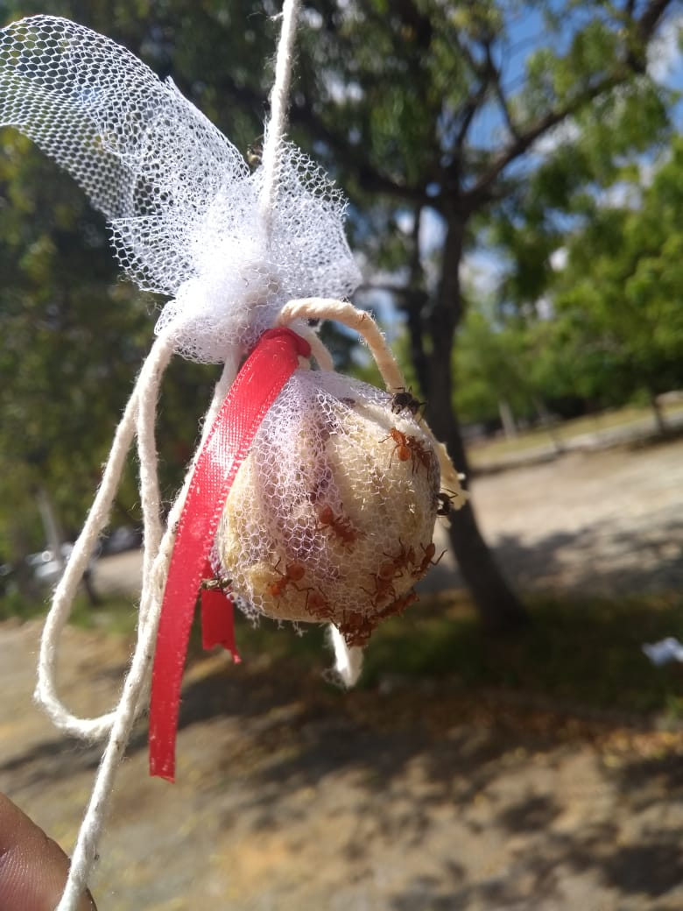

Fig. S3 - CLAM analysis classifying the 19 ant species into four classes according to their occurrence in trees and sampling daytime periods (day and night): no preference (black square); too rare to be assigned specificity preference (gray square); preferring activity in day period (yellow circle); preferring activity in night period (blue triangles).
