Supplemental Material

Table S1 – Summary statistics of seasonal Vallisneria Stress Index across sites for existing condition baseline (ECB19), no-action baseline (NA25f), and preferred alternative (PA25) observed during the period of simulation.
Site | Alternative ¹ | Mean | Standard  Deviation | Minimum | 25ᵗʰ  Quantile | Median | 75ᵗʰ  Quantile | Maximum
BR31 | ECB19 | 0.15 | 0.19 | 0.01 | 0.02 | 0.08 | 0.19 | 0.79
BR31 | NA25f | 0.04 | 0.07 | 0.01 | 0.01 | 0.02 | 0.04 | 0.49
BR31 | PA25 | 0.03 | 0.06 | 0.01 | 0.01 | 0.01 | 0.03 | 0.49
Val-I75 | ECB19 | 0.17 | 0.20 | 0.01 | 0.02 | 0.08 | 0.21 | 0.83
Val-I75 | NA25f | 0.05 | 0.07 | 0.01 | 0.01 | 0.02 | 0.05 | 0.52
Val-I75 | PA25 | 0.04 | 0.07 | 0.01 | 0.01 | 0.02 | 0.04 | 0.52
Bird-IS | ECB19 | 0.19 | 0.22 | 0.01 | 0.03 | 0.10 | 0.23 | 0.88
Bird-IS | NA25f | 0.05 | 0.08 | 0.01 | 0.01 | 0.03 | 0.06 | 0.58
Bird-IS | PA25 | 0.04 | 0.08 | 0.01 | 0.01 | 0.02 | 0.04 | 0.58
FtMyers | ECB19 | 0.32 | 0.27 | 0.01 | 0.12 | 0.24 | 0.44 | 0.99
FtMyers | NA25f | 0.18 | 0.17 | 0.01 | 0.05 | 0.14 | 0.25 | 0.80
FtMyers | PA25 | 0.14 | 0.15 | 0.01 | 0.04 | 0.10 | 0.20 | 0.80
¹ ECB19 = existing condition baseline; NA25f = no action baseline; PA25 = preferred alternative

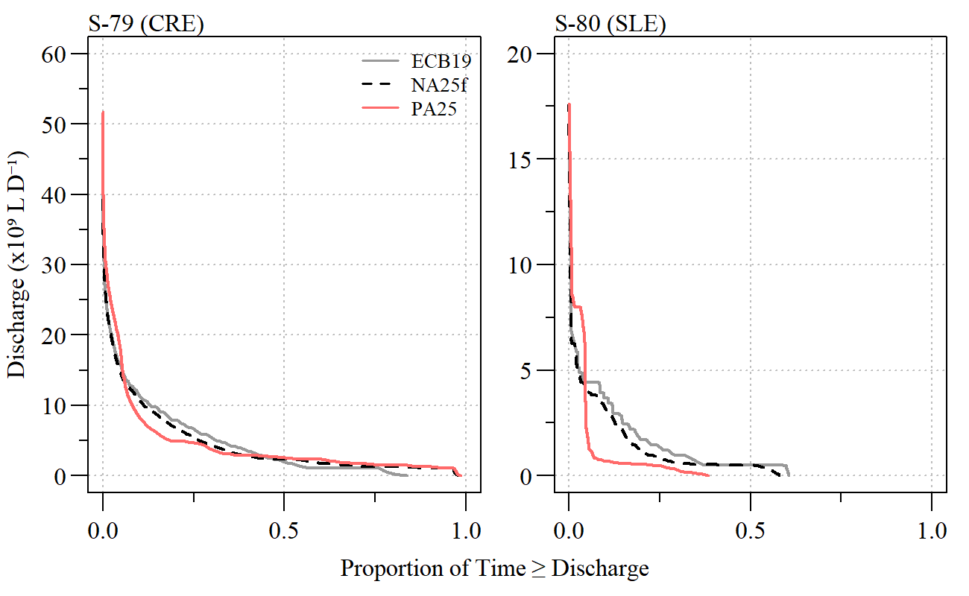Figure S1 – Discharge duration curve for total discharges from S-79 (Caloosahatchee River Estuary) and S-80 (St. Lucie River Estuary) for each alternative during the simulated period of record. Alternatives include the existing condition baseline (ECB19) no-action baseline (NA25f), and preferred alternative (PA25).

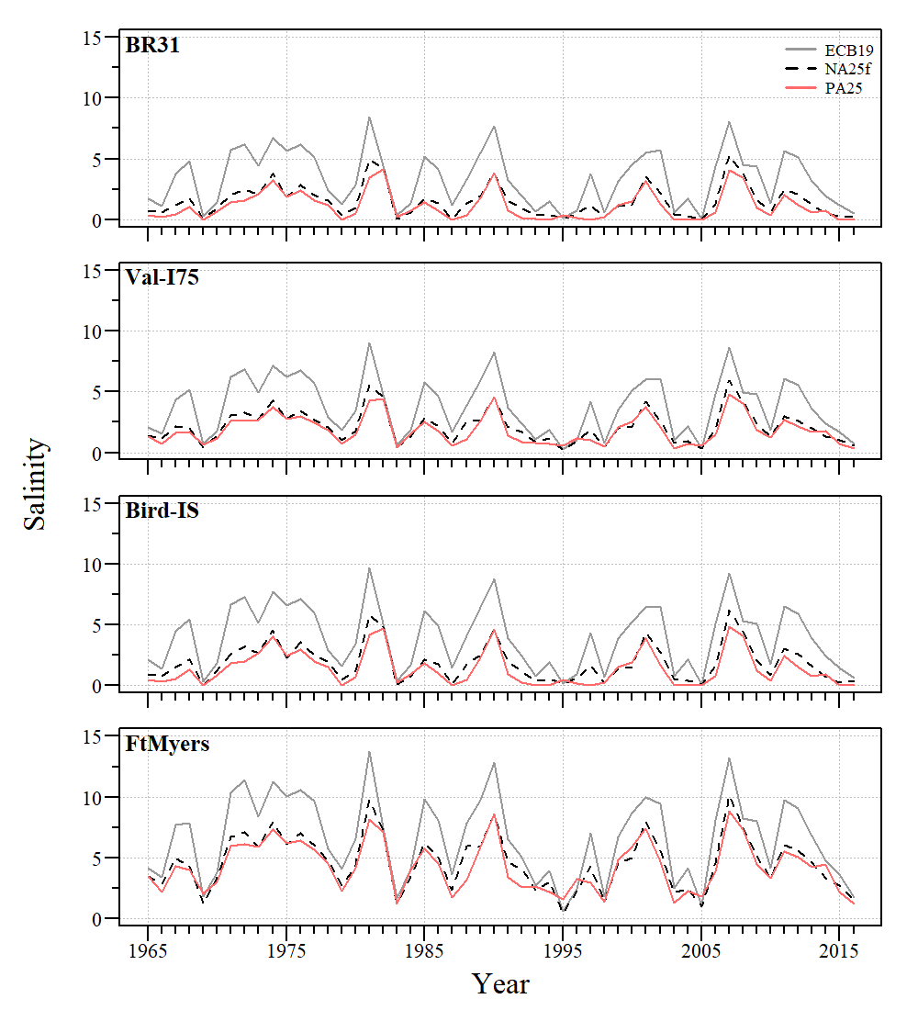
Figure S2 – Annual average simulated salinity for existing condition baseline (ECB19), no-action baseline (NA25f), and preferred alternative (PA25) observed during the period of simulation at salinity simulation sites (Fig 1) in the upper Caloosahatchee River Estuary.

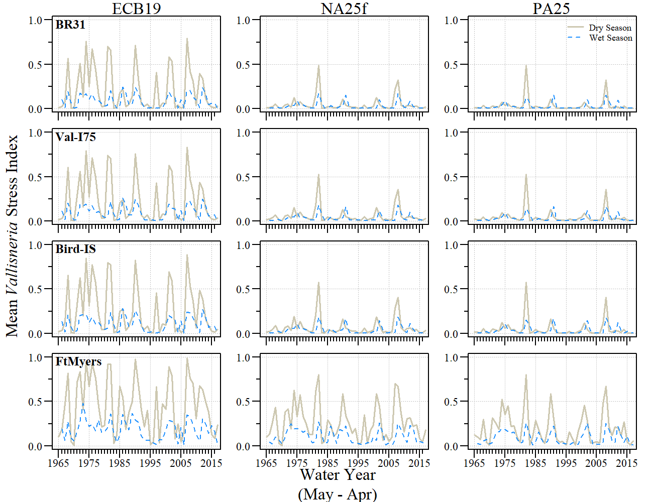
Figure S3 – Annual mean wet and dry season Vallisneria Stress Index for existing condition baseline (ECB19), no-action baseline (NA25f), and preferred alternative (PA25) observed during the period of simulation at salinity simulation sites (Fig 1) in the upper Caloosahatchee River

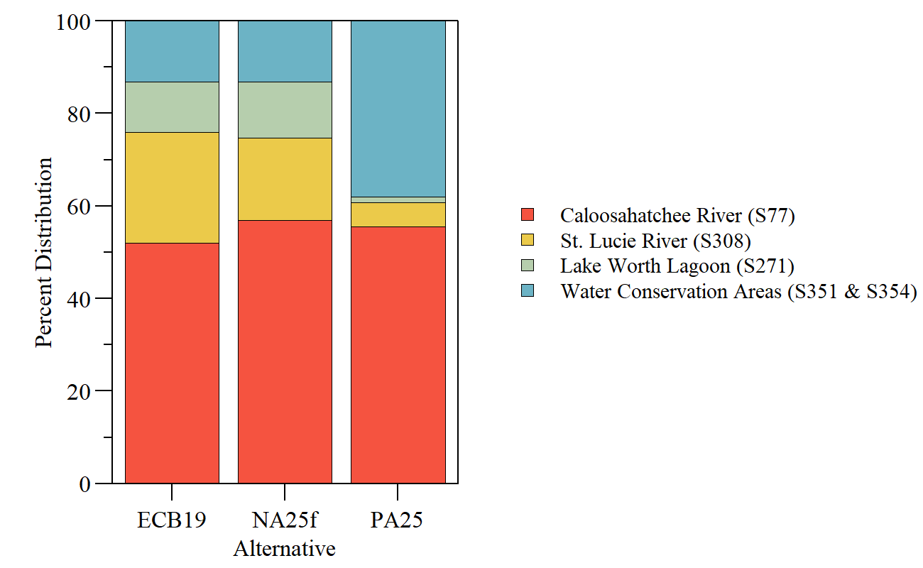
Figure S4 – Average percent distribution of regulatory discharge from Lake Okeechobee to the Caloosahatchee River (S-77), St. Lucie River (S-308), Water Conservation Areas (S-351 and S-352), and Lake Worth Lagoon (S-271) for existing condition baseline (ECB19), no-action baseline (NA25f), and preferred alternative (PA25) observed during the period of simulation.

