SUPPLEMENTARY MATERIAL: Nd:YAG laser vitreolysis for managing symptomatic vitreous floaters: efficacy assessment using vitreous opacity area quantification.

Emmanuel Ankamah, OD, PhD, MBA^{1,2,3}; Jasna Pavičić-Astaloš, MD, PhD^{1,2,3}; Nikolina Budimlija, MD^{1,2,3}; Farahida Ibrahim, MD^{2,3}; Michael O’Keeffe, MD²; Caitriona Kirwan, MD²; Patrick Hayes, MD¹; Eugene Ng, MD^{1,2,3}

#1 Flow diagram describing results of the study
#2 Follow-up duration post laser vitreolysis
#3 Box plots showing the quantitative vitreous opacity areas before and after laser vitreolysis
#4 Best corrected visual acuity outcomes following laser vitreolysis
#5 Intraocular pressure outcomes following laser vitreolysis.
#6 Slit lamp retroillumination image of the crystalline lens showing the posterior capsule injury (a; white arrow) and optic capture of the intraocular lens following cataract surgery (b)
#7 Green channel imaging showing trickle of blood into vitreous from YAG laser retinal injury just infra nasal to the optic disc at Day 0 (a; white arrow) and spontaneous recovery by week 2 without any intervention (b)

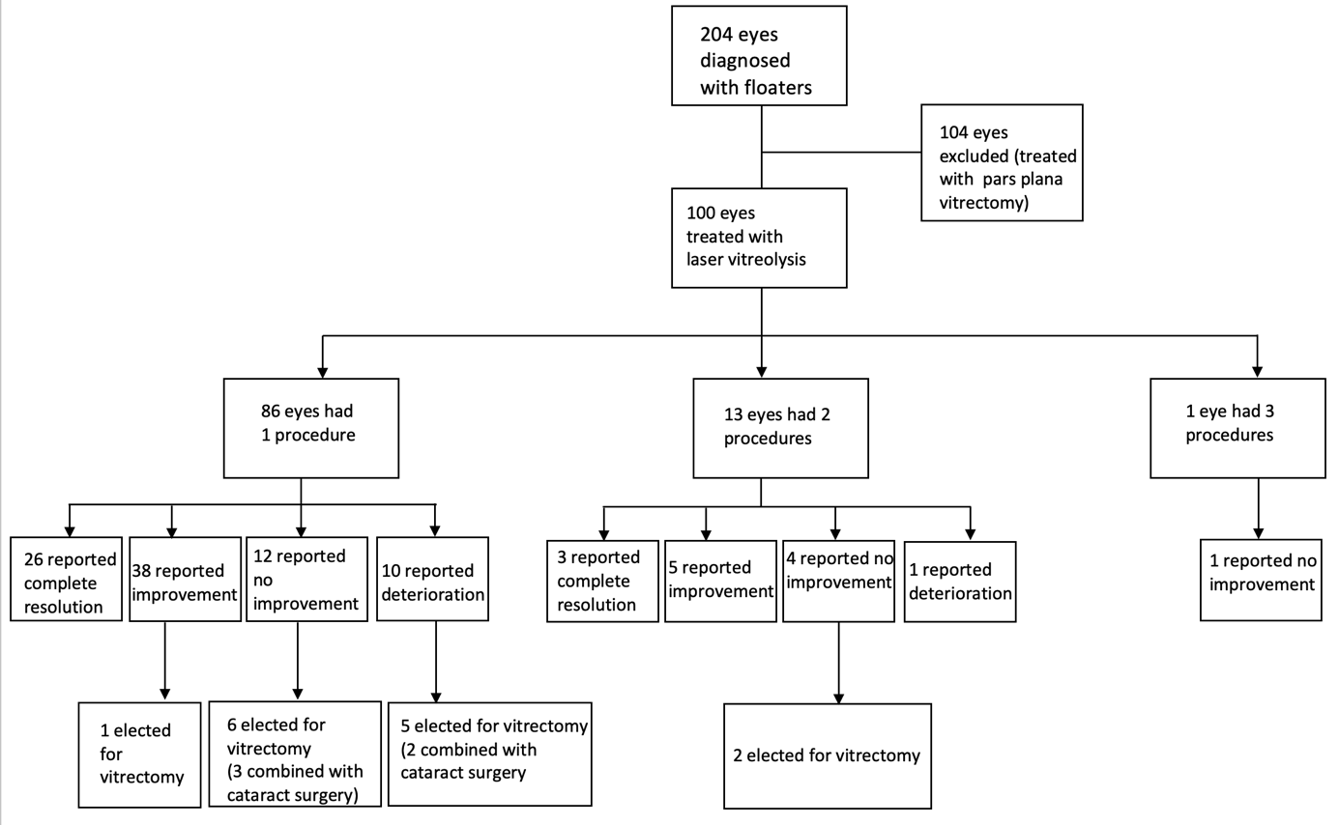
Supplementary Material 1

Supplementary Material 2

Supplementary Material 3

Supplementary Material 4

Supplementary Material 5

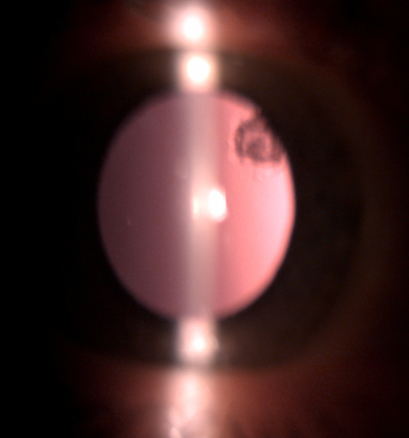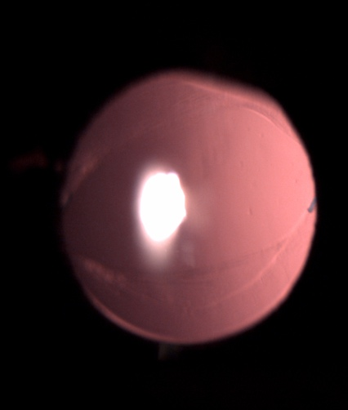
b
a
Supplementary Material 6
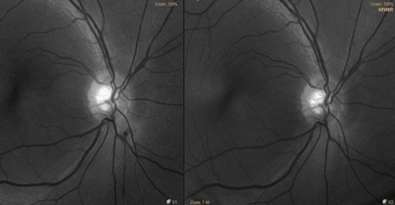
a
b
Supplementary Material 7

