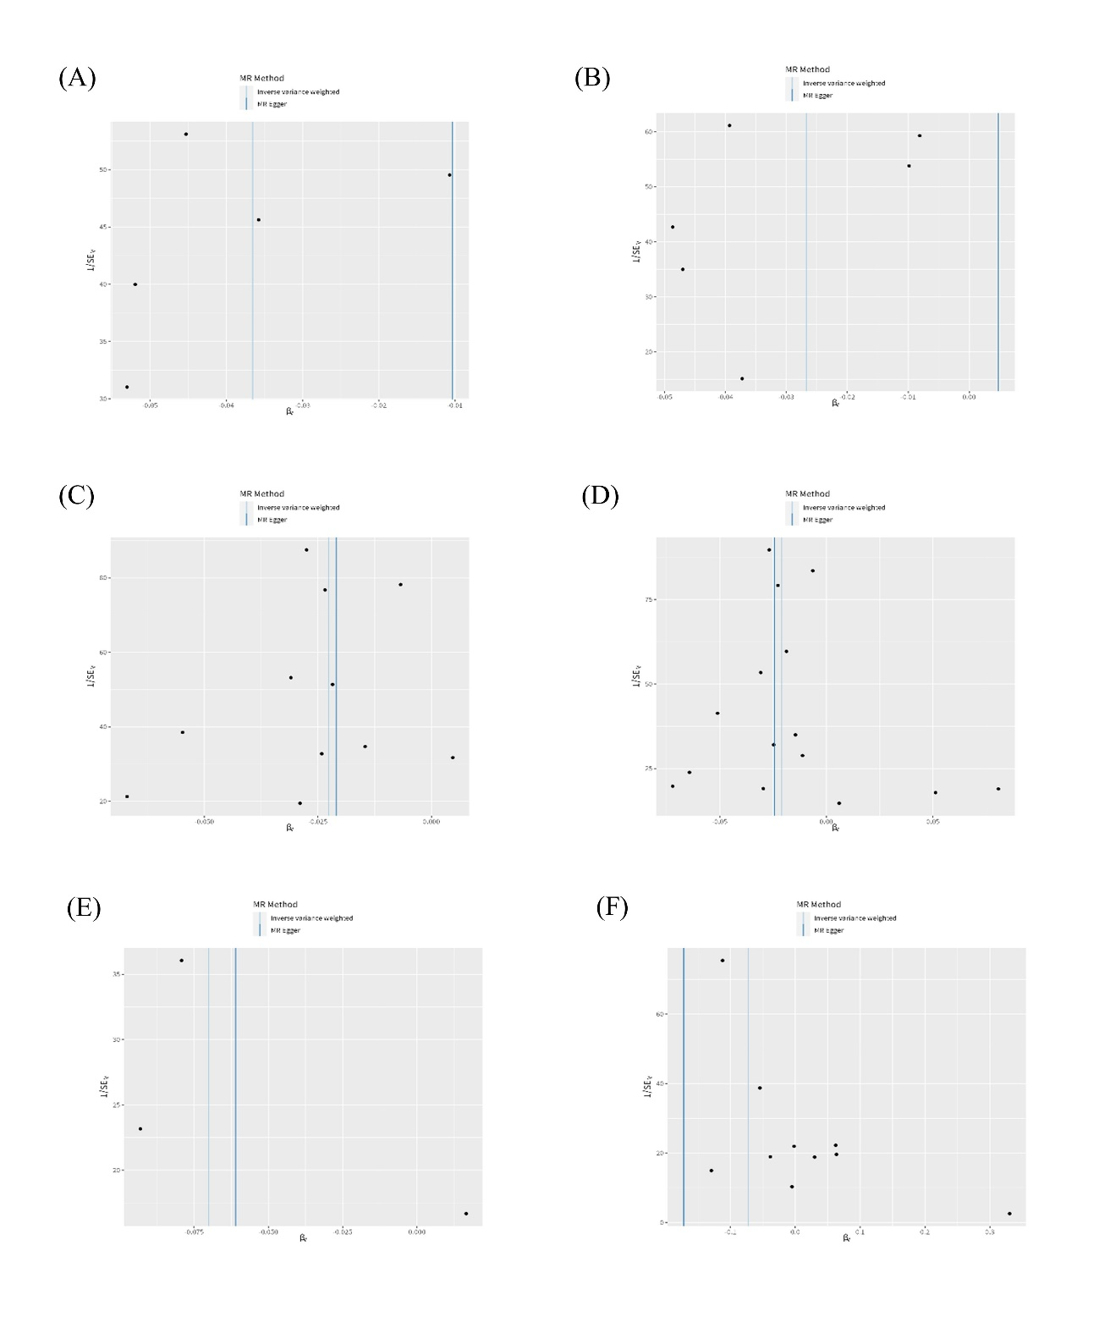
Figure A. Funnel plot for the relationship between the SNP effect size of causal immune traits and the corresponding effect size estimates of AD. (A) CD25++ CD45RA- CD4 not regulatory T cell %T cell, (B) CD25++ CD45RA- CD4 not regulatory T cell %CD4+ T cell, (C) Secreting CD4 regulatory T cell %CD4 regulatory T cell, (D) Activated & secreting CD4 regulatory T cell %CD4 regulatory T cell, (E) HLA DR++ monocyte %monocyte, (F) HLA DR on myeloid Dendritic Cell. AD, Alzheimer’s disease.

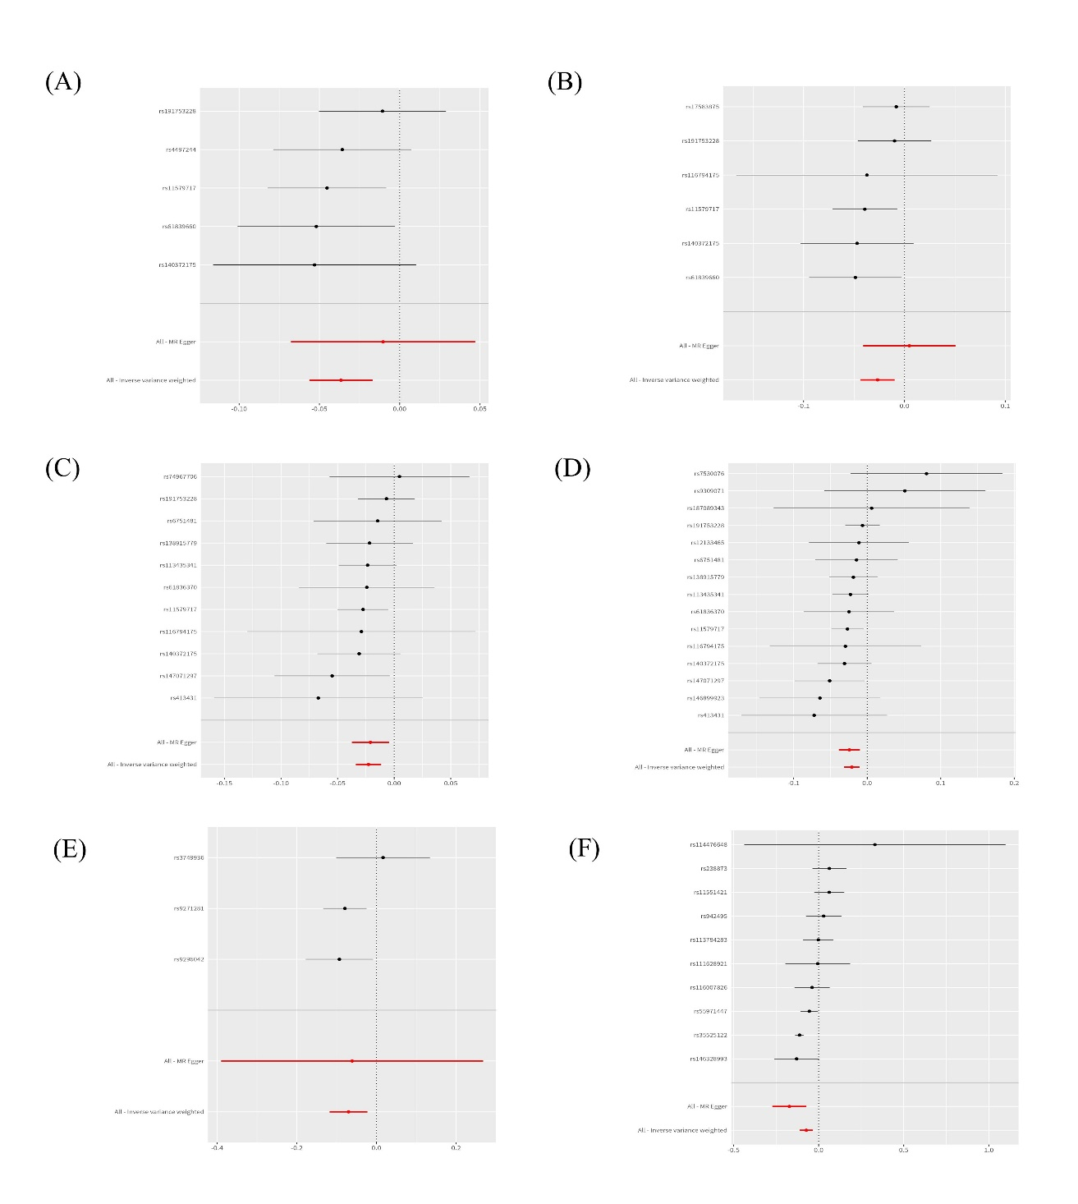
Figure B. Forest plot of causal effects for different immune traits on AD. (A) CD25++ CD45RA- CD4 not regulatory T cell %T cell, (B) CD25++ CD45RA- CD4 not regulatory T cell %CD4+ T cell, (C) Secreting CD4 regulatory T cell %CD4 regulatory T cell, (D) Activated & secreting CD4 regulatory T cell %CD4 regulatory T cell, (E) HLA DR++ monocyte %monocyte, (F) HLA DR on myeloid Dendritic Cell. AD, Alzheimer’s disease.

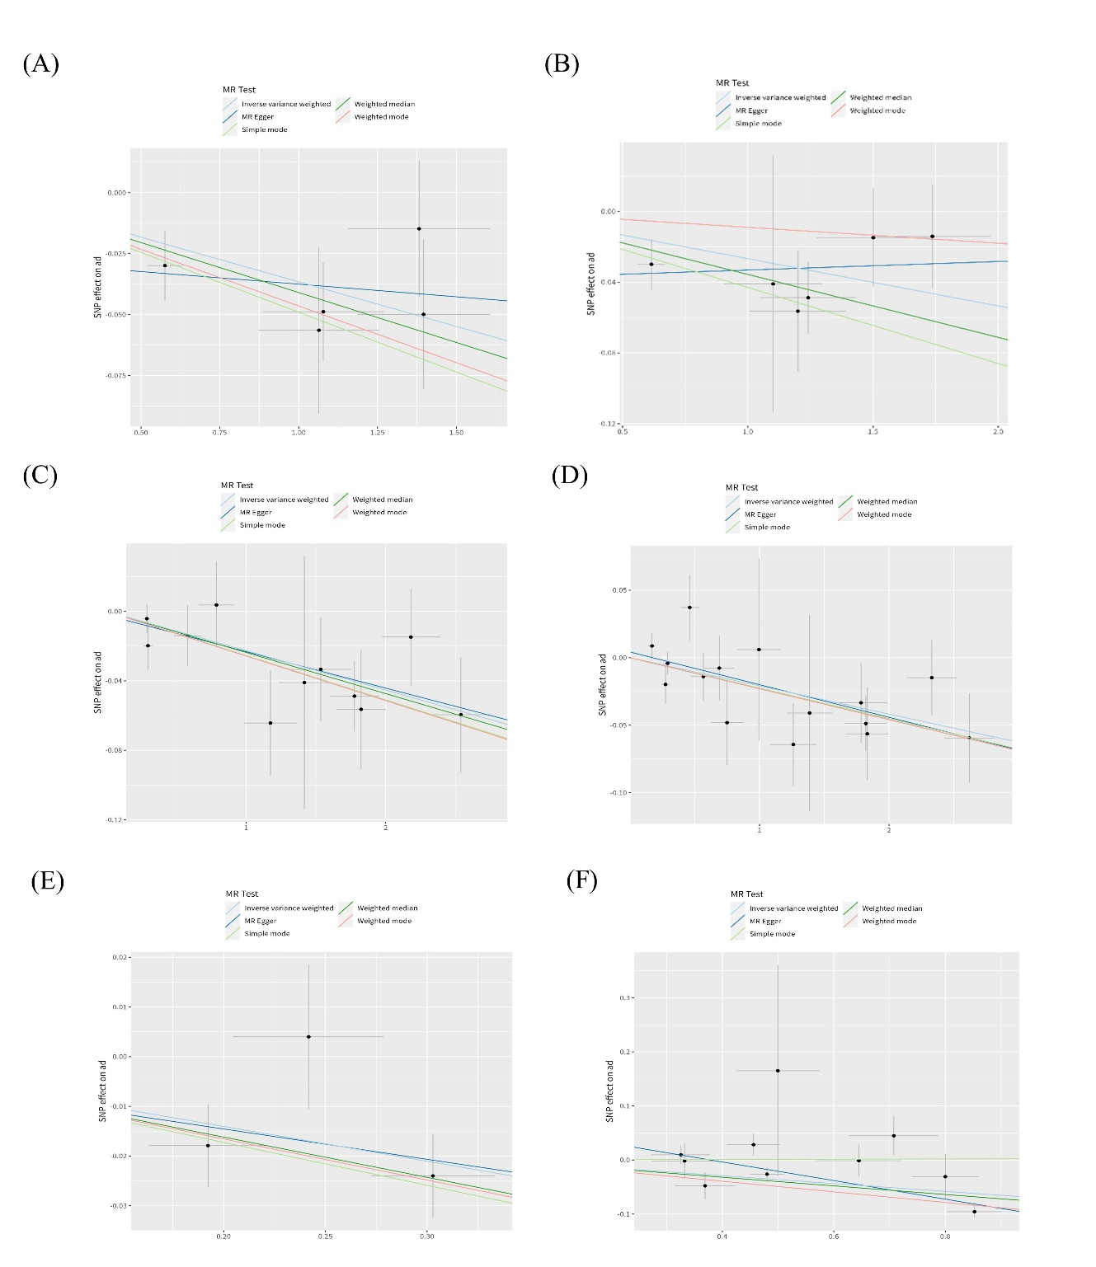
Figure C. Scatter plot for the relationship between the SNP effect size of causal immune traits and the corresponding effect size estimates of AD. (A) CD25++ CD45RA- CD4 not regulatory T cell %T cell, (B) CD25++ CD45RA- CD4 not regulatory T cell %CD4+ T cell, (C) Secreting CD4 regulatory T cell %CD4 regulatory T cell, (D) Activated & secreting CD4 regulatory T cell %CD4 regulatory T cell, (E) HLA DR++ monocyte %monocyte, (F) HLA DR on myeloid Dendritic Cell. AD, Alzheimer’s disease.

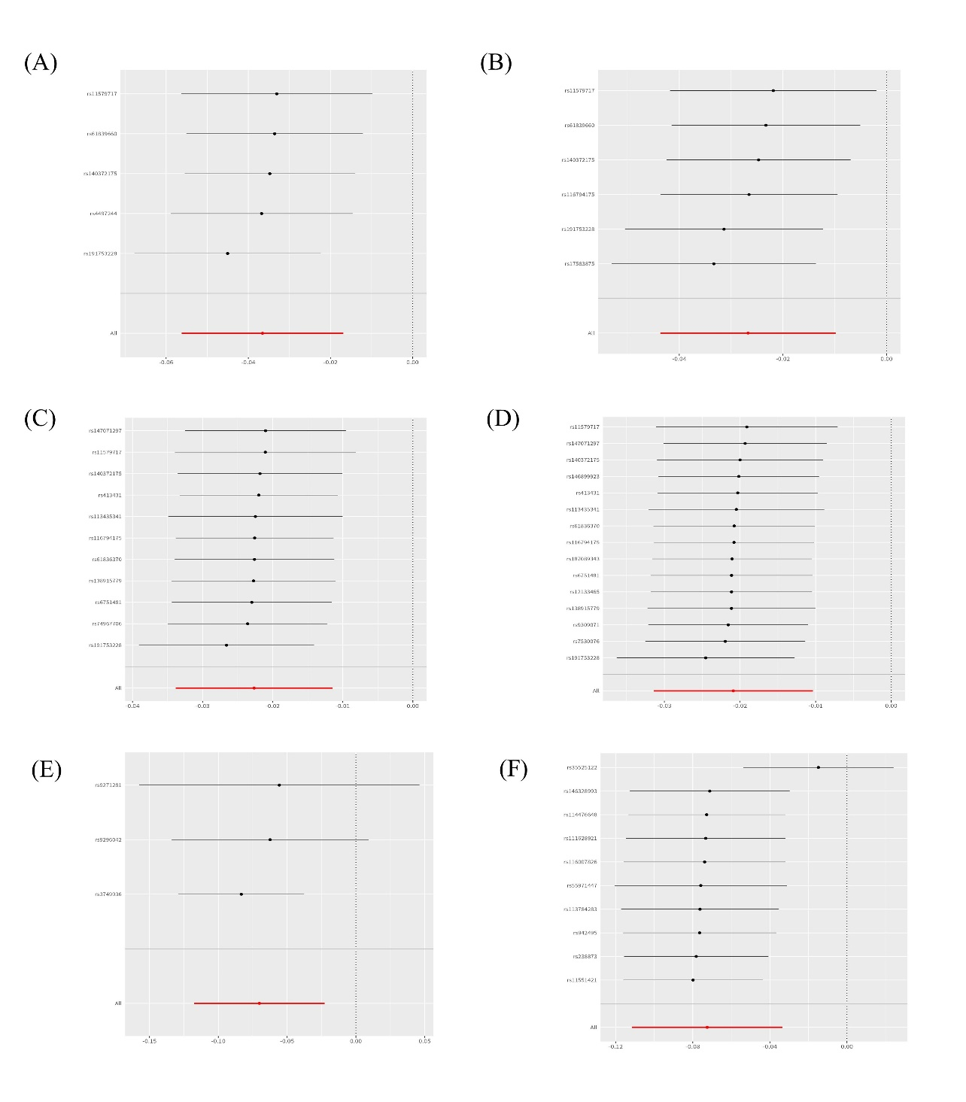Figure D. Leave-one-out plot for single SNP effect size of causal immune traits on AD. (A) CD25++ CD45RA- CD4 not regulatory T cell %T cell, (B) CD25++ CD45RA- CD4 not regulatory T cell %CD4+ T cell, (C) Secreting CD4 regulatory T cell %CD4 regulatory T cell, (D) Activated & secreting CD4 regulatory T cell %CD4 regulatory T cell, (E) HLA DR++ monocyte %monocyte, (F) HLA DR on myeloid Dendritic Cell. AD, Alzheimer’s disease.

