Supplementary Material
Cost-effectiveness analysis of sorafenib, lenvatinib, atezolizumab plus bevacizumab and sintilimab plus bevacizumab for the treatment of advanced hepatocellular carcinoma in China

Gong Hongyu1,2, Ph.D. candidate, Teaching assistant
ONG Siew Chin1*, MD, Professor
Li Fan3, MD, Professor
Zhao Keying3, MD, Associate professor
Weng Zhiying3, MD, Professor
Jiang Zhengyou4, Ph.D. candidate

¹School of Pharmaceutical Sciences, Universiti Sains Malaysia, 11800 USM Penang, Penang City, Malaysia
²Incubation Center for Scientific and Technological Achievements, Kunming Medical University, Chunrong west road 1168, Kunming City, China
³School of Pharmaceutical Science &Yunnan Key Laboratory of Pharmacology for
Natural Products, Kunming Medical University, Chunrong west road 1168, Kunming City, China
⁴School of Public Health, Kunming Medical University, Chunrong west road 1168, Kunming City, China
⁵School of management, Universiti Sains Malaysia, 11800 USM Penang, Penang City, Malaysia

* Correspondence author:
ONG Siew Chin
siewchinong@usm.my
Universiti Sains Malaysia,
Phone: 604-6533888 Ext: 4725 (office)

Table S1 Inclusion and exclusion criteria of the NCT01761266, NCT03434379 and NCT03794440 studies
Criteria | NCT01761266 | NCT03434379 | NCT03794440
Age requirements | ≥18 | ≥18 | ≥18
Previous treatment | No received previous systemic therapy | No previously received systemic therapy | No previous systemic therapy
How HCC diagnosed | Histologically or cytologically, or confirmed clinically in accordance with American Association for the Study of Liver Diseases criteria | Histologic or cytologic analysis or clinical features according to the American Association for the Study of Liver Diseases criteria for patients with cirrhosis | Histologically, cytologically, or clinically confirmed per the American Association for the Study of Liver Disease criteria
Lesions | One or more measurable target lesions | N/A | One or more measurable target lesions
Life expectancy | 12 weeks+ | N/A | 12 weeks+
BCLC stage | B or C | N/A | B or C
ECOG | 0 or 1 | 0 or 1 | 0 or 1
Child-Pugh liver function | A | A | ≤7
Exclusion criteria | With 50% or higher liver occupation, obvious invasion of the bile duct, or invasion at the main portal vein | A history of autoimmune disease；high risk of bleeding | A history of autoimmune  disease,liver transplantation, acute or chronic active HBV  or HCV infection
Abbreviations: BCLC stage, barcelona clinic liver cancer stage; ECOG, Eastern Cooperative Oncology Group; HCC, Hepatocellular carcinoma; HBV, hepatitis B virus; HCV, hepatitis C virus；

Figure S1:The Replicated Kaplan-Meier survival Curves of sorafenib in NCT01761266 Trial
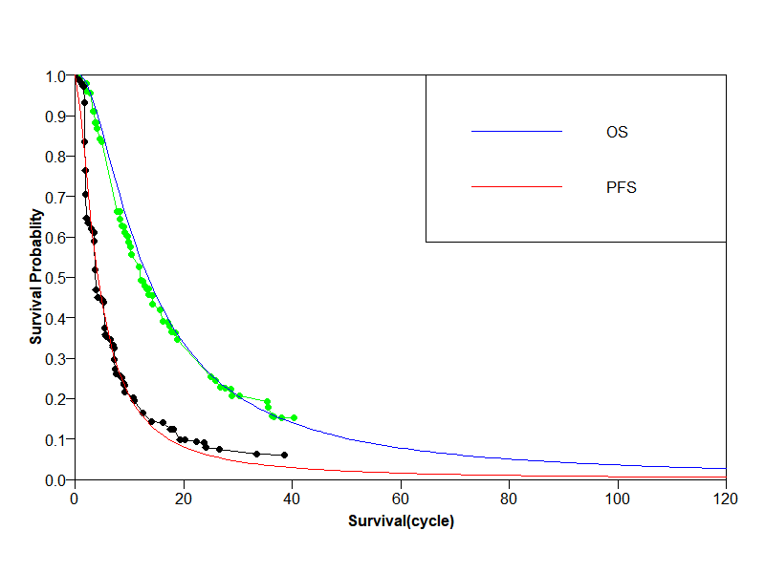
Abbreviations: PFS, progression-free survival; OS, overall survival

Figure S2:The Replicated Kaplan-Meier survival Curves of lenvatinib in NCT01761266 Trial
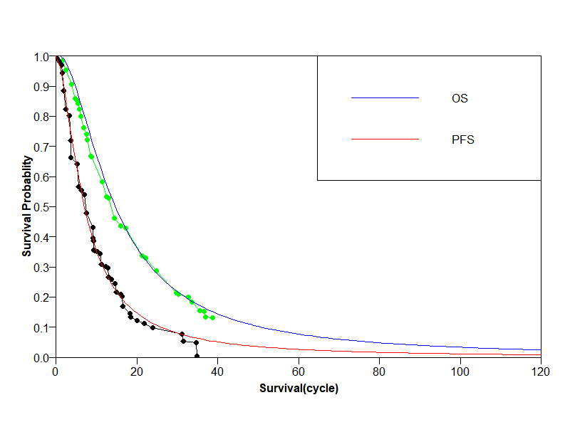
Abbreviations: PFS, progression-free survival; OS, overall survival

Figure S3:The Replicated Kaplan-Meier survival Curves of S+B in NCT03794440 Trial
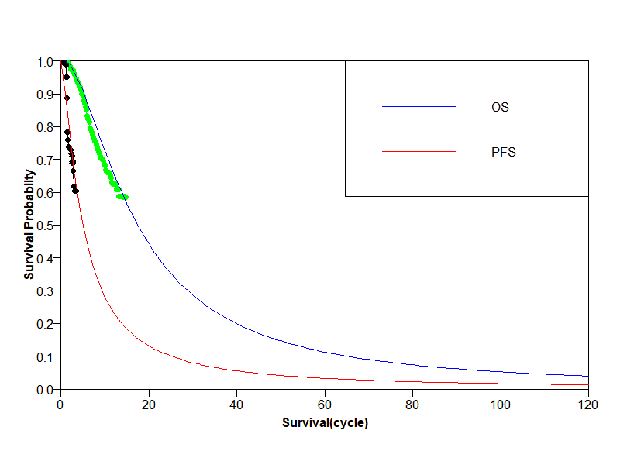
Abbreviations: PFS, progression-free survival; OS, overall survival

Figure S4:The Replicated Kaplan-Meier survival Curves of A+B in NCT03434379 Trial
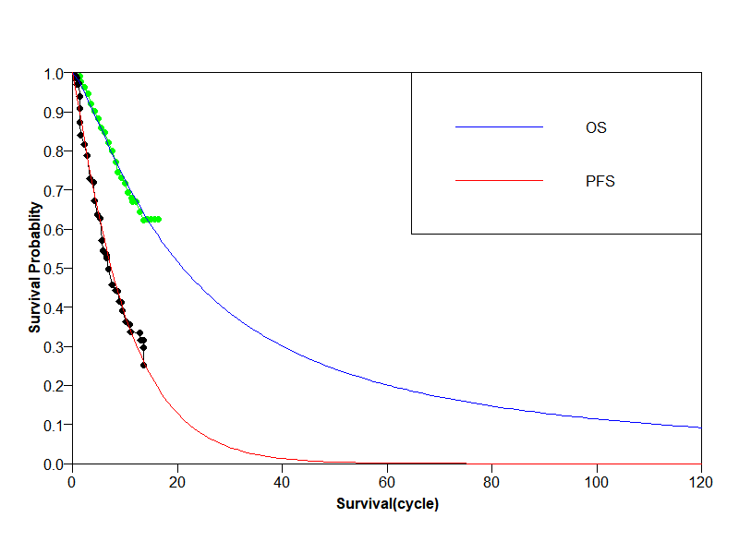
Abbreviations: PFS, progression-free survival; OS, overall survival；

Table S2：One-way sensitivity analysis of sorafenib and lenvatinib, discounted (per patient)

Variable Name | Variable Low | Variable Base | Variable High | Impact | Low-INMB | High-INMB
insurance_lenvatinib | 0.32 | 0.40 | 0.48 | Decrease | -9164.48 | -2710.55
cost_monthly_lenvatinib | 2358.14 | 2947.67 | 3537.20 | Decrease | -8957.86 | -2917.17
util_PF | 0.61 | 0.76 | 0.91 | Increase | -7470.95 | -4404.08
insurance_sorafenib | 0.28 | 0.35 | 0.42 | Increase | -7188.88 | -4686.15
util_PD | 0.54 | 0.68 | 0.82 | Decrease | -7149.45 | -4725.58
cost_monthly_sorafenib | 1371.43 | 1714.29 | 2057.14 | Increase | -7077.58 | -4797.45
cPostProgress | 1419.55 | 1774.44 | 2129.32 | Increase | -6404.11 | -5470.92
cost_test | 130.53 | 163.16 | 195.79 | Decrease | -5996.19 | -5878.84
cost_hypertension | 30.80 | 38.50 | 46.20 | Decrease | -5976.96 | -5898.07
cost_HFSR | 3.37 | 4.21 | 5.05 | Increase | -5940.32 | -5934.72
disc_rate | 0.00 | 0.05 | 0.08 | Increase | -5937.52 | -5937.52
Abbreviations: PFS, progression-free survival; PD, progressed disease; HFSR, hand-foot skin reaction; disc_rate, discount rate;

Table S3：One-way sensitivity analysis of sorafenib and sintilimab–bevacizumab, discounted (per patient)

Variable Name | Variable Low | Variable Base | Variable High | Impact | Low-INMB | High-INMB
insurance_sintilimab_  bevacizumab | 0.36 | 0.45 | 0.54 | Decrease | -17522.29 | -6457.72
cChemo_monthly_sintilimab_bevacizumab | 3816.66 | 4770.83 | 5724.99 | Decrease | -17253.37 | -6726.64
util_PFS | 0.61 | 0.76 | 0.91 | Increase | -13268.47 | -10711.54
insurance_sorafenib | 0.28 | 0.35 | 0.42 | Increase | -13241.37 | -10738.64
cost_monthly_sorafenib | 1371.43 | 1714.29 | 2057.14 | Increase | -13130.07 | -10849.94
util_PD | 0.54 | 0.68 | 0.82 | Increase | -12972.86 | -11007.15
cost_PostProgress | 1419.55 | 1774.44 | 2129.32 | Decrease | -12368.41 | -11611.60
cost_test | 130.53 | 163.16 | 195.79 | Decrease | -12061.50 | -11918.51
cost_hypertension | 30.80 | 38.50 | 46.20 | Decrease | -12032.47 | -11947.53
cost_HFSR | 3.37 | 4.21 | 5.05 | Increase | -11992.80 | -11987.20
disc_rate | 0.00 | 0.05 | 0.08 | Increase | -11990.00 | -11990.00
Abbreviations: PFS, progression-free survival; PD, progressed disease; HFSR, hand-foot skin reaction; disc_rate, discount rate;

Table S4：One-way sensitivity analysis of sorafenib and atezolizumab–bevacizumab, discounted (per patient)

Variable Name | Variable Low | Variable Base | Variable High | Impact | Low-INMB | High-INMB
cost_monthly_atezolizumab_bevacizumab | 8481.08 | 10601.35 | 12721.62 | Decrease | -117640.11 | -70233.05
utility_PD | 0.54 | 0.68 | 0.82 | Increase | -99516.28 | -88356.88
cost_PostProgress | 1419.55 | 1774.44 | 2129.32 | Decrease | -96084.78 | -91788.38
insurance_sorafenib | 0.28 | 0.35 | 0.42 | Increase | -95187.95 | -92685.21
cost_monthly_sorafenib | 1371.43 | 1714.29 | 2057.14 | Increase | -95076.64 | -92796.52
utility_PFS | 0.61 | 0.76 | 0.91 | Increase | -94714.95 | -93158.21
cost_test | 130.53 | 163.16 | 195.79 | Decrease | -94192.88 | -93680.28
cost_hypertension | 30.80 | 38.50 | 46.20 | Decrease | -94022.66 | -93850.51
cost_HFSR | 3.37 | 4.21 | 5.05 | Increase | -93939.38 | -93933.78
disc_rate | 0.00 | 0.05 | 0.08 | Increase | -93936.58 | -93936.58
Abbreviations: PFS, progression-free survival; PD, progressed disease; HFSR, hand-foot skin reaction; disc_rate, discount rate;

Figure S5：One-way sensitivity analysis of ICER of sorafenib and lenvatinib, discounted (per patient), payer system perspective
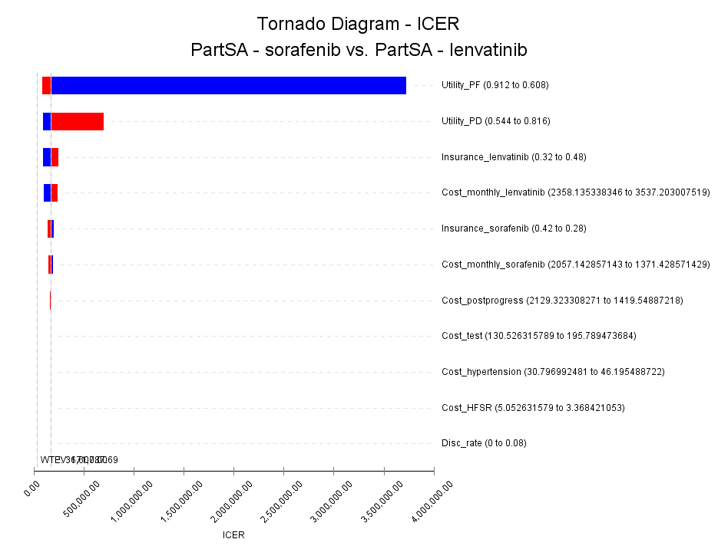
Abbreviations: PartSA, partitioned survival analysis; ICER, incremental cost-effectiveness ration; PF, progression free; PD, progressed-disease; HFSR, hand-foot skin reaction; disc_rate, discount rate;

Figure S6：One-way sensitivity analysis of ICER of sorafenib and sintilimab–bevacizumab, discounted (per patient), payer system perspective
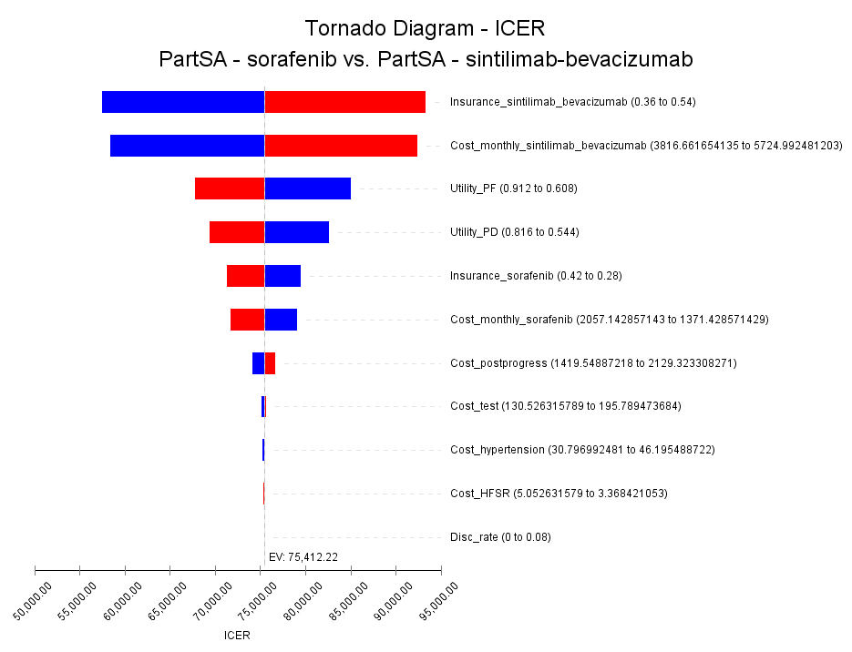
Abbreviations: PartSA, partitioned survival analysis; ICER, incremental cost-effectiveness ration; PF, progression free; PD, progressed-disease; HFSR, hand-foot skin reaction; disc_rate, discount rate;

Figure S7：One-way sensitivity analysis of ICER of sorafenib and atezolizumab–bevacizumab, discounted (per patient), payer system perspective
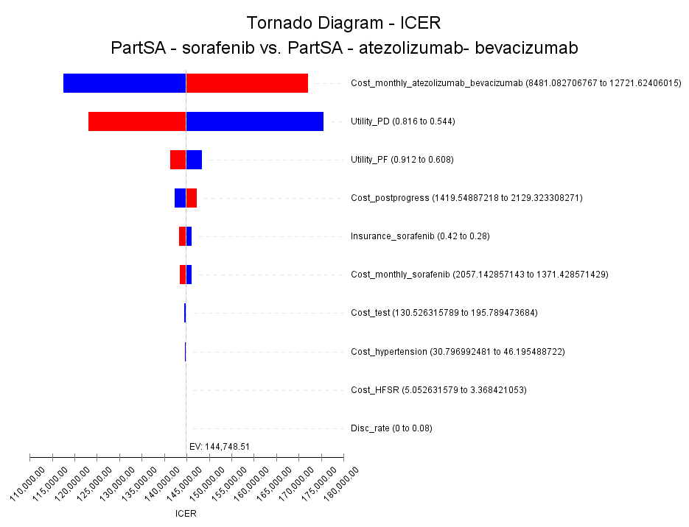
Abbreviations: PartSA, partitioned survival analysis; ICER, incremental cost-effectiveness ration; PF, progression free; PD, progressed-disease; HFSR, hand-foot skin reaction; disc_rate, discount rate;

