CRISPR-AMRtracker: a novel toolkit to monitor the antimicrobial resistance gene transfer in fecal microbiota
Supplementary data
Fig S1. Elimination of the pCas9-oriT and pSGKP-gfp plasmids in the fluorescently labelled strains.
Fig S2. Growth curves of S. Typhimurium 14E1050-sfGFP, E. coli HZE22-sfGFP, K. pneumoniae 50700-sfGFP and their parental strains over 24 h.
Fig S3. Characteristics of the plasmid pCSZ4.
Table S1, strains used in this study.
Table S2, plasmids used in this study.
Table S3, Primers used in this study.
Appendix 1

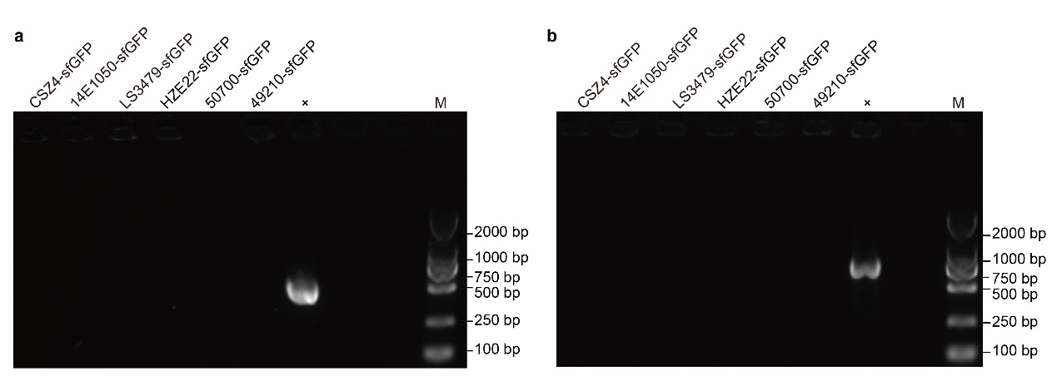Fig S1. Elimination of the pCas9-oriT and pSGKP-gfp plasmids in the fluorescently labelled strains. a. Elimination of the plasmid pSGKP-gfp (pSGKP-arr2-TKPC500GFP, pSGKP-arr2-TNDM500GFP, pSGKP-arr2-TOXA500GFP and pSGKP-Tmcr-500GFP) in the fluorescently labelled CSZ4-sfGFP, 14E1050-sfGFP, LS3479-sfGFP, HZE22-sfGFP, 50700-sfGFP and 49210-sfGFP. The plasmid pSGKP-gfp was used as positive control. b. Deletion of the plasmid pCasKP-oriT in the fluorescently labelled CSZ4-sfGFP, 14E1050-sfGFP, LS3479-sfGFP, HZE22-sfGFP, 50700-sfGFP and 49210-sfGFP. The plasmid pCasKP-oriT was used as positive control.

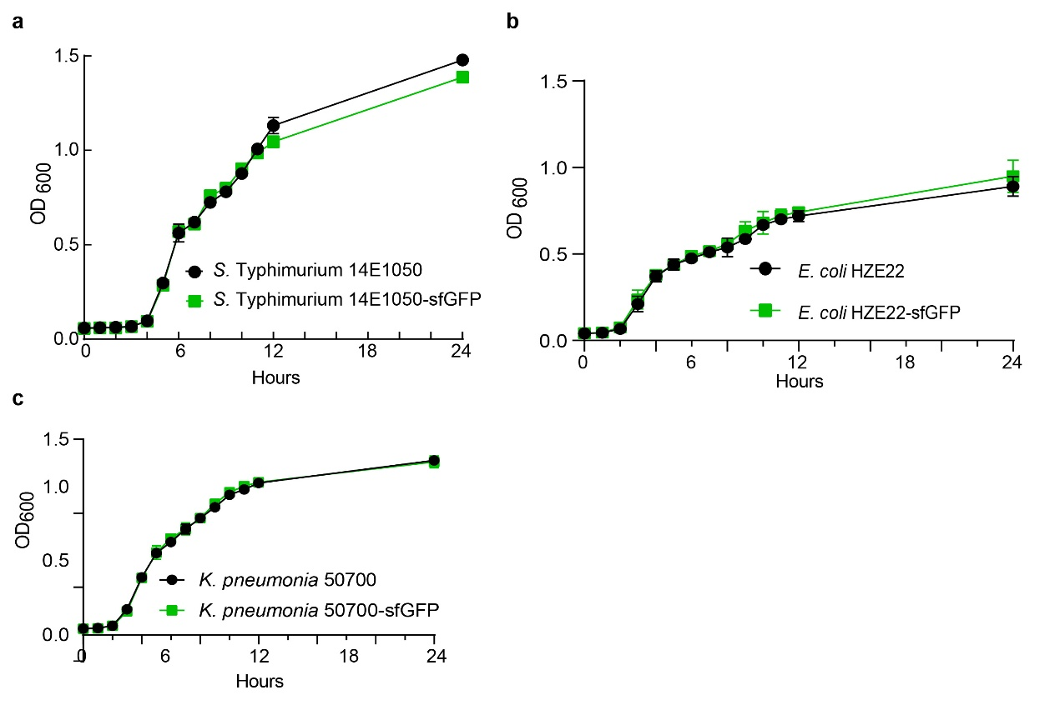

Fig S2. Growth curves of S. Typhimurium 14E1050-sfGFP, E. coli HZE22-sfGFP, K. pneumoniae 50700-sfGFP and their parental strains over 24 h. The experiment was performed with 3 biological replicates.
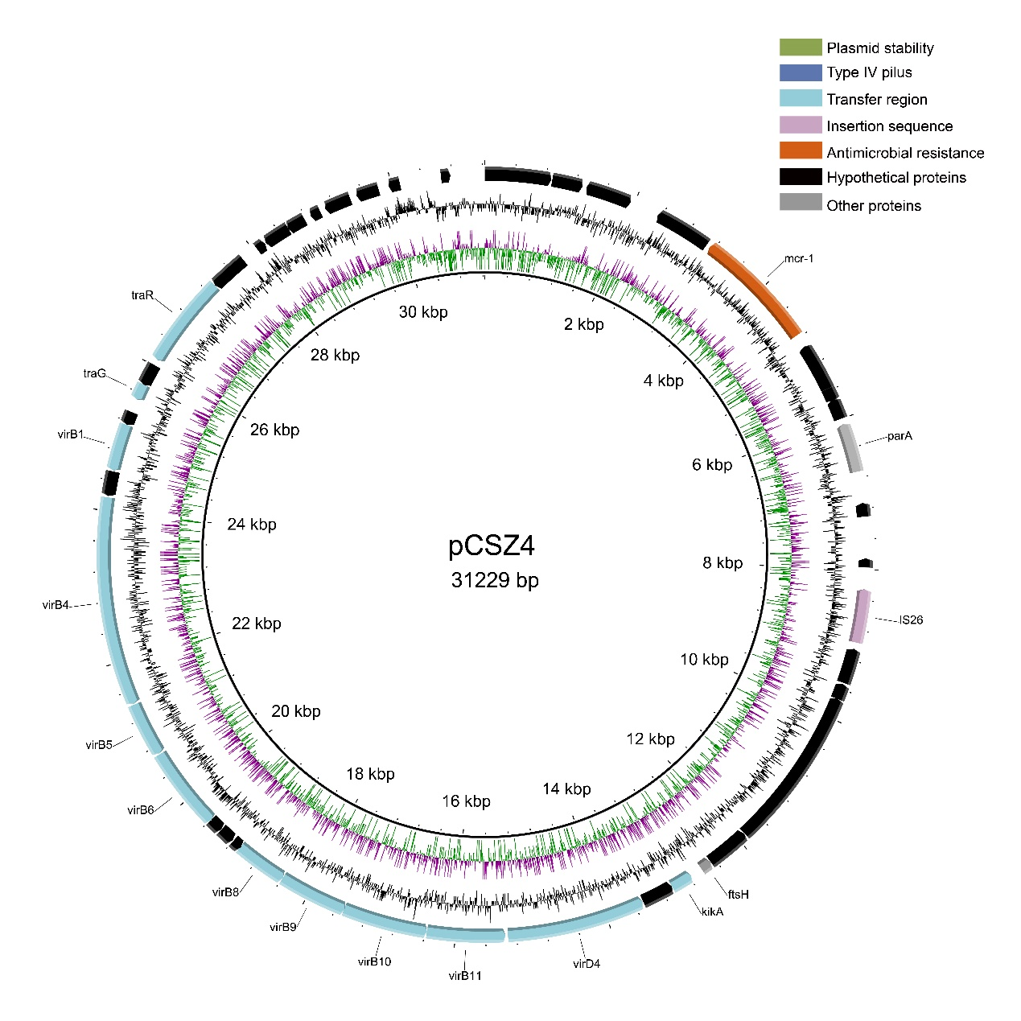
Fig S3. Characteristics of plasmid pCSZ4. Structure of the index plasmid pCSZ4. GC skew and GC content are indicated from the inside out. The positions and transcriptional directions of the predicted ORFs are denoted with arrows. Genes associated with plasmid stability，type IV pili，transfer region，insertion sequence，antimicrobial resistance, hypothetical proteins and other proteins are shown.

Table S1 Bacterial strains used in this study.
Strain | Description | Reference
E. coli WM3064 | RP4 (tra) in chromosome, DAP-, Ts 37°C | [1]
E. coli 1655 | F-, λ-, ilvG-, rfb-50, rph-1 | [2]
E. coli CSZ4 | Host of pCSZ4 plasmid with colistin resistance | [3]
K. pneumoniae 49210 | Host of p49210 plasmid with meropenem resistance | [4]
E. coli HZE22 | Host of pHZE22 plasmid with meropenem resistance | This study
K. pneumoniae 50700 | Host of p50700 plasmid with meropenem resistance | This study
S. Typhimurium LS3479 | Host of pLS3479 plasmid with colistin resistance | This study
S. Typhimurium 14E1050 | Host of p14E1050 plasmid with colistin resistance | This study
E. coli C600* | Derivative of E. coli C600, Sm, Rif^{R}, Cm^{R} | Lab stock
S. Typhimurium ATCC 14028* | Derivative of S. Typhimurium ATCC 14028, Rif^{R} | Lab stock
K. pneumoniae ATCC 700603* | Derivative of K. pneumoniae ATCC 700603, Rif^{R} | Lab stock
A. baylyi ADP1* | Derivative of A. baylyi ADP1, Rif^{R} | Lab stock
E. coli ATCC 25922 | Quality control strain for antibiotic susceptibility testing. | Lab stock
B. subtilis 163 | None | Lab stock
B. subtilis ATCC 6633 | None | Lab stock
E. faecalis ATCC 29212 | None | Lab stock
S. aureus ATCC 29213 | None | Lab stock
L. reuteri 03 | Isolated from C57BL/6 mice faeces | Lab stock
Abbreviations: Ts, thermosensitive; Cm^{R}, chloramphenicol resistance; Sm, streptomycin. Rif, rifampicin resistance; ATCC, American Type Culture Collection

Table S2, plasmids used in this study.
Plasmid | Description | Reference
pCSZ4 | Inc X4, mcr-1, 33kb, conjugative | This study
pHZE22 | Inc HI2, bla_{NDM-1}, conjugative | This study
p49210 | Inc L, bla_{OXA-48,} conjugative | [4]
p50700 | Inc F, bla_{KPC-1,} conjugative | This study
pLS3479 | Inc HI2, mcr-1, conjugative | This study
p14E1050 | Inc I2, mcr-1, bla_{CTX-1},62kb, conjugative | This study
pSV22-CTX | PCR template for P_{trc}-sfGFP | Lab stock
pKD4 | PCR template for kan | [5]
pJS01 | Suicide plasmid (R6K replication origin), contains oriTRP4 fragment, Tn6330 | [6]
pMQ | lacI^{q}, mCh, kan, amp, | This study
pCasKP-oriT | OriT-derivative of pCasKP-apr, pSC101 ori, P_{rpsl}-Cas9, γ, β, exo, apr^{R}, mobilizable | [7]
pSGKP-arr | sgRNA, sacB, arr-3 (Rif^{R}) | [4]
pSGKP-I2 | pSGKP-arr derivative with N20 fragment | This study
Abbreviations: mcr-1, mobilized colistin resistance gene. bla_{NDM-1,} class B metallo-β-lactamases gene. bla_{KPC-1,} carbapenem-hydrolyzing β-lactamase, bla_{OXA-48}, class D β-lactamases gene. mCh, red fluorescent protein gene mCherry. kan, kanamycin resistance gene; amp, ampicillin resistance gene; apr^{R}, apramycin resistance gene; Rif, rifampicin; Ts, thermosensitive. sfGFP, superfolder green fluorescent protein gene.

Table S3 Primers used in this study.
Primers | Sequence ( 5＇→ 3＇)ª | Reference
infu-mcr-N20F | GATGAGTATCGCTCTTGTCAGTTTTAGAGCTAGAAATAGCAAGTTAAAATAAGGC | This study
infu-mcr-N20R | TGACAAGAGCGATACTCATCACTAGTATTATACCTAGGACTGAGCTAGC | This study
mcr-1-N20F | GATGAGTATCGCTCTTGTCA | This study
pSG-testR | CTTGAGAATTGTTGGCGTTGT | This study
mcr-gfp-F1 | TCGAATTCCTGCAGCCCGGGGGATCCTGATCATGCTGCACCAAATGGG | This study
mcr-gfp-R1 | ACGGCATAACAAACCCCACC | This study
mcr-gfp-F2 | ACCCTTGAGCACAGTCAGATT | This study
mcr-gfp-R2 | TCCACCGCGGTGGCGGCCGCTCTAGACATCTTATAGCAGCCCATCGCC | This study
lacGFP-F | GGTGGGGTTTGTTATGCCGTCGCCGATGGAATTCTTGACA | This study
lacGFP-R | AATCTGACTGTGCTCAAGGGTCAGAAATCATCCTTAGCGAAAGCT | This study
CasKP-F | tctggttgttctcaagttcggt | This study
CasKP-R | gtcgctatgacttaacggagc | This study
SGKP-F | aatcgacgctcaagtcagag | This study
SGKP-R | ctaccaactctttttccgaagg | This study
MCR-BamhI | atcggGGATCCatgatgcagcatacttctgtgtg | This study
MCR-AgeI | ATCGGACCGGTacggcataacaaaccccacc | This study
JS01-BamhI | ATCGGGGATCCcaatcattgcgcaatcccat | This study
JS01-AgeI | ATCGGACCGGTccattcgtattatgggcggt | This study
MF | cgcggacaaagtcaaagacc | This study
OR | cagcgaccatcagatcaatctgac | This study
LG-LacIq-H1 | ATCACGAGGCCCTTTCGTCTTctagAAAGCTTGACACCATCGAATGGT | This study
LG-LacIq-H2 | tctgcctcgtgatacgcctaGGGTGCCTAATGAGTGAGCT | This study
LG-mCherry-H1 | taggcgtatcacgaggcaga | This study
LG-mCherry-H2 | CCCTTTCTCCTTGCTGATGTTGTctagATCGTCCATGCCGAGAGTGAT | This study
Kan-H1 | ATCACTCTCGGCATGGACGAGCTGTACAAGTAAAGCGGC | This study
Kan-H2 | CCTTGCTGATGTTGTctagAgaagcCTGCAGTCTAGAC | This study
MQA-H1 | tctagACAACATCAGCAAGGAGA | This study
MQA-H2 | TCGTCCATGCCGAGAGTGAT | This study
Kan-F | CGTTGTCACTGAAGCGGGAA | This study
Kan-R | AAGGCGATAGAAGGCGATGC | This study
N20KPC-F1 | aggctctgaaaatcatctatgttttagagctagaaatagc | This study
N20KPC-R1 | atagatgattttcagagcctactagtattatacctaggac | This study
KPC500GFP-UF | gcaagcttgatatcttgacagc | This study
KPC500GFP-UR | gatgattttcagagccttactgcc | This study
KPC500GFP-F | ggcagtaaggctctgaaaatcatcataggcgtatcacgaggcag | This study
KPC500-GFP-R | taatccatgccgcccgcaaggcttggtcatgactagtgcttg | This study
KPC500GFP-DF | ttctagaactagtggatccccccaaaggtcgccgatcaccac | This study
KPC500GFP-DR | cttgcgggcggcatggatta | This study
N20NDM-F1 | atcgcactagtcctaaatcgcgtcgatcaatgttttagagctagaaatagc | This study
N20NDM-R1 | attgatcgacgcgatttaggactagtattatacctaggac | This study
NDM500GFP-UF | ccgggggatccactacttctagatttgacatcgcgcgcagctg | This study
NDM500GFP-UR | ttaggccaagcgcaccgcaa | This study
NDM500GFP-F | ttgcggtgcgcttggcctaaccttagctttcgctaaggatgat | This study
NDM500GFP-R | tgcgctgaacgacgcctattattctcaccaataaaaaacgcccg | This study
NDM500GFP-DF | aataggcgtcgttcagcgca | This study
NDM500GFP-DR | accgcggtggcggccgctctagacgccgaggtgaaattcgcac | This study
N20OXA-F1 | atataagctgtaaagatatagttttagagctagaaatagc | This study
N20OXA-R1 | tatatctttacagcttatatactagtattatacctaggac | This study
OXA500GFP-UF | ccgggggatccactagttctagaatcaccgcgatgaaatattcagt | This study
OXA500GFP-UR | gacggctatttcacacaaatacgc | This study
OXA500GFP-F | gcgtatttgtgtgaaatagccgtcagctttcgctaaggatgatttctg | This study
OXA500GFP-R | gcatcgagcatcagcattttgtattctcaccaataaaaaacgcccg | This study
OXA500GFP-DF | acaaaatgctgatgctcgatgc | This study
OXA500GFP-DR | caccgcggtggcggccgctctagagggtcaatagcccgattatgg | This study
Target-KPC-F | gcaactgtaagttaccgcgc | This study
Target-KPC-R | agtttggtgtgccggatgac | This study
Target-NDM-F | tcaagatttgcgggatcagc | This study
Target-NDM-R | ctgaccgtgaagtaccaggg | This study
Target-OXA-F | cttgatcgccctcgatttgg | This study
Target-OXA-R | cgagcgtcaaccaattctgg | This study
ªUnderlining indicates restriction sites and N20 sequences.

Appendix 1
Plasmid pCasKP-oriT was constructed as follows: the mobile plasmid pCasKP-oriT consisted of the pCasKP-apr [7] and a RP4oriT fragment constructed in our laboratory using standard molecular cloning techniques [8].
Plasmid pSGKP-Tmcr-500GFP was constructed as follows: plasmid pSGKP-Tmcr-500GFP consisted of the backbone region from pSGKP-I2 with N20 fragment and sfGFP gene. The 20-nt base-pairing region (N20) targeting mcr-1 gene of a sgRNA was designed using the online resource https://eu.idtdna.com/site/order/designtool/index/ CRISPR_CUSTOM. Plasmid pSGKP-arr was chosen as the template. The sgRNA containing a 20-nt base-pairing region introduced in primers was amplified with inverse PCR using primers infu-mcr-N20F and infu-mcr-N20R generating plasmid pSGKP-I2. The recombinant plasmids were validated by PCR using primers mcr-1-N20F, pSG-testR and sequenced to confirm. pSGKP-I2 was digested with BamHI and XbaI as a backbone. The sfGFP fragment was amplified from pSV22-CTX with primers lacGFP-F, lacGFP-R. The homologous sequence H1 with a BamHI restriction site was amplified with primers mcr-gfp-F1, mcr-gfp-R1 and H2 with an XbaI restriction site was amplified with primers mcr-gfp-F2, mcr-gfp-R2, using the genome of strain S. Typhimurium 14E1050 as template. All 3 amplified segments were recombined with the digested pSGKP-I2 with NEBuilder HiFi DNA Assembly Cloning kit leading to the recombinant plasmid pSGKP-Tmcr-500GFP. The recombinant plasmids were validated by sequencing. All primers and plasmids were listed in (Table S3) and (Table S2), respectively.
Similarly, pSGKP-arr2-TNDM500GFP, pSGKP-arr2-TKPC500GFP, and pSGKP-arr2-TOXA500GFP were constructed as this method.
Plasmid pJS05 and pJS06 were constructed as follows: to generate the pJS05 plasmid, a mcr-1 segment was amplified from the CSZ4 with primers MCR-BamhI and MCR-BamhI and MCR-AgeI. The transposon backbone from the linearized pJS01 digested by PstI using primers JS01-BamhI and JS01-AgeI. These two fragments were digested by BamhI and AgeI at the same restriction sites, then ligated to form plasmid pJS05. The same process was used to generate the recombinant plasmid pJS06 but using the CSZ4-sfGFP as template. The recombinant plasmids were validated by sequencing with primers MF and OR at Tsingke, Beijing, China.
Plasmid pMQ was constructed as follows: Two synthetic cassettes containing the mCherry (mch) gene driven by the J23100 promoter and a lacI^{q} gene were first generated. pGEN-MCS were digested by Xbal to generate a backbone containing p15A origin of replication and ampR cassettes. The lacIq fragment was amplified from the template as mentioned above with primers LG-LacIq-H1 and LG-LacIq-H2. The mch fragment was amplified from the template as mentioned above with primers LG-mCherry-H1 and LG-mCherry-H2 and all 3 amplified segments, including the homologous sequences at the ends, were used in the plasmid assembly to generate pmCherry-lacIq-ampR. Then, the kan fragment was amplified from the linearized pKD4 digested by ApaLI with primers Kan-H1 and Kan-H2. Plasmid backbone was amplified from the pmCherry-lacIq-ampR with primers MQA-H1 and MQA-H2. These two amplified segments were used in the plasmid assembly to generate pMQ.
All plasmids were constructed by isothermal assembly with NEBuilder HiFi DNA assembly master mix (New England Biolabs, Beverly, MA, USA). Component parts were made by high-fidelity PCR with Green Taq Mix (Vazyme) or KOD FX Neo (TOYOBO) polymerase, using existing vectors or single colony as PCR templates. PCR products and digested products were purified with the MiniBEST DNA fragment purification kit (Takara, Dalian, China) and MiniBEST agarose gel DNA extraction kit (Takara) before isothermal assembly and transformation into Escherichia coli.

References
1. Dehio C, Meyer M. Maintenance of broad-host-range incompatibility group P and group Q plasmids and transposition of Tn5 in Bartonella henselae following conjugal plasmid transfer from Escherichia coli. Journal of bacteriology. 1997;179 2:538-40; doi: 10.1128/jb.179.2.538-540.1997.
2. Lopatkin AJ, Huang S, Smith RP, Srimani JK, Sysoeva TA, Bewick S, et al. Antibiotics as a selective driver for conjugation dynamics. Nature microbiology. 2016;1 6:16044; doi: 10.1038/nmicrobiol.2016.44.
3. Sun J, Fang LX, Wu Z, Deng H, Yang RS, Li XP, et al. Genetic Analysis of the IncX4 Plasmids: Implications for a Unique Pattern in the mcr-1 Acquisition. Scientific reports. 2017;7 1:424; doi: 10.1038/s41598-017-00095-x.
4. Hao M, He Y, Zhang H, Liao X, Liu Y, Sun J, et al. EnterobacteriaceaeCRISPR-Cas9-Mediated Carbapenemase Gene and Plasmid Curing in Carbapenem-Resistant. Antimicrobial agents and chemotherapy. 2020;64 9; doi: 10.1128/aac.00843-20.
5. Datsenko K, Wanner B. One-step inactivation of chromosomal genes in Escherichia coli K-12 using PCR products. Proceedings of the National Academy of Sciences of the United States of America. 2000;97 12:6640-5; doi: 10.1073/pnas.120163297.
6. He Y, Li X, Miao Y, Lin J, Sun R, Wang X, et al. Apl1The IS Dimer Circular Intermediate Participates in Transposition. Frontiers in microbiology. 2019;10:15; doi: 10.3389/fmicb.2019.00015.
7. Wang Y, Wang S, Chen W, Song L, Zhang Y, Shen Z, et al. CRISPR-Cas9 and CRISPR-Assisted Cytidine Deaminase Enable Precise and Efficient Genome Editing in Klebsiella pneumoniae. Applied and environmental microbiology. 2018;84 23; doi: 10.1128/aem.01834-18.
8. Sleight S, Bartley B, Lieviant J, Sauro H. In-Fusion BioBrick assembly and re-engineering. Nucleic acids research. 2010;38 8:2624-36; doi: 10.1093/nar/gkq179.

