Appendix

Figure 1. Flowchart for recruitment from the survey study to enrollment for the interview study

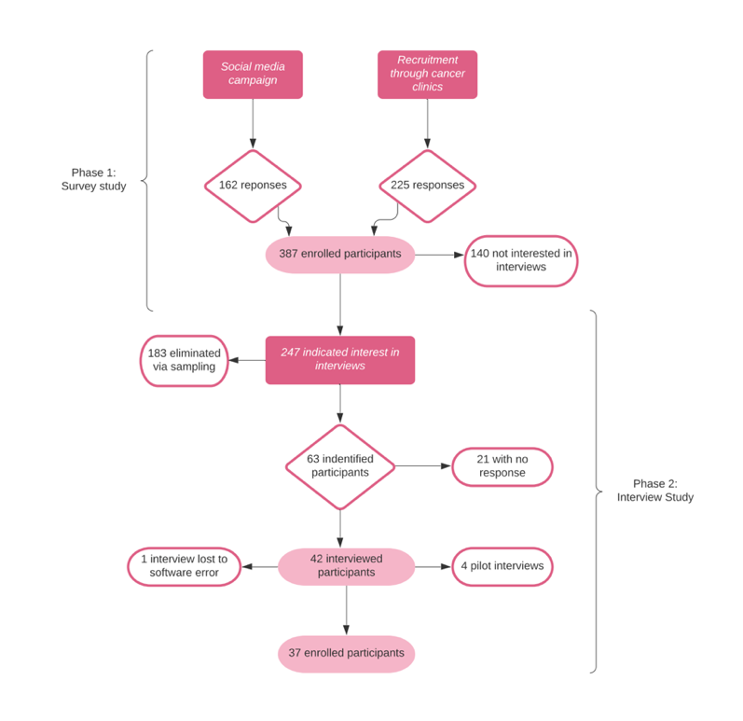

Table 1. Demographic and clinical strata for women invited and enrolled in the study
Strata | Sub-group | Invited (N=63)  N (%) | Enrolled (N=37)  N (%)
I. Age | 49 years or younger | 21 (33.3) | 16 (43.2)
 | 50 to 64 years of age | 20 (31.7) | 10 (27.0)
 | 65 years or older | 22 (34.9) | 11 (29.7)
II. Time since diagnosis | Diagnosed within 2020 | 21 (33.3) | 15 (40.5)
 | Diagnosed 1-2 years prior | 21 (33.3) | 11 (29.7)
 | Diagnosed 3-5 years prior | 21 (33.3) | 11 (29.7)
III. SES | High | 20 (31.7) | 13 (35.1)
 | Mid | 21 (33.3) | 11 (29.7)
 | Low | 22 (34.9) | 13 (35.1)
IV. Region | Urban | 36 (57.1) | 22 (59.5)
 | Rural | 27 (42.9) | 15 (40.5)
Figure 2. Concept map with main themes and subthemes

