Supplementary information

Variabilities and similarities of adult intestinal stem cells derived organoids related to the tissue site of different intestinal segments in pigs.

Soumya K. Kar¹, Marinus F.W. te Pas^{1*}, Roxann Rikkers¹, Ole Madsen², Nico Taverne³, Esther D. Ellen¹, Jerry M. Wells³, Dirkjan Schokker¹

1. Wageningen Livestock Research, Wageningen University and Research, Wageningen, The Netherlands; 2. Animal Breeding and Genomics, Wageningen University and Research, Wageningen, The Netherlands; 3. Host‑Microbe Interactomics, Wageningen University and Research, Wageningen, The Netherlands

Supplementary Materials and Methods
Animal material
All animal handling was done according to the Dutch laws on experimental handling. Animal material was derived from an earlier approved animal experiment (Animal Experimental Committee permission AVD401002015265, 2016.D-0062.027, and 2016.D-0062.040). A 19 day old boar was sacrificed. The intestine was removed, and four adjacent tissue samples were collected from the duodenum, ileum, and colon. Peyer’s Patches (PP) are easily recognized in the ileum and both PP and non-PP-associated tissue was collected for organoid cultures.

Crypt isolation from intestinal tissues and organoid culture
Intestinal samples were scraped to isolate the epithelial crypt cells that were plated in Matrigel (Corning, Corning NY, USA) coated culture dishes using DMEM culture medium supplemented with growth factors as previously described [1]. Stem cells developed into multi cell type 3D organoids. All intestinal organoids were split every 5 days when ~80% of the organoids were larger than 50 μm, and the splitting ratio was between 1:2 and 1:6. Organoids were first disrupted by mechanical shearing by repeated pipetting. If the organoids were not disrupted they were treated with TrypLE (Gibco) for 10 min at 37 ºC. Cultures were frozen after 10 days.

Tissues and Organoid characterization with histology and transcriptomics
Organoid cultures were characterized, compared to in vivo intestine tissue, and organoids from the same and different intestine sections, were compared using RNAseq and histology. Intestinal ileum tissue was fixed in 4% PFA and stained with hematoxylin and eosin (HE) or Crossmon staining [2]. Specific emphasis was put to PP recognition in Ileum samples.
Whole-genome transcriptome profiles were generated with RNAseq and the raw data will become available ENA upon acceptance of the paper. Trim Galore version 0.6.6 [3] with Cutadapt version 1.16 [4] with default settings except for length 35 (default 20) and stringency 6 (default 1), were used to trim low-quality data, remove poly A tails and remove Illumina sequencings adapters. Only paired-end reads where both reads were ≥ 35 bp were used. The trimmed reads were aligned against the pig reference genome and gene annotation (Ensembl Sus scrofa 11.1.103, [5] using STAR version 2.7.3a and default settings [6]. RSEM version 1.3.0 [7] with default settings except for strand specific protocol, which was set to 0 to derive all upstream reads from the reverse strand, was used to estimate expected counts and Transcripts per Million (TPM). In the downstream analysis a TPM threshold of ≥ 1 was used for the heatmap profiles and distance plots (R package limma version 3.40.6 [8]), Principal Component Analysis (PCA), dendrogram clustering (R package stats version 3.6.1 [9]) and heatmaps of the gene expression profiles (R package gplots version 3.0.3, [10] in RStudio version 3.6.1 [11].
To determine Differentially Expressed Genes (DEGs) the RSEM expected counts were used with DESeq2 version 1.24.0 [12] and a False Discovery Rate (FDR) < 0.05 according to the Benjamini-Hochberg (BH) correction [13]. Gene Ontology Biological Processes (GO:BP) and Kyoto Encyclopedia of Genes and Genomes (KEGG) enrichment analyses were determined using ClusterProfiler version 3.12.0 [14] and a FDR < 0.05 using the BH correction. For data handling and visualization, respectively R package dplyr version 0.8.5 [15] and ggplot2 version 3.3.1 [16] were used. For an overview and visualization see Figure S1.

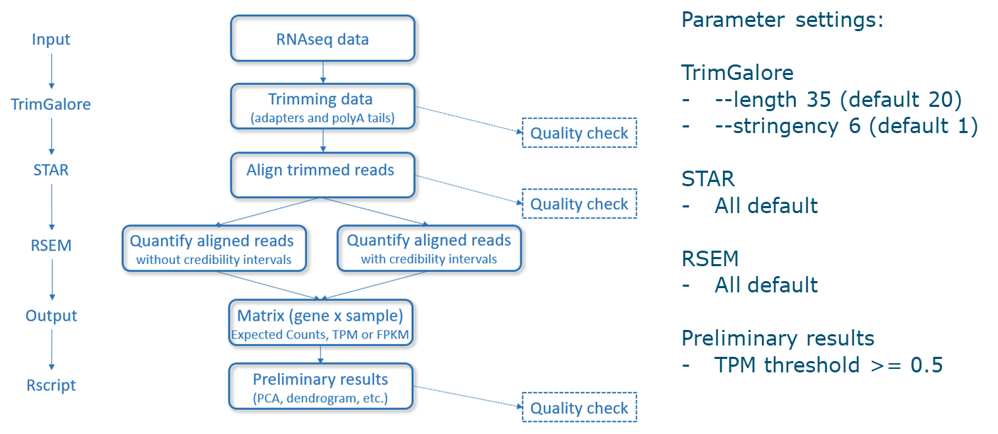
Supplementary Figure S1
Visualization of the RNAseq pipeline.

References
- Van der Hee B, Loonen LMP, Taverne N, Taverne-Thiele JJ, Smidt H, Wells JM (2018). Optimized procedures for generating an enhanced, near physiological 2D culture system from porcine intestinal organoids. Stem Cell Research, 28, 165-171.
- Crossmon G (1937). A modification of Mallory's connective tissue stain with a discussion of the principles involved. Anat Rec 69:33-38.
- Krueger F (2018). Trim Galore v0.6.6. Retrieved from https://www.bioinformatics.babraham.ac.uk/projects/trim_galore/
- Martin M (2011). Cutadapt removes adapter sequences from high-througput sequencing reads. EMBnet J 17:10-12.
- Howe KL, Achuthan P, Allen J, Allen J, Alvarez-Jarreta J, Amode MR, Armean IM, Azov AG, Bennett R, Bhai J, Billis K, Boddu S, Charkhchi M, Cummins C, Da Rin Fioretto L, Davidson C, Dodiya K, El Houdaigui B, Fatima R, Gall A, Giron CG, Grego T, Guijarro-Clarke C, Haggerty L, Hemrom A, Hourlier T, Izuogu OG, Juettemann T, Kaikala V, Kay M, Lavidas I, Le T, Lemos D, Martinez JG, Marugán JC, Maurel T, McMahon AC, Mohanan S, Moore B, Muffato M, Oheh DN, Paraschas D, Parker A, Parton A, Prosovetskaia I, Sakthivel MP, Abdul Salam AI, Schmitt BM, Schuilenburg H, Sheppard D, Steed E, Szpak M, Szuba M, Taylor K, Thormann A, Threadgold G, Walts B, Winterbottom A, Chakiachvili M, Chaubal A, De Silva N, Flint B, Frankish A, Hunt SE, IIsley GR, Langridge N, Loveland JE, Martin FJ, Mudge JM, Morales J, Perry E, Ruffier M, Tate J, Thybert D, Trevanion SJ, Cunningham F, Yates AD, Zerbino DR Flicek P (2021). Ensembl 2021. Nucl Acid Res 49:D884–D891.
- Dobin A, Davis CA, Schlesinger F, Drenkow J, Zaleski C, Jha S, Batut P, Chaisson M, Gingeras TR (2013). STAR: ultrafast universal RNA-seq aligner. Bioinform 29:15-21.
- Li B, Dewey CN (2011). RSEM: accurate transcript quantification from RNA-Seq data with or without a reference genome. BMC Bioinform 12:323. https://doi.org/10.1186/1471-2105-12-323
- Ritchie ME, Phipson B, Wu D, Hu Y, Law CW, Shi W, Smyth GK (2015). Limma powers differential expression analyses for RNA-sequencing and microarray studies. Nucl Acid Res 43(7):e47.
- R Core Team (2019). R: A language and environment for statistical computing. R Foundation for Statistical Computing, Vienna, Austria. URL https://www.R-project.org/.
- Warnes GR, Bolker B, Bonebakker L, Gentleman R, Huber W, Liaw A, Lumley T, Maechler M, Magnusson A, Moeller S, Schwartz M, Venables B (2020). gplots: Various R Programming Tools for Plotting Data. R package version 3.0.3. https://CRAN.R-project.org/package=gplots.
- R Studio Team (2016). RStudio: Integrated Development for R. RStudio, Inc., Boston, MA URL http://www.rstudio.com/.
- Love MI, Huber W, Anders S (2014). Moderated estimation of fold change and dispersion for RNA-seq data with DESeq2. Genome Biol 15(12):550
- Benjamini Y, Hochberg Y (1995). Controlling the false discovery rate: a practical and powerful approach to multiple testing. J R Stat Soc series B (Methodological) 57:289-300.
- Yu G, Wang L-G, Han Y, He Q-Y (2012). ClusterProfiler: an R package for comparing biological themes among gene clusters. OMICS J Integr Biol 16:284-287.
- Wickham H, François R, Henry L, Müller K (2020). dplyr: A Grammar of Data Manipulation. R package version 0.8.5. https://CRAN.R-project.org/package=dplyr.
- Wickham H (2016). ggplot2: Elegant Graphics for Data Analysis. Springer-Verlag New York.

Supplementary Figures Results

RNAseq data

A
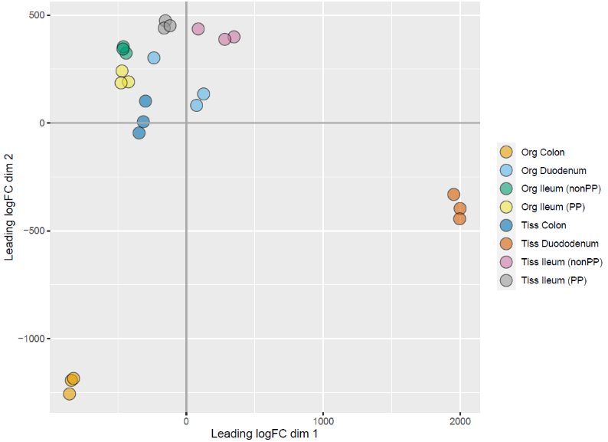

B
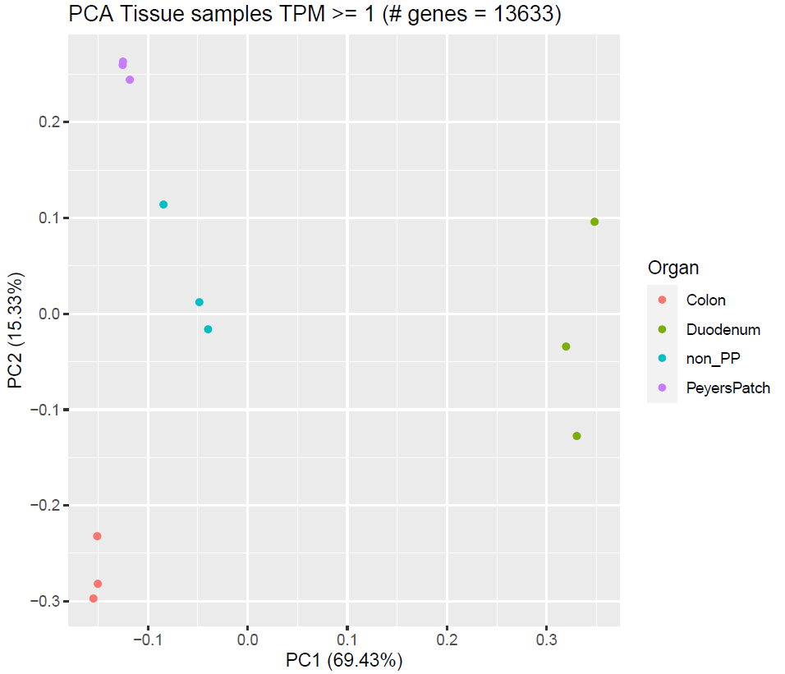

C
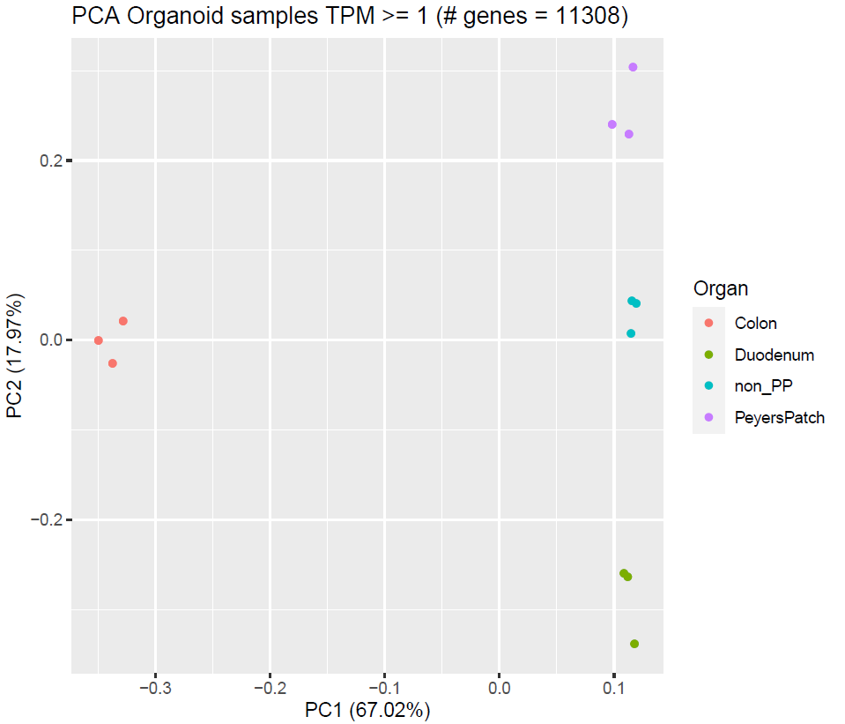

Supplementary Figure S2
Transcriptome profiling and clustering of the intestine segments and derived organoids. A. Organoids cluster: colon is grouped more distant from other organoids; intestine segments cluster: duodenum is grouped more distant from other tissues. B. Intestine segments clustering: duodenum is grouped more distant from other tissues, ileum with and without Peyer’s Patches (PP) are separated; C: organoids clustering: colon is grouped more distant from other intestine segments, ileum with and without PP are separated

A
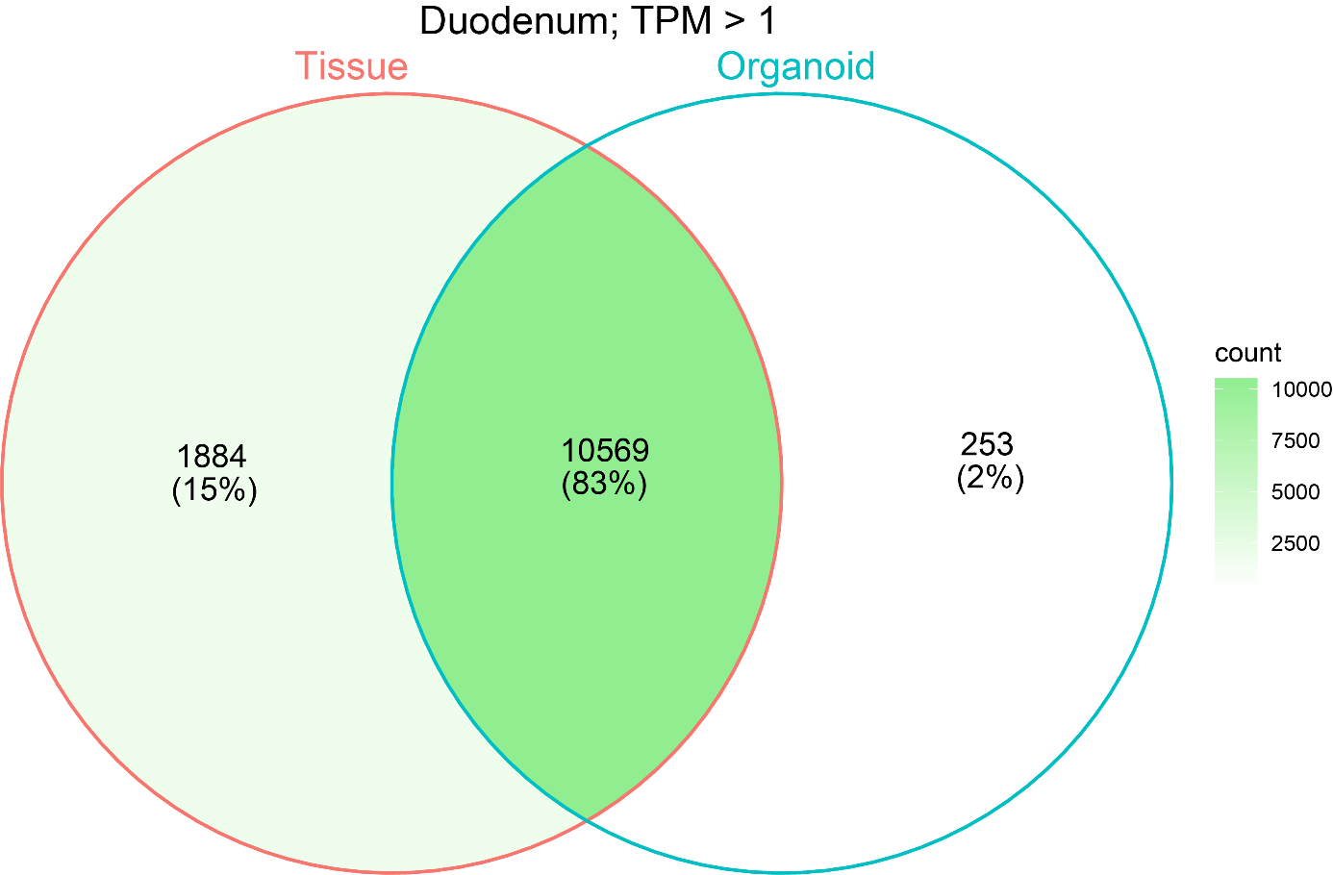

B
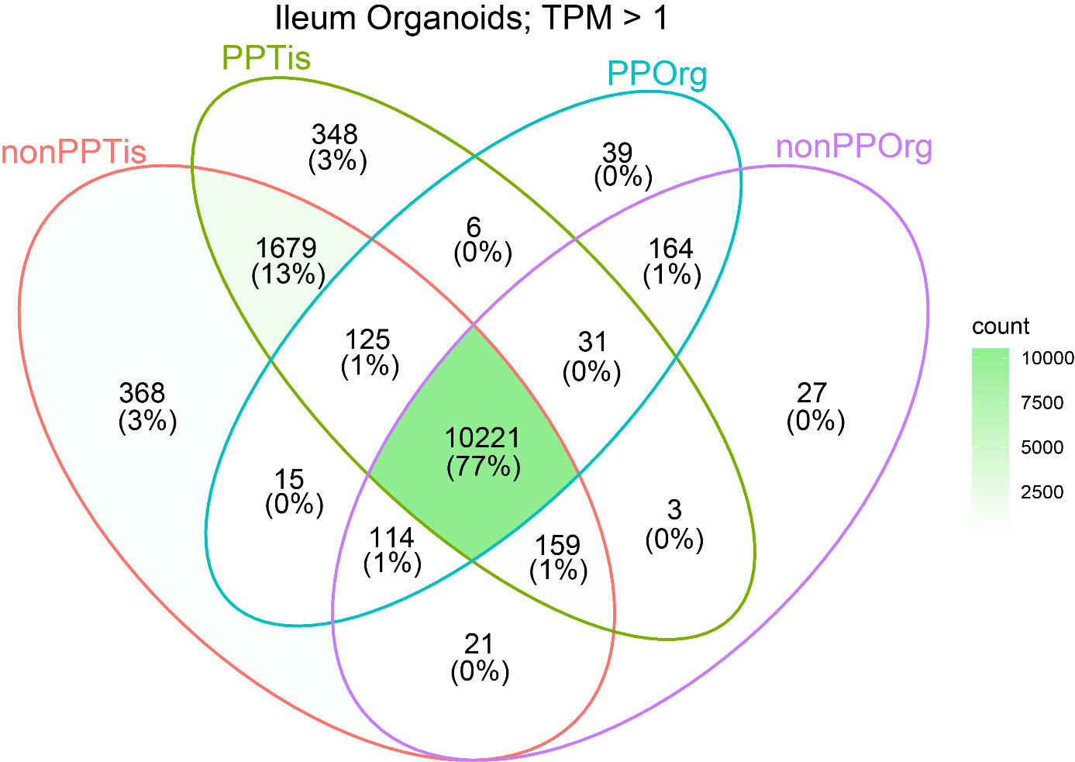

C
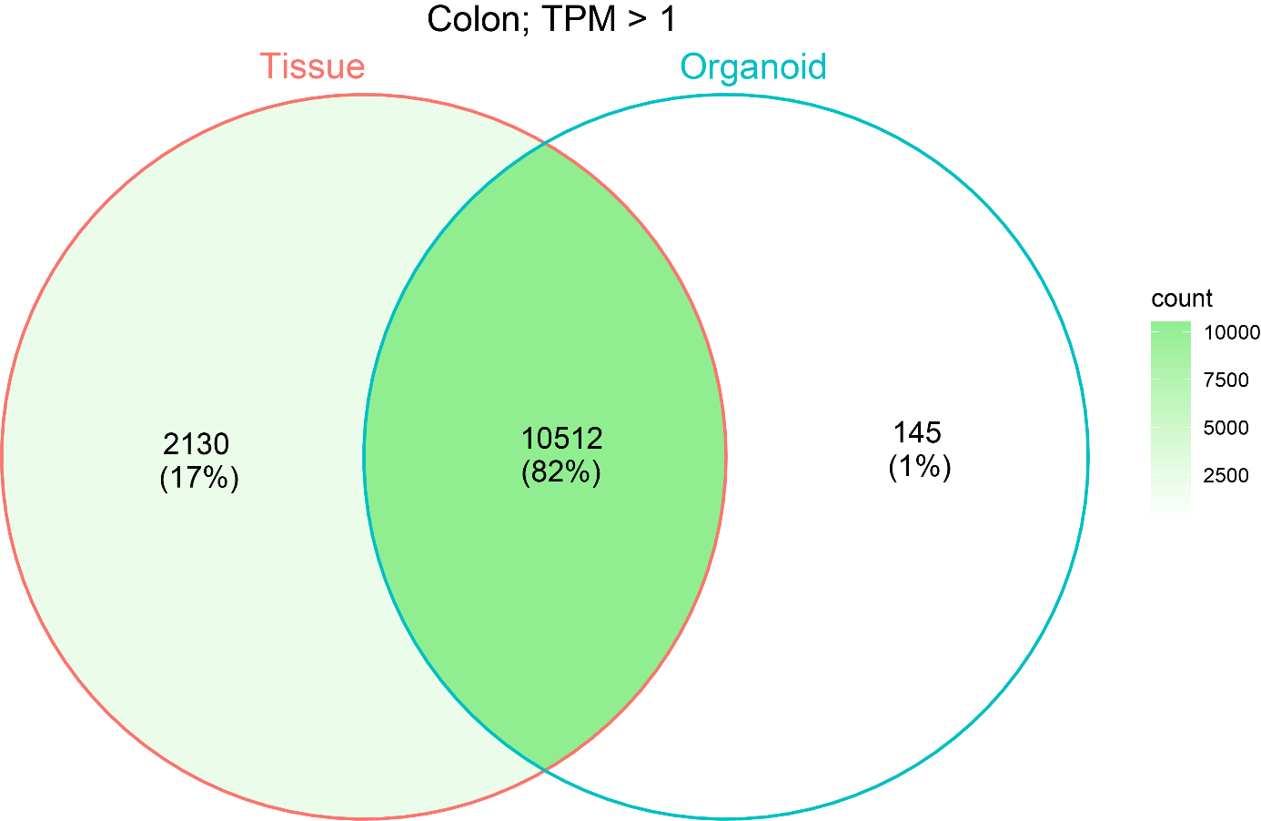

D
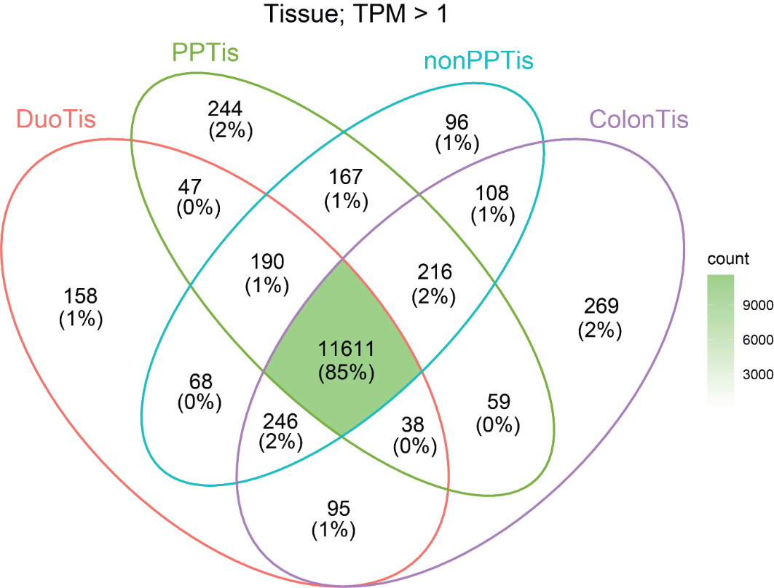

E
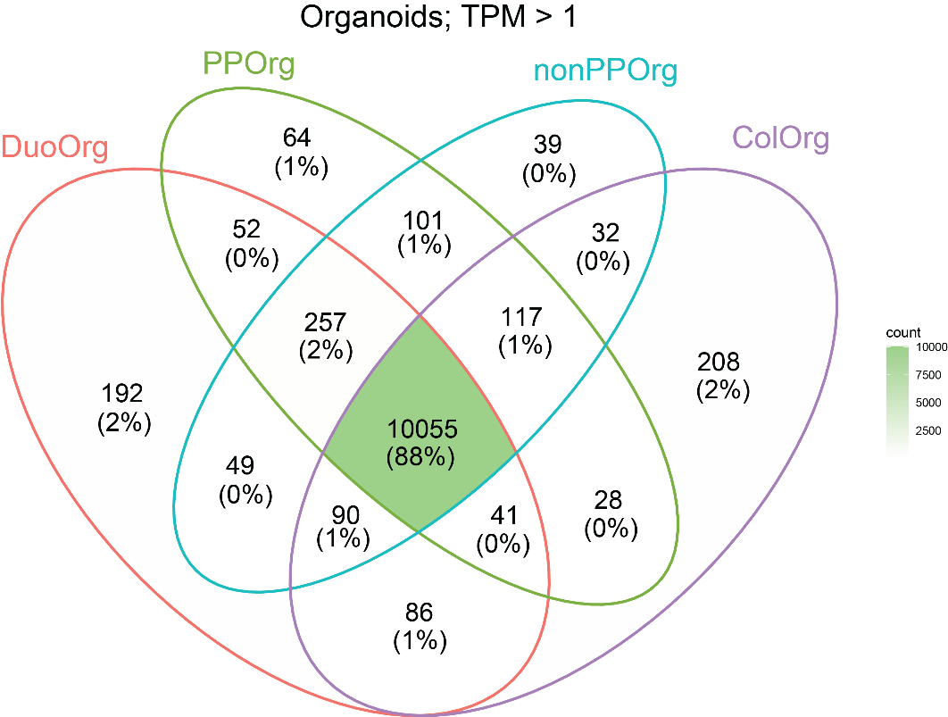

Supplementary Figure S3
Organoids and in vivo tissue transcriptome profiles share large parts of the transcriptome profiles. A: duodenum; B: ileum; C: colon; D: all intestine segments; E: all organoids.

Histological analysis
Histomorphometric analysis of the ileum tissue sections revealed asymmetry in the location of the Peyers Patches (PP) and the mucosal-associated lymphoid follicles (Figure S4). The lymphoid tissue was located only on one side and visually apparent as white patches on the outside of the intestine. In areas containing PP immune cells were close to the follicular-associated epithelium and greater number of immune cells were present in the lamina propria compared to the Non-PP ileal mucosa.

Figure S4.
Ileum from an adult pig. Ileum with Peyers Patches and the epithelial layer above. Above the small PP like domes there is a single cell epithelial layer. Note the lymphoid cells to the basal side of the epithelium. Magnification: 10x.

Supplementary Table S1
RNAseq data of the in vivo intestine segments and derived organoids. For each intestine segment and each organoid site three independent replicates were sequenced.

Type¹ | Intestine segment² | Replicate | Raw reads | Trimmed reads | Uniquely mapped reads | % Uniquely mapped reads
Org | Colon | 1 | 31,714,381 | 31,533,037 | 30,325,264 | 96.17
Org | Colon | 2 | 32,152,612 | 31,968,860 | 30,691,600 | 96.00
Org | Colon | 3 | 32,206,851 | 32,023,915 | 30,719,448 | 95.93
Org | Duodenum | 2 | 32,512,457 | 32,322,568 | 31,213,528 | 96.57
Org | Duodenum | 3 | 31,554,034 | 31,374,898 | 30,116,407 | 95.99
Org | Duodenum | 4 | 31,392,475 | 31,195,789 | 29,914,739 | 95.89
Org | non_PP | 1 | 32,582,814 | 32,372,380 | 31,220,468 | 96.44
Org | non_PP | 3 | 31,669,021 | 31,477,369 | 30,465,928 | 96.79
Org | non_PP | 4 | 33,314,807 | 33,114,369 | 32,085,627 | 96.89
Org | PP | 2 | 32,233,661 | 32,043,423 | 31,031,362 | 96.84
Org | PP | 3 | 32,044,717 | 31,855,144 | 30,744,931 | 96.51
Org | PP | 4 | 32,059,903 | 31,875,090 | 30,809,448 | 96.66
Tis | Colon | 1 | 32,642,040 | 32,369,185 | 30,974,094 | 95.69
Tis | Colon | 2 | 32,019,705 | 31,750,150 | 30,374,240 | 95.67
Tis | Colon | 3 | 31,904,456 | 31,649,360 | 30,313,945 | 95.78
Tis | Duodenum | 2 | 33,081,572 | 32,825,365 | 31,185,179 | 95.00
Tis | Duodenum | 3 | 32,358,845 | 32,111,419 | 30,504,276 | 95.00
Tis | Duodenum | 4 | 33,339,382 | 33,062,548 | 31,363,681 | 94.86
Tis | non_PP | 1 | 31,817,314 | 31,522,870 | 30,130,298 | 95.58
Tis | non_PP | 3 | 31,286,185 | 30,990,652 | 29,618,055 | 95.57
Tis | non_PP | 4 | 33,403,714 | 33,103,480 | 31,757,602 | 95.93
Tis | PP | 2 | 33,095,632 | 32,778,660 | 31,451,696 | 95.95
Tis | PP | 3 | 31,427,506 | 31,137,830 | 29,880,499 | 95.96
Tis | PP | 4 | 32,407,774 | 32,114,062 | 30,792,923 | 95.89
1: Org = organoids, Tis = Tissue (in vivo); 2: PP = Peyer’s Patches from the ileum intestine segment

General overview of the RNAseq data:
Mean ± SD for all samples (organoid and tissue together)
Raw input reads 32,259,200 ± 623,344
Removed basepairs <cutoff 235,393 ± 47,912
Number of input reads 32,023,900 ± 612,736
Uniquely mapped reads number 30,736,900 ± 598,679
Uniquely mapped reads % 95.98 ± 0.55

Total number of genes 31,908
Number of expressed genes (TPM > 0) 15,034
Number of expressed genes (TPM >= 1) 13,113

Supplementary Table S2
Genes expected to be specific/indicative for an intestinal location of the expression and RNAseq expression information. We obtained tissue-specific expressed genes from the Gene atlas expression database (https://www.ebi.ac.uk/gxa/home) and the Tissue-specific Gene Expression and Regulation (TiGER) database (http://bioinfo.wilmer.jhu.edu/tiger/) because they show large differences in expression or differential expression in the PP and nonPP ileum. Org = organoid; Tiss = tissue; PP = Peyers Patches; Duod = duodenum.

Gene name | location | Mean TPM_OrgColon | Mean TPM_OrgDuod | Mean TPM_Org non_PP | meanTPM_OrgPP | Mean TPM_TissColon | Mean TPM_TissDuod | Mean TPM_Tissnon_PP | Mean TPM_TissPP
SLC39A4 | duodenum | 115.490 | 221.030 | 164.320 | 232.553 | 102.657 | 317.000 | 156.197 | 52.693
SLC5A4 | duodenum | 0.520 | 13.790 | 1.693 | 2.933 | 1.017 | 59.703 | 9.887 | 6.867
SLC25A1 | duodenum | 158.727 | 172.743 | 128.313 | 130.463 | 81.523 | 149.620 | 114.037 | 58.367
SLC37A4 | duodenum | 28.960 | 33.247 | 24.067 | 27.377 | 37.427 | 63.407 | 53.577 | 22.113
SLC25A4 | duodenum | 39.467 | 66.663 | 42.137 | 39.003 | 36.383 | 115.570 | 148.430 | 66.730
SLC13A2 | duodenum | 2.353 | 35.473 | 2.977 | 3.310 | 5.797 | 227.560 | 78.463 | 28.523
LECT2 | duodenum | 0.000 | 0.030 | 0.000 | 0.000 | 0.000 | 7.227 | 0.217 | 0.000
SLC44A4 | colon | 328.950 | 288.947 | 216.750 | 338.600 | 586.253 | 397.187 | 371.500 | 149.057
GPA33 | colon | 330.573 | 220.937 | 214.847 | 244.400 | 259.747 | 190.740 | 177.870 | 54.990
NR1I3 | colon | 0.290 | 5.010 | 0.423 | 0.353 | 0.550 | 38.947 | 8.490 | 2.580
NOX1 | colon | 0.570 | 0.013 | 0.067 | 0.127 | 26.797 | 0.077 | 0.893 | 1.040
LYZ | jejunum_ileum | 0.000 | 0.000 | 0.000 | 0.000 | 0.000 | 0.000 | 0.000 | 0.000
SLC5A1 | jejunum_ileum | 23.980 | 133.990 | 46.700 | 188.920 | 42.443 | 300.327 | 211.827 | 158.843
DPP4 | jejunum_ileum | 8.883 | 64.390 | 40.907 | 52.463 | 37.943 | 267.747 | 287.043 | 114.973
VIL1 | jejunum_ileum | 323.867 | 575.247 | 745.953 | 1186.530 | 204.247 | 482.343 | 715.867 | 259.457
FABP2 | jejunum_ileum | 0.000 | 116.577 | 6.240 | 12.540 | 1.033 | 336.780 | 427.233 | 202.170
REG4 | jejunum_ileum | 960.363 | 884.163 | 6555.177 | 7714.497 | 597.313 | 300.020 | 134.550 | 61.910
KLK1 | Ileum PP | 0.000 | 0.000 | 0.000 | 0.000 | 0.217 | 0.050 | 1.243 | 4.400
BAIAP2L2 | colon | 81.490 | 92.210 | 172.243 | 230.590 | 99.963 | 93.647 | 279.897 | 85.570
MYO1A | colon | 72.457 | 188.933 | 187.533 | 342.513 | 151.053 | 305.107 | 293.673 | 145.520
PKP2 | colon | 99.503 | 111.910 | 109.110 | 113.047 | 43.520 | 25.830 | 20.787 | 16.247
A2ML1 | colon | 0.577 | 0.073 | 0.293 | 0.107 | 1.840 | 0.083 | 0.047 | 0.023
APOBEC1 | colon | 24.753 | 95.283 | 82.477 | 145.750 | 19.760 | 107.143 | 16.123 | 16.377
PLEKHG6 | colon | 37.297 | 31.383 | 37.203 | 71.673 | 58.260 | 34.667 | 69.030 | 17.913
GMDS | colon | 320.187 | 186.090 | 268.413 | 336.860 | 381.467 | 162.253 | 127.450 | 52.770
TRIM15 | colon | 18.607 | 18.400 | 22.953 | 35.683 | 57.200 | 38.063 | 73.243 | 24.293
GPX2 | colon | 1798.243 | 157.813 | 1178.213 | 805.867 | 3367.510 | 45.083 | 159.977 | 89.167
PSEN1 | colon | 206.077 | 110.607 | 137.027 | 186.347 | 117.947 | 76.623 | 97.670 | 58.573
FOXA3 | colon | 4.717 | 8.320 | 13.603 | 20.493 | 18.477 | 13.773 | 4.383 | 2.173
TSPAN1 | colon | 2140.690 | 710.513 | 1010.243 | 1708.037 | 3195.127 | 146.100 | 78.053 | 84.027
GCNT3 | colon | 64.237 | 289.293 | 226.333 | 434.043 | 59.647 | 158.740 | 30.273 | 31.177
DUOX2 | colon | 1.907 | 83.623 | 53.320 | 105.613 | 133.653 | 4.310 | 1.797 | 4.770
BMP4 | colon | 3.547 | 5.710 | 5.223 | 7.890 | 17.960 | 9.210 | 11.530 | 12.037
ANXA13 | colon | 38.290 | 811.660 | 531.090 | 729.743 | 50.383 | 105.823 | 87.103 | 42.243
CDH17 | colon | 1320.657 | 480.237 | 841.063 | 971.133 | 493.357 | 286.717 | 586.303 | 179.167
XKR9 | colon | 0.820 | 2.490 | 3.570 | 5.777 | 1.300 | 10.040 | 34.697 | 9.043
GPA33 | colon | 330.573 | 220.937 | 214.847 | 244.400 | 259.747 | 190.740 | 177.870 | 54.990
SLC44A3 | colon | 15.190 | 9.917 | 8.323 | 7.953 | 18.927 | 12.110 | 10.927 | 3.657
CLCA4 | colon | 6.447 | 158.527 | 144.490 | 335.870 | 55.327 | 631.840 | 1138.910 | 324.143
CLCA1 | colon | 294.583 | 60.530 | 835.050 | 1718.303 | 810.620 | 167.460 | 182.227 | 101.880
R3HDML | colon | 0.027 | 0.013 | 0.027 | 0.040 | 0.047 | 0.060 | 0.050 | 0.067
HNF4A | colon | 309.463 | 225.723 | 209.853 | 265.873 | 163.030 | 78.313 | 104.493 | 36.833
MLXIPL | colon | 2.993 | 5.603 | 3.557 | 5.003 | 2.200 | 14.483 | 18.270 | 4.240
TMC5 | colon | 13.140 | 101.003 | 46.243 | 91.010 | 34.563 | 136.707 | 103.843 | 40.787
PROM2 | colon | 13.710 | 267.893 | 135.627 | 155.027 | 0.273 | 0.307 | 0.090 | 0.000
EDAR | colon | 1.037 | 1.017 | 0.343 | 0.753 | 3.017 | 1.463 | 1.440 | 0.867
SLC9A2 | colon | 47.053 | 88.123 | 60.903 | 92.223 | 43.267 | 94.633 | 32.713 | 16.023
ARHGAP25 | colon | 0.017 | 0.020 | 0.020 | 0.030 | 5.890 | 8.417 | 18.993 | 76.990
CORIN | colon | 0.060 | 0.000 | 0.000 | 0.000 | 3.073 | 0.027 | 0.093 | 0.043
CDX2 | colon | 153.360 | 137.997 | 355.070 | 415.243 | 216.083 | 154.633 | 326.080 | 108.943
FREM2 | colon | 0.067 | 0.120 | 0.080 | 0.077 | 0.340 | 0.400 | 0.273 | 0.280
OLFM4 | colon | 8.420 | 147.513 | 23.110 | 10.530 | 2515.853 | 814.247 | 505.817 | 113.863
SLC5A1 | colon | 23.980 | 133.990 | 46.700 | 188.920 | 42.443 | 300.327 | 211.827 | 158.843
HKDC1 | colon | 2.017 | 91.873 | 37.503 | 49.013 | 2.610 | 75.287 | 59.540 | 21.240
KCNH8 | colon | 0.000 | 0.000 | 0.000 | 0.000 | 0.167 | 0.203 | 0.097 | 0.110
LIPH | colon | 93.350 | 124.863 | 101.640 | 144.943 | 31.873 | 34.193 | 39.840 | 15.570
SENP5 | colon | 11.233 | 5.040 | 4.477 | 4.420 | 12.527 | 7.707 | 11.210 | 20.553
MUC13 | colon | 46.210 | 188.770 | 177.240 | 298.073 | 50.397 | 364.110 | 425.737 | 166.053
FANCB | colon | 0.940 | 1.103 | 1.727 | 0.567 | 1.173 | 0.807 | 1.493 | 5.313
HEPH | colon | 99.723 | 191.487 | 221.037 | 259.577 | 56.017 | 96.587 | 78.617 | 29.560
POF1B | colon | 26.927 | 67.557 | 73.843 | 109.713 | 36.690 | 29.673 | 51.500 | 21.663
SLC22A18 | colon | 175.563 | 196.820 | 178.167 | 271.463 | 60.950 | 128.383 | 43.447 | 12.563
LRP4 | colon | 0.070 | 4.880 | 0.457 | 1.120 | 10.950 | 59.190 | 13.800 | 4.930
USH1C | colon | 76.007 | 77.637 | 106.037 | 130.313 | 108.430 | 148.353 | 170.143 | 51.707
B3GNT3 | colon | 231.917 | 47.347 | 90.563 | 94.613 | 129.893 | 8.087 | 4.957 | 8.370
SLC12A2 | colon | 38.043 | 34.190 | 100.700 | 57.330 | 119.460 | 67.627 | 50.303 | 23.890
CDX1 | colon | 53.423 | 47.133 | 62.963 | 56.377 | 34.710 | 7.327 | 10.290 | 3.643
TMPRSS4 | colon | 136.257 | 14.040 | 26.313 | 44.393 | 79.257 | 1.863 | 1.760 | 0.793
TMEM45B | colon | 223.533 | 293.283 | 371.513 | 450.020 | 130.907 | 216.653 | 300.193 | 75.683
ST14 | colon | 516.697 | 262.023 | 369.193 | 508.740 | 331.277 | 133.770 | 199.327 | 77.733
PIGR | colon | 23.440 | 48.200 | 0.877 | 2.147 | 148.477 | 833.793 | 21.463 | 20.407
MYO7B | colon | 156.500 | 120.313 | 106.360 | 138.160 | 201.003 | 122.420 | 183.023 | 65.070
VIL1 | colon | 323.867 | 575.247 | 745.953 | 1186.530 | 204.247 | 482.343 | 715.867 | 259.457
IHH | colon | 182.943 | 32.083 | 32.343 | 76.443 | 93.817 | 32.550 | 48.373 | 21.717
CFTR | colon | 20.790 | 14.220 | 18.323 | 16.403 | 34.720 | 64.193 | 60.620 | 19.540
EVX1 | colon | 1.180 | 0.000 | 0.000 | 0.000 | 1.197 | 0.000 | 0.000 | 0.000
AXIN2 | colon | 5.223 | 3.073 | 5.843 | 5.917 | 12.267 | 12.480 | 28.327 | 7.950
KRT20 | colon | 964.810 | 1761.797 | 2766.043 | 3578.103 | 461.373 | 1000.170 | 404.500 | 263.613
HOXB8 | colon | 9.953 | 0.000 | 16.387 | 13.207 | 2.097 | 0.187 | 5.493 | 3.297
HOXB6 | colon | 57.330 | 0.117 | 46.440 | 34.763 | 140.910 | 1.700 | 172.287 | 56.507
ADAMTS13 | colon | 0.070 | 0.143 | 0.007 | 0.063 | 0.837 | 1.997 | 1.197 | 1.797
DAPK2 | colon | 0.583 | 1.080 | 0.153 | 0.293 | 1.767 | 4.997 | 3.307 | 2.133
SATB2 | colon | 85.807 | 0.130 | 13.743 | 16.447 | 70.513 | 0.097 | 20.487 | 7.973
SLC26A3 | colon | 447.947 | 89.780 | 73.573 | 169.437 | 200.433 | 8.173 | 157.630 | 56.017
DPEP1 | colon | 6.027 | 3.050 | 18.280 | 53.693 | 196.507 | 43.280 | 1827.820 | 426.897
LGALS4 | colon | 173.623 | 160.967 | 187.433 | 228.323 | 172.787 | 118.887 | 76.540 | 34.667
TMPRSS3 | colon | 0.063 | 0.293 | 0.080 | 0.043 | 0.870 | 0.740 | 0.043 | 0.020
RAB20 | colon | 8.113 | 8.217 | 3.453 | 4.377 | 13.313 | 14.740 | 39.943 | 14.250
TFF3 | colon | 335.200 | 533.410 | 2077.503 | 4903.343 | 1057.287 | 1452.040 | 609.570 | 268.633
GRM8 | colon | 0.183 | 0.000 | 0.000 | 0.000 | 0.277 | 0.043 | 0.027 | 0.197
IL1RL2 | colon | 0.000 | 0.000 | 0.000 | 0.000 | 0.427 | 0.030 | 0.043 | 0.040
MT1A | colon | 2.967 | 68.383 | 11.710 | 32.963 | 92.497 | 214.033 | 86.427 | 39.140
SGK2 | colon | 32.443 | 31.127 | 5.760 | 8.297 | 76.700 | 86.800 | 8.723 | 2.133
PTPRH | colon | 56.807 | 117.007 | 99.277 | 172.160 | 80.107 | 128.033 | 97.443 | 45.800
ETV3 | colon | 27.427 | 37.127 | 34.453 | 56.070 | 24.480 | 33.143 | 25.347 | 23.740
TMEM54 | colon | 635.543 | 319.390 | 448.117 | 573.540 | 879.243 | 210.750 | 126.580 | 73.153
EPHB3 | colon | 4.100 | 3.060 | 4.370 | 4.783 | 9.160 | 8.597 | 4.493 | 7.647
SIM2 | colon | 0.067 | 0.000 | 0.000 | 0.000 | 0.037 | 0.013 | 0.013 | 0.027
MYH14 | colon | 234.600 | 194.997 | 164.977 | 237.867 | 398.303 | 149.483 | 195.007 | 67.587
MST1R | colon | 244.363 | 90.663 | 100.587 | 114.010 | 91.893 | 45.727 | 42.347 | 16.277
POU2F3 | colon | 0.543 | 0.123 | 0.437 | 0.927 | 5.177 | 1.260 | 6.057 | 14.067
SLC6A20 | colon | 15.367 | 25.047 | 19.320 | 30.953 | 33.133 | 10.463 | 23.480 | 15.017
DNMT3A | colon | 7.467 | 7.330 | 7.713 | 7.807 | 14.880 | 13.250 | 17.357 | 10.293
REN | colon | 0.000 | 0.000 | 0.000 | 0.000 | 0.030 | 0.000 | 0.030 | 0.030
AQP8 | colon | 3.840 | 3.697 | 2.030 | 11.957 | 19.733 | 71.207 | 29.757 | 13.640
SLC17A4 | colon | 0.000 | 0.000 | 0.000 | 0.000 | 0.000 | 0.000 | 0.000 | 0.000
RSPO1 | colon | 0.000 | 0.380 | 3.117 | 4.603 | 0.440 | 0.460 | 0.840 | 0.337
CYP2S1 | colon | 11.320 | 137.610 | 7.510 | 10.627 | 9.710 | 11.610 | 5.713 | 3.460
ASCL2 | colon | 0.350 | 2.463 | 1.420 | 0.427 | 26.417 | 10.450 | 7.973 | 3.367
COL8A2 | colon | 0.027 | 0.020 | 0.013 | 0.020 | 1.540 | 0.177 | 0.620 | 0.163
RNF186 | colon | 0.970 | 1.430 | 1.813 | 2.907 | 3.980 | 15.860 | 2.703 | 1.347
CLDN3 | colon | 267.270 | 134.713 | 203.980 | 453.757 | 423.353 | 149.483 | 77.343 | 58.010
OVOL2 | colon | 2.680 | 4.847 | 2.113 | 2.787 | 7.947 | 5.943 | 5.773 | 1.487
TMEM92 | colon | 39.177 | 33.837 | 45.267 | 73.047 | 32.633 | 36.517 | 59.653 | 21.373
CLDN2 | colon | 20.600 | 115.657 | 109.057 | 190.540 | 68.973 | 374.403 | 250.560 | 67.500
TRIM7 | colon | 3.060 | 5.830 | 4.050 | 4.317 | 2.430 | 2.593 | 3.730 | 1.423
IL22RA1 | colon | 26.663 | 32.013 | 25.007 | 38.023 | 23.360 | 44.537 | 88.057 | 23.153
HOXB9 | colon | 22.570 | 0.013 | 20.780 | 21.110 | 31.843 | 0.223 | 14.637 | 5.310
KCNQ1 | colon | 270.280 | 249.360 | 204.890 | 254.207 | 154.807 | 146.417 | 30.990 | 12.487
GPR35 | colon | 33.597 | 24.077 | 18.500 | 26.633 | 30.080 | 23.297 | 20.290 | 15.567
REG4 | colon | 960.363 | 884.163 | 6555.177 | 7714.497 | 597.313 | 300.020 | 134.550 | 61.910
NELL2 | ileum | 0.010 | 0.010 | 0.010 | 0.000 | 1.167 | 1.360 | 1.603 | 3.173
FURIN | ileum | 68.700 | 60.087 | 55.263 | 74.187 | 87.457 | 104.980 | 73.440 | 50.853
C15orf39 | ileum | 2.003 | 4.073 | 6.243 | 6.983 | 4.190 | 6.157 | 3.937 | 5.293
IPO4 | ileum | 42.847 | 40.760 | 45.287 | 40.287 | 46.123 | 33.890 | 34.627 | 30.753
CLPTM1 | ileum | 72.703 | 96.977 | 88.570 | 103.843 | 67.417 | 110.113 | 128.907 | 65.010
MEP1B | ileum | 1.330 | 7.140 | 15.123 | 33.580 | 11.063 | 144.747 | 981.777 | 286.040
EPHA7 | ileum | 0.010 | 0.000 | 0.000 | 0.003 | 1.460 | 1.177 | 2.277 | 1.537
TPBG | ileum | 6.927 | 2.997 | 2.300 | 2.473 | 3.237 | 1.677 | 2.477 | 6.687
BMP4 | ileum | 3.547 | 5.710 | 5.223 | 7.890 | 17.960 | 9.210 | 11.530 | 12.037
OSR2 | ileum | 0.097 | 0.287 | 59.093 | 86.953 | 0.143 | 0.920 | 33.873 | 16.067
CDH17 | ileum | 1320.657 | 480.237 | 841.063 | 971.133 | 493.357 | 286.717 | 586.303 | 179.167
SLC39A1 | ileum | 40.377 | 36.527 | 36.290 | 43.143 | 58.200 | 49.747 | 48.310 | 35.703
SYPL2 | ileum | 0.773 | 0.423 | 0.540 | 0.367 | 0.477 | 0.957 | 0.690 | 1.080
CLCA1 | ileum | 294.583 | 60.530 | 835.050 | 1718.303 | 810.620 | 167.460 | 182.227 | 101.880
CLCN7 | ileum | 12.377 | 10.747 | 10.767 | 13.270 | 23.777 | 20.317 | 52.497 | 27.337
ABCA3 | ileum | 15.130 | 5.263 | 9.090 | 14.093 | 16.843 | 5.470 | 12.140 | 22.890
ZNF512 | ileum | 1.263 | 0.937 | 0.700 | 0.637 | 6.957 | 7.413 | 9.987 | 15.283
APOB | ileum | 0.900 | 50.757 | 20.733 | 48.513 | 0.520 | 348.123 | 440.283 | 75.923
SLIT2 | ileum | 0.010 | 0.033 | 0.033 | 0.027 | 0.987 | 0.497 | 0.777 | 0.440
EDNRA | ileum | 0.000 | 0.007 | 0.007 | 0.000 | 3.347 | 2.470 | 2.677 | 0.877
MTTP | ileum | 0.027 | 159.013 | 12.770 | 31.353 | 0.587 | 373.023 | 320.710 | 78.457
MMRN1 | ileum | 0.000 | 0.000 | 0.007 | 0.000 | 8.547 | 5.913 | 9.757 | 3.757
SNCA | ileum | 0.000 | 0.000 | 0.000 | 0.073 | 1.007 | 1.987 | 1.567 | 1.183
TNFRSF19 | ileum | 0.123 | 0.153 | 0.400 | 0.363 | 0.647 | 1.680 | 0.883 | 1.527
SPRY2 | ileum | 87.007 | 35.630 | 18.843 | 31.873 | 50.247 | 23.643 | 34.297 | 9.520
DKK1 | ileum | 0.057 | 0.000 | 0.070 | 0.020 | 0.107 | 0.097 | 0.363 | 2.100
SCD | ileum | 887.490 | 540.923 | 335.257 | 307.507 | 75.843 | 6.897 | 8.303 | 29.617
CNNM2 | ileum | 5.267 | 0.420 | 0.237 | 0.490 | 26.517 | 0.787 | 1.663 | 1.287
SEC61A1 | ileum | 127.553 | 104.430 | 123.280 | 132.727 | 126.680 | 174.157 | 113.297 | 106.583
SI | ileum | 0.053 | 0.327 | 26.190 | 73.997 | 0.703 | 3.120 | 282.537 | 151.080
TFRC | ileum | 184.447 | 155.010 | 51.210 | 41.420 | 72.660 | 129.210 | 22.453 | 39.880
PAX6 | ileum | 0.213 | 0.153 | 0.530 | 0.940 | 0.673 | 0.507 | 1.250 | 2.677
CALR | ileum | 944.383 | 729.133 | 900.720 | 923.003 | 884.257 | 1151.980 | 1330.343 | 869.837
ENC1 | ileum | 8.243 | 3.693 | 5.067 | 7.437 | 3.493 | 7.497 | 2.773 | 1.593
TCOF1 | ileum | 9.893 | 16.843 | 15.580 | 8.200 | 20.197 | 18.693 | 25.773 | 46.120
SPCS2 | ileum | 130.573 | 104.277 | 116.533 | 114.320 | 145.677 | 147.727 | 141.400 | 155.090
GCG | ileum | 41.390 | 1.673 | 242.943 | 520.667 | 153.673 | 0.430 | 351.683 | 85.443
ITGAV | ileum | 20.427 | 56.890 | 29.307 | 43.340 | 31.097 | 32.067 | 29.733 | 20.547
COL5A2 | ileum | 0.393 | 0.363 | 0.517 | 0.400 | 57.240 | 33.280 | 52.280 | 46.527
KIF1A | ileum | 0.640 | 0.237 | 0.387 | 0.580 | 3.180 | 1.303 | 1.330 | 0.440
FGF10 | ileum | 0.000 | 0.007 | 0.000 | 0.000 | 1.777 | 0.427 | 0.227 | 0.210
GAA | ileum | 39.377 | 16.467 | 11.167 | 14.400 | 20.823 | 14.423 | 12.887 | 16.493
SEC14L1 | ileum | 26.713 | 32.217 | 18.373 | 19.683 | 25.100 | 46.010 | 32.320 | 47.783
DHCR7 | ileum | 59.657 | 108.833 | 58.130 | 48.920 | 69.707 | 55.540 | 31.543 | 24.843
SLC4A2 | ileum | 40.780 | 37.097 | 24.500 | 21.273 | 73.990 | 62.450 | 70.707 | 40.163
SLC26A3 | ileum | 447.947 | 89.780 | 73.573 | 169.437 | 200.433 | 8.173 | 157.630 | 56.017
PHF6 | ileum | 11.247 | 11.057 | 10.467 | 8.333 | 15.350 | 14.027 | 28.730 | 73.187
CCDC9 | ileum | 43.710 | 47.130 | 47.027 | 58.657 | 54.167 | 47.583 | 66.060 | 83.530
CPT1C | ileum | 0.013 | 0.050 | 0.090 | 0.010 | 1.590 | 0.710 | 1.523 | 4.617
STX12 | ileum | 53.413 | 72.980 | 63.103 | 76.607 | 47.363 | 60.110 | 45.857 | 30.637
ALDH1A1 | ileum | 105.483 | 7426.123 | 1557.893 | 1653.293 | 50.830 | 1957.893 | 216.827 | 128.590
ZNF398 | ileum | 4.473 | 6.700 | 4.960 | 5.613 | 6.847 | 9.947 | 11.007 | 15.450
GANAB | ileum | 168.883 | 121.993 | 129.653 | 114.900 | 139.973 | 110.413 | 114.887 | 117.020
NDST1 | ileum | 9.100 | 9.463 | 8.777 | 7.670 | 24.960 | 47.463 | 40.790 | 27.203
PCDH18 | ileum | 0.063 | 0.007 | 0.007 | 0.013 | 6.057 | 3.590 | 6.123 | 2.157
KREMEN2 | ileum | 1.337 | 1.670 | 1.443 | 1.323 | 0.850 | 0.017 | 0.550 | 2.330
KITLG | ileum | 10.620 | 7.613 | 11.243 | 10.773 | 14.327 | 22.300 | 18.087 | 8.713
SPIN1 | ileum | 24.457 | 28.187 | 32.010 | 34.200 | 32.023 | 25.397 | 33.757 | 33.657
PTDSS2 | ileum | 33.963 | 36.763 | 28.350 | 35.897 | 57.143 | 48.443 | 49.517 | 30.780
DUSP6 | ileum | 108.533 | 66.077 | 90.670 | 137.293 | 33.237 | 41.410 | 42.323 | 42.243
ALDOB | ileum | 5.700 | 420.937 | 35.790 | 98.380 | 65.200 | 1597.533 | 1020.453 | 370.523
PCDH9 | ileum | 0.000 | 0.000 | 0.000 | 0.000 | 0.223 | 0.090 | 0.147 | 0.117
M6PR | ileum | 64.477 | 75.143 | 62.767 | 62.190 | 65.407 | 61.630 | 119.340 | 87.850

