Supplementary table
Table 1S Shows how to calculate the chances of being a rider for case 1 and case 2 of MCA in collision with other motor vehicle.
 |  |  |  | Case 1 |  |  |  |  | Case 2
Predicting factors |  | Coef. (b_{x}) | Wife |  | Estimated  Coef. | Husband | Estimated  Coef. |  | Patient A | Estimated  Coef. | Patient B | Estimated  Coef.
Constant (b0) |  | -0.96 | 0 |  | -0.96 | 0 | -0.96 |  | 0 | -0.96 | 0 | -0.96
Male |  | 1.55 | 0 |  | 0 | 1 | 1.55 |  | 1 | 1.55 | 1 | 1.55
15-40 years old |  | 2.13 | 0 |  | 0 | 0 | 0 |  | 1 | 2.13 | 1 | 2.13
> 40 years old |  | 2.99 | 1 |  | 2.99 | 1 | 2.99 |  | 0 | 0 | 0 | 0
Skull and facial bones |  | 0.0 | 0 |  | 0 | 0 | 0 |  | 1 | 0 | 1 | 0
Cervical spine and other part of neck |  | 0.0 | 0 |  | 0 | 0 | 0 |  | 0 | 0 | 0 | 0
Rib(s), sternum and thoracic spine |  | 0.0 | 1 |  | 0 | 1 | 0 |  | 0 | 0 | 0 | 0
Pelvis and lumbar spine |  | -0.53 | 0 |  | 0 | 0 | 0 |  | 0 | 0 | 0 | 0
Shoulder and upper arm |  | 0.0 | 1 |  | 0 | 0 | 0 |  | 0 | 0 | 0 | 0
Forearm |  | 0.0 | 0 |  | 0 | 0 | 0 |  | 0 | 0 | 0 | 0
Wrist and hand level |  | 1.03 | 0 |  | 0 | 1 | 1.03 |  | 1 | 1.03 | 0 | 0
Femur |  | -0.79 | 0 |  | 0 | 0 | 0 |  | 0 | 0 | 1 | -0.79
Lower leg, including ankle |  | -0.70 | 0 |  | 0 | 0 | 0 |  | 0 | 0 | 1 | -0.70
Foot, except ankle |  | 0.0 | 0 |  | 0 | 0 | 0 |  | 0 | 0 | 1 | 0
Estimated Probability |  |  |  |  | 88.4 |  | 99.0 |  |  | 97.7 |  | 77.4
Abbreviation: Coef; coefficient

Supplementary figure
Figure 1S. ROC graph of final prediction models for collision accident (A) and non-collision accident (B)
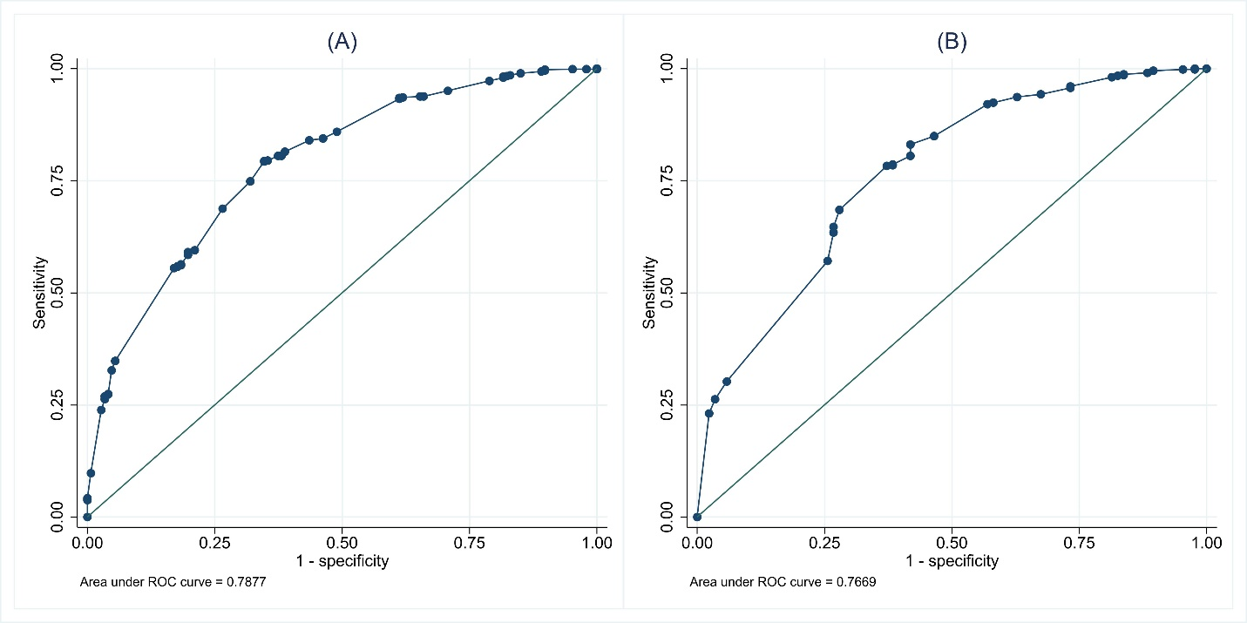

Figure 2S. Fracture distribution of 4 demonstrated cases
