Supplementary information
Design, synthesis, and biological evaluation of quinoline (quinolinone) derivatives as NADPH oxidase (NOX) inhibitors
Lei Zhang^{1,2,3} ·Xinliang Yang⁴ ·Rui Yi⁵ · Siming Wu^{1,2,3} · Qianbin Li^{1,2,3} · Gaoyun Hu^{1,2,3} · Zhuo Chen^{1,2,3}

¹ Department of Medicinal Chemistry, Xiangya School of Pharmaceutical Sciences, Central South University; Changsha 410013, China

² Hunan Key Laboratory of Organ Fibrosis; Changsha 410013, Hunan, China

³ Hunan Key Laboratory of Diagnostic and Therapeutic Drug Research for Chronic Diseases; Changsha 410013, Hunan, China

⁴ Department of Pharmacy, Yueyang Central Hospital, Yiyang 414020, Hunan, China

⁵ Department of Pharmacy, The First Affiliated Hospital of Hunan university of medicine, Huaihua 418099, Hunan, China

Synthesis:
The synthetic route of Series 1 compound is shown in scheme S1
Scheme S1 Synthesis of series 1 compounds.
Reagent and conditions: (a) CHCOCHCOOEt, AcOH, toluene, 110℃. (b) PPA, 160℃. (c) BnBr, KCO3, DMF. (d) I. m-CPBA, CHCl₃ ,0℃. II. Ac₂O. III .1N NaOH, THF-MeOH . V. SOCl₂ py, THF. (e) Phenol or aniline, K₂CO₃, DMF. (f) H₂, 10%Pd-C , THF. (g) I. ClCH₂CH₂OH, K₂CO₃, 80 ℃. II. Ph₃P, CCl₄, reflux. III Saturated heterocyelic, 80℃.
The substituted aniline was mixed 1:1 with ethyl acetoacetate and then added to a mixed system of 18 equivalents of toluene and 1.3 equivalents of acetic acid at reflux for 2 h. The water was separated during the reaction with a Dean-Stark apparatus. The crude product 2 was obtained with a yield of about 49%-53%. Since the crude product was easily decomposed during separation and purification on silica gel column, we directly reacted the crude product with PPA as solvent at 160 °C for 3-4 h to obtain compound 3. We substituted its 4-position oxygen with benzyl bromide to be able to form a quinoline ring for the next reaction. The reaction of compound 3 with bromobenzyl to form compound 4 may yield O-alkylated products as well as N-alkylated products (Scheme S2), while the reaction of 4H-pyridone with bromobenzyl was reported in the literature to give mainly O-alkylated products. The ¹³C and ¹H spectra of both products were theoretically similar. Therefore, we take compound 4a (R1=H) as an example to analyze the HMBC spectrum of the product. The HMBC spectrum (Figure. S1) shows that there is a remote coupling correlation between 11-H (5.36 ppm) and 4-C (160.88 ppm), 12-C (136.74 ppm), 13-C (128.16 ppm) and 17-C (128.16 ppm), which can determine that the product is an O-alkylation product.
we first oxidized compound 4 with m-CPBA to nitrous oxide, and then treated it with acetic anhydride to obtain 2-ethylated product. Then the 2-position ester was hydrolyzed with NaOH, and the 2-hydroxymethyl was converted to chloromethyl with SOCl₂ to obtain compound 8 (Scheme S3).
Compound 9 can be obtained by using DMF as solvent and K₂CO₃ as acid binding agent at 80 ℃ for 4-6 hours, and the yield can reach 88% - 93%. With tetrahydrofuran as the reaction solvent and 10% Pd-C as the catalyst, the reaction can be completed in 4-8 hours under 0.4 MPa H₂ to obtain compound 10. The target compound 13 was synthesized by three processes: chloroethanol substitution, chlorination and heterocyclic substitution with saturated nitrogen (scheme S4). Similar to the reaction between compound 4 and benzyl bromide, compound 10 reacts with chloroethanol to obtain only O-alkylation product 11 in 72% yield. Taking compound 11c (R1=F, X=O, R2=o-Cl) as an example, HMBC spectrum of compound 11c shows 11-H( δ= 4.25 ppm) and 4-C (161.85 ppm) and 12-C(59.67 ppm)are remotely correlated, so it can be determined that the product is O-alkylation product (Figure. S2).

Scheme S2 Synthesis of compound 4

Scheme S3 Synthesis of compound 8

Reagent and conditions: I. m-CPBA, CHCl₃ ,0℃. II. Ac₂O. III .1N NaOH, THF-MeOH . V. SOCl₂ py, THF.

Scheme S4 Synthesis of compound 13.
Reagent and conditions: I. ClCH₂CH₂OH, K₂CO₃, 80 ℃. II. Ph₃P, CCl₄, reflux. III Saturated heterocyelic, 80℃.

Using 14 substituted isatin as raw material, we reacted overnight at 120 ℃ in acetic anhydride as solvent to obtain compound 15. Compound 15 reacted at 100 ℃ of sodium hydroxide solution for 1.5 h, adjusted PH=2 with hydrochloric acid, and filtered to obtain ring expanding product 16. Compound 17 was obtained by esterification of compound 16 with ethanol as solvent and concentrated sulfuric acid as catalyst. When the next compound was synthesized by stirring the reaction at room temperature with DMF as the solvent and potassium carbonate as the base, we found that two products were obtained through TLC monitoring, and the molecular weight of the two products was the same by mass spectrometry analysis.Considering the enol tautomerism of 2 (1H) - quinolinone, we speculated that the two products were N-alkylation and O-alkylation products (scheme S6), and then we confirmed the structures of the two products 18e and 19f with the help of H spectrum, C spectrum and HMBC spectrum (Figure. S3-S4).
Theoretically speaking, the main difference between the two structures is whether 9-C is related to 11-H, because in the HMBC spectrum of N-alkylation products, there will be coupling related signal peaks due to the three chemical bonds between 11-H and 9-C, while there will be no coupling related signal peaks due to the five chemical bonds between 11-H and 9-C of O-alkylation products. The main C and H signals are: 18e: 9-C (138.96), 11-H (5.53), 19f: 9-C (137.28), 11-H (5.58). Therefore, it can be seen from the HMBC spectrum of 18e that there is no correlation signal between 9-C and 11-H, while there is correlation signal between 9-C and 11-H in the HMBC spectrum of 19f. Therefore, the structure of 18e and 19f is determined. Finally, compounds 18 and 19 can be hydrolyzed by sodium hydroxide to obtain target compounds 20 and 21.
The synthesis route of Series 2 compounds is shown in scheme S5:
Scheme S5 Synthesis of series 2 compounds .
Reagent and conditions: h. (CH3CO)₂O, reflux; i. NaOH, H₂O reflux; j. H₂SO₄, EtOH; k. R₂BnBr, K₂CO₃, DMF, rt; l. NaOH, EtOH-H₂O

Scheme S6 Synthesis of compound 18,19

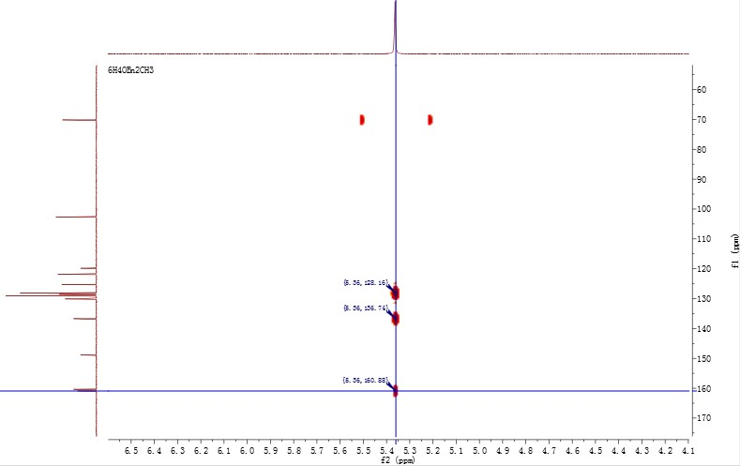

Fig. S1 HMBC spectrum of compound 4a

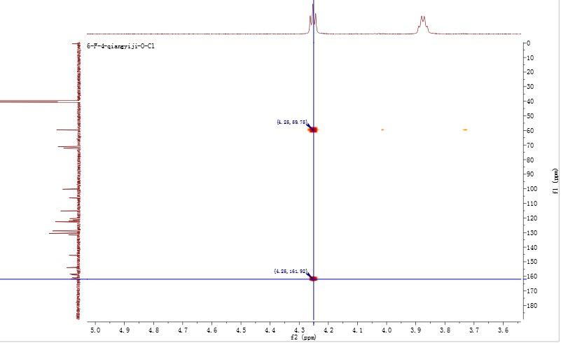
11
-
H

4
-
C

Fig. S2 HMBC spectrum of compound 11c

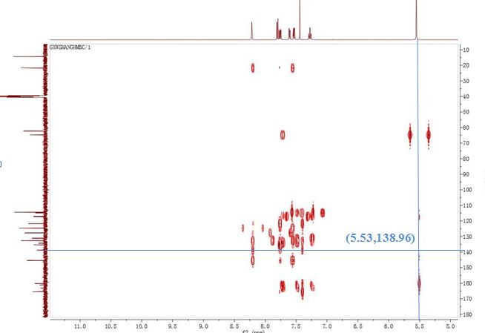
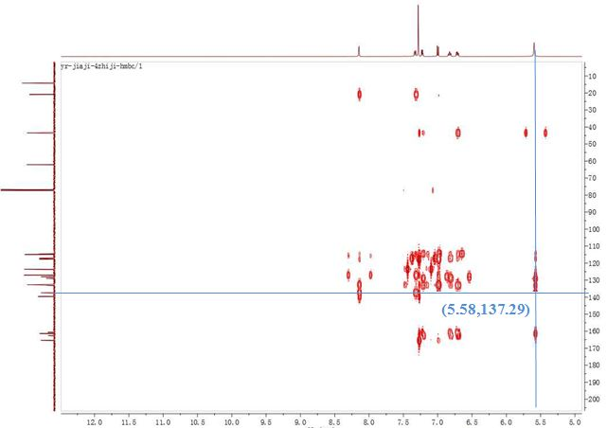
Fig. S3 HMBC spectrum of compound 18e

Fig. S4 HMBC spectrum of compound 19f
Detailed synthetic route and structural information of each compound:
All chemicals, reagents, and solvents were purchased from commercial sources and used without further purification. Reactions were monitored using thin-layer chromatography under ultraviolet (UV) light at 254 nm. The hydrogen reduction device using BLT-2000 medium pressure hydrogen reduction instrument (Beijing Jiawei Kechuang Technology Co. Ltd.).The melting point was measured using a WRS-2 (Shenguang) melting point apparatus. ¹ H NMR and ¹³ C NMR were determined using a Bruker Advance III 400 MHz or 500 MHz nuclear magnetic resonance spectrometer (Bruker, Switzerland). Coupling constants (J) are expressed in Hertz (Hz), and s, d, t, and m are singlet, doublet, triplet, and multiplet, respectively. Mass spectrometry (MS) was determined using MALDI-TOF-MS. The high performance liquid chromatograph was Shimadzu SPD-20A, reversed-phase column type: Agilent® ZORBAX Extend-C18, 5.0 μm, 4.6×250 mm; flow rate: 1.0 mL·min-1; detection wavelength: 254 nm; mobile phase : (1) A: CH₃CN, B: H₂O, (2) A: CH₃OH, B: H₂O, (3) A: CH₃OH, B: 1 % TFA aqueous solution. The purity of the compounds were all over 95%.

4.2.1 2-methylquinolin-4(1H)-one(3a)
Take 12.63 ml (100 mmol) of ethyl acetate and place it in a 50 ml single neck flask, add 9.13 ml (100 mmol) of aniline, drop one drop of concentrated hydrochloric acid, cover it with a drying tube filled with anhydrous calcium chloride, and stir at room temperature for 24 hours. Transfer the generated oil into a 250ml three necked flask, add 60g of polyphosphoric acid (PPA), react at 160 ℃ for 3h, stop heating, and cool to room temperature. Put the reaction flask into a cold trap, add 2mol L NaOH solution by dropping, adjust the pH to 10, and filter to obtain 6.5g of white solid. The yield was 41.7%. mp: 236.9 - 238.3℃, ¹H NMR (500 MHzDMSO- d6) δ 11.58 (s, 1H), 8.03 (d, J = 7.8 Hz, 1H), 7.61 (t, J = 7.6 Hz, 1H), 7.49 (d,J = 8.2 Hz, 1H), 7.27 (t, J = 7.5 Hz, 1H), 5.91 (s, 1H), 2.34 (s, 3H).

4.2.2 6-fluoro-2-methylquinolin-4(1H)-one(3b)
The title compound was prepared in the manner similar to compound 3a , white solid, yield 26.3%, mp: 275.1 - 276.8 ℃, ¹H NMR (500 MHz, DMSO- d6) δ 11.72 (s, 1H), 7.67 (dd, J = 9.3, 2.7 Hz,1H), 7.59-7.50 (m, 2H), 5.92 (s, 1H), 2.35 (s, 3H), HRMS (ESI) m/z calcd for [C10H8FNO+H]+, 178.0663; found, 178.06673 [M+H] +.

4.2.3 6-methoxy-2-methylquinolin-4(1H)-one(3c)
Put 12.63 ml (100 mmol) of ethyl acetate in a 50 ml single neck flask, add 11.30 ml (100 mmol) of p-methoxylaniline, drop one drop of concentrated hydrochloric acid, and stir at 50 ℃ for 24 h. Transfer the generated oil into a 250ml three necked flask, add 60g of polyphosphoric acid (PPA), react at 160 ℃ for 3h, stop heating, and cool to room temperature. Put the reaction flask into a cold trap, add 2 mol L NaOH solution dropwise, adjust the pH to 10, and filter to obtain 11.2 g of white solid with a yield of 59.1%, mp: 258.3-260.7 ℃, 1H NMR (500 MHz, DMSO- d6) δ 11.55 (s, 1H),7.44 (s, 2H), 7.25 (s, 1H), 5.87 (s, 1H), 3.82 (s, 3H), 2.33 (s, 3H). ¹³C NMR (125MHz, DMSO- d6) δ 176.57, 155.66, 149.04, 135.15, 125.92, 122.19, 119.92, 107.87,104.68, 55.71,19.80.

4.2.4 4-(benzyloxy)-2-methylquinoline(s)
Compound 3a 6.4 g (40 mmol) was placed in a 250 ml single-necked flask, 150 ml of N,N-dimethylformamide (DMF) was added and sonicated to dissolve completely. Add 5 g of anhydrous potassium carbonate, 5.2 ml (44 mmol) of benzyl bromide in turn, and stir for reaction at room temperature for 8-10 h. After the reaction is completed, the product is concentrated to dryness under reduced pressure, added with 300 ml of water for ultrasonic treatment for 2 minutes, and extracted twice with 500 ml of ethyl acetate. Concentrate the extract to obtain 9.9 g of white solid with a yield of 91.4%, mp: 112.3 - 112.9 ℃, ¹H NMR (500 MHz, DMSO- d6) δ 8.11 (d, J = 8.3 Hz, 1H), 7.86 (d, J = 8.2 Hz, 1H), 7.72-7.67 (m, 1H),7.57 (d, J = 7.3 Hz, 2H), 7.47 (ddd, J = 14.7, 10.7, 4.3 Hz, 3H), 7.39 (t, J = 7.3 Hz,1H), 7.07 (s, 1H), 5.37 (s, 2H), 2.61 (s, 3H). ¹³C NMR (125 MHz, DMSO- d6) δ 160.91, 160.35, 148.77, 136.69, 130.14, 129.08(2C),128.62, 128.40, 128.17(2C),125.36, 121.83, 119.79, 102.73, 70.15, 25.88.

4.2.5 4-(benzyloxy)-6-methoxy-2-methylquinoline(4b)
The title compound was prepared in the manner similar to compound 4a , white solid, yield 90.8%, mp: 119.3 - 120.6 ℃, ¹H NMR (500 MHz, DMSO- d6) (s, 1H), 7.56 (s, 2H), 7.45 (s, 2H), 7.38 (s, 2H), 7.33 (s, 1H), 7.00 (s, 1H), 5.37 (s, 2H), 3.85 (s, 3H), 2.56 (s, 3H) ¹³C NMR(125 MHz, DMSO- d6) δ 160.02, 157.48, 156.74, 144.61, 136.81, 130.08, 129.09(2C),128.56, 128.05(2C), 121.82, 120.36,102.99, 100.16, 70.01, 55.77, 25.56.

4.2.6 4-(benzyloxy)-2-methylquinoline 1-oxide(5a)
Compound 4a 9.5 g (38 mmol) was placed in a 250 ml single neck flask and dissolved with 180 ml chloroform. Put the reaction flask in cold trap at - 10 ℃ and stir for 5 min, then add 9.0 g m-chloroperobenzoic acid (42 mmol) in batches, continue stirring for 6-8 h and stop the reaction. The reaction solution was washed twice with 300 ml of 2 mol L potassium carbonate solution, and the organic layer was concentrated to dry to obtain 10.08 g of dark brown solid.The resulting residue was purified by silica gel chromatography (PE/EA, v/v, 1:1) to afford the light brown solid. 70% yield, mp: 138.9-142.3 ℃, ¹H NMR (500 MHz, DMSO- d6) δ 8.56 (d, J = 8.4 Hz,1H), 8.19 (d, J = 8.3 Hz, 1H), 7.87-7.81 (m, 1H), 7.70-7.65 (m, 1H), 7.58 (d, J = 7.2Hz, 2H), 7.48-7.43 (m, 2H), 7.40 (t, J = 6.7 Hz, 1H), 7.29 (s, 1H), 5.38 (s, 2H), 2.58 (s,3H). HRMS (ESI) m/z calcd for [C17H15NO2+H]+, 266.1176; found, 266.11890[M+H] +

4.2.7 4-(benzyloxy)-6-methoxy-2-methylquinoline 1-oxide(5c)
The title compound was prepared in the manner similar to compound 5a. white solid, yield: 68.3%, mp: 149.1-149.7 ℃, ¹H NMR (500 MHz, DMSO- d6) δ 8.44 (s, 1H), 7.56 (s, 2H), 7.43 (s, 5H),7.20 (s, 1H), 5.36 (s, 2H), 3.87 (s, 3H), 2.52 (s, 3H). ¹³C NMR (100 MHz, DMSO- d6) δ 158.33, 149.94, 143.33, 136.62, 136.55, 129.11(2C) , 128.67, 128.16(2C), 122.87,122.14, 121.56, 104.87, 101.33, 70.61, 56.02, 18.98.

4.2.8 (4-(benzyloxy)-6-methoxyquinolin-2-yl)methyl acetate(6c)
compound 5c 8.9 g (30 mmol) was placed in a 250 ml single-necked flask, 150 ml of acid anhydride was added and stirred for 8-10 h at room temperature. After reaction, concentrate the reaction solution to obtain 12.5 g oil. Use 38g 300-400 mesh silicon to mix the sample, 300g 300-400 mesh silica gel to dry load the column, petroleum ether and ethyl acetate (v: v=3:1) to elute, and concentrate the fraction containing the product to obtain 7.3 g white solid, with a yield of 71%, mp: 111.7-113.9 ℃, a yield of 71%, ¹H NMR (400 MHz, DMSO- d6) δ 7.84 (s, 1H), 7.57 (s, 2H),7.45 (s, 2H), 7.41 (d, J = 9.1 Hz, 3H), 7.10 (s, 1H), 5.44 (s, 2H), 5.20 (s, 2H), 3.88 (s,3H), 2.13 (s, 3H). ¹³C NMR (100 MHz, DMSO- d6) δ 170.65, 160.61, 157.45, 155.32,144.24, 136.64, 130.56, 129.12(2C) , 128.63, 128.14(2C), 122.51, 121.33, 100.88,100.11, 70.29, 67.29, 55.88, 21.21.

4.2.9 2-(Hydroxymethyl)-4-(benzyloxy)-6-methoxyquinoline(7c)
Compound 6c 7.1 g (21 mmol) was placed in a 250 ml single-necked flask and 50 ml of tetrahydrofuran, 50 ml of methanol and 50 ml of 1 mol \L sodium hydroxide solution were added sequentially and stirred at room temperature for 1-2 h. After reaction, concentrate the organic solvent, add 200 ml of water, extract with 200 ml of ethyl acetate, concentrate to obtain 6.4 g of white solid, recrystallize with 80 ml of mixed solvent of petroleum ether and ethyl acetate (v: v=2:1) to obtain 5.6 g of white solid. Yield: 91%, mp: 123.8-125.1 ℃, ¹H NMR (400 MHz, DMSO D6) δ 7.82 (s, 1H), 7.68-7.30 (m, 7H), 7.22 (s, 1H), 5.53 s, 1H), 5.42 (s, 2H), 4.65 (s,2H), 3.87 (s, 3H). ¹³C NMR (100 MHz, DMSO- d6) δ 161.59, 160.51, 157.00, 144.16,136.79, 130.27, 129.10(2C), 128.56, 128.00(2C), 122.10, 121.07, 100.20, 99.87,70.06, 65.31, 55.80.

4.2.10 4-(benzyloxy)-2-(chloromethyl)quinoline(8a) The title compound was prepared in the manner similar to compound 8c. white solid, yield: 87.3%, mp: 114.3 -115.8℃, HRMS (ESI) m/z calcd for [C17H14ClNO+H]+, 284.0837; found, 284.08298 [M+H] +

4.2.10 4-(benzyloxy)-2-(chloromethyl)-6-methoxyquinoline (8c)
Dissolve compound 7c 5.3 g (18 mmol) in a 250 ml single-necked flask by adding 120 ml tetrahydrofuran. Add 4.2 g (36 mmol) of thionyl chloride and 1 drop of anhydrous pyridine. The solution becomes turbid and stirred for 2-3 h. After reaction, concentrate the dry solvent, add 200 ml of water to dissolve it, and extract it with 200 ml of ethyl acetate. Concentrate the organic layer to obtain 5.2 g of white solid, yield: 83.1%, mp: 122.9 - 124.0 ℃, ¹H NMR (400 MHz, DMSO- d6) δ 7.91-7.85 (m, 1H), 7.58 (s, 2H), 7.44 (m, 5H), 7.28 (s,1H), 5.43 (s, 2H), 4.85 (s, 2H), 3.88 (s, 3H)

4.2.11 4-(benzyloxy)-2-(chloromethyl)-6-fluoroquinoline(8b)
The title compound was prepared in the manner similar to compound 8c. white solid, yield: 88.1%, mp: 141.9-142.8 ℃, 1H NMR (400 MHz, DMSO- d6) δ 8.04 (dd, J = 9.1, 5.3 Hz, 1H), 7.79 (dd,J = 9.5, 1.9 Hz, 1H), 7.70 (t, J = 8.8 Hz, 1H), 7.60 (d, J = 7.5 Hz, 2H), 7.46 (t, J = 7.3Hz, 2H), 7.43–7.35 (m, 2H), 5.44 (s, 2H), 4.88 (s, 2H)

4.2.13 4-(benzyloxy)-2-((2-chlorophenoxy)methyl)quinoline(9a)
Dissolve 0.2 g (0.71 mmol) of compound 8a in a 25 ml single-necked flask with 10 ml DMF. Add 0.26 g (2.03 mmol) of 2-chlorophenol and 0.5 g of potassium carbonate in turn. Stir at 80 ℃ for 3-4 h. After the reaction is complete, concentrate DMF, add 60 ml of water, and extract with 60 ml of ethyl acetate. Concentrate the organic layer to obtain 0.3 g of light yellow solid, mix the sample with 1.0 g of 300-400 mesh silica gel, and load the column with 30 g of 300-400 mesh silica gel, elute with petroleum ether and ethyl acetate (v: v=5:1) to obtain 0.24 g of white solid, yield: 90.1%, mp: 119.1-119.9 ℃, HPLC purity: 99.38% (liquid phase condition A), ¹H NMR (400 MHz, DMSO- d6) δ 8.19 (dd, J = 8.3, 0.9 Hz, 1H), 7.96 (d, J = 8.1 Hz, 1H), 7.78 (ddd, J = 8.4, 6.9, 1.5Hz, 1H), 7.62 – 7.51 (m, 3H), 7.48 (dd, J = 7.9, 1.4 Hz, 1H), 7.45 – 7.39 (m, 2H),7.39 – 7.33 (m, 1H), 7.33 – 7.23 (m, 3H), 6.99 (ddd, J = 7.9, 6.9, 1.9 Hz, 1H), 5.42 (s,2H), 5.38 (s, 2H). ¹³C NMR (100 MHz, DMSO- d6) δ 161.74, 158.87, 153.95, 148.50,136.38, 130.70, 130.52, 129.06(2C), 128.83, 128.65, 128.14(2C), 126.41, 122.51,122.13, 122.06, 120.69, 114.95, 100.25, 72.19, 70.33. HRMS (ESI) m/z calcd for[C23H18ClNO2+H]+, 376.1099; found, 376.10910 [M+H] +.
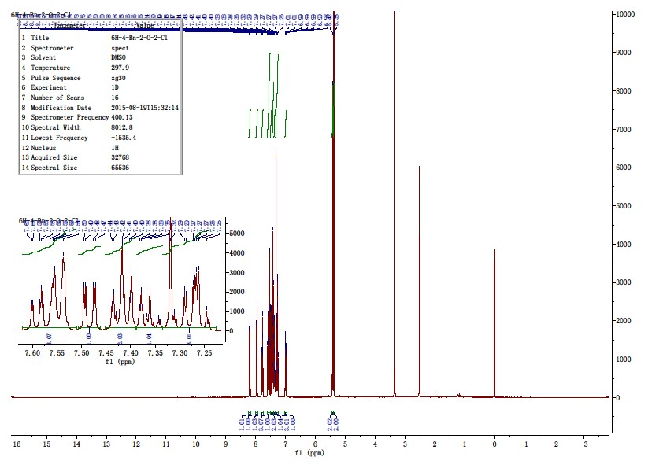

附图

化合物
-
2
氢谱

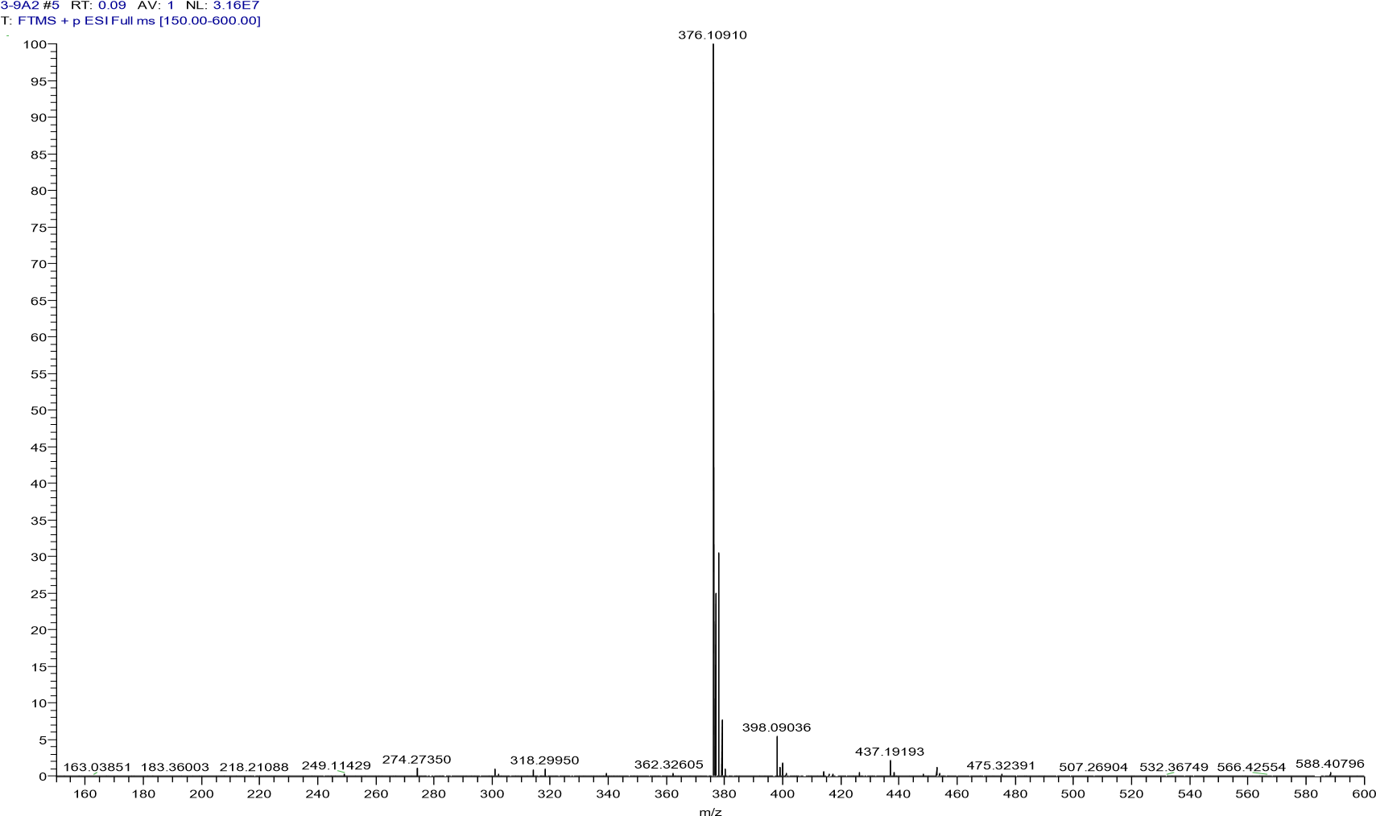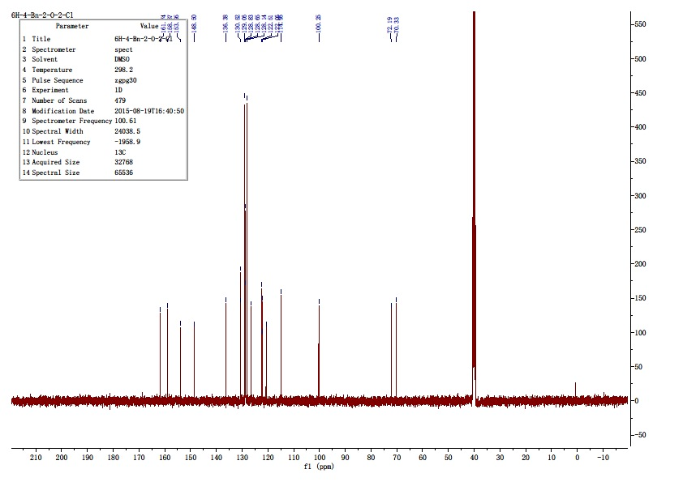
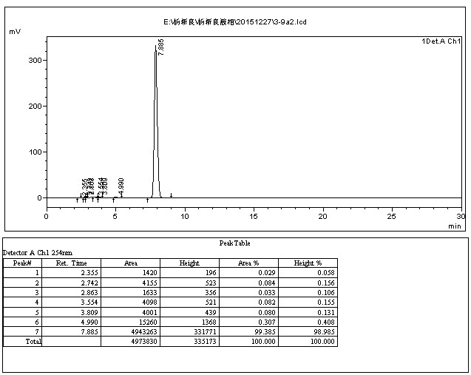

4.2.14 4-(benzyloxy)-2-((3-chlorophenoxy)methyl)quinoline(9b)
The title compound was prepared in the manner similar to compound 9a. white solid, yield: 89.1%, mp: 104.9-105.6 ℃, HPLC purity: 98.62% (liquid phase condition A), ¹H NMR (400 MHz, CDCl3) δ 8.18 (dd, J = 8.3, 0.9 Hz, 1H), 7.96 (d, J = 8.1 Hz, 1H), 7.77 (ddd, J = 8.4, 6.9, 1.4 Hz,1H), 7.62 – 7.51 (m, 3H), 7.48 – 7.40 (m, 2H), 7.40 – 7.30 (m, 2H), 7.29 (s,1H), 7.19(t, J = 2.2 Hz, 1H), 7.10 – 6.98 (m, 2H), 5.42 (s, 2H), 5.31 (s, 2H). ¹³C NMR (125MHz, DMSO- d6) δ 161.76, 159.62, 158.83, 148.51, 136.50, 134.22, 131.41, 130.66,129.04(2C), 128.84, 128.65, 128.23(2C), 126.41, 122.06, 121.49, 120.69, 115.68,114.34, 100.61, 71.89, 70.44. HRMS (ESI) m/z calcd for[C23H18ClNO2+H]+,376.1099; found, 376.10910 [M+H] +.
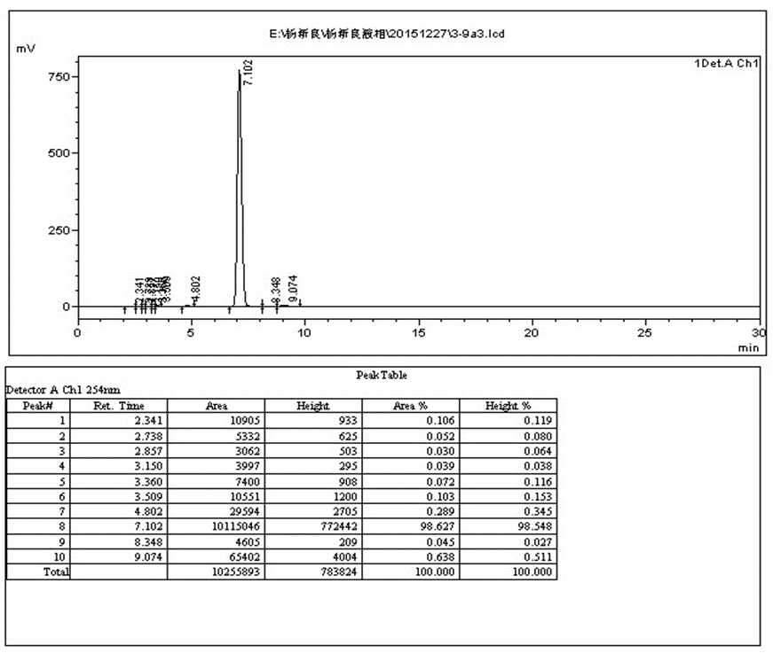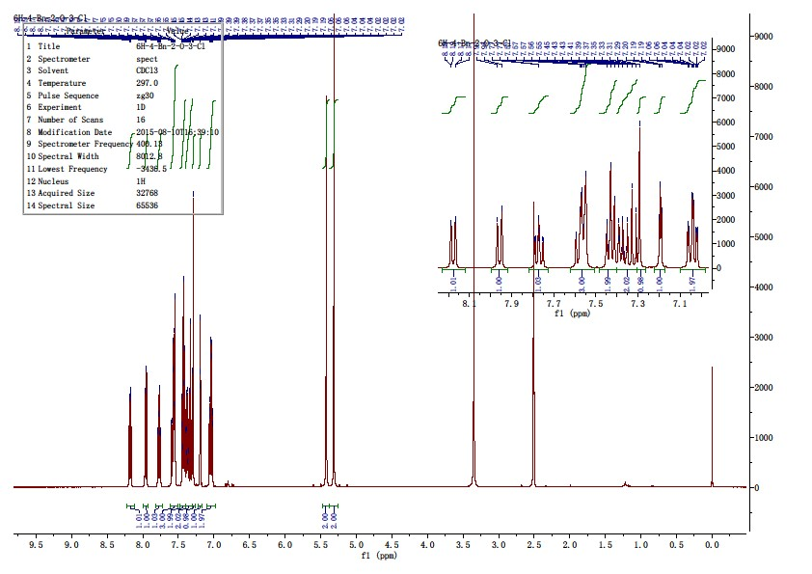

附图

化合
-
氢谱

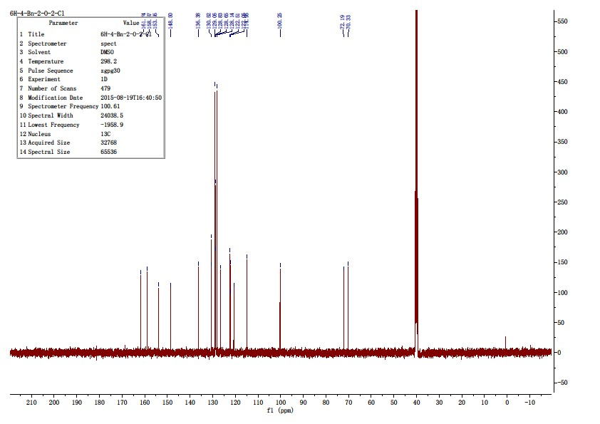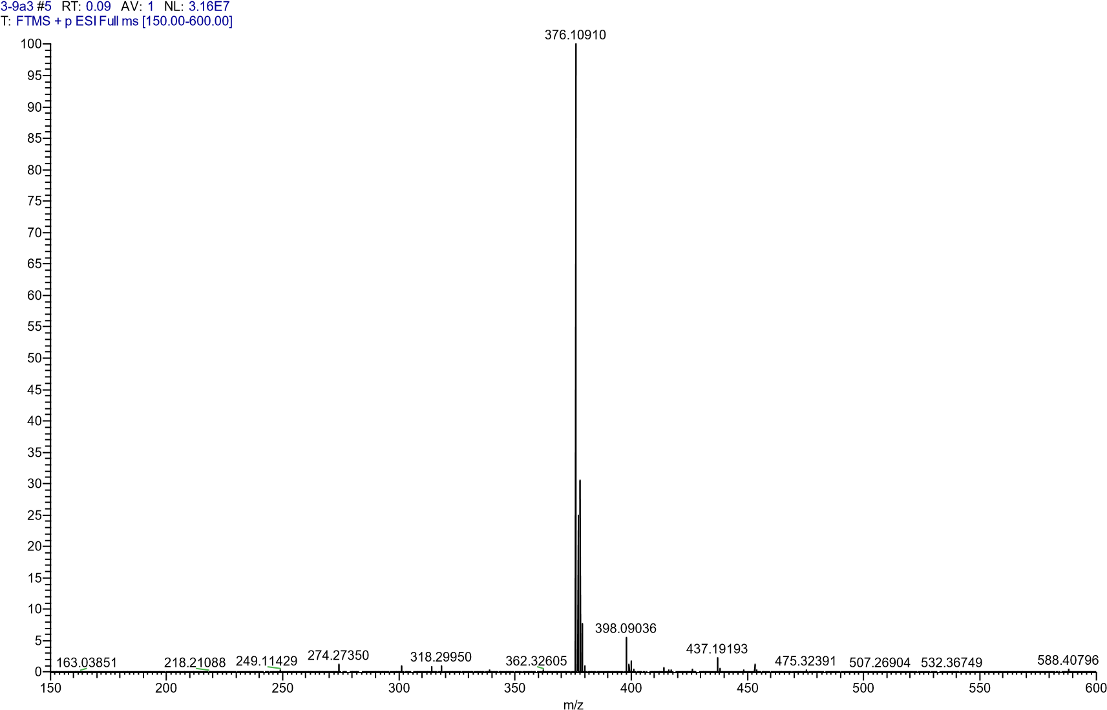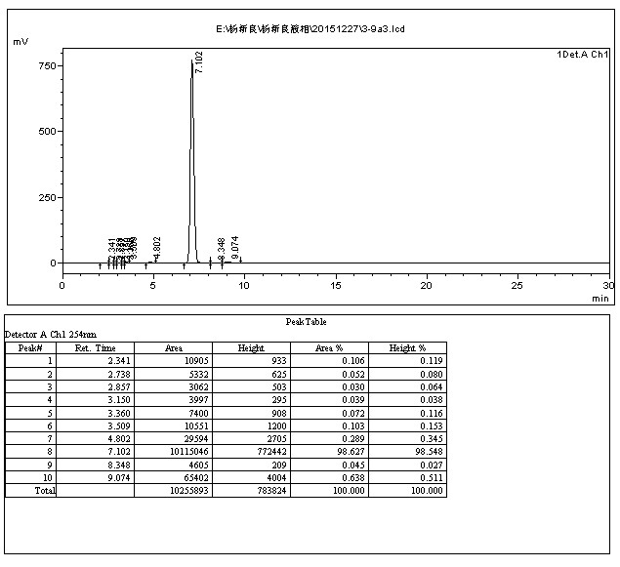

4.2.15 4-(benzyloxy)-2-((4-chlorophenoxy)methyl)quinoline (9c)
The title compound was prepared in the manner similar to compound 9a. white solid, yield: 91.2%, mp: 127.1-129.8 ℃, HPLC purity: 97.37% (liquid phase condition A), ¹H NMR (500 MHz, DMSO- d6) δ 8.17 (dd, J = 8.3, 0.9 Hz, 1H), 7.96 (d, J = 8.2 Hz, 1H), 7.76 (ddd, J = 8.4, 6.9, 1.4Hz, 1H), 7.62 – 7.50 (m, 3H), 7.43 (dd, J = 10.0, 4.6 Hz, 2H), 7.40 – 7.30 (m, 3H),7.26 (s, 1H), 7.14 – 7.05 (m, 2H), 5.41 (s, 2H), 5.29 (s, 2H). 13C NMR (125 MHz,DMSO- d6) δ 161.73, 158.99, 157.52, 148.54, 136.49, 130.62, 129.78(2C), 129.04(2C),128.84, 128.62, 128.19(2C), 126.36, 125.23, 122.05, 120.70, 117.20(2C), 100.52,71.91, 70.41. HRMS (ESI) m/z calcd for [C23H18ClNO2+H]+, 376.1099; found,376.10892 [M+H] +.
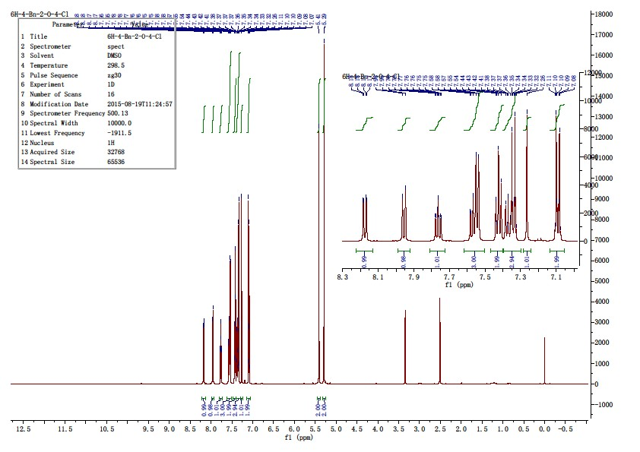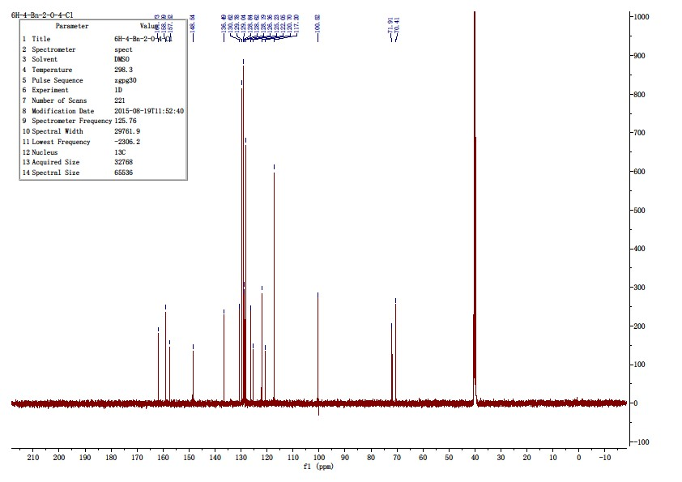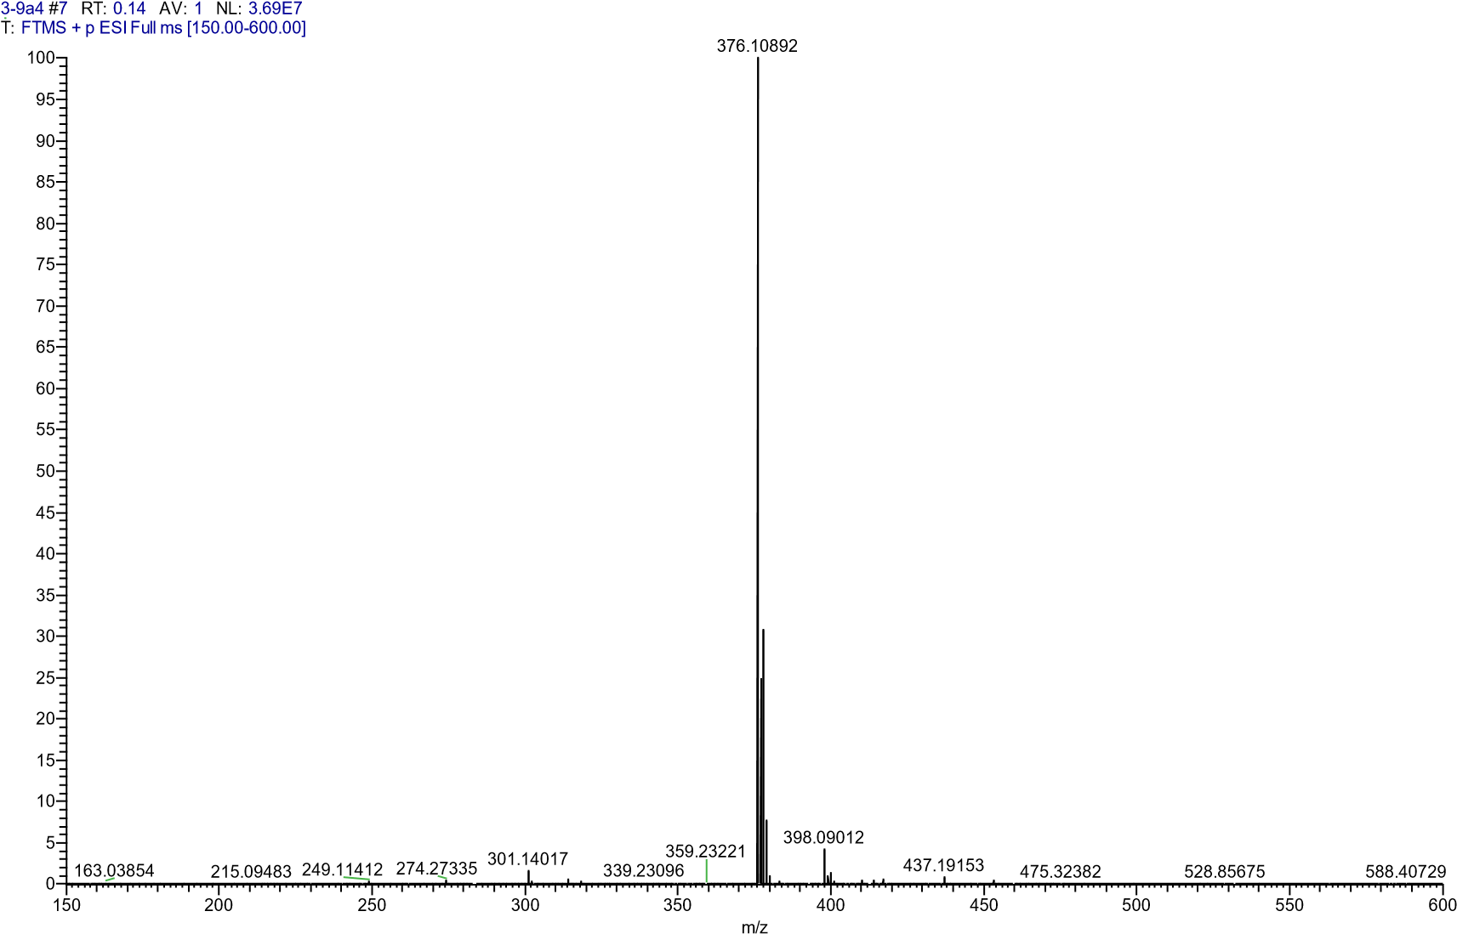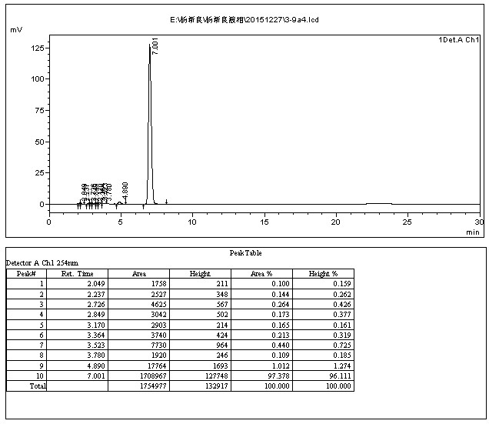
4.2.16 4-(benzyloxy)-2-((2-(trifluoromethyl)phenoxy)methyl)quinoline (9d)
The title compound was prepared in the manner similar to compound 9a. white solid, yield: 89.5%, mp: 140.0 - 141.5 ℃, HPLC purity: 98.20% (liquid phase condition A), ¹H NMR (500 MHz, DMSO- d6) δ 8.19 (dd, J = 8.3, 0.9 Hz, 1H), 7.96 (d, J = 8.1 Hz, 1H), 7.79 (ddd, J = 8.4, 6.9, 1.5 Hz, 1H), 7.68 (dd, J = 7.7, 1.2 Hz, 1H), 7.64 – 7.57 (m, 2H), 7.55 – 7.49 (m, 2H), 7.44 – 7.39 (m, 2H), 7.39 – 7.34 (m, 2H), 7.24 (s, 1H), 7.14 (t, J = 7.6 Hz, 1H), 5.45 (s, 2H), 5.37 (s, 2H). ¹³C NMR (125 MHz, DMSO- d6) δ 161.79, 158.69, 156.22, 148.50, 136.20, 134.78, 130.75, 129.05(2C), 128.81, 128.70, 128.11, 127.35, 126.46, 124.36(2C), 122.05, 121.28, 120.68, 117.77, 114.52, 99.83, 71.89, 70.25. HRMS (ESI) m/z calcd for [C24H18F3NO2+H]+, 410.1362; found, 410.13470 [M+H] +.
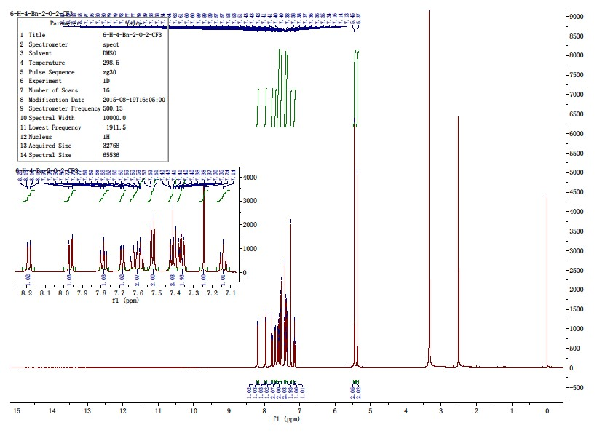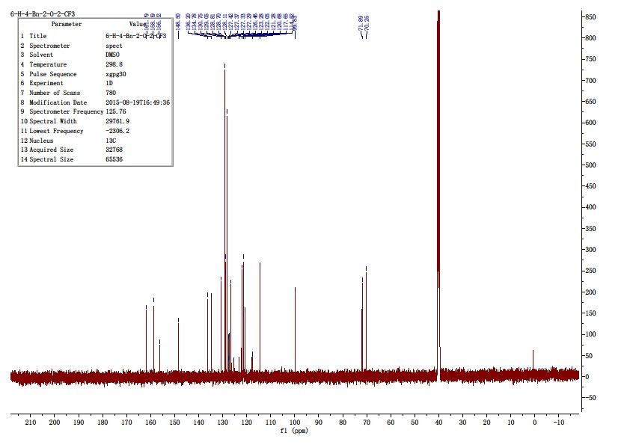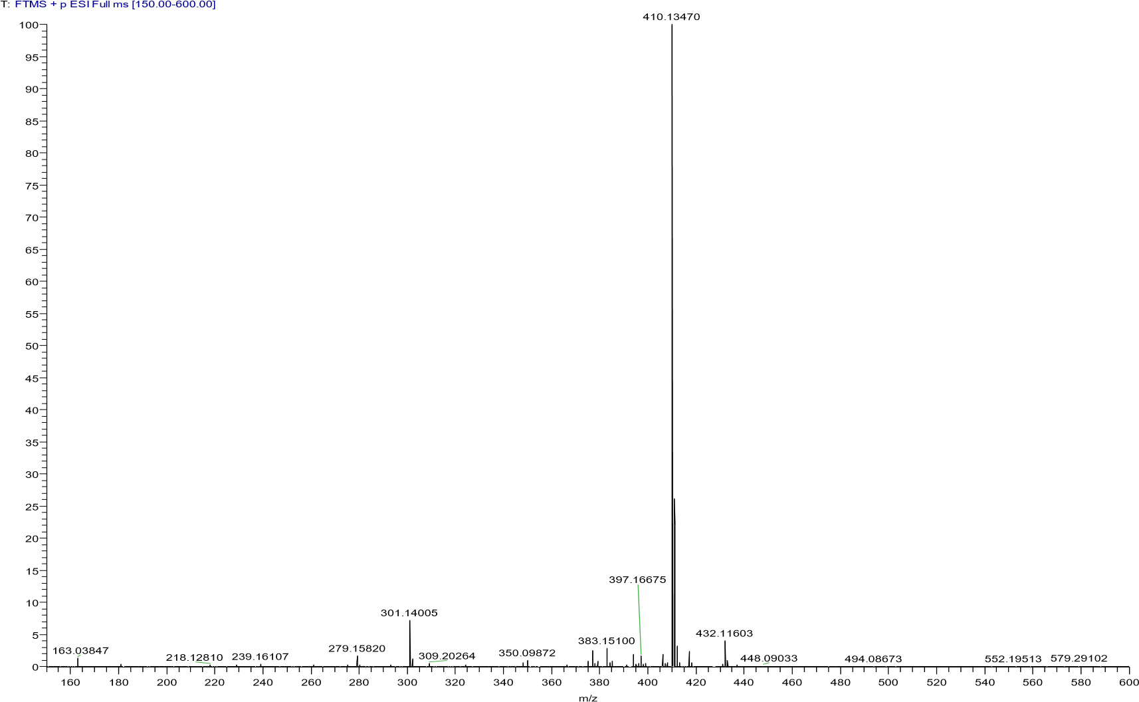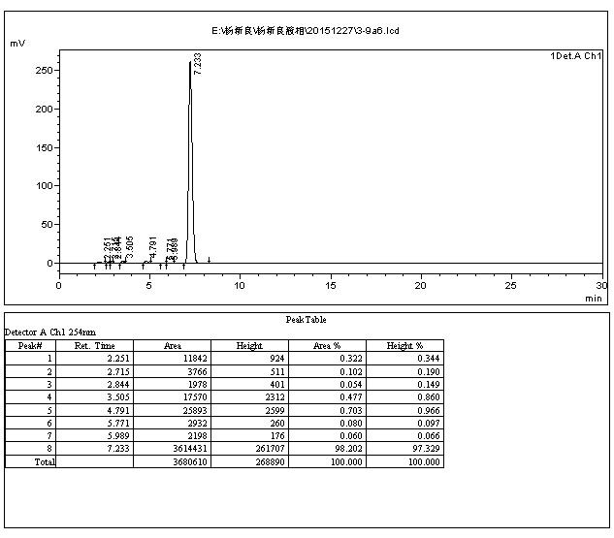

4.2.17 4-(benzyloxy)-2-((2-methoxyphenoxy)methyl)quinoline (9e)
The title compound was prepared in the manner similar to compound 9a. white solid, yield: 90.1%, mp: 100.0 - 102.1 ℃, HPLC purity: 98.57% (liquid phase condition A), ¹H NMR (500 MHz, DMSO- d6) δ 8.18 (d, J = 8.3 Hz, 1H), 7.95 (d, J = 8.4 Hz, 1H), 7.80 – 7.72 (m, 1H), 7.57 (t, J = 7.0 Hz, 3H), 7.43 (t, J = 7.4 Hz, 2H), 7.38 (t, J = 7.3 Hz, 1H), 7.33 (s, 1H), 7.07 (dd, J = 8.0, 1.3 Hz, 1H), 7.03 (dd, J = 8.0, 1.2 Hz, 1H), 6.94 (td, J = 7.9, 1.3 Hz, 1H), 6.85 (td, J = 7.8, 1.4 Hz, 1H), 5.40 (s, 2H), 5.27 (s, 2H), 3.83 (s, 3H). ¹³C NMR (125 MHz, DMSO- d6) δ 161.66, 159.66, 149.92, 148.53, 148.22, 136.48, 130.58, 129.06, 128.83, 128.66, 128.21, 126.30, 122.20, 122.03, 121.21, 120.67, 115.04, 113.00, 100.47, 72.61, 70.33, 56.14. HRMS (ESI) m/z calcd for [C24H21NO3+H]+, 372.1597; found, 372.15894 [M+H] +.

4.2.18 (4-(benzyloxy)-2-((3-methoxyphenoxy)methyl)quinoline9f)
The title compound was prepared in the manner similar to compound 9a. white solid, yield: 89.6%, mp: 113.9-115.2 ℃, HPLC purity: 98.99% (liquid phase condition A), ¹H NMR (400 MHz, DMSO- d6) δ 8.17 (d, J = 9.2 Hz, 1H), 7.97 (d, J = 8.3 Hz, 1H), 7.80 – 7.71 (m, 1H), 7.60 – 7.51 (m, 3H), 7.43 (dd, J = 11.4, 4.4 Hz, 2H), 7.37 (t, J = 7.2 Hz, 1H), 7.28 (s, 1H), 7.20 (t, J = 8.1 Hz, 1H), 6.55 (dd, J = 8.4, 2.2 Hz, 1H), 5.38 (s, 2H), 5.28 (s, 2H), 3.74 (s, 3H). 107.53, 107.18, 101.73, 100.48, 71.68, 70.39, 55.55. HRMS (ESI) m/z calcd for [C24H21NO3+H]+, 372.1597; found, 372.15881 [M+H] +.

4.2.19 4-(benzyloxy)-2-((4-methoxyphenoxy)methyl)quinoline (9g)
The title compound was prepared in the manner similar to compound 9a. white solid, yield: 88.9%, mp: 209.7 - 211.6 ℃, HPLC purity: 98.24% (liquid phase condition A), ¹H NMR (400 MHz, DMSO D6) δ 8.17 (dd, J = 8.3, 0.9 Hz, 1H), 7.95 (d, J = 8.1 Hz, 1H), 7.76 (ddd, J = 8.4, 6.9,1.4 Hz, 1H), 7.60 – 7.51 (m, 3H), 7.48 – 7.41 (m, 2H), 7.38 (ddd, J = 7.3, 3.5, 1.3 Hz,1H), 7.03 – 6.97 (m, 2H), 6.90 – 6.83 (m, 2H), 5.41 (s, 2H), 5.22 (s, 2H), 3.69 (s, 3H). ¹³C NMR (100 MHz, DMSO- d6) δ 161.66, 159.70, 154.15, 152.64, 148.50, 136.53,130.57, 129.06(2C), 128.80, 128.63, 128.21(2C), 126.28, 122.03, 120.66,116.39(2C),115.11(2C), 100.46, 72.18, 70.37, 55.80. HRMS (ESI) m/z calcd for [C24H21NO3+H]+,372.1597; found, 372.15884 [M+H] +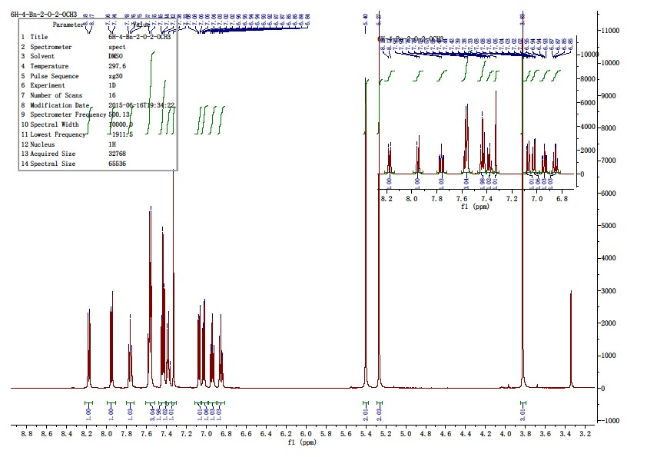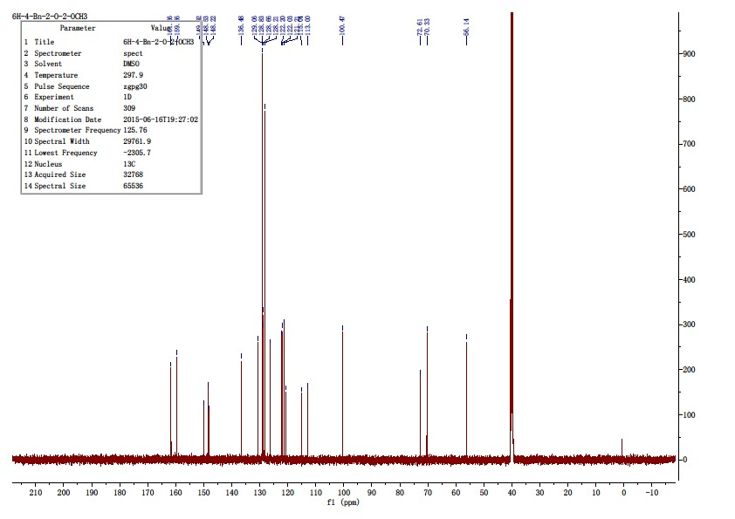
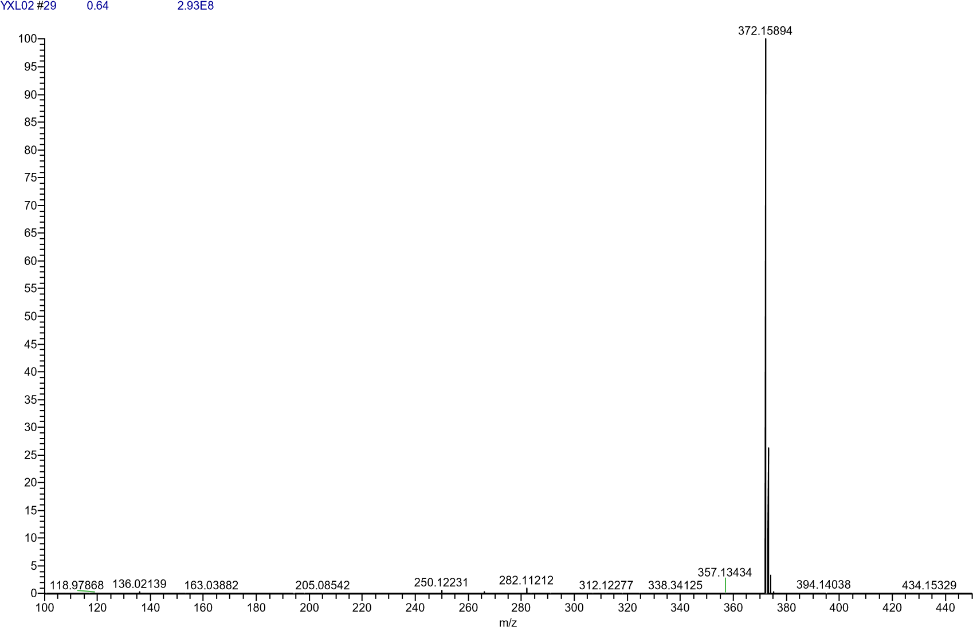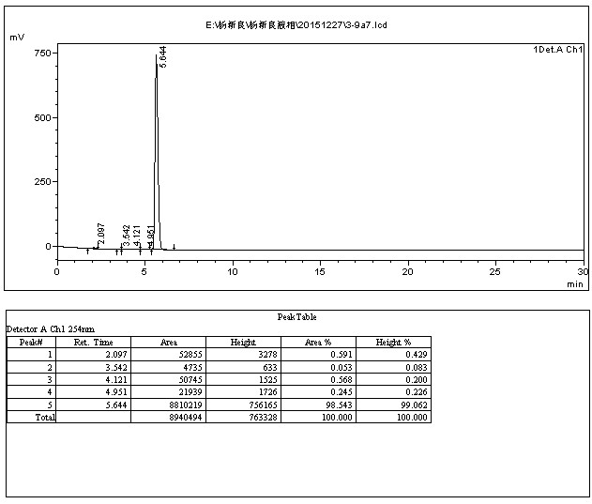

4.2.20 4-(benzyloxy)-2-((2-chlorophenoxy)methyl)-6-fluoroquinoline (9h)
The title compound was prepared in the manner similar to compound 9a. white solid, yield: 88.2%, mp: 137.9 - 139.2 ℃, HPLC purity: 98.91% (liquid phase condition A), ¹H NMR (500 MHz, DMSO D6) δ 8.03 (dd, J = 9.2, 5.3 Hz, 1H), 7.81 (dd, J = 9.5, 2.9 Hz, 1H), 7.69 (td, J = 8.8,2.9 Hz, 1H), 7.55 (d, J = 7.3 Hz, 2H), 7.48 (dd, J = 7.9, 1.4 Hz, 1H), 7.41 (t, J = 7.4Hz, 2H), 7.39 – 7.32 (m, 2H), 7.27 (dtd, J = 9.6, 8.3, 1.4 Hz, 2H), 6.99 (td, J = 7.8, 1.5Hz, 1H), 5.44 (s, 2H), 5.37 (s, 2H). ¹³C NMR (125 MHz, DMSO- d6) δ 161.34 (d, J =5.1 Hz), 160.03(d, J = 245.7 Hz), 158.44 (d, J = 2.4 Hz), 153.89, 145.60, 136.20,131.79 (d, J = 9.1 Hz), 130.52, 129.08(2C), 128.84, 128.68, 128.12(2C), 122.55,122.11, 121.33 (d, J = 9.6 Hz), 120.59(d, J = 26.5 Hz), 114.93, 105.79(d, J = 22.7 Hz),100.93, 72.02, 70.48. HRMS (ESI) m/z calcd for [C23H17ClFNO2+H]+, 394.1005; found, 394.09940 [M+H] +.
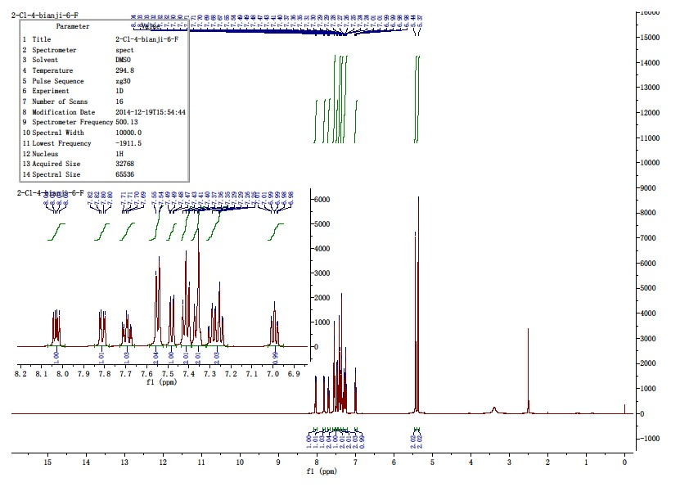

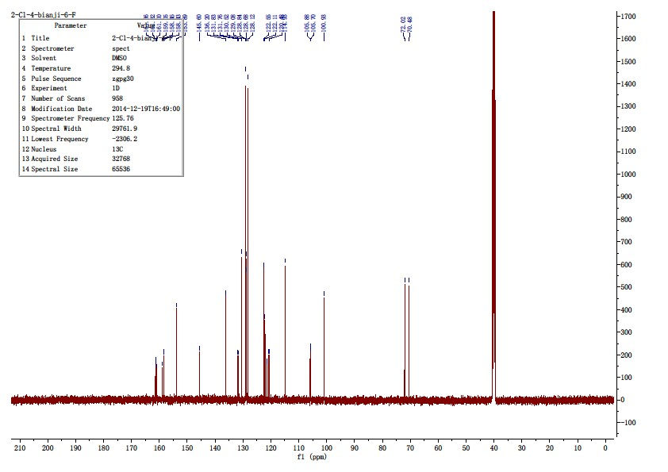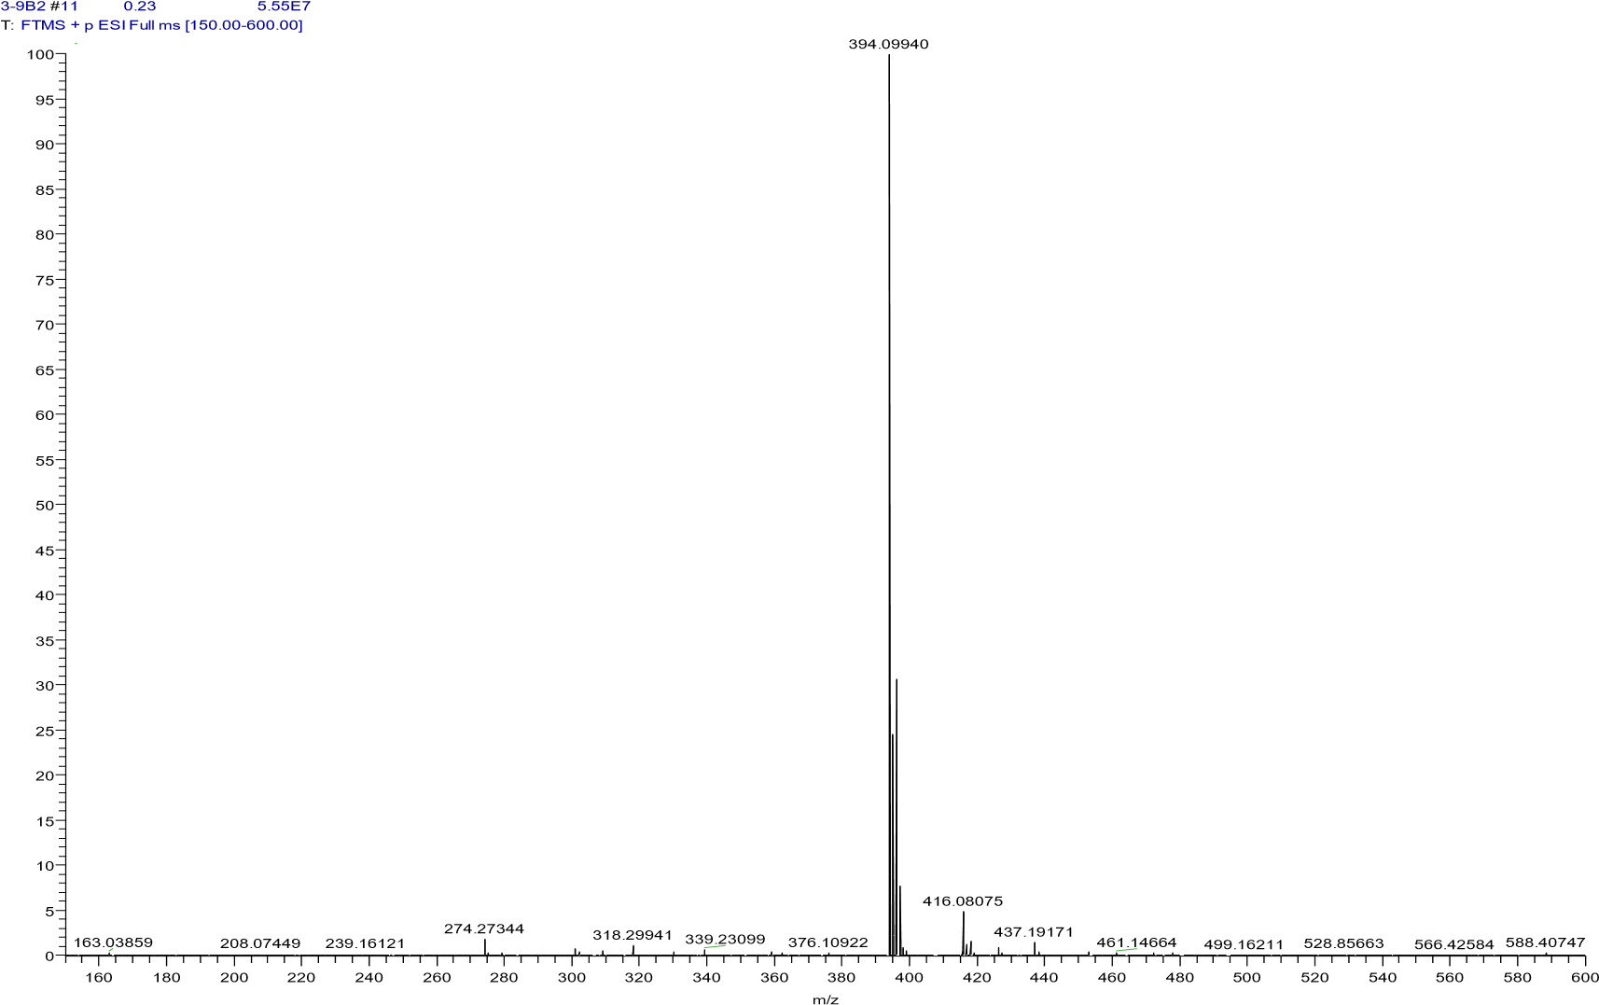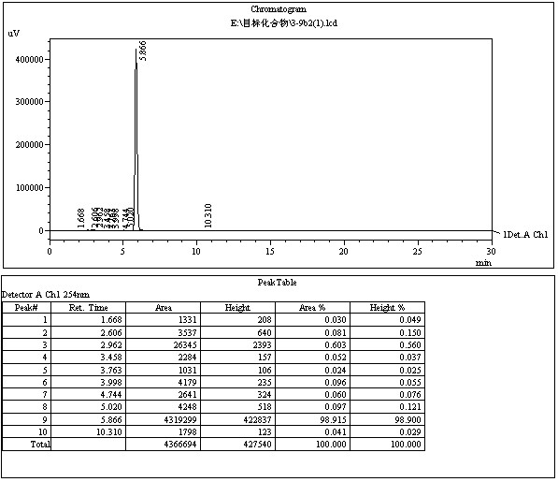

4.2.21 4-(benzyloxy)-2-((2-chlorophenoxy)methyl)-6-methoxyquinoline (9i)
The title compound was prepared in the manner similar to compound 9a. white solid, yield: 90.1%, mp: 102.3 - 104.4 ℃, HPLC purity: 97.97% (liquid phase condition A), ¹H NMR (500 MHz, DMSO- d6) δ 7.88 (d, J = 9.1 Hz, 1H), 7.54 (d, J = 7.2 Hz, 2H), 7.47 (dd, J = 9.1, 2.4 Hz, 2H),7.45 – 7.39 (m, 3H), 7.37 – 7.33 (m, 1H), 7.31 – 7.26 (m, 2H), 7.24 (dd, J = 8.3, 1.6Hz, 1H), 7.01 – 6.96 (m, 1H), 5.44 (s, 2H), 5.33 (s, 2H), 3.90 (s, 3H). ¹³C NMR (125MHz, DMSO- d6) δ 160.74, 157.55, 156.02, 154.00, 144.34, 136.52, 130.54, 130.49,129.08(2C), 128.80, 128.57, 127.96(2C), 122.54, 122.46, 122.14, 121.49, 114.98,100.75, 100.29, 72.24, 70.25, 55.96.HRMS (ESI) m/z calcd for [C24H20ClNO3+H]+,406.1204; found, 406.11932 [M+H] +.
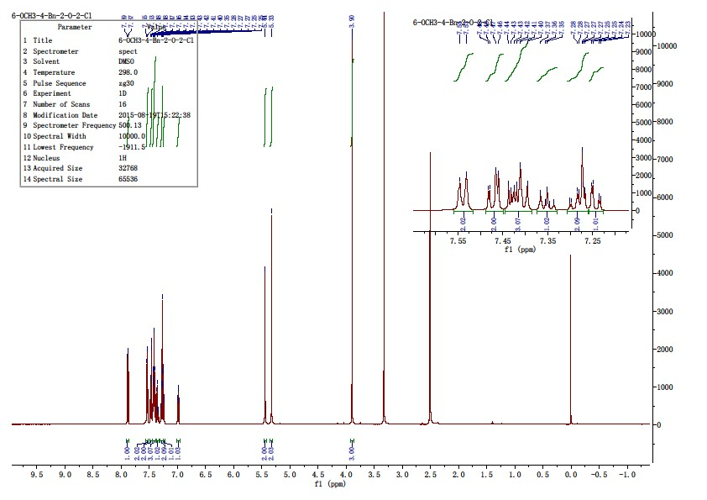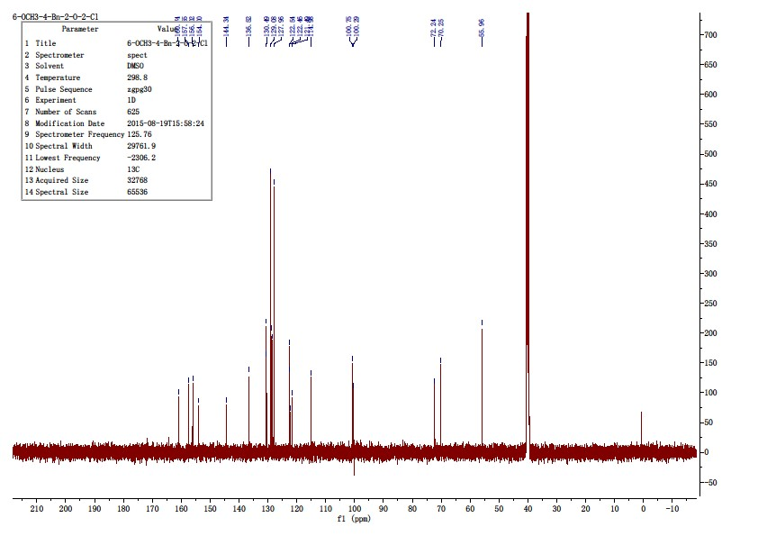
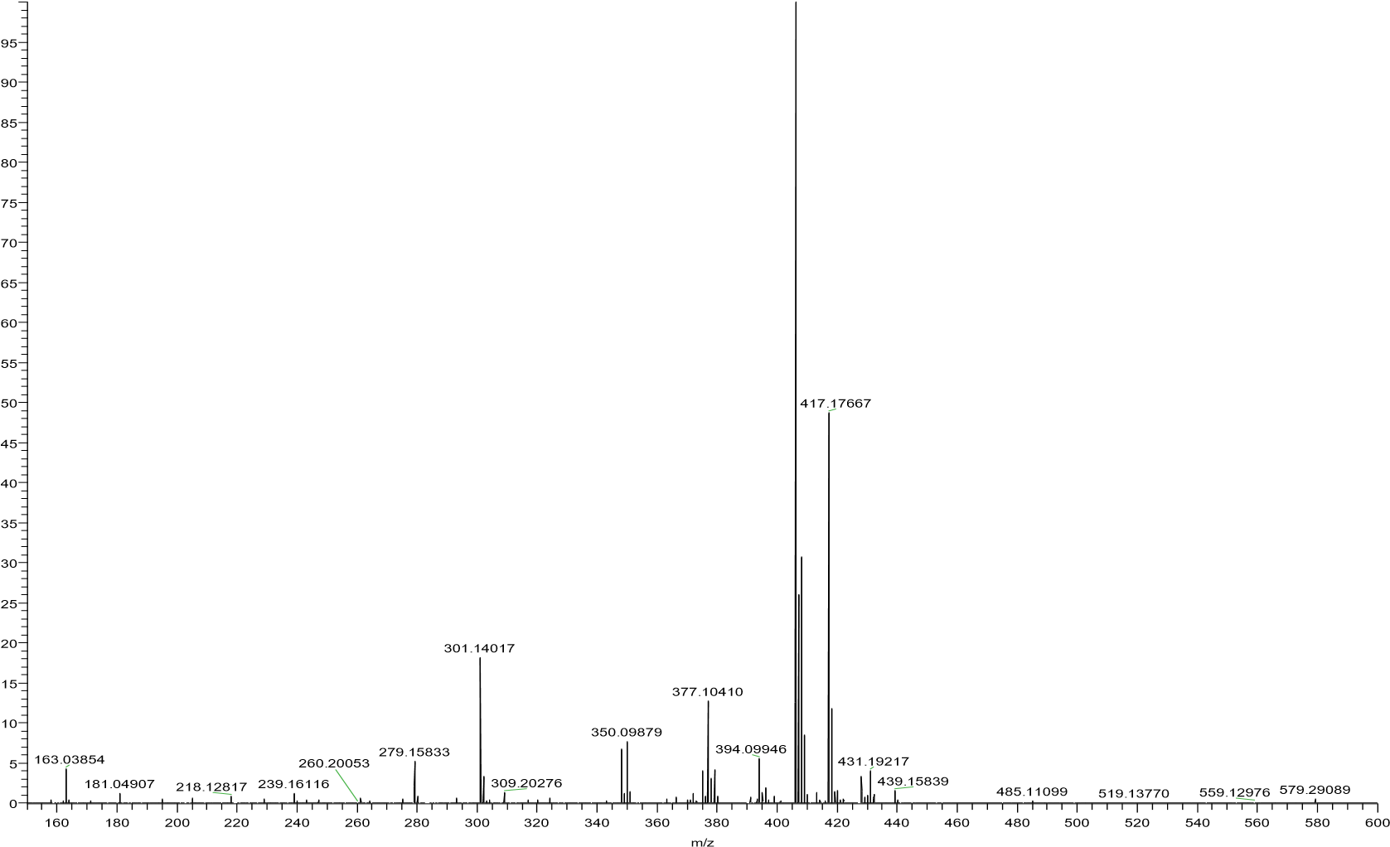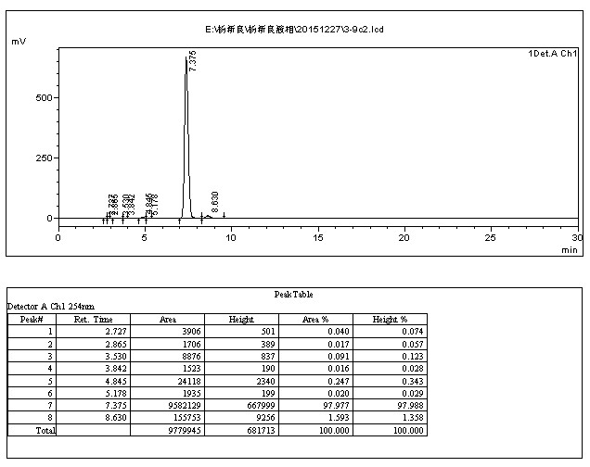

4.2.22 N-((4-(benzyloxy)-6-methoxyquinolin-2-yl)methyl)-2-chloroaniline(9j)
Compound 8a 0.3 g (1.06 mmol) was placed in a 50 ml single-necked flask, dissolve it with 20 ml dioxane, add 0.39 g (3.18 mmol) of 4-methoxylaniline, 0.5 g of potassium carbonate, 0.05 g of potassium iodide in turn, and stir at 80 ℃ for 24 hours. After the reaction is complete, concentrate dioxane, add 60 ml of water, and extract with 60 ml of ethyl acetate. Concentrate the organic layer to obtain 0.8 g of oil, mix the sample with 3.0 g of 300-400 mesh silica gel, pack 50 g of 300-400 mesh silica gel into a column, elute with petroleum ether and ethyl acetate (v: v=10:1) to obtain 0.25 g of white solid in 70.1% yield, mp: 102.9-104.2 ℃, HPLC purity: 98.24% (liquid phase condition A), ¹H NMR (500 MHz, DMSO- d6) δ 7.94 – 7.87 (m, 1H), 7.52 (d, J = 7.1 Hz, 2H), 7.44 – 7.37 (m,4H), 7.37 – 7.32 (m, 1H), 7.30 (dd, J = 7.9, 1.4 Hz, 1H), 7.19 (s, 1H), 7.10 – 7.04 (m,1H), 6.68 (dd, J = 8.2, 1.2 Hz, 1H), 6.60 (td, J = 7.7, 1.3 Hz, 1H), 6.38 (s, 1H), 5.36 (s,2H), 4.55 (s, 2H), 3.87 (s, 3H). ¹³C NMR (125 MHz, DMSO- d6) δ 160.91, 158.14,157.37, 144.27, 136.36, 129.45, 129.06(2C), 128.65, 128.49, 128.21(2C), 122.49,122.46, 121.31, 118.53, 117.36, 112.16, 100.86, 100.43, 99.99, 70.35, 55.91, 48.94.HRMS (ESI) m/z calcd for [C16H13NO2+H]+, 405.1364; found, 405.13498 [M+H] +.
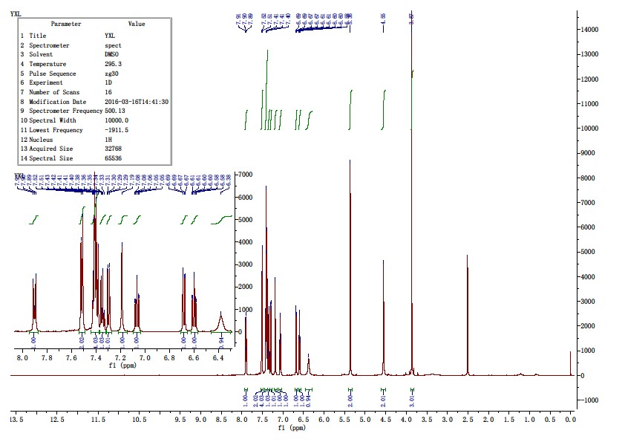
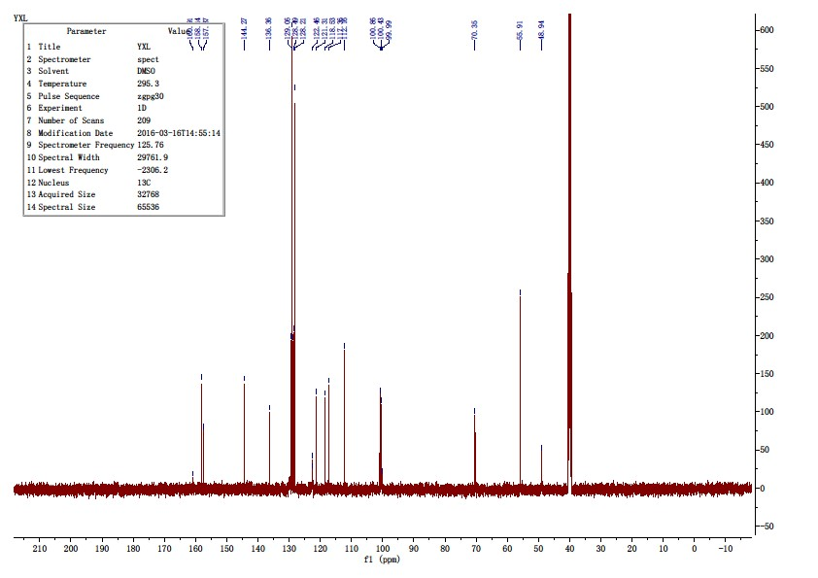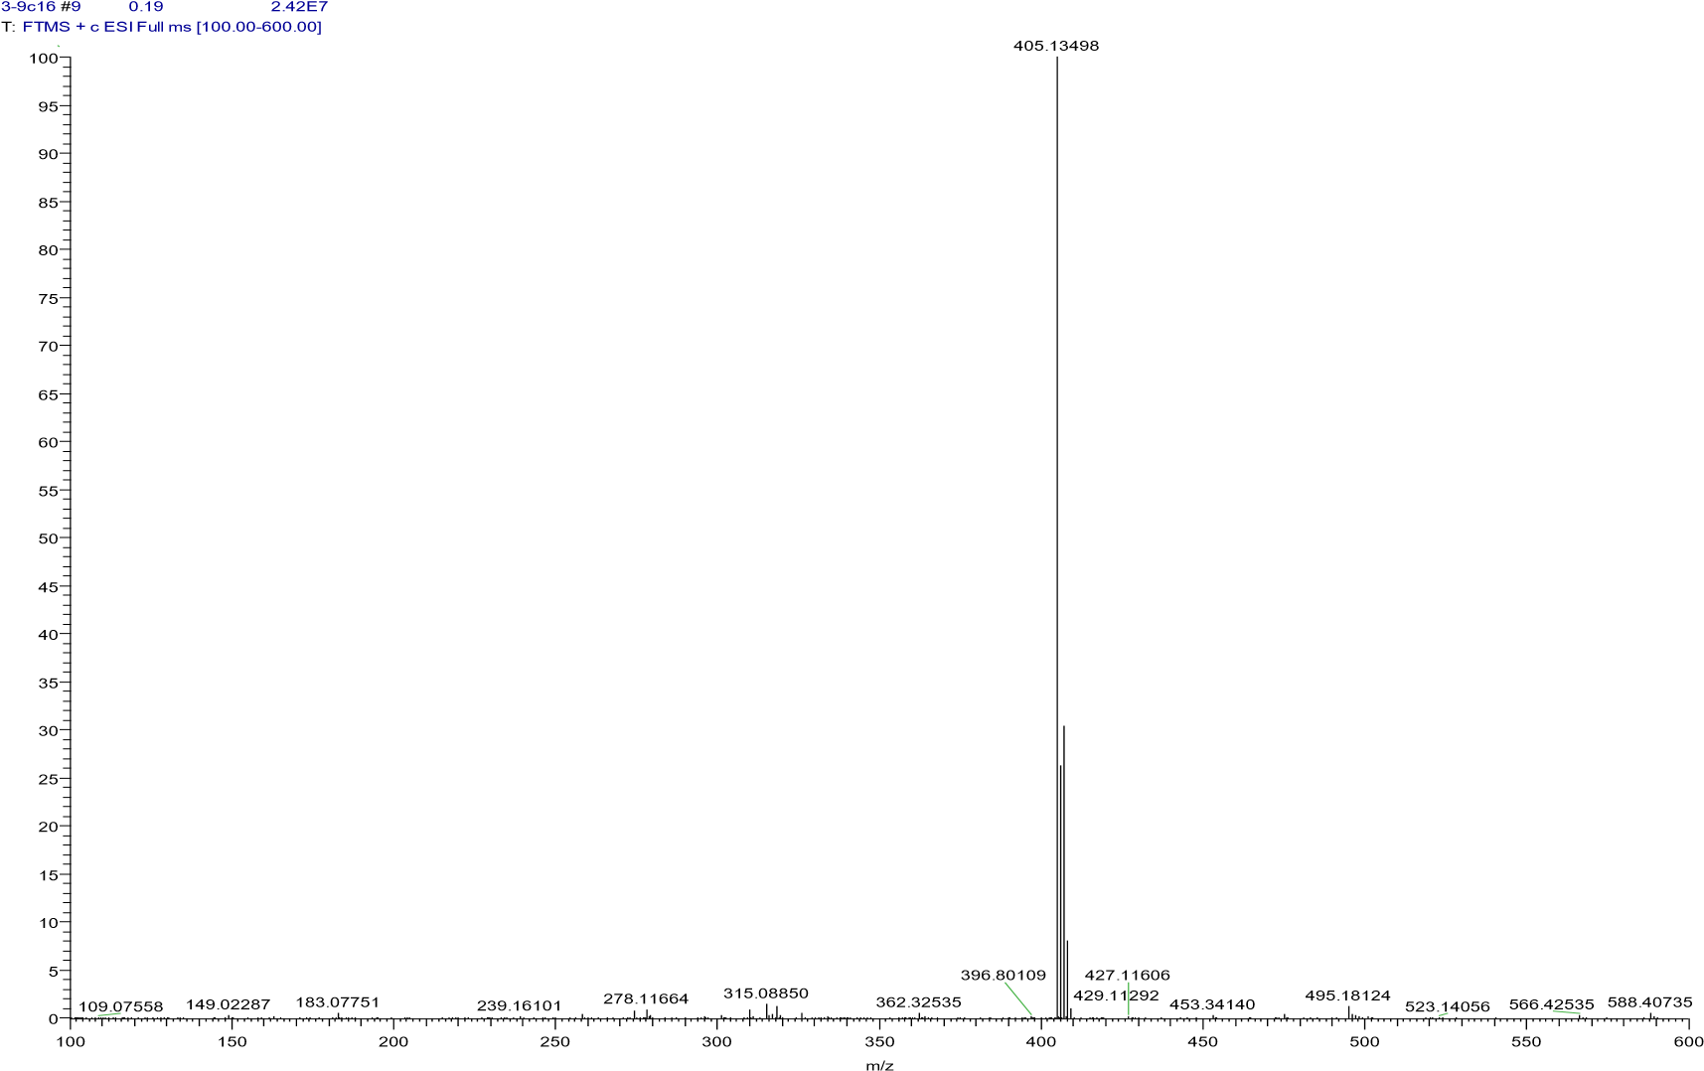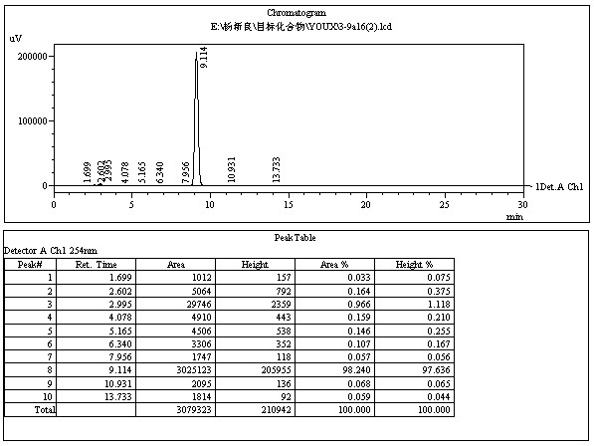
16

4.3.1 2-(phenoxymethyl)quinolin-4(1H)-one(10a)
Compound 9a 0.2 g(0.59 mmol)was placed in a 50 ml reactor and 15 ml of tetrahydrofuran, 15 ml of methanol and 0.01 g of 10% Pd-C were added sequentially, the reactor was placed in a medium pressure hydrogenator and reacted under 0.1 Mpa H2 for 2 h. After reaction, filter and concentrate to obtain 0.15 g of gray white solid, recrystallize with 15 ml of absolute ethanol to obtain 0.13 g of white solid, yield: 87.2%, mp: 254.2-257.4 ℃, HPLC purity: 97.70% (liquid phase condition A), ¹H NMR (500 MHz, DMSO- d6) δ 11.89 (s, 1H), 8.07(d, J = 8.1 Hz, 1H), 7.70 – 7.61 (m, 2H), 7.38 – 7.29 (m, 3H), 7.08 (dd, J = 8.7, 0.9Hz, 2H), 7.00 (t, J = 7.3 Hz, 1H), 6.20 (s, 1H), 5.13 (s, 2H). ¹³C NMR (125 MHz,DMSO- d6) δ 177.48, 158.15, 148.37, 140.65, 132.33, 130.10(2C), 125.48, 125.30(2C),123.61, 121.88, 118.78, 115.30, 108.15, 66.69. HRMS (ESI) m/z calcd for[C16H13NO2+H]+, 252.1019; found, 252.10146 [M+H] +.
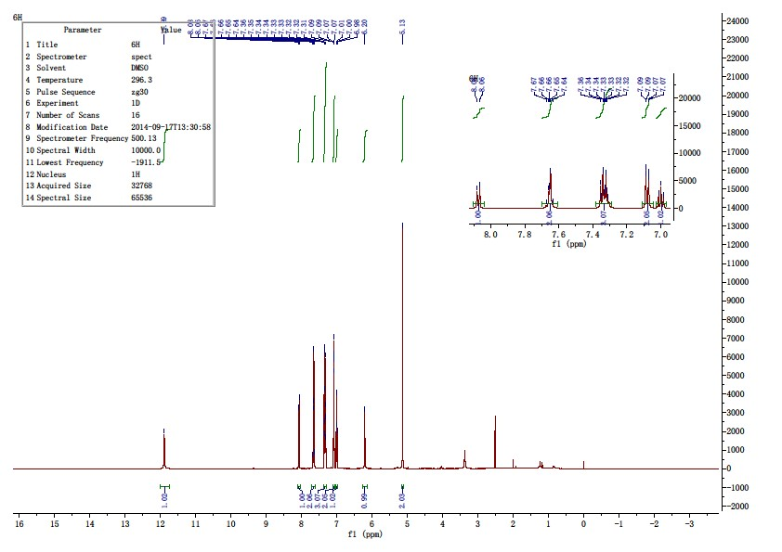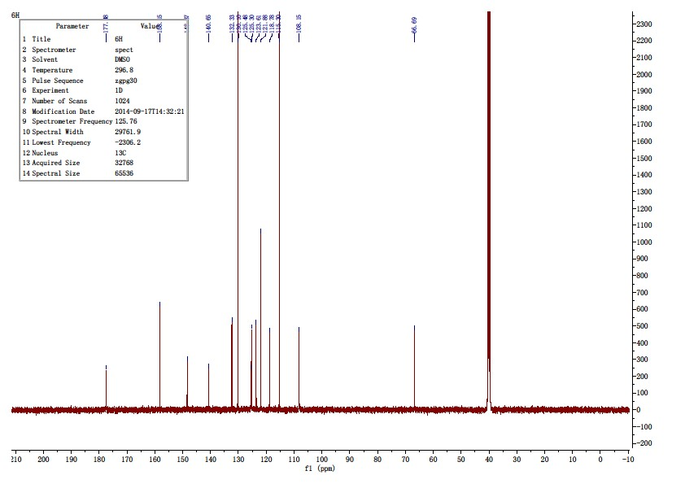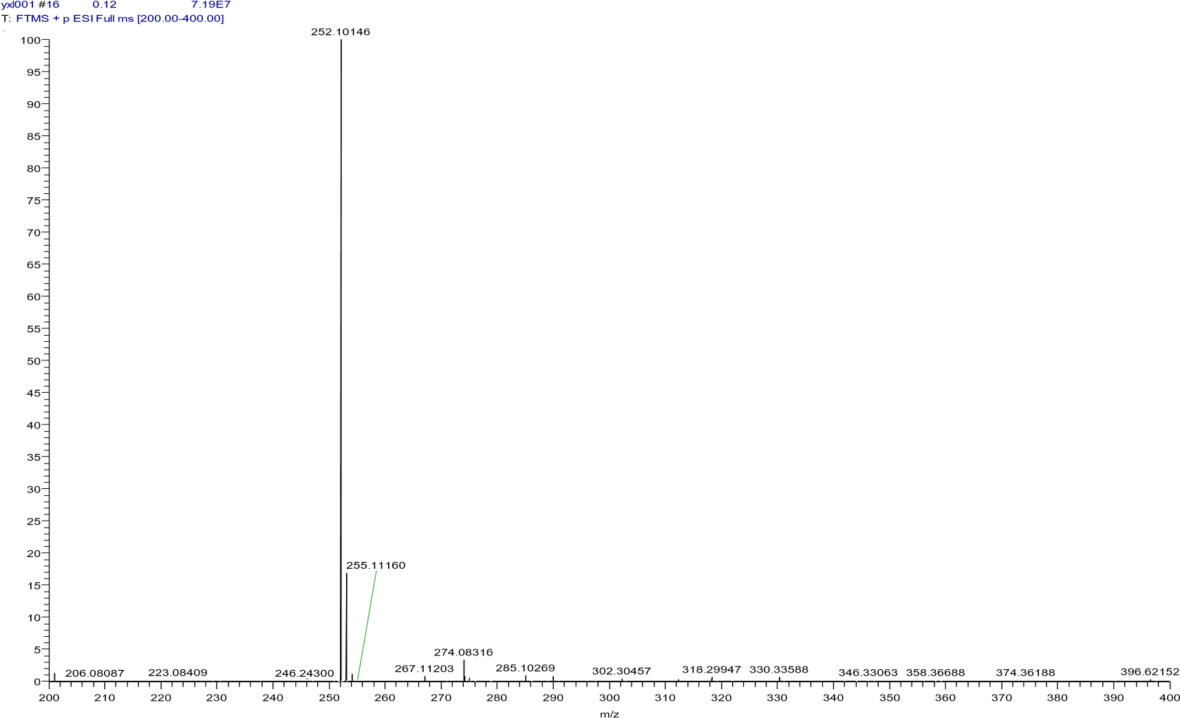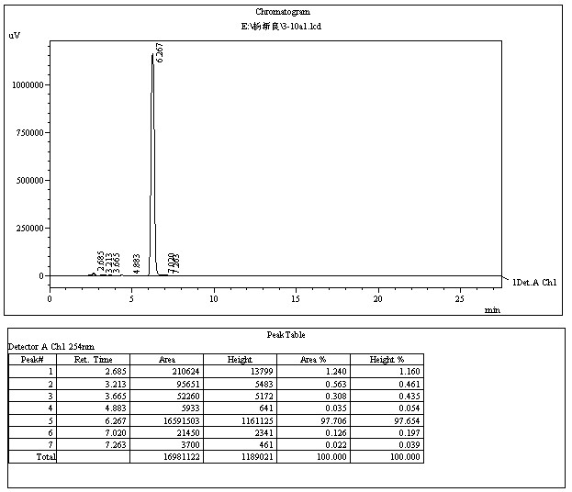

4.3.2 2-((2-chlorophenoxy)methyl)quinolin-4(1H)-one(10b)
The title compound was prepared in the manner similar to compound 10a. White solid, yield: 84.3%, mp: 254.1-256.4 ℃, HPLC purity: 98.91% (liquid phase condition A), ¹H NMR (500 MHz, DMSO- d6) δ 11.88 (s, 1H), 8.07 (d, J = 8.0 Hz, 1H), 7.67 (ddd, J = 8.3, 7.0, 1.4 Hz, 1H), 7.61 (d, J= 8.0 Hz, 1H), 7.49 (dd, J = 7.9, 1.4 Hz, 1H), 7.38 – 7.30 (m, 2H), 7.25 (dd, J = 8.3,1.2 Hz, 1H), 7.03 (t, J = 7.6 Hz, 1H), 6.21 (s, 1H), 5.21 (s, 2H). ¹³C NMR (125 MHz,DMSO- d6) δ 177.50, 153.56, 147.84, 140.60, 132.42, 130.68, 128.89, 125.49, 125.35,123.65, 122.92, 122.13, 118.74, 114.81, 108.07, 67.52. HRMS (ESI) m/z calcd for[C16H12ClNO2+H]+, 286.0629; found, 286.06189 [M+H] +.
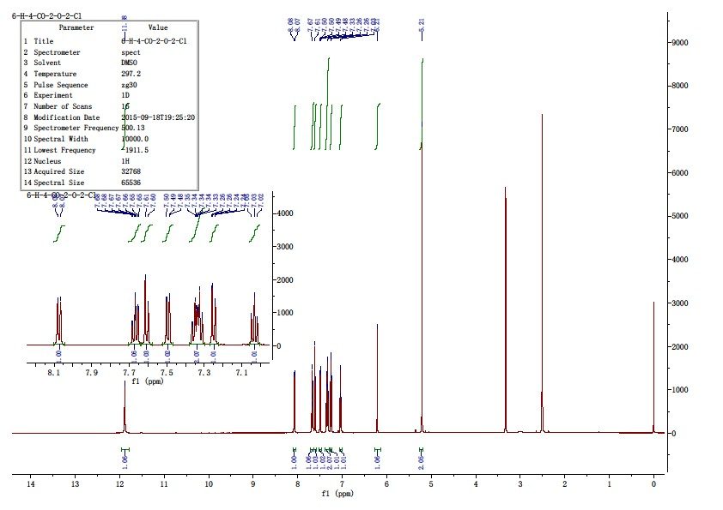
4.3.3 2-((3-chlorophenoxy)methyl)quinolin-4(1H)-one(10c)
The title compound was prepared in the manner similar to compound 10a. White solid, yield: 86.1%, mp: 240.3-242.5 ℃, HPLC purity: 98.22% (liquid phase condition A), ¹H NMR (500 MHz, DMSO- d6) δ 11.83 (s, 1H), 8.08 (d, J = 8.2 Hz, 1H), 7.69 – 7.61 (m, 2H), 7.36 (t, J = 8.2 Hz, 1H),7.32 (t, J = 7.2 Hz, 1H), 7.19 (t, J = 2.1 Hz, 1H), 7.10 – 7.04 (m, 2H), 6.20 (s, 1H),5.16 (s, 2H). ¹³C NMR (125 MHz, DMSO- d6) δ 177.49, 159.10, 147.76, 140.65,134.28, 132.37, 131.49, 125.50, 125.32, 123.65, 121.89, 118.77, 115.53, 114.41,108.34, 67.17. HRMS (ESI) m/z calcd for [C16H12ClNO2+H]+, 286.0629; found,286.06207 [M+H] +.

4.3.4 2-((4-chlorophenoxy)methyl)quinolin-4(1H)-one(10d)
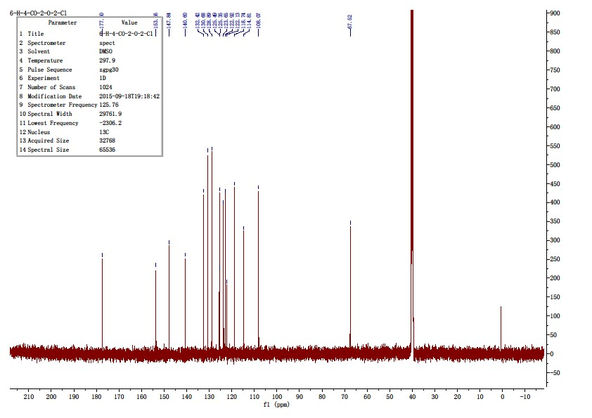
The title compound was prepared in the manner similar to compound 10a. White solid, yield: 86.4%, mp: 268.8-270.5 ℃, HPLC purity: 98.78% (liquid phase condition A), ¹H NMR (400 MHz, DMSO- d6) δ 11.90 (s, 1H), 8.07 (d, J = 7.8 Hz, 1H), 7.72 – 7.61 (m, 2H), 7.44 – 7.35 (m, 2H), 7.33(ddd, J = 8.1, 6.0, 2.0 Hz, 1H), 7.15 – 7.07 (m, 2H), 6.21 (s, 1H), 5.14 (s, 2H). ¹³C NMR (100 MHz, DMSO- d6) δ 177.21, 157.01, 148.13, 140.71, 132.38, 129.86(2C),125.64, 125.25, 123.72, 118.88, 117.15(2C), 115.30, 108.13, 67.17. HRMS (ESI) m/zcalcd for [C16H12ClNO2+H]+, 286.0629; found,
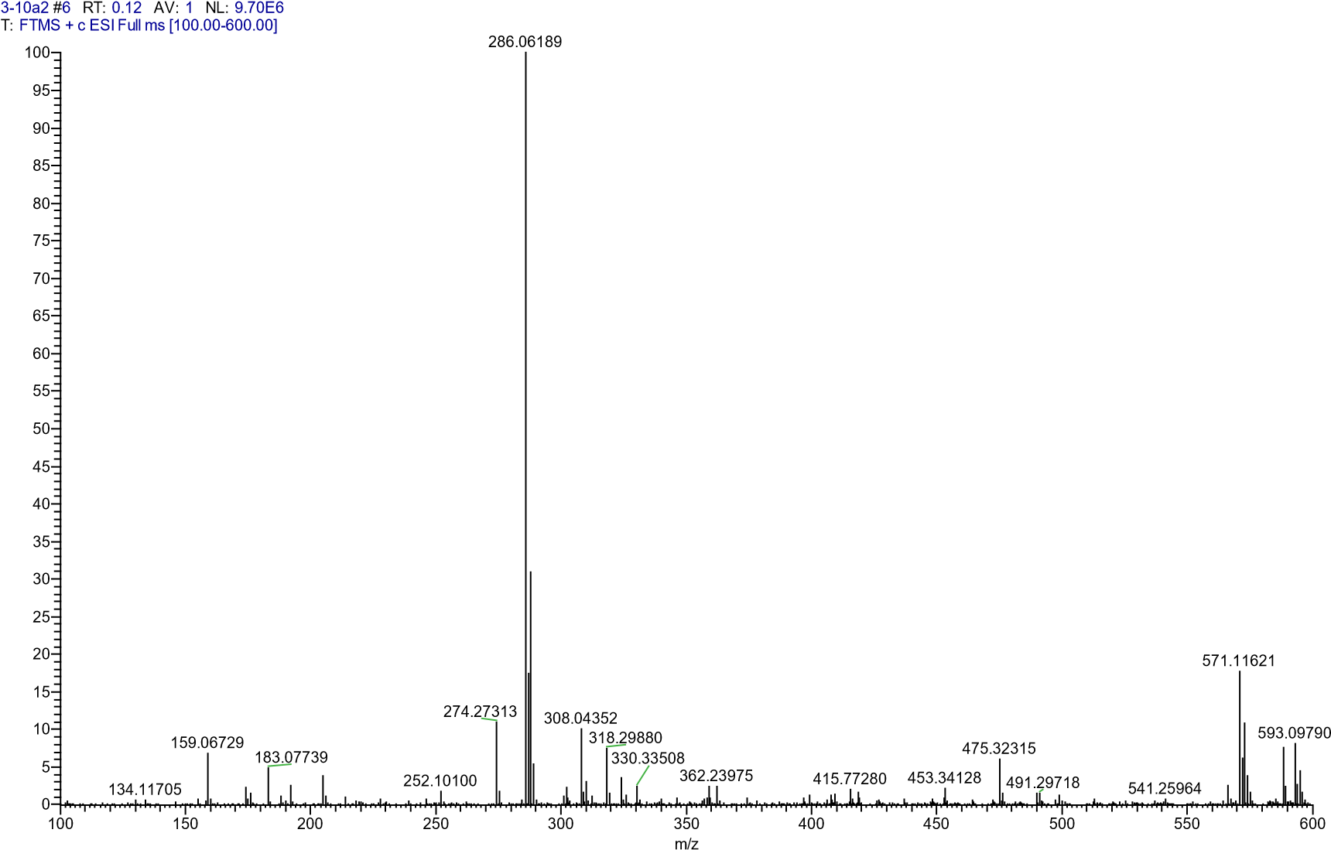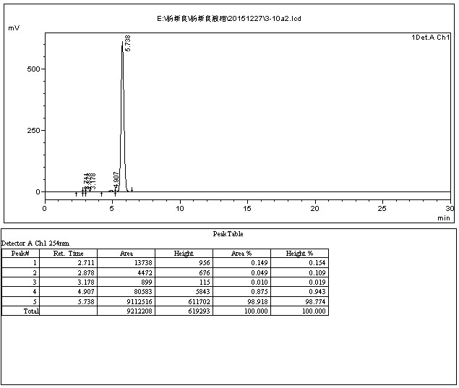

4.3.5 2-((3-chlorophenoxy)methyl)quinolin-4(1H)-one10c)
The title compound was prepared in the manner similar to compound 10a. White solid, yield: 86.1%, mp: 240.7-242.5 ℃, HPLC purity: : 98.22% (liquid phase condition A), 1H NMR (500 MHz, DMSO- d6) δ 11.83 (s, 1H), 8.08 (d, J = 8.2 Hz, 1H), 7.69 – 7.61 (m, 2H), 7.36 (t, J = 8.2 Hz, 1H), 7.32 (t, J = 7.2 Hz, 1H), 7.19 (t, J = 2.1 Hz, 1H), 7.10 – 7.04 (m, 2H), 6.20 (s, 1H), 5.16 (s, 2H). 13C NMR (125 MHz, DMSO- d6) δ 177.49, 159.10, 147.76, 140.65, 134.28, 132.37, 131.49, 125.50, 125.32, 123.65, 121.89, 118.77, 115.53, 114.41, 108.34, 67.17. HRMS (ESI) m/z calcd for [C16H12ClNO2+H]+, 286.0629; found, 286.06207 [M+H]+ 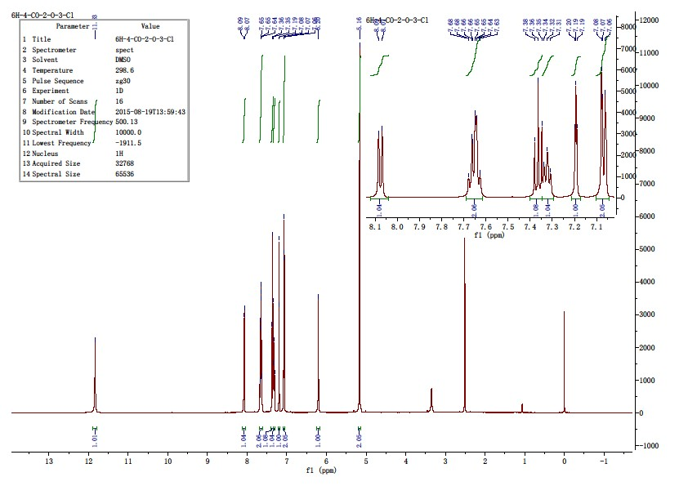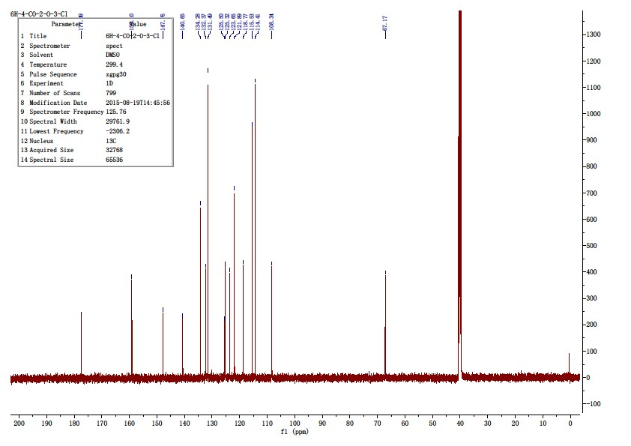

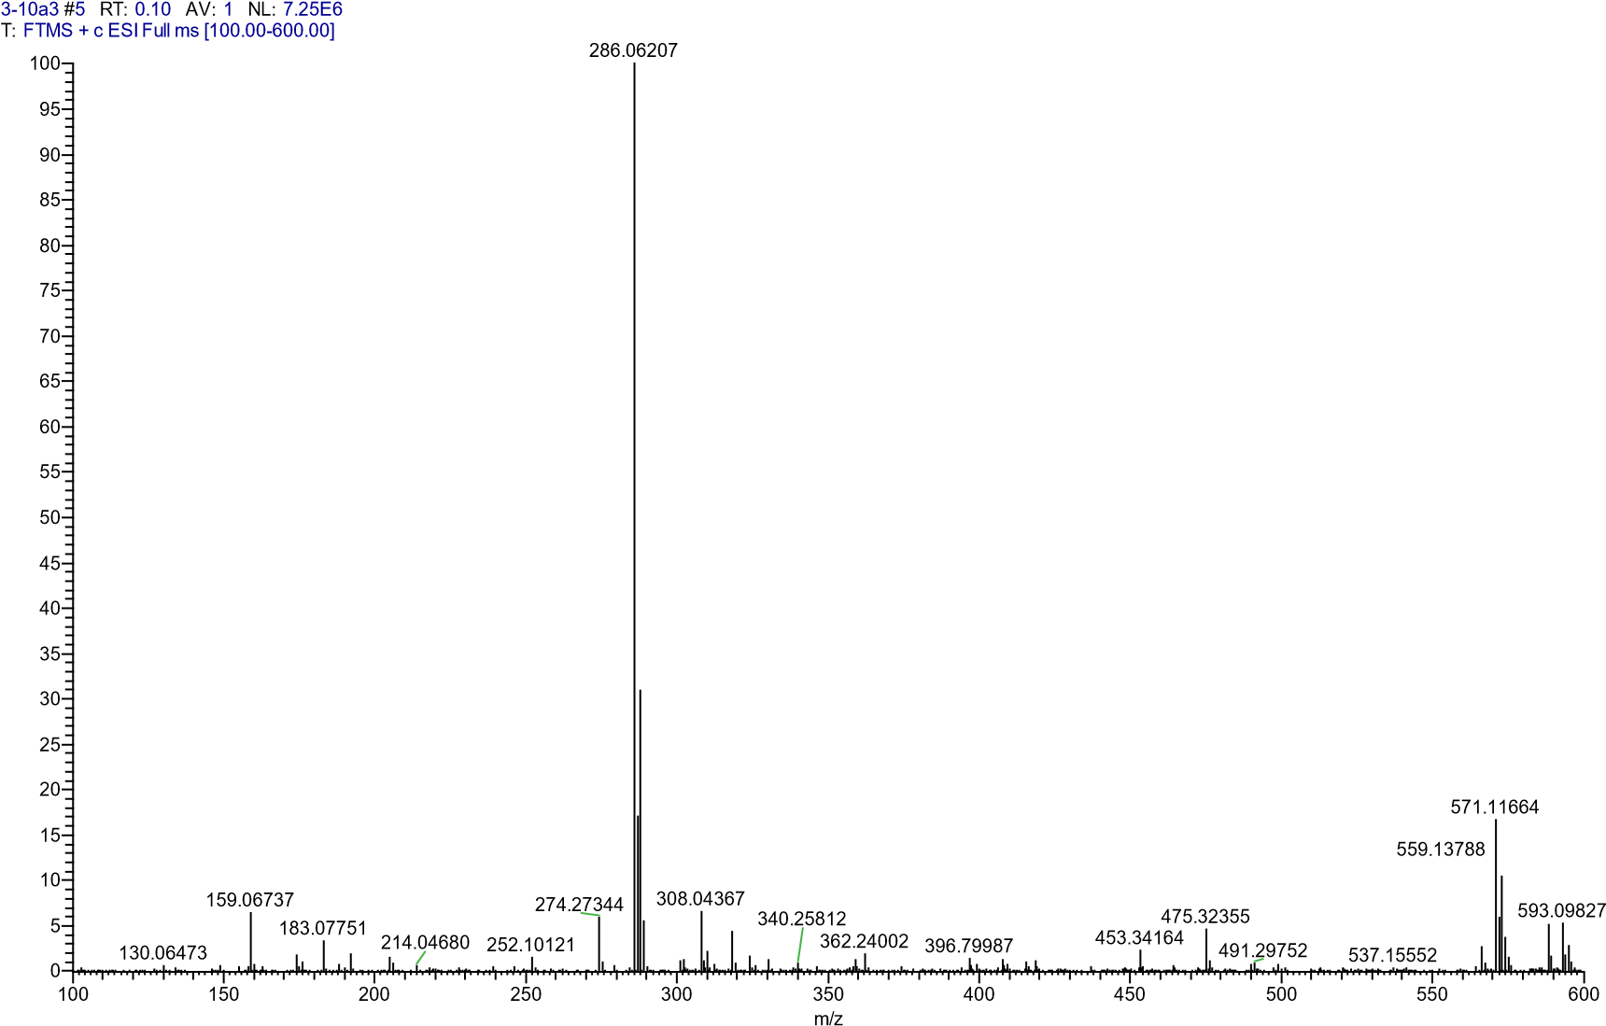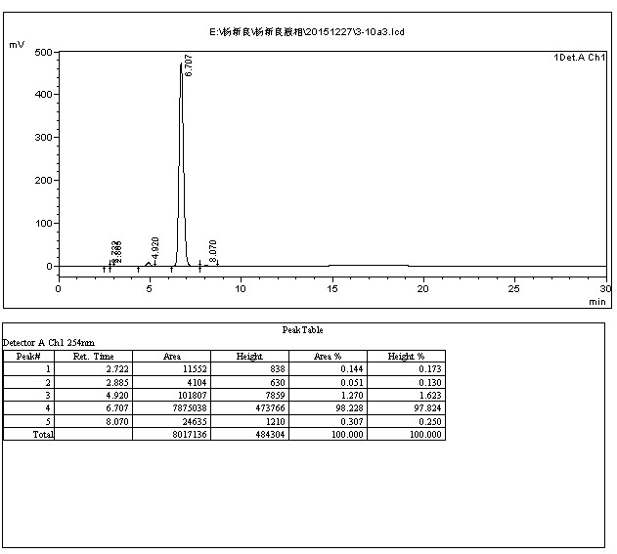
4.3.5 2-((4-chlorophenoxy)methyl)quinolin-4(1H)-one (10d)
The title compound was prepared in the manner similar to compound 10a. White solid, yield: 86.4%, mp: 268.8-270.5 ℃, HPLC purity: 98.78% (liquid phase condition A), ¹H NMR (400 MHz, DMSO- d6) δ 11.90 (s, 1H), 8.07 (d, J = 7.8 Hz, 1H), 7.72 – 7.61 (m, 2H), 7.44 – 7.35 (m, 2H), 7.33 (ddd, J = 8.1, 6.0, 2.0 Hz, 1H), 7.15 – 7.07 (m, 2H), 6.21 (s, 1H), 5.14 (s, 2H). ¹³C NMR (100 MHz, DMSO- d6) δ 177.21, 157.01, 148.13, 140.71, 132.38, 129.86(2C), 125.64, 125.25, 123.72, 118.88, 117.15(2C), 115.30, 108.13, 67.17. HRMS (ESI) m/zcalcd for [C16H12ClNO2+H]+, 286.0629; found, 286.06192 [M+H] +.
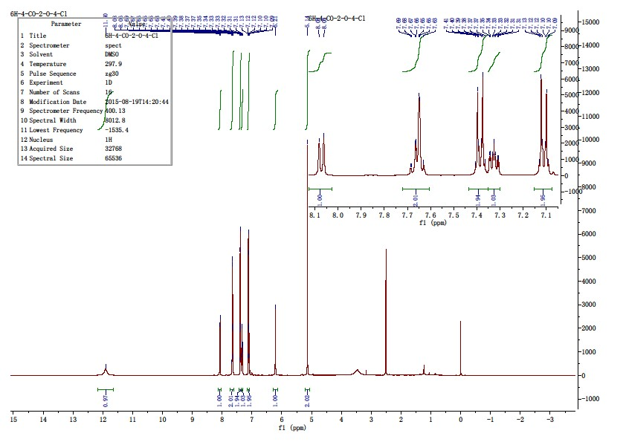

附图

53
化合物
-
4
氢谱

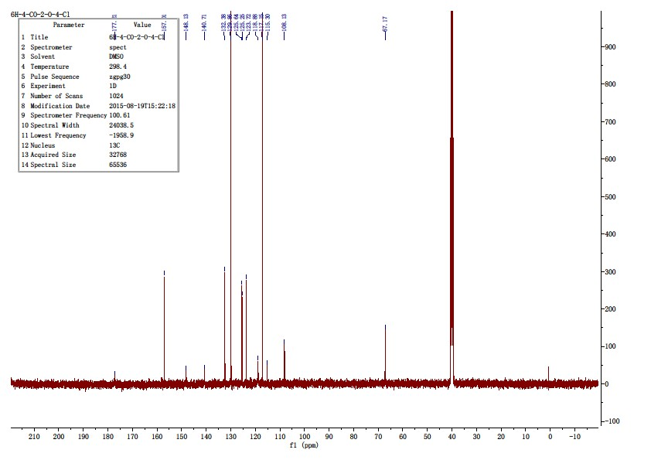
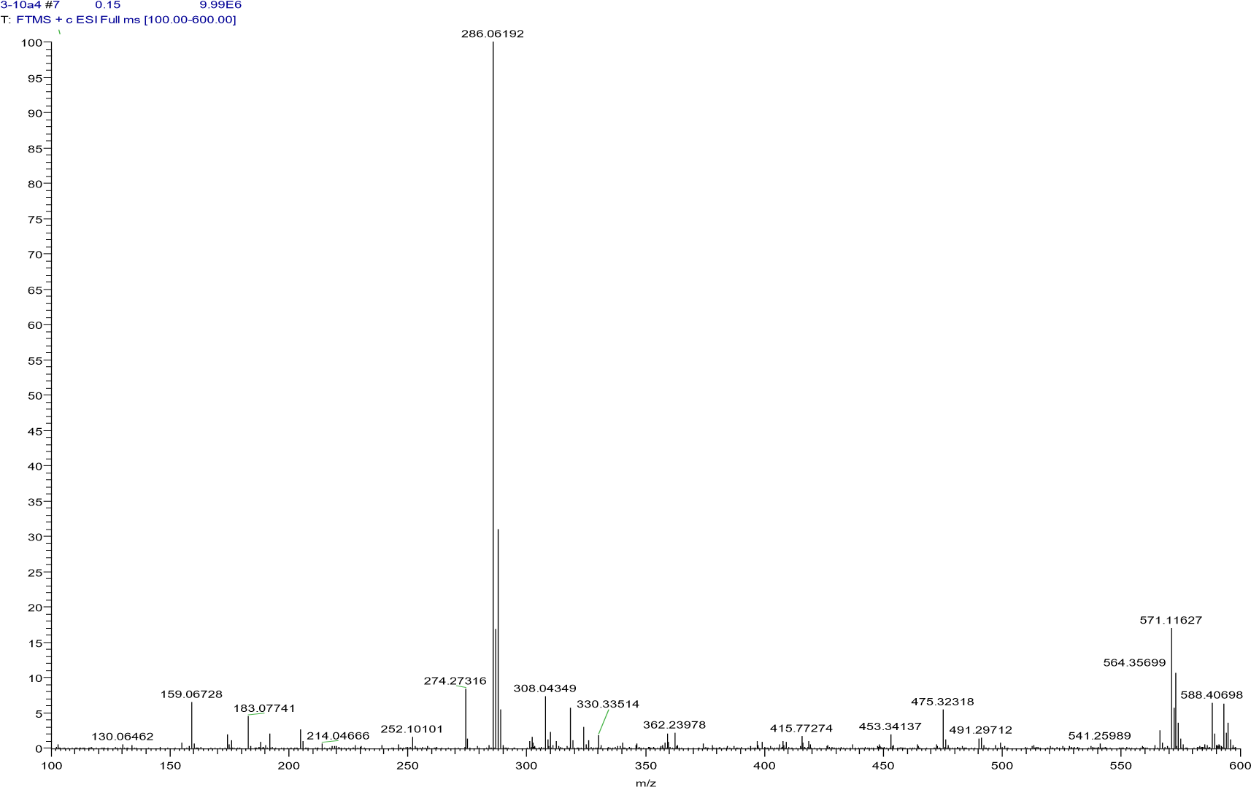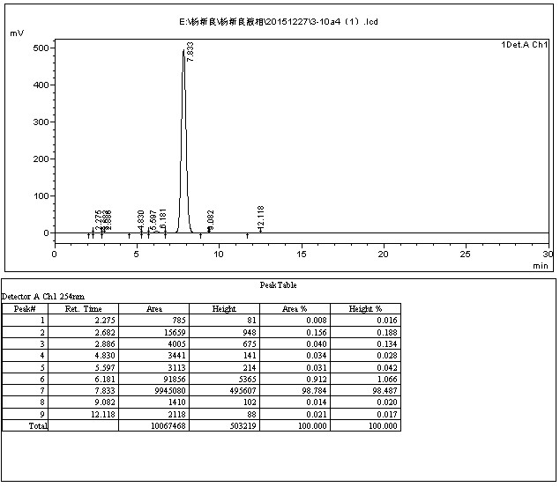
4.3.5 2-((2-fluorophenoxy)methyl)quinolin-4(1H)-one(10e)
The title compound was prepared in the manner similar to compound 10a. White solid, yield: 88.2%, mp: 239.7-242.1 ℃, HPLC purity: 99.20% (liquid phase condition A), ¹H NMR (400 MHz, DMSO- d6) δ 11.92 (s, 1H), 8.08 (d, J = 8.2 Hz, 1H), 7.70 – 7.60 (m, 2H), 7.29 (m, 3H), 7.16 (t, J =7.8 Hz, 1H), 7.01 (ddd, J = 11.2, 7.0, 4.0 Hz, 1H), 6.22 (s, 1H), 5.19 (s, 2H). ¹³C NMR (100 MHz, DMSO- d6) δ 177.53, 152.28(d, J = 246.44 Hz), 147.74, 146.04 (d, J= 10.4 Hz), 140.65, 132.42, 125.48, 125.37, 125.33, 123.66, 122.54 (d, J = 7.0 Hz),118.79, 116.75 (d, J = 17.8 Hz), 116.00, 108.42, 67.84. HRMS (ESI) m/z calcd for[C16H12FNO2+H]+, 270.0925; found, 270.09264 [M+H] +.
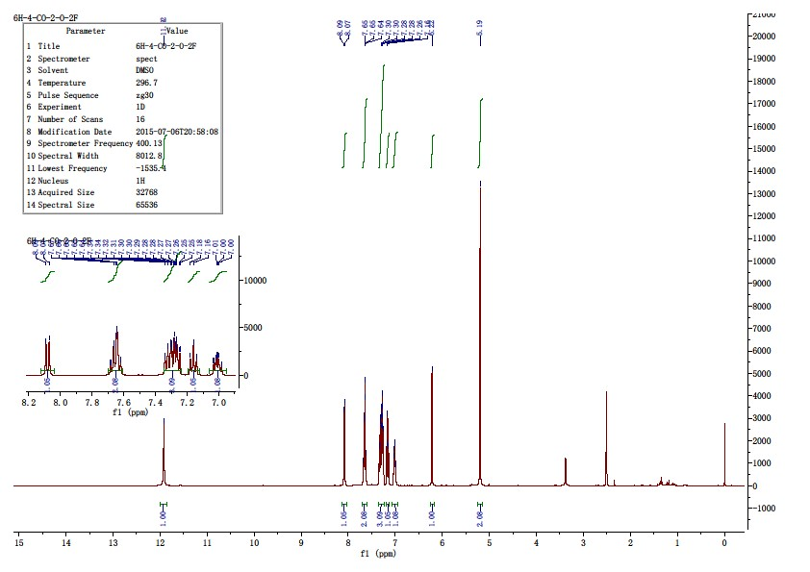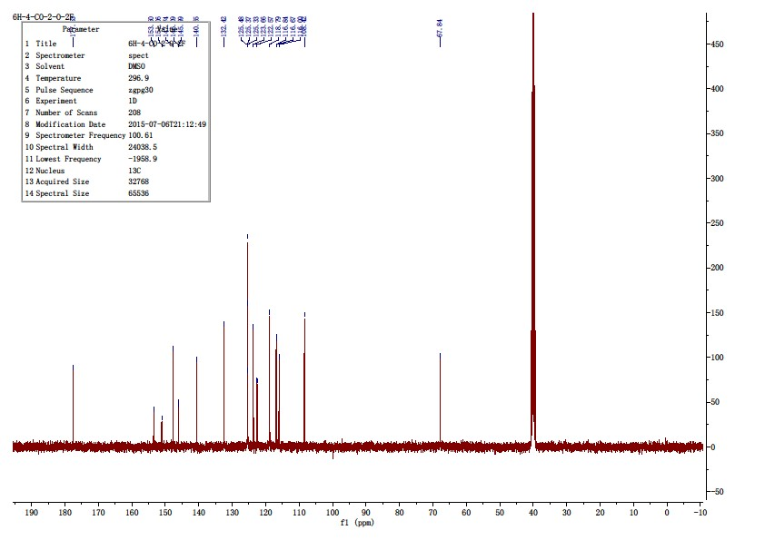

附图

57
化合物
-
a
氢谱

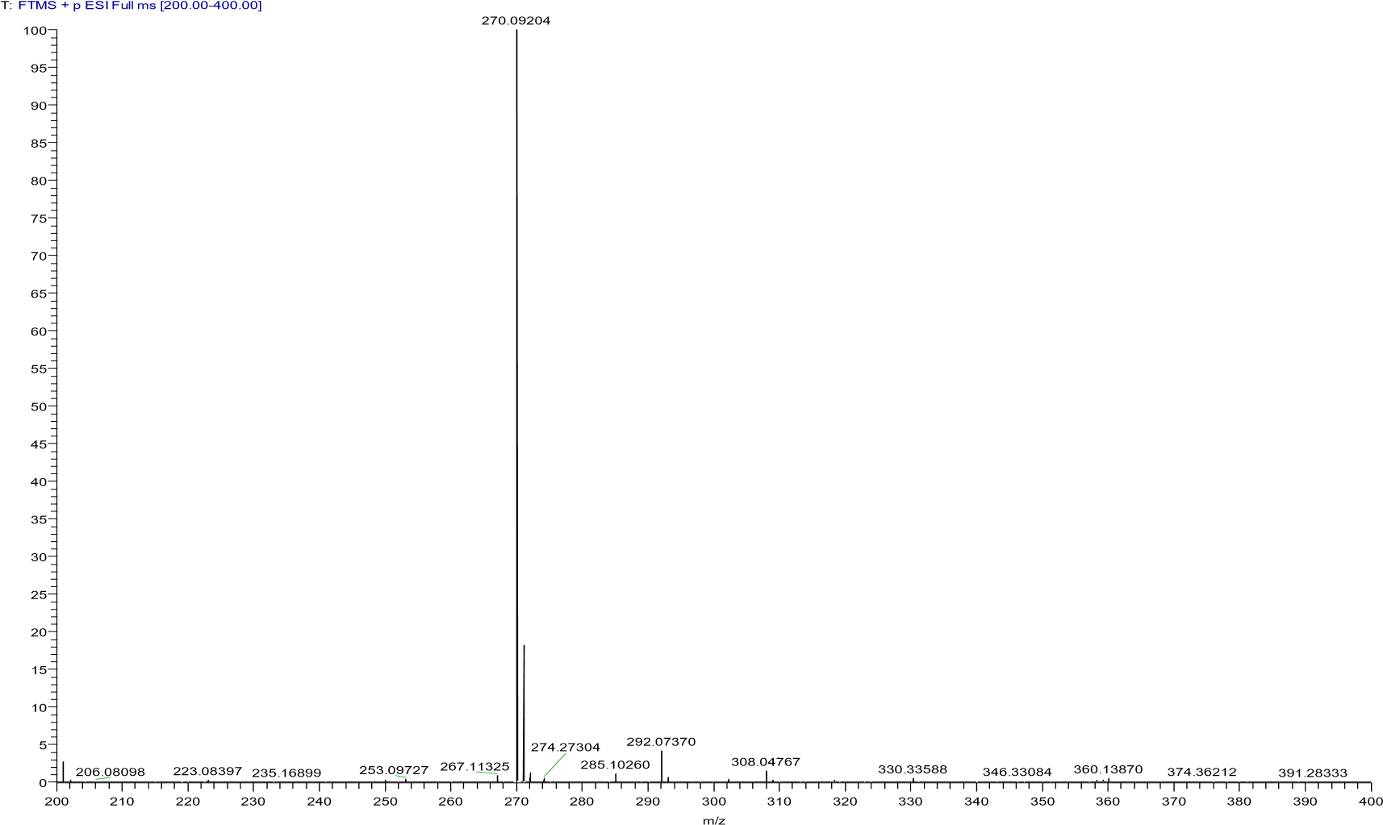
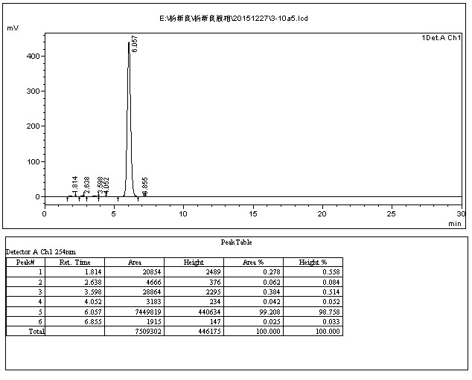
4.3.6 2-((2-(trifluoromethyl)phenoxy)methyl)quinolin-4(1H)-one(10f)
The title compound was prepared in the manner similar to compound 10a. White solid, yield: 89.4%, mp: 260.1-262.3 ℃, HPLC purity: 98.31% (liquid phase condition A), ¹H NMR (500 MHz, DMSO- d6) δ 11.87 (s, 1H), 8.07 (d, J = 7.9 Hz, 1H), 7.68 (dd, J = 15.5, 7.5 Hz, 3H), 7.58 (d, J =8.3 Hz, 1H), 7.33 (dd, J = 12.5, 7.9 Hz, 2H), 7.18 (t, J = 7.5 Hz, 1H), 6.18 (s, 1H),5.28 (s, 2H). ¹³C NMR (125 MHz, DMSO- d6) δ 177.48, 155.79, 147.82, 140.52,134.87, 132.47, 127.48(q, J = 5.04Hz), 125.45, 125.36, 124.17(q, J = 272.16Hz),123.68, 121.69, 118.68, 117.83(q, J = 30.24Hz), 114.33, 107.58, 66.95. HRMS (ESI)m/z calcd for [C17H12F3NO2+H]+, 320.0893; found, 320.08887 [M+H] +.
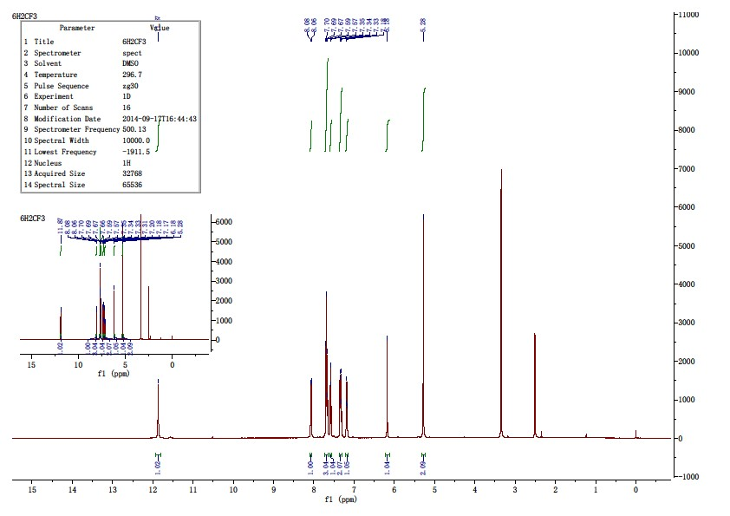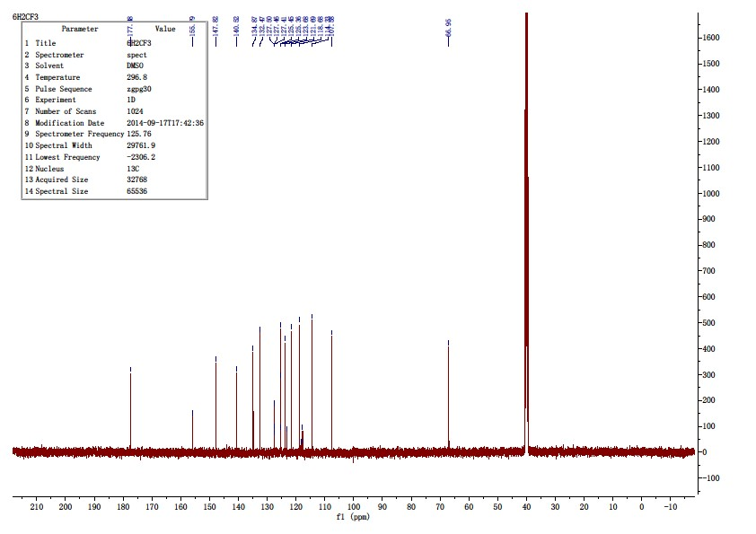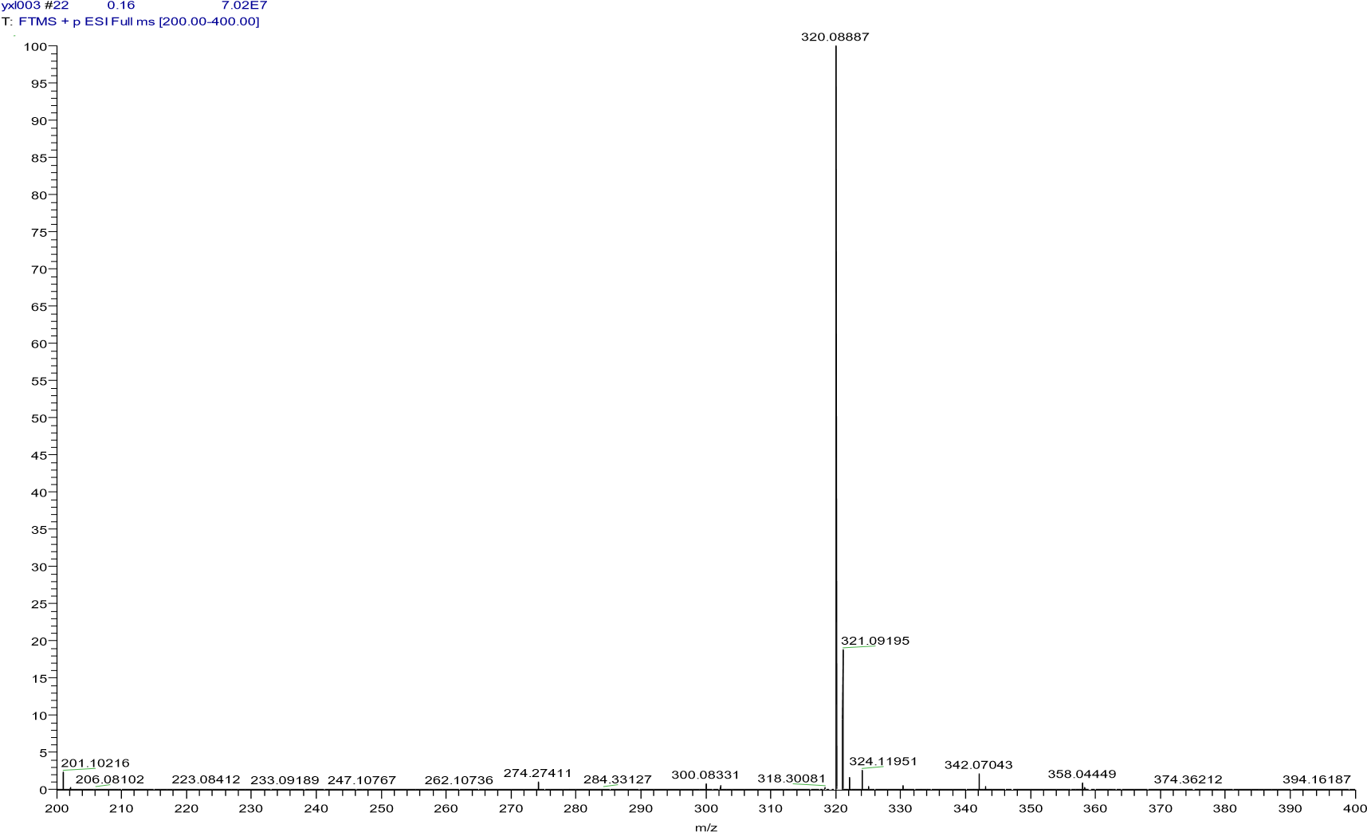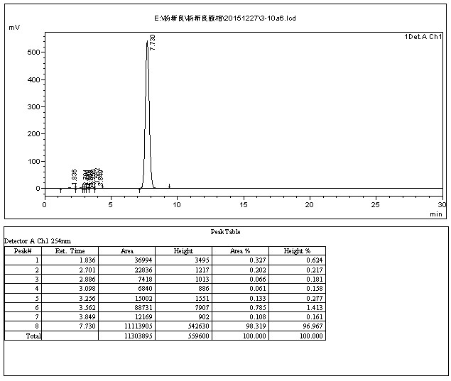

附图
61
化合物
-
6
氢谱

4.3.7 2-((2-methoxyphenoxy)methyl)quinolin-4(1H)-one(10g)
The title compound was prepared in the manner similar to compound 10a. White solid, yield: 90.2%, mp: 175.4 - 177.5 ℃, HPLC purity: 98.92% (liquid phase condition A), ¹H NMR (400 MHz, DMSO- d6) δ 11.86 (s, 1H), 8.07 (d, J = 8.1 Hz, 1H), 7.71 – 7.58 (m, 2H), 7.32 (dd, J = 10.5, 3.9Hz, 1H), 7.05 (ddd, J = 13.6, 8.0, 1.4 Hz, 2H), 6.97 (td, J = 7.7, 1.4 Hz, 1H), 6.90 (td,J = 7.7, 1.6 Hz, 1H), 6.18 (s, 1H), 5.08 (s, 2H), 3.80 (s, 3H). ¹³C NMR (100 MHz,DMSO- d6) δ 177.49, 149.75, 148.44, 147.55, 140.62, 132.34, 125.47, 125.31,123.59, 122.56, 121.12, 118.77, 114.71, 112.88, 108.25, 67.71, 55.96. HRMS (ESI)m/z calcd for [C17H15NO3+H]+, 282.1125; found, 282.11288 [M+H] +.
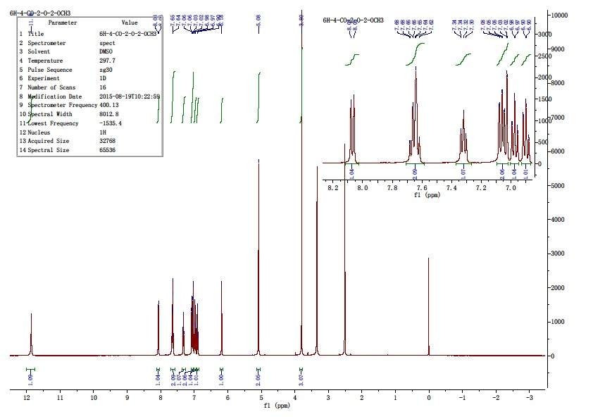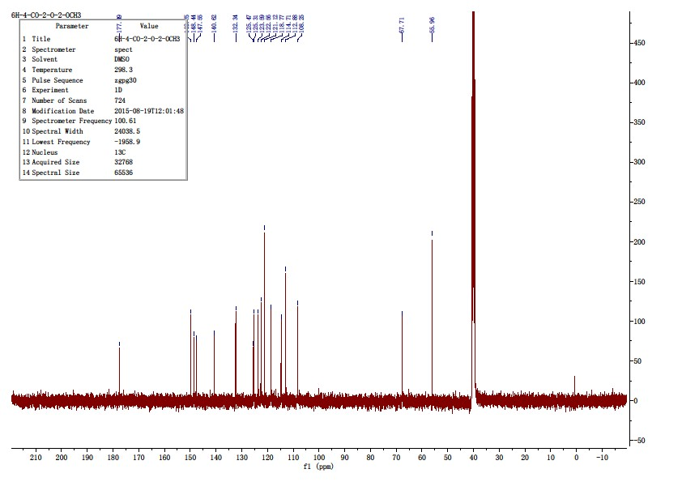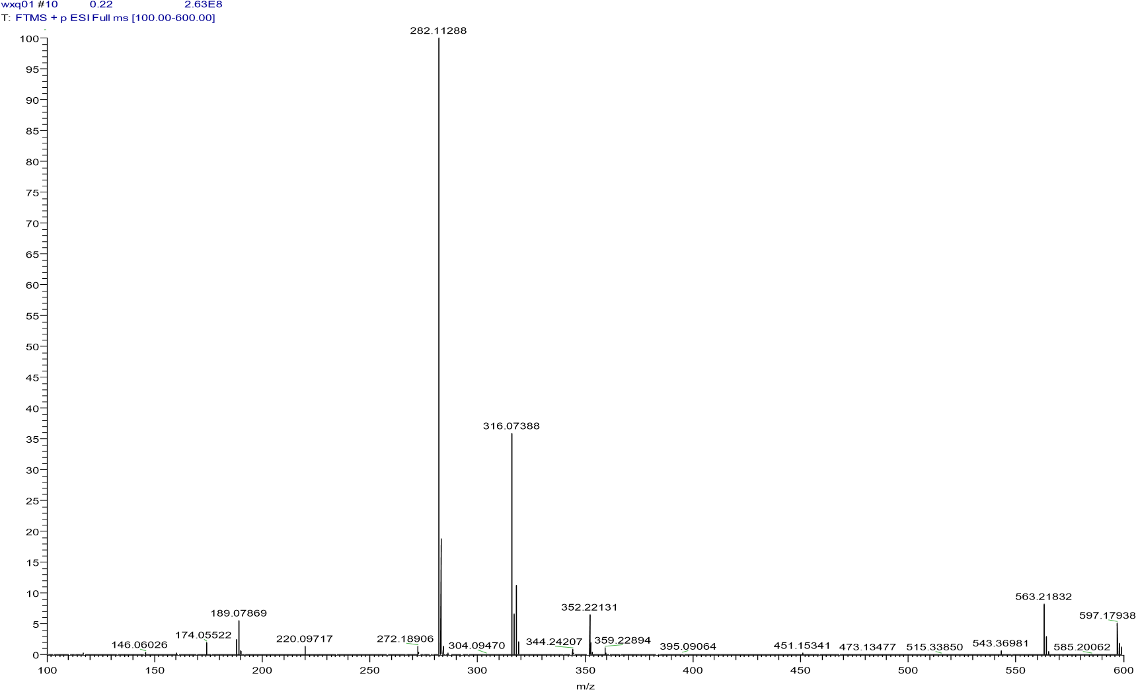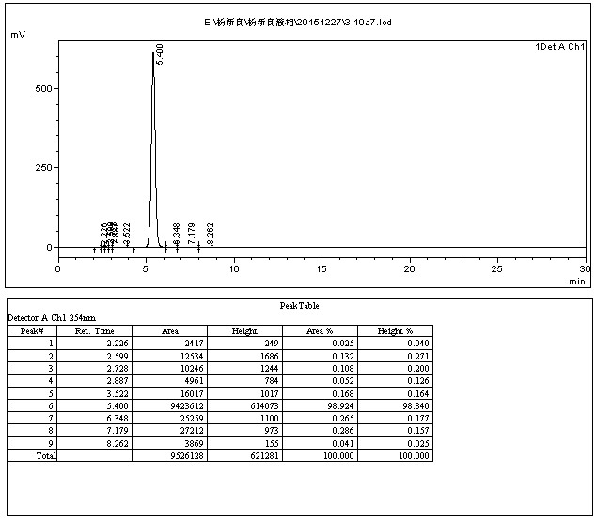

附图
65
氢谱

4.3.8 2-((3-methoxyphenoxy)methyl)quinolin-4(1H)-one)(10h)
The title compound was prepared in the manner similar to compound 10a. White solid, yield: 89.8%, mp: 191.8-193.2 ℃, HPLC purity: 98.63% (liquid phase condition A), ¹H NMR (500 MHz, DMSO- d6) δ 11.83 (s, 1H), 8.08 (d, J = 7.9 Hz, 1H), 7.70 – 7.60 (m, 2H), 7.32 (ddd, J = 8.1, 5.9,2.2 Hz, 1H), 7.23 (t, J = 8.4 Hz, 1H), 6.66 (dd, J = 8.2, 1.7 Hz, 2H), 6.59 (dd, J = 7.6,1.8 Hz, 1H), 6.20 (s, 1H), 5.11 (s, 2H), 3.75 (s, 3H). ¹³C NMR (125 MHz, DMSO- d6) δ 177.49, 161.02, 159.38, 148.28, 140.64, 132.32, 130.59, 125.51, 125.31, 123.59,118.77, 108.18, 107.57, 107.43, 101.77, 66.86, 55.65. HRMS (ESI) m/z calcd for[C17H15NO3+H]+, 282.1125; found, 282.11316 [M+H] +.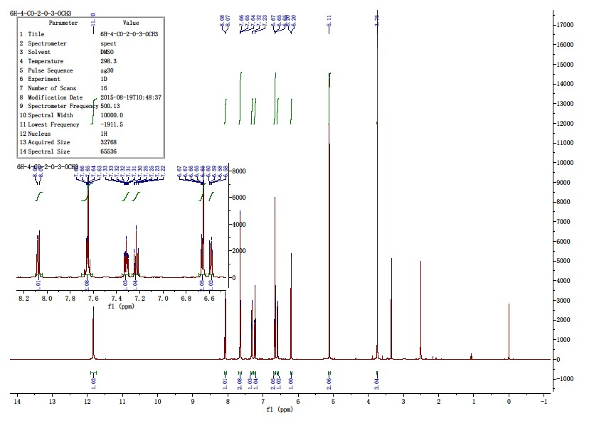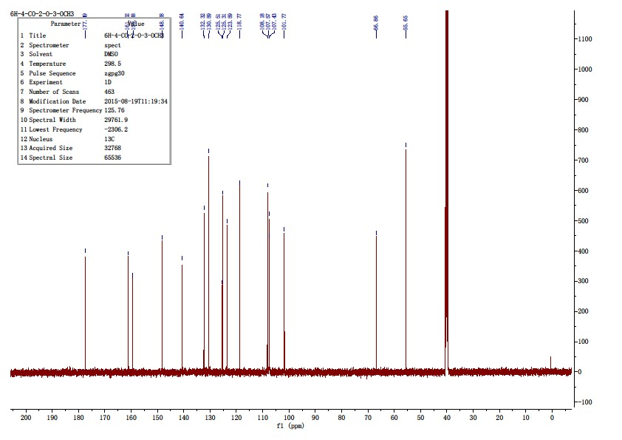

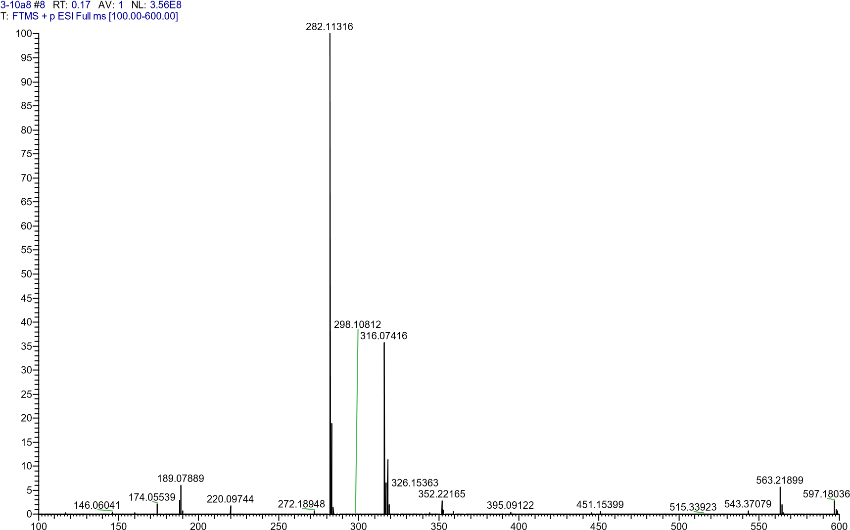
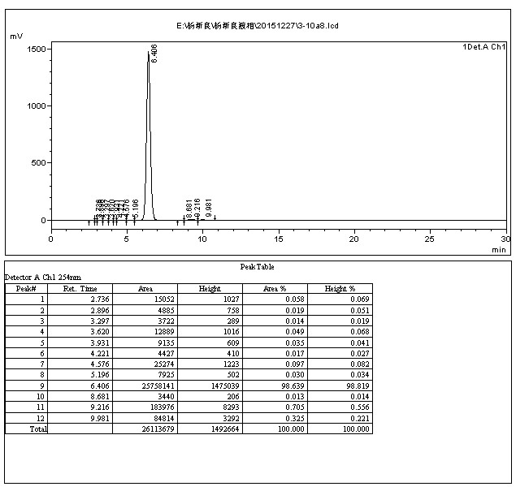

4.3.9 2-((4-methoxyphenoxy)methyl)quinolin-4(1H)-one(10i)
The title compound was prepared in the manner similar to compound 10a. White solid, yield: 88.7%, mp: 209.7-211.6 ℃, HPLC purity: 99.11% (liquid phase condition A), ¹H NMR (400 MHz, DMSO- d6) δ 11.84 (s, 1H), 8.07 (d, J = 8.7 Hz, 1H), 7.65 (d, J = 3.5 Hz, 2H), 7.36 – 7.27 (m, 1H),7.01 (d, J = 9.1 Hz, 2H), 6.89 (d, J = 9.1 Hz, 2H), 6.18 (s, 1H), 5.06 (s, 2H), 3.70 (s,3H). ¹³C NMR (100 MHz, DMSO- d6) δ 177.48, 154.44, 152.08, 148.58, 140.64,132.30, 125.49, 125.30, 123.58, 118.77, 116.41, 115.15, 108.11, 67.39, 55.82. HRMS(ESI) m/z calcd for [C17H15NO3+H]+, 282.1125; found, 282.11298 [M+H] +.
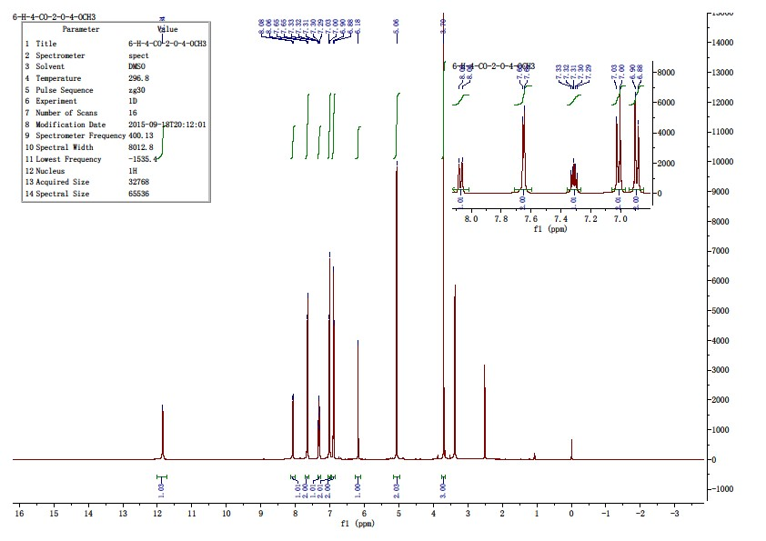

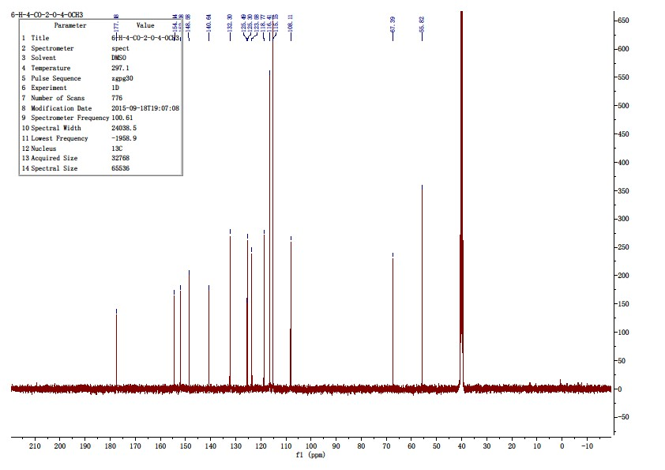
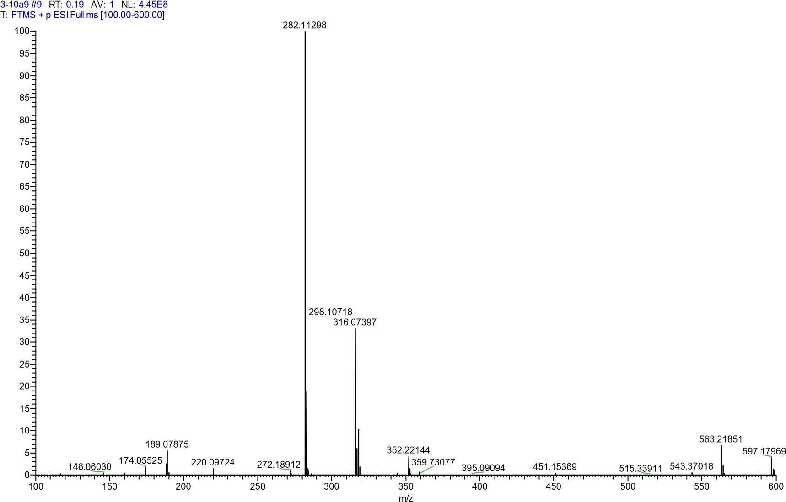

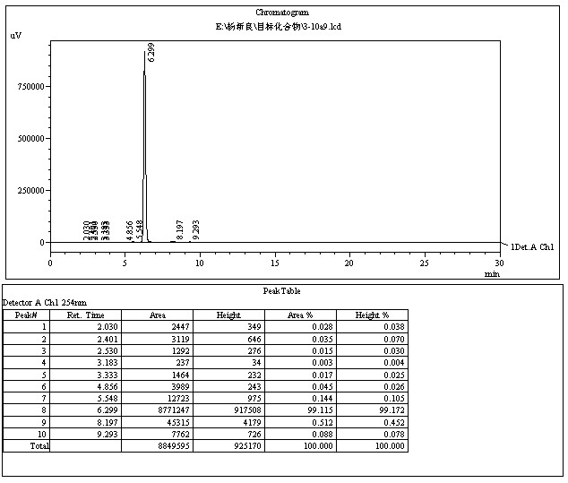

4.3.10 2-((3,4-dimethoxyphenoxy)methyl)quinolin-4(1H)-one(10j)
The title compound was prepared in the manner similar to compound 10a. White solid, yield: 86.3%, mp: 193.5-195.8 ℃, HPLC purity: 98.73% (liquid phase condition A), ¹H NMR (500 MHz, DMSO- d6) δ 11.83 (s, 1H), 8.07 (d, J = 8.0 Hz, 1H), 7.68 – 7.62 (m, 2H), 7.32 (ddd, J = 8.0, 5.3,2.7 Hz, 1H), 6.88 (d, J = 8.8 Hz, 1H), 6.75 (d, J = 2.8 Hz, 1H), 6.56 (dd, J = 8.7, 2.8Hz, 1H), 6.19 (s, 1H), 5.06 (s, 2H), 3.75 (s, 3H), 3.69 (s, 3H). ¹³C NMR (125 MHz,DMSO- d6) δ 177.47, 152.59, 150.16, 148.52, 144.19, 140.62, 132.31, 125.48, 125.30,123.58, 118.76, 113.03, 108.13, 105.07, 101.85, 67.30, 56.49, 56.03. HRMS (ESI)m/z calcd for [C18H17NO4+H]+, 312.1230; found, 312.12488 [M+H] +.
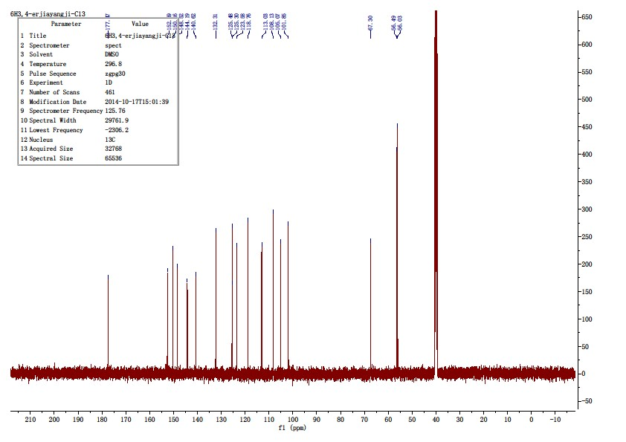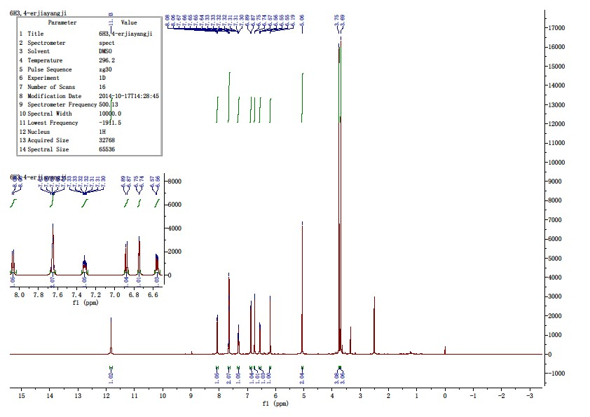

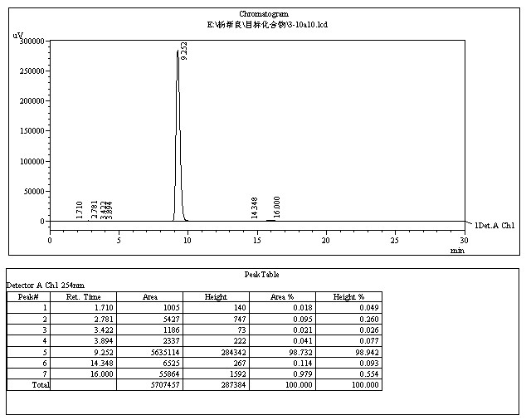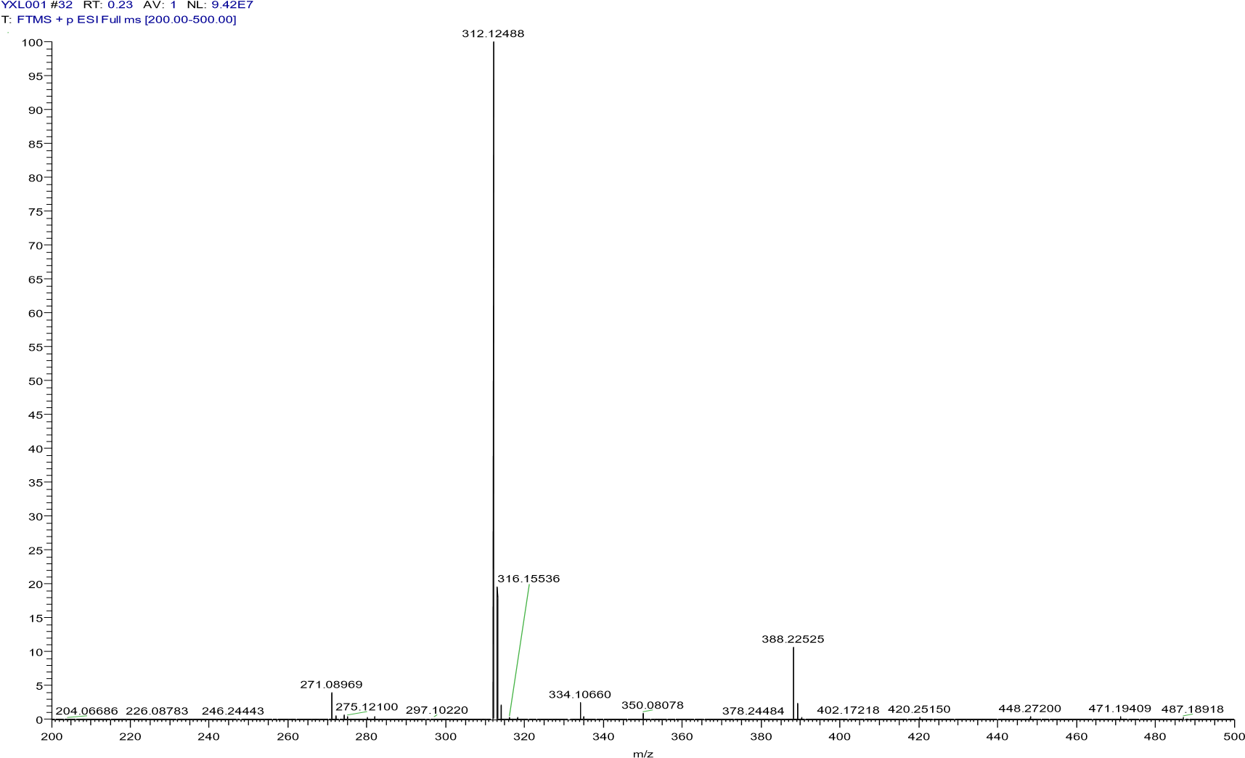
附图
78

化合物
3
-
10
a
10
碳
谱

4.3.11 2-(((2-chlorophenyl)amino)methyl)quinolin-4(1H)-one(10k)
The title compound was prepared in the manner similar to compound 10a. White solid, yield: 85.7%, mp: 254.8-257.2 ℃, HPLC purity: 98.05% (liquid phase condition A), ¹H NMR (500 MHz, DMSO- d6) δ 11.73 (s, 1H), 8.05 (d, J = 8.0 Hz, 1H), 7.68 – 7.56 (m, 2H), 7.30 (t, J = 7.1 Hz, 2H),7.08 (t, J = 8.2 Hz, 1H), 6.69 – 6.58 (m, 2H), 6.20 (t, J = 6.1 Hz, 1H), 6.04 (s, 1H),4.44 (d, J = 6.0 Hz, 2H). ¹³C NMR (125 MHz, DMSO- d6) δ 177.11, 151.87, 143.89,140.65, 132.14, 129.63, 128.52, 128.47, 125.32, 125.26, 123.49, 118.62, 117.86,112.11, 106.50, 44.57. HRMS (ESI) m/z calcd for [C16H13ClN2O4+H]+, 285.0789; found, 285.07867 [M+H] +.
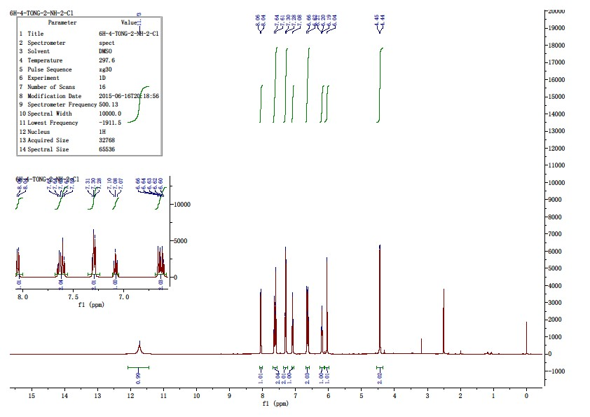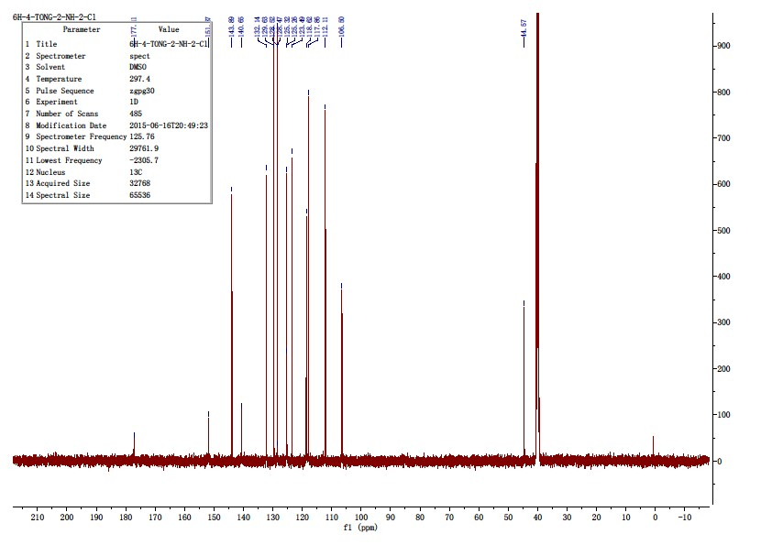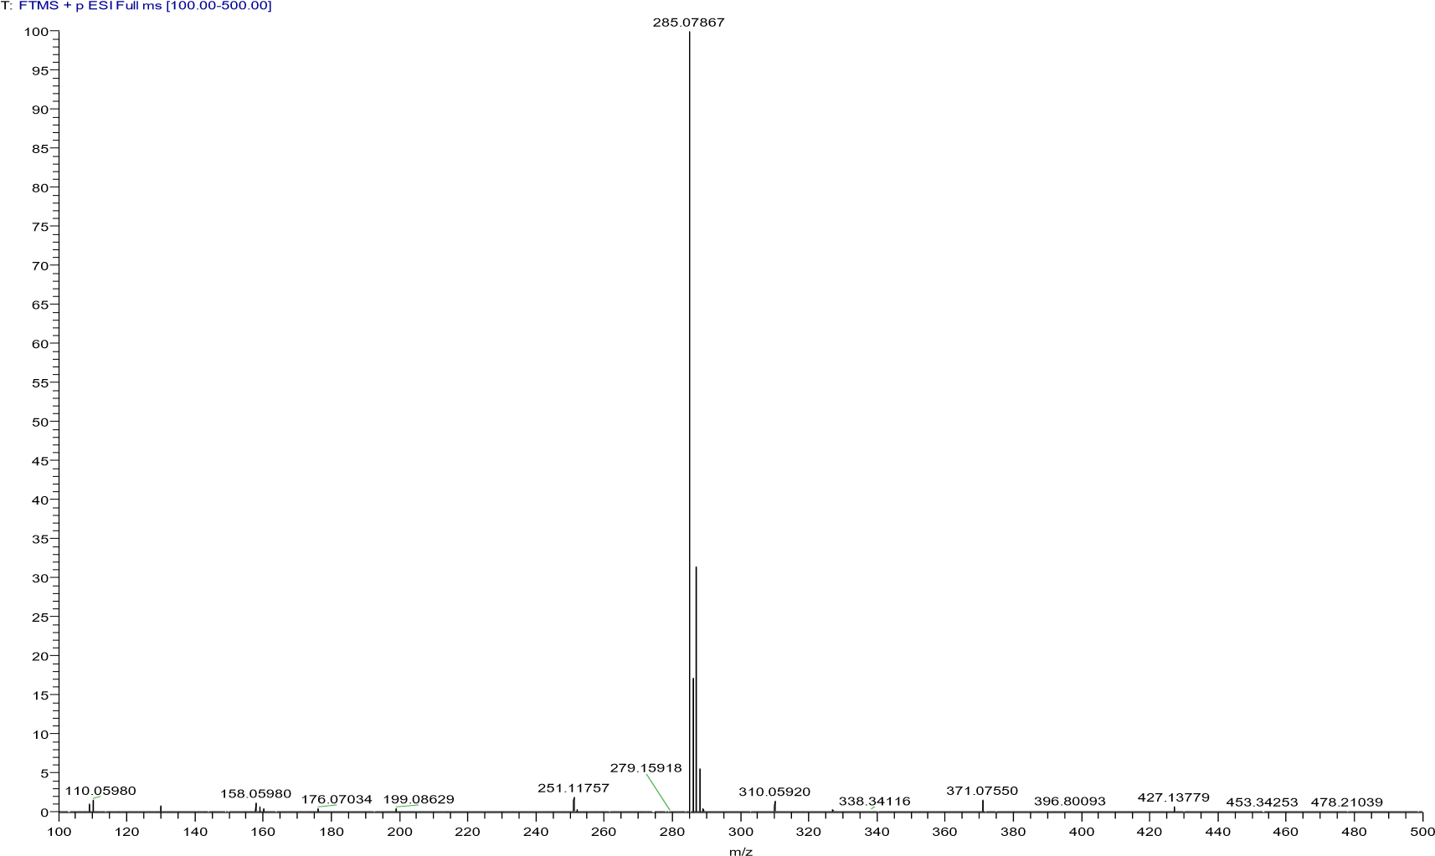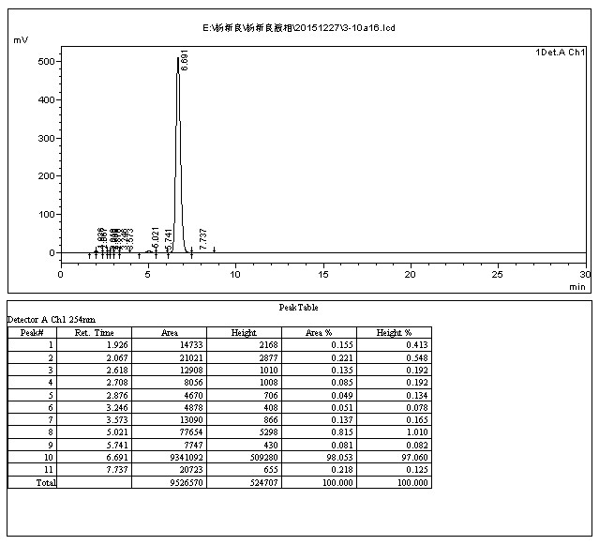

-

4.3.12 N-(4-(((4-oxo-1,4-dihydroquinolin-2-yl)methyl)amino)phenyl)acetamide(10l)
The title compound was prepared in the manner similar to compound 10a. White solid, yield: 79.9%, mp: 269.0 - 271.7 ℃, HPLC purity: 98.30% (liquid phase condition A), ¹H NMR (400 MHz, DMSO- d6) δ 11.57 (s, 1H), 9.57 (s, 1H), 8.04 (d, J = 7.7 Hz, 1H), 7.69 – 7.56 (m, 2H), 7.34 – 7.21 (m, 3H), 6.57 (d, J = 8.9 Hz, 2H), 6.14 (t, J = 6.2 Hz, 1H), 6.07 (d, J = 1.2 Hz, 1H), 4.26 (d, J = 6.1 Hz, 2H), 1.95 (s, 3H). ¹³C NMR (100 MHz, DMSO- d6) δ 177.36, 167.75, 152.34, 144.55, 140.59, 132.01, 130.02, 125.48, 125.28, 123.31, 121.23(2C), 118.57(2C), 112.88, 106.85, 45.34, 24.16. HRMS (ESI) m/z calcd for [C18H17N3O2+H]+ , 308.1394; HRMS (ESI) m/z calcd for [C18H17N3O2+Na]+ , 330.1213; found, 308.13745 [M+H] + ; 330.11905 [M+Na] + .
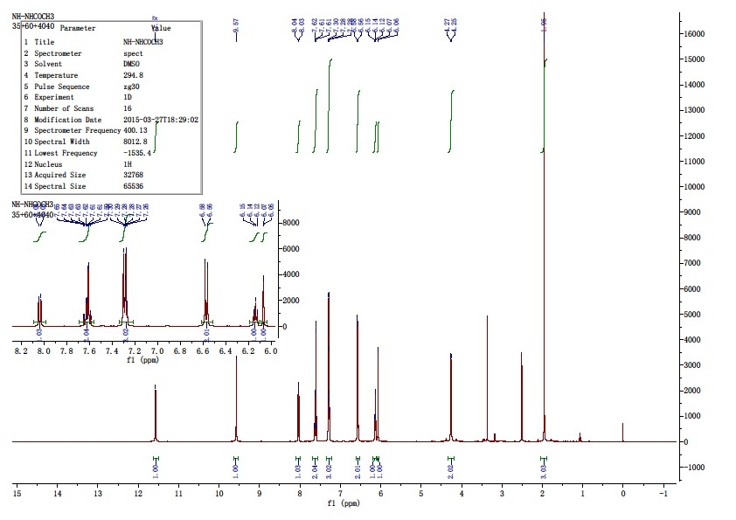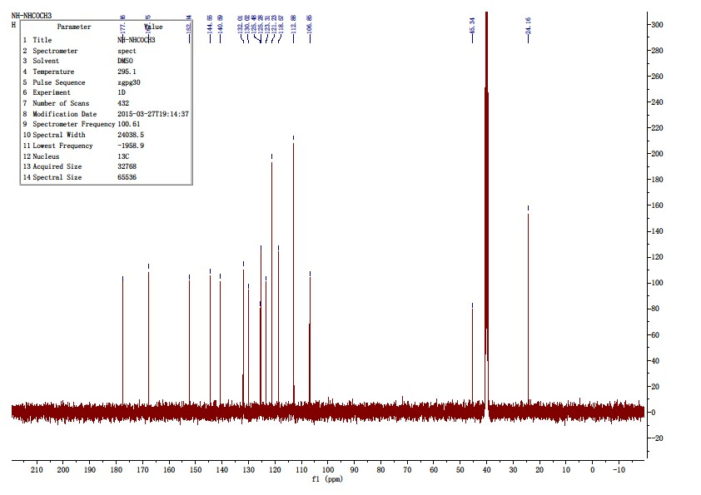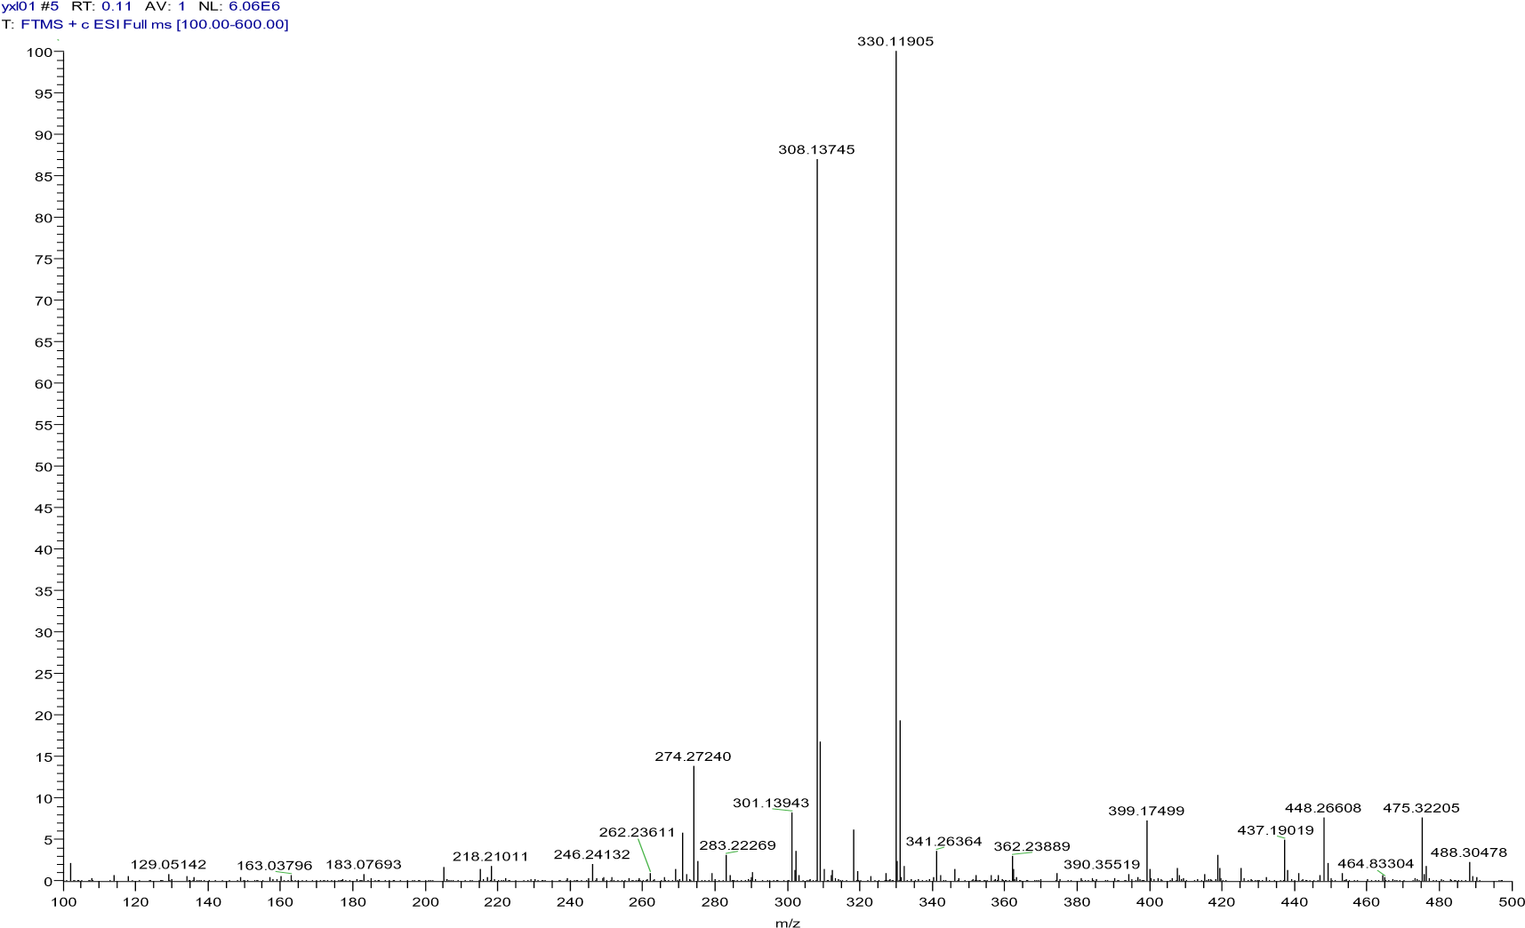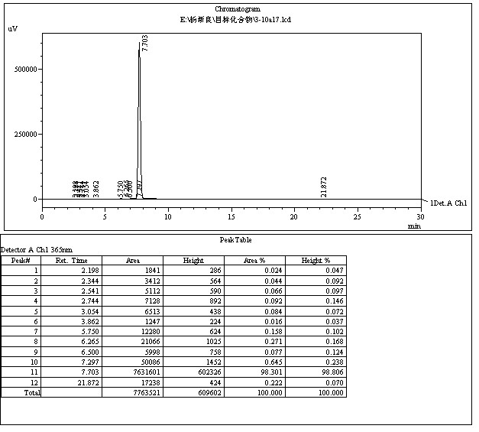

4.3.13 6-fluoro-2-(phenoxymethyl)quinolin-4(1H)-one(10m)
The title compound was prepared in the manner similar to compound 10a. White solid, yield: 90.6%, mp: 239.6 - 242.4 ℃, HPLC purity: 98.88% (liquid phase condition A), ¹H NMR (500 MHz, DMSO- d6) δ 12.01 (s, 1H), 7.79 – 7.67 (m, 2H), 7.58 (td, J = 8.7, 3.0 Hz, 1H), 7.34 (t, J = 8.0 Hz, 2H), 7.08 (d, J = 8.0 Hz, 2H), 7.00 (t, J = 7.3 Hz, 1H), 6.21 (s, 1H), 5.14 (s, 2H). ¹³C NMR (125 MHz, DMSO- d6) δ 176.65, 158.78(d, J = 241.92Hz), 158.12, 148.61, 137.36, 130.11(2C), 126.64 (d, J = 6.5 Hz), 121.94, 121.57 (d, J = 8.1 Hz), 121.16(d, J = 25.20 Hz), 115.33(2C), 109.33(d, J = 21.42 Hz), 107.35, 66.68. HRMS (ESI) m/z calcd for [C16H12FNO2+H]+ , 270.0925; found, 270.09264 [M+H] + .
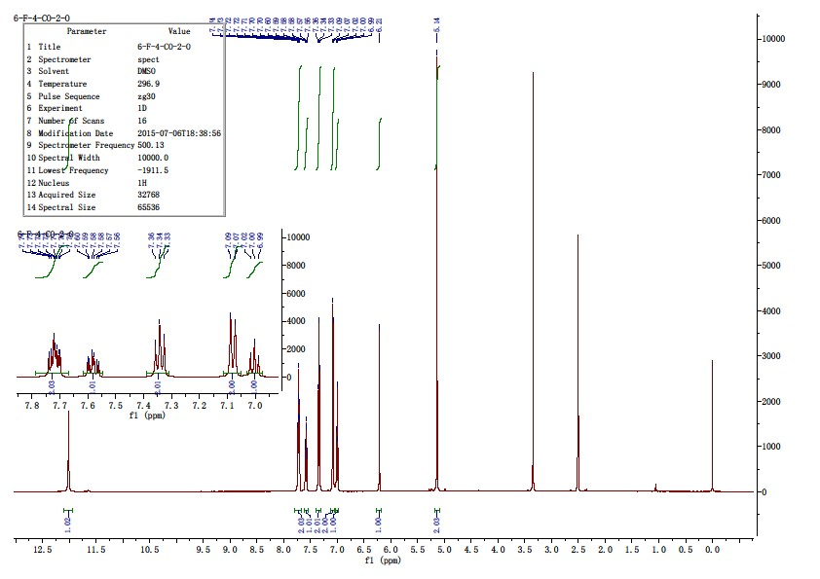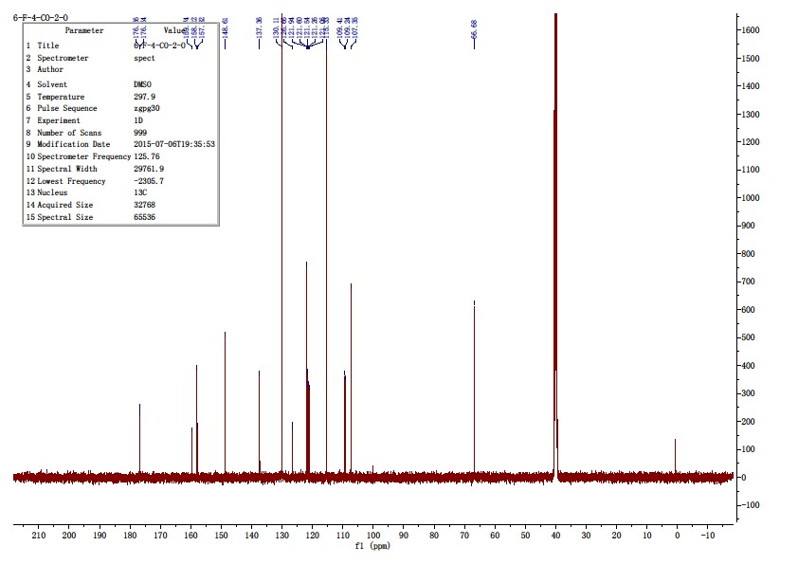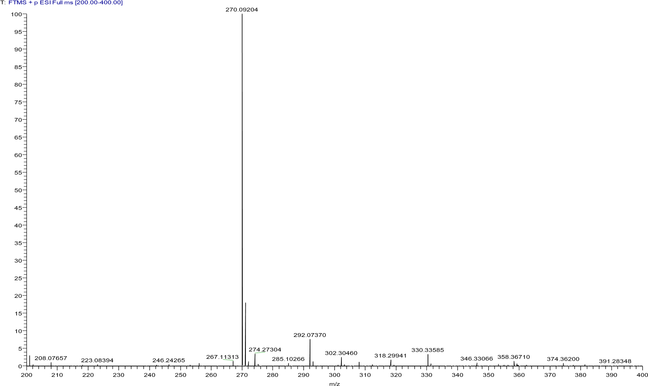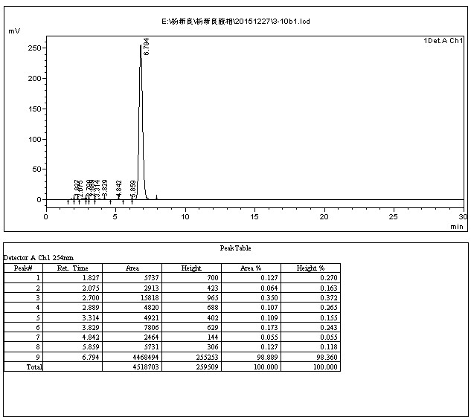

-

4.3.14 2-((2-chlorophenoxy)methyl)-6-fluoroquinolin-4(1H)-one(10n)
The title compound was prepared in the manner similar to compound 10a. White solid, yield: 84.8%, mp: 244.9 - 247.1 ℃, HPLC purity: 98.68% (liquid phase condition A), ¹H NMR (500 MHz, DMSO- d6) δ 12.07 (s, 1H), 7.76 – 7.67 (m, 2H), 7.59 (td, J = 8.7, 3.0 Hz, 1H), 7.50 (dd, J = 7.9, 1.5 Hz, 1H), 7.39 – 7.32 (m, 1H), 7.25 (dd, J = 8.3, 1.1 Hz, 1H), 7.04 (td, J = 7.7, 1.3 Hz, 1H), 6.23 (d, J = 0.9 Hz, 1H), 5.22 (s, 2H). ¹³C NMR (125 MHz, DMSO- d6) δ 176.67(d, J = 2.52Hz), 158.80(d, J = 243.18Hz), 153.49, 148.12, 137.32, 130.69, 128.92, 126.60(d, J = 6.3Hz), 122.96, 122.08, 121.57(d, J = 8.82Hz), 121.30(d, J = 26.46Hz), 114.77, 109.32(d, J = 22.68Hz), 107.26, 67.41. HRMS (ESI) m/z calcd for [C16H11ClFNO2+H]+ , 304.0535; found, 304.05496 [M+H] + .
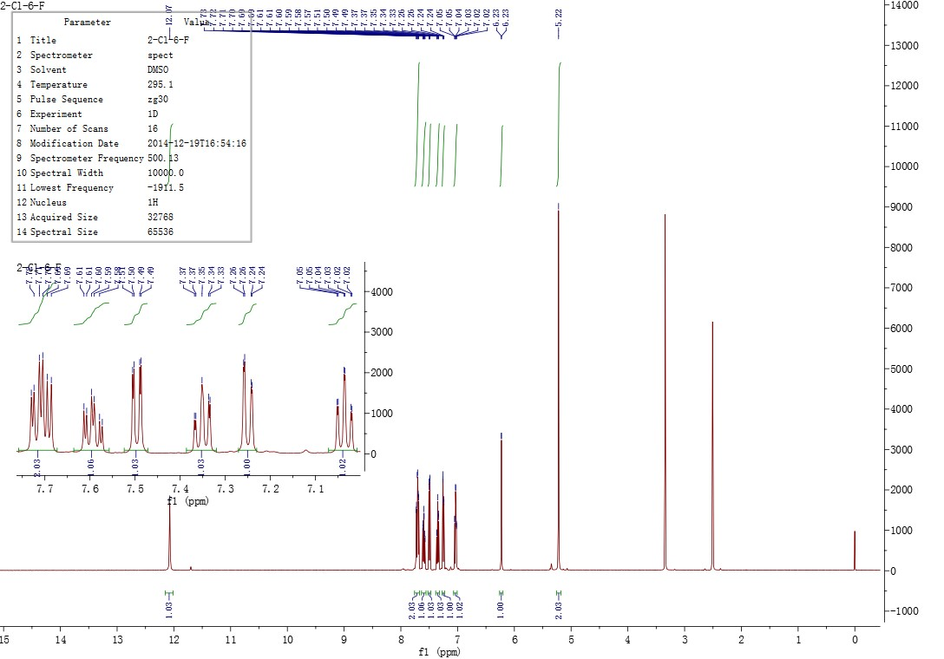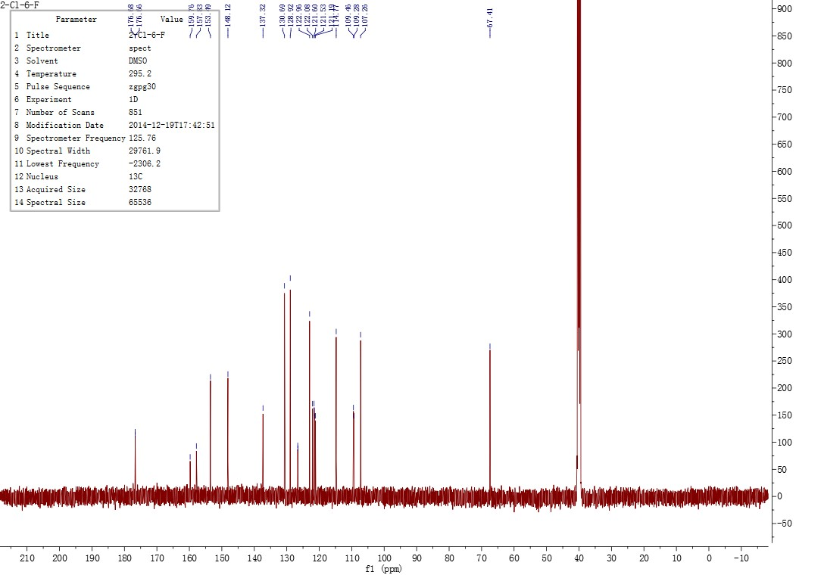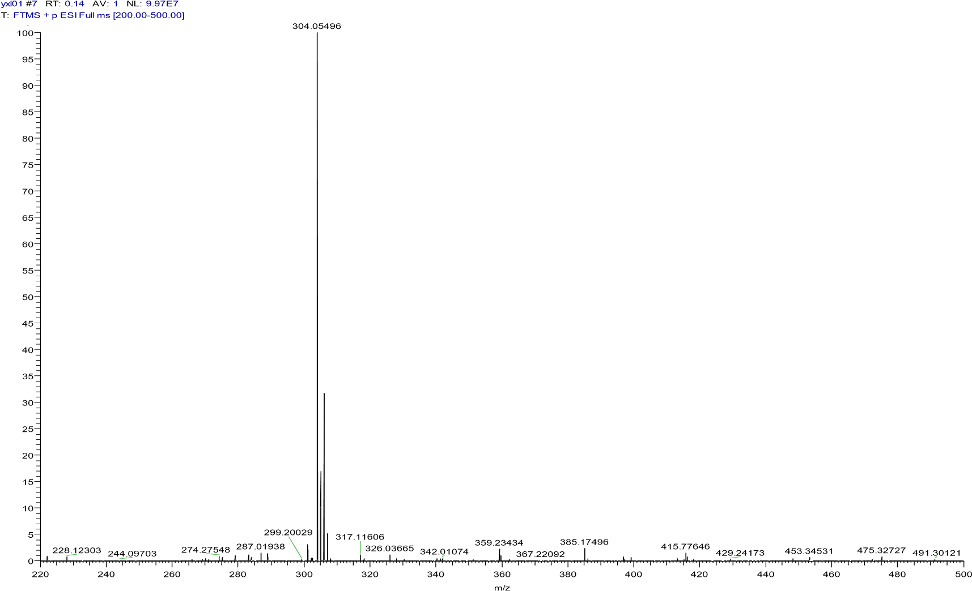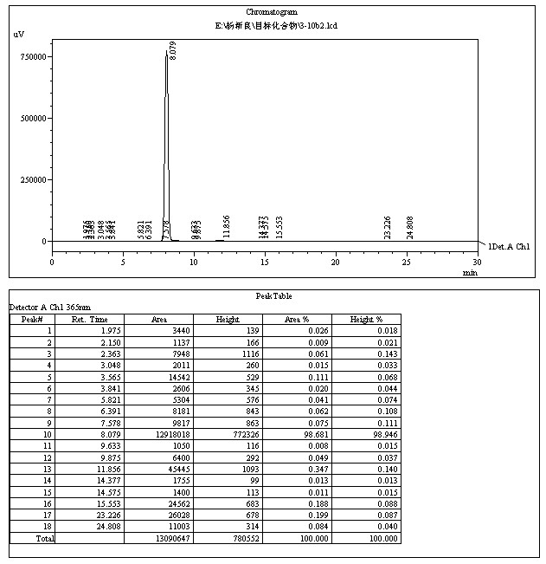

4.3.15 6-fluoro-2-((2-(trifluoromethyl)phenoxy)methyl)quinolin-4(1H)-one(10o)
The title compound was prepared in the manner similar to compound 10a. White solid, yield: 89.7%, mp: 285.5 - 289.3 ℃, HPLC purity: 97.14% (liquid phase condition A), ¹H NMR (400 MHz, DMSO- d6) δ 12.04 (s, 1H), 7.77 – 7.63 (m, 4H), 7.59 (td, J = 8.6, 2.9 Hz, 1H), 7.34 (d, J = 8.6 Hz, 1H), 7.18 (t, J = 7.6 Hz, 1H), 6.19 (s, 1H), 5.29 (s, 2H). ¹³C NMR (100 MHz, DMSO d6) δ 176.65(d, J = 2.52 Hz), 158.80(d, J = 242.4 Hz), 155.75, 148.09, 137.24, 134.87, 127.46(q, J = 6.06 Hz), 126.57(d, J = 7.07 Hz), 124.16(q, J = 272.7 Hz), 121.75, 121.44, 121.35(d, J = 34.34 Hz), 117.84(q, J = 32.32 Hz), 114.38, 109.39(d, J = 27.72 Hz), 106.78, 66.92. HRMS (ESI) m/z calcd for [C17H11F4NO2+H]+ , 338.0799; found, 338.07892 [M+H] + .
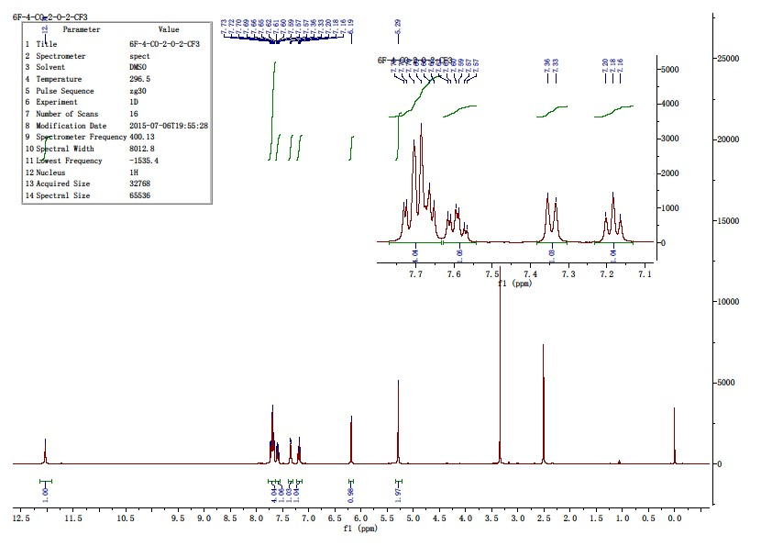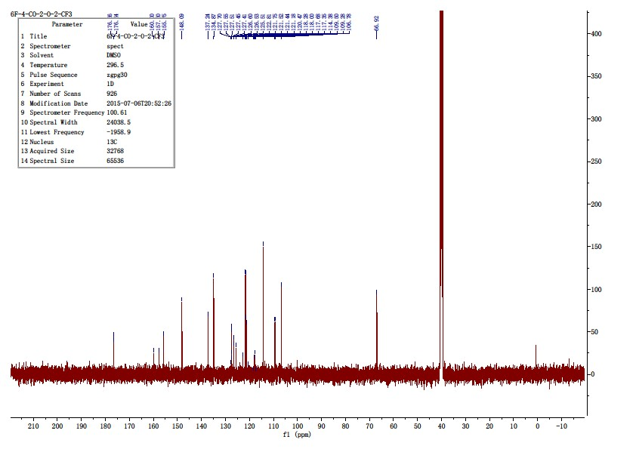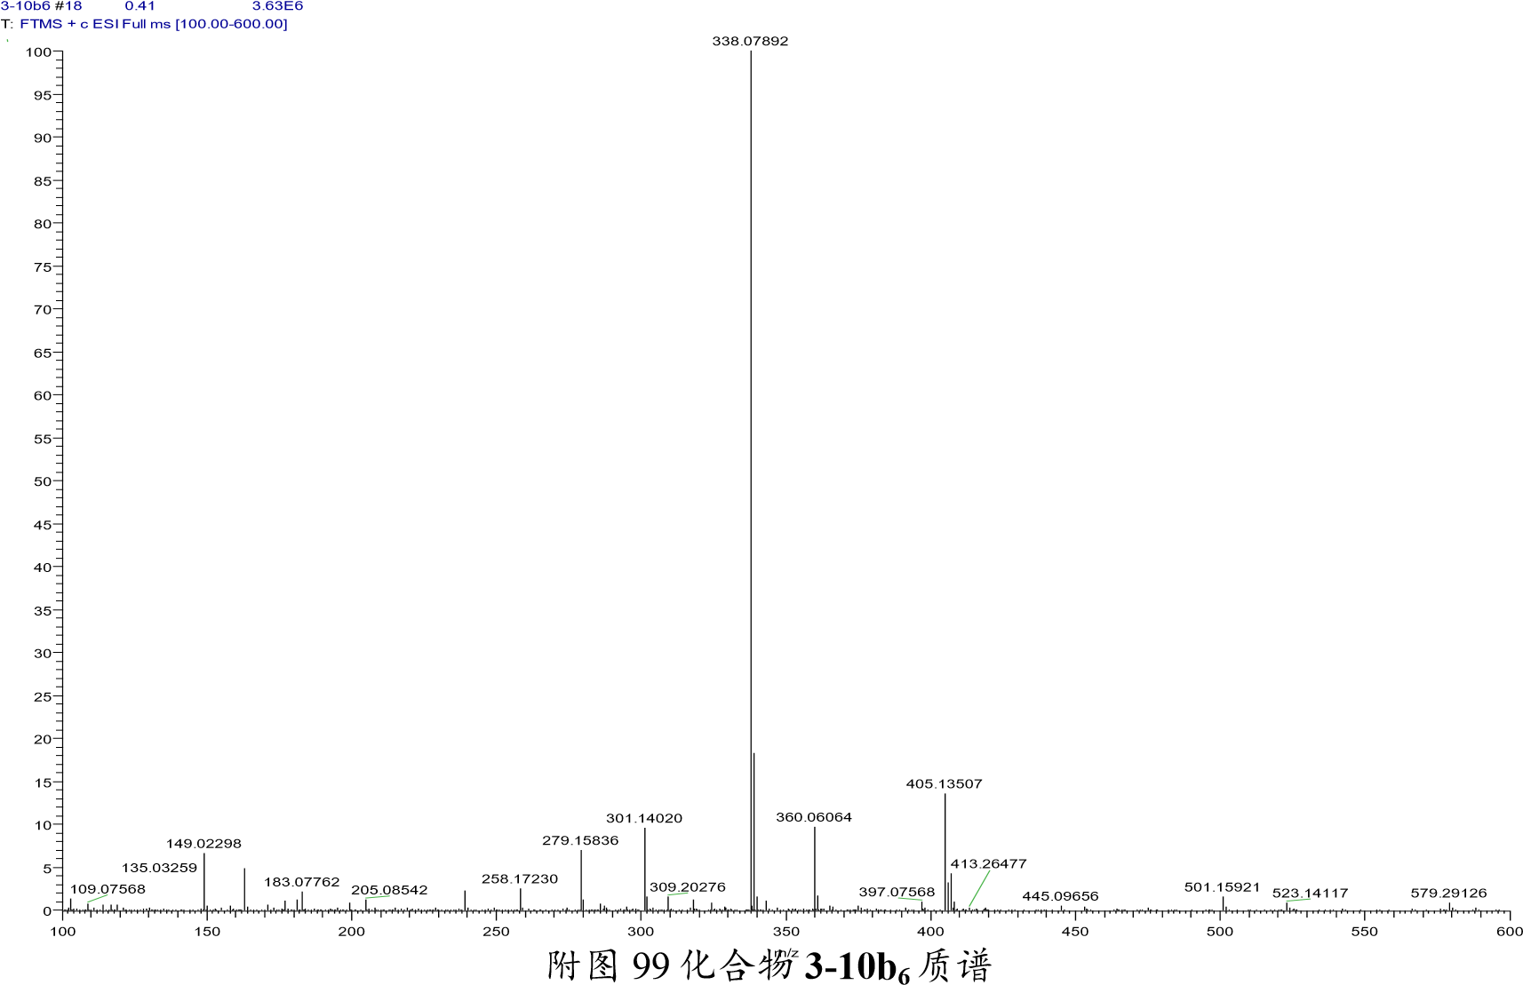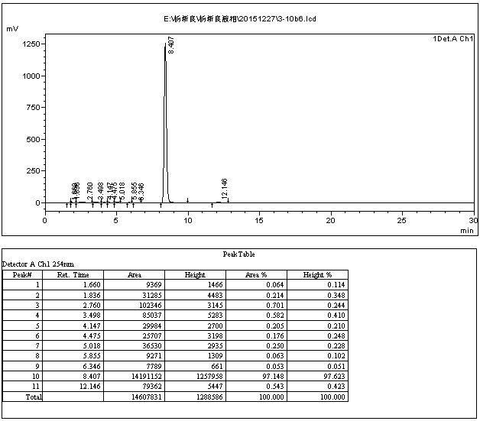

4.3.16 2-((3,4-dimethoxyphenoxy)methyl)-6-fluoroquinolin-4(1H)-one(10p)
The title compound was prepared in the manner similar to compound 10a. White solid, yield: 88.5%, mp: 234.5 - 236.9 ℃, HPLC purity: 99.46% (liquid phase condition A), ¹H NMR (500 MHz, DMSO- d6) δ 11.99 (s, 1H), 7.76 – 7.68 (m, 2H), 7.58 (td, J = 8.7, 3.0 Hz, 1H), 6.87 (d, J = 8.8 Hz, 1H), 6.74 (d, J = 2.8 Hz, 1H), 6.55 (dd, J = 8.7, 2.7 Hz, 1H), 6.21 (s, 1H), 5.07 (s, 2H), 3.75 (s, 3H), 3.69 (s, 3H). ¹³C NMR (125 MHz, DMSO- d6) δ 176.66, 158.77(d, J = 241.92 Hz), 152.54, 150.16, 148.78, 144.24, 137.34, 126.62(d, J = 6.30 Hz), 121.56(d, J = 7.56 Hz), 121.14(d, J = 25.20 Hz), 113.03, 109.32(d, J = 21.42Hz), 107.31, 105.09, 101.86, 67.25, 56.48, 56.02. HRMS (ESI) m/z calcd for [C18H16FNO4+H]+ , 330.1136; found, 330.11328 [M+H] + .
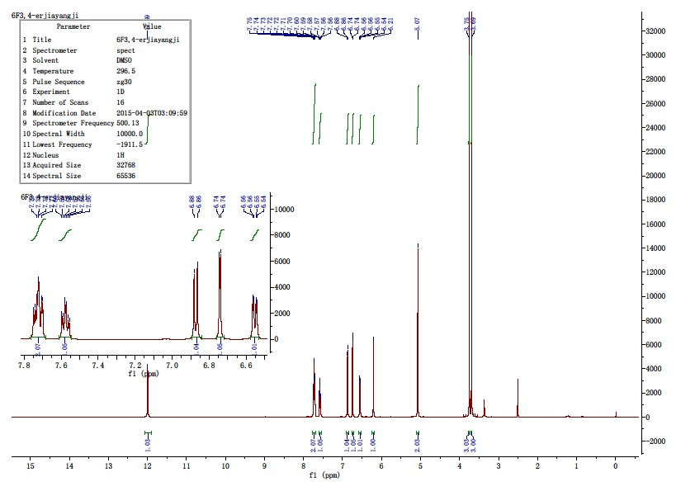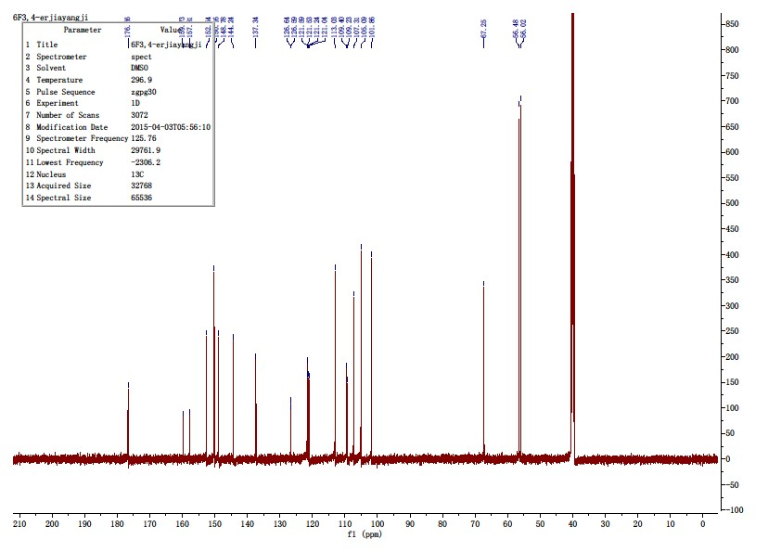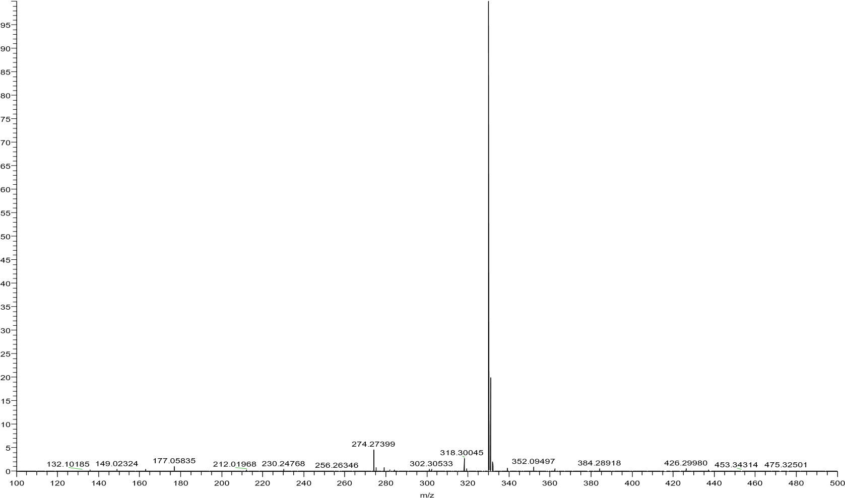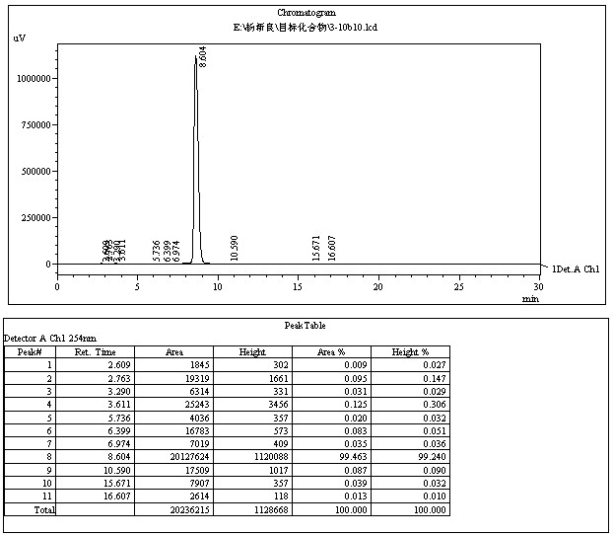

4.3.17 N-(4-(((6-fluoro-4-oxo-1,4-dihydroquinolin-2-yl)methyl)amino)phenyl)acetamide(10q)
The title compound was prepared in the manner similar to compound 10a. White solid, yield: 86.3%, mp: 273.1 - 275.2 ℃, HPLC purity: 98.30% (liquid phase condition A), ¹H NMR (500 MHz, DMSO- d6) δ 11.74 (s, 1H), 9.58 (s, 1H), 7.72 – 7.65 (m, 2H), 7.54 (td, J = 8.7, 2.9 Hz, 1H), 7.29 (d, J = 8.7 Hz, 2H), 6.57 (d, J = 8.7 Hz, 2H), 6.15 (t, J = 6.0 Hz, 1H), 6.09 (s, 1H), 4.27 (d, J = 5.9 Hz, 2H), 1.96 (s, 3H). ¹³C NMR (125 MHz, DMSO- d6) δ 176.53, 176.51, 167.78, 158.65(d, 241.92Hz), 152.71, 144.52, 137.29, 130.07, 126.61 (d, J = 6.4 Hz), 121.32(d, J = 7.56 Hz), 121.26(2C), 120.76 (d, J = 25.40 Hz), 112.92(2C), 109.28(d, J = 21.42 Hz), 106.10, 45.39, 24.15. HRMS (ESI) m/z calcd for [C18H16FN3O2+H]+ , 326.1299; found, 326.13007 [M+H] + .
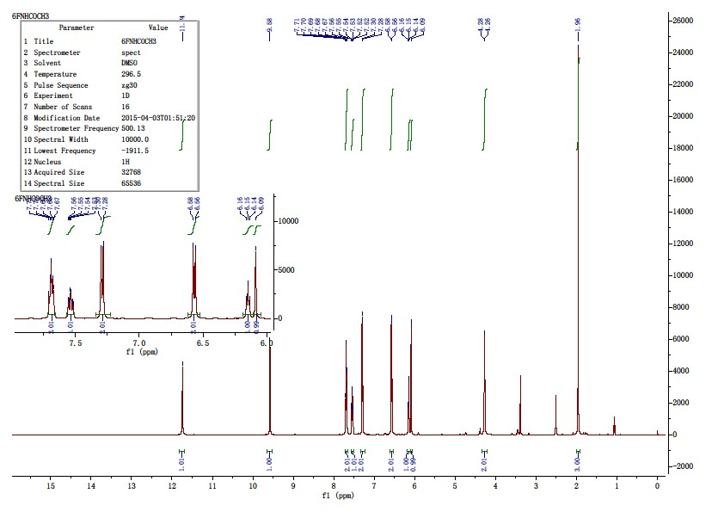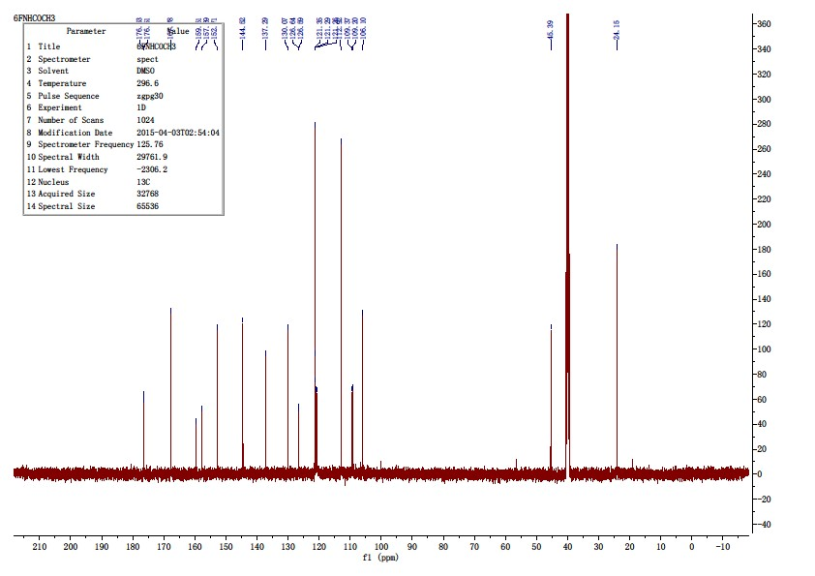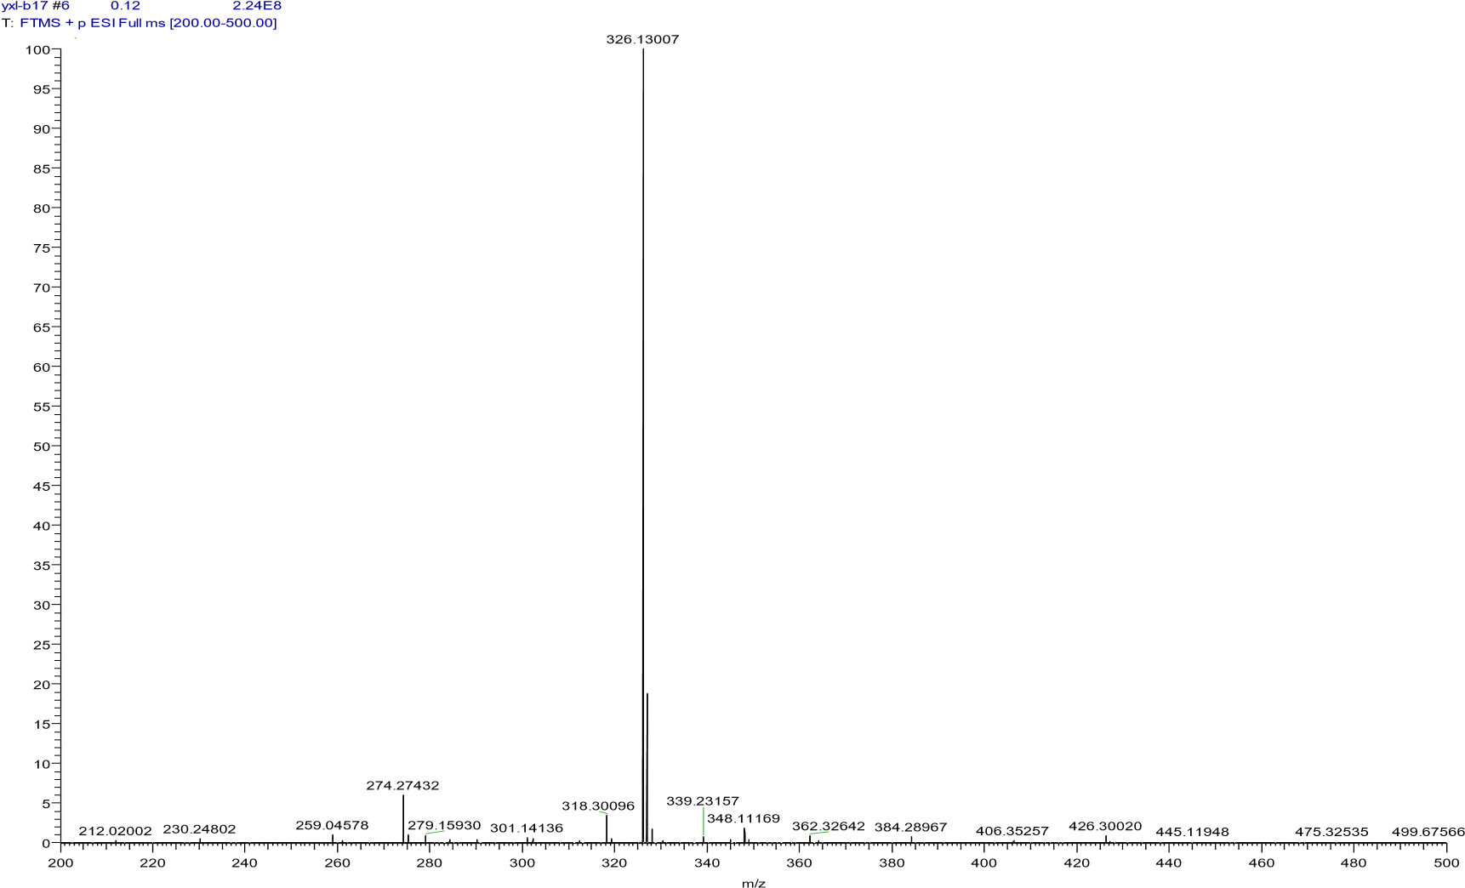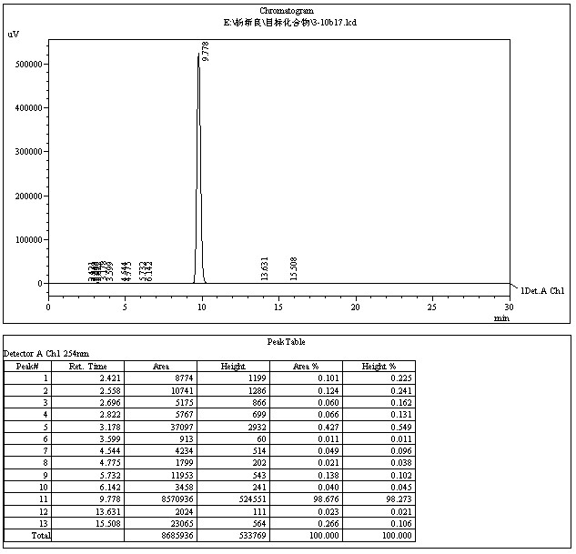

4.3.19 6-methoxy-2-(phenoxymethyl)quinolin-4(1H)-one(10r)
The title compound was prepared in the manner similar to compound 10a. White solid, yield: 90.2%, mp: 251.6 - 252.8 ℃, HPLC purity: 98.03% (liquid phase condition A), ¹H NMR (500 MHz, DMSO- d6) δ 11.85 (s, 1H), 7.61 (d, J = 9.0 Hz, 1H), 7.49 (d, J = 2.8 Hz, 1H), 7.36 – 7.29 (m, 3H), 7.07 (d, J = 8.0 Hz, 2H), 7.00 (t, J = 7.3 Hz, 1H), 6.17 (s, 1H), 5.11 (s, 2H), 3.84 (s, 3H). ¹³C NMR (125 MHz, DMSO- d6) δ 176.84, 158.21, 156.02, 147.30, 135.24, 130.08, 126.55, 122.71, 121.86, 120.54, 115.32, 107.15, 104.69, 66.81, 55.80. HRMS (ESI) m/z calcd for [C17H15NO3+H]+ , 282.1125; found, 282.11230 [M+H] + .
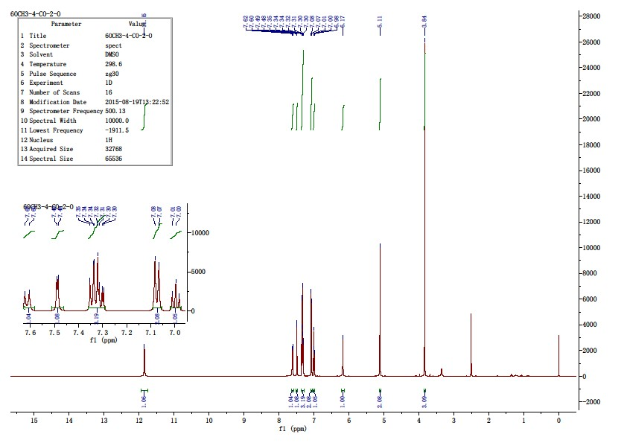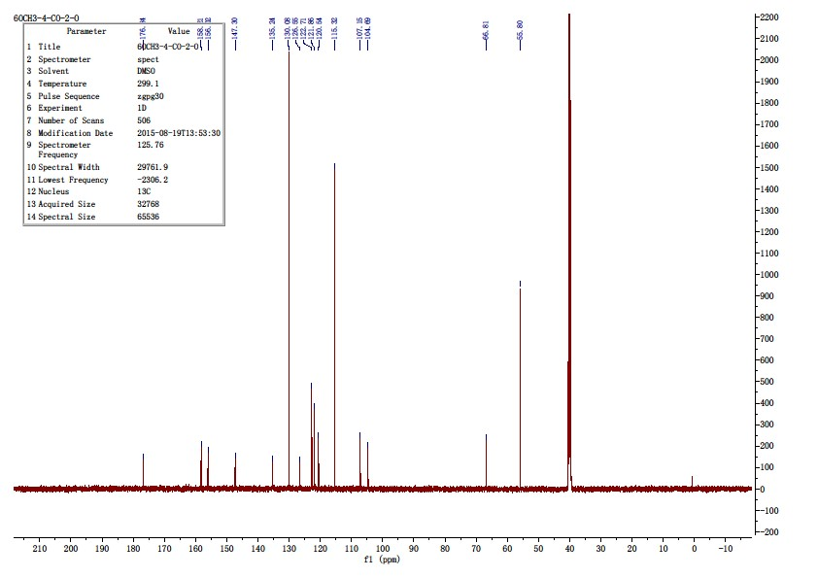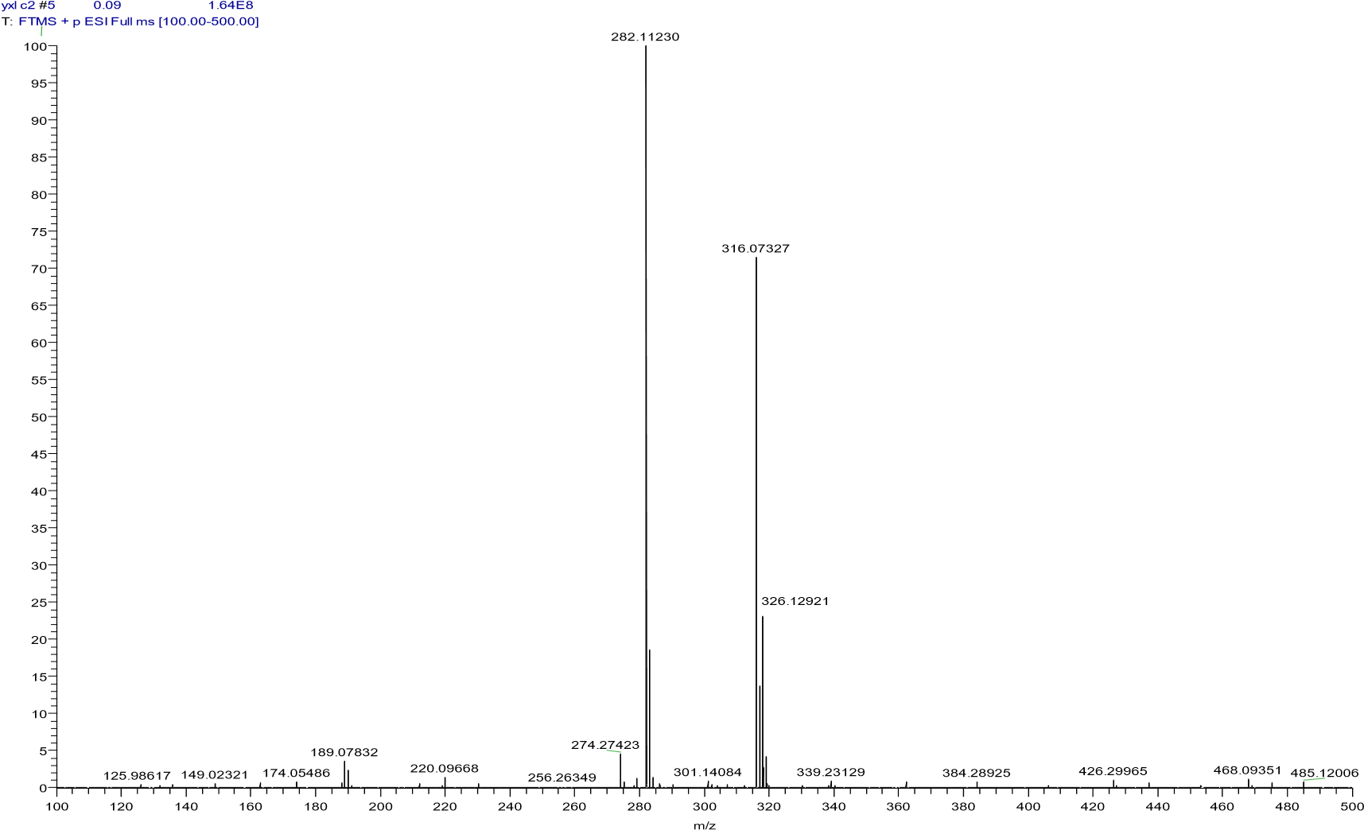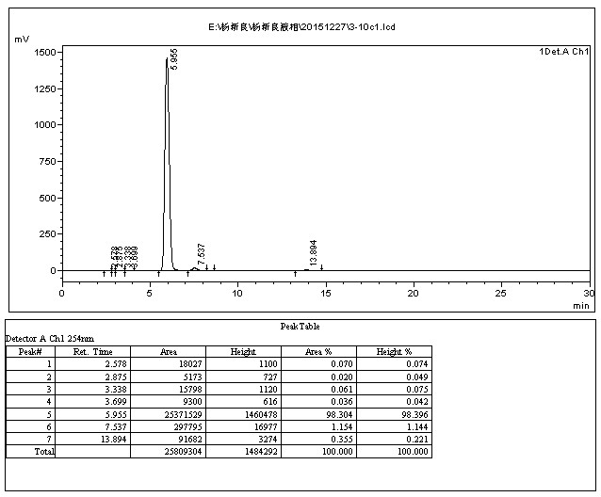

4.3.20 2-((2-chlorophenoxy)methyl)-6-methoxyquinolin-4(1H)-one(10s)
The title compound was prepared in the manner similar to compound 10a. White solid, yield: 79.3%, mp: 243.3 - 244.8 ℃, HPLC purity: 97.07% (liquid phase condition A), ¹H NMR (500 MHz, DMSO- d6) δ 12.36 (s, 1H), 7.71 (d, J = 9.1 Hz, 1H), 7.49 (dd, J = 11.2, 5.9 Hz, 2H), 7.40 (d, J = 2.9 Hz, 1H), 7.34 (t, J = 8.3 Hz, 1H), 7.25 (d, J = 7.8 Hz, 1H), 7.03 (t, J = 7.3 Hz, 1H), 6.45 (s, 1H), 5.29 (s, 2H), 3.86 (s, 3H). ¹³C NMR (125 MHz, DMSO- d6) δ 174.82, 156.58, 153.52, 148.28, 135.61, 130.68, 128.90, 125.40, 123.62, 122.96, 122.14, 121.25, 114.90, 106.22, 103.99, 67.55, 55.94. HRMS (ESI) m/z calcd for [C17H14ClNO3+H]+ , 316.0735; found, 316.07333 [M+H] +
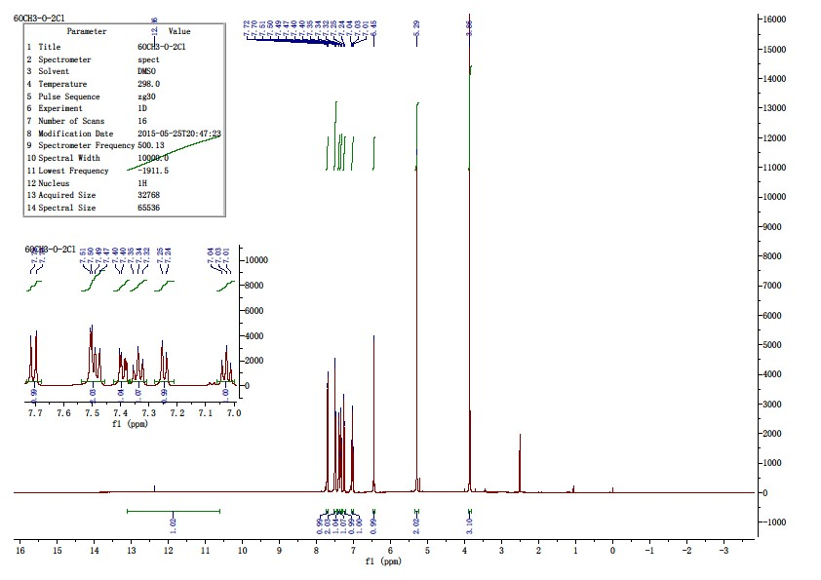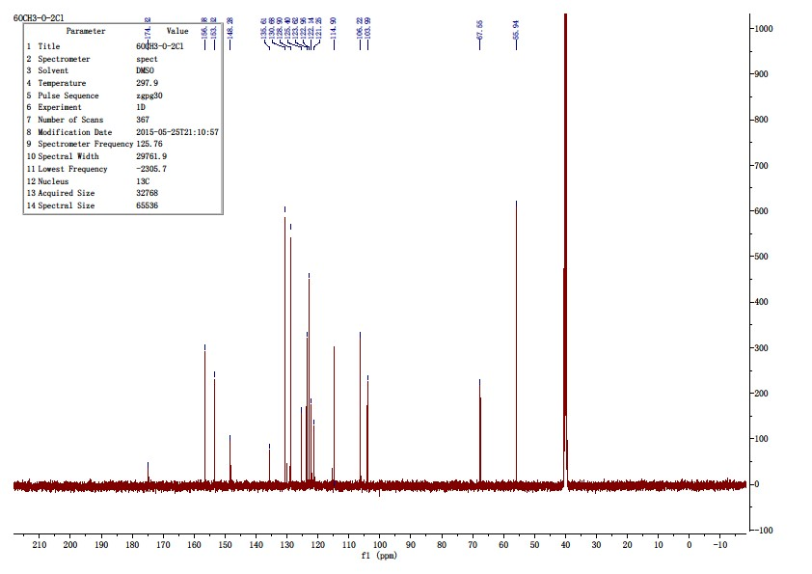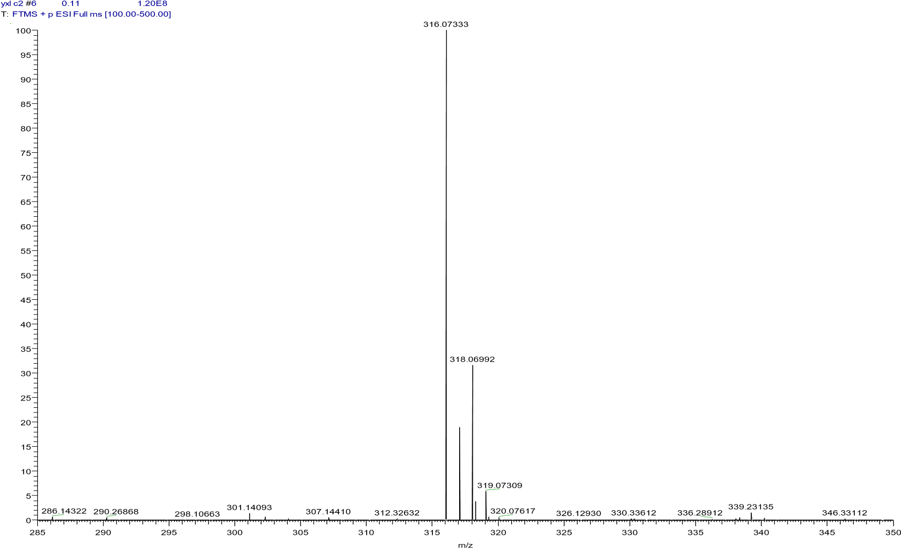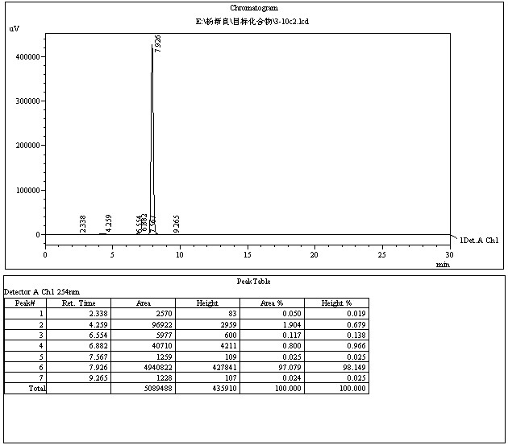

4.3.21 6-methoxy-2-((2-(trifluoromethyl)phenoxy)methyl)quinolin-4(1H)-one(10t)
The title compound was prepared in the manner similar to compound 10a. White solid, yield: 84.3%, mp: 266.2 - 267.8 ℃, HPLC purity: 98.84% (liquid phase condition A), ¹H NMR (500 MHz, DMSO- d6) δ 11.87 (s, 1H), 7.68 (t, J = 7.5 Hz, 2H), 7.55 (d, J = 9.0 Hz, 1H), 7.48 (d, J = 2.7 Hz, 1H), 7.36 – 7.30 (m, 2H), 7.17 (t, J = 7.5 Hz, 1H), 6.15 (s, 1H), 5.26 (s, 2H), 3.84 (s, 3H). ¹³C NMR (125 MHz, DMSO- d6) δ 176.84, 156.06, 155.84, 146.75, 135.11, 134.85, 127.46(q, J = 5.04 Hz), 126.50, 124.17(q, J = 272.16 Hz), 122.88, 121.67, 120.46, 117.85(q, J = 30.24 Hz), 114.36, 106.62, 104.67, 67.06, 55.83. HRMS (ESI) m/z calcd for [C18H14F3NO3+H]+ , 350.0999; found, 350.09872 [M+H] + .
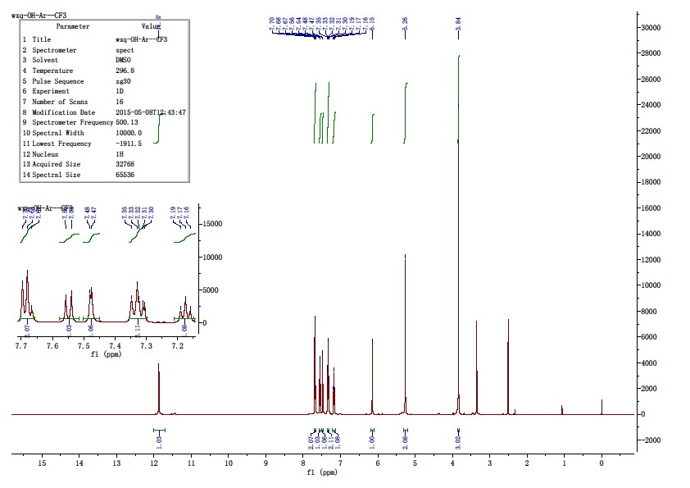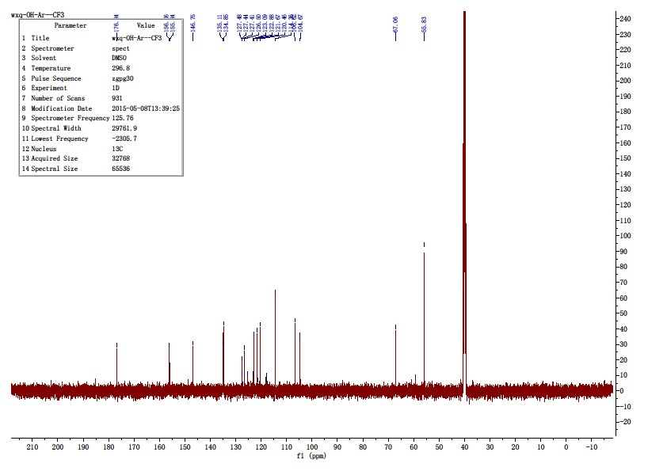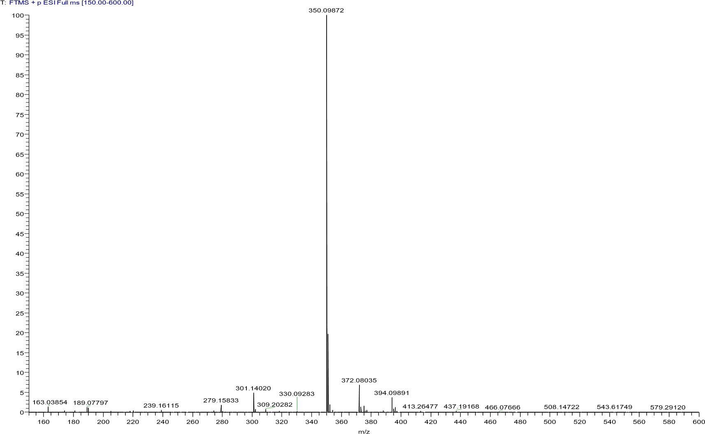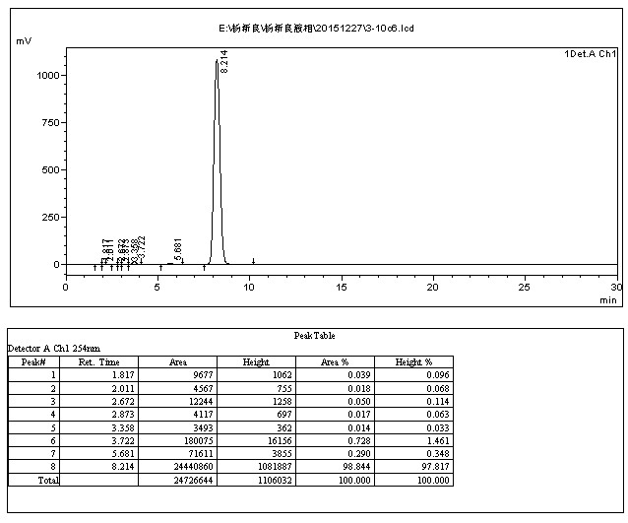

4.3.22 2-(((2-chlorophenyl)amino)methyl)-6-methoxyquinolin-4(1H)-one(10u)
The title compound was prepared in the manner similar to compound 10a. White solid, yield: 79.8%, mp: 237.4 - 240.1 ℃, HPLC purity: 97.63% (liquid phase condition A), ¹H NMR (500 MHz, DMSO- d6) δ 12.25 (s, 1H), 7.65 (d, J = 9.0 Hz, 1H), 7.46 (d, J = 2.8 Hz, 1H), 7.34 (dd, J = 9.0, 2.8 Hz, 1H), 7.28 (d, J = 7.7 Hz, 1H), 7.07 (t, J = 7.5 Hz, 1H), 6.62 (m, 2H), 6.23 (s, 1H), 6.16 (s, 1H), 4.48 (d, J = 3.2 Hz, 2H), 3.83 (s, 3H). ¹³C NMR (125 MHz, DMSO- d6) δ 175.33, 156.26, 151.76, 143.88, 135.38, 129.63, 128.46, 125.62, 123.01, 120.71, 118.64, 117.88, 112.08, 105.16, 104.29, 55.87, 44.58. HRMS (ESI) m/z calcd for [C17H15ClN2O2+H]+ , 315.0895; found, 315.08917 [M+H] + .
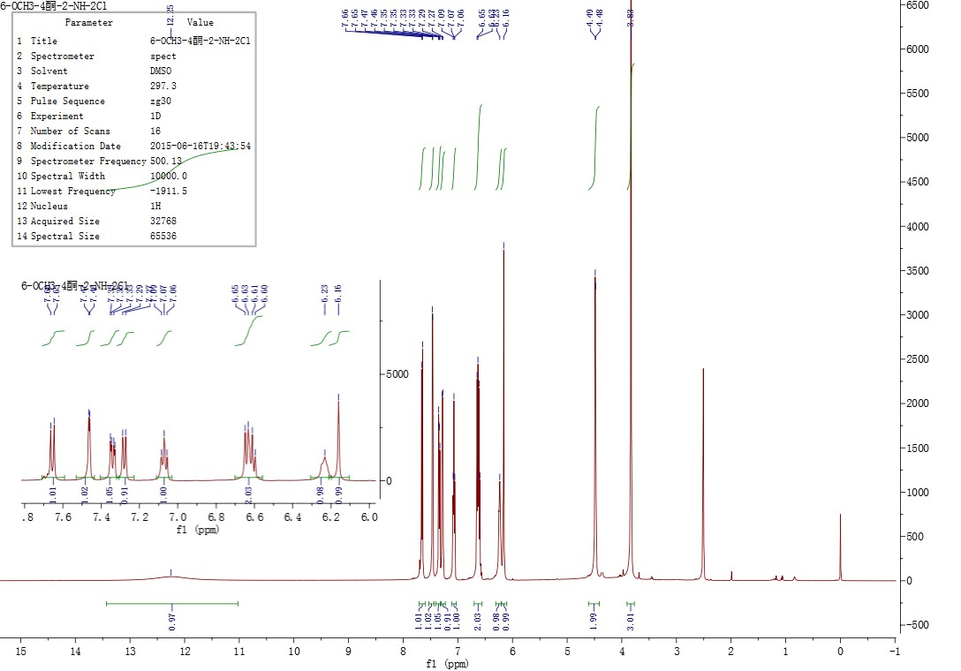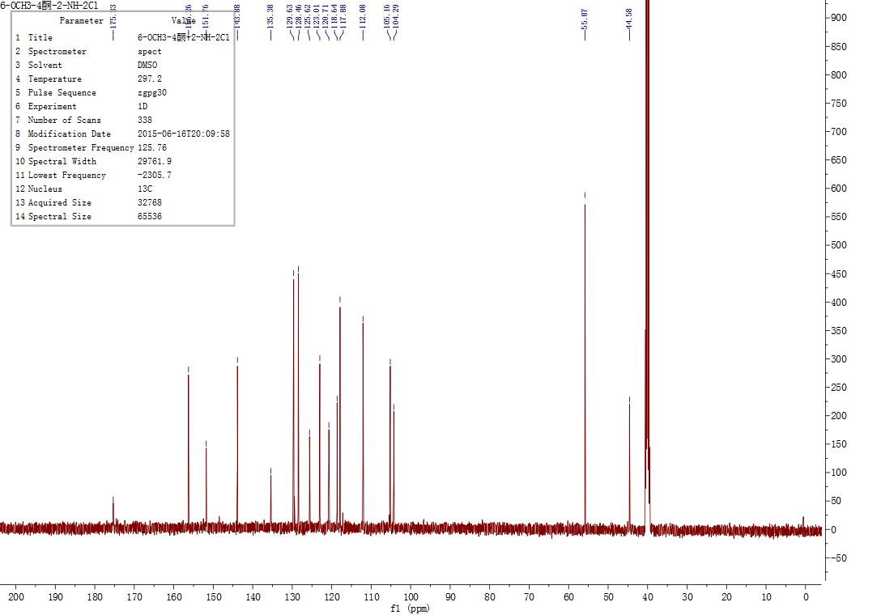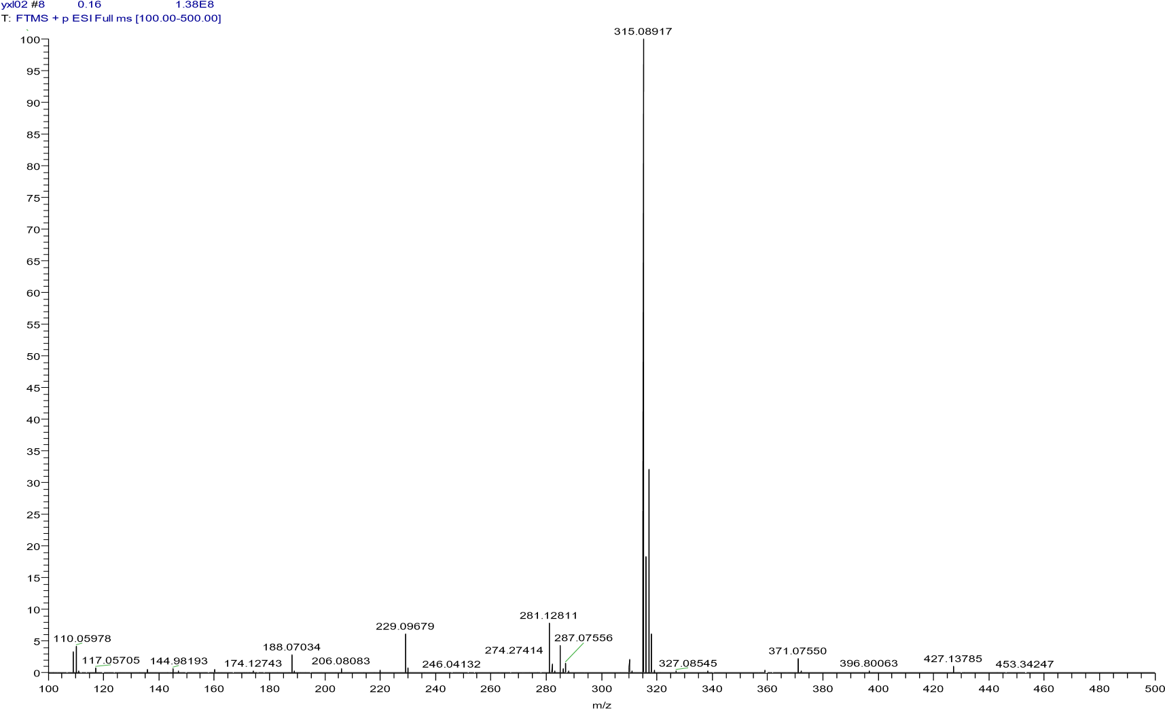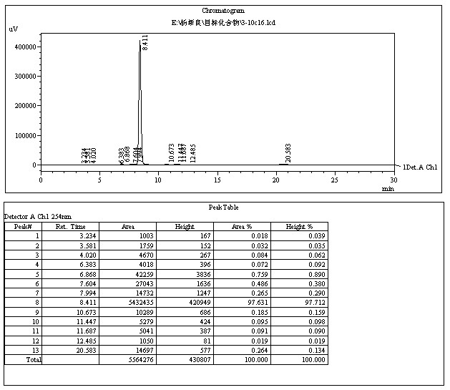

4.3.23 6-methoxy-2-(((4-methoxyphenyl)amino)methyl)quinolin-4(1H)-one(10v)
The title compound was prepared in the manner similar to compound 10a. White solid, yield: 84.2%, mp: 233.7 - 236.3 ℃, HPLC purity: 98.59% (liquid phase condition A), ¹H NMR (500 MHz, DMSO- d6) δ 11.54 (s, 1H), 7.58 (d, J = 9.0 Hz, 1H), 7.45 (d, J = 2.9 Hz, 1H), 7.27 (dd, J = 9.0, 3.0 Hz, 1H), 6.76 – 6.69 (m, 2H), 6.58 (d, J = 8.9 Hz, 2H), 6.05 (s, 1H), 5.92 (t, J = 6.1 Hz, 1H), 4.23 (d, J = 6.1 Hz, 2H), 3.82 (s, 3H), 3.62 (s, 3H). ¹³C NMR (125 MHz, DMSO- d6) δ 176.72, 155.80, 151.78, 151.50, 142.63, 135.16, 126.51, 122.26, 120.31, 115.12(2C), 114.03(2C), 105.90, 104.74, 100.00, 55.75, 45.83. HRMS (ESI) m/z calcd for [C18H18N2O3+H]+ , 311.1390; found, 311.13876 [M+H] + .
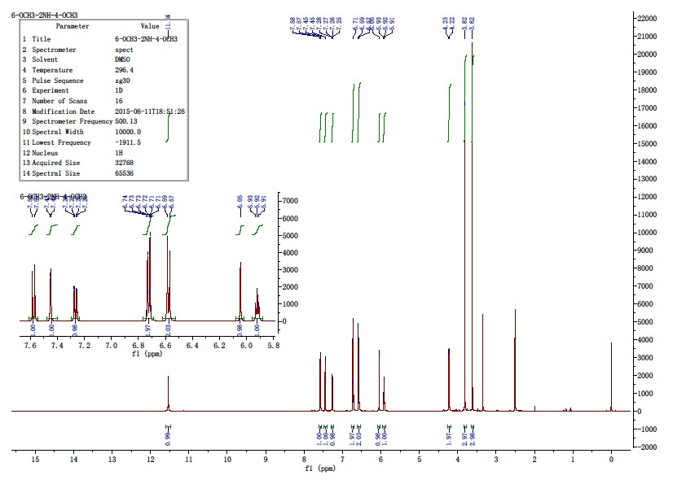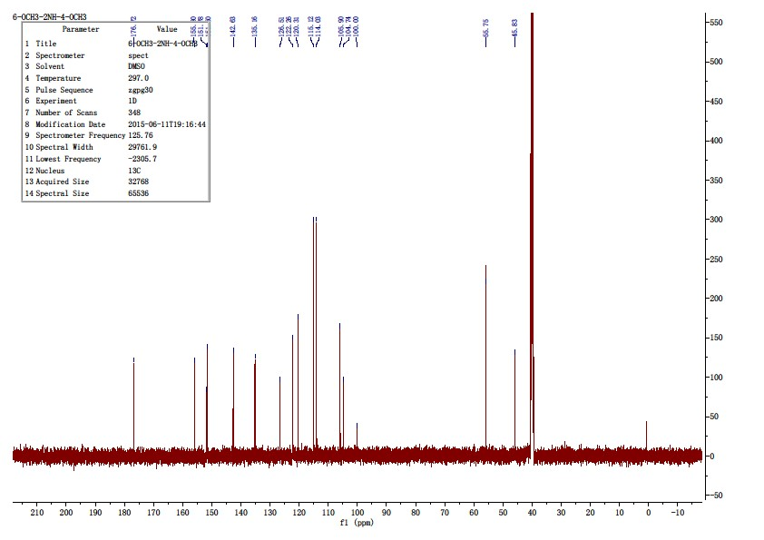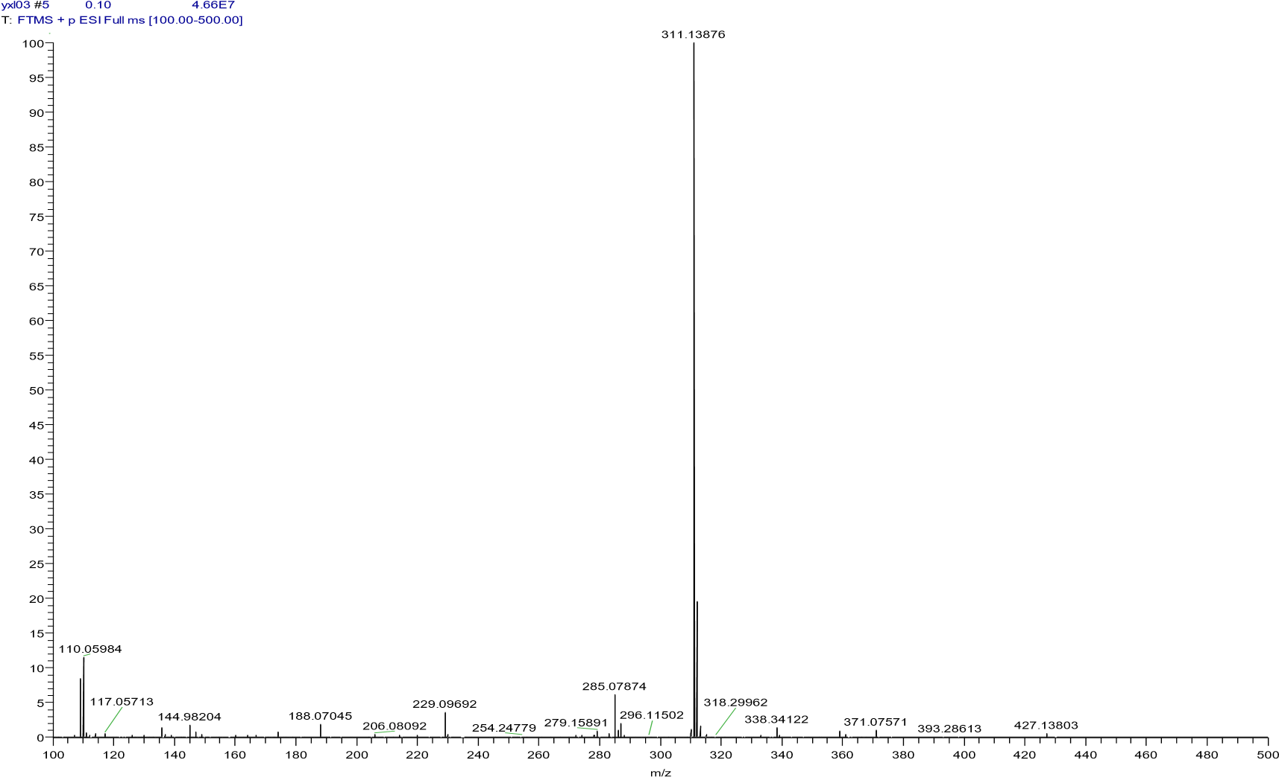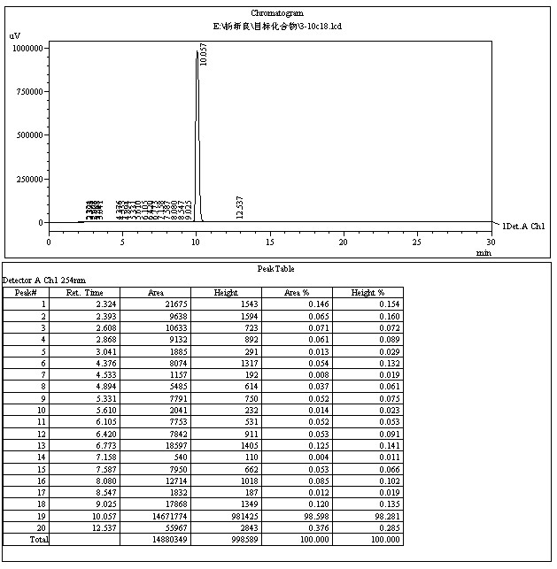

4.4.1 2-((2-((2-(trifluoromethyl)phenoxy)methyl)quinolin-4-yl)oxy)ethan-1-ol(11a)
Compound 10f 1.2 g (0.38 μmmol) was placed in a 100 ml single neck bottle, add 60 ml of N, N-dimethylformamide (DMF), ultrasound, and add 1.0 g of 2-chloroethanol (12.50 μ Mmol), add 2.0 g potassium carbonate (1.45 μ Mmol) at 80 ℃ for 10 h. After the reaction is complete, vacuum with diaphragm, concentrate and remove DMF and excess 2-chloroethanol. Concentrate and dry to obtain a brown solid, dissolve the solid with 100 ml ethyl acetate and 100 ml water, pour it into a separating funnel for extraction, wash the organic layer twice with 100 ml water respectively, and concentrate the organic layer to obtain 1.4 g of light brown solid. Mix 5 g of 300 – 400 mesh silica gel with the sample, fill 70 g of 300 – 400 mesh silica gel with the column by dry method, elute with the eluent of petroleum ether and ethyl acetate (v: v=3:1), and obtain 0.98 g of white solid. Yield: 72.1%, mp: 149.9-151.8 ℃, HPLC purity: 98.51% (liquid phase condition A), ¹H NMR (400 MHz, DMSO- d6) δ 8.24 (dd, J = 8.3, 0.9 Hz, 1H), 7.95 (d, J = 8.2 Hz, 1H), 7.78 (ddd, J = 8.4, 6.9, 1.4 Hz, 1H), 7.69 (d, J = 7.7 Hz, 1H), 7.65 (t, J = 7.5 Hz, 1H), 7.62 – 7.55 (m, 1H), 7.39 (d, J = 8.4 Hz, 1H), 7.19 – 7.09 (m, 2H), 5.45 (s, 2H), 5.09 (t, J = 5.7 Hz, 1H), 4.21 (t, J = 4.7 Hz, 2H), 3.88 (dd, J = 9.9, 5.2 Hz, 2H). ¹³C NMR (100 MHz, DMSO- d6) δ 162.18, 158.75, 156.17, 148.42, 134.81, 130.64, 128.70, 127.33 (q, J = 5.1 Hz), 126.13, 124.39(q, J = 273.7 Hz), 122.32, 121.23, 120.61, 117.69(q, J = 30.3 Hz), 114.44, 99.10, 71.74, 65.46, 59.62. HRMS (ESI) m/z calcd for [C19H16F3NO3+H]+ , 364.1155; found, 364.11392 [M+H] + .
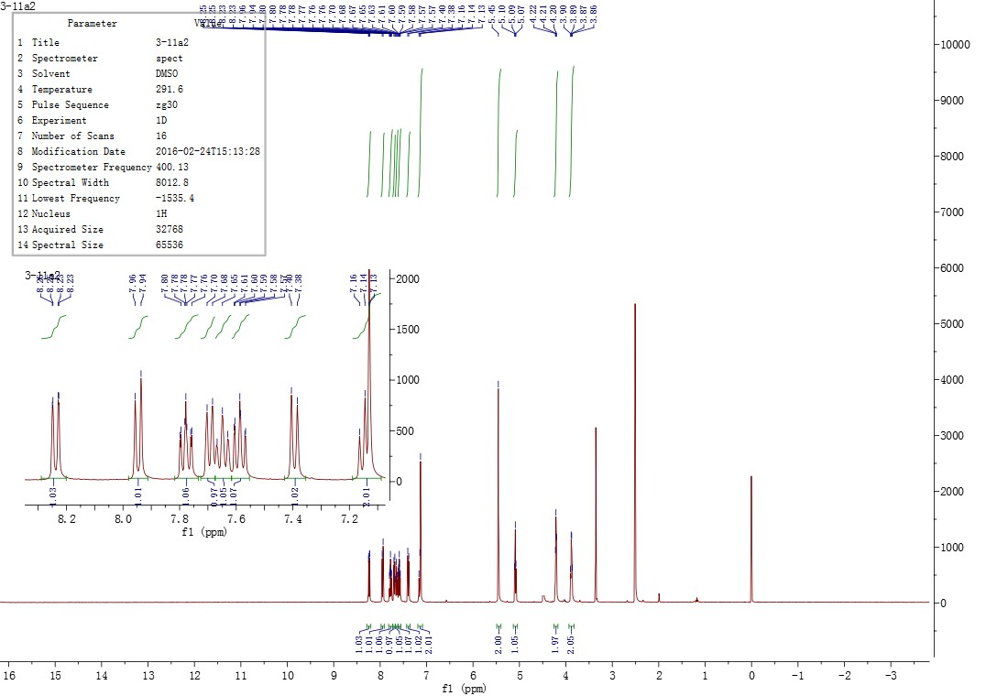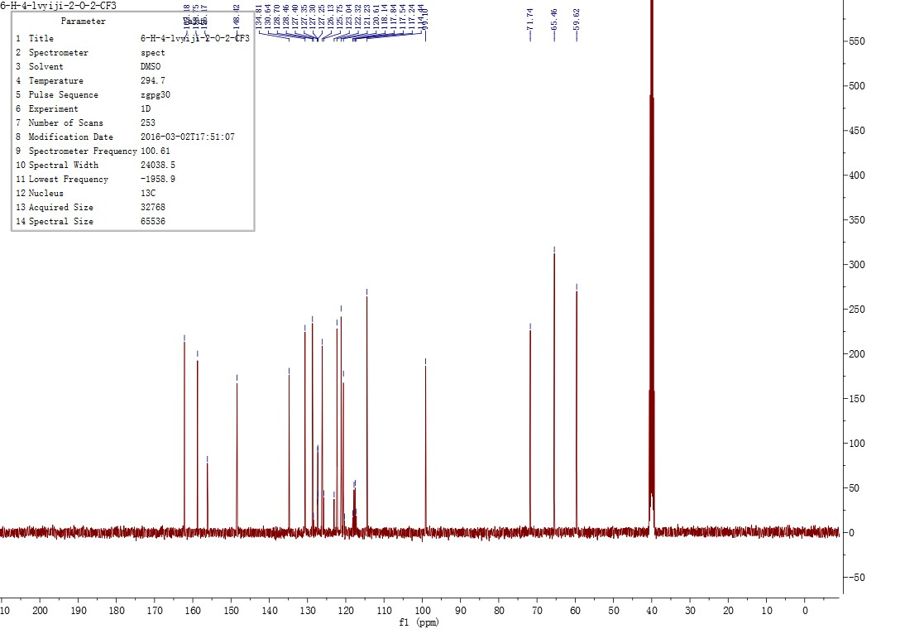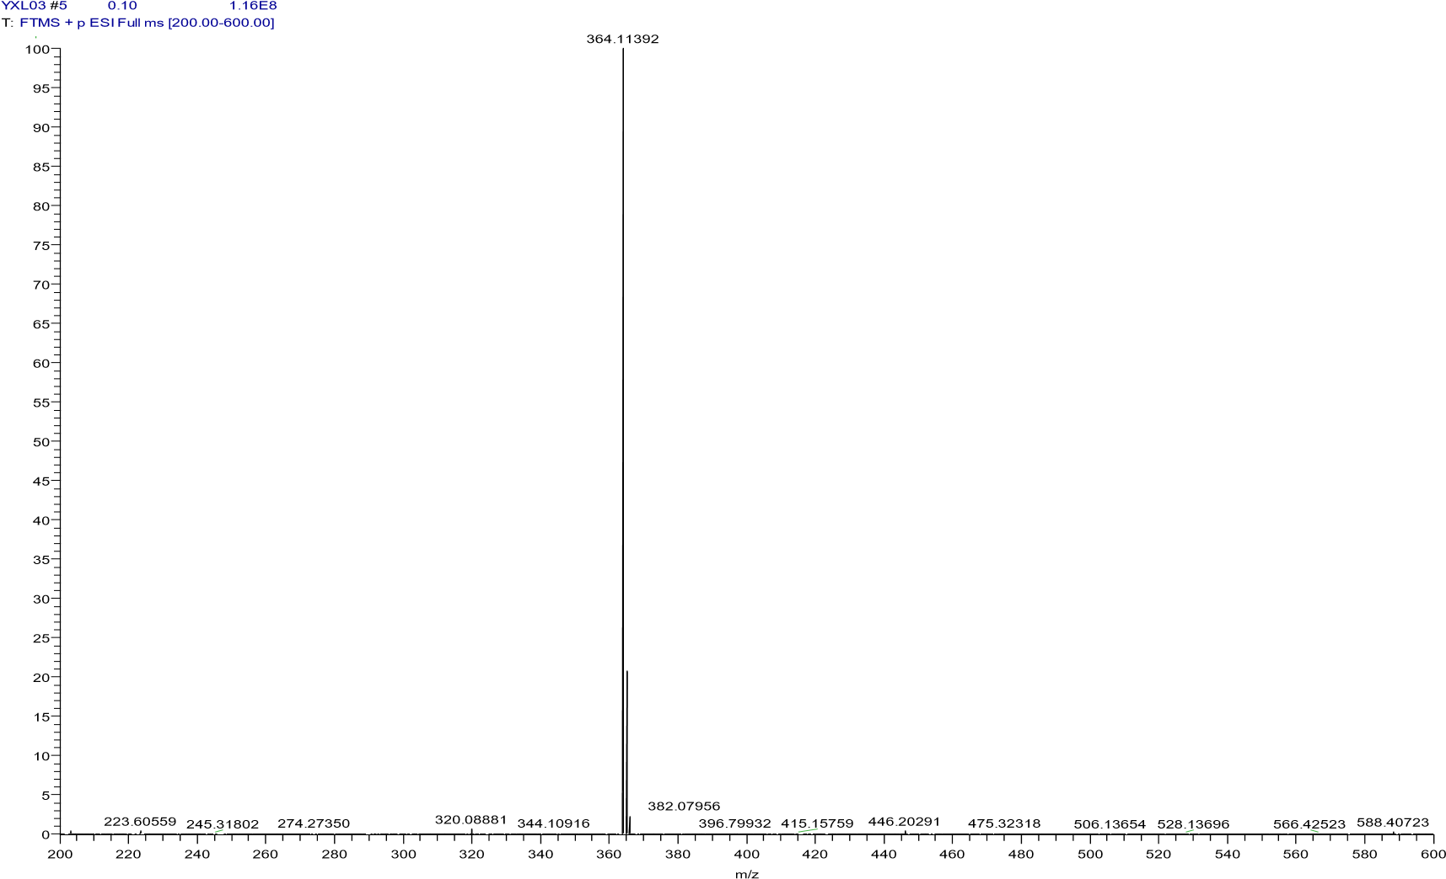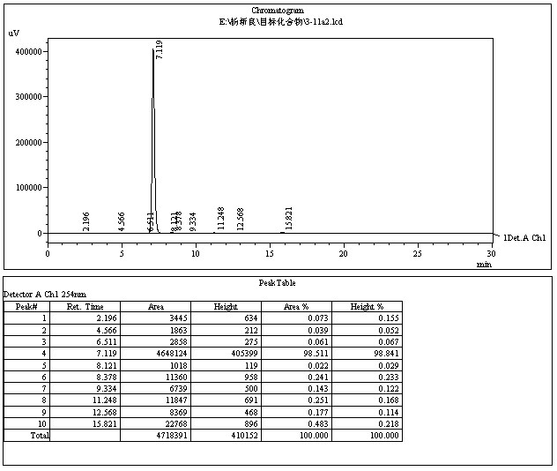

4.4.2 2-((2-chlorophenoxy)methyl)-4-(pyridin-2-ylmethoxy)quinoline(11b)
Compound 10b 0.2 g (0.701 mmol) was placed in a 25 ml single neck flask, add 15 ml of N, N-dimethylformamide (DMF), ultrasound, add 0.1 g of 2-chloroethyl pyridine (0.787 mmol), add 0.5 g of potassium carbonate (36.23 mmol), and stir at 80 ℃ for 8 h. After the reaction is complete, vacuum with diaphragm, concentrate and remove DMF. The brown solid is obtained after being concentrated and dried. The solid is dissolved with 50 ml ethyl acetate and 50 ml water, poured into a separating funnel for extraction, and the organic layer is washed twice with 50 ml water respectively. The organic layer is concentrated to obtain 0.28 white solid. Mix the sample with 1.2 g of 300 – 400 mesh silica gel, fill the column with 20 g of 300 – 400 mesh silica gel by dry method, elute with the eluent of petroleum ether and ethyl acetate (v: v=5:1), and obtain 0.18 g of white solid. Yield: 69.2%, mp: 98.0-100.0 ℃, HPLC purity: 99.20% (liquid phase condition A), ¹H NMR (400 MHz, DMSO- d6) δ 8.24 (dd, J = 8.3, 0.9 Hz, 1H), 7.95 (d, J = 8.2 Hz, 1H), 7.78 (ddd, J = 8.4, 6.9, 1.4 Hz, 1H), 7.69 (d, J = 7.7 Hz, 1H), 7.65 (t, J = 7.5 Hz, 1H), 7.62 – 7.55 (m, 1H), 7.39 (d, J = 8.4 Hz, 1H), 7.19 – 7.09 (m, 2H), 5.45 (s, 2H), 5.09 (t, J = 5.7 Hz, 1H), 4.21 (t, J = 4.7 Hz, 2H), 3.88 (dd, J = 9.9, 5.2 Hz, 2H). ¹³C NMR (100 MHz, DMSO- d6) δ 162.18, 158.75, 156.17, 148.42, 134.81, 130.64, 128.70, 127.33 (q, J = 5.1 Hz), 126.13, 124.39(q, J = 273.7 Hz), 122.32, 121.23, 120.61, 117.69(q, J = 30.3 Hz), 114.44, 99.10, 71.74, 65.46, 59.62. HRMS (ESI) m/z calcd for [C22H17ClN2O2+H]+ , 377.1051; found, 377.10406 [M+H] + .
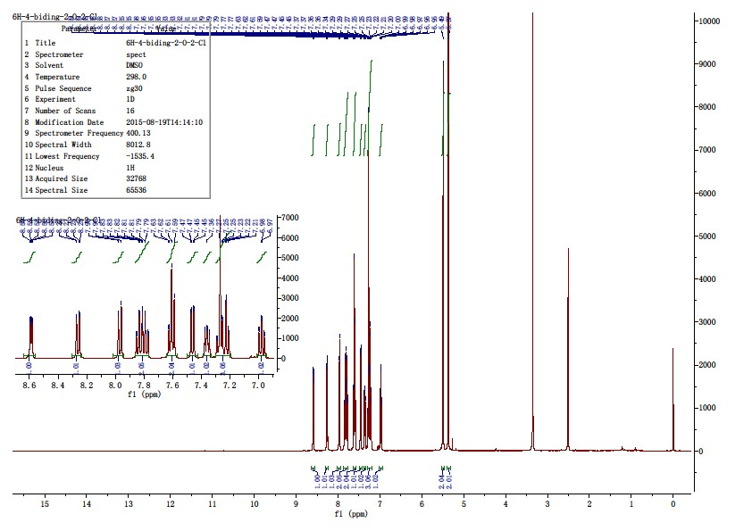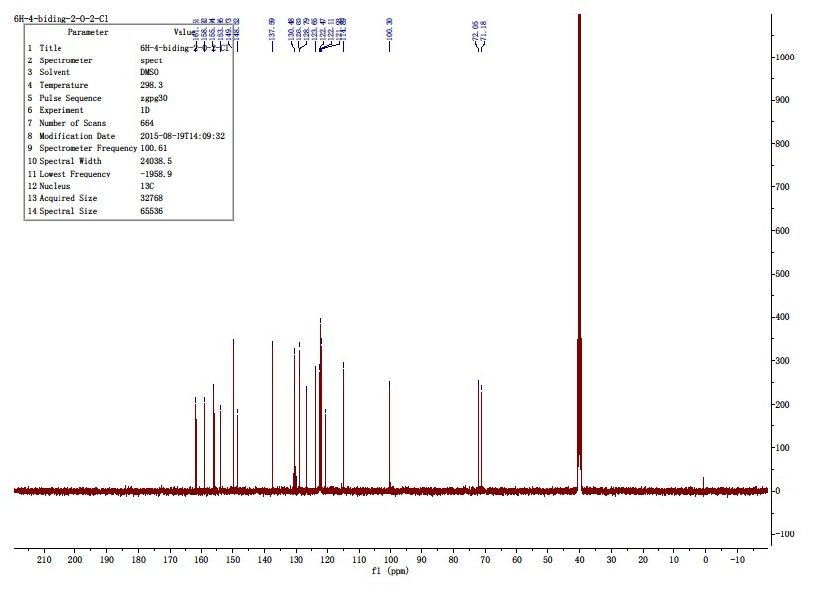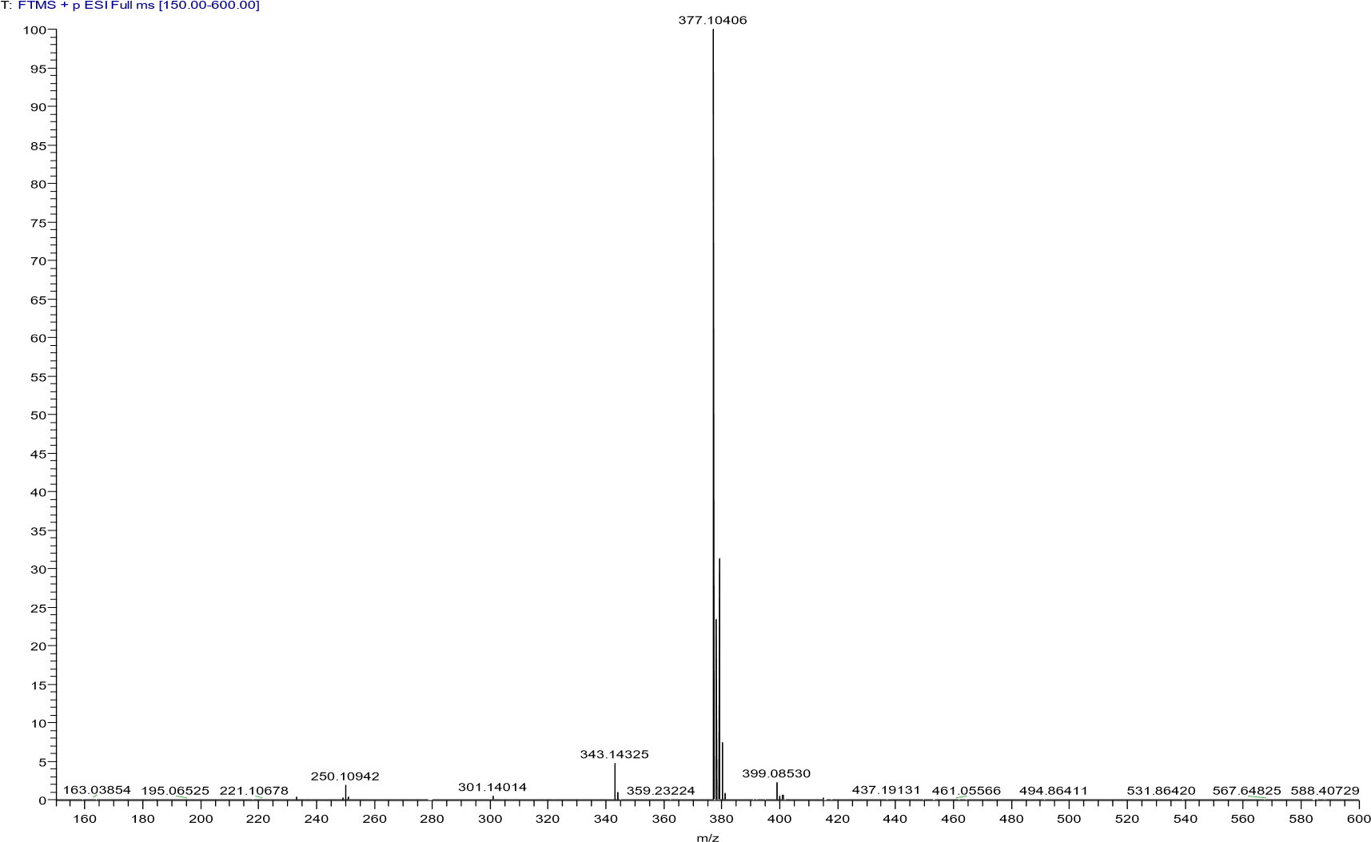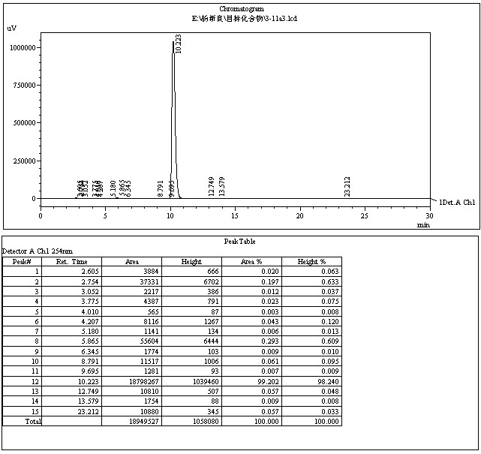

-

4.4.3 2-((2-((2-chlorophenoxy)methyl)-6-fluoroquinolin-4-yl)oxy)ethan-1-ol(11c)
The title compound was prepared in the manner similar to compound 11a. White solid, yield: 71.3%, mp: 171.3 - 173.7 ℃, HPLC purity: 99.35% (liquid phase condition A), ¹H NMR (500 MHz, DMSO- d6) δ 8.01 (dd, J = 9.2, 5.4 Hz, 1H), 7.94 (dd, J = 9.7, 2.9 Hz, 1H), 7.68 (td, J = 8.8, 3.0 Hz, 1H), 7.48 (dd, J = 7.9, 1.2 Hz, 1H), 7.36 – 7.26 (m, 2H), 7.24 (s, 1H), 7.03 – 6.95 (m, 1H), 5.38 (s, 2H), 5.10 (t, J = 5.9 Hz, 1H), 4.25 (t, J = 4.7 Hz, 2H), 3.88 (dd, J = 9.6, 5.1 Hz, 2H). ¹³C NMR (125 MHz, DMSO- d6) δ 161.85 (d, J = 5.0 Hz), 159.97(d, J = 245.7Hz), 158.51 (d, J = 2.3 Hz), 158.50, 153.98, 145.59, 131.67 (d, J = 9.0 Hz), 130.52, 128.87, 122.58, 122.15, 121.35 (d, J = 10.0 Hz), 120.46(d, J = 26.5 Hz), 115.10, 106.19(d, J = 23.9 Hz), 100.24, 72.20, 71.08, 59.67. HRMS (ESI) m/z calcd for [C18H15ClFNO3+H]+ , 348.0797; found, 348.07907 [M+H] + .
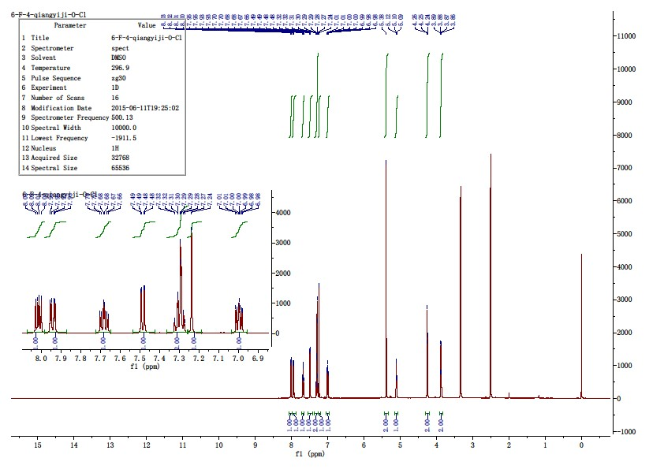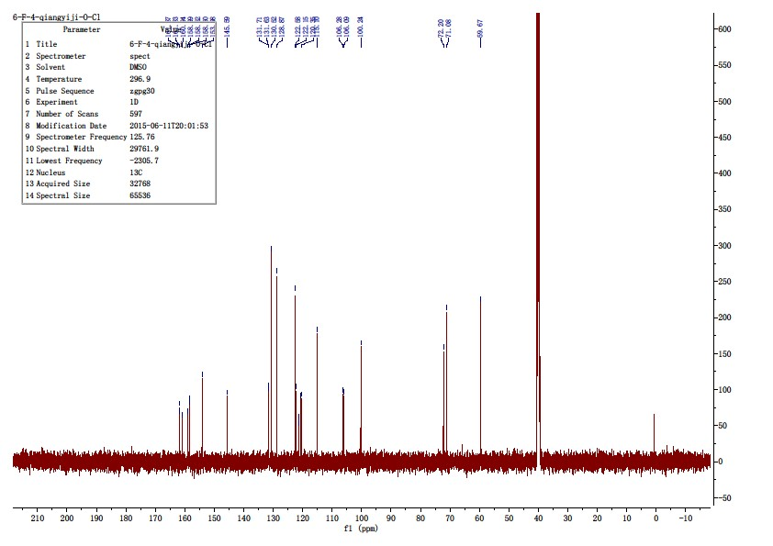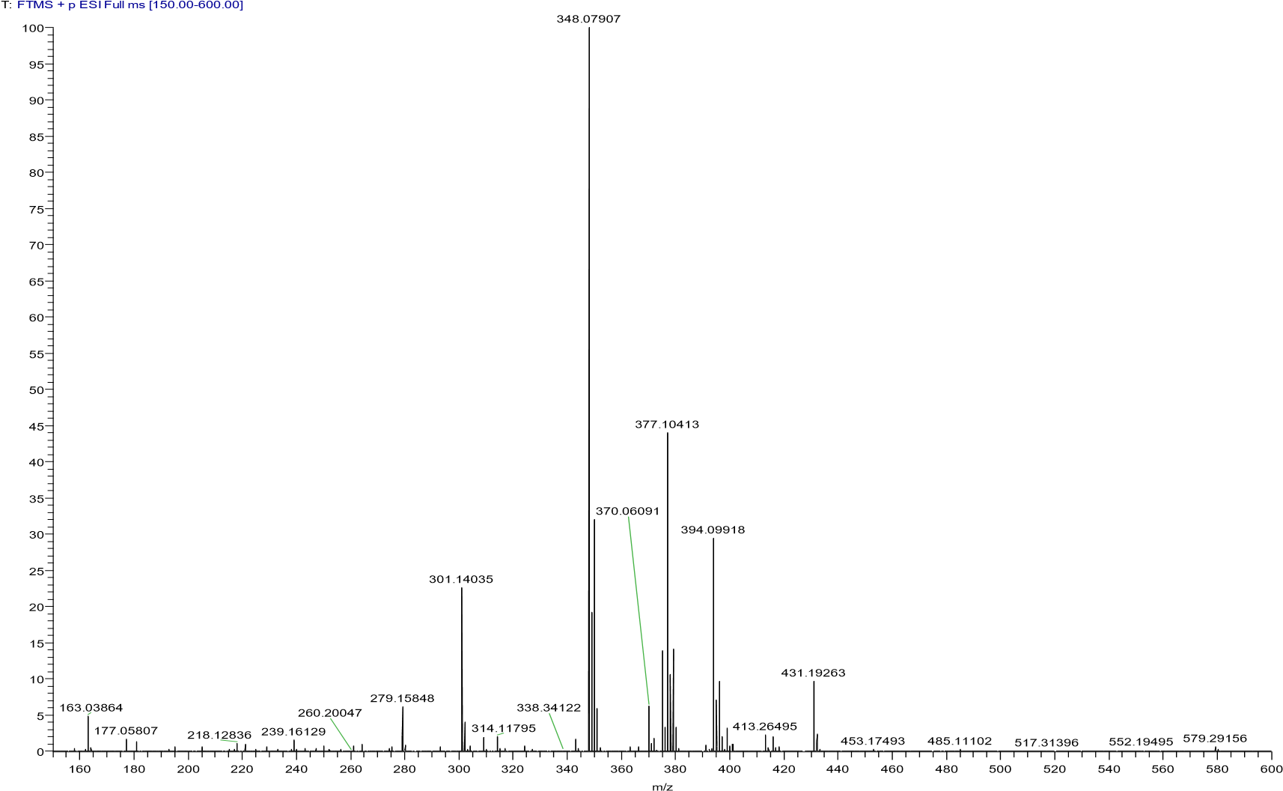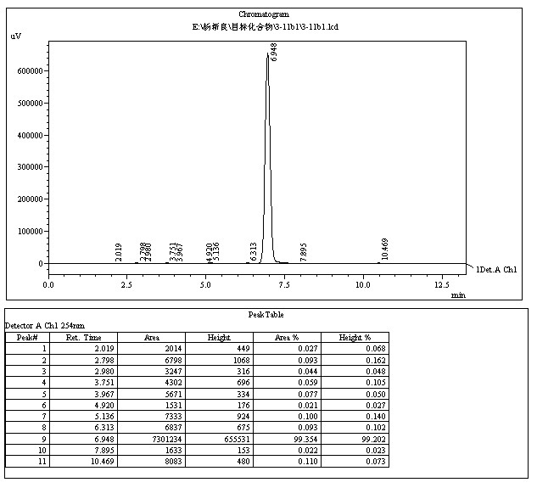

4.4.3 4-(2-chloroethoxy)-2-((2-chlorophenoxy)methyl)-6-fluoroquinoline (12c)
Take 2.0 g of compound 11c (5.76 μmol) Put it into a 250 ml single-neck bottle, add 150 ml carbon tetrachloride, dissolve it by ultrasound, and add 0.2 g triphenyl phosphorus (0.76 μ mol), refluxing and stirring for 6 hours, after the reaction is complete, concentrate and dry the reaction solution to obtain 2.3 g of white solid, mix the sample with 10 g of 300 – 400 mesh silica gel, column with 100 g of 300 – 400 mesh silica gel, elute with petroleum ether and ethyl acetate(v: v=5:1) to obtain 1.6 g of white solid. Yield: 76.2%, mp:138.2 - 140.3℃, 1H NMR (500 MHz, DMSO- d6) δ 8.05 (dd, J = 9.2, 5.3 Hz, 1H), 7.79 (dd, J = 9.5, 2.9 Hz, 1H), 7.71 (td, J = 8.8, 2.9 Hz, 1H), 7.53 – 7.45 (m, 1H), 7.37 – 7.24 (m, 3H), 7.06 – 6.94 (m, 1H), 5.33 (d, J = 54.9 Hz, 2H), 4.64 – 4.51 (m, 2H), 4.22 – 4.04 (m, 2H).

4.4.4 2-((2-chlorophenoxy)methyl)-4-(2-(pyrrolidin-1-yl)ethoxy)quinoline (13a)
Compound 12a 0.3 g (0.91 μmol) was placed in a 25 ml single neck flask, add 15 ml pyrrolidine (0.18 mol), and stir the reaction at 80 ℃. After the reaction is complete, it is concentrated under reduced pressure to obtain 0.35 g of brown oil. After being placed for 24 h, the brown oil turns into a brown solid. It is recrystallized with 15 ml of 50% ethanol to obtain 0.13 g of white solid, with a yield of 37.3%, mp: 103.1-105.1 ℃, HPLC purity: 98.78% (liquid phase condition A), ¹H NMR (500 MHz, DMSO- d6) δ 8.13 (dd, J = 8.3, 0.9 Hz, 1H), 7.94 (d, J = 8.3 Hz, 1H), 7.76 (ddd, J = 8.4, 6.9, 1.4 Hz, 1H), 7.62 – 7.54 (m, 1H), 7.48 (dd, J = 7.8, 1.1 Hz, 1H), 7.35 – 7.25 (m, 2H), 7.21 (s, 1H), 7.00 (tt, J = 6.5, 5.2 Hz, 1H), 5.40 (s, 2H), 4.36 (t, J = 5.6 Hz, 2H), 2.94 (t, J = 5.6 Hz, 2H), 2.65 – 2.53 (m, 4H), 1.78 – 1.59 (m, 4H). ¹³C NMR (125 MHz, DMSO- d6) δ 161.94, 158.93, 154.00, 148.50, 130.61, 130.51, 128.85, 128.82, 126.30, 122.53, 122.15, 122.00, 120.63, 115.10, 99.63, 72.29, 68.46, 54.59, 54.18(2C), 23.72(2C). HRMS (ESI) m/z calcd for [C22H23ClN2O2+H]+ , 382.1448; found, 383.15121 [M+H] + .
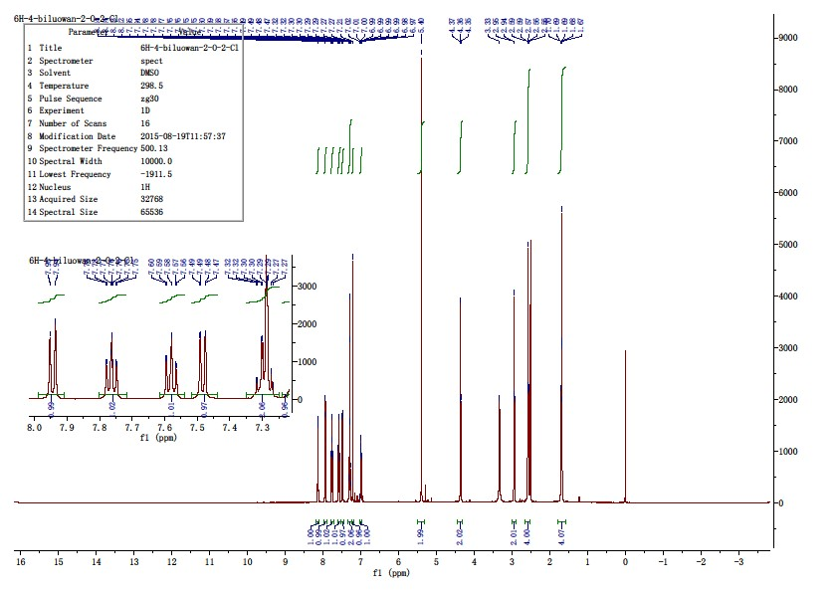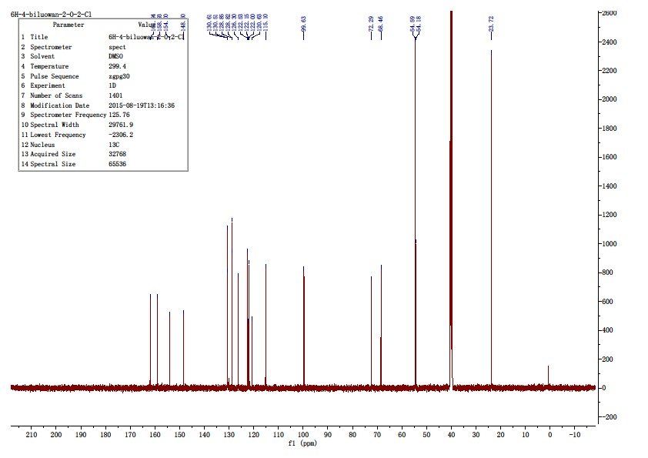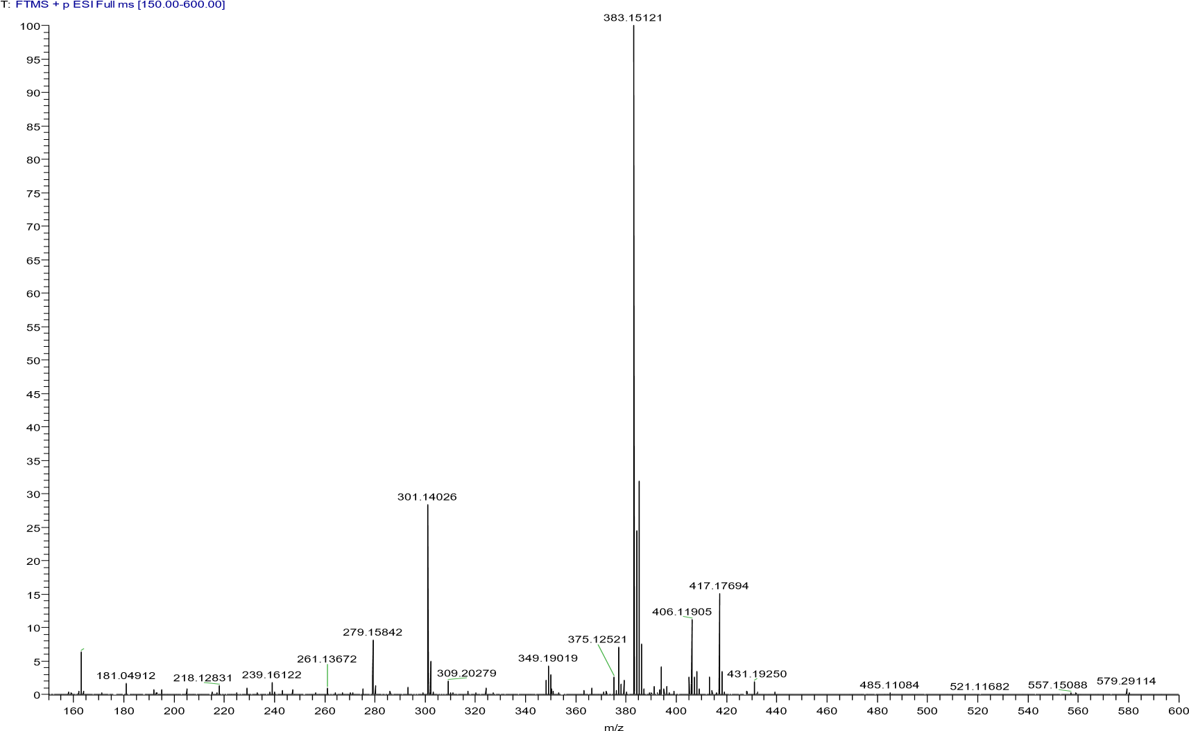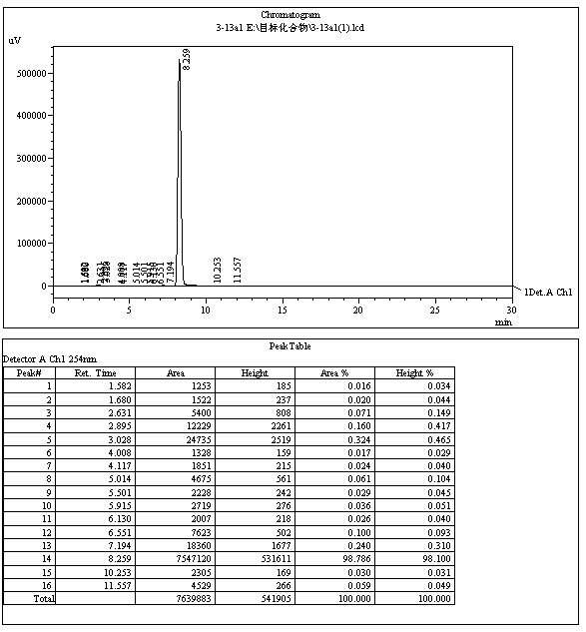

4.4.5 2-((2-chlorophenoxy)methyl)-4-(2-(piperidin-1-yl)ethoxy)quinoline(13b)
The title compound was prepared in the manner similar to compound 13a. White solid, yield: 37.2%, mp: 85.9 - 86.9 ℃, HPLC purity: 99.25% (liquid phase condition A), ¹H NMR (500 MHz, CDCl3) δ 8.20 (d,J = 8.0 Hz, 1H), 7.99 (d, J = 8.4 Hz, 1H), 7.72 (t, J = 7.7 Hz, 1H), 7.51 (t, J = 7.6 Hz,1H), 7.42 (dd, J = 7.9, 1.2 Hz, 1H), 7.23 – 7.17 (m, 2H), 7.04 (d, J = 8.2 Hz, 1H), 6.93(t, J = 7.6 Hz, 1H), 5.41 (s, 2H), 4.39 (t, J = 5.8 Hz, 2H), 2.94 (t, J = 5.8 Hz, 2H), 2.59(s, 4H), 1.67 – 1.59 (m, 4H), 1.50 – 1.42 (m, 2H). ¹³C NMR (125 MHz, CDCl3) δ 162.37, 158.81, 153.89, 148.53, 130.35, 130.02, 128.30, 127.90, 125.48, 122.98,122.02, 121.90, 120.88, 114.01, 98.36, 72.04, 67.00, 57.42, 55.05(2C), 26.04(2C),24.13. HRMS (ESI) m/z calcd for [C23H25ClN2O2+H]+, 397,1677; found, 397.16666[M+H] +.
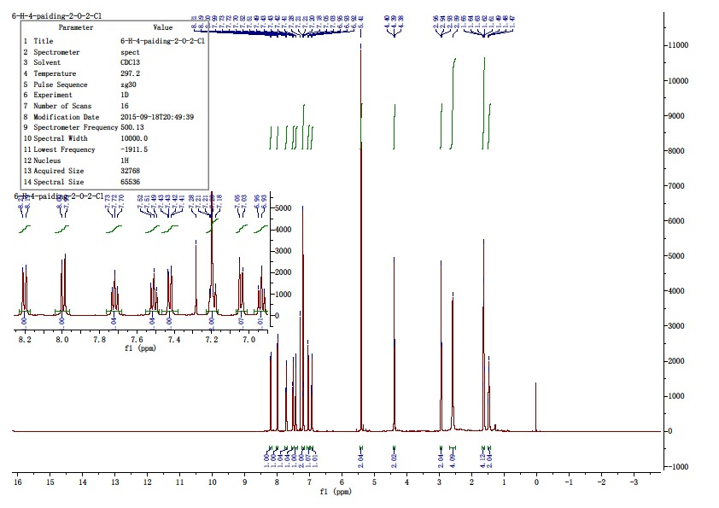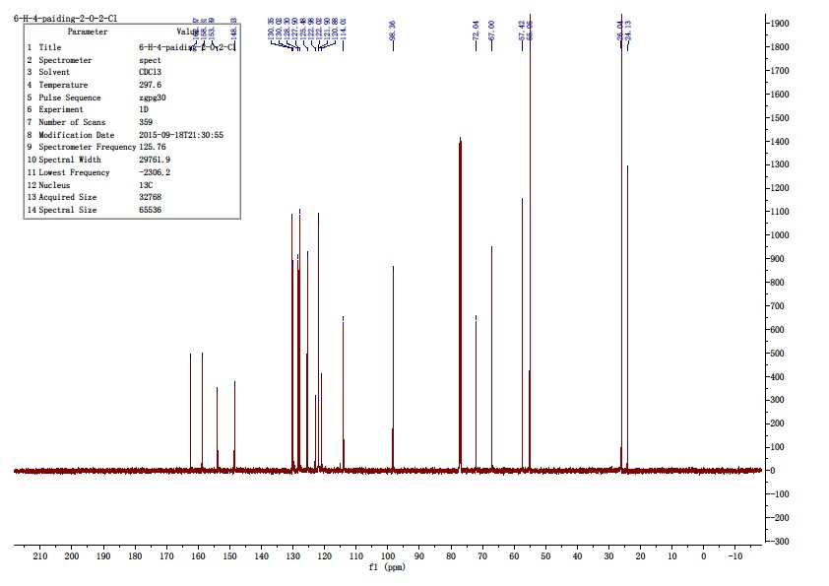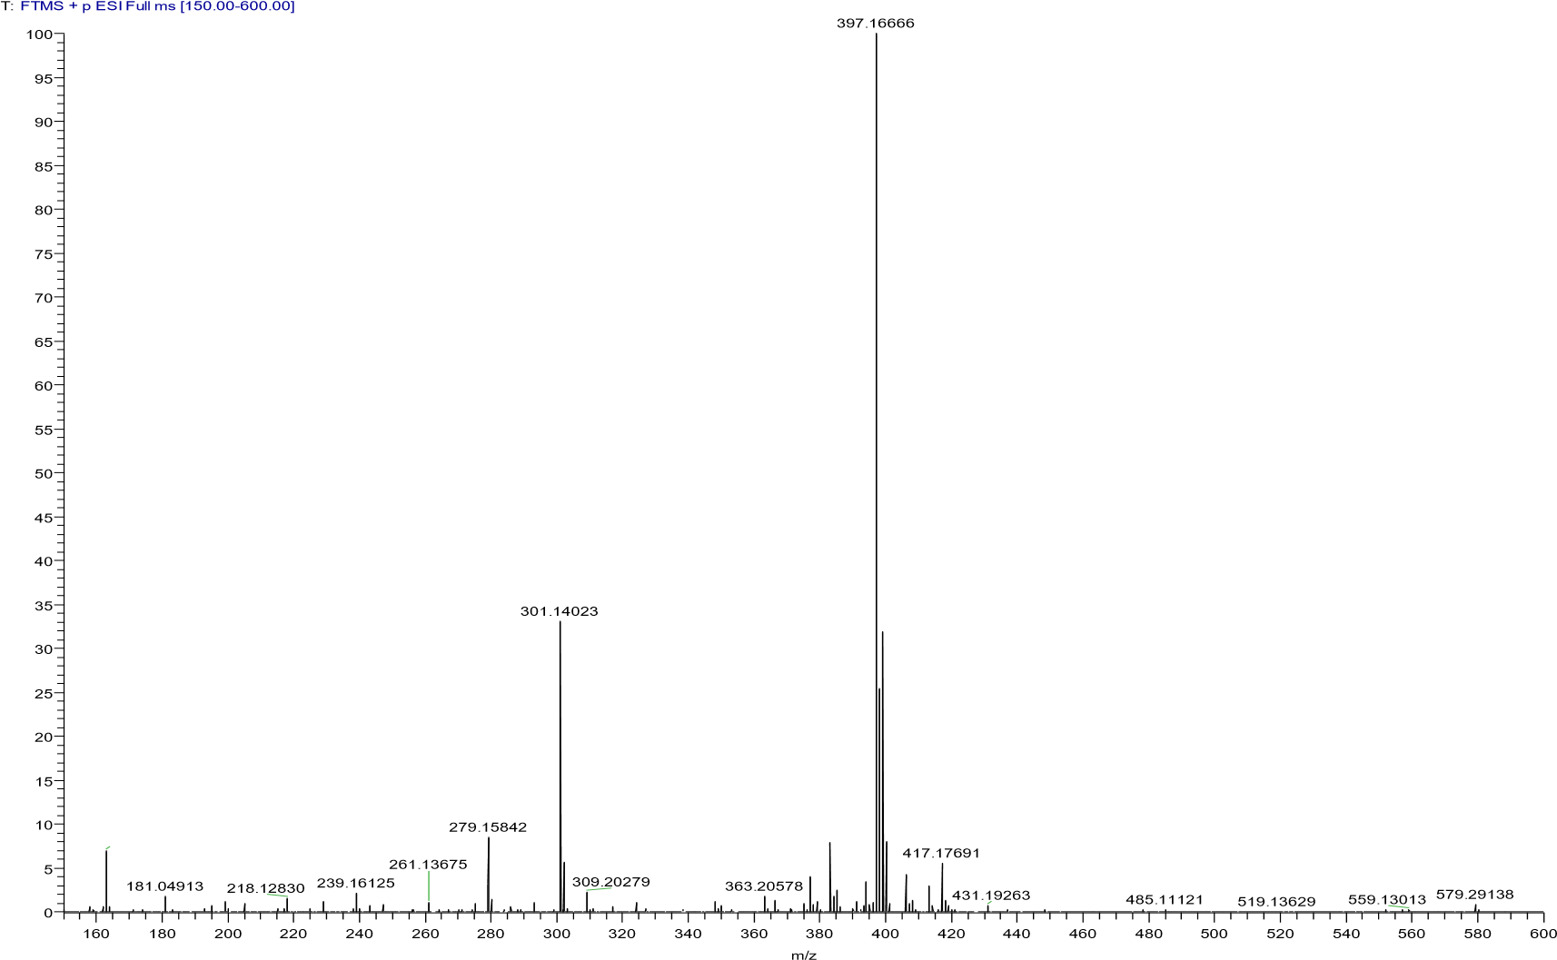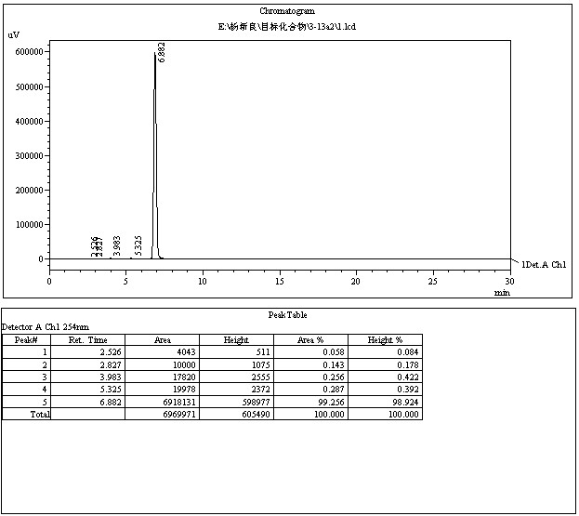

4.4.6 2-((2-chlorophenoxy)methyl)-4-(2-(4-methylpiperazin-1-yl)ethoxy)quinoline(13c)
The title compound was prepared in the manner similar to compound 13a. White solid, yield: 37.4%, mp: 85.5-87.4 ℃, HPLC purity: 98.71% (liquid phase condition B), 1H NMR (500 MHz, CDCl3) δ 8.19 (d,J = 8.3 Hz, 1H), 8.00 (d, J = 8.4 Hz, 1H), 7.76 – 7.70 (m, 1H), 7.52 (t, J = 7.5 Hz, 1H),7.43 (dd, J = 7.9, 1.5 Hz, 1H), 7.23 – 7.17 (m, 2H), 7.05 (d, J = 8.3 Hz, 1H), 6.94 (td,J = 7.7, 1.1 Hz, 1H), 5.41 (s, 2H), 4.40 (t, J = 5.6 Hz, 2H), 3.00 (t, J = 5.6 Hz, 2H),2.73 (s, 4H), 2.53 (s, 4H), 2.33 (s, 3H). ¹³C NMR (125 MHz, CDCl3) δ 162.24, 158.76,153.78, 148.44, 130.32, 130.07, 128.25, 127.92, 125.55, 122.87, 121.94, 121.90,120.76, 113.93, 98.29, 71.89, 66.94, 56.63, 55.05(2C), 53.59(2C), 46.00. HRMS (ESI)m/z calcd for [C23H26ClN3O2+H]+, 412.1786; found, 412.17783 [M+H] +.
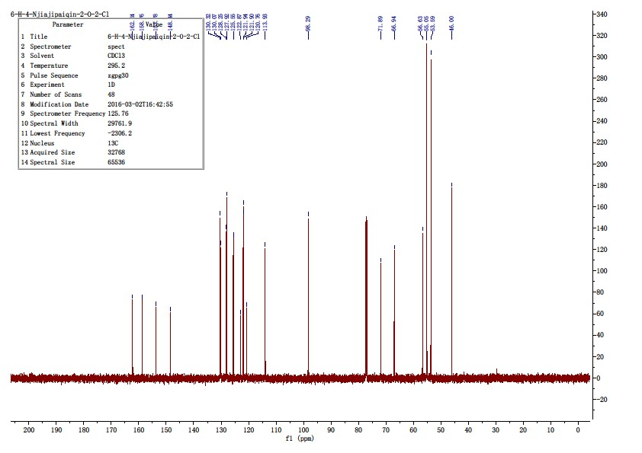
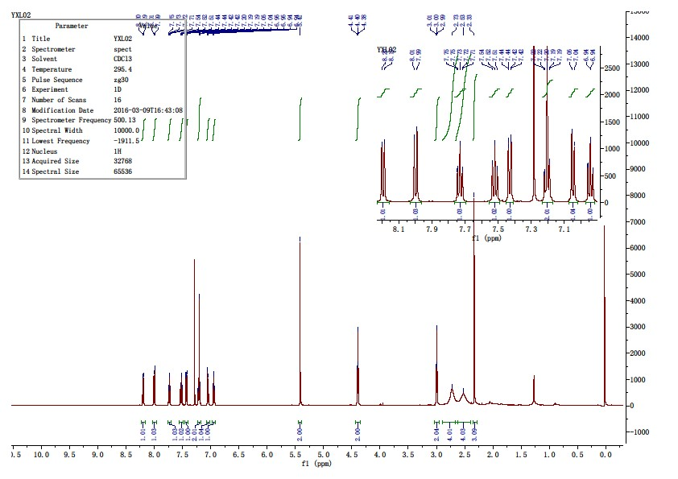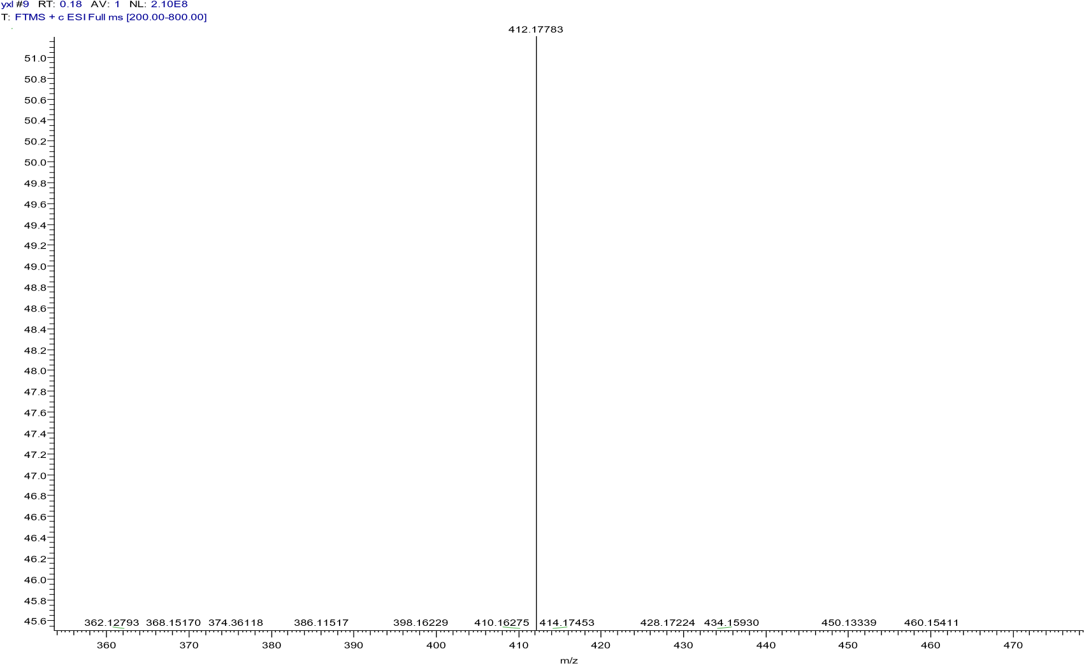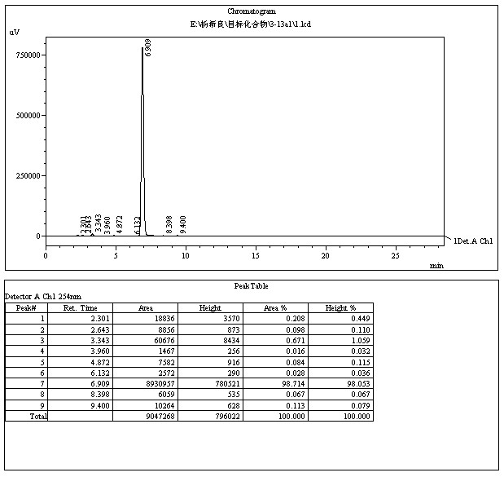

附图
150
化合物
3
-
13
a
3

氢谱

附图
151
化合物
3
-
13
a

碳谱

附图
152
化合物
3
-
13
a
3
质谱

4.4.7 4-(2-(pyrrolidin-1-yl)ethoxy)-2-((2-(trifluoromethyl)phenoxy)methyl)quinoline
(13d)
The title compound was prepared in the manner similar to compound 13a. White solid, yield: 34.3%, mp: 105.5-107.0 ℃, HPLC purity: 98.62% (liquid phase condition B), ¹H NMR (400 MHz, CDCl3) δ 8.22(d, J = 8.3 Hz, 1H), 7.99 (d, J = 8.4 Hz, 1H), 7.75 – 7.68 (m, 1H), 7.64 (d, J = 7.7 Hz,1H), 7.49 (m, 2H), 7.19 (s, 1H), 7.11 (d, J = 8.4 Hz, 1H), 7.05 (t, J = 7.6 Hz, 1H),5.42 (s, 2H), 4.38 (t, J = 5.6 Hz, 2H), 3.07 (t, J = 5.6 Hz, 2H), 2.77 – 2.65 (m, 4H),1.88 – 1.79 (m, 4H). ¹³C NMR (100 MHz, CDCl3) δ 162.45, 158.54, 155.95, 148.50, 133.54, 130.06, 128.23, 127.23 (q, J = 5.2 Hz), 125.51, 123.92, 122.07(q, J = 283.8Hz), 120.85, 120.54, 119.86, 118.8923 (q, J = 31.3 Hz), 113.13, 98.24, 71.26, 68.20,54.94, 54.46, 23.60. HRMS (ESI) m/z calcd for [C23H23F3N2O2+H]+, 417.1784; found,417.17706 [M+H] +.
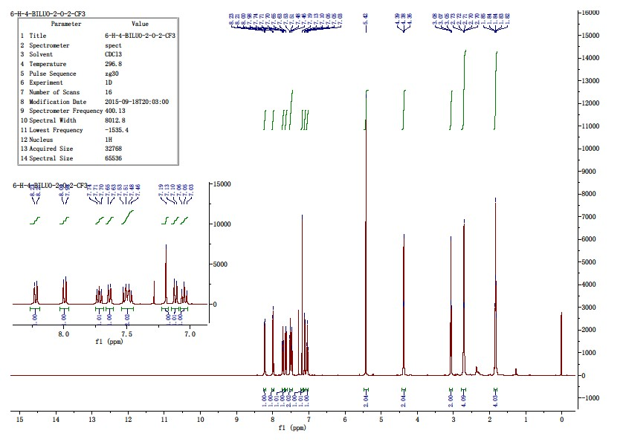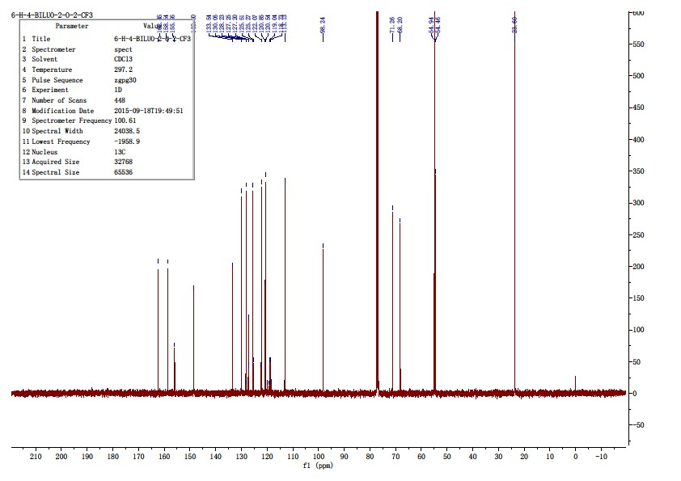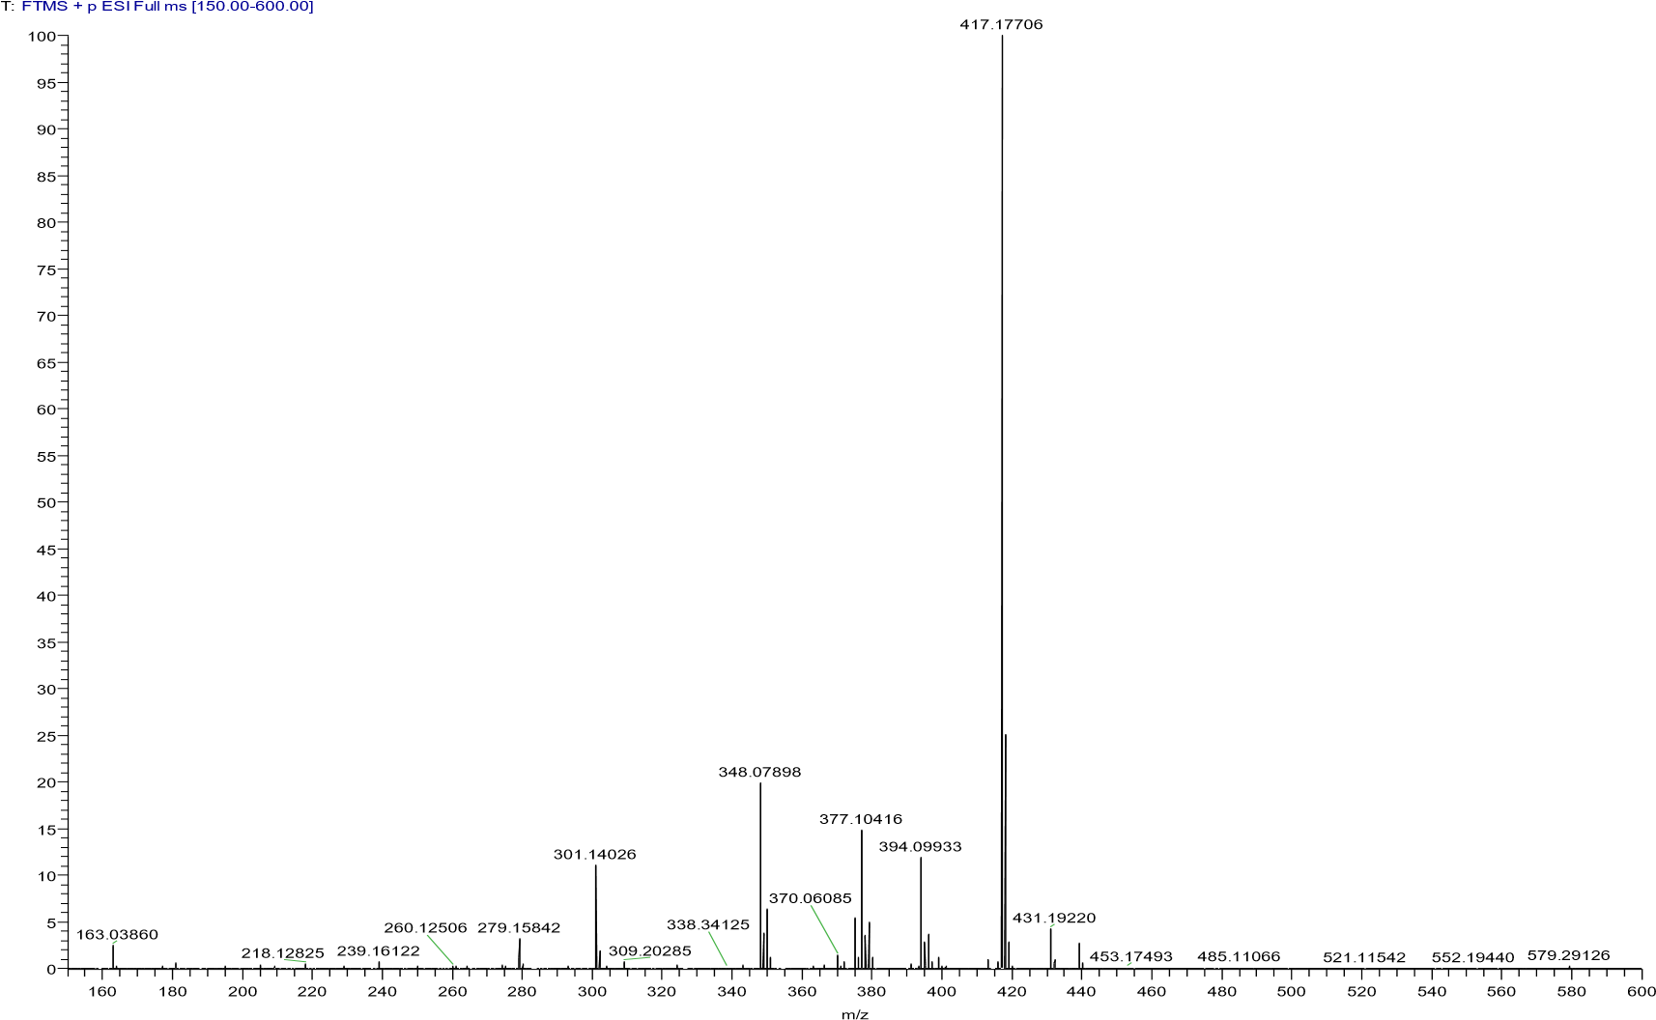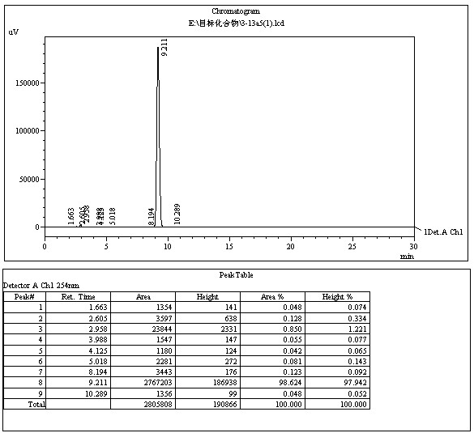

4.4.8 4-(2-(piperidin-1-yl)ethoxy)-2-((2-(trifluoromethyl)phenoxy)methyl)quinoline (13e)
The title compound was prepared in the manner similar to compound 13a. white solid, yield: 37.8%, mp: 85.1 - 85.4 ℃, HPLC purity: 98.22% (liquid phase condition B), ¹H NMR (400 MHz, CDCl3) δ 8.21(dd, J = 8.3, 0.8 Hz, 1H), 7.99 (d, J = 8.4 Hz, 1H), 7.77 – 7.69 (m, 1H), 7.65 (d, J =7.7 Hz, 1H), 7.50 (dd, J = 16.7, 8.5 Hz, 2H), 7.18 (s, 1H), 7.12 (d, J = 8.4 Hz, 1H),7.06 (t, J = 7.6 Hz, 1H), 5.43 (s, 2H), 4.38 (t, J = 5.6 Hz, 2H), 2.96 (t, J = 5.6 Hz, 2H),2.60 (s, 4H), 1.68 – 1.57 (m, 4H), 1.52 – 1.42 (m, 2H). ¹³C NMR (100 MHz, CDCl3) δ 162.40, 158.50, 155.96, 148.49, 133.52, 130.01, 128.24, 127.19 (q, J = 5.1 Hz),125.48, 123.93(q, J = 273.7 Hz), 122.04, 120.86, 120.51, 118.87(q, J = 30.3 Hz),113.12, 98.24, 71.31, 66.99, 57.41, 54.96(2C), 26.04(2C), 24.13. HRMS (ESI) m/zcalcd for [C24H25F3N2O2+H]+, 431.1941; found, 431.19217 [M+H] +.
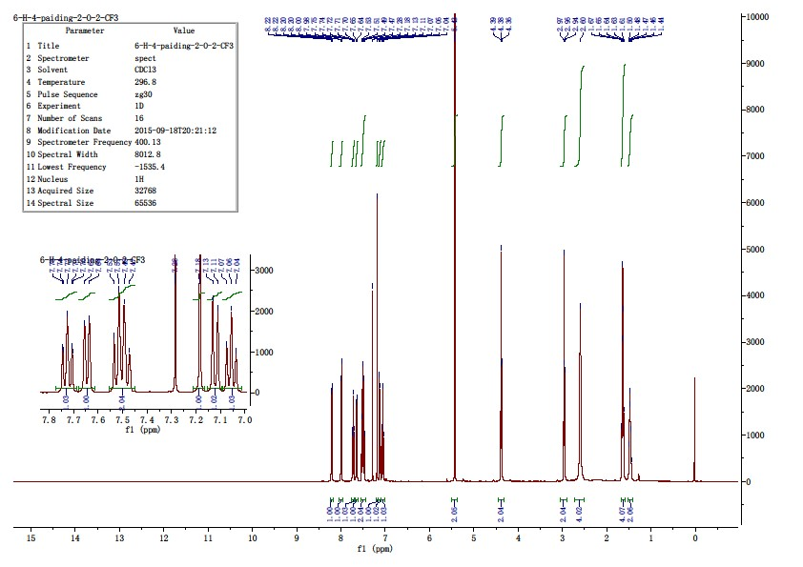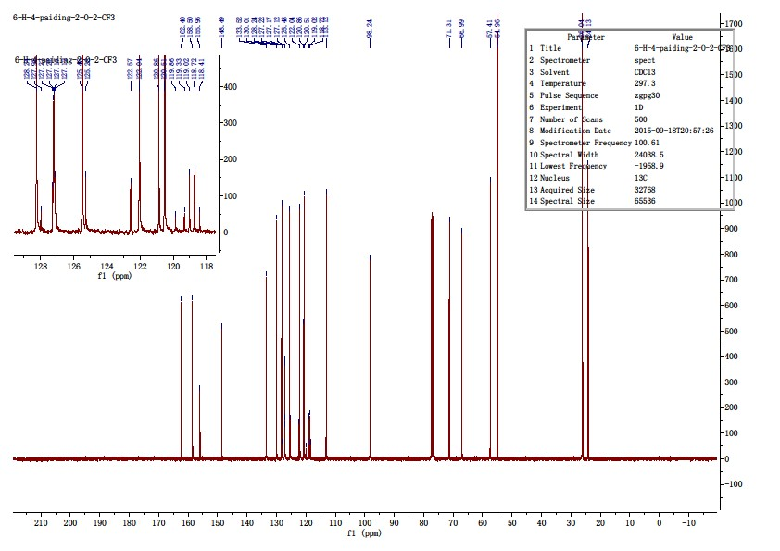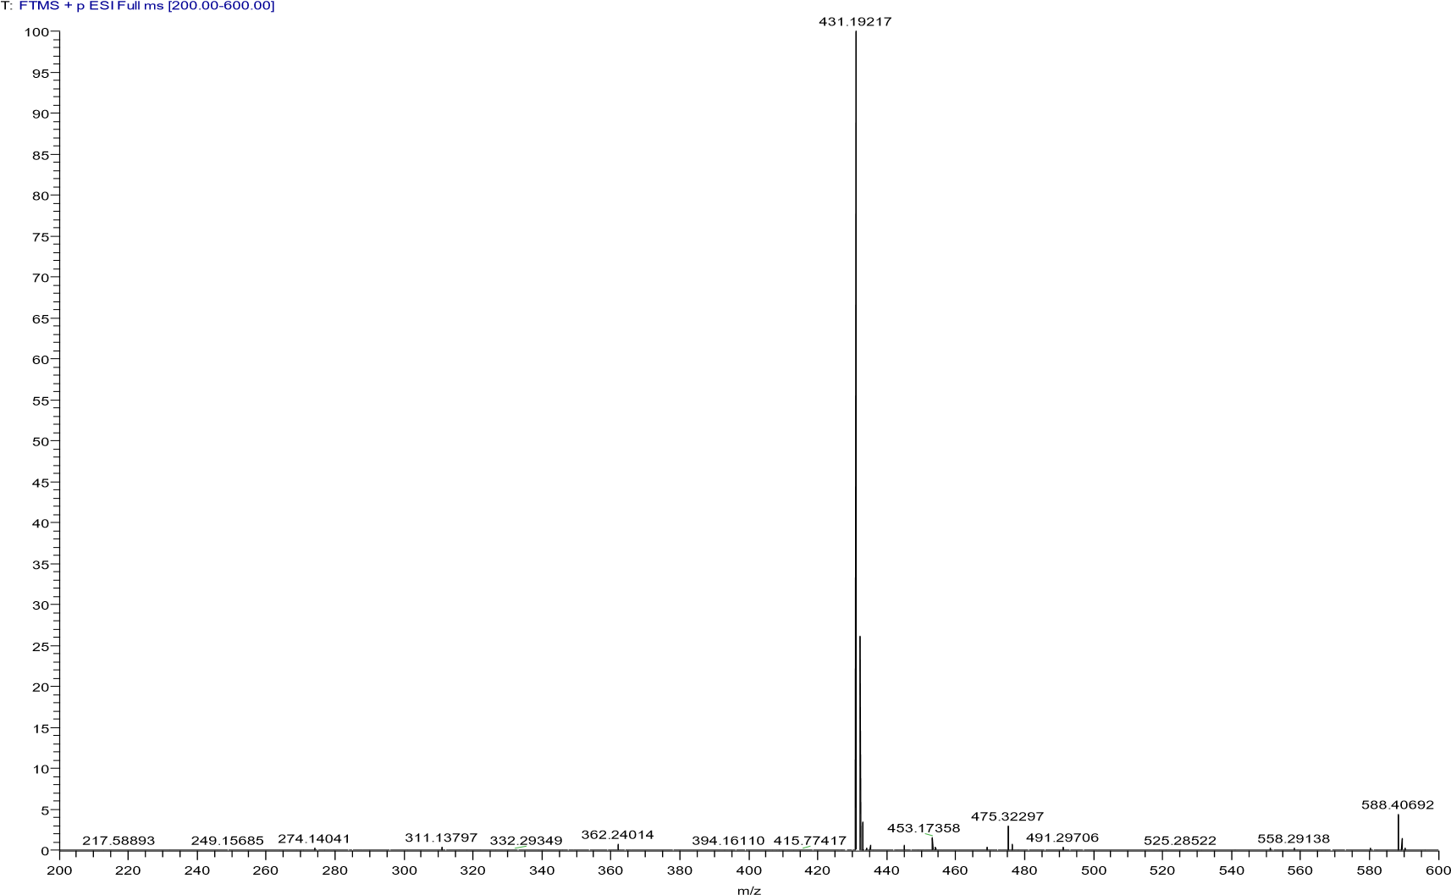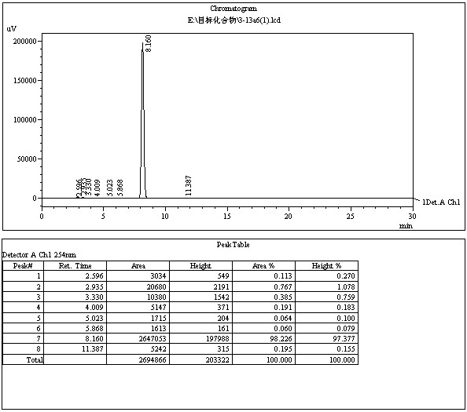

附图
157

化合物
3
-
a
13
5

HPLC
图谱

附图
158

化合物
3
-
13
a
6
氢谱

4.4.9 4-(2-(4-methylpiperazin-1-yl)ethoxy)-2-((2-(trifluoromethyl)phenoxy)methyl)
quinoline (13f)
The title compound was prepared in the manner similar to compound 13a. white solid, yield: 36.9%, mp: 89.5 - 91.3 ℃, HPLC purity: 97.04% (liquid phase condition B), ¹H NMR (500 MHz, CDCl3) δ 8.18 (d,J = 8.3 Hz, 1H), 7.98 (d, J = 8.4 Hz, 1H), 7.75 – 7.69 (m, 1H), 7.63 (d, J = 7.6 Hz,1H), 7.50 (dt, J = 10.6, 7.6 Hz, 2H), 7.18 (s, 1H), 7.12 (d, J = 8.4 Hz, 1H), 7.05 (t, J =7.6 Hz, 1H), 5.41 (s, 2H), 4.37 (t, J = 5.4 Hz, 2H), 2.99 (t, J = 5.4 Hz, 2H), 2.72 (s,4H), 2.52 (s, 4H), 2.32 (s, 3H). ¹³C NMR (125 MHz, CDCl3) δ 162.32, 158.49, 155.96,148.48, 133.54, 130.06, 128.25, 127.21(q, J = 5.0 Hz), 125.56, 123.92(q, J = 272.2Hz), 121.96, 120.81, 120.56, 118.87(q, J = 30.2 Hz), 113.16, 98.24, 71.29, 66.95,56.62, 55.04, 53.44, 45.90. HRMS (ESI) m/z calcd for [C24H26F3N3O2+H]+, 446.2050; found, 446.20273[M+H] +.
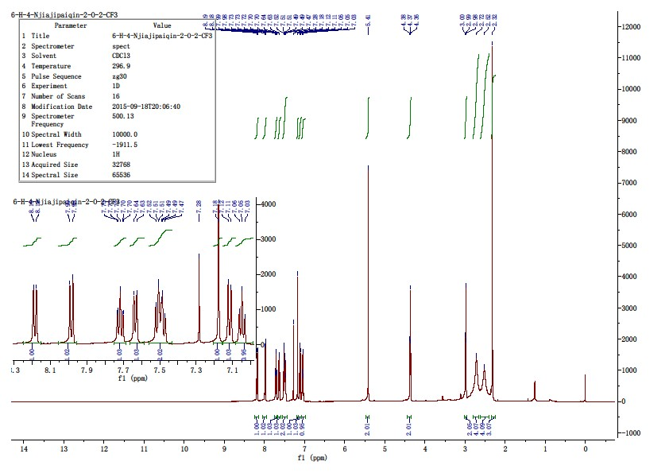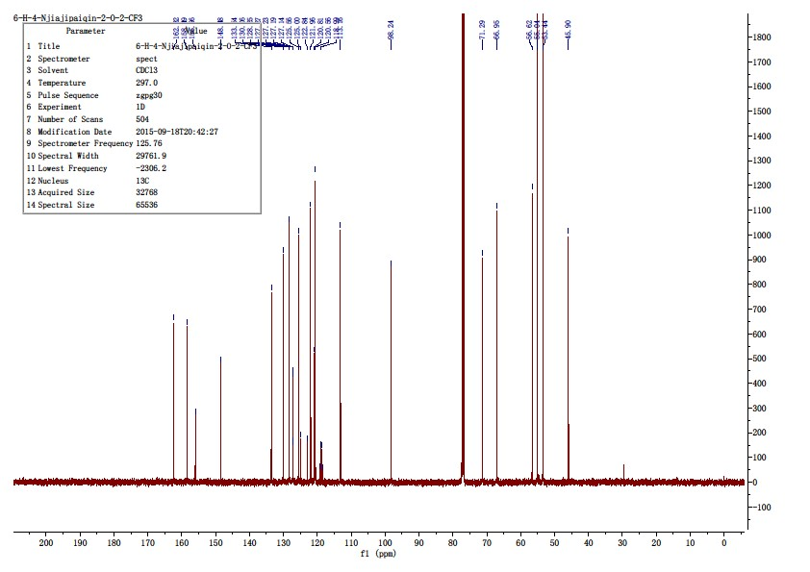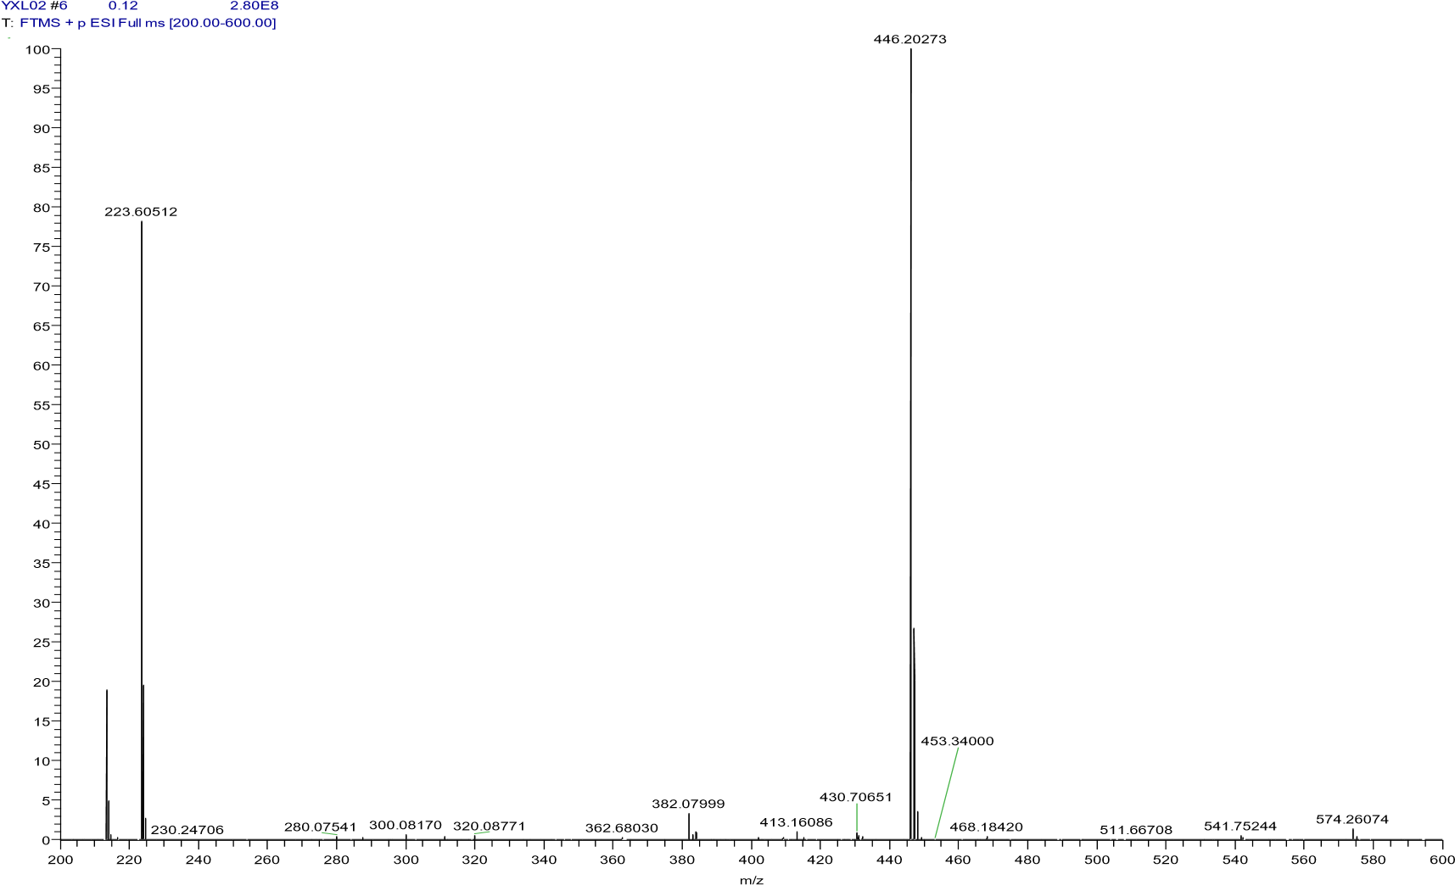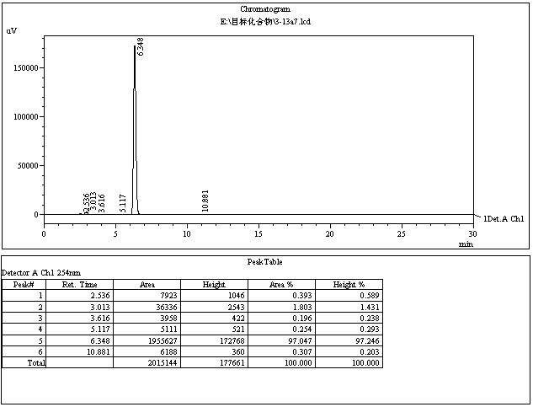

4.4.10 2-((2-chlorophenoxy)methyl)-6-fluoro-4-(2-(pyrrolidin-1-yl)ethoxy)quinoline (13g)
The title compound was prepared in the manner similar to compound 13a. white solid, yield: 33.8%, mp: 90.2-92.0 ℃, HPLC purity: 97.02% (liquid phase condition B), ¹H NMR (500 MHz, DMSO- d6) δ 8.03– 7.95 (m, 1H), 7.73 – 7.67 (m, 1H), 7.67 – 7.60 (m, 1H), 7.46 (t, J = 8.5 Hz, 1H),7.27 (d, J = 7.1 Hz, 2H), 7.22 (d, J = 9.4 Hz, 1H), 7.02 – 6.93 (m, 1H), 5.36 (d, J =9.4 Hz, 2H), 4.32 (d, J = 4.9 Hz, 2H), 2.90 (d, J = 4.9 Hz, 2H), 2.54 (s, 4H), 1.66 (s,4H). ¹³C NMR (125 MHz, DMSO- d6) δ 161.46 (d, J = 4.9 Hz), 159.93(d, J = 245.7Hz), 158.48 (d, J = 2.1 Hz), 153.91, 145.56, 131.77 (d, J = 9.0 Hz), 130.50, 128.85,122.52, 122.08, 121.19 (d, J = 9.5 Hz), 120.43(d, J = 25.2 Hz), 114.97, 105.65 (d, J =23.2 Hz), 100.21, 72.06, 68.55, 54.56(2C), 54.08, 23.67(2C). HRMS (ESI) m/z calcdfor [C22H22ClFN2O2+H]+, 401.1427; found, 401.14160 [M+H] +.
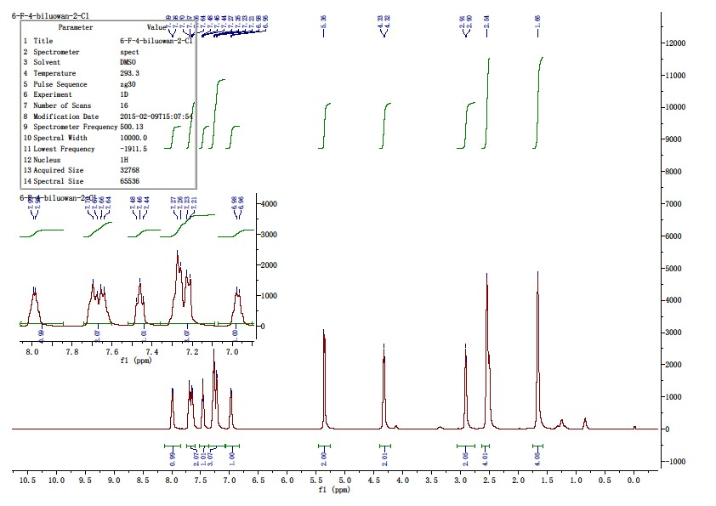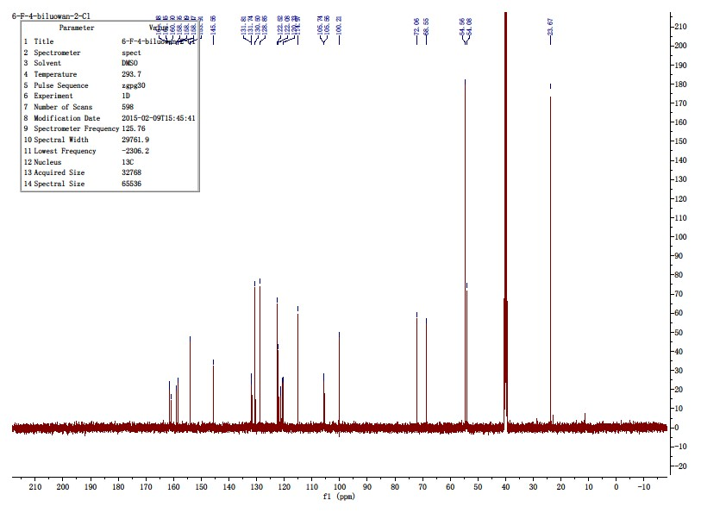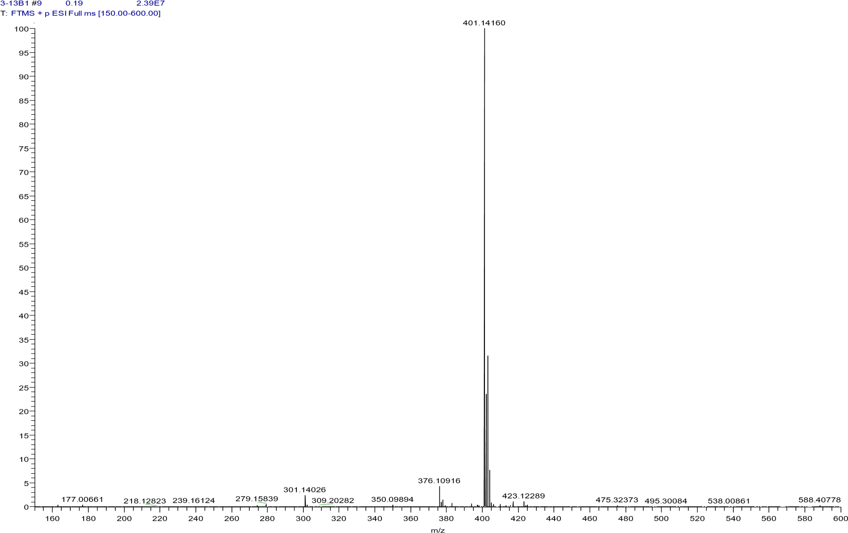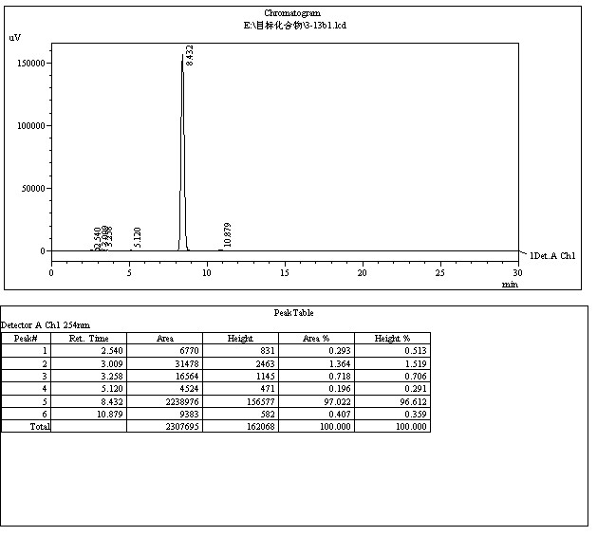

4.4.11 2-((2-chlorophenoxy)methyl)-6-fluoro-4-(2-(piperidin-1-yl)ethoxy)quinoline (13h)
The title compound was prepared in the manner similar to compound 13a. white solid, yield: 35.9%, mp: 78.6-80.1 ℃, HPLC purity: 98.25% (liquid phase condition B), ¹H NMR (400 MHz, DMSO- d6) δ 7.99(dd, J = 9.0, 5.3 Hz, 1H), 7.74 – 7.59 (m, 2H), 7.46 (d, J = 7.9 Hz, 1H), 7.33 – 7.20(m, 3H), 6.98 (t, J = 7.2 Hz, 1H), 5.35 (s, 2H), 4.32 (t, J = 5.5 Hz, 2H), 2.78 (t, J = 5.5Hz, 2H), 2.44 (s, 4H), 1.53 – 1.40 (m, 4H), 1.34 (d, J = 4.6 Hz, 2H). ¹³C NMR (100MHz, DMSO- d6) δ 161.49 (d, J = 5.1 Hz), 159.92(d, J = 246.4 Hz), 158.43 (d, J = 2.3Hz), 153.94, 145.55, 131.74 (d, J = 9.2 Hz), 130.49, 128.82, 122.50, 122.09, 121.23(d, J = 9.6 Hz), 120.38(d, J = 25.3 Hz), 114.95, 105.65(d, J = 23.2 Hz), 100.32, 72.10,67.29, 57.08, 54.75(2C), 26.08(2C), 24.30. HRMS (ESI) m/z calcd for[C23H24ClFN2O2+H]+, 415.1583; found, 415.1588 [M+H] +.
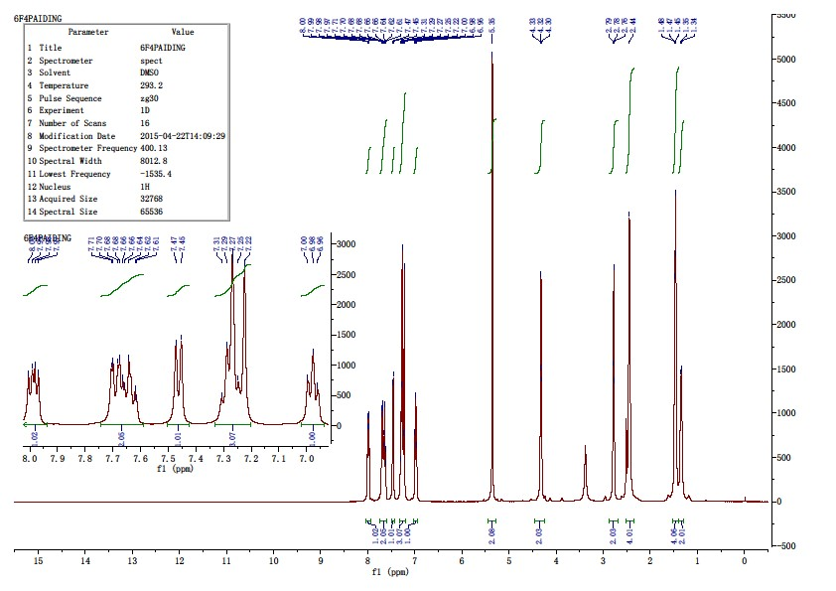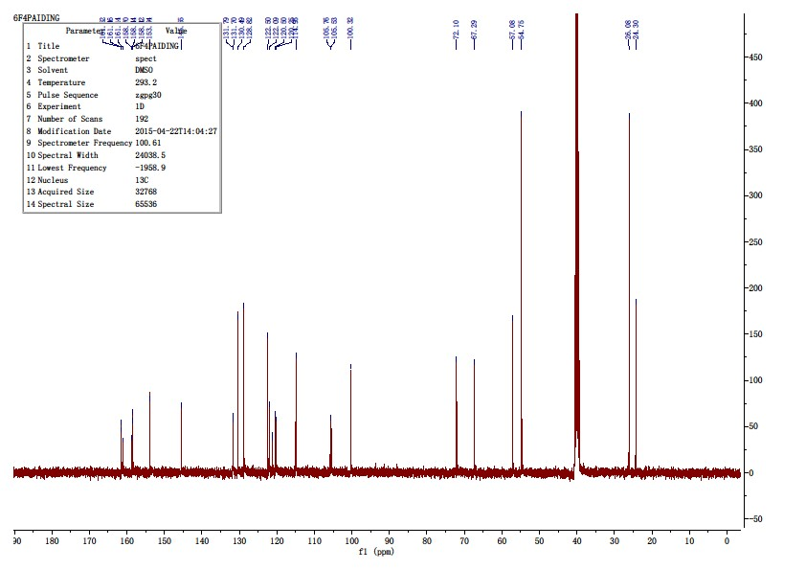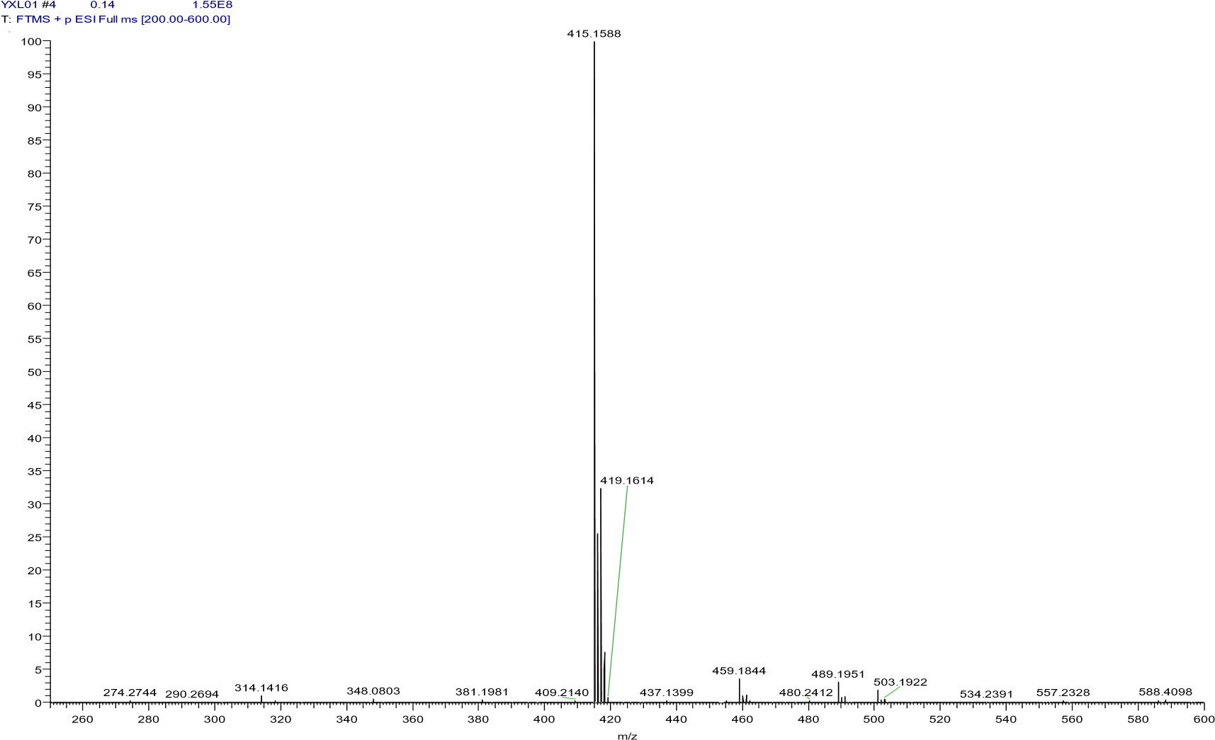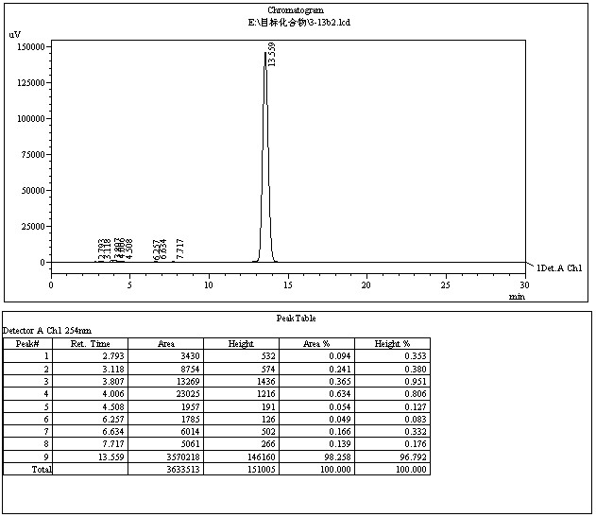

4.4.12 2-((2-chlorophenoxy)methyl)-6-fluoro-4-(2-(4-methylpiperazin-1-yl)ethoxy)
quinolin (13i)
The title compound was prepared in the manner similar to compound 13a. white solid, yield: 35.5%, mp: 95.2-97.0 ℃, HPLC purity: 98.78% (liquid phase condition B), ¹H NMR (500 MHz, DMSO- d6) δ 8.00(s, 1H), 7.71 (d, J = 8.2 Hz, 1H), 7.65 (m, 1H), 7.47 (d, J = 7.0 Hz, 1H), 7.26 (m, 3H),6.98 (s, 1H), 5.36 (s, 2H), 4.34 (s, 2H), 2.83 (s, 2H), 2.51 (s, 4H), 2.29 (s, 4H), 2.12 (s,3H). ¹³C NMR (125 MHz, DMSO- d6) δ 161.50 (d, J = 4.9 Hz), 158.98, 158.46, 153.96,145.57, 131.78 (d, J = 9.1 Hz), 130.51, 128.84, 122.54, 122.11, 121.25 (d, J = 9.4 Hz),120.42(d, J = 25.2 Hz), 115.02, 105.68(d, J = 27.7 Hz), 100.43, 72.16, 67.27, 56.34, 55.20(2C), 53.37(2C), 46.18. HRMS (ESI) m/z calcd for [C23H25ClFN3O2+H]+,430.1692; found, 430.16669 [M+H] +.
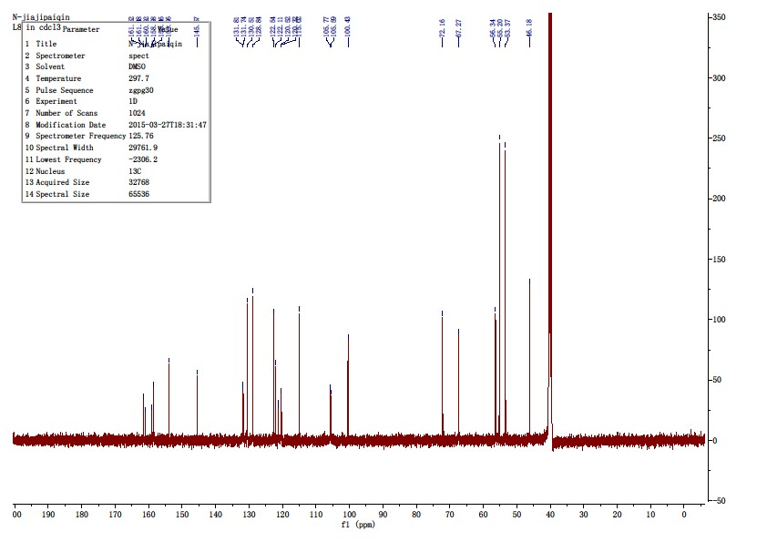
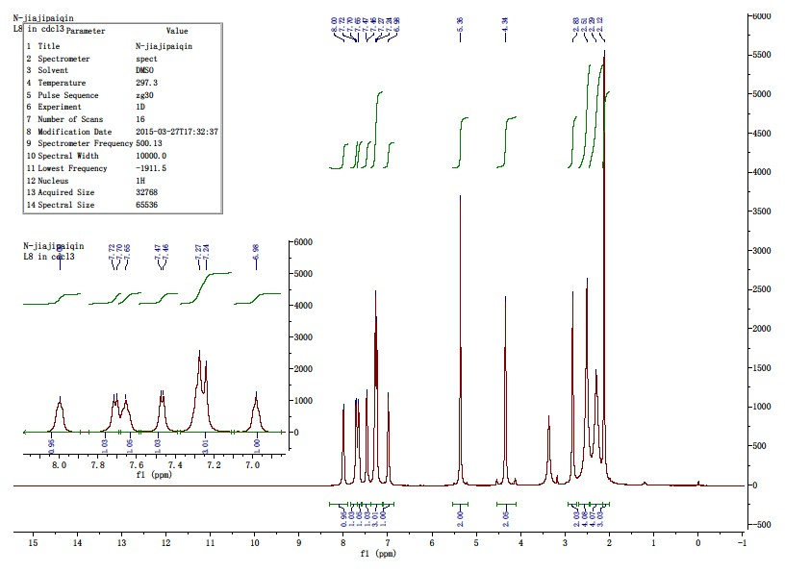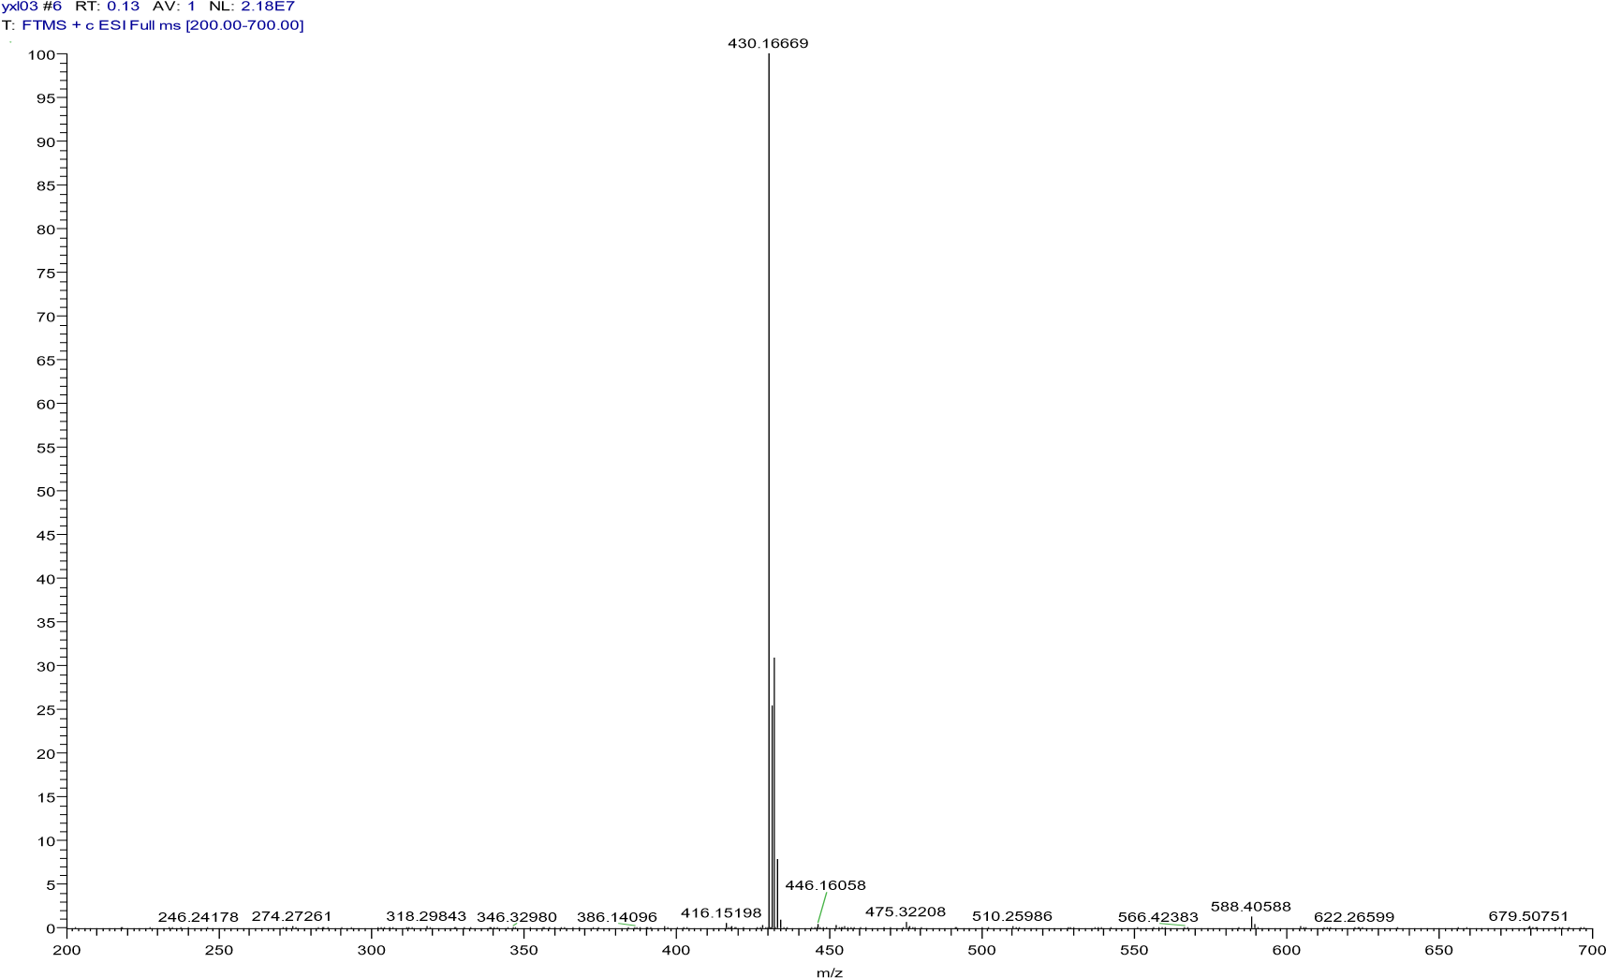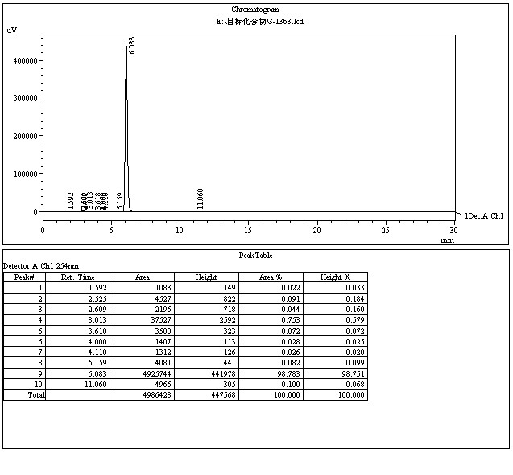
166

4.4.13 4-(2-((2-((2-chlorophenoxy)methyl)-6-fluoroquinolin-4-yl)oxy)ethyl)morpholi-ne (13j)
The title compound was prepared in the manner similar to compound 13a. white solid, yield: 38.2%, mp: 97.3-99.2 ℃, HPLC purity: 97.07% (liquid phase condition B), ¹H NMR (500 MHz, DMSO- d6) δ 8.00(dd, J = 8.7, 5.3 Hz, 1H), 7.73 (d, J = 7.8 Hz, 1H), 7.67 (t, J = 8.5 Hz, 1H), 7.47 (d, J= 7.7 Hz, 1H), 7.28 (dd, J = 20.6, 11.5 Hz, 3H), 6.99 (t, J = 7.1 Hz, 1H), 5.36 (s, 2H),4.37 (t, J = 4.8 Hz, 2H), 3.57 (s, 4H), 3.38 (s, 4H), 2.84 (t, J = 4.8 Hz, 2H). ¹³C NMR(125 MHz, DMSO- d6) δ 161.48 (d, J = 5.0 Hz), 159.96(d, J = 244.4 Hz), 158.46,153.94, 145.56, 131.78 (d, J = 8.9 Hz), 130.52, 128.87, 122.55, 122.08, 121.23 (d, J =9.5 Hz), 120.47(d, J = 25.2 Hz), 115.00, 105.71(d, J = 23.9 Hz), 100.42, 72.13, 67.10,66.67(2C), 56.80, 53.98(2C). HRMS (ESI) m/z calcd for [C22H22ClFN2O3+H]+,417.1376; found, 417.13824 [M+H] +.
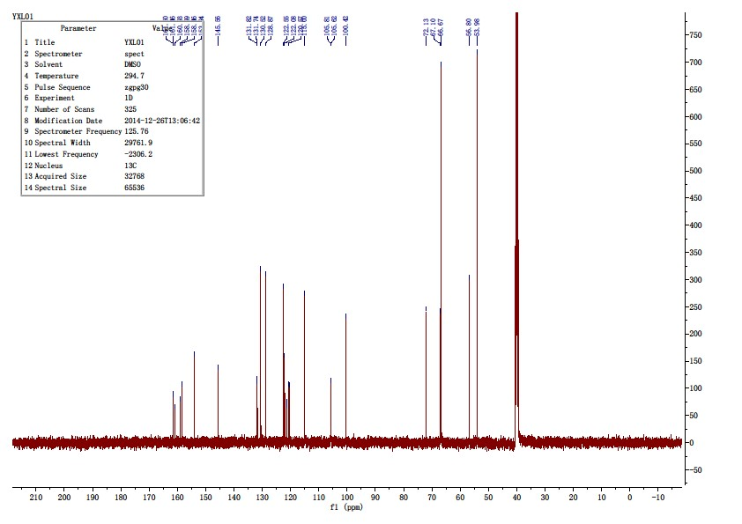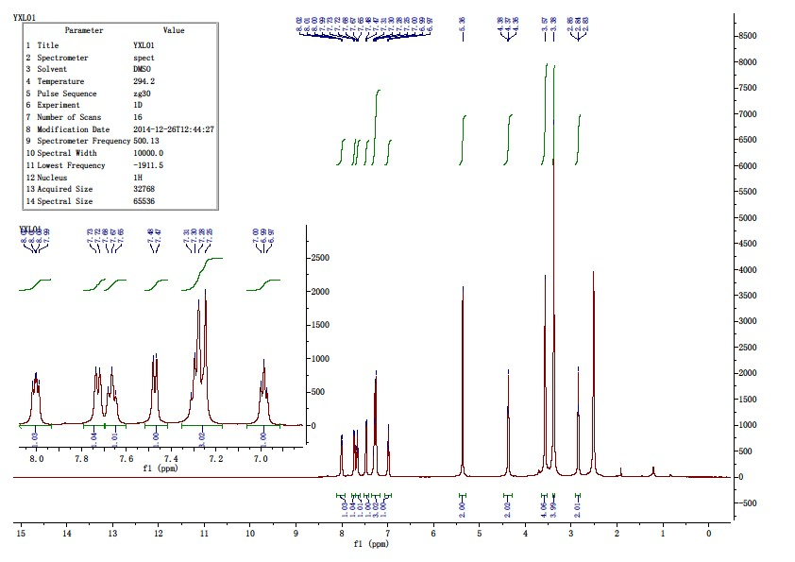

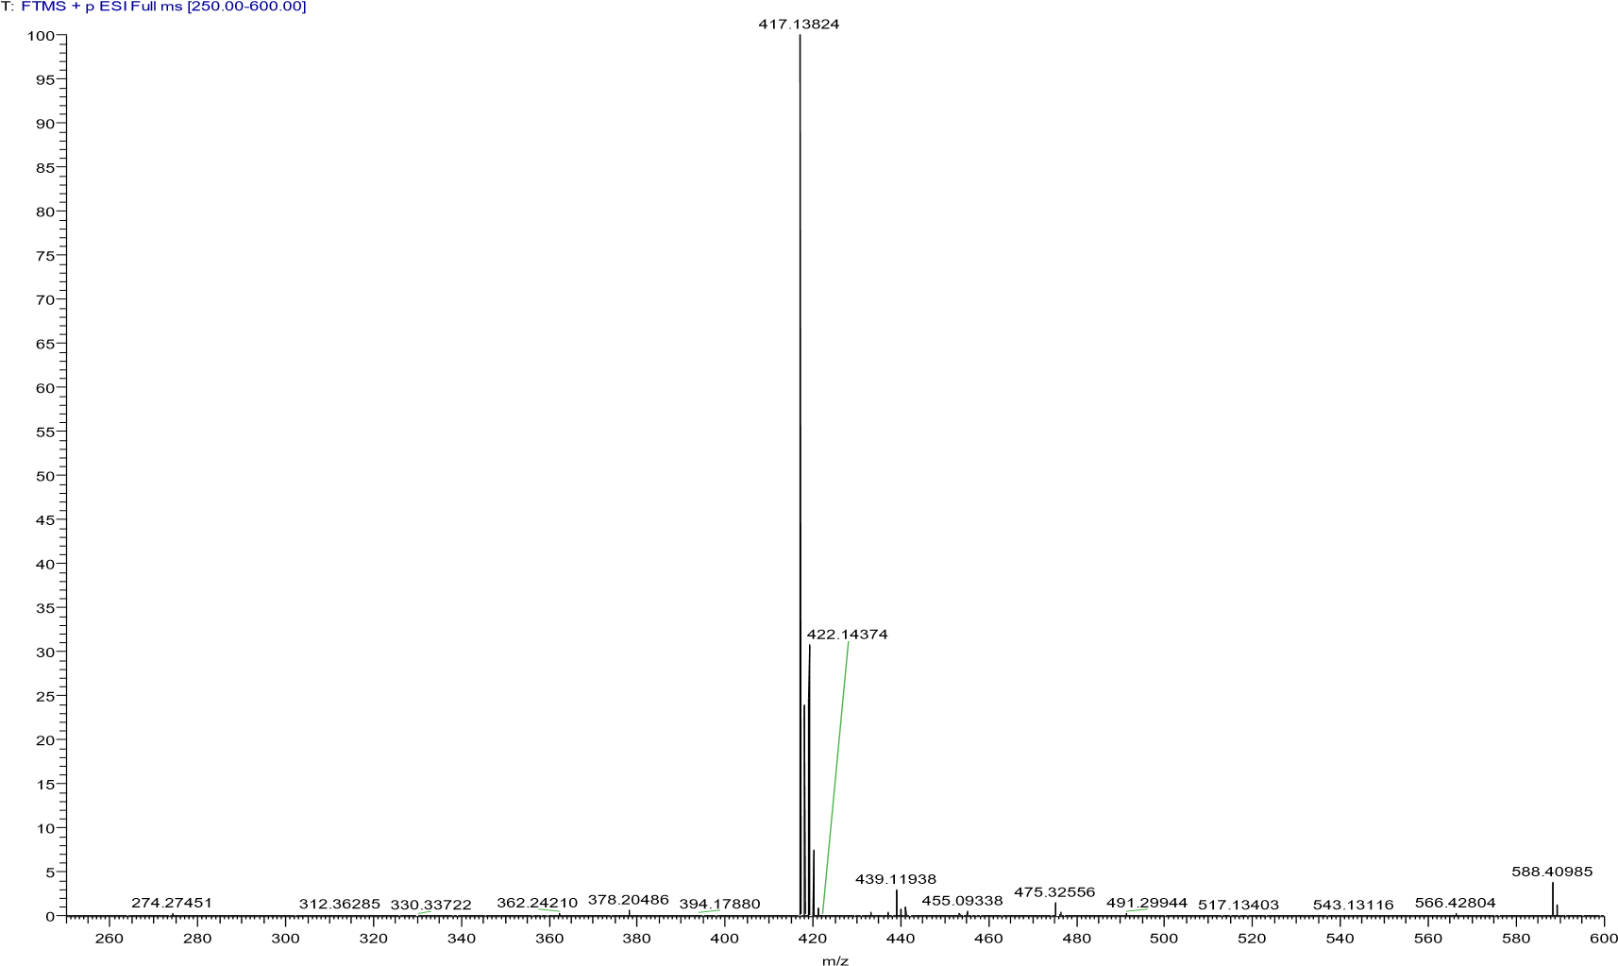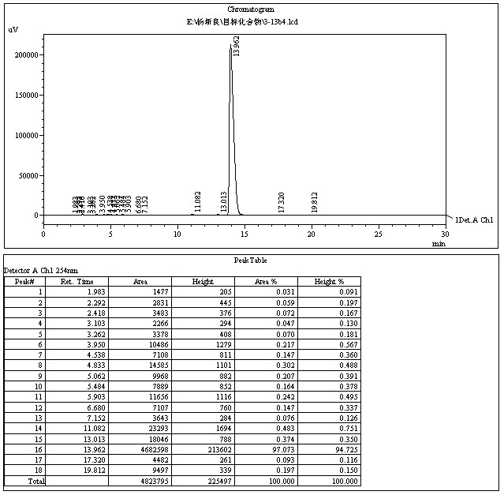

4.4.14 2-((2-chlorophenoxy)methyl)-6-methoxy-4-(2-(pyrrolidin-1-yl)ethoxy)quinoline (13k)
The title compound was prepared in the manner similar to compound 13a. white solid, yield: 36.4%, mp: 86.7 - 88.2 ℃, HPLC purity: 99.28% (liquid phase condition B), ¹H NMR (500 MHz, CDCl3) δ 7.90 (d,J = 9.2 Hz, 1H), 7.47 (d, J = 2.8 Hz, 1H), 7.41 (dd, J = 7.9, 1.5 Hz, 1H), 7.37 (dd, J =9.2, 2.9 Hz, 1H), 7.22 – 7.16 (m, 2H), 7.04 (dd, J = 8.3, 1.1 Hz, 1H), 6.92 (td, J = 7.7,1.2 Hz, 1H), 5.38 (s, 2H), 4.40 (t, J = 5.9 Hz, 2H), 3.94 (s, 3H), 3.07 (t, J = 5.9 Hz,2H), 2.74 – 2.68 (m, 4H), 1.87 – 1.80 (m, 4H). ¹³C NMR (125 MHz, CDCl3) δ 161.23,157.21, 155.96, 153.87, 144.32, 130.23, 129.78, 127.81, 122.89, 122.10, 121.74,121.43, 113.94, 100.11, 98.60, 71.93, 67.99, 55.39, 54.85(2C), 54.37, 23.59(2C). HRMS (ESI) m/z calcd for [C23H25ClN2O3+H]+, 413.1626; found, 413.16080 [M+H] +.
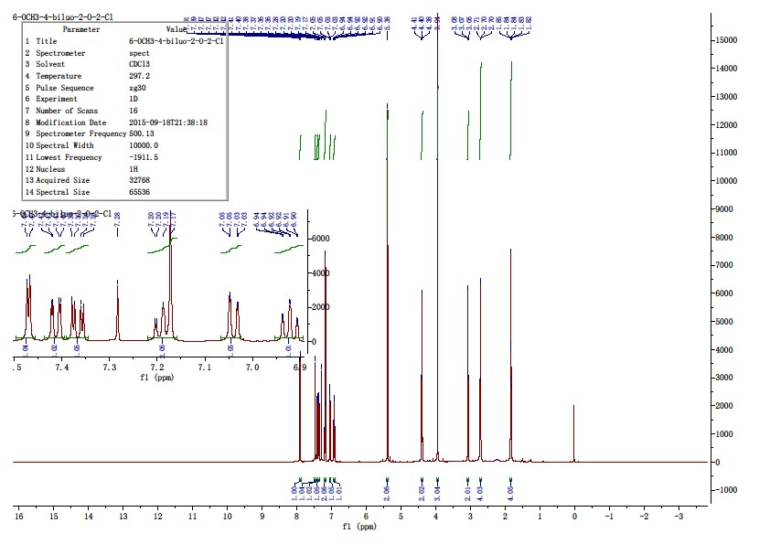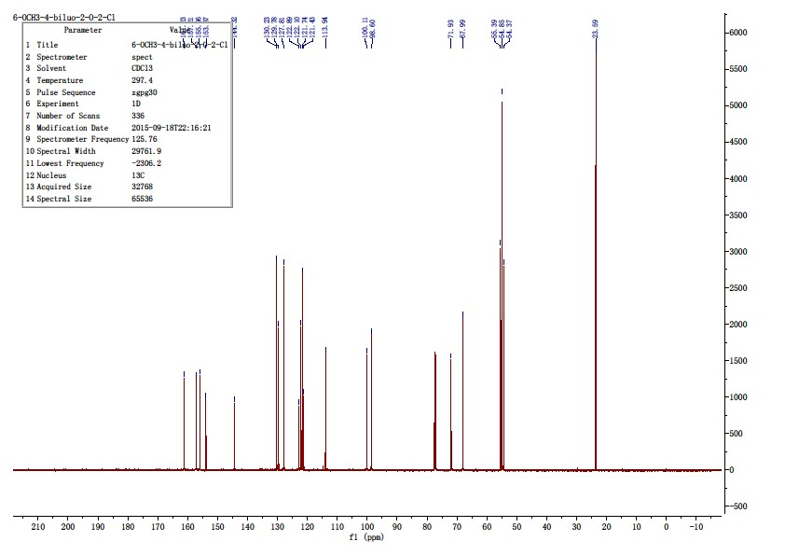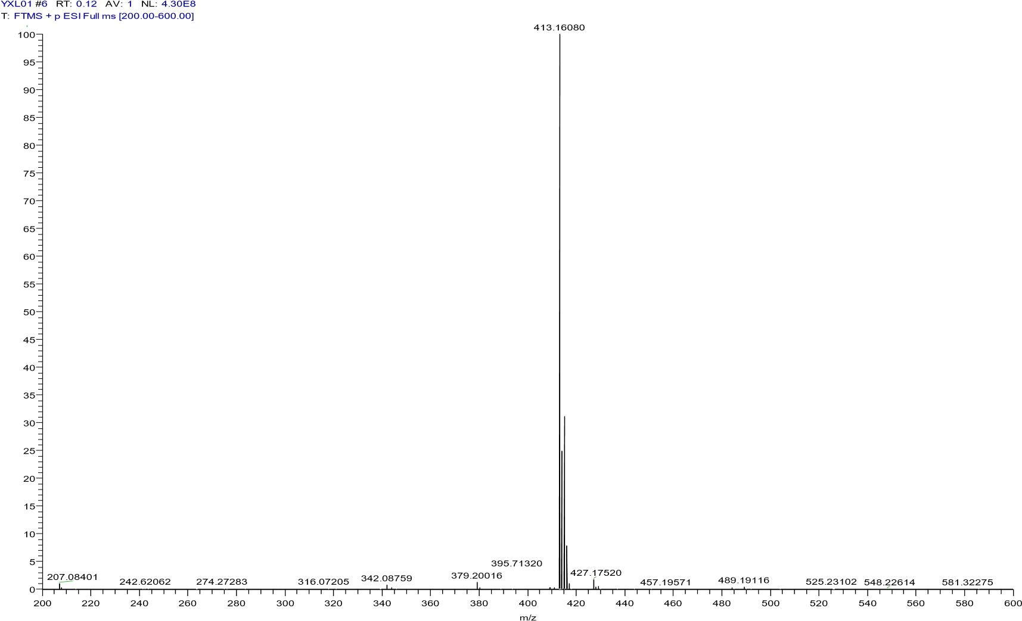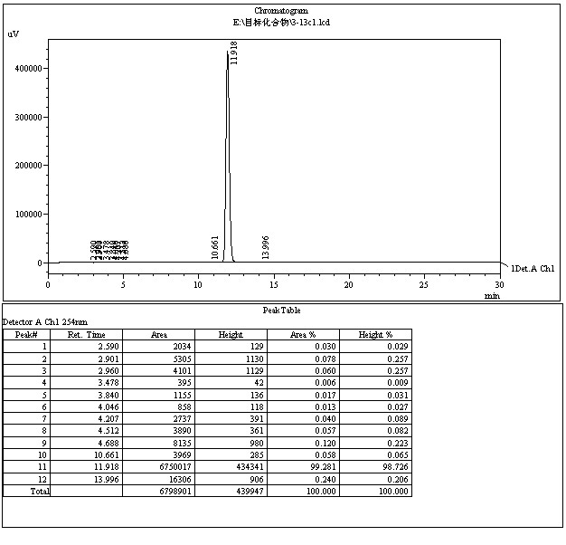

4.4.15 2-((2-chlorophenoxy)methyl)-6-methoxy-4-(2-(piperidin-1-yl)ethoxy)quinoline (13l)
The title compound was prepared in the manner similar to compound 13a. white solid, yield: 35.4%, mp: 84.6-85.9 ℃, HPLC purity: 97.25% (liquid phase condition B), ¹H NMR (400 MHz, CDCl3) δ 7.90 (t,J = 8.0 Hz, 1H), 7.44 (d, J = 2.8 Hz, 1H), 7.40 (dd, J = 7.9, 1.5 Hz, 1H), 7.35 (dd, J =9.2, 2.9 Hz, 1H), 7.21 – 7.11 (m, 2H), 7.03 (dd, J = 8.2, 1.0 Hz, 1H), 6.91 (td, J = 7.8, 1.1 Hz, 1H), 5.36 (s, 2H), 4.37 (t, J = 5.9 Hz, 2H), 3.93 (s, 3H), 2.93 (t, J = 5.9 Hz,2H), 2.58 (s, 4H), 1.62 (dt, J = 11.1, 5.6 Hz, 4H), 1.47 (dd, J = 11.3, 5.9 Hz, 2H). ¹³C NMR (100 MHz, CDCl3) δ 161.31, 157.28, 156.05, 153.89, 144.32, 130.29, 129.79,127.88, 122.91, 122.23, 121.82, 121.49, 114.00, 100.08, 98.67, 71.99, 66.82, 57.37,55.48, 55.06(2C), 26.02(2C), 24.12. HRMS (ESI) m/z calcd for [C24H27ClN2O3+H]+,427.1783; found, 427.17593 [M+H] +.
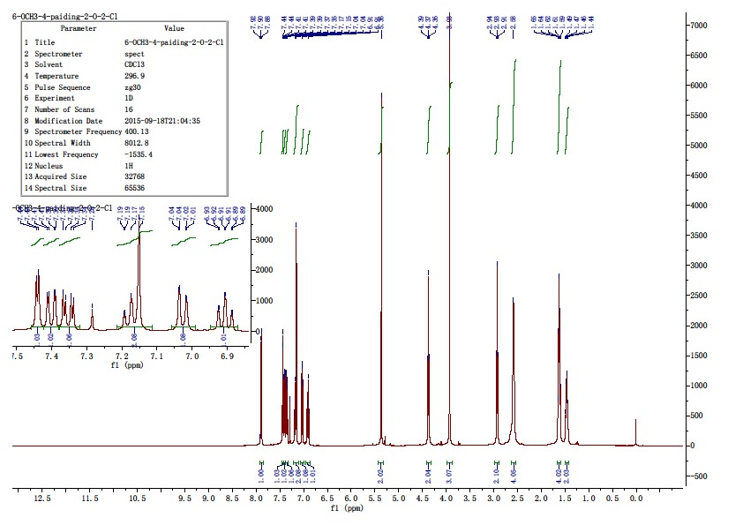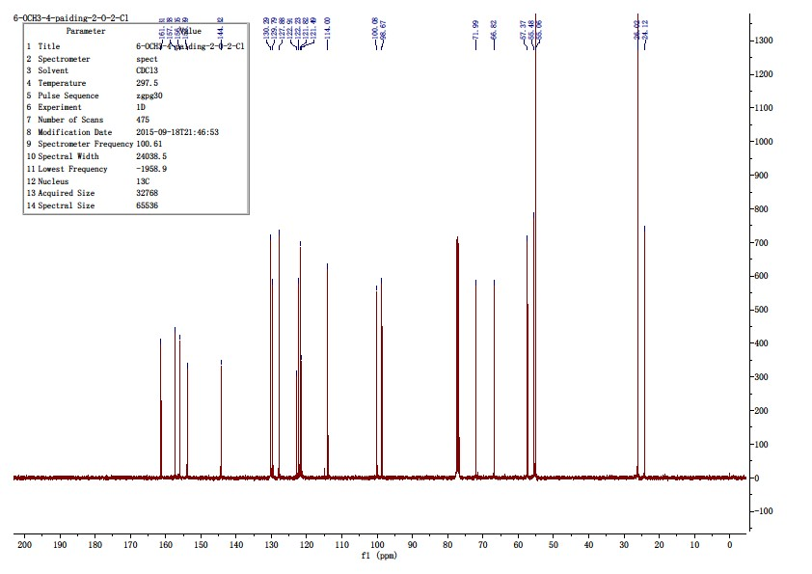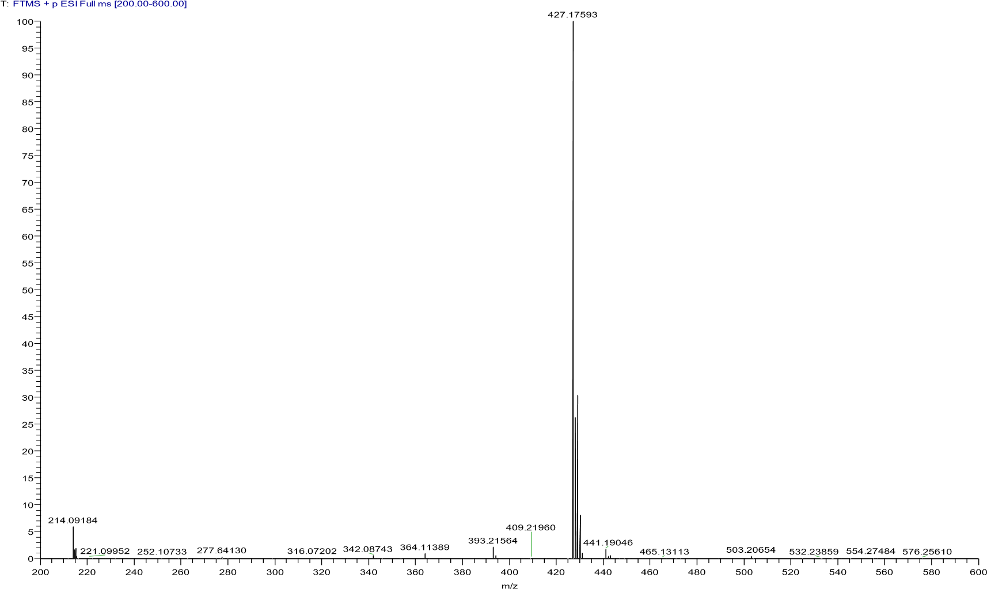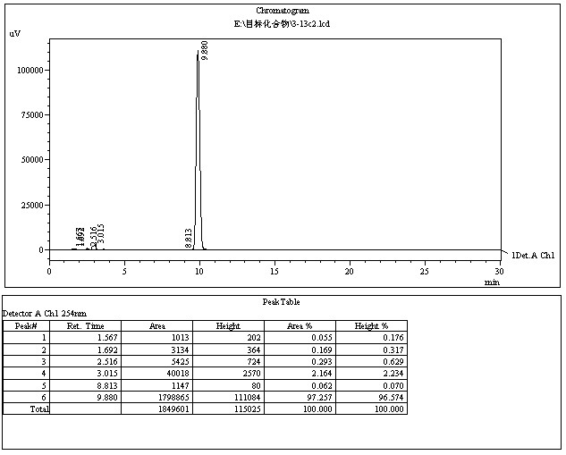

4.5.1 1-acetylindoline-2,3-dione (15a)
Mix 60 ml of acetic anhydride into a 100 ml round bottom flask, add 4.8 g (3.26 mmol) of indoline-2,3-dione while stirring, place the reaction solution in an oil bath at 120oC overnight, cool to room temperature, pour the reaction solution into a beaker with 50 ml of water, add an equal volume of ethyl acetate, filter, evaporate, and obtain 2.0 g of solid. Yield: 73.30%. Not purified, to be put directly into the next step of the reaction.

4.5.2 1-acetyl-5-methylindoline-2,3-dione(15b)
The title compound was prepared in the manner similar to compound 15a. Using 5-methylindoline-2,3-dione as raw material, a yellow solid is obtained with a yield of 66.30%, Not purified, to be put directly into the next step of the reaction.

4.5.3 2-oxo-1,2-dihydroquinoline-4-carboxylic acid(16a)
Dissolve 1.8 g (45.00 mmol) of sodium hydroxide solid in 50 ml of water, pour the solution into a flask, add 2.0 g (10.57 mmol) of 15a while stirring, and react in an oil bath at 100 ℃ for 1.5 h. Monitor the reaction by spotting the plate, stop the reaction, let it cool to room temperature, add 1 M of hydrochloric acid solution to it, adjust the pH of the solution to 2. During this process, a large amount of yellow solid will be precipitated, filtered and dried, resulting in 16a, 1.3 g of yellow solid, yield: 65.33%. Not purified, to be put directly into the next step of the reaction.

4.5.4 6-methyl-2-oxo-1,2-dihydroquinoline-4-carboxylic acid(16b)
The title compound was prepared in the manner similar to compound 16a. Using 15b as raw material, a yellow solid is obtained with a yield of 66.30%, Not purified, to be put directly into the next step of the reaction.

4.5.5 Ethyl 2-oxo-1,2-dihydroquinoline-4-carboxylate(17a)
Dissolve the material by stirring and adding 60 ml of anhydrous ethanol to a 100 ml round bottom flask containing 1 g (5.29 mmol)16a, then add 1 ml of concentrated sulfuric acid and let it react overnight under reflux conditions, stop the reaction, add 1 M of sodium hydroxide solution to neutralize the solution, spin off the anhydrous ethanol, then extract with ethyl acetate 3 times. Dried with anhydrous sodium sulfate for 3 h, filtered off the anhydrous sodium sulfate, spun off the ethyl acetate solution, dissolved the solid obtained with dichloromethane, added 3 g of 80-100 mesh silica gel to it for mixing, loaded the column with 200-300 silica gel, and passed the column with the unfolding system petroleum ether and ethyl acetate (v: v=2:1) to obtain the crude product 0.76 g17a, a yellow solid, yield: 66.09%.Not purified, to be put directly into the next step of the reaction.

4.5.6 Ethyl 6-methyl-2-oxo-1,2-dihydroquinoline-4-carboxylate(17b)
The title compound was prepared in the manner similar to compound 17a. Using 16b as raw material, a yellow solid is obtained with a yield of 60.29%, Not purified, to be put directly into the next step of the reaction.

4.5.7 Ethyl 1-(2-chloro-4-fluorobenzyl)-2-oxo-1,2-dihydroquinoline-4-carboxylate
(18a)
Compound 17a, 0.5 g (1.90 mmol), 0.51 g (2.29 mmol) 2-chloro-4-fluorobenzyl bromide, 0.34 g (2.46 mmol) potassium carbonate and 50 ml DMF were added to a 100 ml round bottom flask and the reaction was stirred at room temperature for 3 h. And monitor with TLC point plate, and the reaction is completed. Stop the reaction, cool it slightly to room temperature, pour the reaction solution into ice water, stir fully, yellow solids are separated, filter by suction, wash the filter cake with anhydrous ethanol several times, dry it, recrystallize the dry white solids with ethyl acetate twice, and obtain white solid in 20.32% yield, 98.6-99.2 oC melting point and 98.25% HPLC (liquid phase condition A). ¹H NMR (500 MHz, DMSO- d6) δ 8.45 (dd, J = 8.5, 1.3 Hz, 1H), 7.91 (dd, J = 8.5, 1.2 Hz, 1H), 7.77 (ddd, J = 8.5, 6.7, 1.6 Hz, 2H), 7.57 (ddd, J = 8.3, 6.9, 1.3 Hz, 1H), 7.53 (dd, J = 8.8, 2.7 Hz, 1H), 7.49 (s, 1H), 7.28 (td, J = 8.5, 2.6 Hz, 1H), 5.59 (s, 2H), 4.44 (q, J = 7.1 Hz, 2H), 1.38 (t, J = 7.1 Hz, 3H). ¹³C NMR (126 MHz, DMSO- d6) δ 165.52, 160.76, 146.99, 139.49, 134.43, 132.77, 132.70, 131.03, 130.90, 127.94, 126.06, 125.67, 121.79, 117.28, 117.08, 114.97, 114.81,114.61,64.84,62.32,14.40.HRMS (ESI) m/z calcd for [C19H15ClFNO3+ H]+ :360.0724; found:360.0803[M+H]+ .
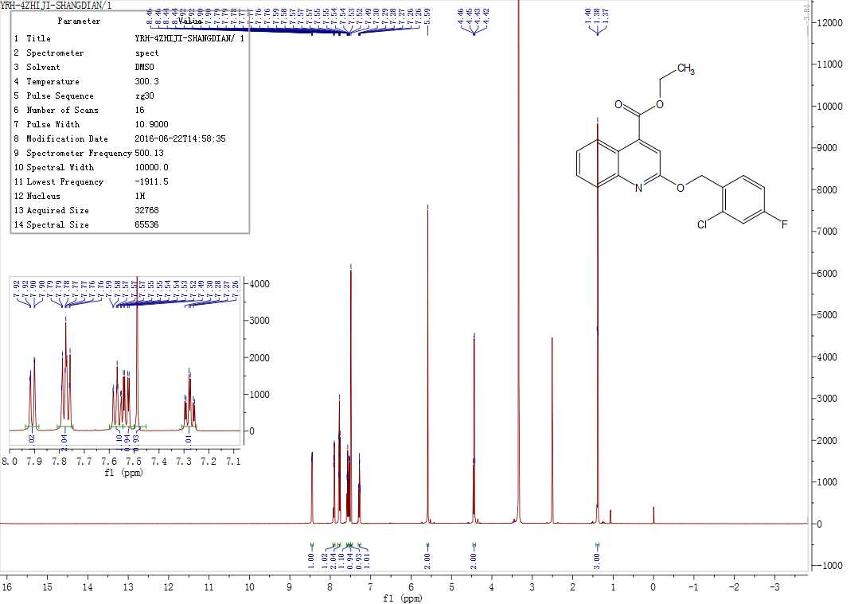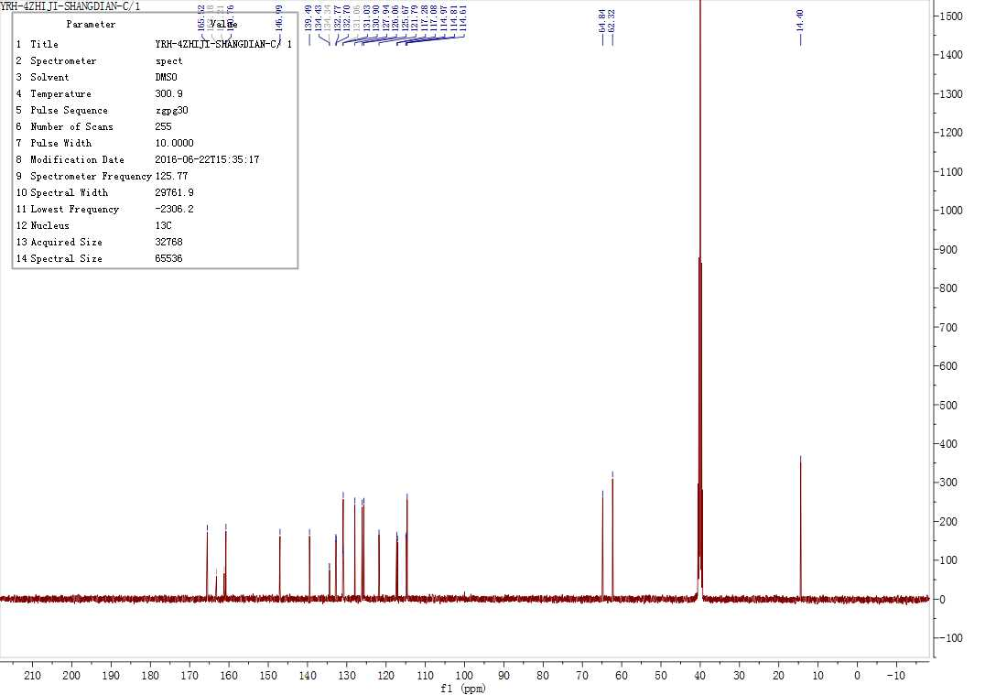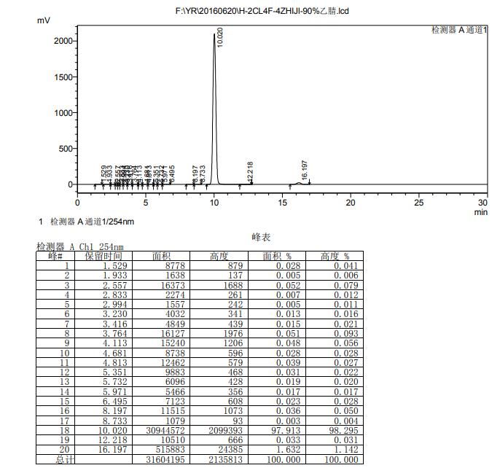
4.5.8 Ethyl 1-benzyl-2-oxo-1,2-dihydroquinoline-4-carboxylate(18b)
The title compound was prepared in the manner similar to compound 18a. ompound 17a and benzyl bromide are used as raw materials to obtain a white solid in 10.12% yield, 109.2-110.3 oC melting point and 99.06% HPLC (liquid phase condition A). ¹H NMR(500 MHz, DMSO- d6) δ 8.48 (d, J = 8.4 Hz, 1H), 7.84 (d, J = 8.3 Hz, 1H), 7.67 (t, J =7.9 Hz, 1H), 7.55-7.43 (m, 3H), 7.40-7.33 (m, 3H), 7.33-7.27 (m, 1H), 5.48 (s, 2H),4.36 (qd, J = 7.1, 2.0 Hz, 2H), 1.32 (td, J = 7.1, 1.9 Hz, 3H). ¹³C NMR (126 MHz,DMSO- d6) δ 165.38, 160.98, 147.17, 137.14, 130.51, 128.73, 128.52, 128.25, 127.85,125.68, 125.64, 121.80, 114.96, 67.85, 62.08, 14.30. HRMS (ESI) m/z calcd for [C19H17NO3+H]+:308.1242; found:308.1283[M+H]+.
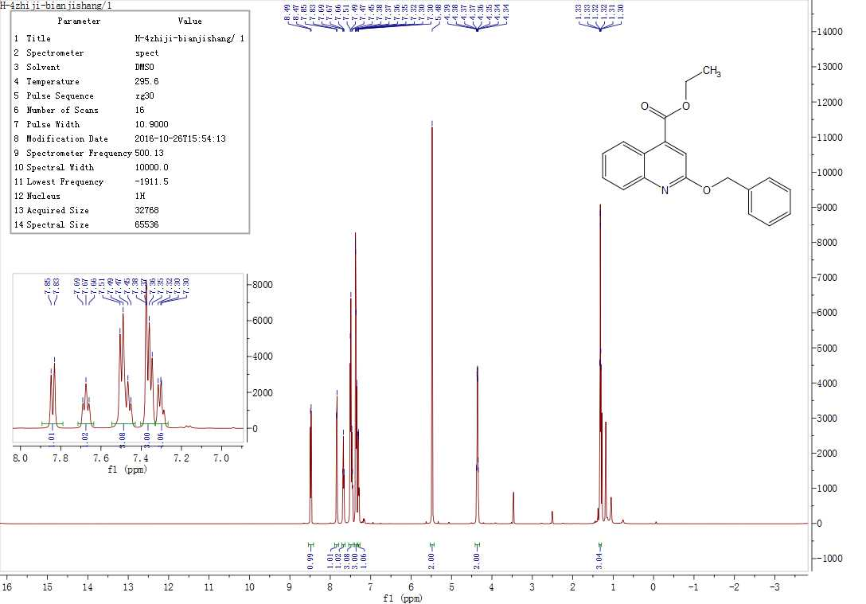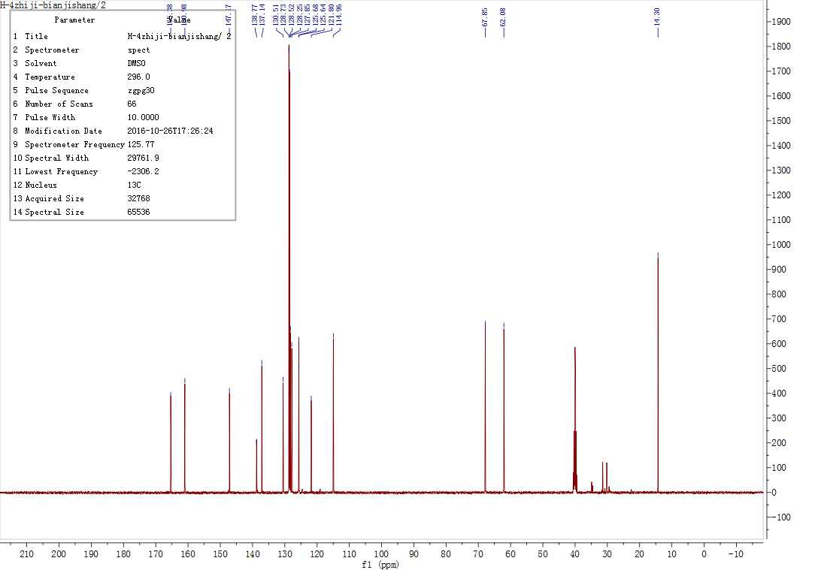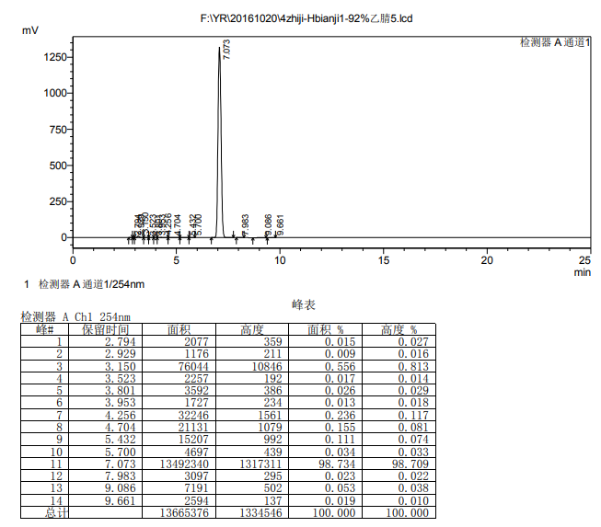
4.5.9 Ethyl 1-(4-methylbenzyl)-2-oxo-1,2-dihydroquinoline-4-carboxylate(18c)
The title compound was prepared in the manner similar to compound 18a. Compound 17a and 4-methyl benzyl bromide are used as raw materials to obtain a white solid in 14.15% yield, 102.3-103.1 oC melting point and 99.02% HPLC (liquid phase condition A). ¹H NMR (500 MHz, DMSO- d6) δ 8.44 (dd, J = 8.5, 1.4 Hz, 1H), 7.87 (dd, J = 8.4, 1.2Hz, 1H), 7.74 (ddd, J = 8.3, 6.9, 1.4 Hz, 1H), 7.53 (ddd, J = 8.2, 6.9, 1.3 Hz, 1H),7.48-7.31 (m, 3H), 7.18 (d, J = 7.7 Hz, 2H), 5.47 (s, 2H), 4.41 (q, J = 7.1 Hz, 2H),2.29 (s, 3H), 1.36 (t, J = 7.1 Hz, 3H). ¹³C NMR (126 MHz, DMSO- d6) δ 165.51,161.08, 147.15, 139.06, 137.61, 134.09, 130.70, 129.34, 128.73, 127.87, 125.79,125.64, 121.70, 114.90, 67.16, 62.18, 14.33. HRMS (ESI) m/z calcd for [C19H16FNO3+H]+:326.1148;found: 326.1199[M+H]+.
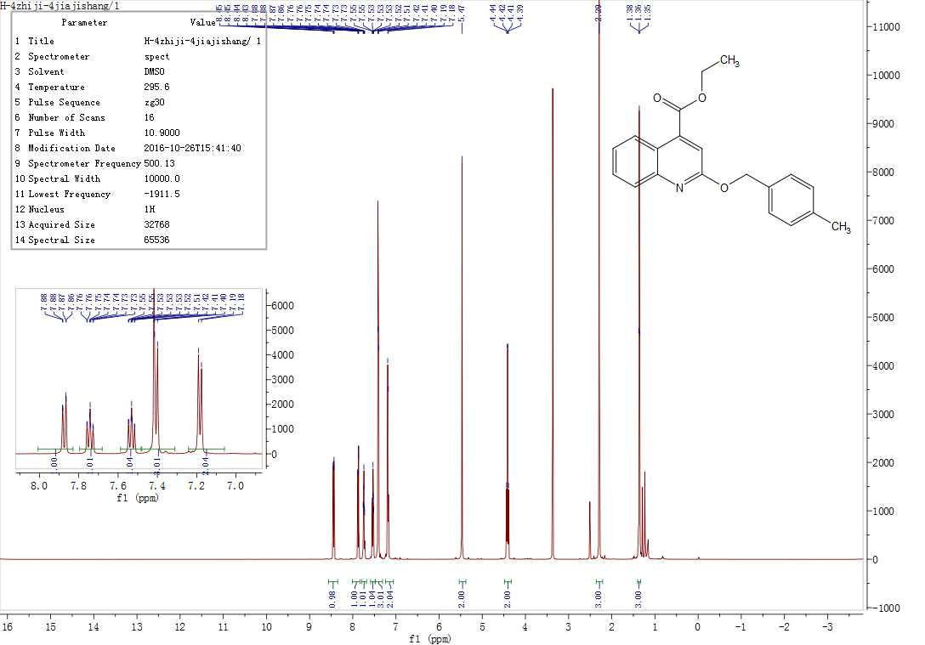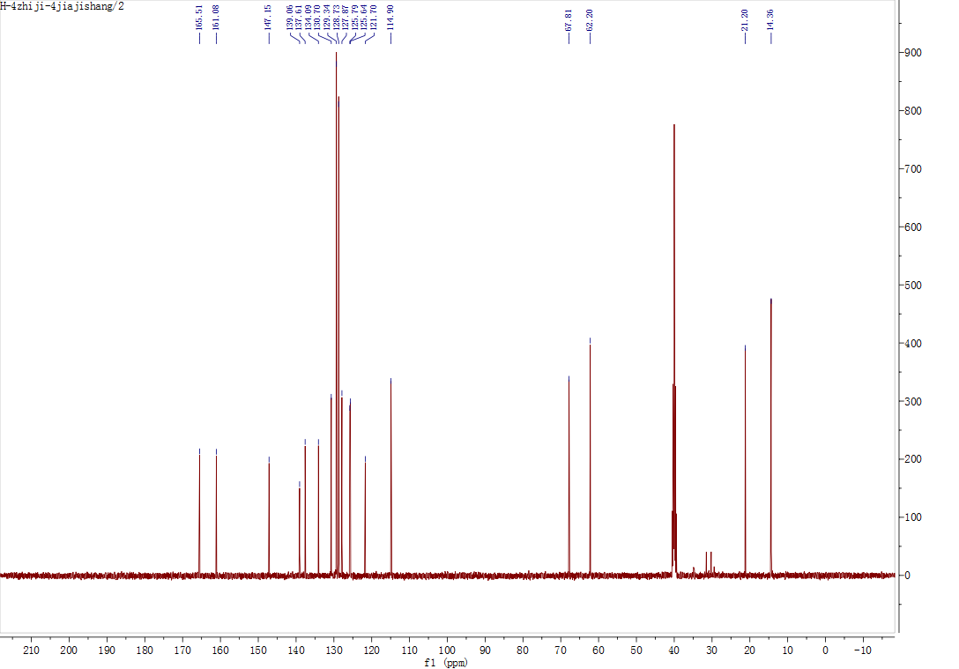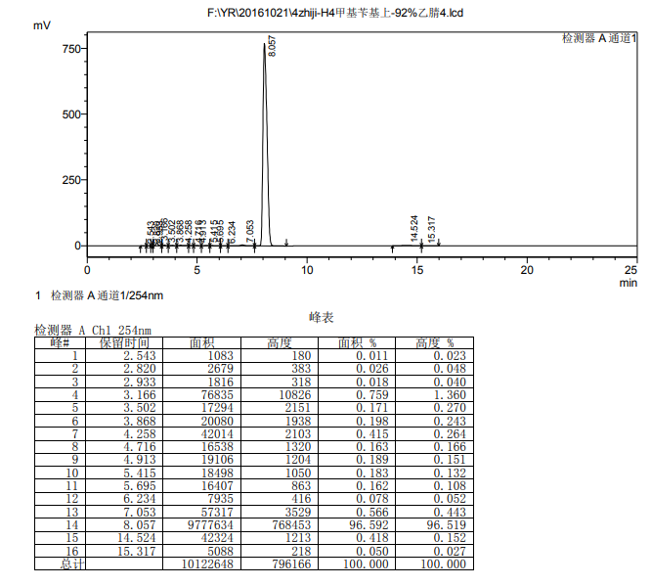
4.5.10 Ethyl 1-(4-fluorobenzyl)-2-oxo-1,2-dihydroquinoline-4-carboxylate(18d)
The title compound was prepared in the manner similar to compound 18a. Compound 17a and 4-fluorobenzyl bromide are used as raw materials to obtain a white solid in 16.23% yield, 51.9-60.6 oC melting point, and 99.51% HPLC (liquid phase condition A). ¹H NMR(500 MHz, DMSO- d6) δ 8.44 (dd, J = 8.4, 1.3 Hz, 1H), 7.89 (dd, J = 8.4, 1.2 Hz, 1H),7.76 (ddd, J = 8.3, 6.9, 1.5 Hz, 1H), 7.65-7.57 (m, 2H), 7.55 (ddd, J = 8.3, 7.0, 1.3 Hz,1H), 7.45 (s, 1H), 7.28-7.18 (m, 2H), 5.51 (s, 2H), 4.43 (q, J = 7.1 Hz, 2H), 1.37 (t, J= 7.1 Hz, 3H). ¹³C NMR (126 MHz, DMSO- d6) δ 165.46, 160.93, 147.09, 139.04,130.92, 130.85, 130.68, 127.85, 125.82, 125.64, 121.74, 115.66, 115.49, 114.85,67.16,62.18, 14.33. HRMS (ESI) m/z calcd for [C19H16FNO3+H]+:326.1148; found: 326.1199[M+H]+.
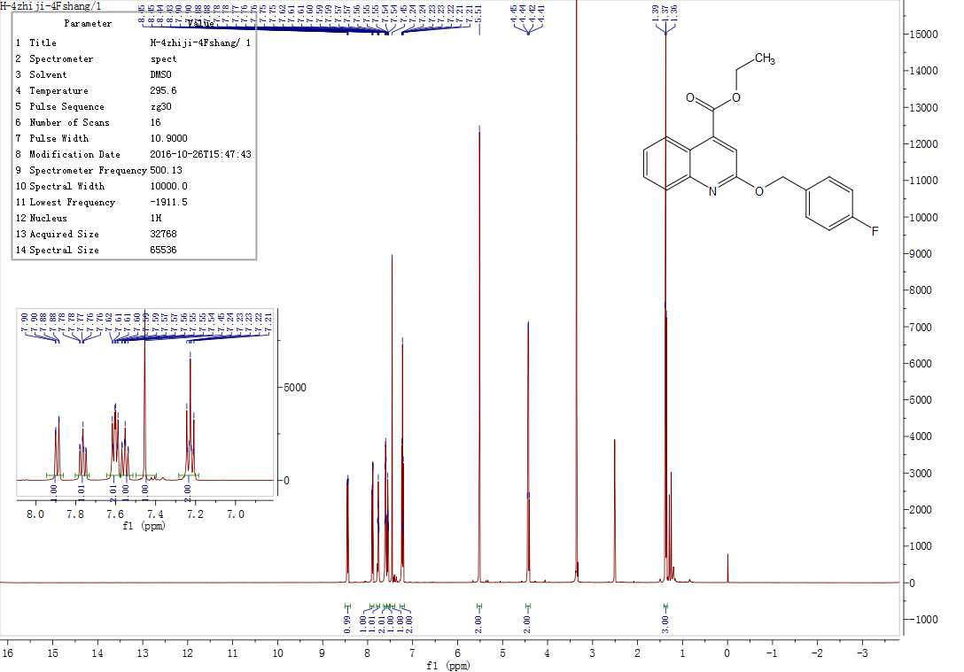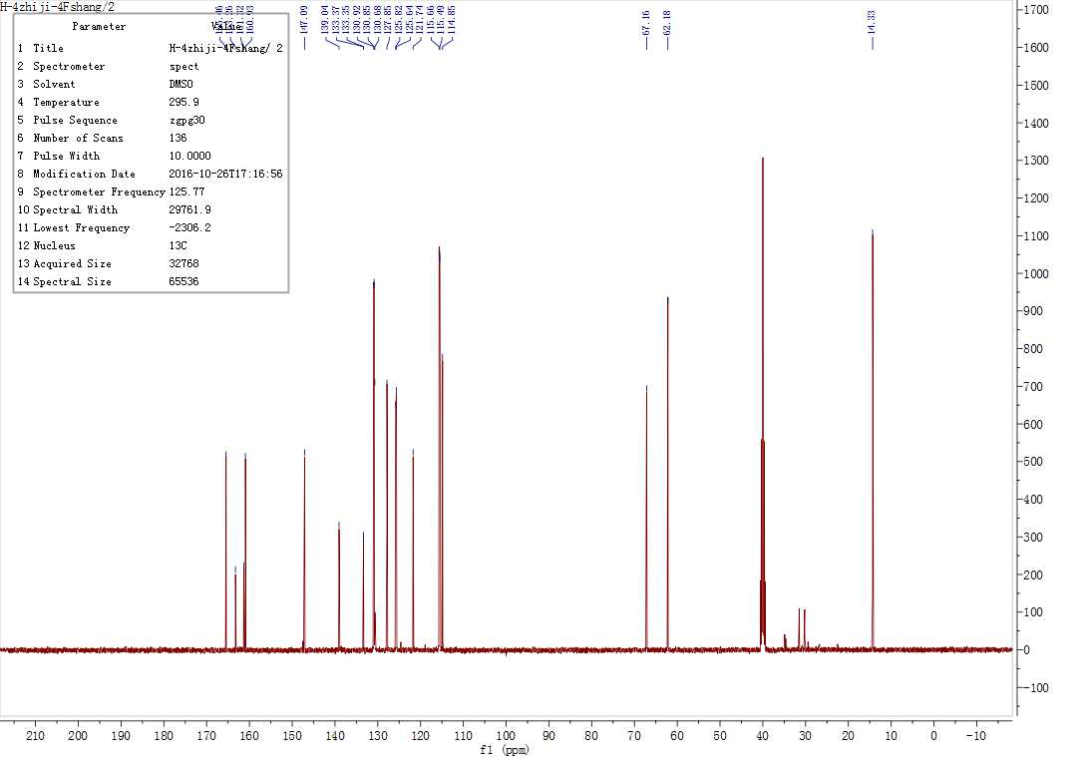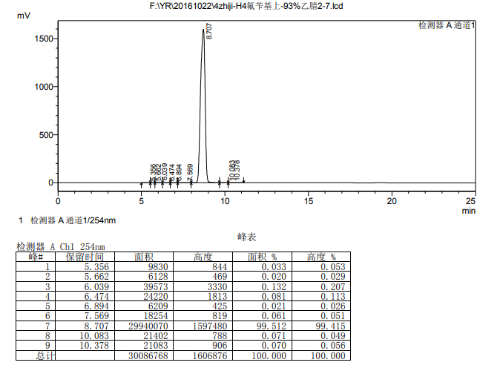

4.5.11Ethyl1-(2-chloro-4-fluorobenzyl)-6-methyl-2-oxo-1,2-dihydroquinoline-4-carboxylate(18e)
The title compound was prepared in the manner similar to compound 18a. Compound 17a and 2-chloro-4-fluorobromobenzyl were used as raw materials to obtain a white solid in 15.36% yield, 89.3-90.2 oC melting point and 97.33% HPLC (liquid phase condition A). ¹H NMR (500 MHz, DMSO- d6) δ 8.22 (t, J = 1.3 Hz, 1H), 7.80 (d, J = 8.4 Hz, 1H),7.76 (dd, J = 8.7, 6.3 Hz, 1H), 7.61 (dd, J = 8.5, 2.0 Hz, 1H), 7.53 (dd, J = 8.8, 2.7 Hz,1H), 7.44 (s, 1H), 7.28 (td, J = 8.5, 2.6 Hz, 1H), 5.55 (s, 2H), 4.43 (q, J = 7.1 Hz, 2H),2.50 – 2.47 (m, 3H), 1.38 (t, J = 7.1 Hz, 3H). ¹³C NMR (126 MHz, DMSO- d6) δ 165.54, 161.16, 160.22, 145.38, 138.86, 134.34, 132.73, 132.66, 132.63, 132.55,131.11, 127.69, 124.61, 121.74, 117.24, 117.04, 114.97, 114.76, 114.38, 64.71, 62.19,21.71,14.41, 14.39. HRMS (ESI) m/z calcd for [C20H17ClFNO3+H]+: 374.0881; found:374.0957[M+H]+.

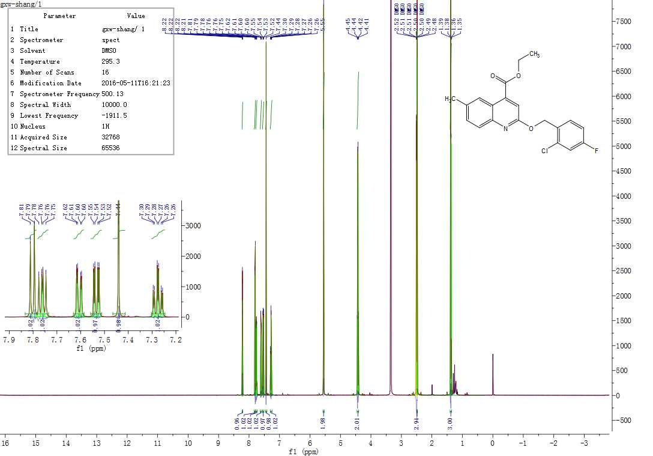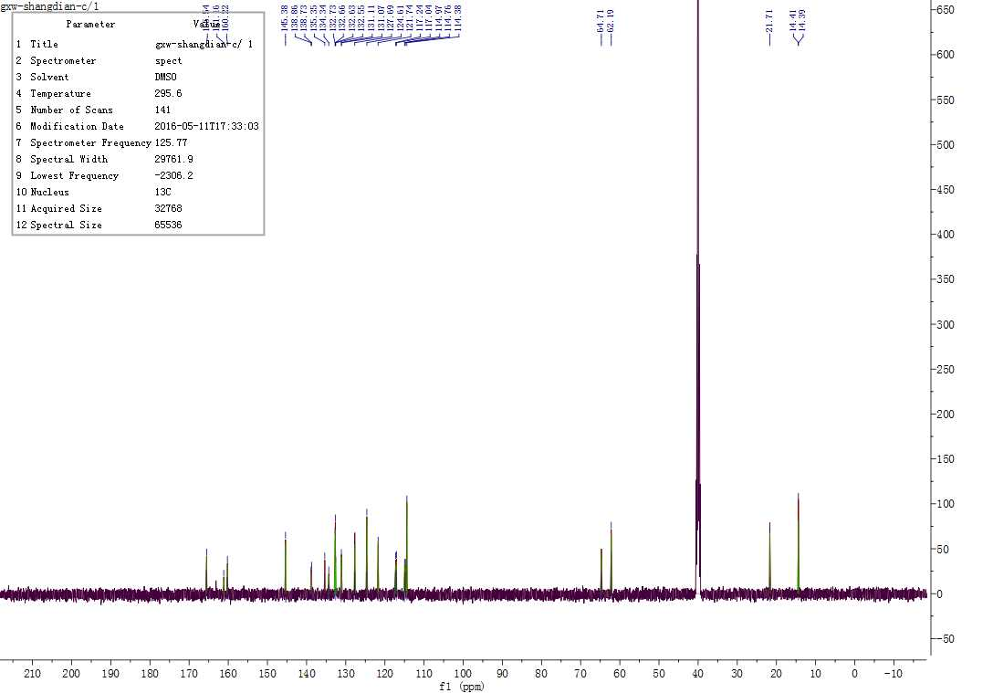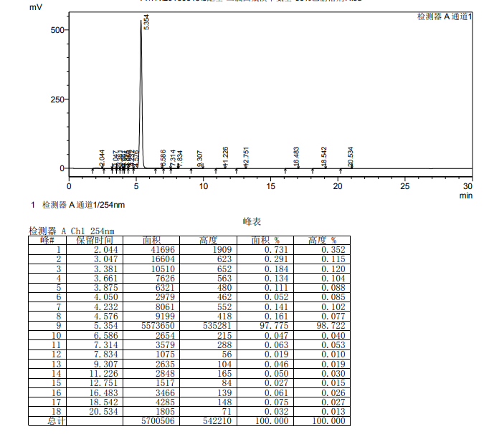
4.5.12 Ethyl 2-((2-chloro-4-fluorobenzyl)oxy)quinoline-4-carboxylate(19a)
The title compound was prepared in the manner similar to compound 18a. Compound 17a and 2-chloro-4-fluorobromobenzyl were used as raw materials to obtain a white solid in 60.12% yield, 169.6-170.9 oC melting point and 98.54% HPLC (liquid phase condition A). ¹H NMR (500 MHz, DMSO- d6) δ 8.15 (dd, J = 8.1, 1.5 Hz, 1H), 7.62 (ddd, J = 8.7,7.2, 1.5 Hz, 1H), 7.59 (dd, J = 8.7, 2.7 Hz, 1H), 7.35 (ddd, J = 8.2, 7.2, 1.1 Hz, 1H),7.25 (dd, J = 8.7, 1.1 Hz, 1H), 7.11 (s, 1H), 7.06 (td, J = 8.6, 2.7 Hz, 1H), 6.70 (dd, J =8.8, 5.9 Hz, 1H), 5.51 (s, 2H), 4.45 (q, J = 7.1 Hz, 2H), 1.39 (t, J = 7.1 Hz, 3H). ¹³C NMR (126 MHz, DMSO- d6) δ 165.41, 160.80, 140.57, 139.69, 133.03, 132.94,132.21, 129.82, 129.79, 128.54, 128.47, 127.23, 123.37, 122.97, 117.56, 117.36,117.24, 115.75, 115.26, 115.09, 62.54, 43.57, 14.37. HRMS (ESI) m/z calcd for[C19H15ClFNO3+H]+:360.0724; found:360.0800[M+H]+.
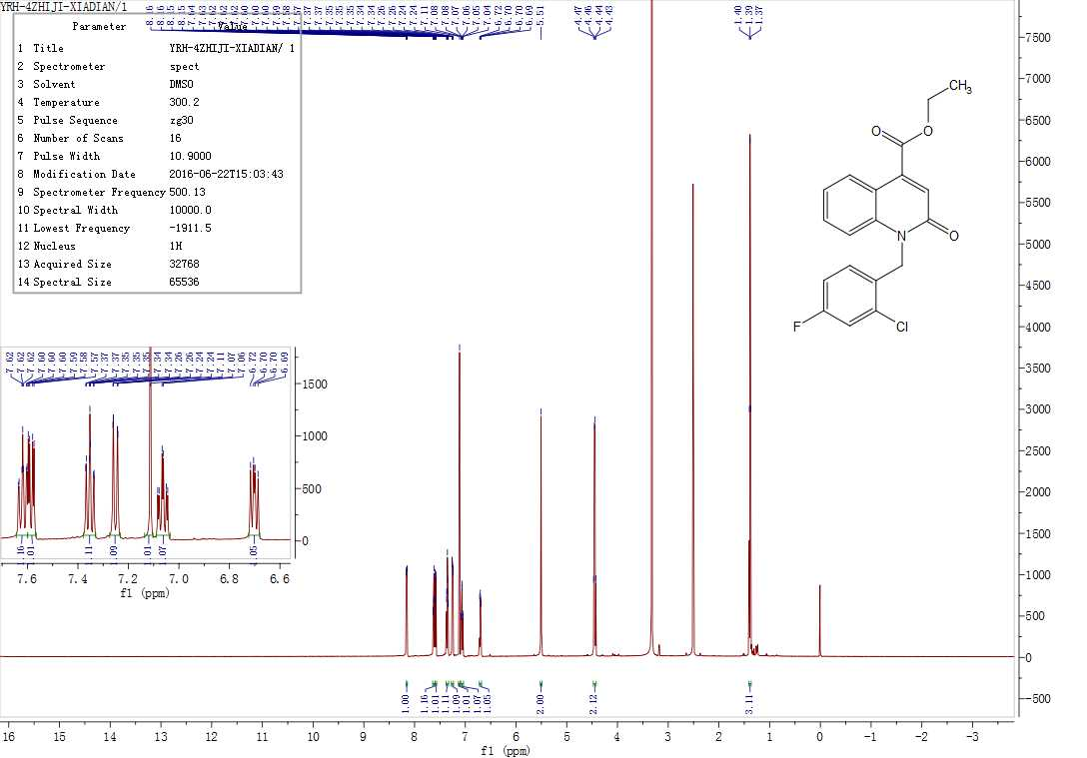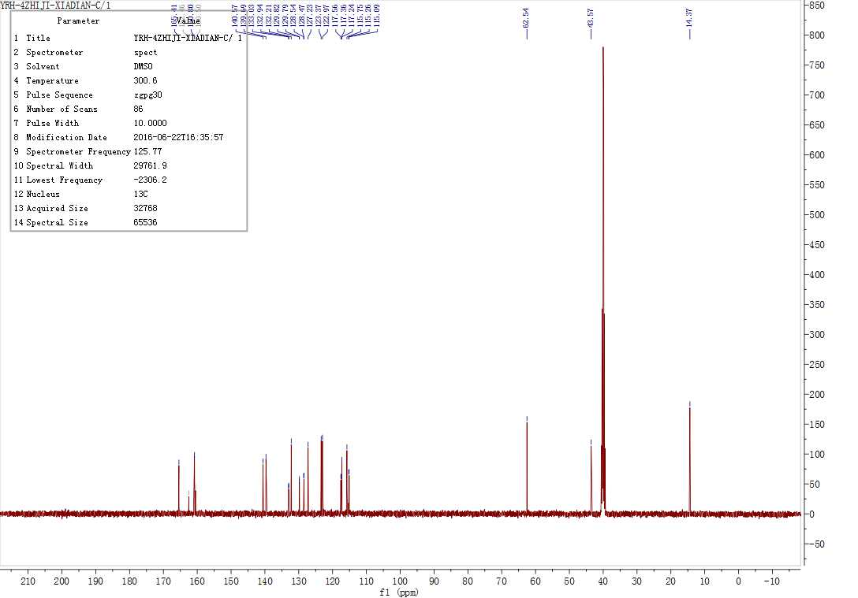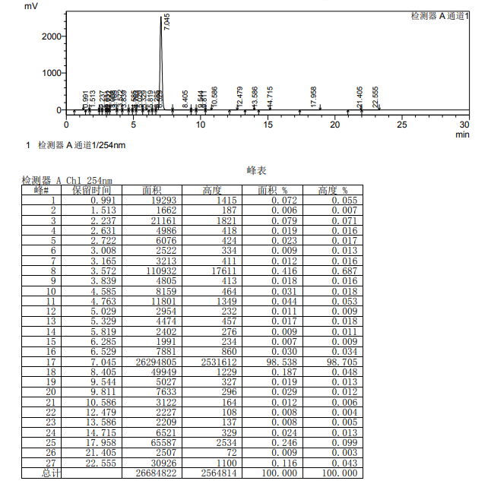
4.5.13 Ethyl 2-(benzyloxy)quinoline-4-carboxylate(19c)
The title compound was prepared in the manner similar to compound 18a. Compound 17a and benzyl bromide are used as raw materials to obtain a white solid with a yield of 65.21%, a melting point of 119.5-120.8 oC, and a HPLC of 98.95% (liquid phase condition A). ¹H NMR(500 MHz, DMSO- d6) δ 8.12 (dd, J = 8.1, 1.4 Hz, 1H), 7.58 (ddd, J = 8.6, 7.0, 1.5 Hz,1H), 7.47 (d, J = 8.6 Hz, 1H), 7.31 (td, J = 7.4, 5.5 Hz, 3H), 7.28 -7.17 (m, 3H), 7.11 (s, 1H), 5.57 (s, 2H), 4.43 (q, J = 7.1 Hz, 2H), 1.38 (t, J = 7.1 Hz, 3H). ¹³C NMR (126MHz, DMSO- d6) δ 165.46, 160.93, 140.33, 139.78, 136.79, 131.92, 129.15, 127.61,127.06, 126.93, 123.12, 123.02, 117.14, 116.28, 62.51, 45.44, 14.39. HRMS (ESI)m/z calcd for [C19H17NO3+H]+:308.1242; foun d:308.1292[M+H]+.
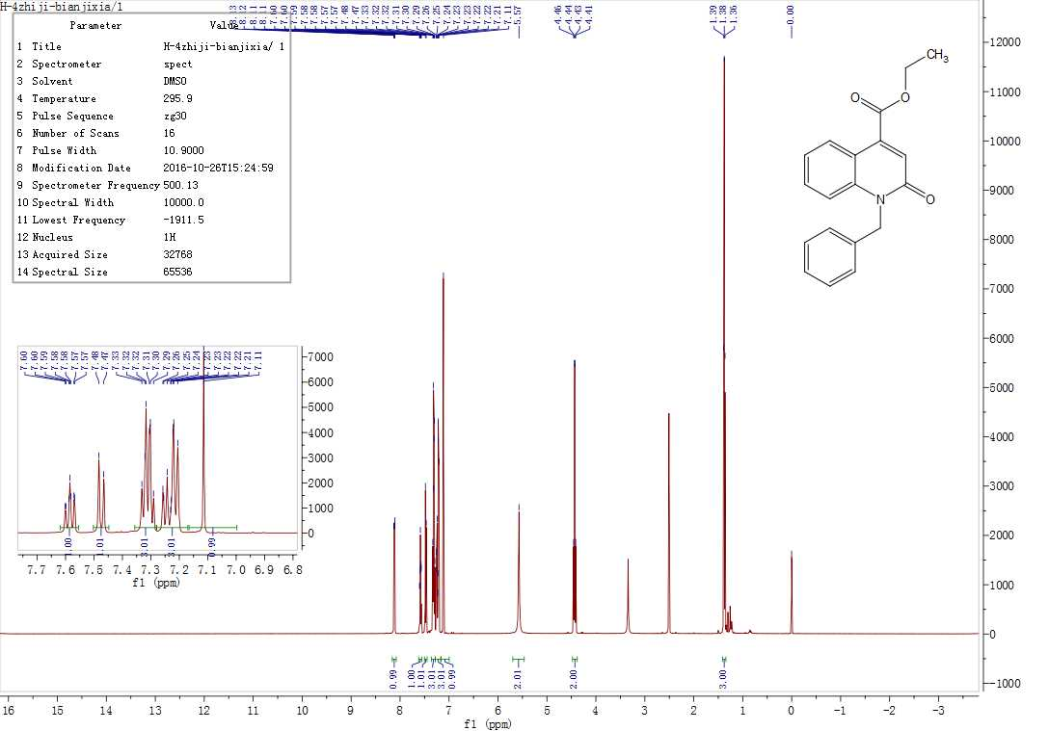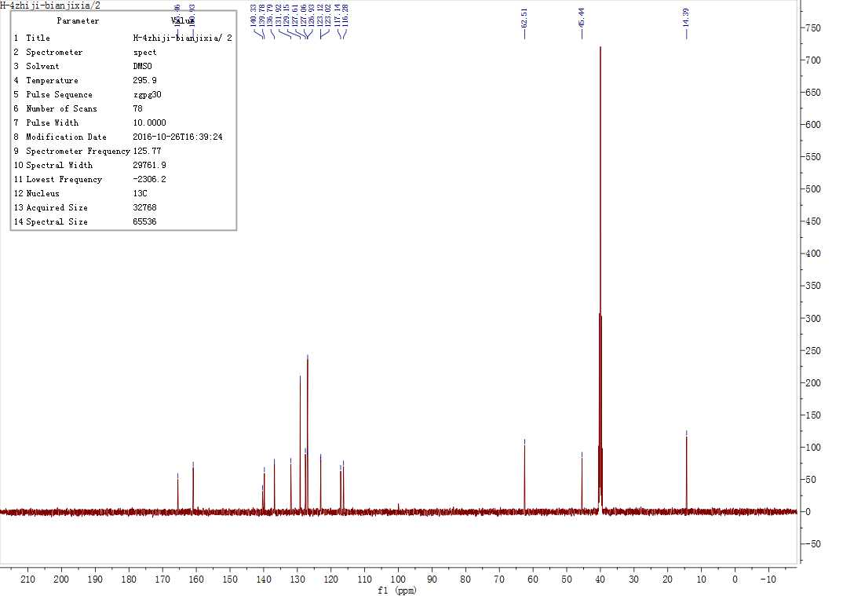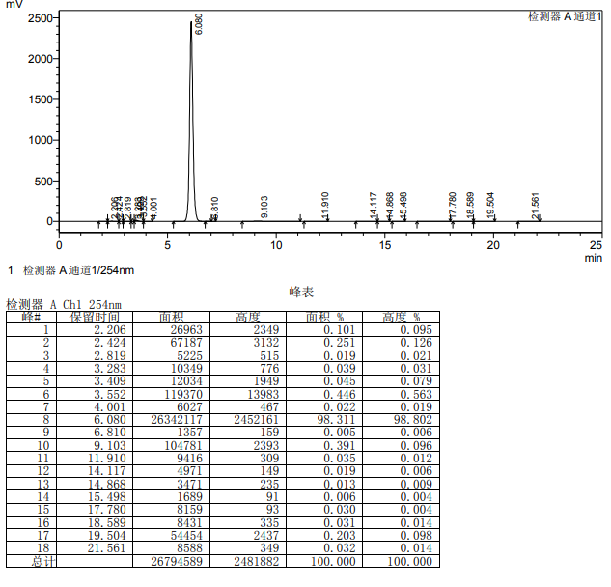
4.5.14 Ethyl 2-((4-methylbenzyl)oxy)quinoline-4-carboxylate(19d)
The title compound was prepared in the manner similar to compound 18a. Compound 17a and 4-methyl benzyl bromide are used as raw materials to obtain a white solid in 60.12% yield, 120.5-121.6 oC melting point and 98.23% HPLC (liquid phase condition A). ¹H NMR (500 MHz, DMSO- d6) δ 8.11 (dd, J = 8.1, 1.5 Hz, 1H), 7.58 (ddd,J = 8.6, 7.1, 1.5 Hz, 1H), 7.47 (d, J = 8.6 Hz, 1H), 7.30 (ddd, J = 8.1, 7.1,1.0 Hz, 1H), 7.19-6.99 (m, 5H), 5.52 (s, 2H), 4.43 (q, J = 7.1 Hz, 2H), 2.24(s, 3H), 1.38 (t, J = 7.1 Hz, 3H). ¹³C NMR (126 MHz, DMSO- d6) δ 160.92,140.30, 139.76, 136.77, 133.75, 131.88, 129.70, 127.02, 126.94, 123.08, 123.01,117.12, 116.33, 62.50, 45.19, 21.07, 14.39. HRMS (ESI) m/z calcd for [C20H19NO3+H]+:322.1398; found:322.1439[M+H]+.
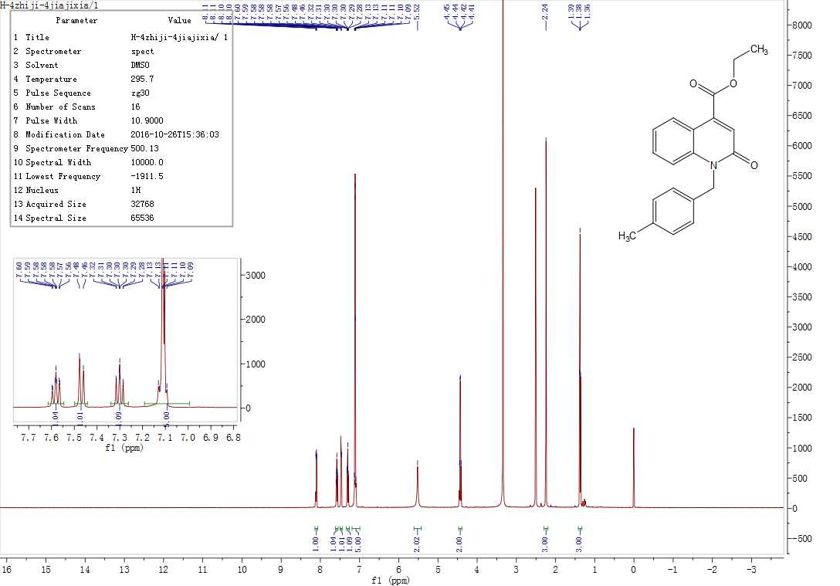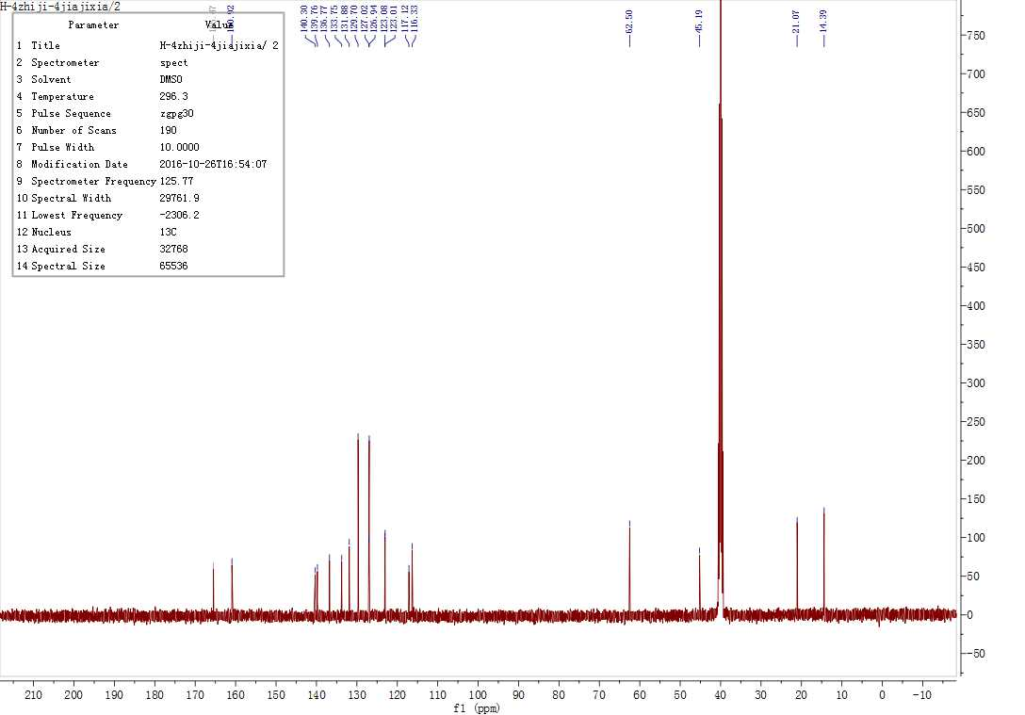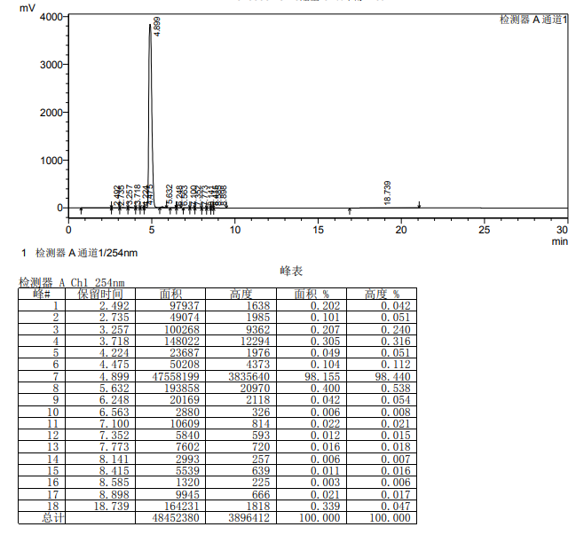
4.5.15 Ethyl 2-((4-fluorobenzyl)oxy)quinoline-4-carboxylate(19e)
The title compound was prepared in the manner similar to compound 18a. Compound 17a and 4-fluorobenzyl bromide are used as raw materials to obtain a white solid in 99.02% yield, 112.8-114.3 oC melting point and 99.02% HPLC (liquid phase condition A). ¹H NMR (500 MHz, DMSO- d6) δ 8.11 (dd, J = 8.1, 1.5 Hz, 1H), 7.60 (ddd, J = 8.6, 7.1,1.5 Hz, 1H), 7.53-7.47 (m, 1H), 7.35-7.25 (m, 3H), 7.19-7.12 (m, 2H), 7.11 (s, 1H),5.55 (s, 2H), 4.43 (q, J = 7.1 Hz, 2H), 1.37 (t, J = 7.1 Hz, 3H). ¹³C NMR (126 MHz,DMSO- d6) δ 165.45, 160.92, 140.38, 139.68, 132.95, 131.97, 129.16, 129.09, 127.10,123.18, 123.02, 117.17, 116.20, 116.04, 115.86, 62.51, 44.78, 14.38.HRMS (ESI)m/z calcd for [C19H16FNO3+H]+:326.1148;found:326. 1199[M+H]+.
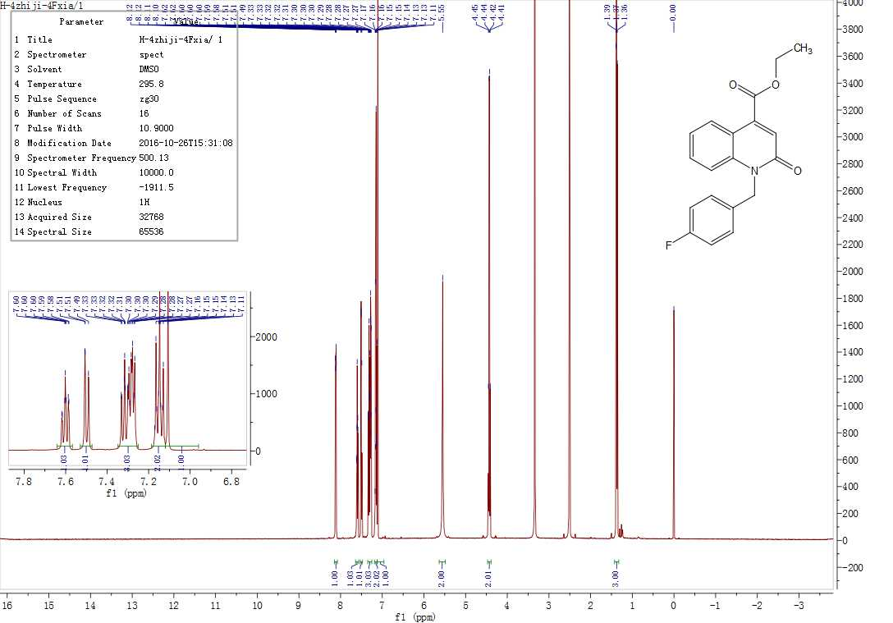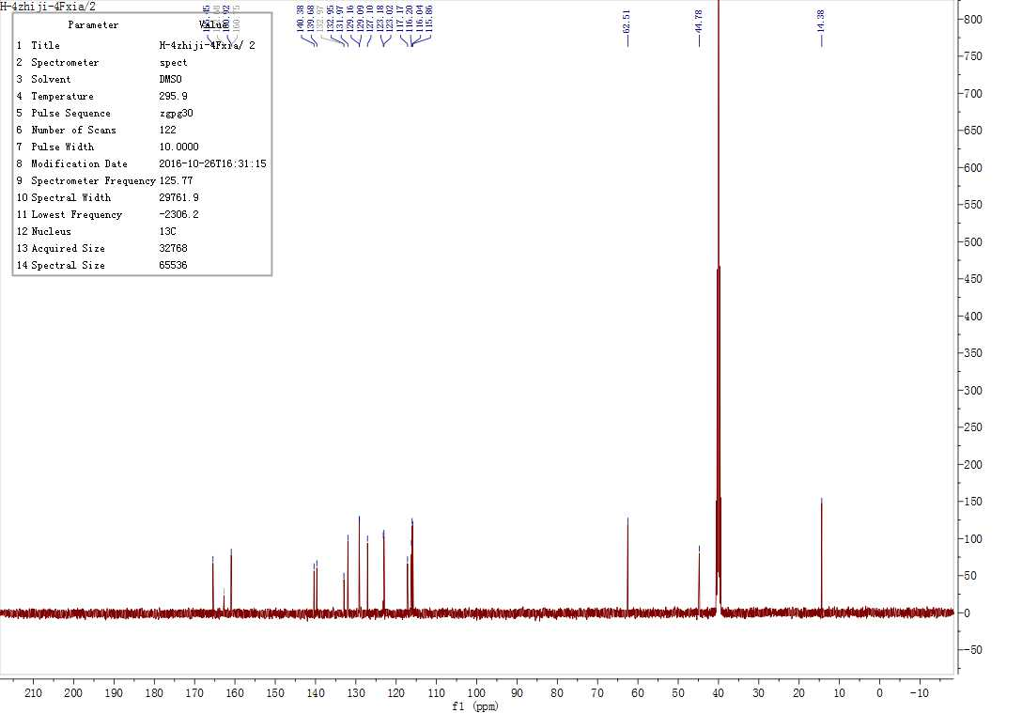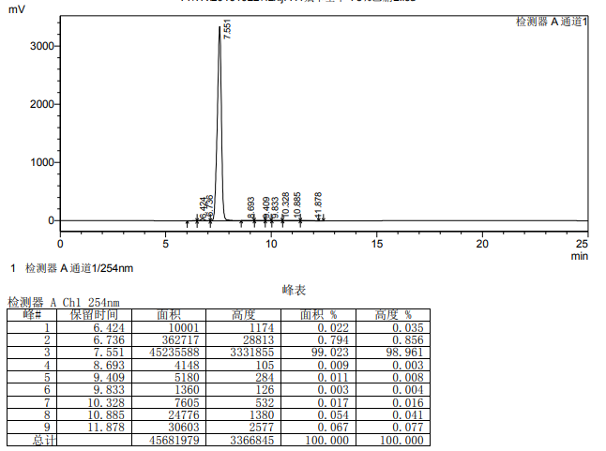
4.5.16 Ethyl 2-((2-chloro-4-fluorobenzyl)oxy)-6-methylquinoline-4-carboxylate(19f)
The title compound was prepared in the manner similar to compound 18a. Compound 17a and 2-chloro-4-fluorobromobenzyl were used as raw materials to obtain a white solid in 60.35% yield, 136.0-136.7 oC melting point and 98.04% HPLC (liquid phase condition A). ¹H NMR (500 MHz, Chloroform-d) δ 8.19 – 8.11 (m, 1H), 7.33 (dd, J = 8.6,2.1 Hz, 1H), 7.28 (d, J = 2.6 Hz, 2H), 7.23 (dd, J = 8.3, 2.5 Hz, 1H), 7.00(d, J = 8.7 Hz, 1H), 6.83 (td, J = 8.3, 2.6 Hz, 1H), 6.71 (dd, J = 8.7, 5.8Hz, 1H), 5.59 (s, 2H), 4.51 (q, J = 7.2 Hz, 2H), 1.61 (s, 3H), 1.48 (t, J = 7.1 Hz, 3H). ¹³C NMR (126 MHz, Chloroform-d) δ 165.37, 161.38, 139.65, 137.39, 133.18, 133.10, 132.80, 132.70, 128.89, 128.06, 127.99, 127.05, 123.60, 117.67, 117.20, 117.00, 114.92, 114.61, 114.44, 62.15, 43.48 , 20.87, 14.19. HRMS (ESI) m/z calcd for [C20H17ClFNO3+ H]+:374.0881; found:374.0960[M+H]+.
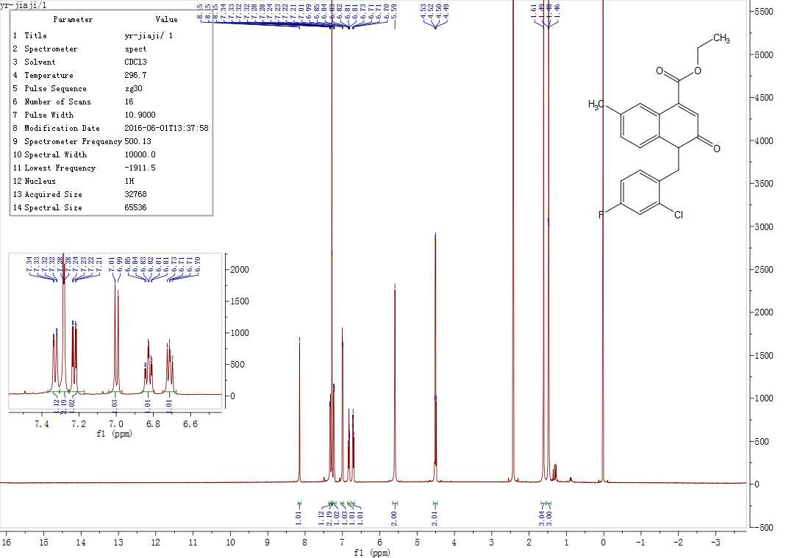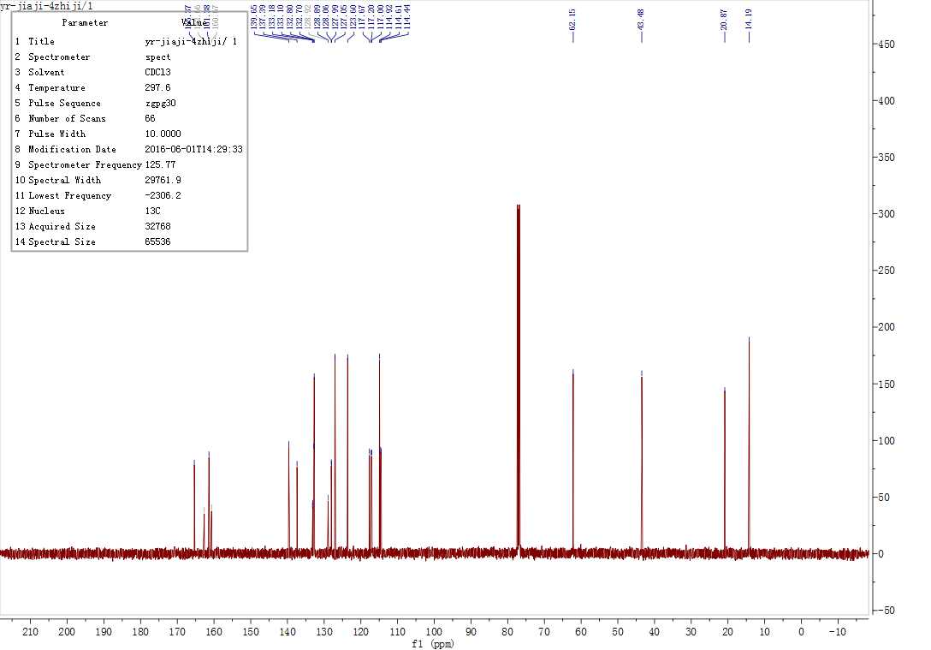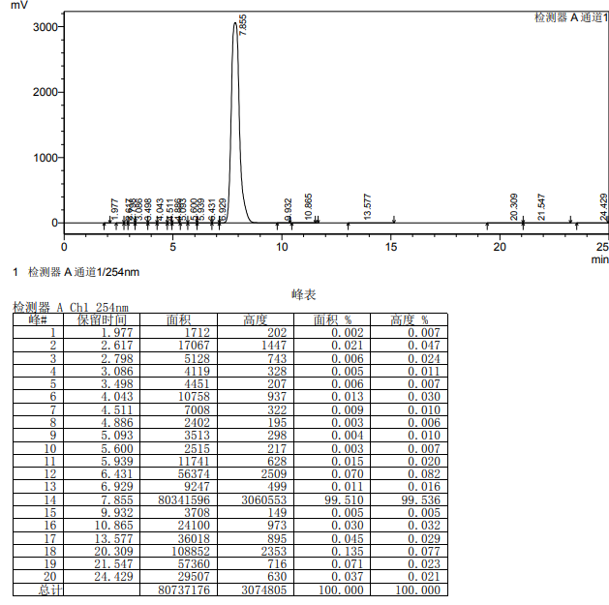

4.5.17 2-((2-chloro-4-fluorobenzyl)oxy)-6-methylquinoline-4-carboxylic acid(20a)
Dissolve 0.1 g (0.27 mmol) of 18e in a 50 ml round-bottom flask, then add 20 ml of anhydrous ethanol to it and clarify the solution, then add 10 ml of aqueous solution containing 0.11 g (2.75 mmol) of sodium hydroxide to it, let it stir for 2 h .Click the plate to monitor the reaction. After the reaction is completed, stop the reaction. Add 1 M hydrochloric acid solution to the reaction solution, adjust the pH of the solution to 6-7, and then spin off the ethanol, Use ethyl acetate for extraction, combine the extracted organic phase and spin it dry, dissolve the solid obtained with ethyl acetate, add 1 g of 80-100 mesh silica gel to it for sample mixing, use 200-300 mesh silica gel for column loading, elute with the development system of petroleum ether: ethyl acetate=5:1, and obtain 0.07 g of compound 7c1, a white solid 82.36% yield, 128.6-129.4 oC melting point and 97.58% HPLC (liquid phase condition B). ¹H NMR (500 MHz, DMSO- d6) δ 13.88 (s, 1H), 8.30 (s, 1H), 7.86 – 7.70 (m, 2H), 7.57 (ddd, J = 28.0, 8.7, 2.3 Hz, 2H), 7.41 (s, 1H), 7.28 (td, J = 8.5, 2.7 Hz, 1H), 5.56 (s, 2H), 2.49 (s, 3H). ¹³C NMR (126 MHz, DMSO- d6) δ 167.45, 160.36, 160.34, 145.42, 140.18, 135.10, 132.62, 132.54, 132.52, 132.45, 131.18, 127.63, 124.99, 122.06, 117.26, 117.21, 117.06, 114.94, 114.90, 114.77, 114.16, 114.13, 64.63, 21.73. HRMS (ESI) m/z calcd for [C18H13ClFNO3+H] + :346.0568; found:346.0648[M+H]+
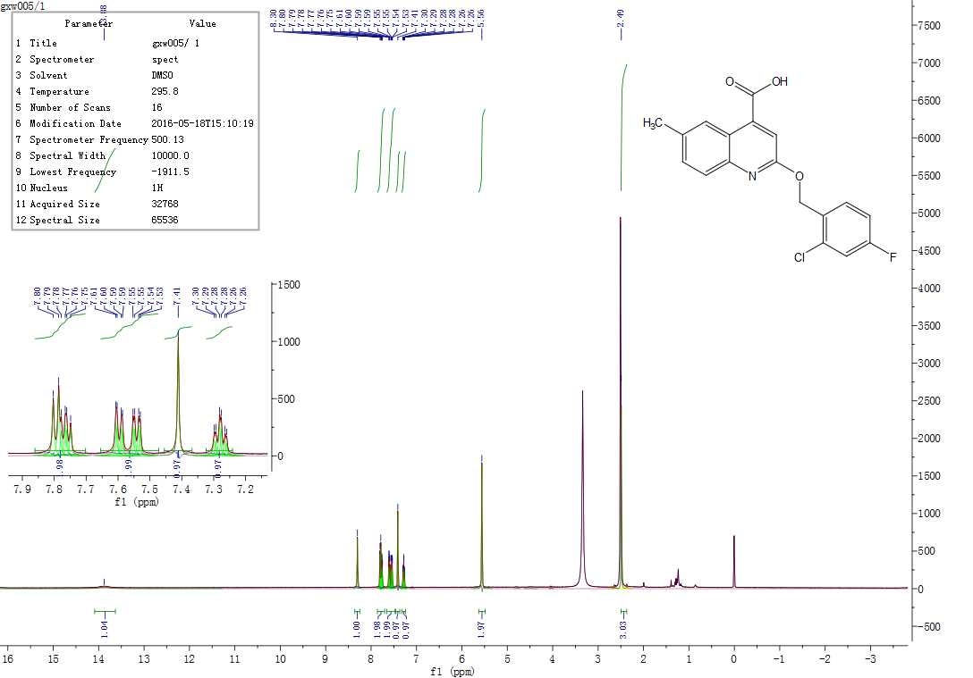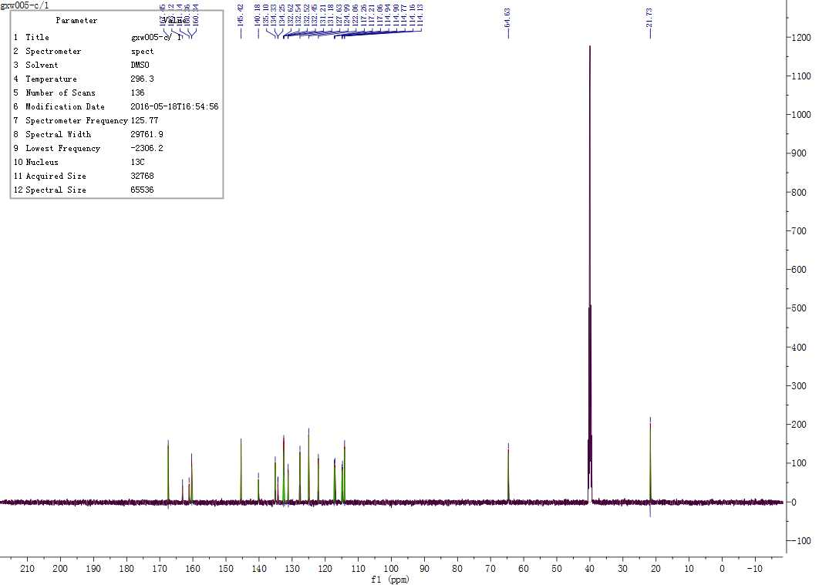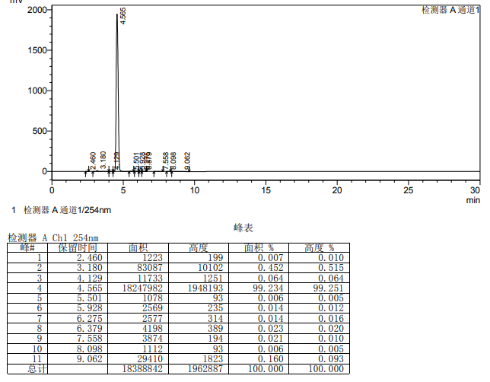

4.5.18 2-((4-methylbenzyl)oxy)quinoline-4-carboxylic acid(20b)
The title compound was prepared in the manner similar to compound 20a. Compound 18c is used as raw material to obtain a white solid in 79.25% yield, 156.3-157.8 oC melting point and 98.29% HPLC (liquid phase condition B). ¹H NMR (500MHz, DMSO- d6) δ 8.53 (d, J = 8.4 Hz, 1H), 7.88 (d, J = 8.3 Hz, 1H), 7.75(t, J = 7.7 Hz, 1H), 7.53 (t, J = 7.7 Hz, 1H), 7.49-7.30 (m, 3H), 7.20 (d, J= 7.7 Hz, 2H), 5.49 (s, 2H), 2.31 (s, 3H). ¹³C NMR (126 MHz, DMSO- d6) δ 167.44, 161.26, 147.17, 140.74, 137.63, 134.23, 130.60, 129.38, 128.80, 127.82, 126.04, 125.63, 122.02, 114.50, 67.72, 21.23. HRMS (ESI) m/z calcd for [C18H15NO3+H]+:294.1085; found:294.1122[M+H]+.
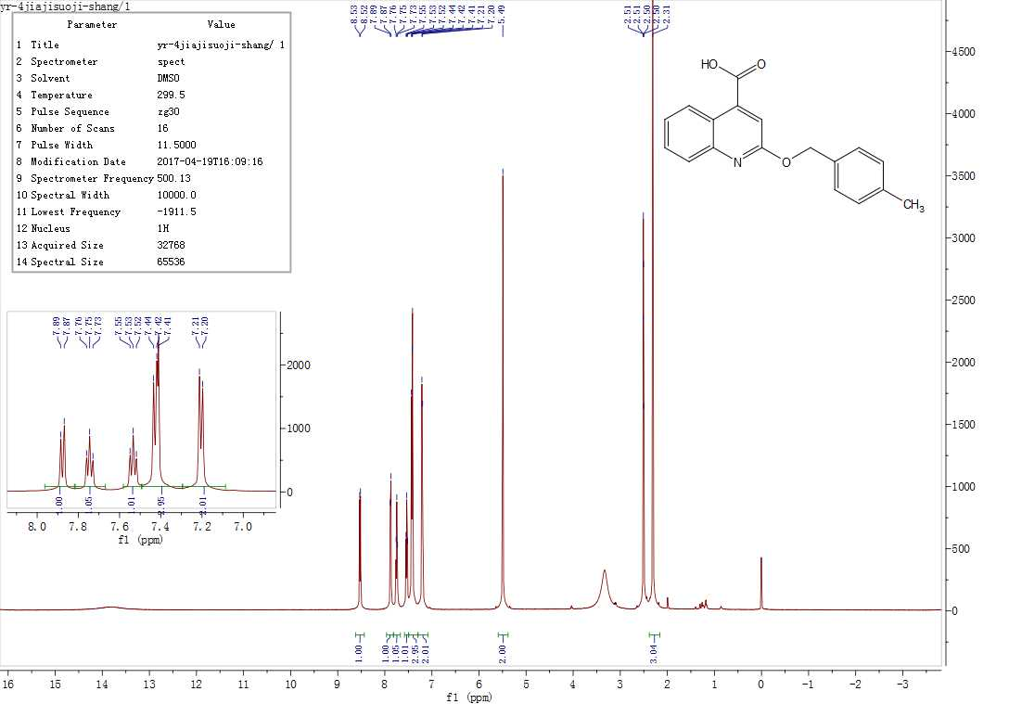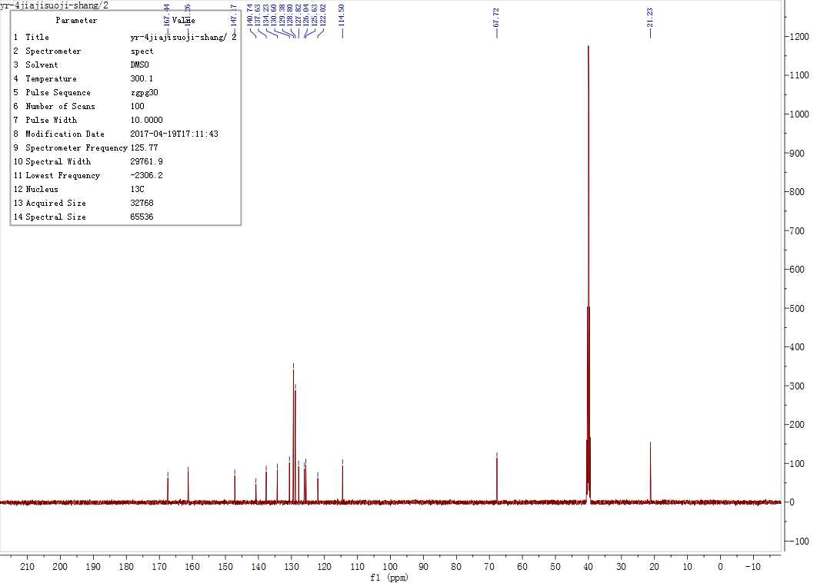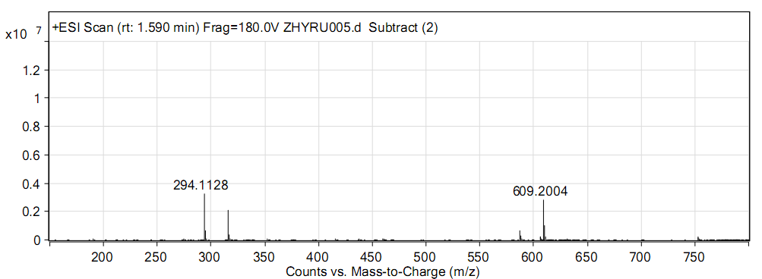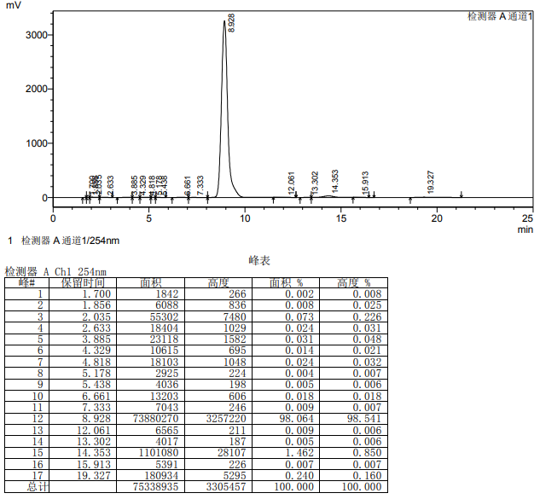

4.5.19 1-(4-methylbenzyl)-2-oxo-1,2-dihydroquinoline-4-carboxylic acid(21a)
The title compound was prepared in the manner similar to compound 20a. Compound 19d is used as raw material to obtain a white solid in 84.65% yield, 168.9-169.6 oC melting point and 98.73% HPLC (liquid phase condition B). ¹H NMR (500MHz, DMSO- d6) δ 8.20 (d, J = 8.0 Hz, 1H), 7.60-7.53 (m, 1H), 7.45 (d, J = 8.6 Hz,1H), 7.29 (t, J = 7.6 Hz, 1H), 7.11 (s, 4H), 7.07 (s, 1H), 5.51 (s, 2H), 2.24 (s, 3H). ¹³C NMR (126 MHz, DMSO- d6) δ 167.28, 161.17, 141.63, 139.78, 136.74, 133.85,131.62, 129.68, 127.35, 126.94, 122.90, 122.36, 117.48, 116.17, 45.17, 21.06. HRMS(ESI) m/z calcd for [C18H15NO3+H]+:294.1085; found:294.1128[M+H]+.
