Regulations of hydrophilicity of cellulosic nanosheets by polarity of coagulation bath
Lvgang Li^{a,c}, Fei Huang^{a,c}, Yifan Guo^{a,b}, Jiahao Wang^{a,c}, He Zhang^{a,c}, Rong Zeng^{a,c}, Zuowan Zhou^{b,c}*
ª School of Materials Science and Engineering, Southwest Jiaotong University, Chengdu 610031, P R China.
^{b} School of Chemistry, Southwest Jiaotong University, Chengdu 610031, P R China.
^{c} Key Laboratory of Advanced Technologies of Materials (Ministry of Education), Southwest Jiaotong University, Chengdu 610031, P R China.
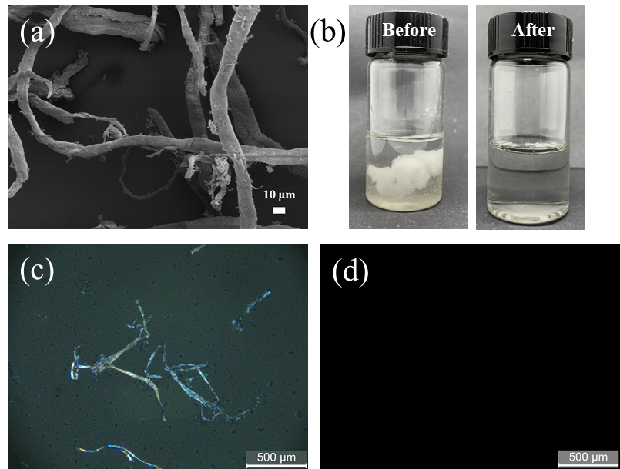
Fig. S1 Structure and morphologies of cellulose raw material and before and after dissolution, (a) SEM image of cellulose raw material, (b) Optical image of before and after cellulose dissolution; POM image of cellulose solution in (c) the just-dissolved state and (d) after dissolution for 1 h.

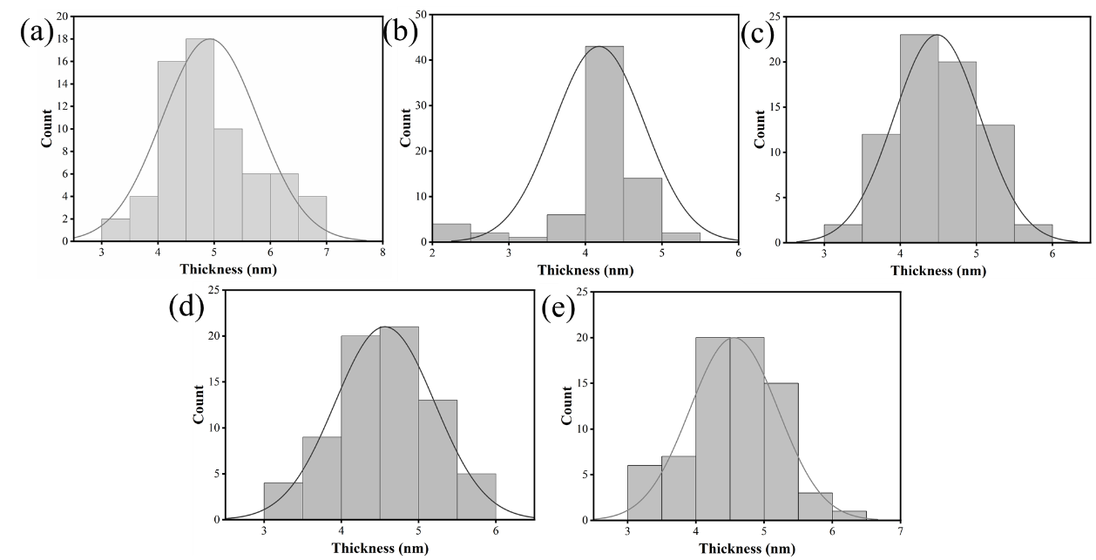
Fig. S2 Statistical thickness distribution of regenerated cellulose nanosheets was prepared in different coagulation baths. (a) RCNs-H₂O, (b) RCNs-DMSO, (c) RCNs-Ac, (d) RCNs-THF, and (e) RCNs-CHX.

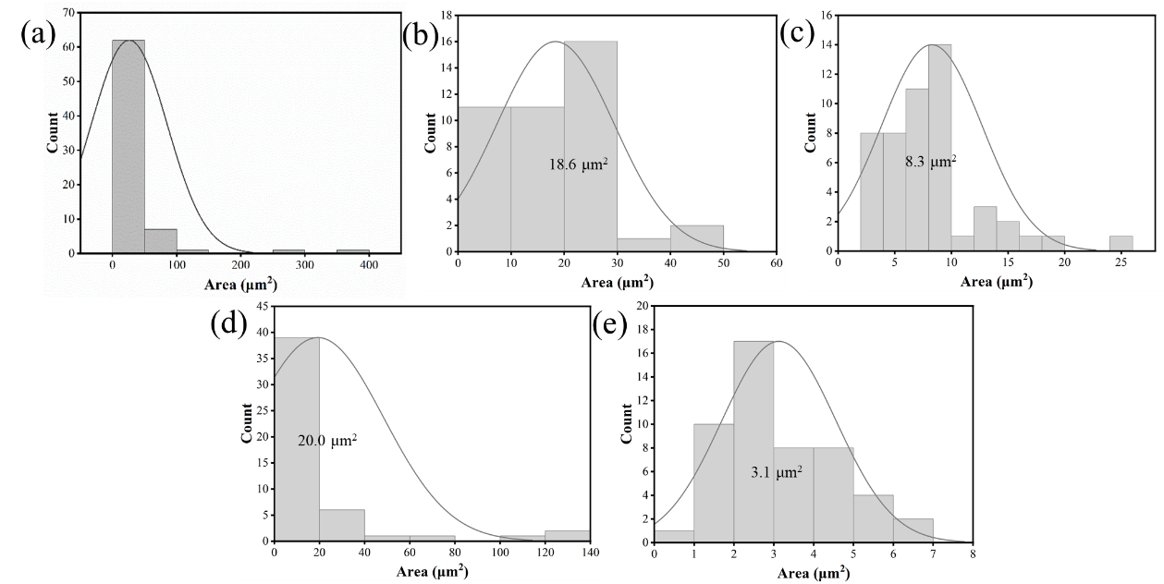
Fig. S3 Statistical area distribution of regenerated cellulose nanosheets was prepared in different coagulation baths. (a) RCNs-H₂O, (b) RCNs-DMSO, (c) RCNs-Ac, (d) RCNs-THF, and (e) RCNs-CHX.

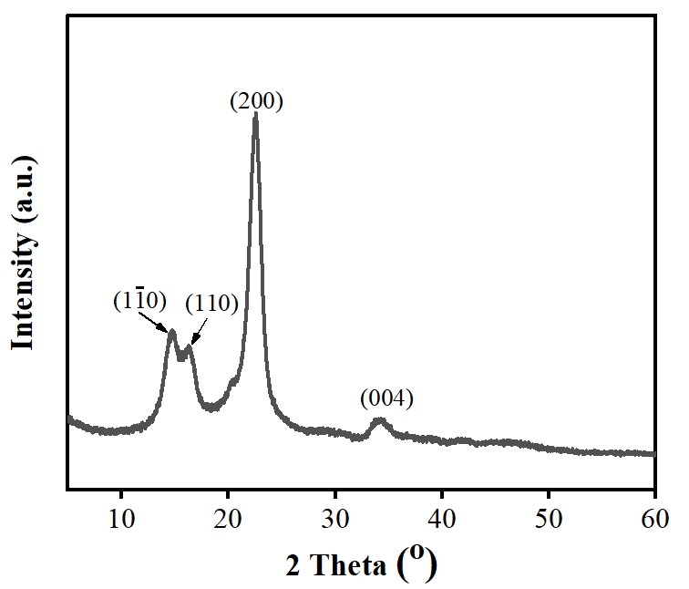
Fig. S4 XRD pattern of cellulose raw material.

Table S1 XRD parameters of RCNs prepared with different coagulants.

According to the characteristics of the monoclinic crystal system of cellulose II crystal type (α = 90.00°, β = 90.00°, γ = 117.18°), it is known that ∠OAC = 62.82°, OA = 8.10 Å and AC = 9.03 Å. Fig. S5d shows the (1$\overline{1}$0) crystal plane of the cellulose II, which can be approximated by D_{||(020)}. According to Euler’s cosine theorem, the conversion equation between grain size perpendicular to the grain plane and grain size parallel to the grain plane is as follows:
OC² = OA² + AC² – 2OA·AC·cos∠OAC
Solving for OC = 8.96 Å, the following relationship based on the cosine theorem is further obtained:
$$\text{cos}\text{∠}\text{OAC=}\frac{{\text{OA}}^{\text{2}}\text{+}{\text{OC}}^{\text{2}}\text{-}{\text{AC}}^{\text{2}}}{\text{2OA}\text{·}\text{OC}}$$
Solving for ∠COA=63.68º, ∠DAE=26.32° is obtained from the conditions AD⊥OC and DE⊥OA.
AE = AD·cos26.32º
D_{⊥(1}$\overline{\text{1}}$_{0)-||(020)} = D_{⊥(1}$\overline{\text{1}}$₀₎·cos(26.32º) = 0.90·D_{⊥(1}$\overline{\text{1}}$₀₎ (1)
The grain size of the (1$\overline{1}$0) crystal plane of cellulose II crystal form can also be decomposed along the (110) crystal plane. The schematic diagram of the model is shown in Fig. S5e. Due to monoclinic crystal system of cellulose II (γ = 117.18º, a = 8.10 Å, b = 9.03 Å), ∠BOA=117.18°, OA=8.10 Å and OB=9.03 Å are obtained, according to the cosine theorem:
AB² = OA² + OB² – 2OA·OB·cos∠BOA
Solving for AB=14.63 Å, AF=0.5·AB = 0.7 Å, further according to the cosine theorem:
OD = OA·cos∠DOA= 3.59 Å
It can be seen from the above that OF = 0.5 OC = 4.48 Å, then DF = OF-OD = 0.89 Å. sin∠FAD=$\frac{DF}{AF}$ is obtained from the condition AD⊥OF.
Solving for ∠FAD=6.99°, AE = AD·cos6.99° is obtained from the condition DE⊥EA.
So D_{⊥(1}$\overline{\text{1}}$_{0)-||(110)} = D_{⊥(1}$\overline{\text{1}}$₀₎·cos(6.99º) = 0.99·D_{⊥(1}$\overline{\text{1}}$₀₎ (2)
The (020) crystal plane grain size of cellulose II crystal is used to decompose along the (1$\overline{1}$0) crystal plane, as shown in Fig. S5f. ∠COA=63.68° is known form the above result, and the ∠OFE=26.32° is obtained from condition DE⊥OA.
FG = FE·cos26.32°
D_{⊥(020)-||(1}$\overline{\text{1}}$₀₎ = D_{⊥(020)}·cos(26.32º) = 0.90·D_{⊥(020)} (3)
The (020) crystal plane grain size of cellulose II crystal is used to decompose along the (110) crystal plane, as shown in Fig. S5g, the OA=8.10 Å, OB=9.03 Å and AB=14.63 Å are known from the above results, according to the cosine theorem:
$$\text{cos}\text{∠}\text{BAO =}\frac{{\text{AB}}^{\text{2}}\text{+}{\text{OA}}^{\text{2}}\text{-}{\text{OB}}^{\text{2}}}{\text{2AB}\text{·}\text{OA}}$$
Solving for ∠BAO = 33.29°, the ∠EFG=90°-∠FAE=56.71° is obtained from the condition DE⊥OA and EG⊥AF.
FG = FE·cos56.71°
D_{⊥(020)-||(110)} = D_{⊥(020)}·cos56.71º= 0.55·D_{⊥(020)} (4)
The (110) crystal plane grain size of cellulose II crystal is used to decompose along the (1$\overline{1}$0) crystal plane, as shown in Fig. S5h, the ∠EOA=56.71° is obtained due to the conditions of ∠BAO=33.29° and OE⊥AB, ∠FOE=6.97° is obtained by the ∠COA=63.68°, and OF = OE·cos6.97° is obtained from the condition of the EF⊥OD.
D_{⊥(110)-||(1}$\overline{\text{1}}$₀₎ = D_{⊥(110)}·cos(6.97º) = 0.99·D_{⊥(110)} (5)
The (110) crystal plane grain size of cellulose II crystal is used to decompose along the (020) crystal plane, as shown in Fig. S5i. The OF = OE·cos56.71° is obtained from the condition of the ∠EOA=56.71°.
D_{⊥(110)-||(020)} = D_{⊥(110)}·cos(56.71º) = 0.55·D_{⊥(110)} (6)
Therefore, a summary of the conversion relationship between grain size perpendicular to the grain plane and grain size parallel to the grain plane, as shown in table S2.
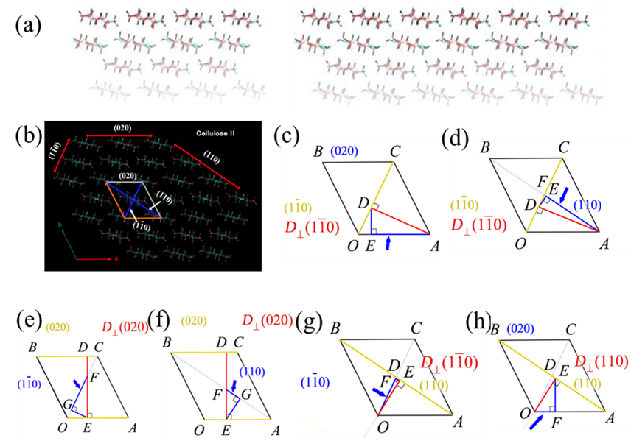
Fig. S5 Schematic diagram of the crystalline structure of cellulose II, Regenerated cellulose material with exposed (020) crystal planes of (a) small and (b) large size crystals. (c) Typical cellulose II diffraction crystal planes, (d) and (e) are schematic diagrams of the model for the decomposition of the (1$\overline{\text{1}}$0) plane grain size of cellulose II along the (020) and (110) planes, respectively. (f) and (g) are schematic diagrams of the model for the decomposition of the (020) plane grain size of cellulose II along the (1$\overline{\text{1}}$0) and (110) planes, respectively. (h) and (i) are schematic diagrams of the model for the decomposition of the (110) plane grain size of cellulose II along the (1$\overline{\text{1}}$0) and (020) planes, respectively.

Table 2. Conversion relationship between the grain size of each crystal plane and the grain size parallel to each crystal plane in cellulose II crystal form.
⊥Grain size  ||Grain size | D_{⊥(1}$\overline{\text{1}}$₀₎ | D_{⊥(110)} | D_{⊥(020)}
D_{||(1}$\overline{\text{1}}$₀₎ | — | 0.99 | 0.90
D_{||(110)} | 0.99 | — | 0.55
D_{||(020)} | 0.90 | 0.55 | —

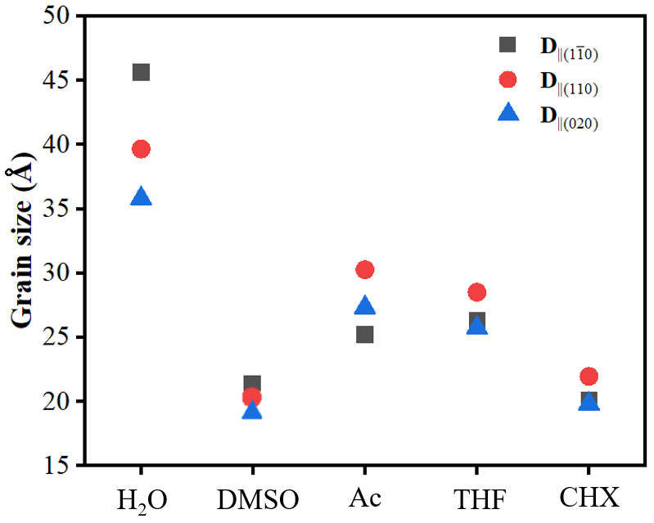
Fig. S6 The variation of grain size parallel to the grain surface with the polarity of the coagulation baths.

