Supporting Information
Efficient production of salvianic acid A from L-dihydroxyphenylalanine through a tri-enzyme cascade
Jiahui Yang¹, Wanqing Wei², Changzheng Gao³, Wei Song¹, Cong Gao², Xiulai Chen², Jia Liu², Liang Guo², Liming Liu², Jing Wu^{1*}
¹ School of Life Science and Health Engineering, Jiangnan University, Wuxi 214122, China
² State Key Laboratory of Food Science and Technology, Jiangnan University, Wuxi 214122, China
³ Department of Cardiology, Affiliated Hospital of Jiangnan University, Wuxi, 214122, China
*Corresponding author: Jing Wu
Mailing address: School of Life Science and Health Engineering, Jiangnan University, Wuxi 214122, China
Fax/Tel.: +86-510-85910059
E-mail: wujing@jiannan.edu.cn

This doc file includes:
Supplementary Table S1 to Table S6
Supplementary Figure S1 to Figure S10

Supplementary Tables
Table S1. The primers used in this study
Name | Primer (5’-3’)
Primers for gene amplification
LaPPR-F | ATCACCACAGCCAGGATCCGATGATGAAAATTCTGAAC
LaPPR-R | CATTATGCGGCCGCAAGCTTTTAATAGCCGCGGGTCAGAT
PmLAAD-F | AAGAAGGAGATATACATATGATGAACATTTCAAGGAGAA
PmLAAD-R | GTTTCTTTACCAGACTCGAGTTACTTCTTAAAACGATCCA
CbFDH-F | ATCACCACAGCCAGGATCCGATGAAGATCGTGTTAGTCCT
CbFDH-R | CATTATGCGGCCGCAAGCTTTTATTTTTTATCGTGTTTCC
Primers for mechanism test
G66A-F | GTGCAAGCGATGAGCGCGGCGGTGGATTATCTG
G66A-R | CAGCGGCAGATAATCCACCGCCGCGCTCATCGC
R224A-F | CTGTTTATTAACATTGGCGCGGGCCCGAGCGTG
R224A-R | CATATCCACGCTCGGGCCCGCGCCAATGTTAAT
E253A-F | CTGGATGTGGTTGATCCGGCGCCGCTGCCGCAA
E253A-R | GCTATCTTGCGGCAGCGGCGCCGGATCAACCAC
H272A-F | AACGTGCTGCTGACCCCGGCGATTAGCGGCACC
H272A-R | CGGCACGGTGCCGCTAATCGCCGGGGTCAGCAG
G275A-F | CTGACCCCGCATATTAGCGCGACCGTGCCGCAG
G275A-R | GCGCAGCTGCGGCACGGTCGCGCTAATATGCGG
T276A-F | ACCCCGCATATTAGCGGCGCGGTGCCGCAGCTG
T276A-R | GCGCAGCTGCGGCACCGCGCCGCTAATATGCGG
Primers for the site mutation
H89-F | GCGAACACGAGCGGCATTNNKGCGGAACCG
H89-R | TTCCGCAATCGGTTCCGCMNNAATGCCGCT
H143-F | GTGATTTTTGGCACCGGCNNKATTGGCAGC
H143-R | CGCAATGGTGCTGCCAATMNNGCCGGTGCC
P256-F | GTTGATCCGGAACCGCTGNNKCAAGATAGC
P256-R | CCACAGCGGGCTATCTTGMNNCAGCGGTTC
H143D-F | GTGATTTTTGGCACCGGCGATATTGGCAGC
H143D-R | CGCAATGGTGCTGCCAATATCGCCGGTGCC

Table S2. Data collection and refinement statistics of apo-LaPPR crystal structure.
 | apo-LaPPR
PDB code | 8HPG
Data collection
Space group | P 1 21 1
Cell dimensions
a, b, c (Å) | 89.89, 48.97, 89.89
α, β, γ (Å) | 90.00, 116.72, 90.00
Resolution (Å) | 23.49-3.79 (3.79-3.89)
R_{merge} | 0.141
R_{pim} | 0.062
I/σI | 7.29
Completeness (%) | 42.7
Refinement
No. reflections | 6138
R_{work}/R_{free} | 0.25755/0.27950
No. atoms | 9448
B factors (Å²) | 28.83
r. m. s. deviations
bond lengths (Å) | 0.0061
bond angles (Å) | 1.5321

Table S3. Specific enzyme activities of L-AAD from different organisms
Enzymes | Organisms |  | Specific activityª  (U·mg⁻¹ protein)
PvL-AAD |  | Proteus vulgaris | 7.09±0.39
PmL-AAD^{S98A} |  | Proteus mirabilis | 8.32±0.26
PmL-AAD^{H295S/V437S} |  | Proteus mirabilis | 9.42±0.35
PmL-AAD^{S98A/T105A/S106A/L341A} |  | Proteus mirabilis | 7.65±0.28
PmL-AAD^{T105A/S412A/E417A/E340A/E145A} |  | Proteus mirabilis | 8.15±0.17
Note. L-AAD: L-amino acid deaminase
ª The specific activity was determined with 10 μM purified L-AAD and 10 mM L-DOPA in 1 mL Tris-HCl buffer (50 mM, pH7.0) at 30 °C for 10 min. The data represent mean ± SD, as determined from three independent experiments.

Table S4. Specific enzyme activities of α-keto acid reductase from different organisms
Enzymes | Organisms | Specific activityª  (U·mg⁻¹ protein)
LaPPR | Lactobacillus. sp. CGMCC9967 | 5.78±0.26
LfDLDH | Lactobacillus fermentum JN248 | 3.09±0.08
SoHPPR | Soleostemon scutellarioides | 0.92±0.05
PlHPPR | Plectranthus scutellarioides | 0.65±0.07
WiPPR | Wickerhamia fluorescens | 0.55±0.04
ScHPPR | Scutellaria baicalensis | n/a
PmL-AAD^{T105A} | Proteus mirabilis | 8.15±0.17
Note. DLDH: D-lactate dehydrogenase; HPPR: hydroxyphenylpyruvate reductase; PPR: phenylpyruvate reductase; n/a, not available.
ªThe specific activity was determined with 10 μM purified α-Keto acid reductase 10 mM DHPPA, and 0.5 mM NADH in 1 mL Tris-HCl buffer (50 mM, pH 7.0) at 30 ℃ for 5 min. The data represent mean ± SD, as determined from three independent experiments.

Table S5. Specific enzyme activities of PmLAAD, LaPPR and CbFDH in E. coli
Strains | PmLAAD activity(U·mL⁻¹) | LaPPR activity(U·mL⁻¹) | CbFDH activity(U·mL⁻¹)
E. coli YJH01 | 145.21 ± 3.72 | 36.21 ± 1.06 | 357.1 ± 10.21
E. coli YJH02 | 133.51 ± 3.51 | 63.15 ± 2.56 | 309.58 ± 8.71
E. coli YJH05 | 127.63 ± 3.15 | 87.55 ± 2.82 | 178.56 ± 4.32
E. coli YJH12 | 94.38 ± 2.87 | 112.36 ± 3.12 | 139.32 ± 4.21
PmLAAD: Activity was determined with 20 g L⁻¹ Whole-cell catalyst, 50 g L⁻¹ L-DOPA, in 1 mL Tris-HCl buffer (50 mM, pH 7.0) at 30 ℃ for 5 min.
LaPPR: Activity was determined with 20 g L⁻¹ Whole-cell catalyst, 50 g L⁻¹ DHPPA, 5mM NADH in 1 mL Tris-HCl buffer (50 mM, pH 7.0) at 30 ℃ for 5 min.
CbFDH: Activity was determined with 20 g L⁻¹ Whole-cell catalyst, 50 g L⁻¹ HCOONa, 5mM NAD⁺ in 1 mL Tris-HCl buffer (50 mM, pH 7.0) at 30 ℃ for 5 min.
The data represent mean ± SD, as determined from three independent experiments.

Table S6. Types and sequences of different RBS
Types | sequence | Translation rate
RBS-1 | TACTAATATTTAACCAGCTTGGTAC | 105.38
RBS-2 | GGCTAGATACTTGGGTTCTGTAA | 211.42
RBS-3 | TTAATAAGGAGATATA | 301.05
RBS-4 | CGCGTTCCAAAAAACTATAAACAAGCAC | 372.48
RBS-5 | TCCCGTAATACAAAGTTTAGTC | 413.58
RBS-6 | TAACCATTTACGGCCAGCTC | 466.23
RBS-7 | TCAAAGTCAAAT ACAAAGTTAAAGTT | 536.71
RBS-8 | TTTGTCAAATATAGCGGCCA ATAATTGT | 593.61
RBS-9 | CGGTCCTACGGCCCCAGT | 734.14
RBS-10 | TCTTAGTCTGCTACTGTTAATCAT | 826.77

Supplementary Figures
Figure S1. SDS-PAGE analysis. (a) The purified PmLAAD, LaPPR and CbFDH enzyme; (b) Three enzymes PmLAAD, LaPPR and CbFDH co-expressed in E. coli YJH01.
Figure S2. Detection of SAA product in vitro biosynthesis pathway. (a) Analysis of the standard sample and the retention time of SAA was 18.17 min; (b) Analysis of the reaction mixture in vitro, and SAA product was detected at 18.17 min.

Figure S3. Characterization of pure SAA by LC-MS. (ESI⁻) m/z: C₉H₁₀O₅ [M-H]⁻, 197.

Figure S4. Detection of DHPPA intermediate in the reaction mixture by HPLC. (a) Standard sample of DHPPA, the retention time was 10.66 min; (b) Analysis of the remaining DHPPA intermediate in reaction mixture, and DHPPA was detected at 10.67 min.

Figure S5. The asymmetric unit of LaPPR contains two essentially identical units.

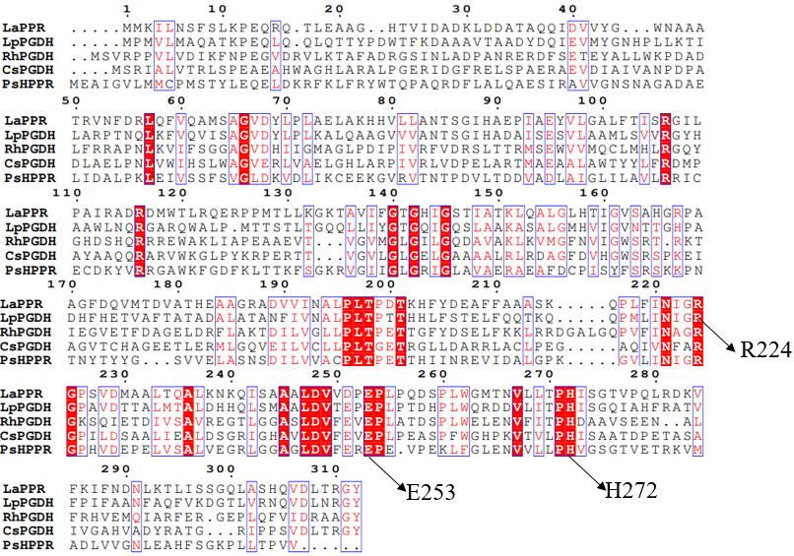
Figure S6. Multiple sequence alignment of LaPPR with homologous PGDH sequences from superfamily.

Figure S7. (a) Structural alignment of LaPPR (green) and LaPPR^{Mu2} (blue); (b) Ramachandran plot of LaPPR^{Mu2} structure.

Figure S8. (a) Root-mean-square-deviation (RMSD) calculated from MD simulations
of LaPPR-NADH-DHPPA and LaPPR^{Mu2}-NADH-DHPPA complex. (b) B-factor calculated from MD simulations of LaPPR-NADH-DHPPA and LaPPR^{Mu2}-NADH-DHPPA complex. (c) Distances of hydride transfer and proton transfer (d₁ and d₂) calculated from 50 ns MD simulations on the LaPPR-NADH-DHPPA complex. (d)Distances of hydride transfer and proton transfer (d₁ and d₂) calculated from 50 ns MD simulations on the LaPPR^{Mu2}-NADH-DHPPA complex. Mean ± standard deviation is shown for 25000 snapshots of the 50 ns MD simulations.

Figure S9. (a) The wild-type LaPPR pocket, shown in yellow, has a volume size of 989 Å³; (b)The mutant LaPPR^{Mu2} pocket, shown in yellow, has a volume size of 1359 Å³. The pocket volume for each of the structures has been computed with the POCASA server.

Figure S10. (a) Effect of conversion temperature on SAA concentration. The conversion reactions were performed in a 10 mL volume of 50 mM Tris-HCl buffer, pH 7.0, containing 3 mM NAD⁺, with 20 g L⁻¹ wet whole-cell biocatalysts, 50 g L⁻¹ L-DOPA and 60 g L⁻¹ sodium formate, in 20-40 °C for 12 h. (b) Effect of conversion pH on SAA concentration. The conversion reactions were performed in a 10 mL volume of 50 mM Tris-HCl buffer, pH 6.5-9.0 containing 3 mM NAD⁺, with 20 g L⁻¹ wet whole-cell biocatalysts, 50 g L⁻¹ L-DOPA and 60 g L⁻¹ sodium formate, in 30 °C for 12 h. (c) Effect of concentration of NAD⁺ on SAA concentration. The conversion reactions were performed in a 10 mL volume of 50 mM Tris-HCl buffer, pH 7.0, containing 0.2-1.6 mM NAD⁺, with 20 g L⁻¹ wet whole-cell biocatalysts, 50 g L⁻¹ L-DOPA and 60 g L⁻¹ sodium formate, in 30 °C for 12 h. (d) Effect of concentration of whole-cell catalyst on SAA concentration. The conversion reactions were performed in a 10 mL volume of 50 mM Tris-HCl buffer, pH 7.0, containing 0.6 mM NAD⁺, with 10-40 g L⁻¹ wet whole-cell biocatalysts, 50 g L⁻¹ L-DOPA and 60 g L⁻¹ sodium formate, in 30 °C for 12 h. The data represent mean ± SD, as determined from three independent experiments.

