Supplementary Information

An Optimized GATK4 Pipeline for Plasmodium falciparum Whole Genome Sequencing Variant Calling and Analysis.
K. Niaré et al.

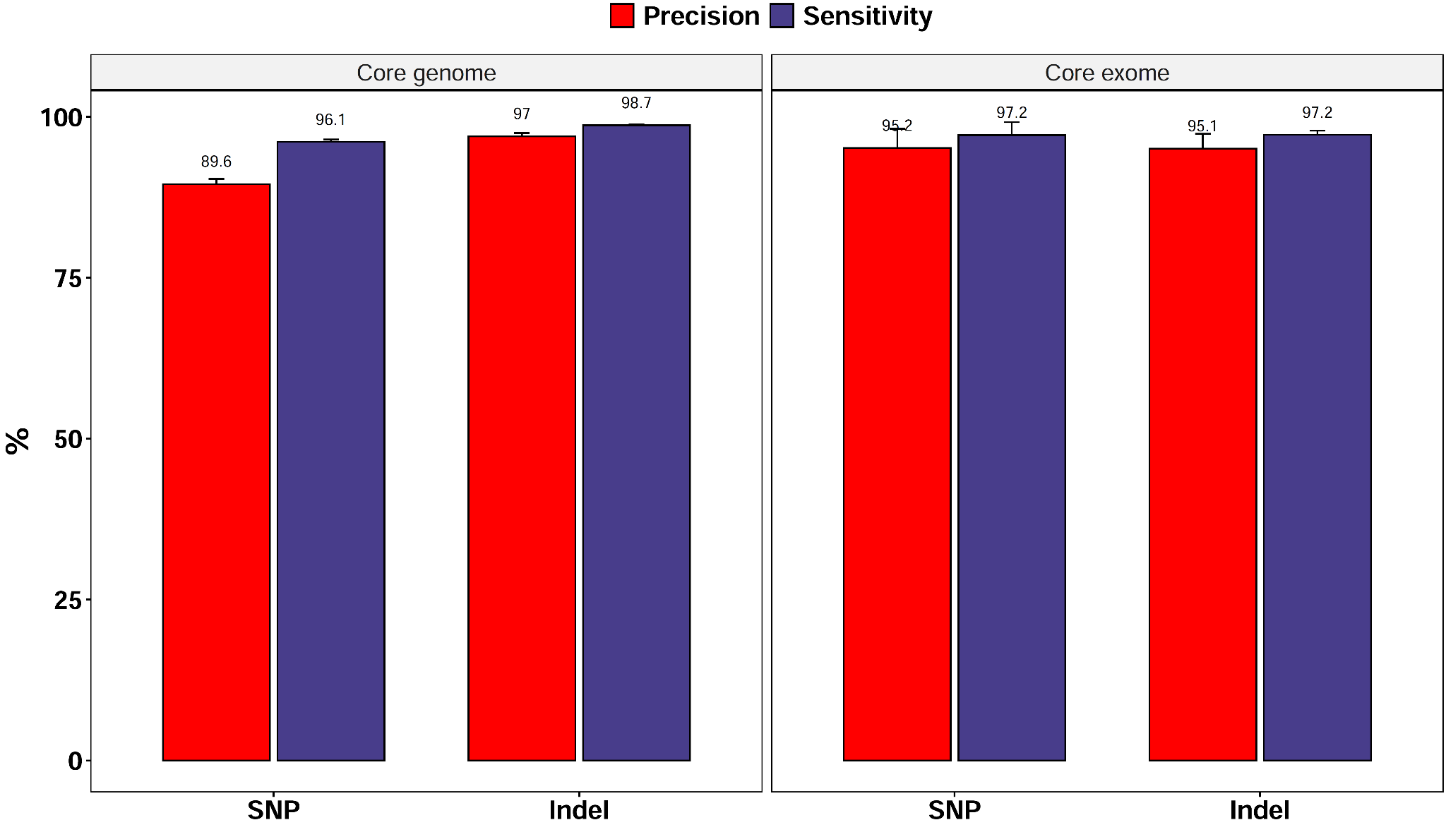
Fig. S 1: Quality of the GATK variant calling on the in silico training dataset as compared to direct calls from assemblies reference call sets within the core genome. Core genome excludes subtelomeric and internal hypervariable regions. Core exome corresponds to all coding sequences within the core genome. PACBIO assemblies for 10 laboratory strains (7G8, Dd2, GA01, GB4,GN01, HB3, IT, KH01, KH02 and SN01) were included in the analysis. For each strain, in silico synthetic 2kb overlapping reads at 100X coverage to the genome were used to call variants with GATK version 4.
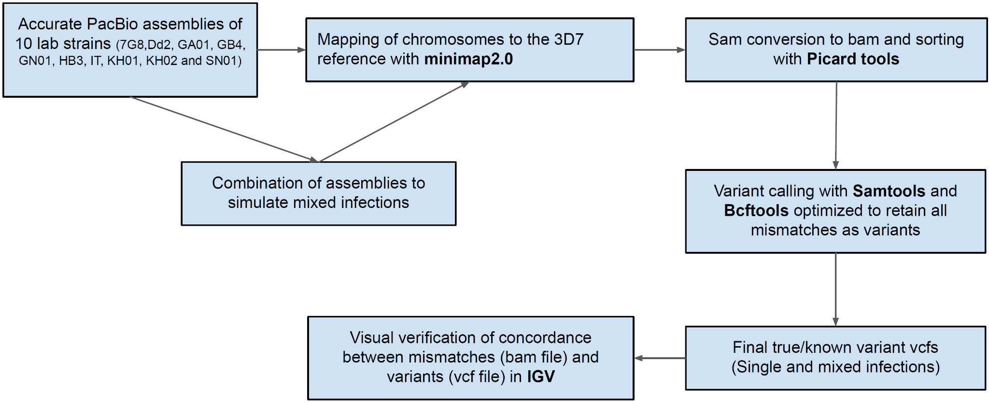

Fig. S2: Workflow different steps in reference thruth set for 10 laboratory strains.

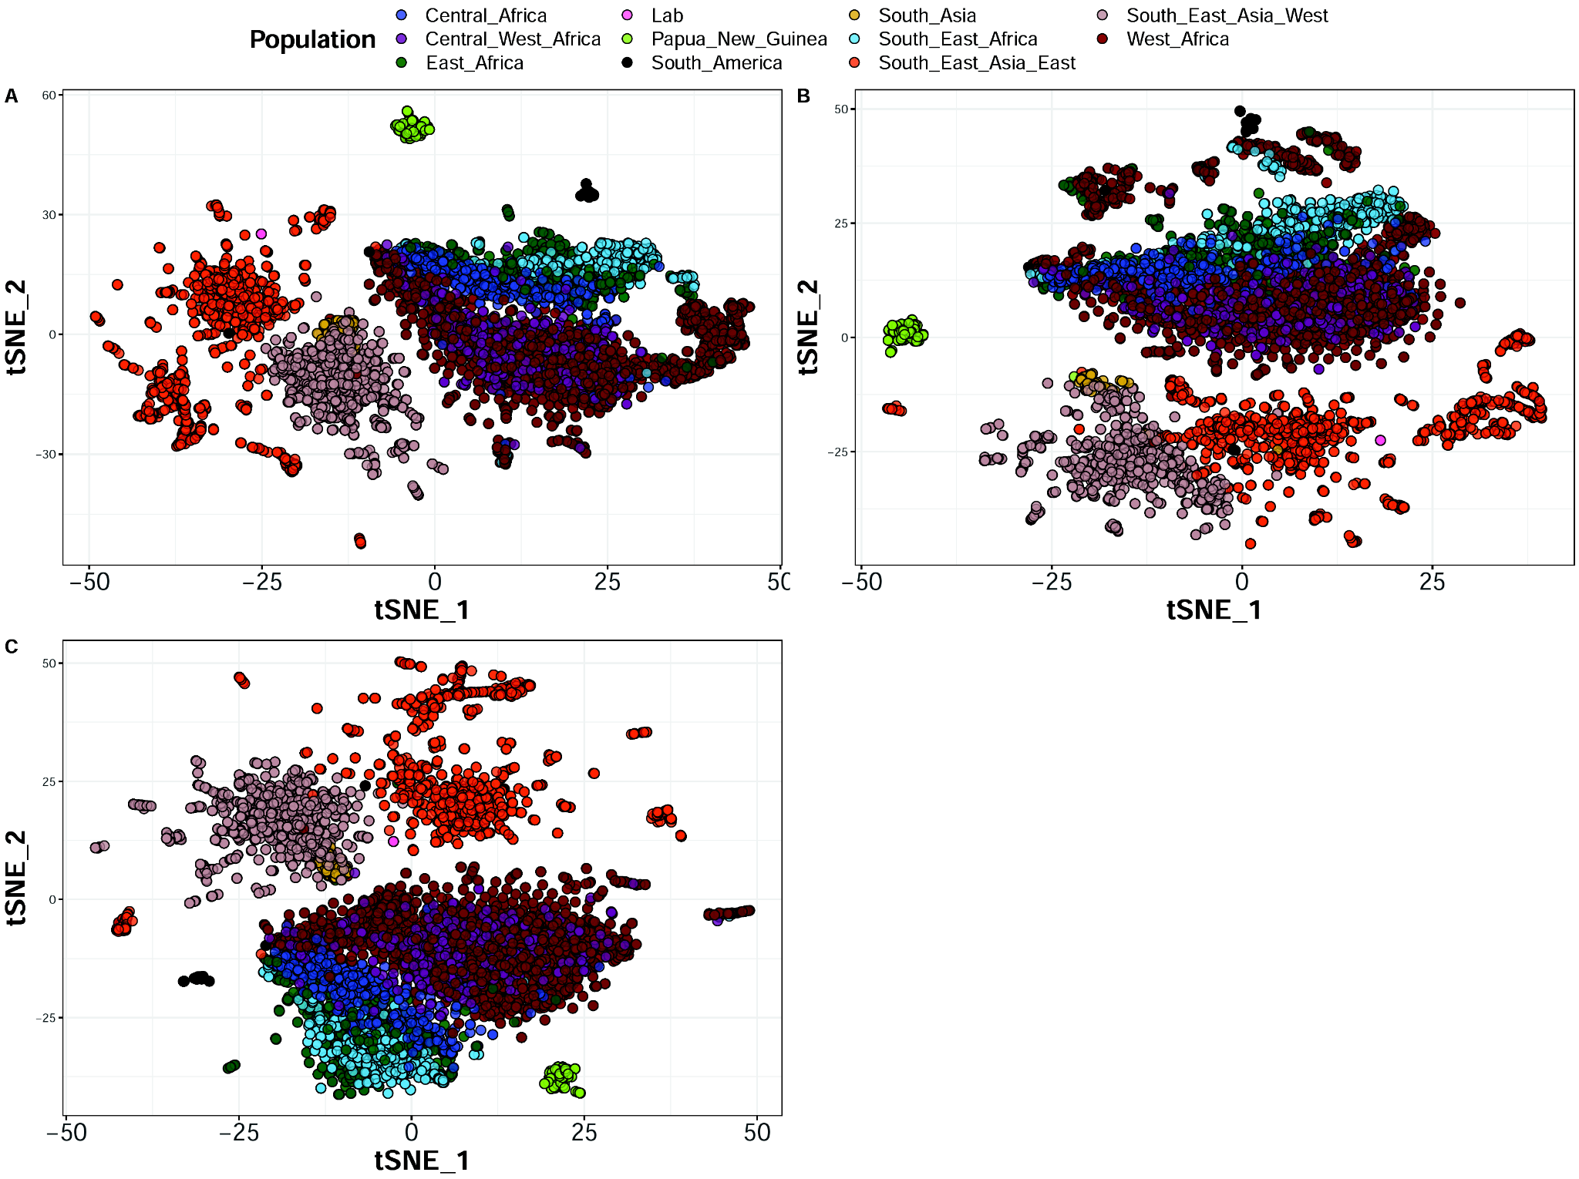
Fig. S3: Malaria parasite population structure of malaria across subcontinents. t-distributed stochastic neighbor embedding (tSNE) was computed from the variance-standardized genetic relationship matrix generated using A) SNPs and indels combined, B) indels only and C) SNPs only. Variant data from chromosome 1 were pruned for linkage disequilibrium and only samples with less than 20% missing genotypes were kept.

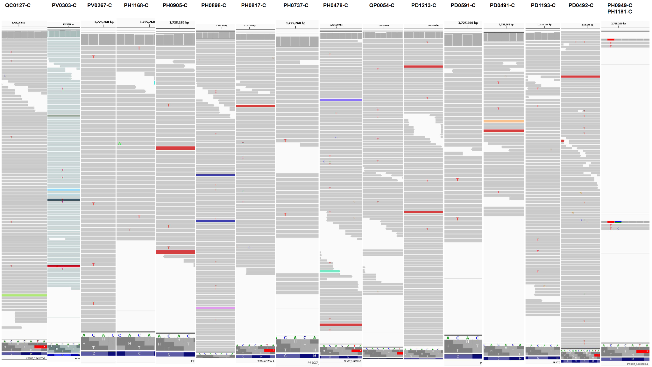
Fig. S4: Visualization of k13 C580Y mutations detected only by the fully optimized GATK4 pipeline (pipeline 2) at ploidy 6. The mutation consists of the substitution of C by T (red) at position 1,725,259. The visualization was done in IGV. The two samples (PH0949-C and PH1181-C) at the end were detected as mutants by GATK3 but filtered out by the optimized GATK4 due to poor read coverage (2X)
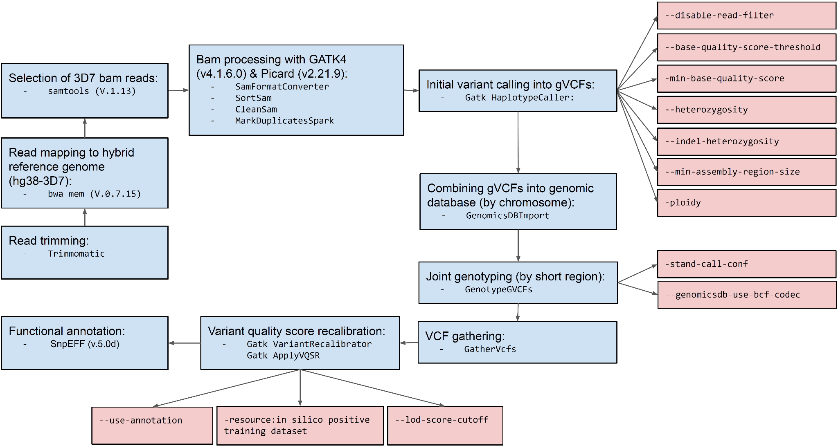

Fig. S5: Diagram illustrating the fully optimized GATK4 pipeline (pipeline 2). Optimized parameters are highlighted red.

Supplementary tables

Table S1: High-quality read data of 10 strains for which there exists accurate PACBIO assemblies.

Strains | Read Coverage  First quartile | Read coverage Median | Read coverage Third quartile | Insert size  Median | Insert size Median absolute deviation | Read length Mean | Read quality Mean
7G8 | 48 | 56 | 64 | 524 | 108 | 250 | 33.8
Dd2 | 44 | 52 | 59 | 505 | 99 | 250 | 34
GA01 | 38 | 44 | 50 | 504 | 99 | 250 | 33.9
GB4 | 36 | 44 | 50 | 524 | 104 | 250 | 33.4
GN01 | 29 | 35 | 40 | 505 | 87 | 250 | 33.6
HB3 | 30 | 36 | 42 | 489 | 94 | 250 | 33.6
IT | 159 | 181 | 199 | 405 | 83 | 250 | 33.9
KH01 | 63 | 81 | 100 | 435 | 113 | 250 | 34.2
KH02 | 31 | 37 | 43 | 464 | 82 | 250 | 33.9
SN01 | 43 | 51 | 58 | 460 | 76 | 250 | 34.3

Table S2: Quality scores of public shorter illumina read samples. Samples include single (7G8, GB4 and HB3) and mixed infections of 7G8 and HB3 at different proportions.

Strains | Read Coverage First quartile | Read coverage Median | Read coverage Third quartile | Insert size  Median | Insert size Median absolute deviation | Read length Mean | Read quality Mean
7G8 | 61 | 104 | 137 | 230 | 37 | 100 | 34.2
GB4 | 60 | 101 | 131 | 314 | 36 | 76 | 34.3
HB3 | 68 | 129 | 173 | 224 | 37 | 100 | 34.2
90%HB3+10%7G8 | 71 | 133 | 174 | 229 | 37 | 100 | 34.2
50%HB3+50%7G8 | 71 | 111 | 139 | 227 | 37 | 100 | 34.2
25%HB3+75%7G8 | 69 | 112 | 144 | 224 | 37 | 100 | 34.2
5%HB3+95%7G8 | 60 | 116 | 162 | 230 | 37 | 100 | 34.2

Table S3: Performance of SNP calling in simulated mixed infection samples from IT and KH01 laboratory strains using the optimized pipeline2 at ploidy 6 and 2

Mixed infections | True Positives |  | False positive |  | Variants rescued with ploidy 6 | Extra false positives with ploidy 6
 | Ploidy 6 | Ploidy 2 | Ploidy 6 | Ploidy 2
5%IT:95%KH01 | 2646 | 2197 | 509 | 161 | 449 | 348
10%IT:90%KH01 | 2859 | 2500 | 894 | 231 | 359 | 663
15%IT:85%KH01 | 2848 | 2736 | 570 | 344 | 112 | 226
20%IT:80%KH01 | 2890 | 2788 | 1322 | 367 | 102 | 955
25%IT:75%KH01 | 2913 | 2818 | 852 | 369 | 95 | 483
50%IT:50%KH01 | 2912 | 2834 | 721 | 371 | 78 | 350

