Supplementary Information
for
Enhanced bulk photovoltaic effect in two-dimensional ferroelectric CuInP₂S₆
Yue Li^{1,2,} #, Jun Fu^{1,2, #}, Xiaoyu Mao^{1,2, #}, Chen Chen^{1,2}, Heng Liu^{1,2}, Ming Gong^{3,4,*} and Hualing Zeng^{1,2,*}
1. International Center for Quantum Design of Functional Materials (ICQD), Hefei National Laboratory for Physical Science at the Microscale, and Synergetic Innovation Center of Quantum Information and Quantum Physics, University of Science and Technology of China, Hefei, Anhui 230026, China

2. Key Laboratory of Strongly-Coupled Quantum Matter Physics, Chinese Academy of Sciences, Department of Physics, University of Science and Technology of China, Hefei, Anhui 230026, China

3. CAS Key Laboratory of Quantum Information, University of Science and Technology of China, Hefei, 230026, People's Republic of China

4. Synergetic Innovation Center of Quantum Information and Quantum Physics, University of Science and Technology of China, Hefei, Anhui 230026, China

# Contribute equally to this work
* Corresponding author

Supplementary note 1: The depolarization effect of the reading bias in CIPS bulk photovoltaics
In conventional photovoltaics, the V_{oc} is directly determined from the I-V measurement by sweeping the reading bias in a wide range. However, for 2D materials, due to the ultrathin film thickness at atomic scale, low voltage applied in the direction perpendicular to the 2D plane results in large electric field strength. For example, for films with the thickness of 1 nm, applying 1 V DC voltage leads to an electric field strength at 1×10⁷ V/cm in the out-of-plane direction. This value is much larger than the coercive electric field strength of 2D ferroelectric CIPS ( ~7.5×10⁵ V/cm as shown Figure S2). Therefore, applying wide range reading bias in photocurrent study leads to strong depolarization effect in CIPS. As shown in Figure S6, high bias up to -0.7 V was applied in the I-V curve measurement of device #6. The I-V curve deviates from the linearity and shrinks when the DC voltage is above -0.3 V. As a result of the depolarization effect, the nominal V_{oc} (-0.55 V) from the I-V curve should be smaller than that from the initial state of the device. By linear fit to the I-V curve, we find a much larger V_{oc} at -1.04 V (see Figure S6). To avoid this problem, when measuring the I-V curve at bright state of our devices the reading voltage is therefore limited withtin the range of ±0.1 V (equivalent to an electric field strength at ~10⁵ V/cm). The V_{oc} is then determined through a linear fit to the I-V curve with extended DC bias range (see Figure 2a and Figure S5).

Supplementary Figures
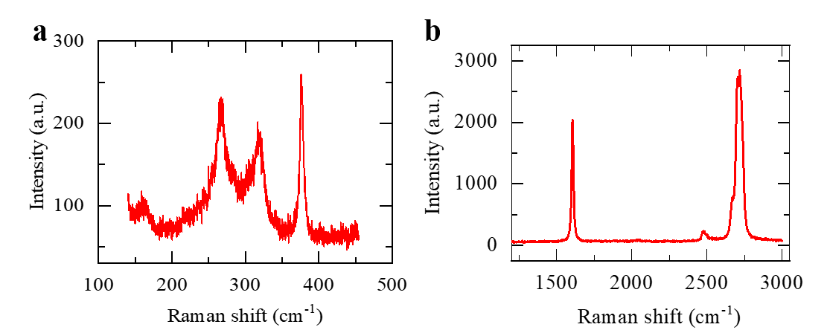
Figure S1. Raman spectra of single crystal CIPS and bilayer graphene. (a) Raman spectrum of CIPS nanoflakes on SiO₂/Si substrate. Three dominated Raman peaks are observed. (b) Raman spectrum of the bottom graphene in device #3. Typical G mode and 2D mode peaks are observed.The intensity ratio of I_{2D} to I_{G} is 3/2, which indicates that the graphene used is bilayer.

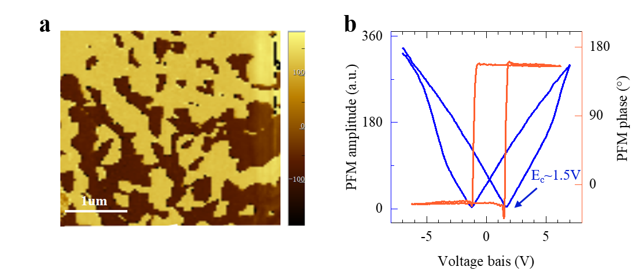
Figure S2. PFM characterization of CIPS nanoflakes. (a) PFM phase image of the spontaneous electric polarizations in 20 nm CIPS. The scale bar is 1 μm. (b) Single-point PFM amplitude and phase hysteresis loop measurement. The coercive voltage is about 1.5 V as confirmed from the ferroelectric hysteresis loop.

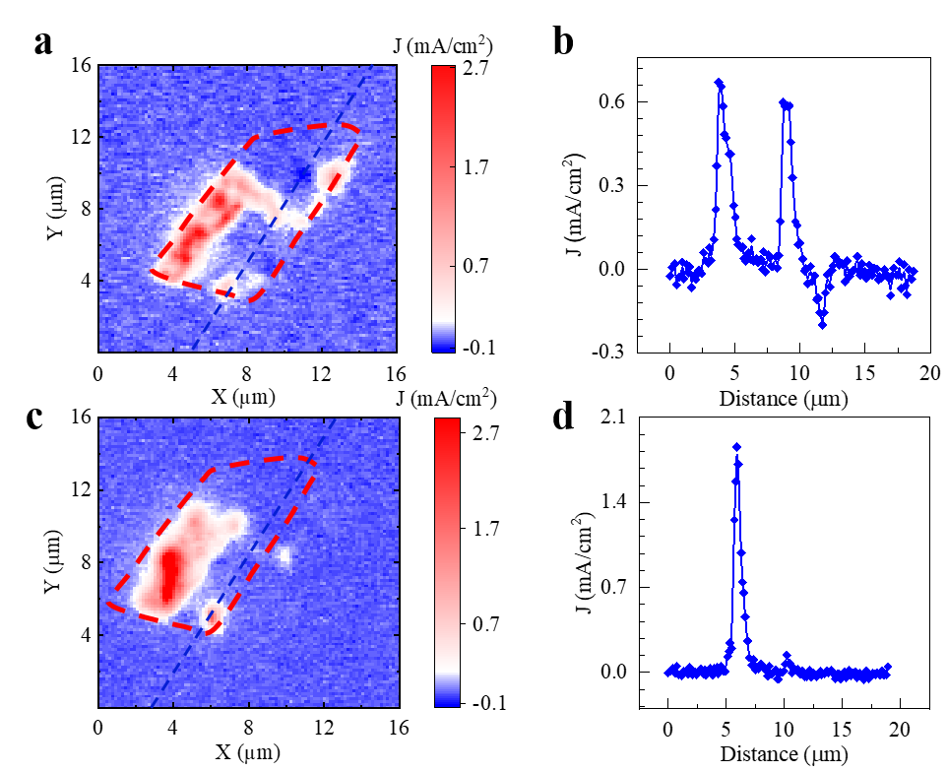
Figure S3. The spatial confinement of the photocurrent in CIPS. (a) Zero-bias photocurrent mapping under the irradiation of 405 nm laser. (b) The spatial distribution of the photocurrent along the dotted blue line as marked in Figure S3a. Outside the overlapping area, the photocurrent is at the noise level. Inside the overlapping area, the J_{sc} is either positive or negative, which corresponds to the spontaneous downward and upward polarization in CIPS. The spatial resuliton in the photocurrent mapping is 160 nm. (c) Zero-bias photocurrent mapping of the same device after 370 K annealing. Upon annealing, the spontaneous electric polarizations in CIPS are renovated. Correspondingly, the pattern of the J_{sc} mapping changes if compared with Figure S3a. (d) The spatial distribution of the photocurrent along the dotted blue line as marked in Figure S3c. Due to the thermal-induced ferroelectric polarization redistribution the negative photocurrent disappears.
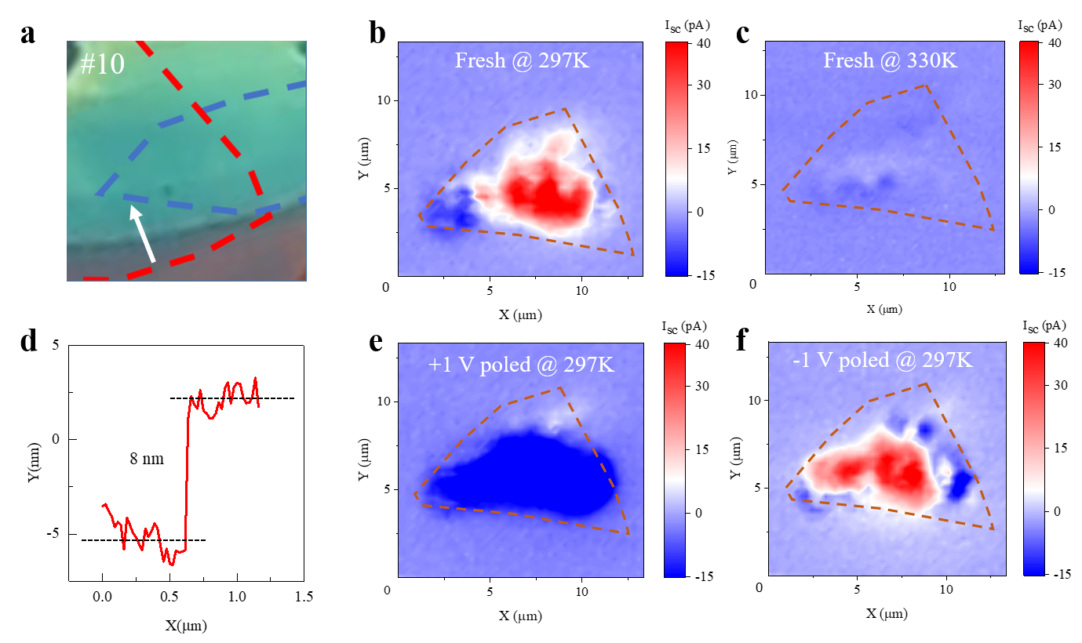
Figure S4. The dependence of the zero-bias photocurrent mapping on poling voltage and temperature. (a) The optical image of device #10. (b)&(c) The zero-bias photocurrent mapping on fresh device under the irradiation of 405 nm laser at 297K and 330K. Above T_{c}, negligible I_{sc} is observed. (d) The AFM measurement of the CIPS in device #10 as indicated by the white arrow in Figure S4a. The thickness of the CIPS used in device #10 is 8 nm. (e) & (f) The zero-bias photocurrent mapping under the irradiation of 405 nm laser after +1 V and -1 V voltage polarized. Clear sign change of the I_{sc} is observed, indicating the switchable BPVE in CIPS.

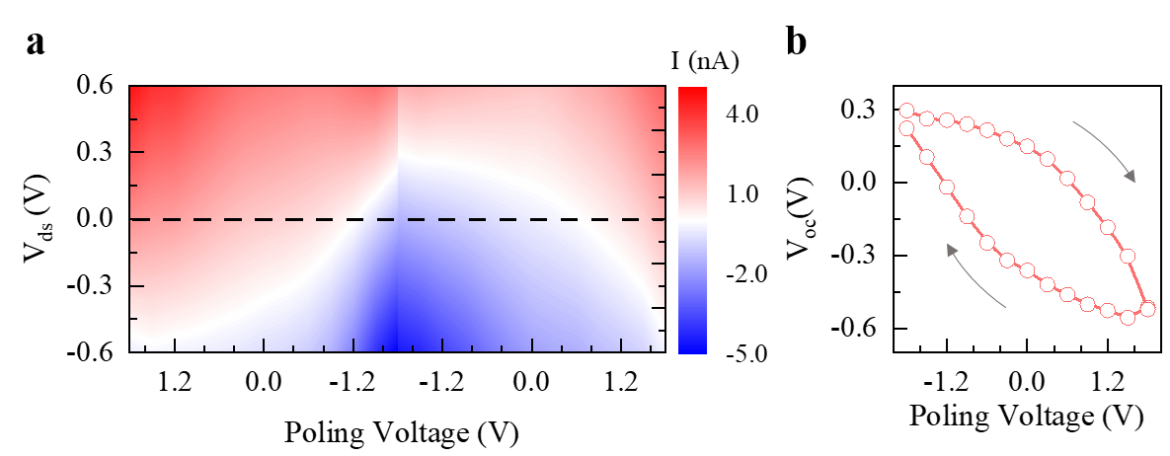
Figure S5. Extended electriclly switchable BPVE in CIPS. (a) The extended I-V curve in device #3 with a linear fit. (b) The V_{oc} as a function of the poling voltage.

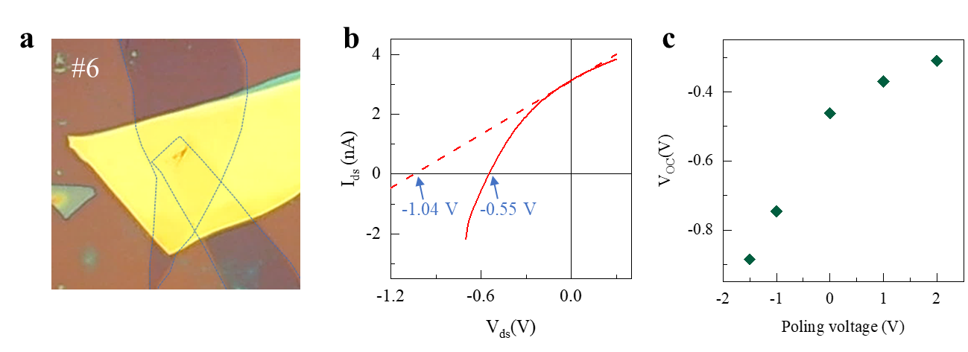
Figure S6. The depolarization effect of the reading bias in BPVE measurement. (a) The optical image of device #6. The blue dotted lines indicate the area of the top and bottom graphene electrodes. (b) The photovoltaic characteristic measured in a wide range reading voltage from -0.7 V to 0.3 V. The I-V curve deviates from linear when the reading voltage is larger than -0.3 V. By linear fit (red dashed line) to the I-V curve, we get a larger V_{oc} at -1.04 V (c) The V_{oc} dependence on poling voltage.

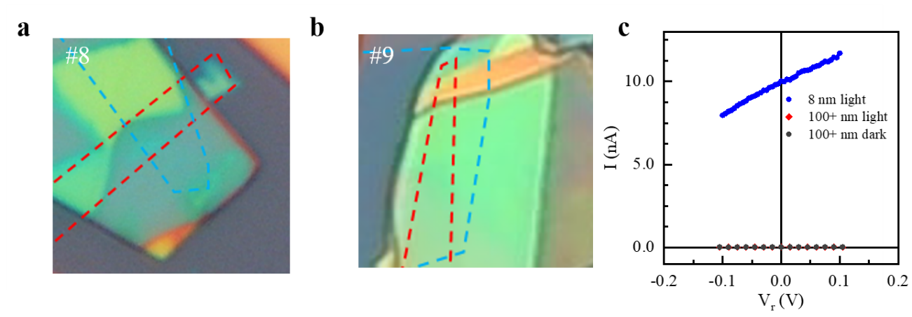
Figure S7. The photovoltaic effect study on CIPS with film thickness above 100 nm. (a) & (b) The optical images of device #8 & device #9. The blue and red dotted shapes indicate the bottom and top graphene electrodes respectively. The thickness of the CIPS film in device #8 and device #9 are 120 nm and 230 nm respectively, which are confirmed by AFM (Figure S9h & S9i). (c) The photovoltaic characteristic of 8 nm and above 100 nm CIPS under the irradiation of 405 nm laser at same power density, the CIPS above 100 nm shows photocurrent at the order of noise level and coincides with the dark current.

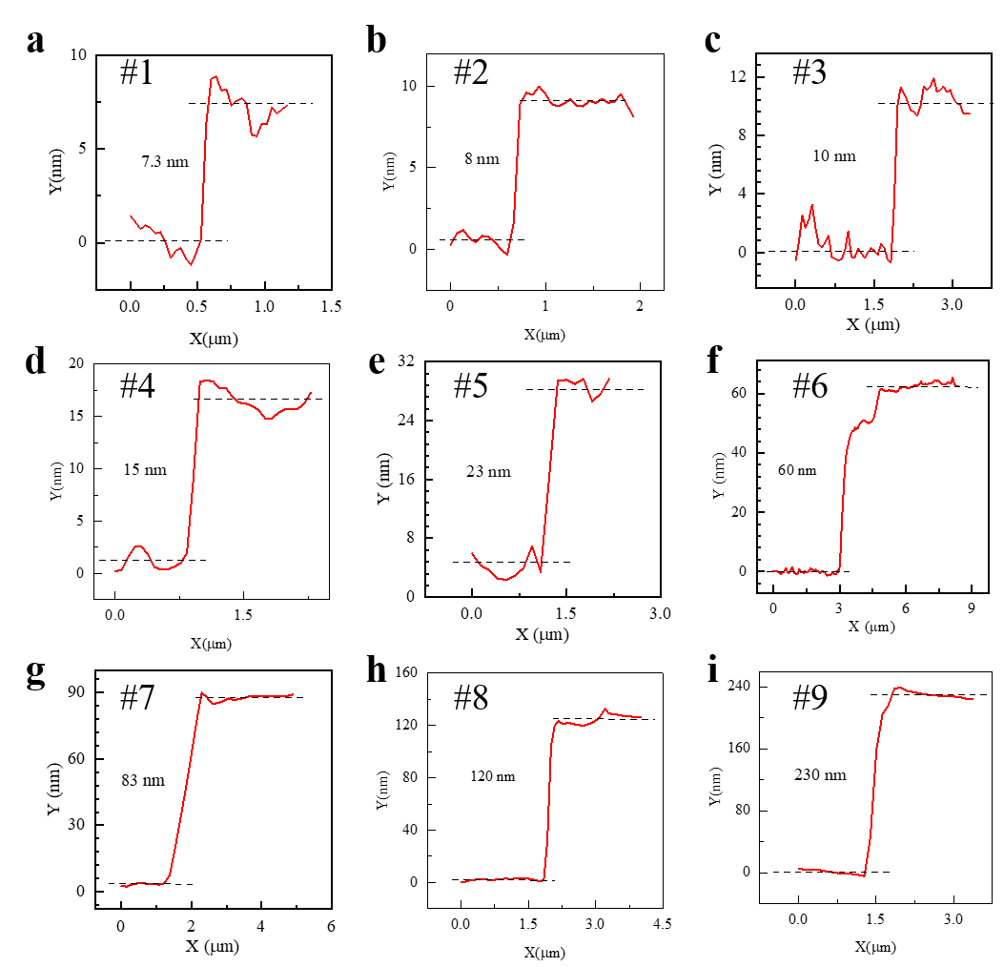
Figure S8. The thickness identification for different CIPS samples. (a) – (i) The thickness of CIPS presented in Figure 5b, ranging from 8 nm to 230 nm as confirmed by the AFM measurements in contact mode.

