New insights on ENSO teleconnection asymmetry and ENSO forced atmospheric circulation variability over North America

Climate Dynamics

Authors: Margaret Sutton^{1,*}, Sarah M. Larson¹, Emily Becker²

¹ Department of Marine, Earth, and Atmospheric Sciences, North Carolina State University, Raleigh, NC, USA
² Cooperative Institute for Marine and Atmospheric Studies, University of Miami, Miami, FL, USA
* Current affiliation: Areté

Corresponding Author: Sarah Larson (slarson@ncsu.edu)

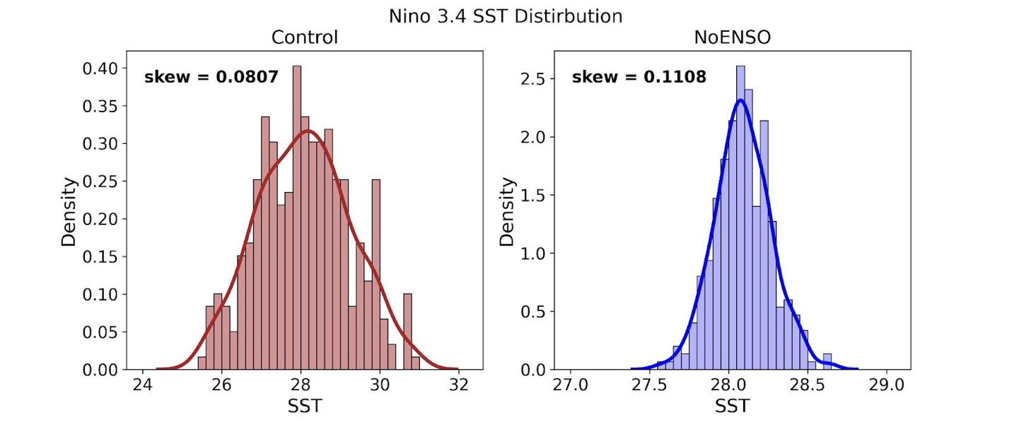
Figure S1. Distribution of the Nino3.4 SST averaged over DJF for the CTRL (left panel) and NoENSO (right panel) experiments. Skewness is shown in the upper left corner of each panel.

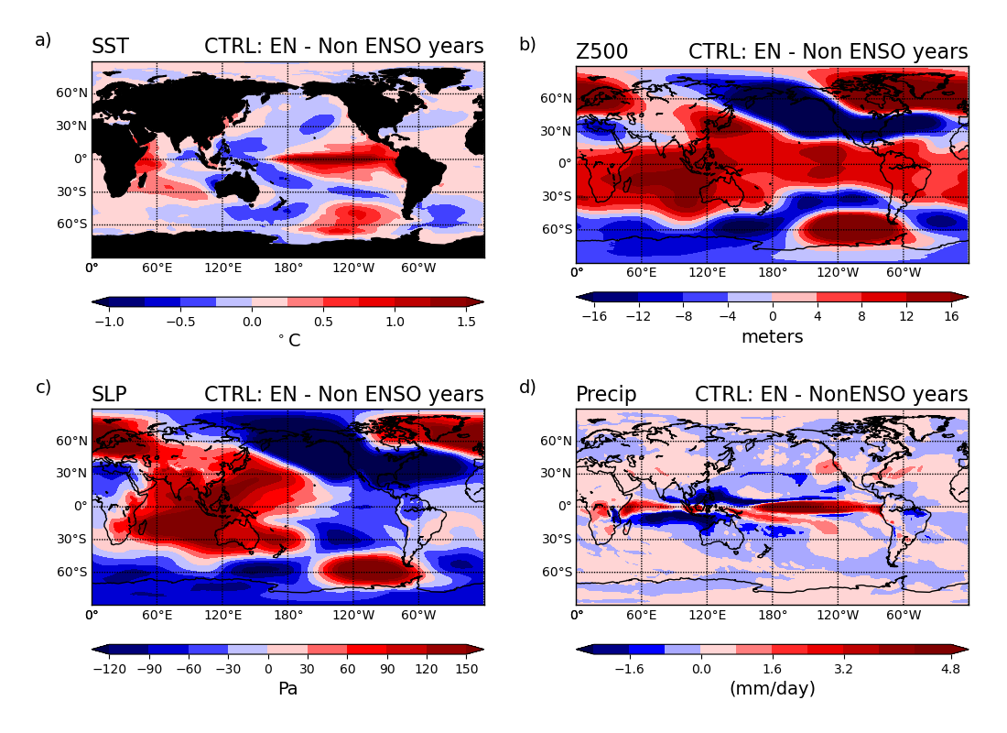
Figure S2. Similar to Figure 5, except the difference in the DJF-averaged climatology between El Niño (EN) and ENSO-Neutral years in the CTRL experiment.

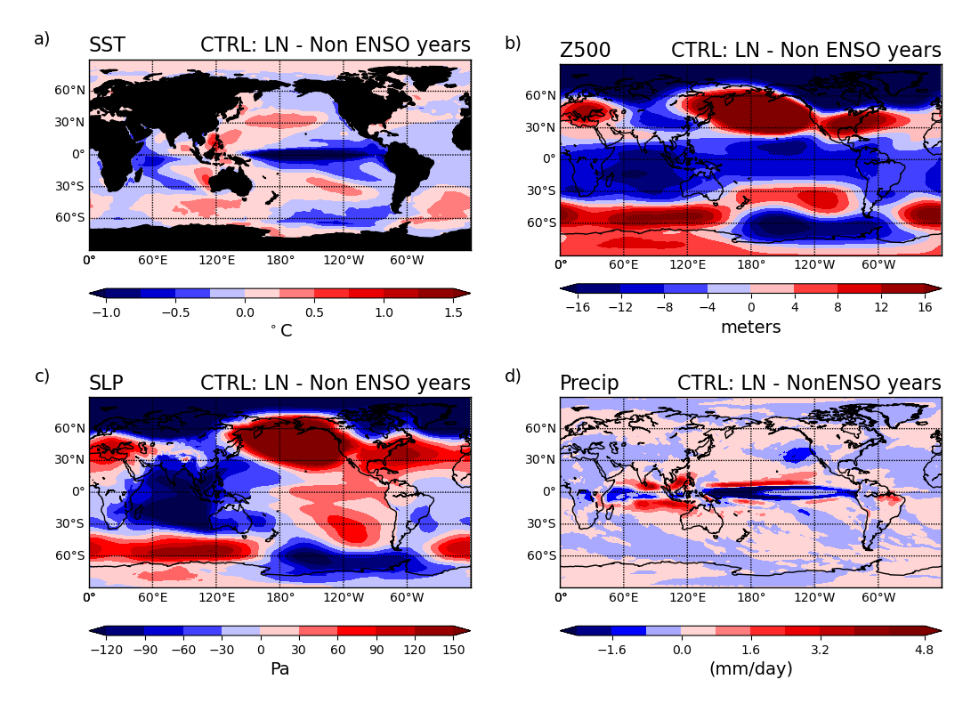
Figure S3. Similar to Figure 5, except the difference in the DJF-averaged climatology between La Niña (LN) and ENSO-Neutral years in the CTRL experiment.

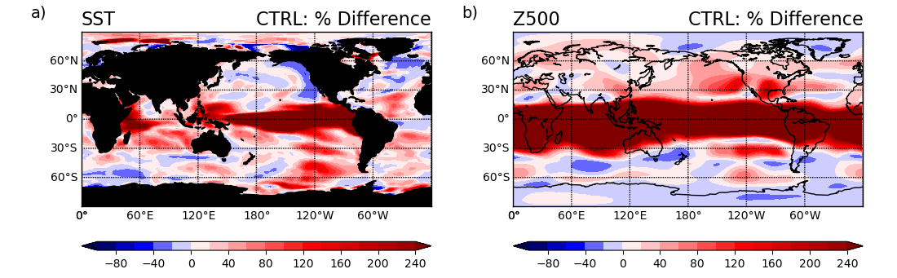
Figure S4. Percent difference in DJF variance from ENSO versus ENSO neutral years, relative to ENSO neutral years from the CTRL. a) % difference in SST variance and b) % difference in Z500 variance. Red shading indicates ENSO increases variance.

