Appendix A: Resistance Training Program Exercises (Weeks 1-6)
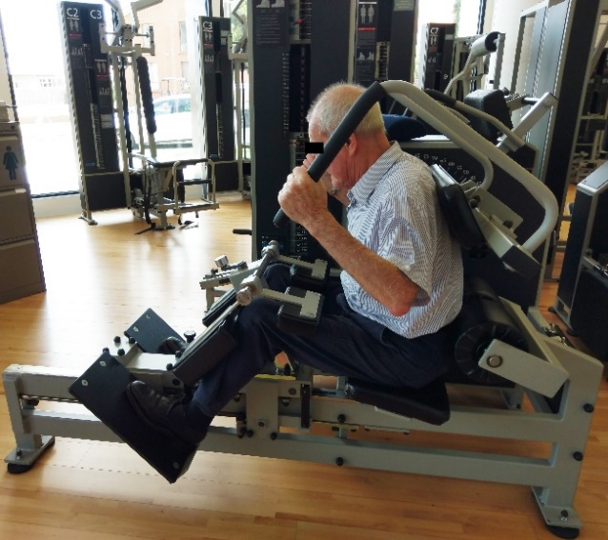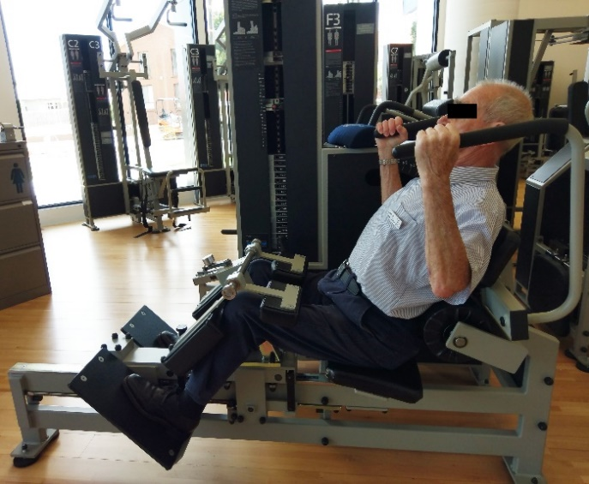
A)
B)
- Back Extension A) starting position B) end position
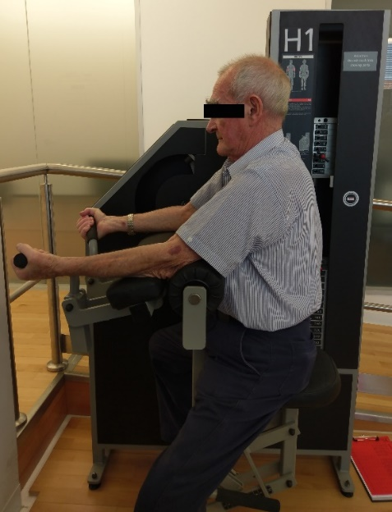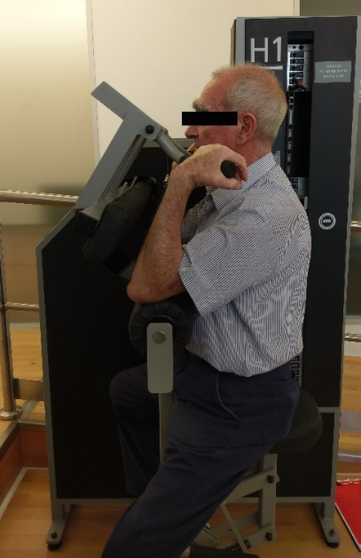
B)
A)
- Biceps curl A) starting position B) end position
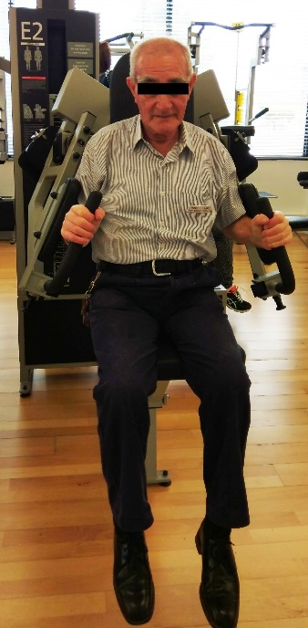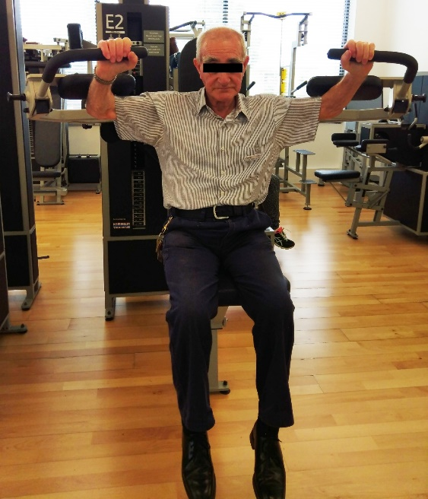
B)
A)
- Lateral Raise A) starting position B) end position
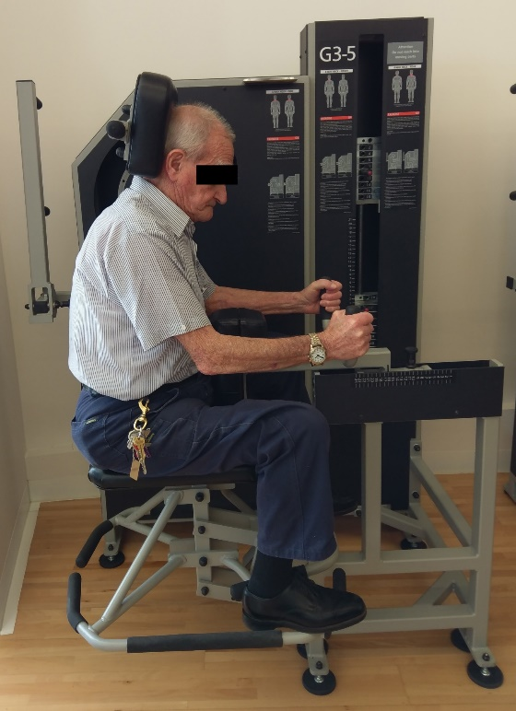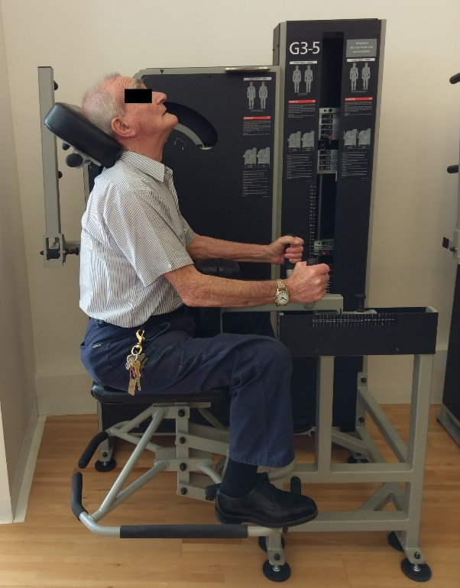
B)
A)
- Neck Extension (added from week 2) A) starting position B) end position
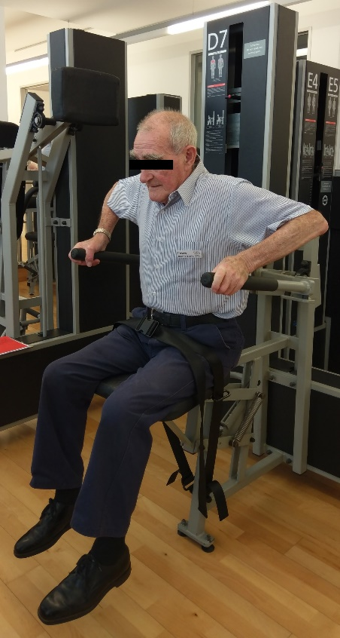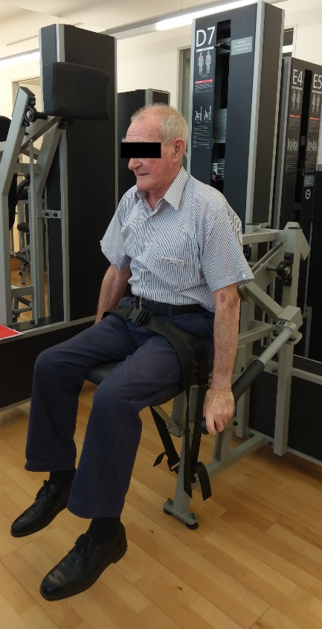
A)
B)
- Triceps pushdown A) starting position B) end position
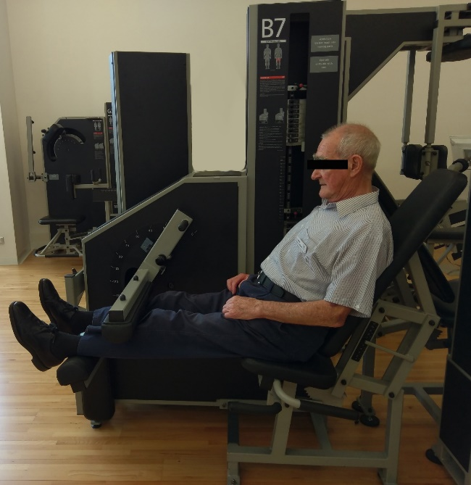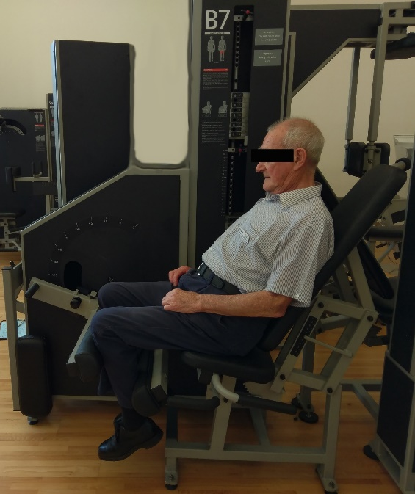
B)
A)
- Knee flexion (Seated hamstring curl) A) starting position B) end position
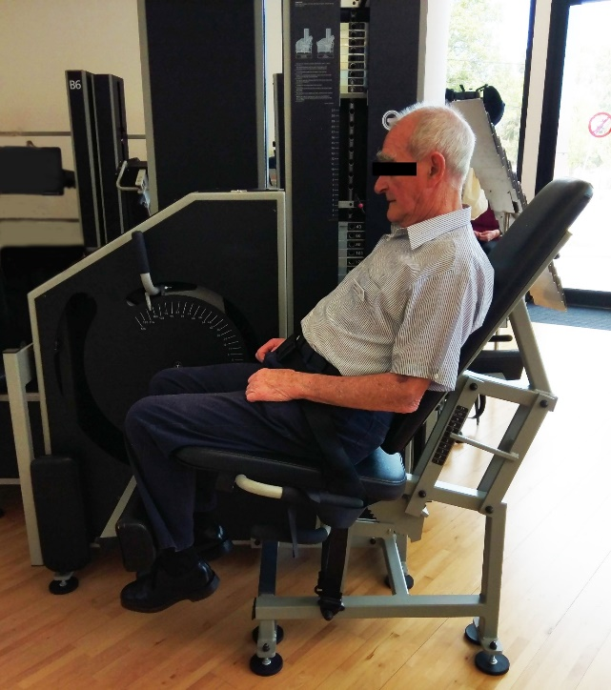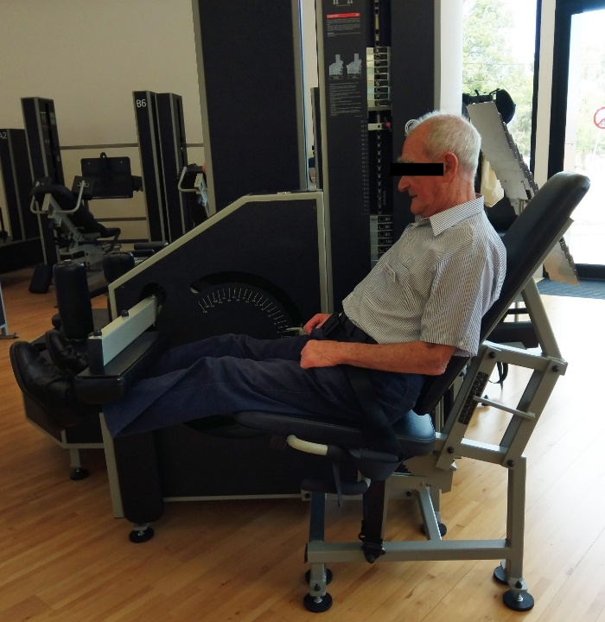
B)
A)
- Knee Extension A) starting position B) end position

