BIOGRAPHY
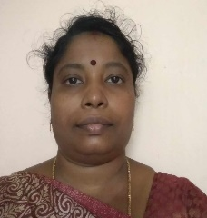 | Priethamje Vithya.K¹ is from Puducherry, India. She is Currently perusing research in the Department of Electronics and Communication Engineering at Sri Manakula Vinayagar Engineering College, Puducherry, India. She got her B.E (ECE) from Madras University, M.Tech- Digital Communication and networking she has got about 14 years of teaching experience.
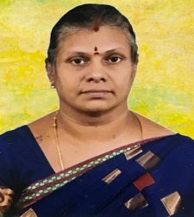 | Dr. L.M.Varalaksmi² is from Puducherry India. She is Currently heads the Department of instrumentation and control Engineering at Sri Manakula Vinayagar Engineering College, Puducherry, India. She got her B.E (ECE) from Madras University, M.Tech and Ph.D in Electronics and Communication Engineering from Pondicherry University. She has about 24 years of teaching experience.

