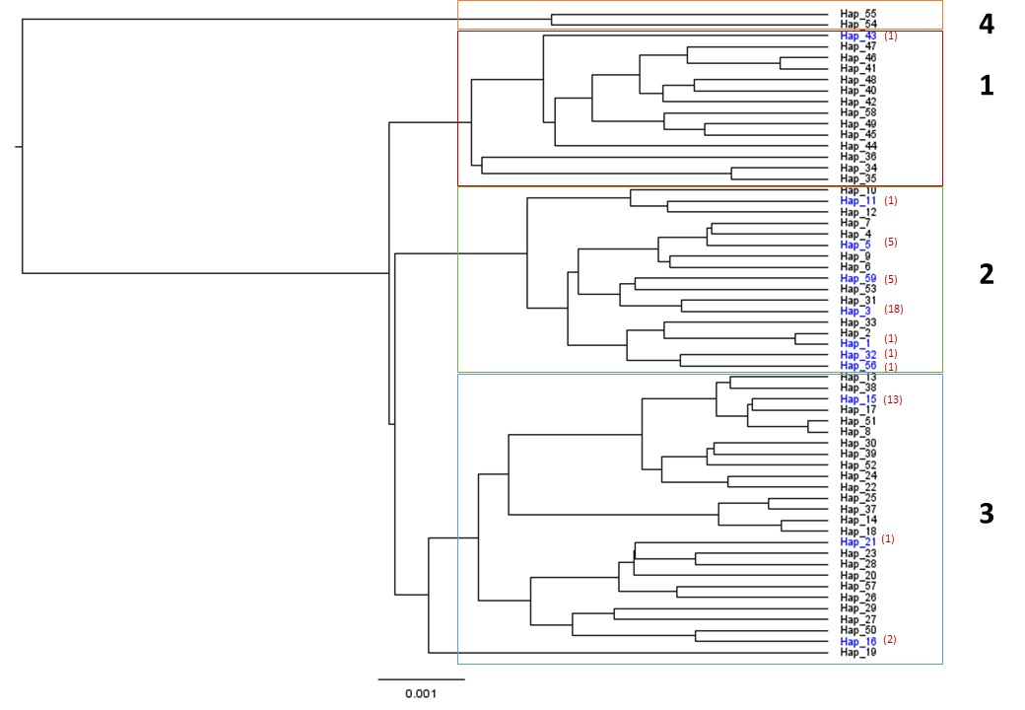
Supplementary Figure 1. Phylogenetic tree from BEAST analysis of 59 haplotype cox1 sequences of I. ovatus. The blue labelled haplotypes indicate the presence of Rickettsia infection. The red parenthesis beside is the number of Rickettsia positive individuals per haplotype. The black labelled haplotypes are negative for Rickettsia infection.

