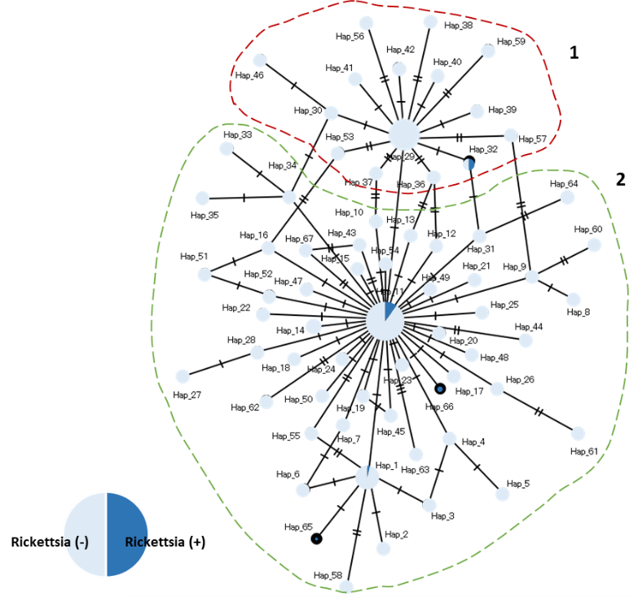
Supplementary Figure 2. Median joining network of the 66 cox1 haplotype sequences of Rickettsia positive and negative H. flava. Haplotype groups are indicated as 1 and 2.

