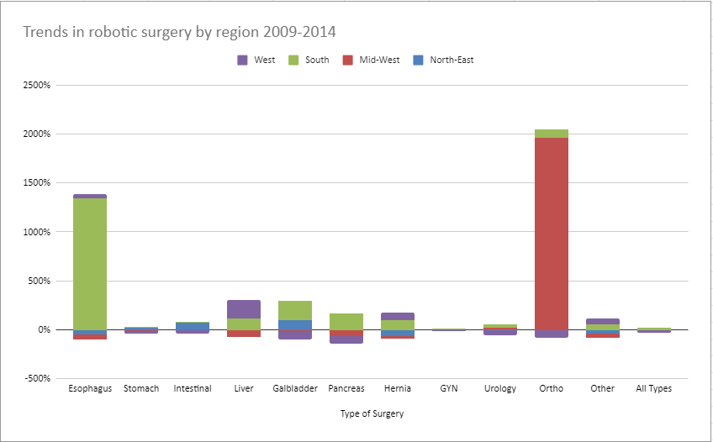

Table 3. Trends in robotic surgery by region 2009 – 2014.

