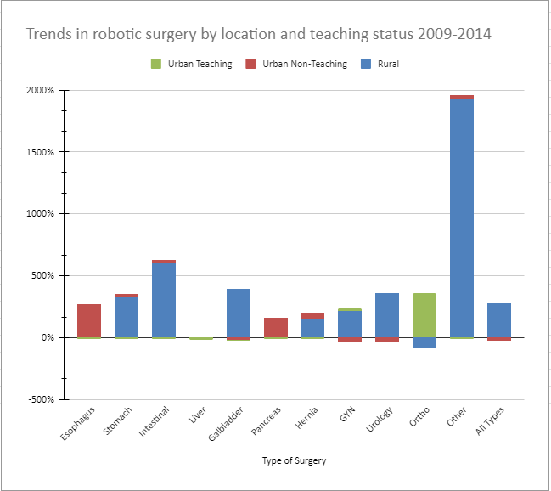

Table 2. Trends in robotic surgery by location and teaching status 2009 – 2014.

