Figure S1. Metabolite abundance [pmol/mg (cdw)] in each strain was measured by mass spectrometry-based metabolomics. The data was used for log2 fold ratio heatmap in the Figure 5.
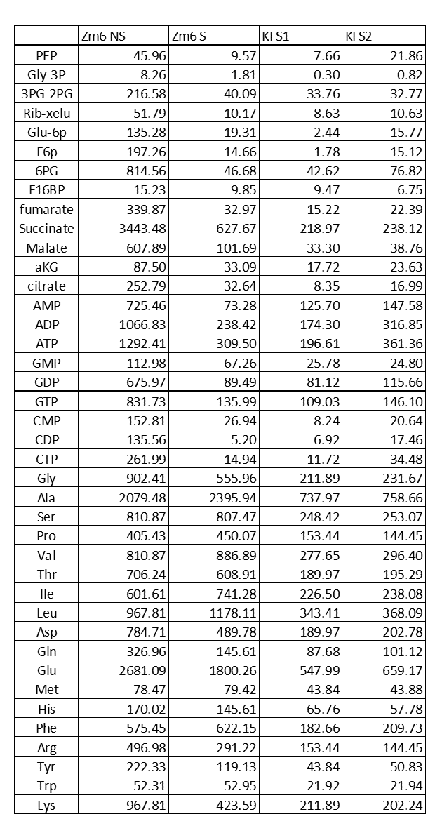

Table S1. A list of abbreviation of measured metabolites.
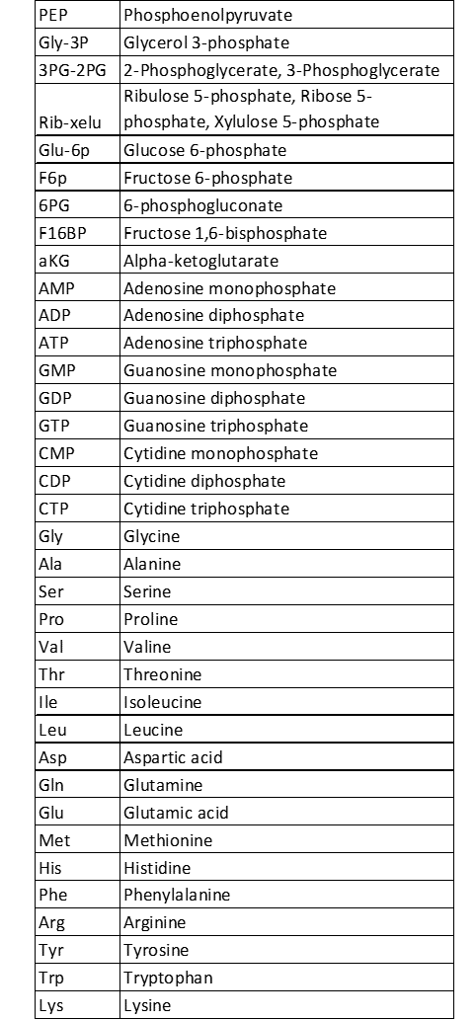
Table S2. List of detected mutations in the lab stock Zm6 strain.
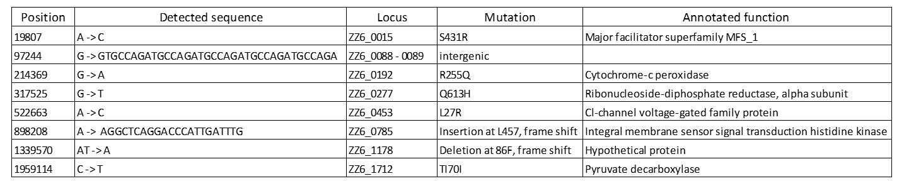
Table S.3 CDW/OD₆₀₀ conversion factor in each strain under saline/non-saline condition.
