Supplementary Data

Supplementary Figure
Figure S1. Survival rate of s-TDAPT according to time in the study population.
Figure S2. Standardized mean differences in baseline characteristics between the two groups in the weighted and unweighted cohorts.
Figure S3. Kaplan‒Meier survival analysis for MACEs, bleeding events, and NCEs in the IPTW-applied cohort.

Supplementary Tables
Table S1. Baseline clinical characteristics of all patients, including the non-TDAPT group.
Table S2. Baseline clinical characteristics of the patients with very complex coronary lesions.
Table S3. Clinical outcomes of patients with very complex coronary lesions.
Table S4. Baseline clinical characteristics of patients in the weighted cohort.

Supplementary Figures
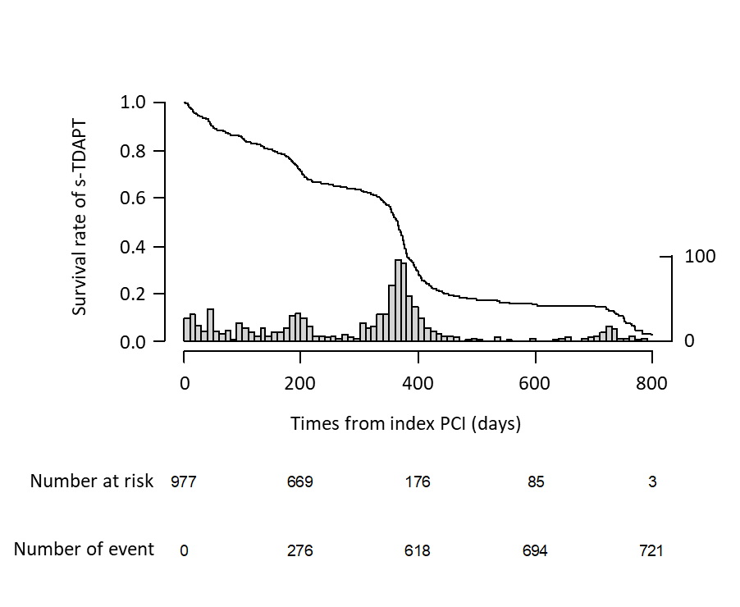
Figure S1. Survival rate of s-TDAPT according to time in the study population.
The follow-up visits were scheduled at 1, 3, 6, 12, and 24 months; but actual follow-up dates varied from days to a few weeks. Therefore, the actual continuation rate of s-TDAPT was plotted using a Kaplan‒Meier survival estimator. The histogram indicates the number of discontinuation of s-TDAPT at the time.
The s-TDAPT continued in 76.6% of patients at 6 months and 49.5% of patients at 1 year. More than 30% of patients discontinued the standard dose of TDAPT at approximately 1 year after index PCI.

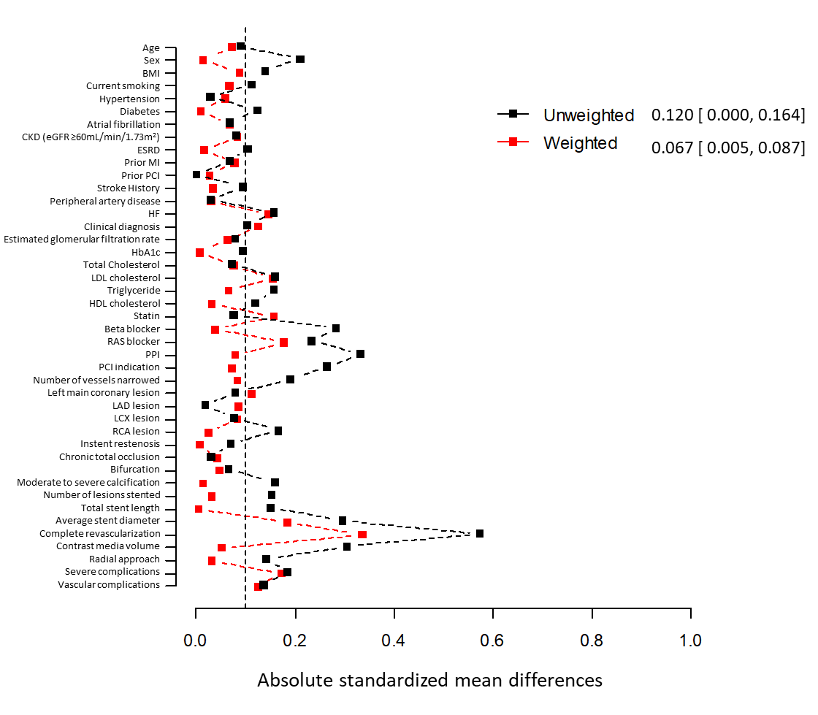
Figure S2. Standardized mean differences in baseline characteristics between the two groups in the weighted and unweighted cohorts.
The SMD was significantly lower in the weighted cohort than in the unweighted cohort, and most variables’ SMDs were reduced <0.1 in the weighted cohort.

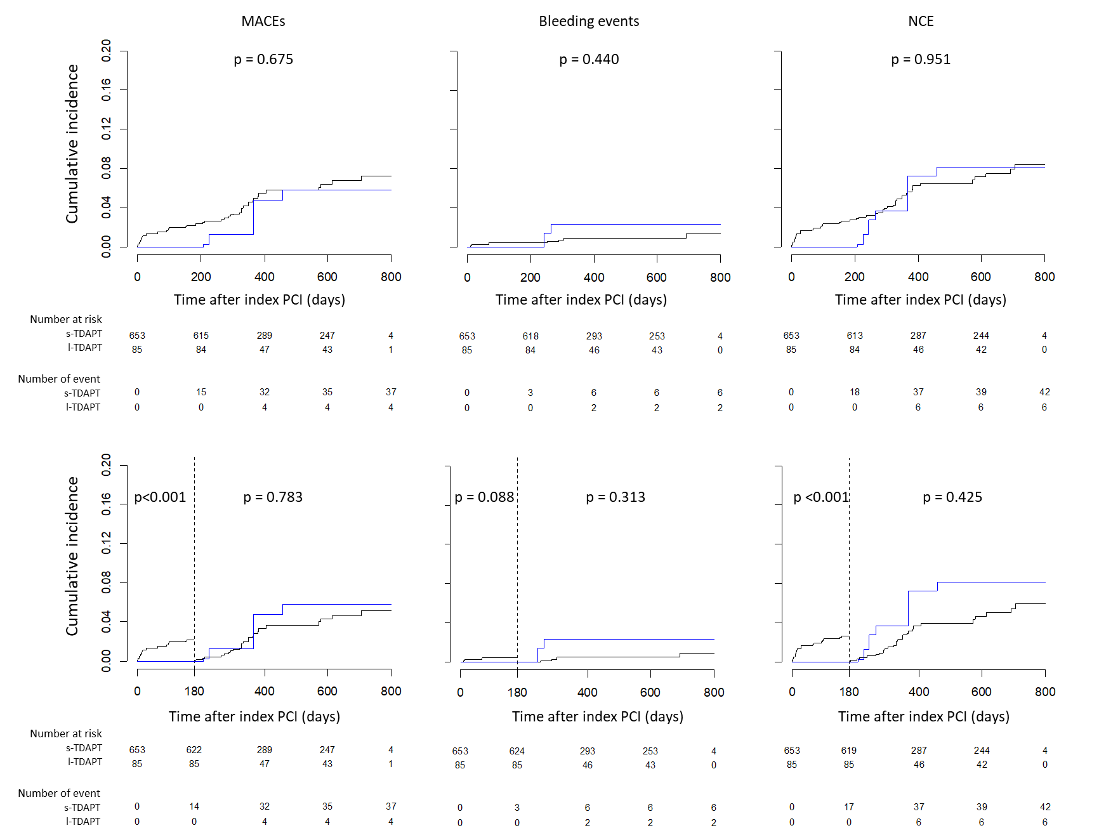

Figure S3. Kaplan‒Meier survival analysis for MACEs, bleeding events, and NCEs in the IPTW-applied cohort.
The cumulative incidences of all clinical events were not significantly different between the s-TDAPT and l-TDAPT groups (upper panel). Landmark analyses also showed that the cumulative incidences of all clinical events were not significantly different beyond 6 months after PCI.
MACE, major adverse cardiovascular event; NCE, net clinical event; PCI, percutaneous coronary intervention; TDAPT, ticagrelor-based dual antiplatelet agent; l-TDAPT, low-dose TDAPT; s-TDAPT, standard-dose TDAPT.

Supplementary Tables
Table S1. Baseline clinical characteristics of whole patients including the non-TDAPT group.
 | s-TDAPT | l-TDAPT | non-TDAPT
n | N=657 | N=115 | N=205 | p values
Clinical characteristics
Age (year) | 60.3±11.6 | 61.3±10.5 | 64.3±10.9 | <0.001
Age ≥75 years | 330 (50.2) | 65 (56.5) | 138 (67.3) | <0.001
Male sex | 557 (84.8) | 88 (76.5) | 162 (79.0) | 0.031
BMI (kg/m²) | 25±3.6 | 24.6±3.1 | 24.8±3.0 | 0.346
Smoking |  |  |  | 0.001
Never | 236 (35.9) | 40 (34.8) | 101 (49.3)
Former | 116 (17.7) | 28 (24.3) | 41 (20.0)
Current | 305 (46.4) | 47 (40.9) | 63 (30.7)
Hypertension | 316 (48.1) | 57 (49.6) | 108 (52.7) | 0.517
Diabetes | 184 (28.0) | 26 (22.6) | 48 (23.4) | 0.264
Atrial fibrillation | 18 (2.7) | 2 (1.7) | 5 (2.4) | 0.815
CKD (eGFR ≤60 mL/min/1.73m²) | 86 (13.1) | 12 (10.4) | 30 (14.6) | 0.565
ESRD | 4 (0.6) | 2 (1.7) | 2 (1.0) | 0.445
Prior MI | 18 (2.7) | 2 (1.7) | 9 (4.4) | 0.339
Prior PCI | 40 (6.1) | 7 (6.1) | 17 (8.3) | 0.526
Prior PVD | 4 (0.6) | 1 (0.9) | 1 (0.5) | 0.915
HF | 8 (1.2) | 0 (0.0) | 2 (1.0) | 0.487
Clinical diagnosis |  |  |  | 0.942
Stable angina | 23 (3.5) | 5 (4.3) | 7 (3.4)
Unstable angina | 170 (25.9) | 27 (23.5) | 58 (28.3)
NSTEMI | 180 (27.4) | 36 (31.3) | 56 (27.3)
STEMI | 284 (43.2) | 47 (40.9) | 84 (41.0)
eGFR (mL/min/1.73m²) | 83.8±21.5 | 85.5±21.2 | 78.5±20.8 | 0.003
HbA1c (%) | 6.7±1.4 | 6.5±1.2 | 6.5±1.1 | 0.346
Total cholesterol (mg/dL) | 183.5±47.8 | 186.8±45 | 176±45.7 | 0.076
LDL cholesterol (mg/dL) | 113.7±40.9 | 107.6±34.8 | 111.9±46 | 0.338
Triglyceride (mg/dL) | 169.1±123.1 | 152.4±85.4 | 157.1±93.1 | 0.196
HDL cholesterol (mg/dL) | 44.3±10.2 | 45.6±10.3 | 43.4±9.6 | 0.175
Statin | 631 (96) | 112 (97.4) | 199 (97.1) | 0.658
Beta blocker | 387 (58.9) | 83 (72.2) | 127 (62.0) | 0.026
ACEI/ARB | 372 (56.6) | 78 (67.8) | 122 (59.5) | 0.076
PPI | 316 (48.1) | 74 (64.3) | 120 (58.5) | 0.001
Angiographic characteristics
PCI situation |  |  |  | 0.013
Elective (≥24 hours) | 327 (49.8) | 45 (39.1) | 82 (40.0)
Emergent (<90 min) | 235 (35.8) | 56 (48.7) | 83 (40.5)
Urgent (<24 hours) | 95 (14.5) | 14 (12.2) | 40 (19.5)
Disease extent* |  |  |  | 0.382
1 vessel disease | 294 (44.7) | 60 (52.2) | 90 (43.9)
2 vessel disease | 229 (34.9) | 39 (33.9) | 69 (33.7)
3 vessel disease | 134 (20.4) | 16 (13.9) | 46 (22.4)
LMCA | 47 (7.2) | 6 (5.2) | 15 (7.3) | 0.734
LAD | 509 (77.5) | 90 (78.3) | 145 (70.7) | 0.121
LCX | 244 (37.1) | 47 (40.9) | 89 (43.4) | 0.246
RCA | 317 (48.2) | 46 (40) | 108 (52.7) | 0.093
In stent restenosis | 15 (2.3) | 4 (3.5) | 6 (2.9) | 0.704
Chronic total occlusion | 45 (6.8) | 7 (6.1) | 15 (7.3) | 0.916
Bifurcation | 61 (9.3) | 13 (11.3) | 22 (10.7) | 0.708
Severe calcified lesions | 63 (9.6) | 17 (14.8) | 21 (10.2) | 0.240
Numbers of lesions | 1.5±0.7 | 1.8±1.1 | 1.4±0.7 | <0.001
Total stent length (mm) | 42.6±27.7 | 46.9±28.4 | 41.2±25.2 | 0.197
Average stent diameter (mm) | 3.2±0.4 | 3.1±0.4 | 3.2±0.4 | 0.013
Complete revascularization | 503 (76.6) | 110 (95.7) | 162 (79.0) | <0.001
Contrast amount (mL) | 184.3±66.7 | 165.3±57.6 | 169.2±67.6 | 0.001
Radial only | 431 (65.6) | 83 (72.2) | 127 (62) | 0.182
Access site crossover | 259 (39.4) | 6 (5.2) | 61 (29.8) | <0.001
Serious complications** | 11 (1.7) | 0 (0.0) | 3 (1.5) | 0.378
Vascular complications† | 6 (0.9) | 0 (0.0) | 2 (1.0) | 0.582
Clinical outcomes
MACE | 40 (6.1) | 4 (3.5) | 9 (4.4) | 0.398
Death | 16 (2.4) | 0 (0.0) | 3 (1.5) | 0.186
CV death | 5 (0.8) | 0 (0.0) | 3 (1.5) | 0.363
Myocardial infarction | 4 (0.6) | 1 (0.9) | 1 (0.5) | 0.915
Ischemic stroke | 1 (0.2) | 1 (0.9) | 2 (1.0) | 0.194
Repeat revascularization | 22 (3.3) | 3 (2.6) | 3 (1.5) | 0.363
Stent thrombosis | 2 (0.3) | 0 (0.0) | 1 (0.5) | 0.751
Bleeding | 7 (1.1) | 2 (1.7) | 15 (7.3) | <0.001
Composite event | 46 (7.0) | 6 (5.2) | 21 (10.2) | 0.189
Data were presented as the mean ± SD or N (%).
*A left main lesion was considered as a composite of LAD and LCX lesions.
** including cardiogenic shock, transient hypotension, pulmonary edema, cardiac tamponade, acute limb ischemia, renal injury (including dialysis) and temporary mechanical ventilation
† including hematoma, AV fistula, pseudoaneurysm, deep vein thrombosis and infection
BMI, body mass index; CKD, chronic kidney disease; eGFR, estimated glomerular filtration rate; NSTEMI, non-ST segment elevation myocardial infarction; STEMI, ST segment elevation myocardial infarction; ARB, angiotensin receptor blocker; ACEI, angiotensin converting enzyme inhibitor; PPI, proton-pump inhibitor; PCI, percutaneous coronary intervention; LMCA, left main coronary artery disease; LAD, left anterior descending artery; LCX, left circumflex artery; RCA, right coronary artery; MACE, major adverse cardiovascular event; CV, cardiovascular

Table S2. Baseline clinical characteristics of the patients with very complex coronary lesions
 | s-TDAPT | l-TDAPT
n | N=336 | N=57 | p values
Clinical characteristics
Age (year) | 61.7±11.5 | 64±9.7 | <0.001
Age ≥60 years | 183 (54.5) | 39 (68.4) | 0.069
Male sex | 287 (85.4) | 45 (78.9) | 0.038
BMI (kg/m²) | 25±3.4 | 24.2±2.8 | 0.304
Smoking |  |  | 0.013
Never | 129 (38.4) | 17 (29.8)
Former | 52 (15.5) | 18 (31.6)
Current | 155 (46.1) | 22 (38.6)
Comorbidities
Hypertension | 172 (51.2) | 33 (57.9) | 0.427
Diabetes | 119 (35.4) | 16 (28.1) | 0.353
Atrial fibrillation | 10 (3.0) | 2 (3.5) | 1.000
CKD (eGFR ≤60 mL/min/1.73m²) | 45 (13.4) | 9 (15.8) | 0.781
ESRD | 2 (0.6) | 1 (1.8) | 0.915
Prior MI | 14 (4.2) | 1 (1.8) | 0.614
Prior PCI | 27 (8) | 5 (8.8) | 1.000
Prior PVD | 3 (0.9) | 0 (0.0) | 1.000
HF | 7 (2.1) | 0 (0.0) | 0.577
Clinical diagnosis |  |  | 0.513
Stable angina | 14 (4.2) | 4 (7.0)
Unstable angina | 96 (28.6) | 12 (21.1)
NSTEMI | 95 (28.3) | 19 (33.3)
STEMI | 131 (39) | 22 (38.6)
Laboratory tests
eGFR (mL/min/1.73m²) | 82.2±21.3 | 82.8±23 | 0.840
HbA1c (%) | 6.9±1.5 | 6.5±1.2 | 0.090
Total cholesterol (mg/dL) | 182.8±51 | 180.3±42.1 | 0.727
LDL cholesterol (mg/dL) | 113.9±44.5 | 102.1±33.7 | 0.057
Triglyceride (mg/dL) | 164.2±120.2 | 134.7±66.6 | 0.072
HDL cholesterol (mg/dL) | 44.4±10.4 | 45.8±9.9 | 0.358
Medications
Statin | 325 (96.7) | 55 (96.5) | 1.000
Beta blocker | 199 (59.2) | 42 (73.7) | 0.054
ACEI/ARB | 191 (56.8) | 35 (61.4) | 0.618
PPI | 164 (48.8) | 36 (63.2) | 0.063
Discontinuation of s-TDAPT | 208 (61.9) | 57 (100) | <0.001
Time to Discontinuation of s-TDAPT | 406.5±150.2 | 155.2±98.2 | <0.001
Discontinuation of TDAPT | 203 (60.4) | 45 (78.9) | 0.011
Time to Discontinuation of TDAPT | 376 [354, 421] | 369 [324, 396] | 0.065
Angiography and lesions
PCI situation |  |  | 0.382
Elective (≥24 hours) | 165 (49.1) | 24 (42.1)
Emergent (<90 min) | 121 (36.0) | 26 (45.6)
Urgent (<24 hours) | 50 (14.9) | 7 (12.3)
Disease extent* |  |  | 0.096
1 vessel disease | 59 (17.6) | 8 (14.0)
2 vessel disease | 143 (42.6) | 33 (57.9)
3 vessel disease | 134 (39.9) | 16 (28.1)
LMCA | 47 (14.0) | 6 (10.5) | 0.619
LAD | 279 (83.0) | 50 (87.7) | 0.489
LCX | 193 (57.4) | 37 (64.9) | 0.361
RCA | 208 (61.9) | 33 (57.9) | 0.669
In stent restenosis | 8 (2.4) | 4 (7.0) | 0.143
Chronic total occlusion | 45 (13.4) | 7 (12.3) | 0.986
Bifurcation with side branch | 61 (18.2) | 13 (22.8) | 0.517
Moderate to severe calcified lesion | 63 (18.8) | 17 (29.8) | 0.081
Numbers of lesions | 1.8±0.9 | 2.5±1.1 | <0.001
Total stent length (mm) | 54.9±31.9 | 64.9±29.6 | 0.027
Average stent diameter (mm) | 3.1±0.4 | 3.0±0.4 | 0.074
Complete revascularization | 252 (75.0) | 52 (91.2) | <0.001
Procedure
Contrast amount (mL) | 198.5±73.1 | 187.7±53.4 | 0.289
Radial access only | 213 (63.4) | 43 (75.4) | 0.106
Serious complications** | 5 (1.5) | 0 (0.0) | 0.773
Vascular complications† | 4 (1.2) | 0 (0.0) | 0.909
Data were presented as the mean ± SD or N (%).
*A left main lesion was considered as a composite of LAD and LCX lesions.
** including cardiogenic shock, transient hypotension, pulmonary edema, cardiac tamponade, acute limb ischemia, renal injury (including dialysis) and temporary mechanical ventilation
† including hematoma, AV fistula, pseudoaneurysm, deep vein thrombosis and infection
BMI, body mass index; CKD, chronic kidney disease; eGFR, estimated glomerular filtration rate; NSTEMI, non-ST segment elevation myocardial infarction; STEMI, ST segment elevation myocardial infarction; ARB, angiotensin receptor blocker; ACEI, angiotensin converting enzyme inhibitor; PPI, proton-pump inhibitor; PCI, percutaneous coronary intervention; LMCA, left main coronary artery disease; LAD, left anterior descending artery; LCX, left circumflex artery; RCA, right coronary artery; MACE, major adverse cardiovascular event; CV, cardiovascular

Table S3. Clinical outcomes of the patients with very complex coronary lesions
 | s-TDAPT | l-TDAPT | Univariate |  | Multivariate*
 | N=336 | N=57 | HR (95% CI) | p values | HR (95% CI) | p values
whole follow-up
MACE | 24 (7.1%) | 2 (3.5%) | 0.46 (0.11-1.96) | 0.295 | 0.68 (0.16-2.92) | 0.608
Bleeding events | 1 (0.3%) | 2 (3.5%) | 12.0 (1.12-137) | 0.040 | - | -
NCE | 25 (7.4%) | 4 (7.0%) | 0.92 (0.32-2.63) | 0.872 | 1.69 (0.55-5.13) | 0.357
beyond 6 months
MACE | 14 (4.2%) | 2 (3.5%) | 0.78 (0.18-3.41) | 0.736 | 1.22 (0.28-5.39) | 0.794
Bleeding events | 1 (0.3%) | 2 (3.5%) | 12.0 (1.12-137) | 0.040 | - | -
NCE | 15 (4.5%) | 4 (7.0%) | 1.52 (0.50-4.58) | 0.458 | 1.79 (0.59-5.45) | 0.307
*Multivariate model includes age, sex, BMI, current smoking, diabetes, hypertension, eGFR, LDL cholesterol, prior PCI, clinical diagnosis, atrial fibrillation, medications and lesion characteristics
The multivariate model was reduced using a backword variable selection procedure (criterion p>0.05).
MACE, major adverse cardiovascular event; NCE, net clinical event

Table S4. Baseline clinical characteristics of patients in the IPTW-applied cohort
 | s-TDAPT | l-TDAPT
n | N=653 | N=85 | p values | SMD
Clinical characteristics
Age (years) | 60.5±11.5 | 61.3±10.2 | 0.524 | 0.073
Male sex | 550 (84.3) | 72 (84.8) | 0.885 | 0.015
BMI (kg/m²) | 25±3.5 | 24.7±3 | 0.442 | 0.088
Smoking | 299 (45.8) | 36 (42.4) | 0.599 | 0.067
Hypertension | 316 (48.5) | 44 (51.4) | 0.641 | 0.059
Diabetes | 181 (27.7) | 23 (27.3) | 0.945 | 0.009
Atrial fibrillation | 18 (2.7) | 2 (1.7) | 0.568 | 0.068
CKD (eGFR ≤60 mL/min/1.73m²) | 85 (13.0) | 9 (10.3) | 0.529 | 0.084
ESRD | 5 (0.8) | 1 (0.6) | 0.828 | 0.016
Prior MI | 18 (2.7) | 4 (4.1) | 0.589 | 0.078
Prior PCI | 41 (6.3) | 6 (7.0) | 0.838 | 0.027
Prior CVA | 20 (3.1) | 3 (3.8) | 0.822 | 0.035
Prior PVD | 4 (0.6) | 0 (0.4) | 0.683 | 0.031
HF | 7 (1.1) | 0 (0.0) | 0.312 | 0.147
Clinical diagnosis |  |  | 0.742 | 0.127
Stable angina | 23 (3.5) | 2 (2.8)
Unstable angina | 172 (26.4) | 26 (30.2)
NSTEMI | 174 (26.7) | 25 (29.1)
STEMI | 283 (43.4) | 32 (37.9)
eGFR (mL/min/1.73m²) | 83.7±21.7 | 85.1±21.4 | 0.633 | 0.063
HbA1c (%) | 6.7±1.4 | 6.7±1.2 | 0.955 | 0.007
Total cholesterol (mg/dL) | 183±47.5 | 179.6±40.5 | 0.483 | 0.076
LDL cholesterol (mg/dL) | 112.1±40.2 | 106.5±31.9 | 0.150 | 0.155
Triglyceride (mg/dL) | 136 [94, 196] | 134 [100, 189] | 0.832 | 0.000
HDL cholesterol (mg/dL) | 44.3±10.2 | 44.6±10.3 | 0.795 | 0.033
Statin | 629 (96.3) | 84 (98.8) | 0.063 | 0.158
Beta blocker | 396 (60.7) | 53 (62.6) | 0.770 | 0.039
ACEI/ARB | 381 (58.3) | 57 (66.9) | 0.180 | 0.177
PPI | 330 (50.6) | 46 (54.6) | 0.537 | 0.080
Angiographic characteristics
PCI situation |  |  | 0.857 | 0.072
Elective (≥24 hours) | 315 (48.3) | 40 (47.5)
Emergent (<90 min) | 246 (37.7) | 34 (40.5)
Urgent (<24 hours) | 91 (14.0) | 10 (12.0)
Disease extent* |  |  | 0.814 | 0.084
1 vessel disease | 298 (45.7) | 41 (47.9)
2 vessel disease | 226 (34.6) | 26 (30.7)
3 vessel disease | 129 (19.7) | 18 (21.4)
LMCA | 46 (7.1) | 4 (4.4) | 0.482 | 0.113
LAD | 506 (77.5) | 69 (81.0) | 0.490 | 0.086
LCX | 247 (37.8) | 35 (41.9) | 0.508 | 0.084
RCA | 308 (47.2) | 39 (46.0) | 0.847 | 0.025
In stent restenosis | 17 (2.6) | 2 (2.7) | 0.939 | 0.008
Chronic total occlusion | 45 (6.8) | 5 (5.8) | 0.702 | 0.044
Bifurcation | 65 (9.9) | 10 (11.4) | 0.697 | 0.048
Moderate to severe calcified lesions | 66 (10.1) | 8 (9.7) | 0.889 | 0.014
Number of lesions stented | 1.6±0.9 | 1.7±0.9 | 0.781 | 0.033
Total stent length (mm) | 43.1±28.1 | 43.3±25.5 | 0.962 | 0.005
Average stent diameter (mm) | 3.2±0.4 | 3.1±0.4 | 0.135 | 0.184
Complete revascularization | 517 (79.2) | 77 (91.0) | 0.050 | 0.335
Contrast amount (mL) | 181.9±66 | 185.5±69.9 | 0.727 | 0.052
Radial only | 432 (66.2) | 55 (64.6) | 0.807 | 0.032
Serious complications** | 10 (1.5) | 0 (0.0) | 0.237 | 0.173
Vascular complications† | 6 (0.9) | 0.0 (0.0) | 0.302 | 0.136
Data were presented as the mean ± SD or N (%).
*A left main lesion was considered as a composite of LAD and LCX lesions.
** including cardiogenic shock, transient hypotension, pulmonary edema, cardiac tamponade, acute limb ischemia, renal injury (including dialysis) and temporary mechanical ventilation
† including hematoma, AV fistula, pseudoaneurysm, deep vein thrombosis and infection
BMI, body mass index; CKD, chronic kidney disease; eGFR, estimated glomerular filtration rate; NSTEMI, non-ST segment elevation myocardial infarction; STEMI, ST segment elevation myocardial infarction; ARB, angiotensin receptor blocker; ACEI, angiotensin converting enzyme inhibitor; PPI, proton-pump inhibitor

