Supplementary information for
Mechanically Controlled High-Performance Molecular Photoswitch

Zhenyu Yang^{1,4}, Pierre-André Cazade^{2,4}, Jin-Liang Lin^{1,4}, Zhou Cao¹, Ningyue Chen¹, Dongdong Zhang¹, Lian Duan¹, Christian A. Nijhuis³, Damien Thompson^{2✉} & Yuan Li^{1✉}
¹ Key Laboratory of Organic Optoelectronics and Molecular Engineering and Laboratory of Flexible Electronics Technology, Department of Chemistry, Tsinghua University, Beijing 100084, China.
² Department of Physics, Bernal Institute, University of Limerick, Limerick, V94 T9PX, Ireland.
³ Department of Molecules and Materials MESA+ Institute for Nanotechnology, Molecules Center and Center for Brain-Inspired NanoSystems Faculty of Science and Technology, University of Twente; Enschede, The Netherlands.

⁴ These authors contributed equally: Zhenyu Yang, Pierre-André Cazade, and Jin-Liang Lin
✉Corresponding author. Email: damien.thompson@ul.ie and yuanli_thu@tsinghua.edu.cn

This file includes:
Materials and Methods Supplementary Figs. 1 to 27
Simulation and calculation Supplementary Figs. 28 to 32
Supplementary Tables 1-3
Supplementary References (S1-S21)

Synthesis
All commercial reagents and solvents were used as received without further purification unless otherwise mentioned. Column chromatography was performed with silica gel (pore size 60 Å, 200-300 mesh particle size) and thin layer chromatography (TLC) was performed on silica gel with GF254 indicator. All yields given refer to isolated yields unless otherwise noted. Nuclear magnetic resonance (NMR) spectra were recorded on a 400 MHz Bruker spectrometer. Chemical shifts were reported in ppm. Coupling constants (J values) were reported in Hertz. ¹H NMR chemical shifts were referenced to CHCl₃ (7.26 ppm). ¹³C NMR chemical shifts were referenced to CDCl₃ (77.16 ppm). High resolution mass spectra (ESI or APCI) was recorded on a LCMS-IT/TOF (Shimadzu. Japan) mass spectrometer or Waters Xevo G2 Q-TOF mass spectrometer.
Supplementary Fig. 1.The synthetic route to target molecules TPE-C₁₀-SH.

TPE-OH

Synthesized according to the reference^{S1}. 1-bromo-1′,2,2′-triphenylethene (8.00 g, 23.9 mmol), 4-hydroxyphenylboronic acid (15.0 g, 50 mmol), potassium carbonate (13.8 g, 100 mmol) aqueous solution of potassium carbonate (2 M, 14.5 mL), tetrabutyl ammonium bromide (300 mg), 50 mL of degassed tetrahydrofuran and Pd(PPh₃)₄ (50 mg) were added into a 100 mL two necked bottle. After degassing by bubbling with N₂ for 15 min, the mixture was then heated at 85 °C for 18 h under N₂ atmosphere. The mixture was then cooled down to room temperature, the solid was filtered and then solvent was removed by rotary evaporator, the crude product was puriﬁed by column chromatography (silica gel, CH₂Cl₂/petroleum ether = 1/1 v/v), TPE-OH was obtained as a white powder in 94% yield (7.83 g). ¹H NMR (400 MHz, CDCl₃) δ 7.14 – 6.99 (m, 15H), 6.91 – 6.87 (m, 2H), 6.58 – 6.54 (m, 2H), 4.58 (s, 1H). ¹³C NMR (101 MHz, CDCl₃) δ 154.13, 144.12, 144.02, 144.01, 140.56, 140.31, 136.49, 132.86, 131.49, 131.47, 131.45, 127.84, 127.74, 126.51, 126.39, 114.72. TOF-MS m/z calc for C₂₆H₂₀O [M+H]⁺ 349.1592, found 349.1606.
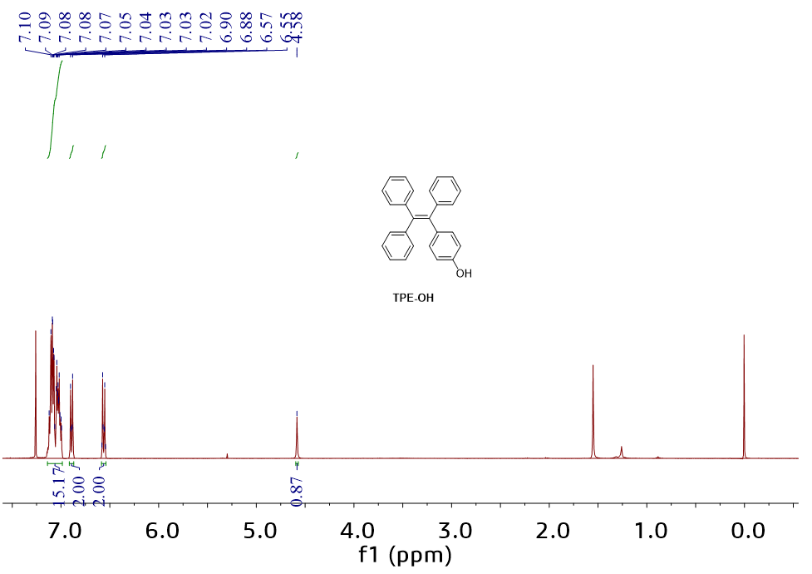
Supplementary Fig. 2. The ¹H-NMR spectrum of TPE-OH.
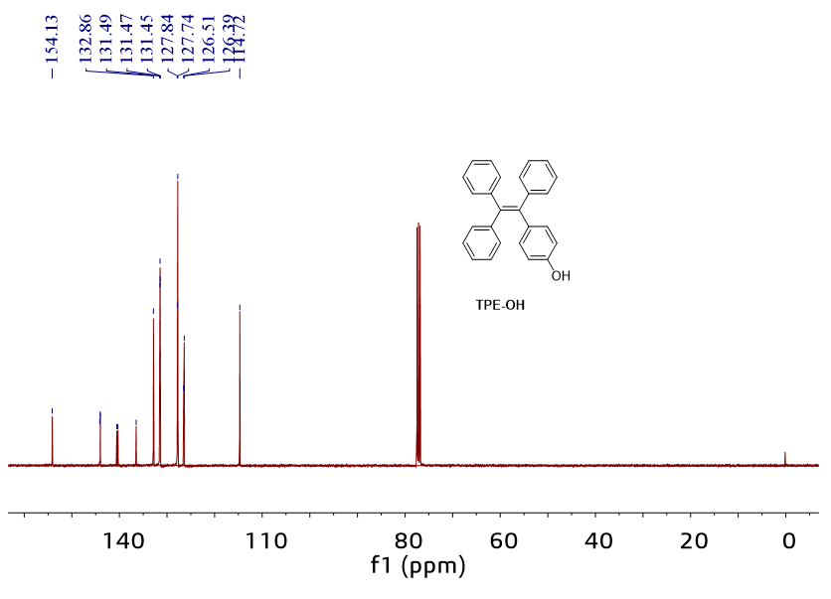
Supplementary Fig. 3. The ¹³C-NMR spectrum of TPE-OH.

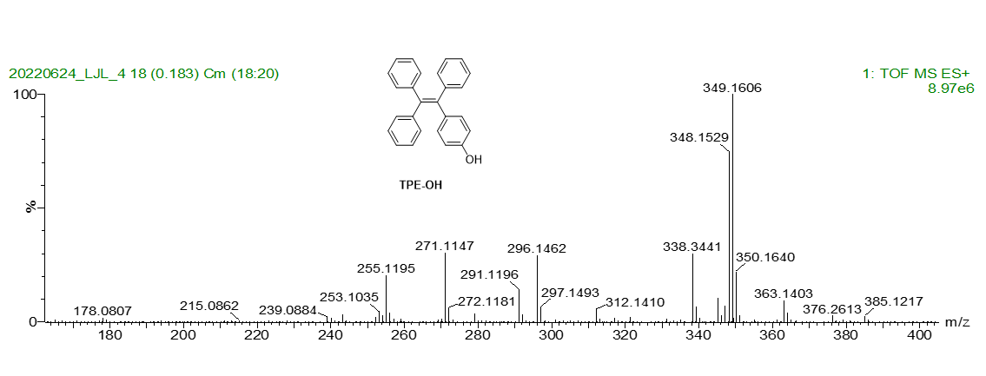
Supplementary Fig. 4. The HRMS spectrum of TPE-OH.
TPE-C₁₀-Br
Synthesized according to the reference ^{S2}. TPE-OH (1.00 g, 2.87 mmol), 1,10-dibromodecane (4.31 g, 14.4 mmol) and potassium carbonate (0.59 g, 4.31 mmol) were added into a 250 mL round-bottom flask, stirred and refluxed in CH₃CN (100 mL) under N₂ atmosphere overnight, then cooled to room temperature. The mixture was then cooled down to room temperature, the solid was filtered and then solvent was removed by rotary evaporator, the crude product was puriﬁed by column chromatography (silica gel, petroleum ether to CH₂Cl₂/petroleum ether = 1/9 v/v) to yield TPE-C₁₀-Br as a white solid (0.98 g, 60%). ¹H NMR (400 MHz, CDCl₃) δ 7.16 – 7.00 (m, 15H), 6.93 (d, J = 8.7 Hz, 2H), 6.64 (d, J = 8.7 Hz, 2H), 3.88 (t, J = 6.5 Hz, 2H), 3.42 (t, J = 6.9 Hz, 2H), 1.92 – 1.82 (m, 2H), 1.81 – 1.71 (m, 2H), 1.45 (br, 4H), 1.36 – 1.29 (m, 8H). ¹³C NMR (101 MHz, CDCl₃) δ 157.81, 144.19, 144.13, 140.73, 140.10, 135.99, 132.60, 131.50, 131.46, 131.44, 127.80, 127.68, 126.43, 126.30, 113.70, 67.88, 34.04, 32.94, 29.54, 29.47, 29.42, 28.86, 28.28, 26.17. TOF-MS m/z calc for C₃₆H₃₉OBr [M+H]⁺ 567.2263, found 567.2252.
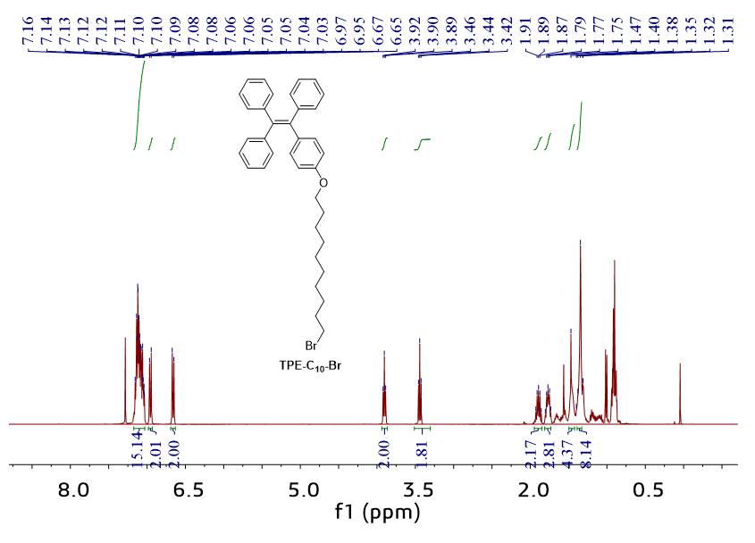
Supplementary Fig. 5. The ¹H-NMR spectrum of TPE-C₁₀-Br.
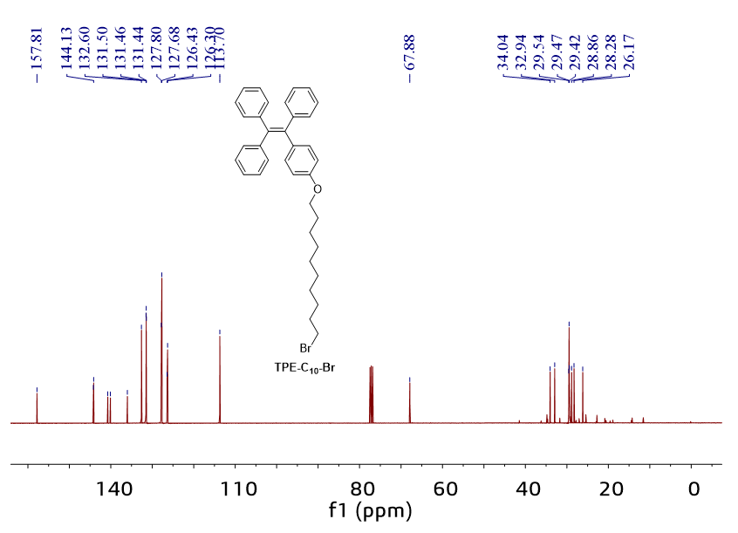
Supplementary Fig. 6. The ¹³C-NMR spectrum of TPE-C₁₀-Br.
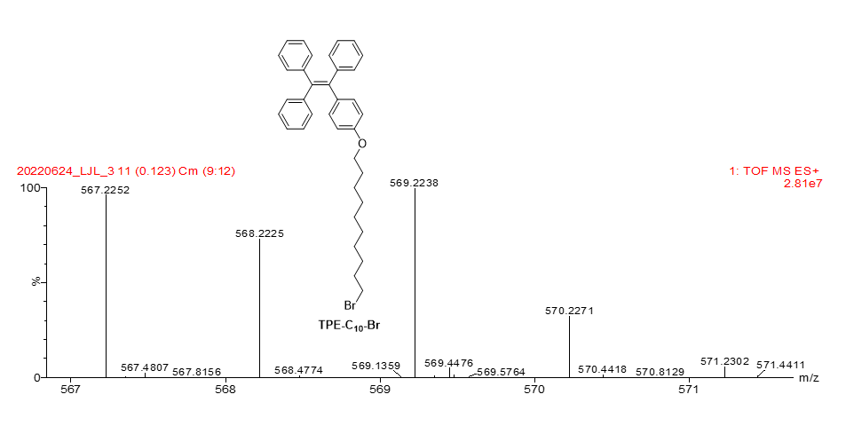
Supplementary Fig. 7. The HRMS spectrum of TPE-C₁₀-Br.

TPE-C₁₀-SAc
TPE-C₁₀-Br (0.82 g, 1.44 mmol) and potassium ethanethioate (0.75 g, 6.53 mmol) were added into a 250 mL flask containing CH₃CN (100 mL). After degassing by bubbling with N₂ for 15 min, the mixture was then heated at 85 °C for 12 h under N₂ atmosphere. The mixture was then cooled down to room temperature, the solid was filtered and then solvent was removed by rotary evaporator. The crude product was puriﬁed by column chromatography (silica gel, CH₂Cl₂/petroleum ether = 1/9 v/v). TPE-C₁₀-SAc was obtained as white solid (0.524 g, 65%). ¹H NMR (400 MHz, CDCl₃) δ 7.16 – 7.00 (m, 15H), 6.96 – 6.90 (m, 2H), 6.66 – 6.60 (m, 2H), 3.87 (t, J = 6.6 Hz, 2H), 2.87 (t, J = 7.3 Hz, 2H), 2.33 (s, 2H), 1.78 – 1.69 (m, 2H), 1.62 – 1.53 (m, 8H), 1.47 – 1.29 (m, 1H). ¹³C NMR (101 MHz, CDCl₃) δ 195.95, 157.78, 144.15, 144.10, 140.70, 140.06, 135.95, 132.57, 131.47, 131.43, 131.40, 127.78, 127.66, 126.40, 126.28, 113.68, 67.87, 30.72, 29.59, 29.54, 29.46, 29.45, 29.39, 29.23, 29.16, 28.88, 26.14. TOF-MS m/z calc for C₃₈H₄₂O₂S [M+H]⁺ 563.2984, found 563.2952.
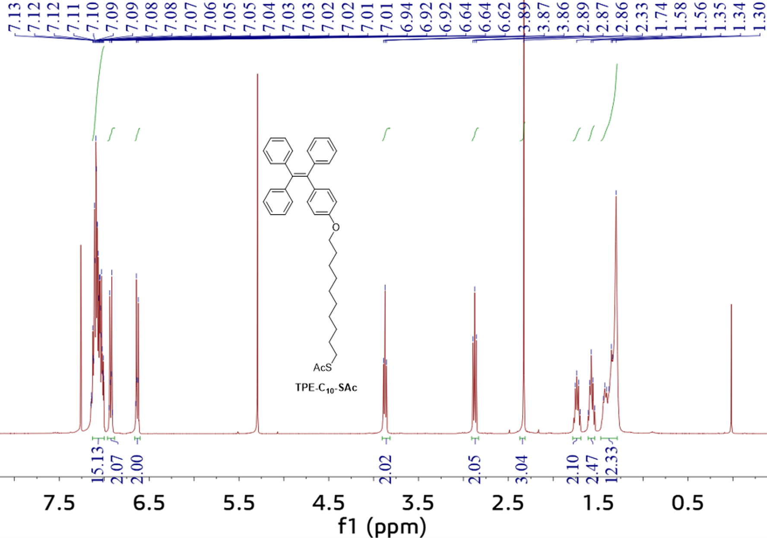
Supplementary Fig. 8. The ¹H-NMR spectrum of TPE-C₁₀-SAc.
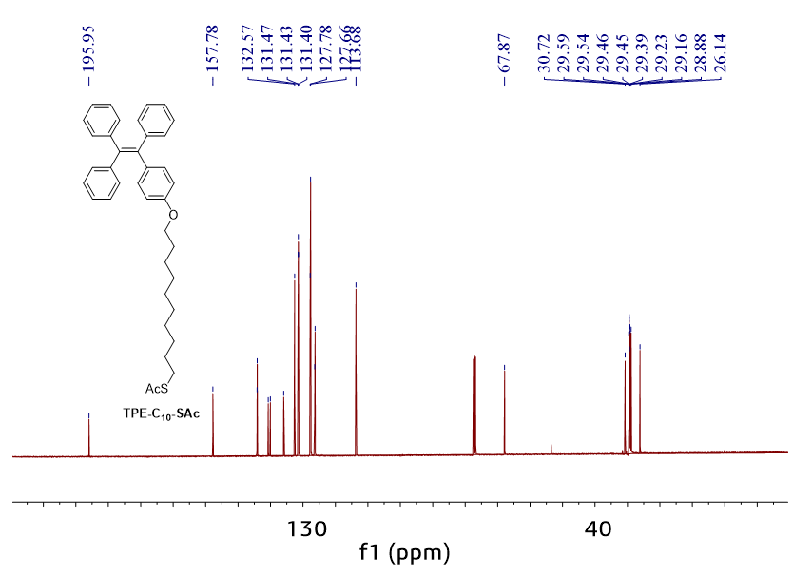
Supplementary Fig. 9. The ¹³C-NMR spectrum of TPE-C₁₀-SAc.
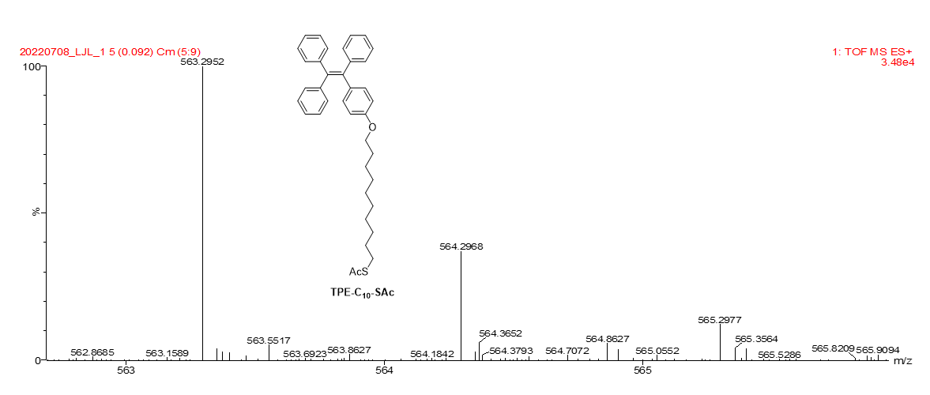
Supplementary Fig. 10. The HRMS spectrum of TPE-C₁₀-SAc.
TPE-C₁₀-SH
Synthesized according to the reference ^{S3}. A solution of TPE-C₁₀-SAc (563 mg, 1.0 mmol) in 25 mL anhydrous THF was cooled to 0 °C under nitrogen atmosphere, 2.82 mL LiAlH₄ (1 M in THF) was added dropwise. After stirring for additional 30 min at 0 °C, the reaction mixture was warmed to room temperature and stirred for another 1 h. After cooling again to 0 °C, 3N hydrochloric acid was added until the entire solid was dissolved. The organic phase is separated and washed with brine, dried over Na₂SO₄, dried over sodium sulfate, filtered, and concentrated using rotary evaporation. The crude product was puriﬁed by column chromatography (silica gel, CH₂Cl₂/petroleum ether = 1/9 v/v), TPE-C₁₀-SH was obtained as a white solid (0.313 g, 60%). ¹H NMR (400 MHz, CDCl₃) δ 7.12-1.02 (m, 15H), 6.92 (d, J = 8.0 Hz, 2H), 6.62 (d, J = 8.1 Hz, 2H), 3.87 (t, J = 6.4 Hz, 2H), 2.52 (q, J = 7.3 Hz, 2H), 1.77 – 1.69 (m, 2H), 1.66 – 1.56 (m, 2H), 1.45 – 1.28 (m, 12H). ¹³C NMR (101 MHz, CDCl3) δ 157.82, 144.21, 144.16, 140.74, 140.11, 136.01, 132.64, 131.54, 131.51, 131.48, 127.84, 127.72, 126.46, 126.33, 113.71, 67.92, 34.18, 29.62, 29.59, 29.53, 29.45, 29.20, 28.52, 26.20, 24.81. TOF-MS m/z calc for C₃₆H₄₀OS [M+H]⁺ 521.2878, found 521.2859.
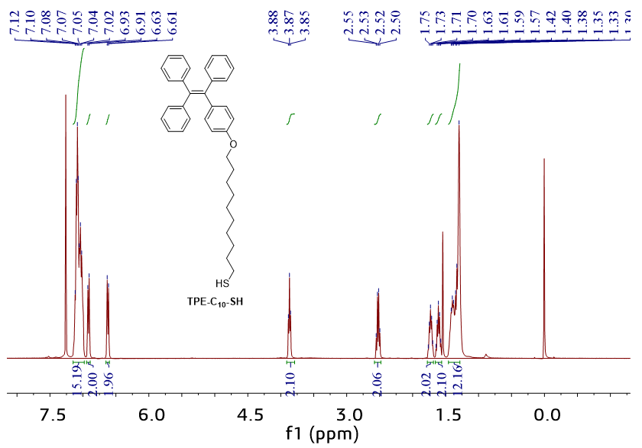
Supplementary Fig. 11. The ¹H-NMR spectrum of TPE-C₁₀-SH.
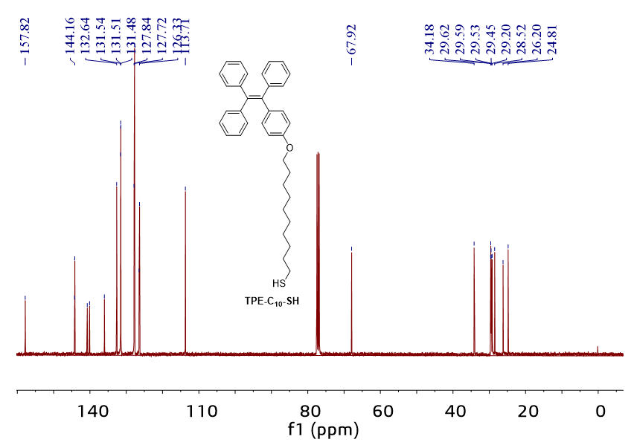
Supplementary Fig. 12. The ¹³C-NMR spectrum of TPE-C₁₀-SH.
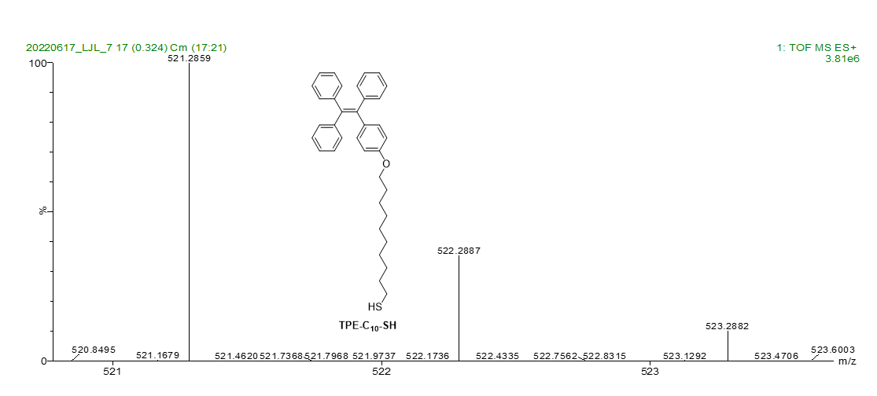
Supplementary Fig. 13. The HRMS spectrum of TPE-C₁₀-SH.

Atomic-force microscope (AFM)
Supplementary Fig. 14 illustrates the AFM image of the Au surface after bending at various bending degrees and then recovering to flat. It has been reported that a large RMS roughness value of the metal surface can lead to large amounts of defects in SAMs that results in large leakage current ^{S4}. Whether in the most convex bending (Supplementary Fig. 14a) or the most concave bending condition (Supplementary Fig. 14h), we do not observe significant change of the RMS roughness or any fluctuation. Thus, the observed low and high current intensity is not induced by any change of the Au surface during bending.
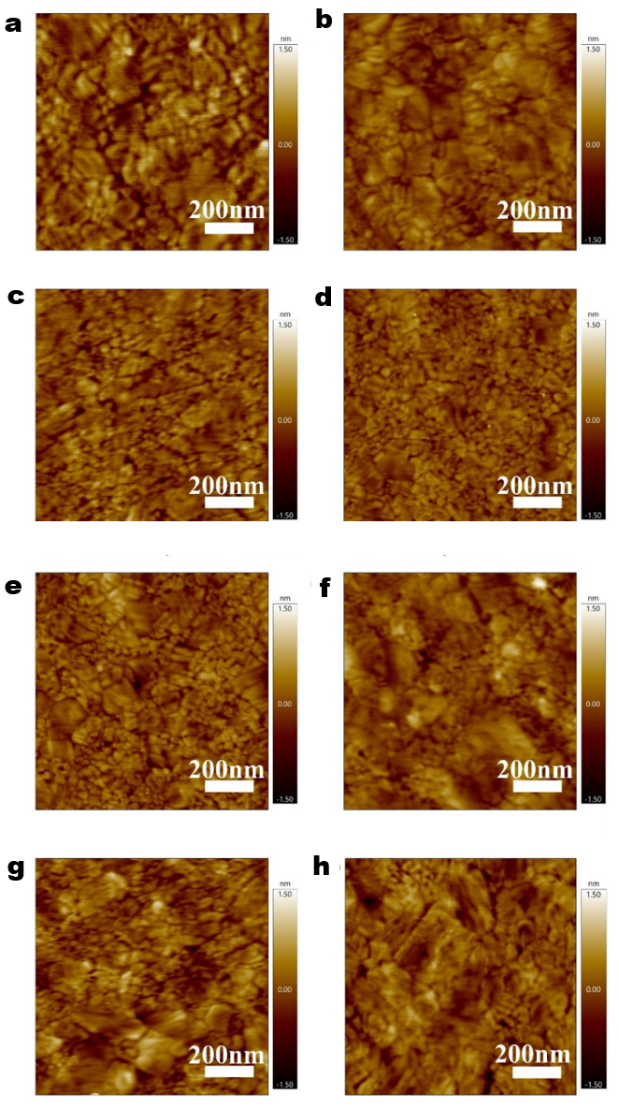
Supplementary Fig. 14. AFM images of the gold substrates recovered from various bending radii R (as defined in Supplementary Fig. 15.): a, - 18.3 mm (RMS = 0.312) , b, - 22.7 mm (RMS = 0.237), c, - 34.4 mm (RMS = 0.248), d, ∞ mm (RMS = 0.219), e, 34.4 mm (RMS = 0.247), f, 22.7 mm (RMS = 0.245), g, 18.3 mm (RMS = 0.308) and h, 17.0 mm (RMS = 0.289).
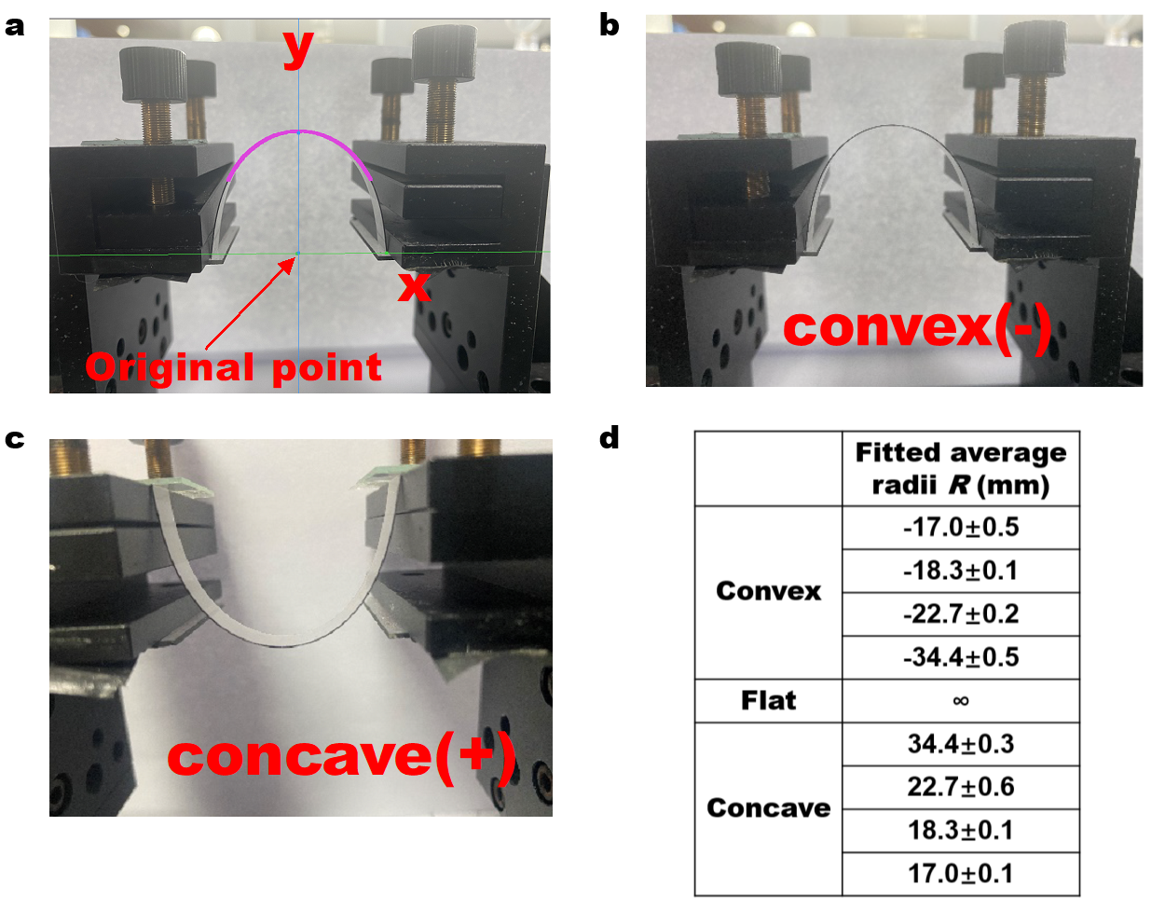
Supplementary Fig. 15. a, b, c, Photograph of the junctions created on mechanically bent electrodes. d, The results of fitted average radii across the range of electrode shapes, extracted from the data in Supplementary Figs. 16-17.
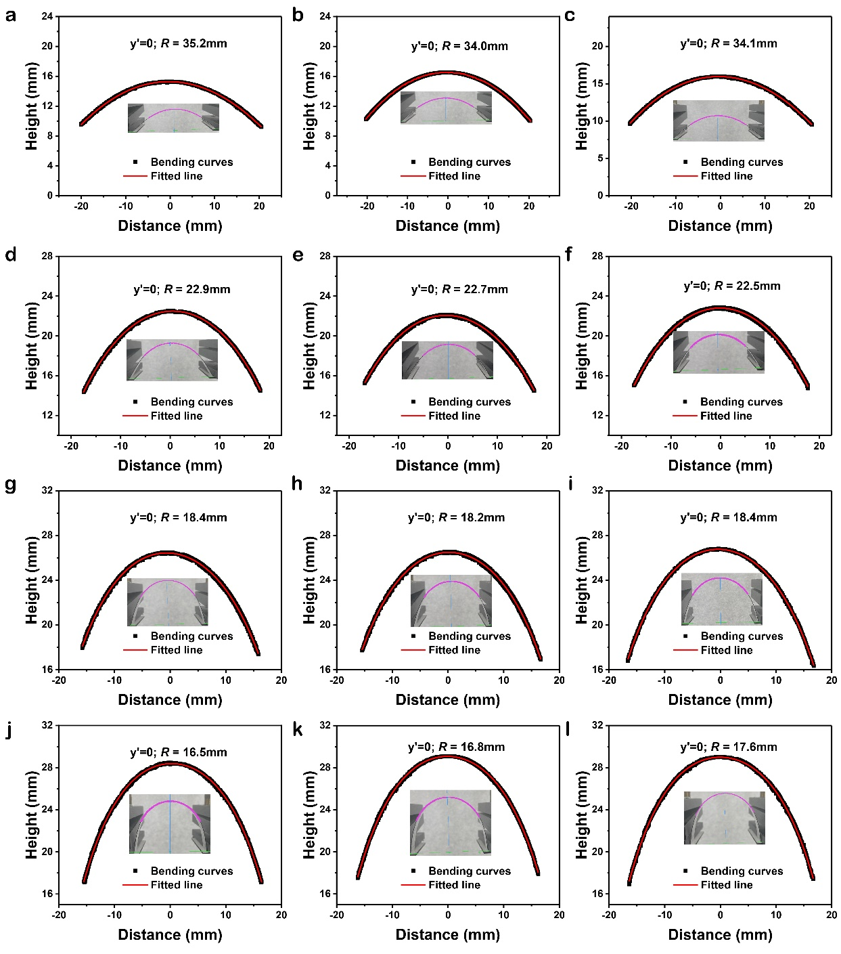
Supplementary Fig. 16.The real bending curves (inset) and fitted mathematic curves (red line) at various convex bending. We measured four different extents of convex bending and each R was fitted three times. Supplementary Fig. 15d shows the average R results. The convex R = -34.4±0.5 mm was fitted from a, b and c. R = -22.7±0.2 mm was fitted from d, e and f. R = -18.3±0.1 mm was fitted from g, h and i. R = -17.0±0.5 mm was fitted from j, k and l.
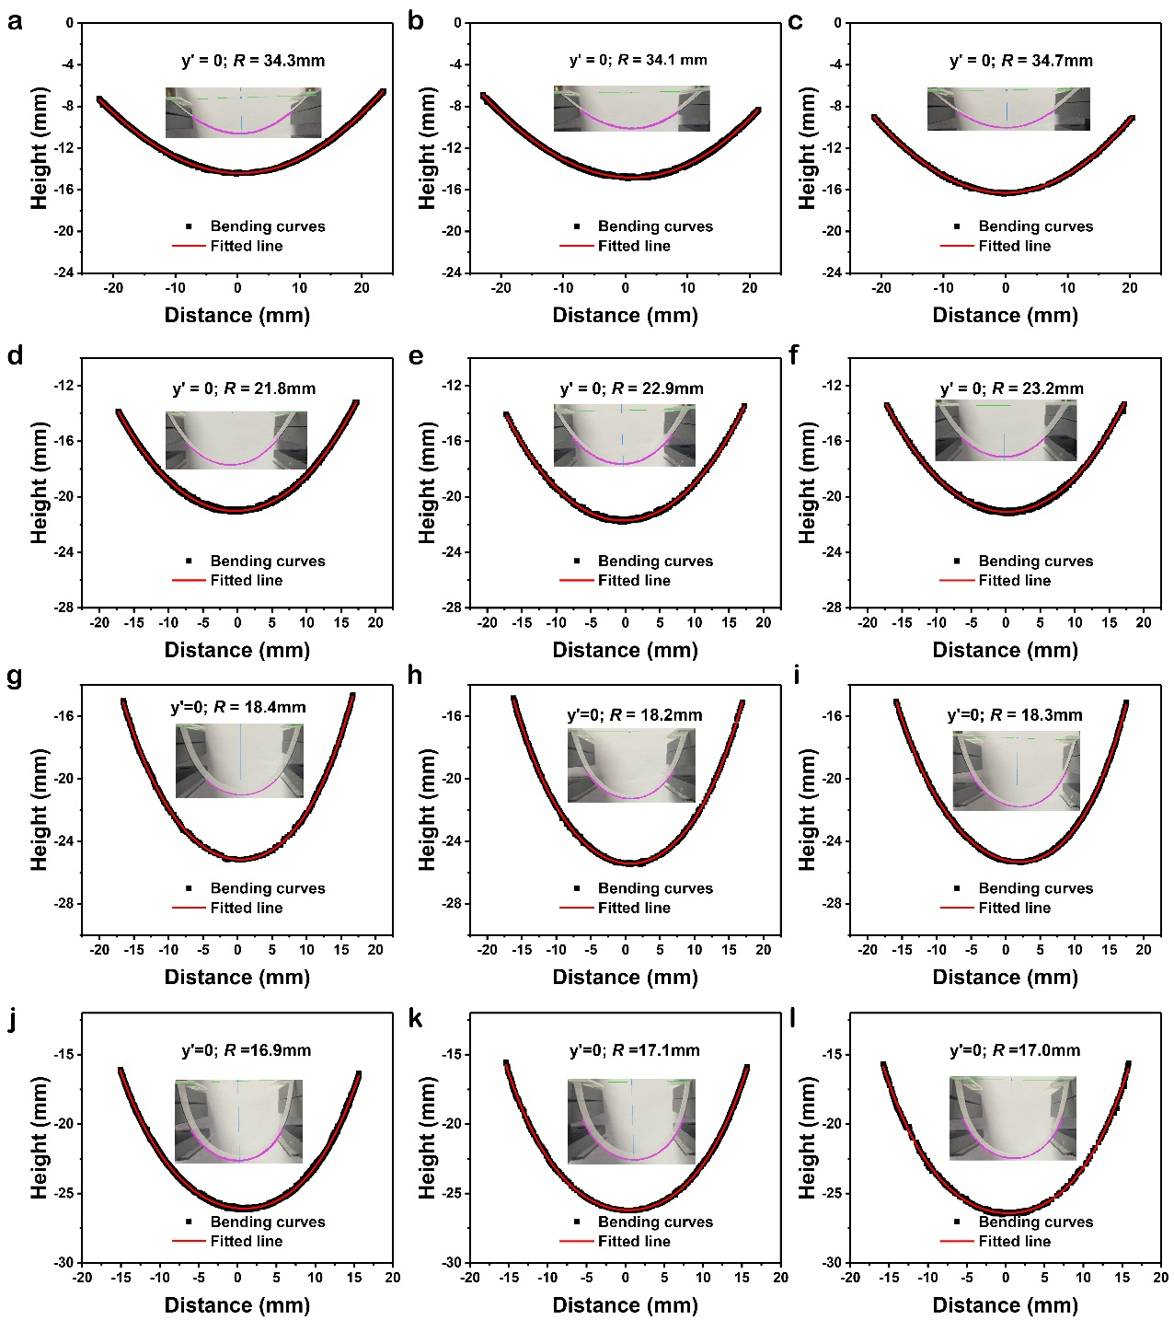
Supplementary Fig. 17. The real bending curves (inset) and fitted mathematic curves (red line) at various concave bending. We measured four different extents of concave bending and each R was fittled three times. Supplementary Fig. 15d shows the average R results. The concave R = 34.4±0.3 mm was fitted from a, b and c. R = 22.7±0.6 mm was fitted from d, e and f. R = 18.3±0.1 mm was fitted from g, h and i. R = 17.0±0.1 mm was fitted from j, k and l.

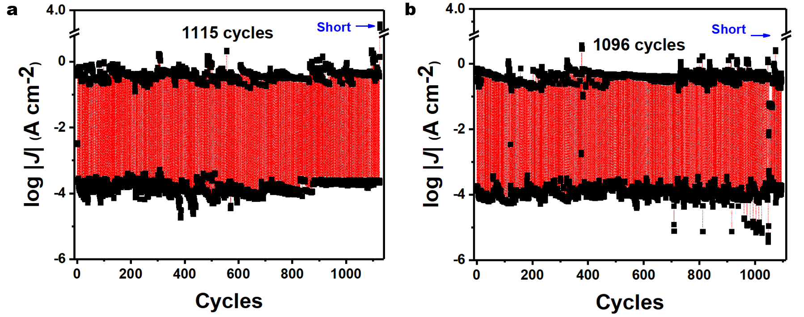
Supplementary Fig. 18. The real-time on-off cycles of Au-SC₁₀-O-TPE at R = 17.0 mm with a, 1115 and b, 1096 cycles. The current density values were recorded at -1 V.

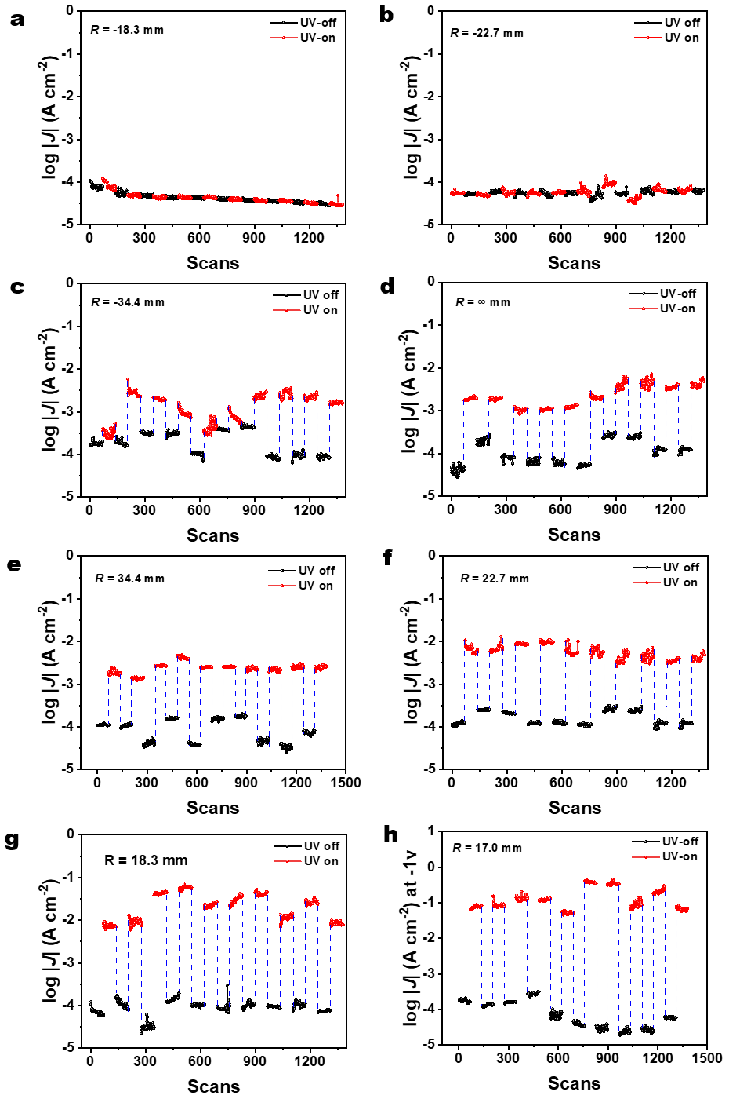
Supplementary Fig. 19. The in-situ on/off switch cycle of Au-SC₁₀-O-TPE SAM at bending radii of a, -34.4 mm, b, -22.7 mm, c, -34.4 mm, d, flat, e, 34.4 mm, f, 22.7 mm, g, 18.3 mm and h, 17.0 mm.

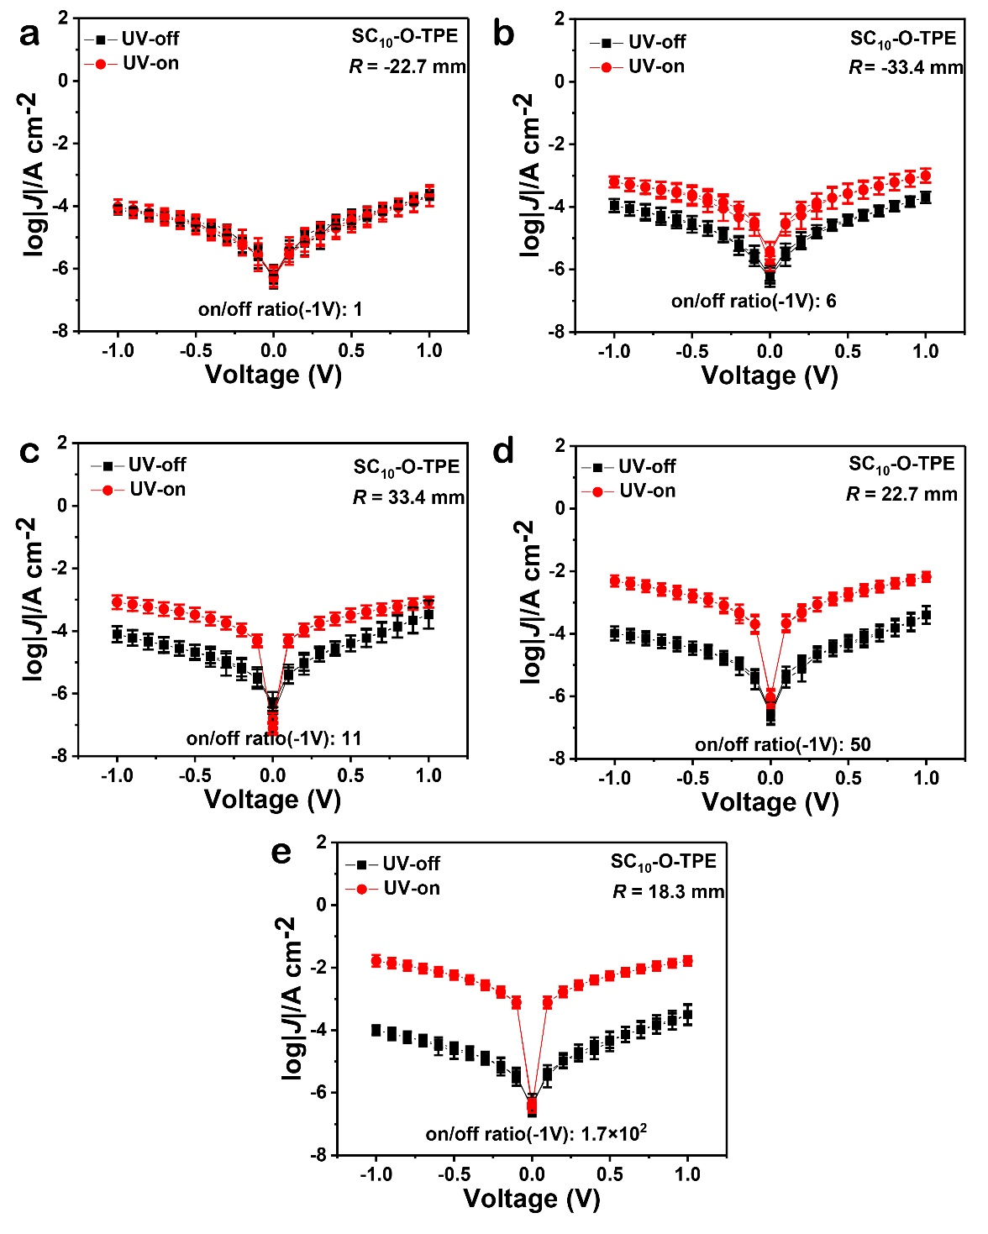

Supplementary Fig. 20. LogJ(V) curves of Au-SC₁₀-O-TPE at bending radii a, R = - 22.7 mm, b, R = - 33.4 mm c, R = 33.4 mm d, R = 22.7 mm and e, R = 18.3 mm .

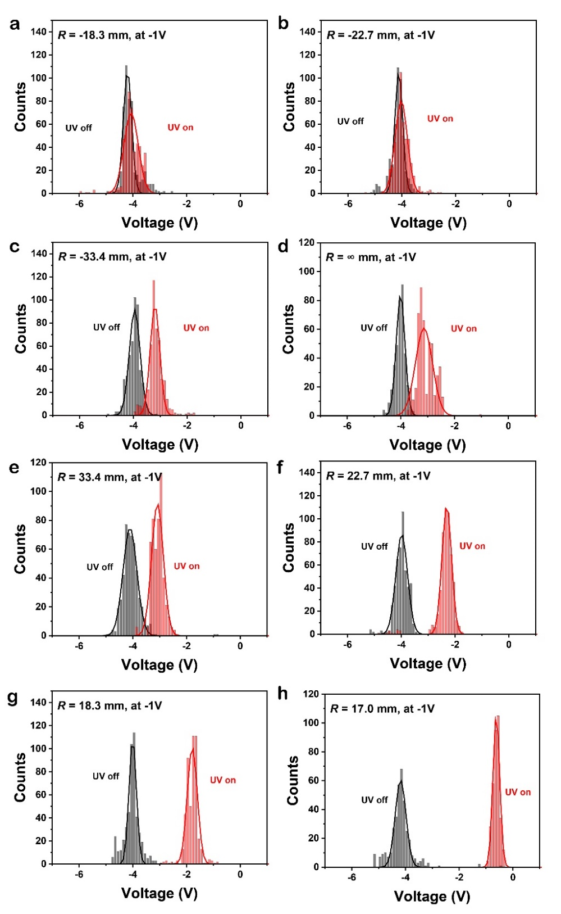
Supplementary Fig. 21. Histogram of Au-SC₁₀-O-TPE bending at a, R = -18.3 mm, b, R = -22.7 mm, c, R = -33.4 mm, d, R = ∞ mm, e, R = 33.4 mm, f, R = 22.7 mm, g, R = 18.3 mm and h, R = 17.0 mm.
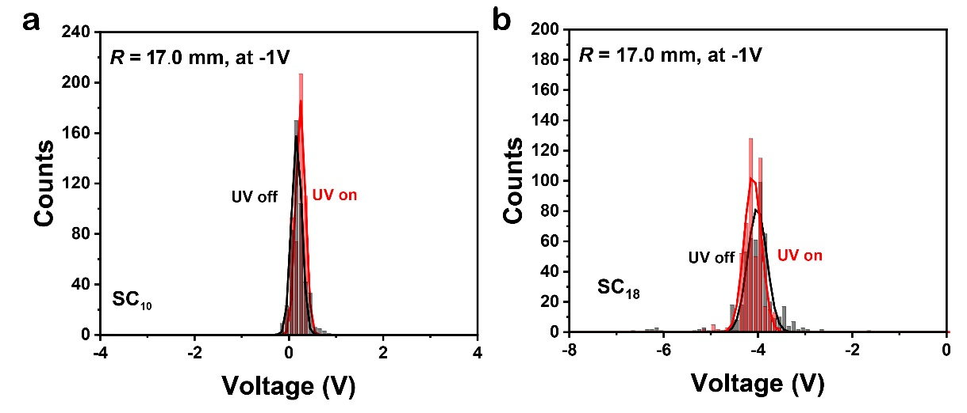
Supplementary Fig. 22. Histogram of a, Au-SC₁₀ and b, Au-SC₁₈ SAM at R = 17.0 mm.

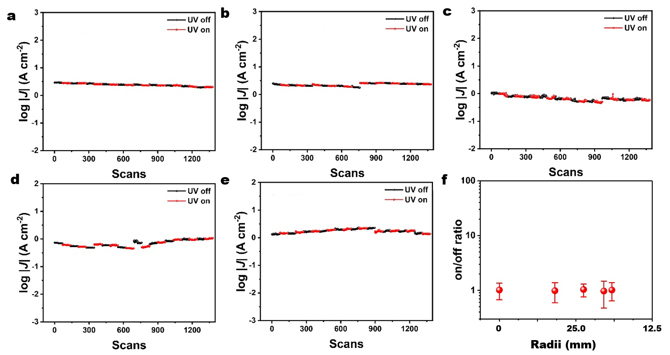
Supplementary Fig. 23. The in-situ on/off switch cycle of Au-SC₁₀ at bending radii of a, flat, b, 34.4 mm, c, 22.7 mm, d, 18.3 mm and e, 17.0 mm . f, The diagram of on/off ratio as a function of R of the Au-SC₁₀ control system.
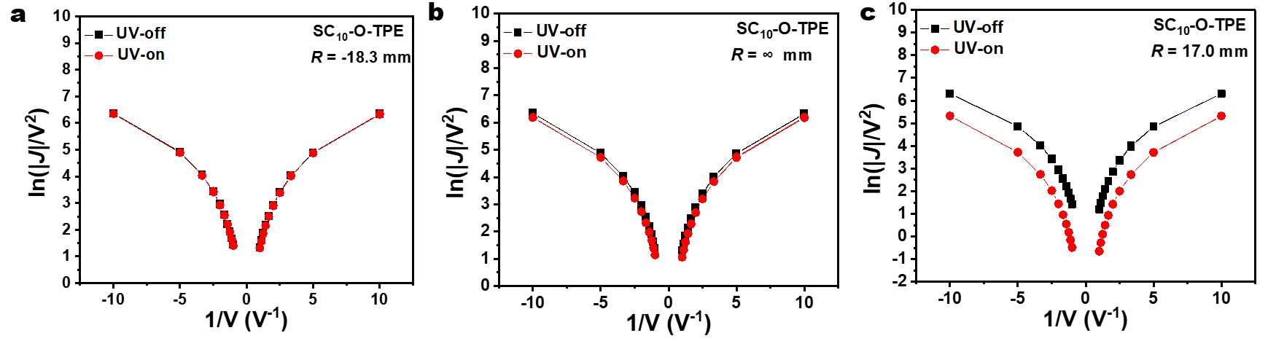
Supplementary Fig. 24. Fowler−Nordheim (FN) plots for Au-SC₁₀-O-TPE,derived from the current-density data in Fig. 2a-c at different bending raddi a, R = -18.3 mm, b, flat R = ∞ mm, and c, R = 17.0 mm.

Spectroscopy
Near edge X-ray absorption fine structure (NEXAFS) spectroscopy. Supplementary Fig. 25 shows the angular dependent NEXAFS data at C K-edge for SAMs of Au-SC₁₀-O-TPE at different bending radii. The lowest resonance peaks are due to the transitions from C 1s to π*_{C=C} orbitals (at ~286.2 eV). Here we hypothesize that the vector π* of the four phenyls is canceled due to their symmetry. Thus, the total vectors of π* orbitals of TPE is parallel to the middle C=C bond in Supplementary Fig. 25c, which connect the four phenyls. The peak at ~288.4 eV is ascribed to C-H orbitals. The broader signals at higher photon energy are assigned to σ* transitions. Assuming a random azimuthal orientation between molecular plane and substrate, the π* resonances intensity (I*) ratio at 90º and 40º incident angles (θ) can be expressed as follows:
$\frac{I_{π^{*}}\text{(}\text{α}\text{, }\text{90°)}}{I_{π^{*}}\text{(}\text{α}\text{, }\text{40°)}}\text{=}\frac{{\text{P}\text{(sin}}^{\text{2}}\text{α}{\text{sin}}^{\text{2}}\text{90°+2}{\text{cos}}^{\text{2}}\text{α}{\text{cos}}^{\text{2}}\text{90°)+(1-}\text{P}\text{)}{\text{sin}}^{\text{2}}\text{α}}{{\text{P}\text{(sin}}^{\text{2}}\text{α}{\text{sin}}^{\text{2}}\text{40°+2}{\text{cos}}^{\text{2}}\text{α}{\text{cos}}^{\text{2}}\text{40°)+(1-}\text{P}\text{)}{\text{sin}}^{\text{2}}\text{α}}$ (1)
in which P = 0.90 is the linear polarisation factor, and α is the average tilt angle of the middle C=C
bond long axis with respect to the substrate surface normal ^{S5, S6}.
X-ray photoelectron spectroscopy (XPS) and ultraviolet photoelectron spectroscopy (UPS). We recorded UPS spectrum to determine the HOMO levels (E_{HOMO}) and work function. HOMO level is calculated from the E_{cut off} of the secondary electron peak and HOMO-onset (E_{HOMO-onset}). Supplementary Fig. 25a and b shows the secondary electron peak and HOMO onset edge of the UPS spectra. The detailed analysis procedure has been reported before ^{S7}:
E_{HOMO} = hv- (E_{cut off} –E_{HOMO- onset}) (2)
where hv is the incident photon energy 21.2 eV. We determined the values of E_{cut off} from the intercept between the linear extrapolation of the baseline and linear extrapolation of the secondary electron peak (Supplementary Fig. 25b). Similarly, the values of E_{HOMO-onset} were determined from the intercept between the linear extrapolation of the baseline and linear extrapolation of the lower binding energy side of HOMO onset peak (Supplementary Fig. 25b).
Work function (WF) is also calculated from the UPS spectrum and by the following equation:
WF = hv- (E_{cut off} –E_{Fermi} ) (3)
where hv is also the incident photon energy 21.2 eV. All UPS spectra were referenced to the Fermi edge of a clean Au surface and therefore the values of E_{Fermi} is 0 eV.
Next, we can also estimate the LUMO energy level (E_{LUMO}) by using the values of the optical HOMO-LUMO gap obtained from the emission spectra (Fig. 3a and Supplementary Table 3) subtract the values of E_{HOMO}. The values of E_{LUMO} are listed in the Supplementary Table 3.
Supplementary Fig. 26-27 shows the XPS spectrum of Au-SC₁₀ and Au-SC₁₀-O-TPE SAMs at different convex and concave bending radius. All the Au singnal (Supplementary Fig. 26b, f, j and Supplementary Fig. 27b, f, j) include two peaks of Au 4f_{5/2} and Au 4f_{7/2}. The carbon signal can be fitted to servel peaks. From low to high binding energy, these C1s peaks are corresponding to phenyl (centered at ~284.0 eV ), C-C (centered at ~284.4 eV ), C=C (centered at ~285.2 eV ) and C-O (centered at ~286.0 eV ), respectively. The weak peaks centered at ~ 291.0 eV is attributed to π-π* satellite.
All the sulfur signals (Supplementary Fig 26d, h, l and 27d, h, l) are assigned to S2p_{1/2} and S2p_{3/2}. We fitted the 2p spin-orbit doublet with a splitting of 1.18 eV and an area ratio of S 2p_{3/2}:2p_{1/2} = 2:1. The 2p_{3/2} and 2p_{1/2} peaks are centered at ~161.8 eV (red line) and at ~163.1 eV (green line). The spectra indicate formatioin of dense, well packed Au-SC₁₀-O-TPE SAMs on the gold electrode.
We calculated the surface coverage from the sulfur signal using eq. 4.
I_{0,S} = I_{s} / exp (-d / λ) (4)
Here, I_{0,S} is the initial signal generated from the 2p orbital of S atoms without attenuation over the thickness of SAMs. The reported theoretical value of Γ_{SAM} of Au-SC₁₀ SAMs on Au (111) ^{S8} surface is 9 × 10⁻¹⁰ mol/cm². The X-ray photoelectron spectrum of Au-SC₁₀ is shown in Supplementary Fig. 26a-d. Thus, we compared the values of I_{0,S} of the SAMs formed on Au substrate surfaces against the value I_{0,S} of SC₁₀ SAMs (Supplementary Fig. 26a-d) formed on Au substrate to estimate the relative Γ_{SAM} values of the SAMs in this study. The estimated Γ_{SAM} of Au-SC₁₀-O-TPE is 5.9 × 10⁻¹⁰ mol/cm².

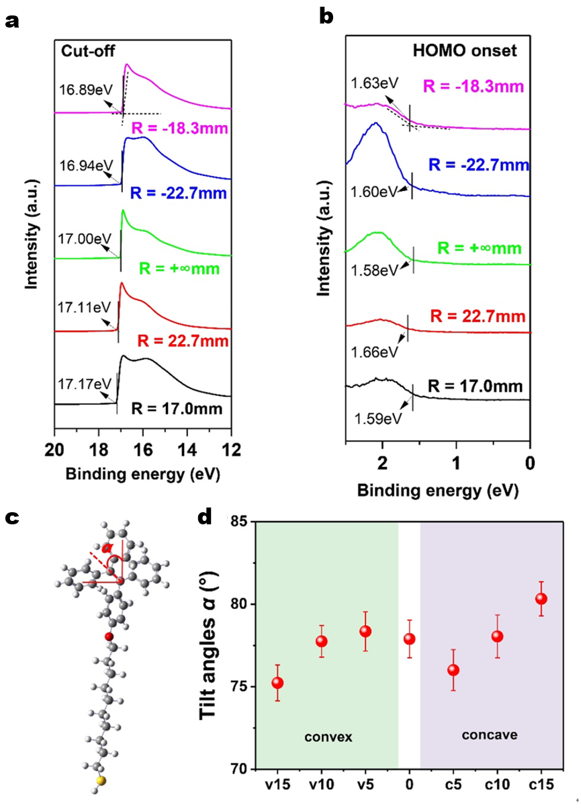

Supplementary Fig. 25. UPS of Au-SC₁₀-O-TPE at different bending condition. a, Cut-off edge and b, HOMO onset edge of the UPS spectrum. c, 3D model of HSC₁₀-O-TPE molecule. The tilt angle α is defined as the angle of average π* of the molecule against the surface normal. d, The plot of tilt angles α predicted from the molecular dynamics models (see Supplementary Fig. 29 below).
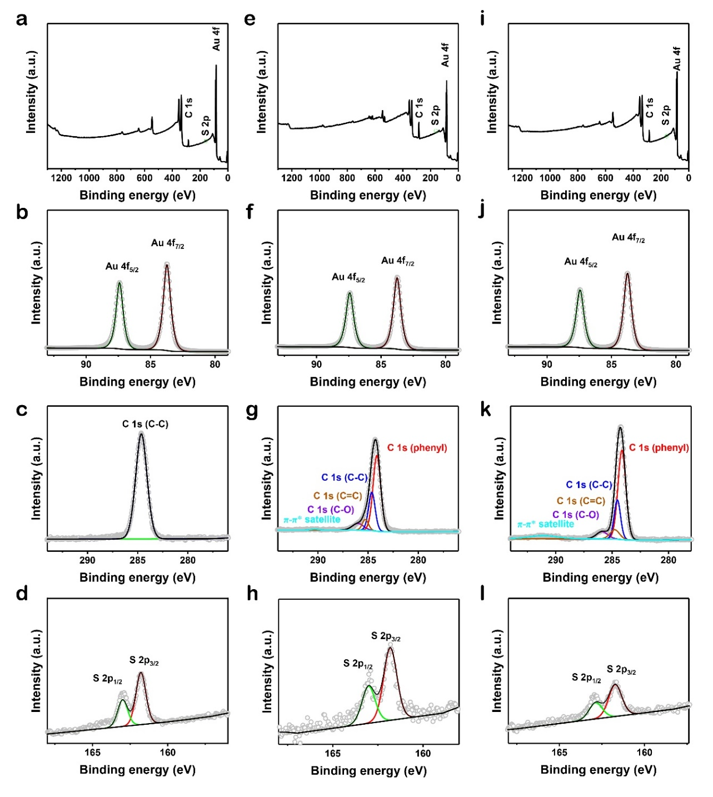
Supplementary Fig. 26. XPS of Au-SC₁₀ at flat: a, survey; b, Au spectrum; c, C spectrum and d, S spectrum. XPS of Au-SC₁₀-O-TPE at -18.3 mm convex bending: e, survey; f, Au spectrum; g, C spectrum and h, S spectrum. XPS of Au-SC₁₀-O-TPE at -22.7 mm convex bending: i, survey; j, Au spectrum; k, C spectrum and l, S spectrum. All the spectra were recorded at θ = 90°. θ is the emission angles that between the emission electrons and the surface.
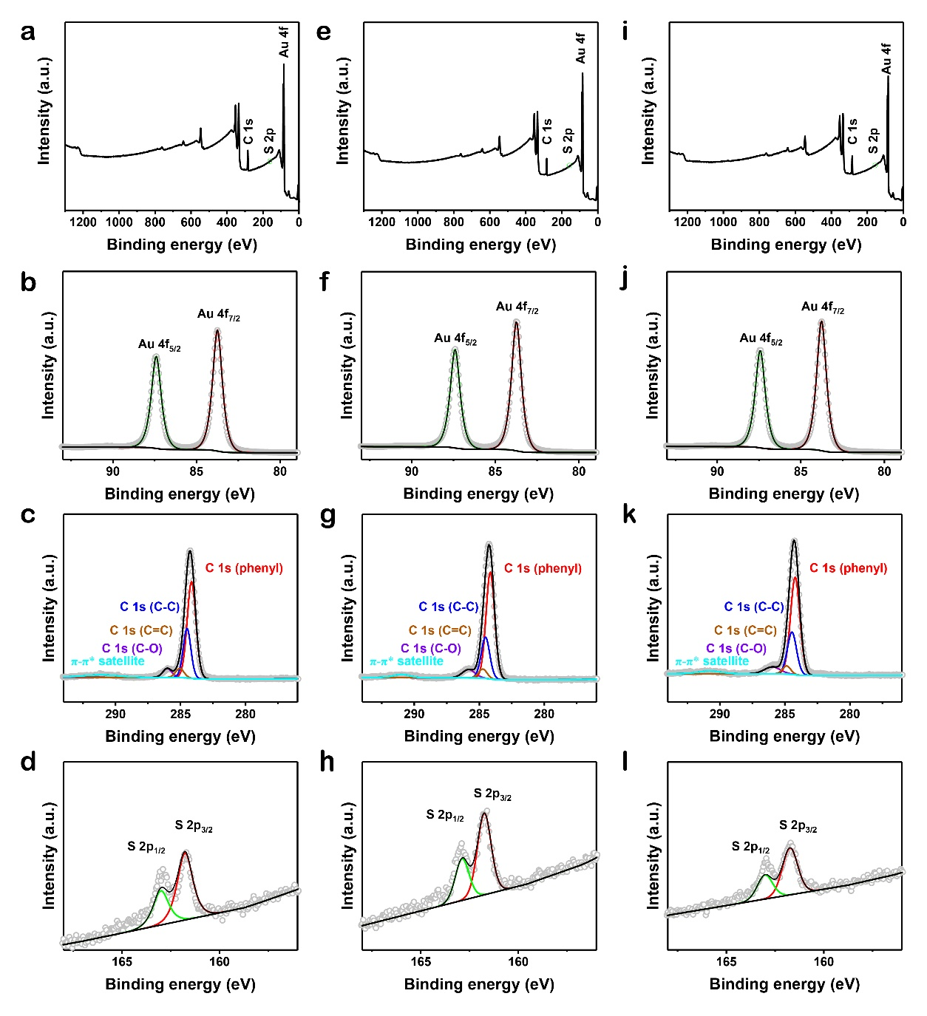
Supplementary Fig. 27. XPS of Au-SC₁₀-O-TPE at flat: a, survey; b, Au spectrum; c, C spectrum and d, S spectrum. XPS of Au-SC₁₀-O-TPE at 22.7 mm concave bending: e, survey; f, Au spectrum; g, C spectrum and h, S spectrum. XPS of Au-SC₁₀-O-TPE at 17.0 mm concave bending: i, survey; j, Au spectrum; k, C spectrum and l, S spectrum.
Simulation and calculation

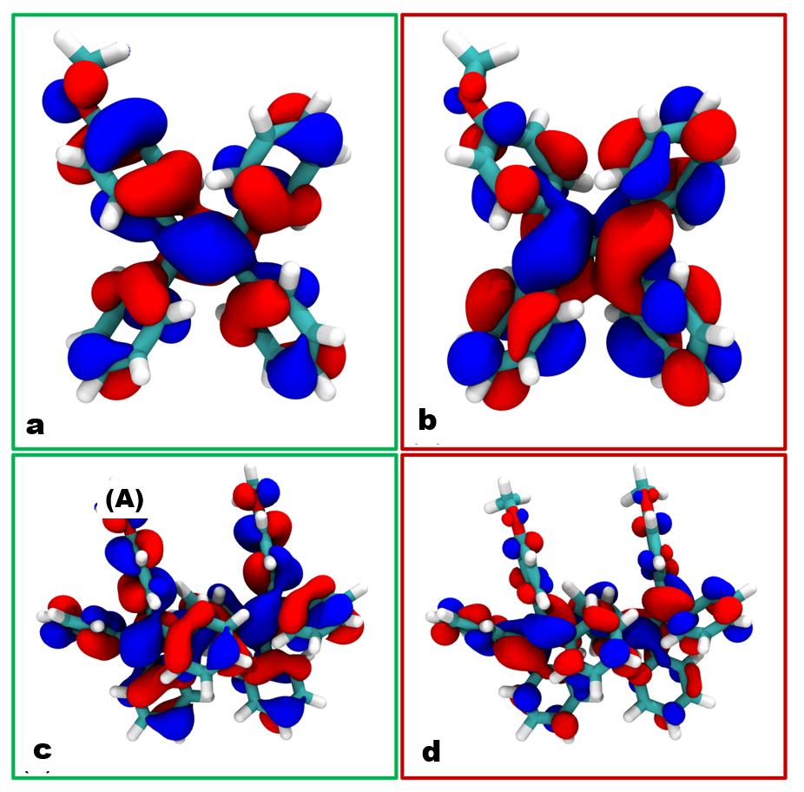

Supplementary Fig. 28. Molecular orbitals computed from DFT calculations of the AIE monomer a, b and of the crystal dimer c, d. a and c depict the HOMO (green boxes) of the monomer and dimer, respectively. b and d depict the LUMO (red boxes) of the monomer and dimer, respectively.
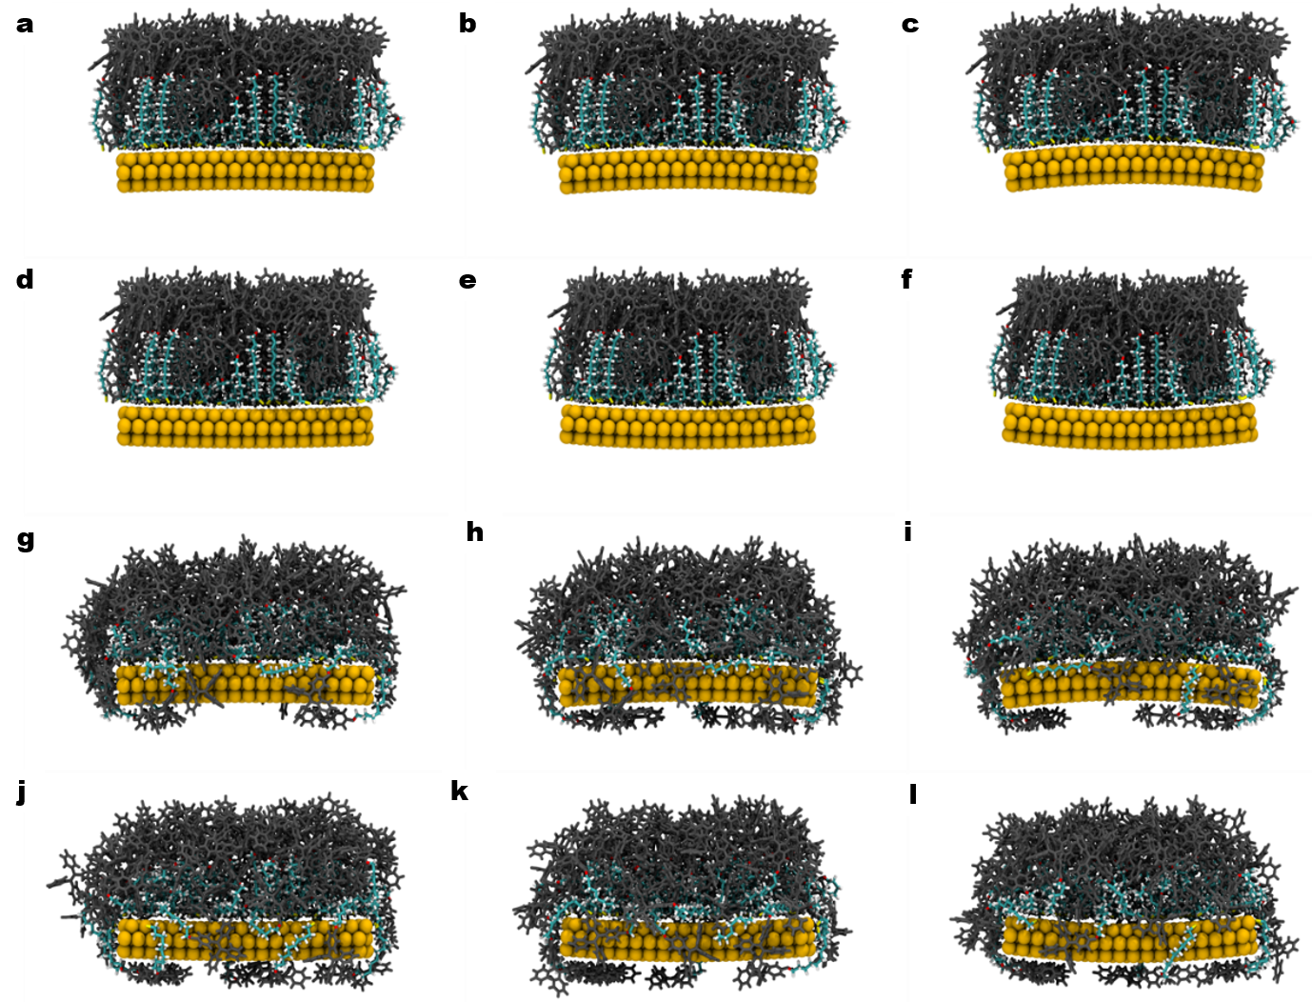

Supplementary Fig. 29. Computed SAM structures from MD simulations with the supporting gold electrode bent at 5°, 10°, 15° in a convex fashion (a, b, c, g, h, i) and in a concave fashion (d, e, f, g, k, l). The starting structures are shown in a-f. The final structures are shown in g-l. The gold atoms are shown as van der Waals spheres, the SAM alkyl chains as sticks (Carbon in cyan, Oxygen in red, Sulfur in yellow, Hydrogen in white), and the AIE-active headgroups as grey sticks.

Supplementary Fig. 30 shows computed heat maps of phenyl rings relative orientation with respect to their separation. For all systems except the most concave with +15° curvature, the pair distribution is relatively diffuse with a large hill centered around an orientation angle of 90° (loose T-stack) that extends to large distance demonstrating the large-scale correlation of the SAM structure. The most concave model shows a higher level of structuration with high density at short distance with peaks showing a marked tendency towards 60° and 120° for the relative orientation. This predicts that the most concave SAM geometry forces the molecules to depart from the weak, sparsely populated T-stack structure to favor more extensive parallel stacking that was prevented by steric constraints prior to the mechanically-stimulated supramolecular crowding in the most aggregated junction. The MD models confirm that concave curvature is therefore able to induce a well-defined and large-scale ordering of the SAM (see main text Fig. 4b, and also reduced atomic fluctuations in the most concave c15 model in Supplementary Fig. 31 above) that maximizes π-π stacking by increasing the TPE head groups proximity, leading to an improvement in the supramolecular interaction (main text Fig. 4c) in good agreement with the red-shifting of the UV-vis spectrum in the DFT calculations (main text Fig. 4d) and in good agreement with the experimental materials characterization and measured device properties (main text Fig. 1-3 and Supplementary Information and analysis above).

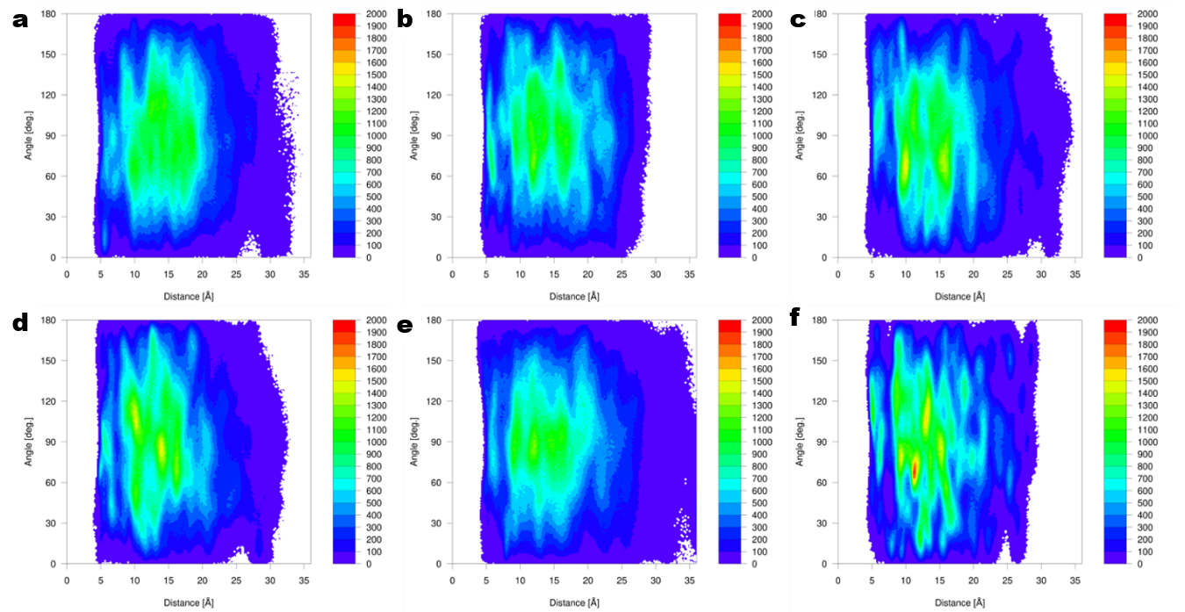

Supplementary Fig. 30. Heat maps of phenyl rings orientation vs. inter-molecular separations for the convex (a, b, and c) and the concave SAM geometries (d, e, and f), for 5° (a, d), 10° (b, e) and 15° (d, f) curvatures. The values are computed over 1000 nanoseconds of dynamics for all SAMs and measured between the same central molecule and surrounding patch of 20 molecules to ensure consistency between models and avoid edge effects.
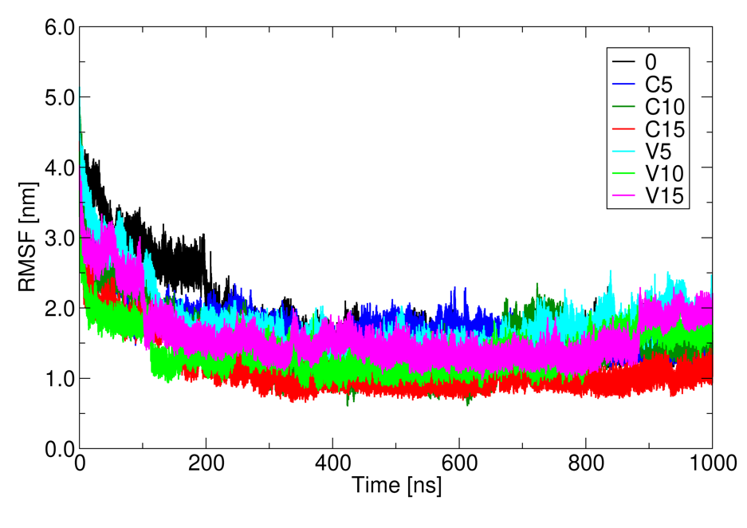

Supplementary Fig. 31. Computed root mean square fluctuation (RMSF) of the SAM non-hydrogen atoms.

Supplementary Fig. 32 shows the results of the transport calculations performed in dark conditions (no photoexcitation) on dimers obtained from the convex (Supplementary Fig. 32a) and concave (Supplementary Fig. 32b) MD models (Supplementary Fig. 29). The calculated larger current (Supplementary Fig. 32c) in the concave assembly reflects the lowering of the acceptor levels (DOS in Supplementary Fig. 32d) consistent with the computed (Fig. 4d) and measured (Fig. 3b) UV-Vis spectra. This places the low-lying empty levels close to the Fermi level, for easy population during photoexcitation, as reflected also in the computed transmission function (Supplementary Fig. 32e). Populating the lowest unoccupied orbitals close to the Fermi level promotes the transmission and explains the current increase measured experimentally for the concave system during photoexcitation.

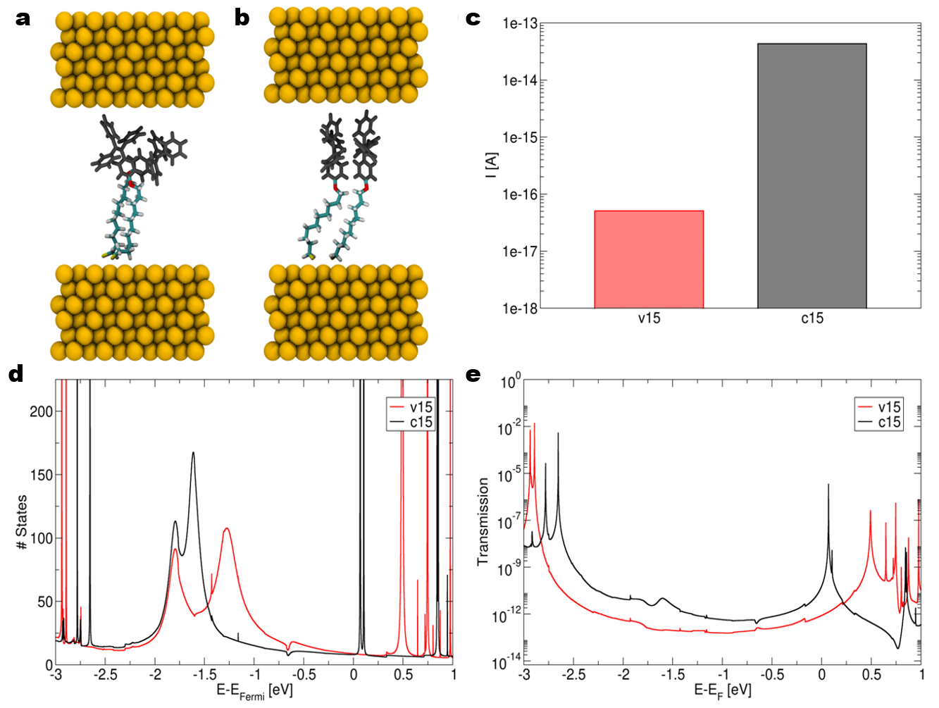

Supplementary Fig. 32. Representation of transport models consisting of Au-SC₁₀-O-TPE dimers from molecular dynamics calculations performed with a, a convex bending angle of 15˚, and b, a concave bending angle of 15˚. The alkyl chains are shown as colored sticks (Carbon in cyan, Oxygen in red, Sulfur in yellow, Hydrogen in white), the TPE headgroups as grey sticks, and the gold electrode atoms as gold colored spheres. c, Computed current in dark conditions (no photoexcitation) for the convex (red bar) and concave (black bar) systems with a biasing potential of 0.5 V. d, Density of States (DOS) for the convex (v15) and concave (c15) assemblies during transport at 0.5 V. e, Transmission functions for v15 (red) and c15 (black).

Supplementary Table 1. Cross comparison of SAM-based molecular photoswitches.
Monolayer molecule | Technique | Maximum ON/OFF ratio | Average ON/OFF ratioª | Switching time | The largest ON/OFF cycles | In situ | mechanism | reference
diarylethene oligomers | C-AFM^{b} | 400 | NA^{c} | 60 min | 2 | N | photocyclization | Ref.[9]
azobenzenes | AFM | NA | 1.1 | 20s | 30 | Y | photoisomerization | Ref.[10]
hemicyanine dyes | STAN^{d} | NA | <100 | ~ 1min | 50 | N | conjugated portion resonance with the electrodes | Ref.[11]
diarylethene | Device | NA | ~10 | 60min | NA | N | Photocyclization | Ref.[12]
Azobenzene-thiophene molecular | C-AFM and EGaIn^{e} | 7,000 | 1,500 | 90min | NA | N | photoisomerization | Ref.[13]
Diarylethene and bisthienyl benzene | C-AFM | 10,000 | NA | 1h | NA | N | photoisomerization | Ref.[14]
Au-SC₁₀₋O-TPE | EGaIn | 10,539 | 3,800 | ~140ms | >1,600 | Y | Coulomb interaction^{f} | This work
- We define on-off-on or off-on-off as one cycle
- C-AFM: conducting atomic force microscope
- NA: not available
- STAN: SAM-templated addressable nano-gap
- EGaIn: eutectic gallium and indium
- Enhancement of the Coulomb interaction between the electrons and holes
Supplementary Table 2: Cross comparison of single-molecule photoswitches.
single molecule | Technique | Maximum ON/OFF ratio | Average ON/OFF ratio | Switching time | The largest ON/OFF cycles | In situ | mechanism | reference
perylene tetracarboxylic diimide | STM-BJsª | NA | ~1.4 | 0.03s | NA | N | exciton-binding | Ref.[15]
4,4′-bipyridine | STM-BJs | NA | 1.4 | 10min | NA | N | Hot-Electrons | Ref.[16]
Diarylethene | DLL^{b}  method | NA | 107.1 ± 56.3 | >1s | 100 | Y | PC and HOMO-LUMO gap change | Ref.[17]
Diarylethene | MCBJs | NA | 38.3 ± 17.6 | NA | NA | N | PC^{d} | Ref.[18]
Diarylethene | SWNT^{c} | ~20 | NA | ~20min | 4 | N | PC | Ref.[19]
Azobenzene | STM | NA | NA | 3hours | NA | N | PS^{e} | Ref.[20]
Dimethyldihydropyrene | MCBJ | 10,000 | NA | >30min | 5 | N | PS | Ref.[21]
a: STM-BJs: scanning tunneling microscopy break junction
b: DLL: dash-line lithographic
c: SWNTs: single-walled carbon nanotubes
d: PC: photocyclization
e: PS: photoisomerization

Supplementary Table 3. Measured on/off ratio, HOMO and LUMO energy level, work function, emission peak position, and TPE tilt angles for the Au-SC₁₀-O-TPE SAMs at various bending radii.
Radius R (mm) | on/off ratio | HOMO (eV) | WF (eV) | Emission peak (nm) | LUMO (eV) | Tilt angle (°)
-18.3±0.1 | 1.0±0.4 | -5.94±0.05 | 4.31±0.03 | 464.0±0.3 | -3.27±0.05 | 56±5
-22.7±0.2 | 1.0±0.4 | -5.86±0.04 | 4.26±0.04 | 464.3±0.5 | -3.19±0.04 | 57±5
∞ | 26.4±4.6 | -5.78±0.03 | 4.20±0.02 | 464.8±0.2 | -3.11±0.03 | 59±5
22.7±0.6 | 40.0±4.4 | -5.75±0.02 | 4.09±0.03 | 465.6±0.4 | -3.09±0.02 | 60±5
17.0±0.1 | 3800±100 | -5.62±0.02 | 4.03±0.02 | 466.2±0.3 | -2.96±0.02 | 69±5

Supplementary References:

S1 Xu, B. et al. High-performance two-photon absorption luminophores: large action cross sections, free from fluorescence quenching and tunable emission of efficient non-doped organic light-emitting diodes. J. Mater. Chem. C 2, 3416-3428 (2014).
S2 Cao, T., Li, D., Yao, X., Xu, Y. & Ma, X. Preparation and properties of organo-soluble tetraphenylethylene monolayer-protected gold nanorods. Dyes Pigm. 124, 1-5 (2016).
S3 Yuan, L. et al. Transition from direct to inverted charge transport Marcus regions in molecular junctions via molecular orbital gating. Nat. Nanotechnol. 13, 322-329 (2018).
S4 Nijhuis, C. A., Reus, W. F. & Whitesides, G. M. Mechanism of rectification in tunneling junctions based on molecules with asymmetric potential drops. J. Am. Chem. Soc. 132, 18386-18401 (2010).
S5 Nerngchamnong, N. et al. The role of van der Waals forces in the performance of molecular diodes. Nat. Nanotechnol. 8, 113-118 (2013).
S6 Yuan, L. et al. Controlling the direction of rectification in a molecular diode. Nat. Commun. 6, 6324 (2015).
S7 Qi, Y. et al. Filled and empty states of alkanethiol monolayer on Au (111): Fermi level asymmetry and implications for electron transport. Chem. Phys. Lett. 511, 344-347 (2011).
S8 Yuan, L., Jiang, L. & Nijhuis, C. A. The Drive Force of Electrical Breakdown of Large-Area Molecular Tunnel Junctions. Adv. Funct. Mater. 28, 1801710 (2018).
S9 Hnid, I., Frath, D., Lafolet, F., Sun, X. & Lacroix, J.-C. Highly efficient photoswitch in diarylethene-based molecular junctions. J. Am. Chem. Soc. 142, 7732-7736 (2020).
S10 Berson, J., Moosmann, M., Walheim, S. & Schimmel, T. Mechanically induced switching of molecular layers. Nano Lett. 19, 816-822 (2019).
S11 Pourhossein, P., Vijayaraghavan, R. K., Meskers, S. C. J. & Chiechi, R. C. Optical modulation of nano-gap tunnelling junctions comprising self-assembled monolayers of hemicyanine dyes. Nat. Commun. 7, 11749 (2016).
S12 Kim, D. et al. Flexible molecular-scale electronic devices composed of diarylethene photoswitching molecules. Adv. Mater. 26, 3968-3973 (2014)
S13 Smaali, K. et al. High on-off conductance switching ratio in optically-driven self-assembled conjugated molecular systems. ACS Nano 4, 2411-2421 (2010).
S14 Hnid, I. et al. Unprecedented on/off ratios in photoactive diarylethene-bisthienylbenzene molecular junctions. Nano Lett. 21, 7555-7560 (2021).
S15 Zhou, J., Wang, K., Xu, B. & Dubi, Y. Photoconductance from exciton binding in molecular junctions. J. Am. Chem. Soc. 140, 70-73 (2018).
S16 Fung, E. D., Adak, O., Lovat, G., Scarabelli, D. & Venkataraman, L. Too hot for photon-assisted transport: hot-electrons dominate conductance enhancement in illuminated single-molecule junctions. Nano Lett. 17, 1255-1261 (2017).
S17 Jia, C. et al. Covalently bonded single-molecule junctions with stable and reversible photoswitched conductivity. Science 352, 1443-1445 (2016).
S18 Kim, Y. et al. Charge transport characteristics of diarylethene photoswitching single-molecule junctions. Nano Lett. 12, 3736-3742 (2012).
S19 Whalley, A. C., Steigerwald, M. L., Guo, X. & Nuckolls, C. Reversible switching in molecular electronic devices. J. Am. Chem. Soc. 129, 12590-12591 (2007)
S20 Comstock, M. J. et al. Reversible photomechanical switching of individual engineered molecules at a metallic surface. Phys. Rev. Lett. 99, 038301 (2007).
S21 Roldan, D. et al. Charge transport in photoswitchable dimethyldihydropyrene-type single-molecule junctions. J. Am. Chem. Soc. 135, 5974-5977 (2013).

