A B C
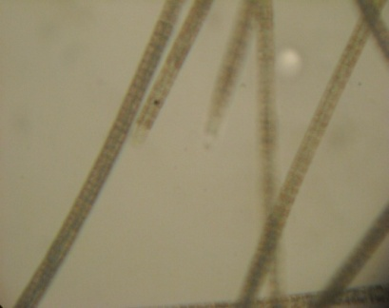
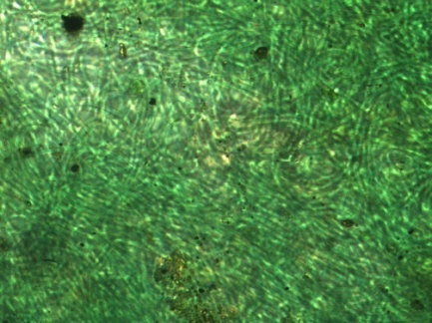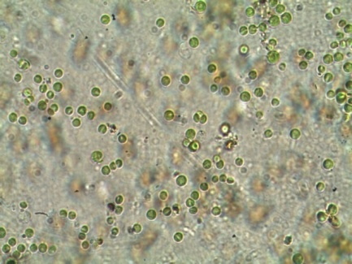
D E F
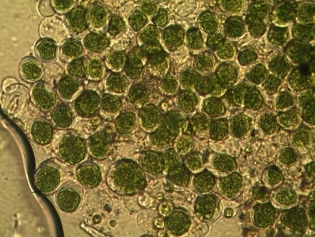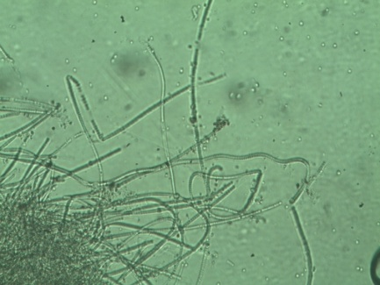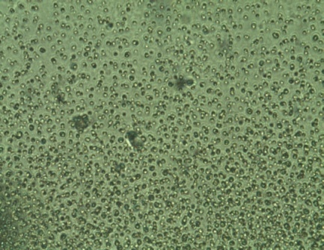
G H I
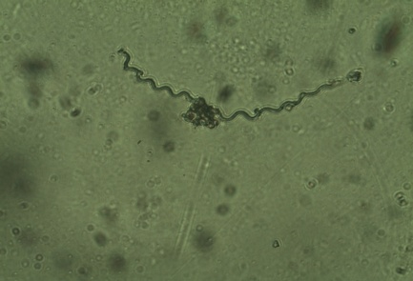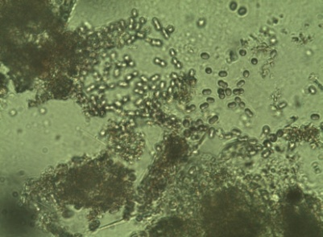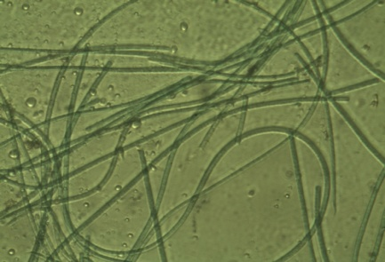

J K L
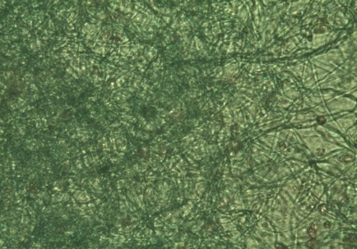
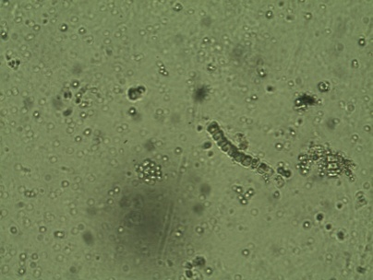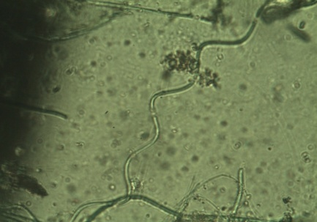
Fig S1. Cyanobacteria morphological identification photos (A) Phormidium tenue (B) Chroococcus minor(C) Trichodesmium erythraeum(D) Chroococcus tenax (E) Spirulina subsalsa (F) Synechocystis pevalekii (G) Spirulina Sp.(H) Synechococcus elongatous (I)Oscillatoria salina (J) Phormidium ambiguum(K) Chlorogloea fritschii (L) Spirulina major
A B C
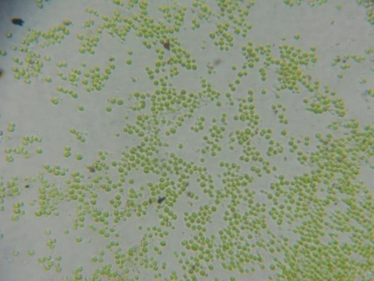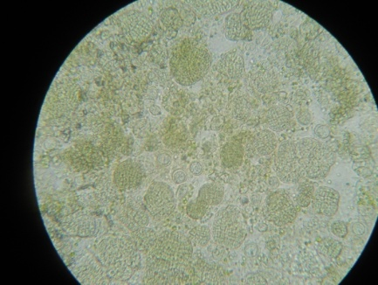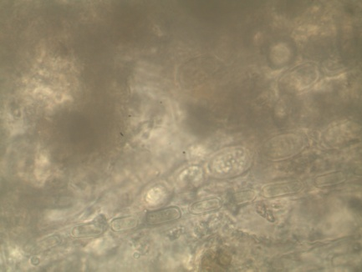
D E F
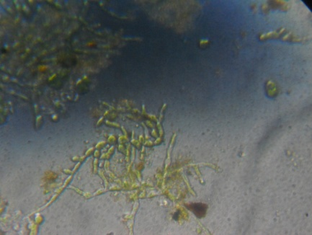
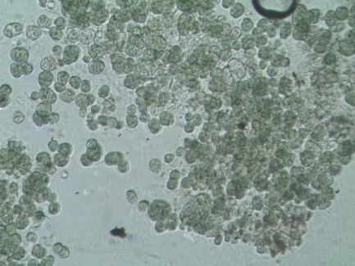 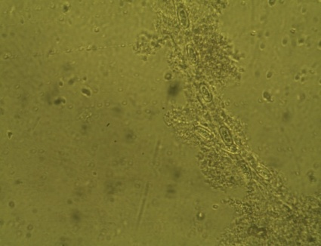
G H I
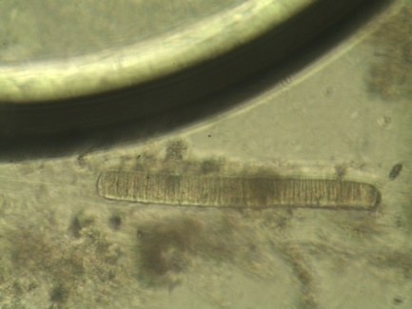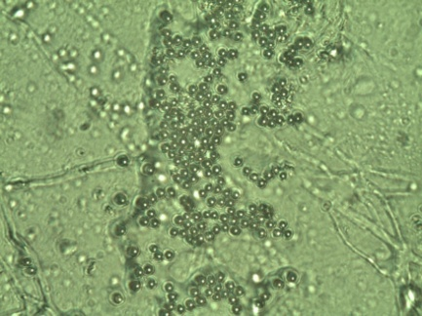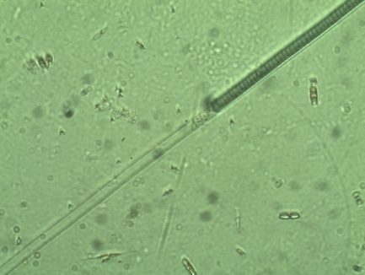
J
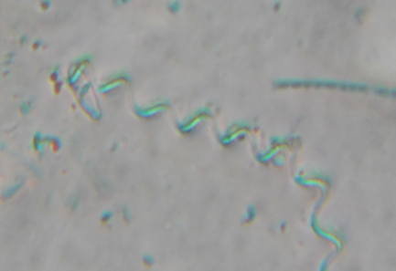

Fig S2. Cyanobacteria morphological identification photos (A) Microcystis aeruginosa, (B) Myxosarcina concinna (C)Anabaena iyengarii (D) Plectonema terebrans(E) Gloeocapsa sp.
(F) Anabaena sp.(G) Oscillatoria tenuis H) Aphanocapsa sp.(I) Lyngbya majuscula. (J).Spirulina sp.

