SUPPLEMENTARY CONTENTS
e-Table 1: Search strategy
e-Table 2. NOS Risk of Bias Scale for Included Studies
e-Figure 1. Funnel plot of meta-analysis for prevalence of frailty.
e-Figure 2. Funnel plot of meta-analysis for pulmonary function.
e-Figure 3. Funnel plot of meta-analysis for CAT score.
e-Figure 4. Funnel plot of meta-analysis for mMRC score.
e-Figure 5. Funnel plot of meta-analysis for 6MWD.
e-Figure 6. Funnel plot of meta-analysis for mortality.

e-Table 1. Search strategy
Database | Search number | Search Details
Pubmed | #1 | "pulmonary disease, chronic obstructive"[MeSH Terms]
Pubmed | #2 | "chronic obstructive bronchitis"[Text Word]
Pubmed | #3 | "chronic obstructive pulmonary disease"[Text Word]
Pubmed | #4 | "COPD"[Text Word]
Pubmed | #5 | "chronic obstructive airway disease"[Text Word]
Pubmed | #6 | "chronic obstructive lung disease"[Text Word]
Pubmed | #7 | "emphysema"[Text Word]
Pubmed | #8 | "bronchitis"[Text Word]
Pubmed | #9 | "pulmonary disease, chronic obstructive"[MeSH Terms] OR "chronic obstructive bronchitis"[Text Word] OR "chronic obstructive pulmonary disease"[Text Word] OR "COPD"[Text Word] OR "chronic obstructive airway disease"[Text Word] OR "chronic obstructive lung disease"[Text Word] OR "emphysema"[Text Word] OR "Bronchitis"[Text Word]
Pubmed | #10 | "frailty"[MeSH Terms]
Pubmed | #11 | "Frailty"[MeSH Terms]
Pubmed | #12 | "frail elderly"[Text Word]
Pubmed | #13 | "frail"[Text Word]
Pubmed | #14 | "Frailty"[MeSH Terms] OR "frail elderly"[Text Word] OR "frail"[Text Word]
Pubmed | #15 | ("pulmonary disease, chronic obstructive"[MeSH Terms] OR "chronic obstructive bronchitis"[Text Word] OR "chronic obstructive pulmonary disease"[Text Word] OR "COPD"[Text Word] OR "chronic obstructive airway disease"[Text Word] OR "chronic obstructive lung disease"[Text Word] OR "emphysema"[Text Word] OR "Bronchitis"[Text Word]) AND ("Frailty"[MeSH Terms] OR "frail elderly"[Text Word] OR "frail"[Text Word]) AND 2002/01/01:2022/07/01[Date - Publication]
EMBASE | #1 | 'chronic obstructive lung disease'/exp
EMBASE | #2 | 'chronic obstructive pulmonary disease':kw
EMBASE | #3 | 'copd':kw
EMBASE | #4 | 'chronic obstructive airway disease':kw
EMBASE | #5 | 'chronic obstructive bronchitis':kw
EMBASE | #6 | 'pulmonary disease':kw
EMBASE | #7 | 'emphysema':kw
EMBASE | #8 | 'bronchitis':kw
EMBASE | #9 | #1 OR #2 OR #3 OR #4 OR #5 OR #6 OR #7 OR #8
EMBASE | #10 | 'frailty'/exp
EMBASE | #11 | 'frail elderly':kw
EMBASE | #12 | 'frail':kw
EMBASE | #13 | #10 OR #11 OR #12
EMBASE | #14 | #9 AND #13
EMBASE | #15 | #9 AND #13 AND [01-01-2002]/sd NOT [02-07-2022]/sd
The Cochrane Library | #1 | [Pulmonary Disease, Chronic Obstructive] explode all trees
The Cochrane Library | #2 | (Chronic Obstructive Bronchitis):kw
The Cochrane Library | #3 | (chronic obstructive pulmonary disease):kw
The Cochrane Library | #4 | (COPD):kw
The Cochrane Library | #5 | (Chronic Obstructive Airway Disease):kw
The Cochrane Library | #6 | (Chronic Obstructive Lung Disease):kw
The Cochrane Library | #7 | emphysema:kw
The Cochrane Library | #8 | (bronchitis):kw
The Cochrane Library | #9 | #1 or #2 or #3 or #4 or #5 or #6 or #7 or #8
The Cochrane Library | #10 | [Frailty] explode all trees
The Cochrane Library | #11 | frail:kw
The Cochrane Library | #12 | (frail elderly):kw
The Cochrane Library | #13 | #10 or #11 or #12
The Cochrane Library | #14 | #9 and #13 with Cochrane Library publication date Between Jan 2002 and Jul 2022
Web of science | #1 | ((TS=(frailty)) OR AK=(frail)) OR AK=(frailty elderly)
Web of science | #2 | (((((((TS=(Pulmonary Disease, Chronic Obstructive)) OR AK=(Chronic Obstructive Bronchitis)) OR AK=(chronic obstructive pulmonary disease)) OR AK=(COPD)) OR AK=(Chronic Obstructive Airway Disease)) OR AK=(Chronic Obstructive Lung Disease)) OR AK=(emphysema)) OR AK=(bronchitis)
Web of science | #3 | #2 AND #1

e-Table 2. NOS Risk of Bias Scale for Included Studies
Author | Year | Case definition | Representativeness | Control selection | Control definition | Comparability | Ascertainment of exposure | Same method of ascertainment for case and controls | Non-Response rate | NOS
Finamore | 2021 | 1 | 1 | 1 | 1 | 2 | 1 | 1 | 0 | 8
kagiali | 2022 | 1 | 1 | 1 | 1 | 2 | 1 | 1 | 0 | 8
Kennedy | 2019 | 1 | 1 | 1 | 1 | 2 | 1 | 1 | 1 | 9
Kusunose | 2017 | 1 | 1 | 0 | 1 | 1 | 1 | 1 | 0 | 6
Luo | 2021 | 1 | 1 | 1 | 1 | 2 | 1 | 1 | 1 | 9
Maddocks | 2016 | 1 | 1 | 1 | 1 | 0 | 1 | 1 | 1 | 7
Naval | 2021 | 1 | 1 | 1 | 1 | 2 | 1 | 1 | 0 | 8
Yee | 2020 | 1 | 1 | 0 | 1 | 2 | 1 | 1 | 0 | 7
Bernabeu-Mora | 2017 | 1 | 1 | 1 | 1 | 1 | 1 | 1 | 1 | 8
Dias | 2020 | 1 | 1 | 0 | 1 | 1 | 1 | 1 | 1 | 7
Gale | 2018 | 1 | 1 | 0 | 1 | 0 | 1 | 1 | 0 | 5
Galizia | 2011 | 1 | 1 | 0 | 1 | 0 | 1 | 1 | 1 | 6
Gephine | 2021 | 1 | 1 | 0 | 1 | 2 | 1 | 1 | 1 | 8
Hanlon | 2022 | 1 | 1 | 0 | 1 | 2 | 1 | 1 | 1 | 8
Hirai | 2019 | 1 | 1 | 1 | 1 | 0 | 1 | 1 | 0 | 6
Lahousse | 2016 | 1 | 1 | 0 | 1 | 2 | 1 | 1 | 1 | 8
Medina-Mirapeix | 2018 | 1 | 1 | 1 | 1 | 2 | 1 | 1 | 0 | 8
Park | 2021 | 1 | 1 | 0 | 1 | 2 | 1 | 1 | 1 | 8
Scarlata | 2021 | 1 | 1 | 1 | 1 | 1 | 1 | 1 | 0 | 7
Ushida | 2022 | 1 | 1 | 0 | 1 | 2 | 1 | 1 | 0 | 7

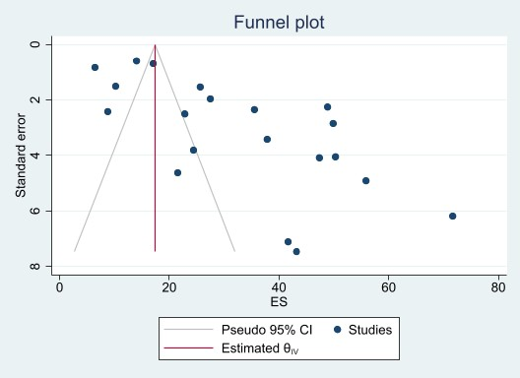
e-Figure 1. Funnel plot of meta-analysis for prevalence of frailty.

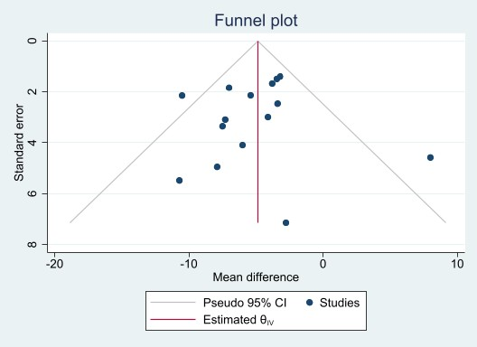
e-Figure 2. Funnel plot of meta-analysis for pulmonary function.
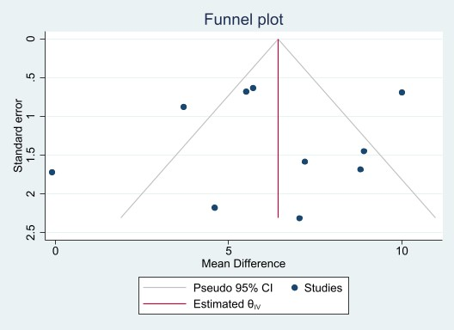
e-Figure 3. Funnel plot of meta-analysis for CAT score.
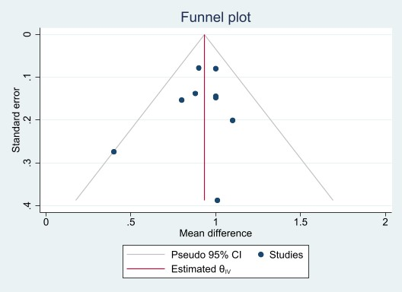
e-Figure 4. Funnel plot of meta-analysis for mMRC score.
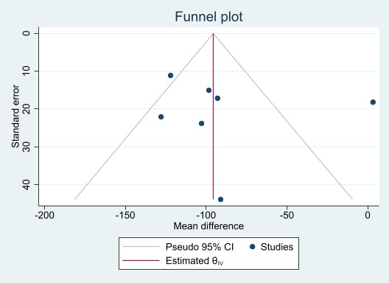
e-Figure 5. Funnel plot of meta-analysis for 6MWD.
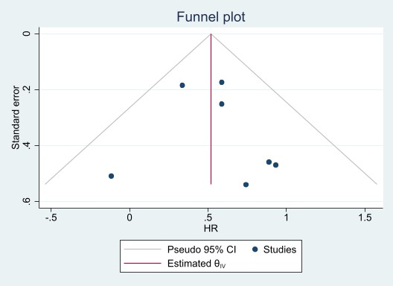
e-Figure 6. Funnel plot of meta-analysis for mortality.

