Additional file 1
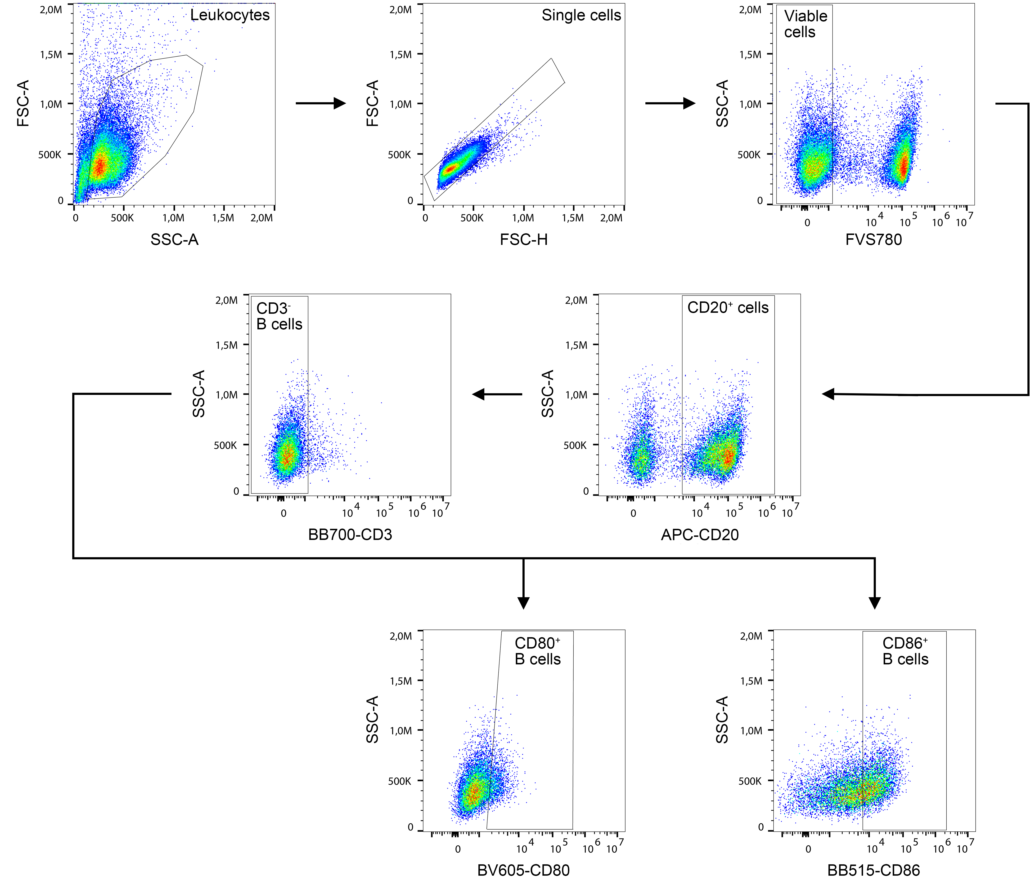
Fig. S1 Gating strategy for B cell activation. A leukocyte gate was set and single cells were determined by forward scatter (FSC)-height (FSC-H) and FSC-area (FSC-A). Dead cells were excluded, following which CD20⁺ cells were identified and CD20⁺CD3⁻ B cells were discriminated from the CD20⁺CD3⁺ cell population. Finally, the CD20⁺CD3⁻CD80⁺ and CD20⁺CD3⁻CD86⁺ B cell populations were identified.

Fig. S2 Layout of the antibody array used for investigating cytokines. GCSF = granulocyte colony stimulating factor; GM-CSF = granulocyte macrophage-colony stimulating factor; GRO = growth regulated proteins; IL = interleukin; IFN = interferon; MCP = monocyte chemoattractant protein; MIG = monokine induced by gamma interferon; Pos = positive; Neg = negative; RANTES = regulated on activation, normal T cell expressed and secreted (also known as CCL5); TNF = tumor necrosis factor; TGF = transforming growth factor

