Microbial strain resolution and retention analyses from shotgun metagenomic sequencing data of the upper respiratory tract

Nadezda Mostacci¹, Tsering Monika Wüthrich¹, Léa Siegwald², Silas Kieser², Ruth Steinberg^{3,4}, Olga Sakwinska², Philipp Latzin³, Insa Korten³ and Markus Hilty^{1x}

¹Institute for Infectious Diseases, University of Bern, Bern, Switzerland.
²Nestlé Research, Lausanne, Switzerland
³Division of Respiratory Medicine, Department of Paediatrics, Inselspital, University of Bern, Switzerland
⁴Graduate School for Biomedical Science, University of Bern, Switzerland

SUPPLEMENTARY MATERIAL

Supplementary table 1: Parameters according to 18 different tries*
Try | BREADTH_  THRESHOLD | TRIM_  SEQUENCES | MARKER_IN_N_  SAMPLES | SAMPLE_WITH_N_  MARKERS
0 | 80 | 50 | 80 | 20
1 | 80 | 50 | 50 | 10
2 | 80 | 50 | 50 | 15
3 | 80 | 50 | 80 | 15
4 | 80 | 50 | 50 | 5
5 | 70 | 50 | 50 | 5
6 | 60 | 50 | 50 | 5
7 | 50 | 50 | 50 | 5
8 | 40 | 50 | 50 | 5
9 | 30 | 50 | 50 | 5
10 | 20 | 50 | 50 | 5
11 | 50 | 50 | 40 | 5
12 | 50 | 50 | 30 | 5
13 | 50 | 40 | 50 | 5
14 | 50 | 30 | 50 | 5
15 | 50 | 50 | 50 | 20
16 | 50 | 50 | 50 | 10
17 | 50 | 50 | 50 | 15

*Default and chosen settings are defined in try 0 and 7 (yellow), respectively

Supplementary table 2: Species found by StrainPhlAn in NP samples (new parameters used)
Species | Found in # samples
Escherichia coli - contaminant | 397
Streptococcus mitis | 281
Streptococcus pneumoniae | 263
Dolosigranulum pigrum | 240
Streptococcus sp M334 | 230
Corynebacterium pseudodiphtheriticum | 165
Haemophilus haemolyticus | 152
Moraxella catarrhalis | 150
Haemophilus influenzae | 148
Corynebacterium accolens | 148
Haemophilus sp C1 | 142
Streptococcus oralis | 126
Streptococcus sp SK643 | 118
Ochrobactrum sp POC9 | 102
Streptococcus sp HMSC070B10 | 96
Staphylococcus aureus | 90
Human betaherpesvirus 5 | 88
Staphylococcus epidermidis | 73
Moraxella nonliquefaciens | 69
Moraxella lacunata | 58
Streptococcus phage MM1 | 51
Acinetobacter pittii | 50
Moraxella osloensis | 44
Streptococcus sp NLAE zl C503 | 42
Thermus parvatiensis | 36
Thermus thermophilus | 36
Moraxella lincolnii | 33
Enhydrobacter aerosaccus | 31
Staphylococcus haemolyticus | 30
Haemophilus aegyptius | 26
Streptococcus phage PH10 | 26
Acinetobacter sp WC 141 | 24
Acinetobacter baumannii | 22
Acinetobacter phage Bphi B1251 | 21
Streptococcus sp oral taxon 058 | 20
Bacillus cereus group | 20
Cutibacterium acnes | 16
Staphylococcus argenteus | 15
Moraxella equi | 15
Staphylococcus phage PT1028 | 14
Acinetobacter nosocomialis | 13
Staphylococcus capitis | 13
Staphylococcus arlettae | 12
Staphylococcus phage StB20 | 12
Staphylococcus sciuri | 12
Sphingomonas paucimobilis | 11
Lysinibacillus sphaericus | 11
Lactococcus lactis | 10
Comamonas aquatica | 10
Streptococcus pseudopneumoniae | 9
Klebsiella pneumoniae | 9
Klebsiella quasipneumoniae | 8
Sphingobium yanoikuyae | 8
Aerococcus viridans | 8
Haemophilus sp HMSC71H05 | 7
Paracoccus sanguinis | 7
Staphylococcus hominis | 7
Staphylococcus saprophyticus | 7
Malassezia restricta | 6
Gemella haemolysans | 6
Staphylococcus caprae | 6
Lysinibacillus fusiformis | 6
Pseudomonas aeruginosa group | 6
Enterobacter cloacae complex | 6
Klebsiella variicola | 5
Streptococcus salivarius CAG 79 | 5
Acinetobacter schindleri | 5
Staphylococcus virus PH15 | 5
Bacillus oceanisediminis | 5
Sphingobium lucknowense | 5
Staphylococcus virus CNPH82 | 5
Acinetobacter variabilis | 5
Pseudomonas putida group | 5
Aerococcus urinaeequi | 5
Bifidobacterium longum | 4
Sphingobacterium multivorum | 4
Brevundimonas diminuta | 4
Streptococcus parasanguinis | 4
Staphylococcus xylosus | 4
Klebsiella quasivariicola | 4
Actinobacillus ureae | 4
Streptococcus salivarius | 4
Elizabethkingia anophelis | 4
Lactobacillus gasseri | 4
Lactobacillus paragasseri | 4
Staphylococcus gallinarum | 4

Supplementary table 3: Species found by StrainPhlAn in OP samples
Species | Found in # samples
Streptococcus mitis | 252
Streptococcus sp M334 | 250
Streptococcus pneumoniae | 246
Streptococcus oralis | 238
Streptococcus sp SK643 | 236
Streptococcus sp HMSC071D03 | 233
Rothia mucilaginosa | 231
Neisseria subflava | 228
Haemophilus sp HMSC71H05 | 227
Streptococcus infantis | 227
Streptococcus sp HMSC070B10 | 225
Streptococcus sp HMSC034E03 | 223
Granulicatella elegans | 221
Neisseria flavescens | 221
Neisseria polysaccharea | 220
Haemophilus parainfluenzae | 218
Streptococcus sp oral taxon 058 | 217
Haemophilus haemolyticus | 211
Streptococcus parasanguinis | 210
Neisseria gonorrhoeae | 210
Haemophilus sp C1 | 209
Neisseria meningitidis | 207
Streptococcus sp HMSC067H01 | 204
Gemella haemolysans | 203
Veillonella infantium | 201
Prevotella melaninogenica | 201
Streptococcus salivarius | 198
Neisseria sp HMSC064E01 | 193
Streptococcus salivarius CAG 79 | 192
Fusobacterium sp oral taxon 370 | 191
Streptococcus sp F0442 | 191
Actinomyces odontolyticus | 190
Aggregatibacter sp oral taxon 458 | 189
Streptococcus peroris | 187
Streptococcus australis | 185
Streptococcus sp HPH0090 | 183
Porphyromonas somerae | 182
Neisseria macacae | 180
Veillonella sp T11011 6 | 178
Streptococcus vestibularis | 176
Prevotella sp F0091 | 175
Veillonella atypica | 174
Actinomyces sp HMSC035G02 | 171
Neisseria sicca | 171
Prevotella sp oral taxon 306 | 171
Fusobacterium periodonticum | 171
Prevotella jejuni | 169
Streptococcus thermophilus | 169
Actinomyces sp HPA0247 | 163
Campylobacter concisus | 160
Fusobacterium nucleatum | 155
Veillonella dispar | 154
Neisseria perflava | 149
Streptococcus phage EJ 1 | 146
Prevotella scopos | 145
Streptococcus phage PH10 | 144
Actinomyces sp ICM47 | 143
Gemella sanguinis | 142
Haemophilus paraphrohaemolyticus | 137
Neisseria mucosa | 130
Leptotrichia sp oral taxon 215 | 126
Streptococcus sp A12 | 124
Neisseria lactamica | 123
Veillonella parvula | 121
Morococcus cerebrosus | 112
Gemella morbillorum | 112
Streptococcus phage SM1 | 111
Leptotrichia hofstadii | 110
Prevotella sp oral taxon 299 | 109
Haemophilus influenzae | 109
Prevotella pallens | 106
Haemophilus parahaemolyticus | 106
Leptotrichia wadei | 104
Actinomyces sp oral taxon 180 | 98
Leptotrichia sp oral taxon 212 | 98
Atopobium parvulum | 96
Haemophilus sputorum | 95
Actinomyces graevenitzii | 95
Prevotella salivae | 93
Streptococcus pseudopneumoniae | 92
Prevotella nigrescens | 92
Neisseria sp oral taxon 014 | 92
Oribacterium sinus | 91
Neisseria cinerea | 89
Prevotella sp oral taxon 473 | 87
Capnocytophaga sputigena | 87
Capnocytophaga gingivalis | 82
Bulleidia extructa | 80
Capnocytophaga leadbetteri | 73
Actinomyces sp oral taxon 181 | 73
Streptococcus sanguinis | 70
Prevotella histicola | 70
Ochrobactrum sp POC9 | 66
Leptotrichia sp oral taxon 879 | 65
Solobacterium moorei | 62
Atopobium rimae | 61
Leptotrichia sp oral taxon 498 | 61
Leptotrichia sp oral taxon 847 | 60
Eubacterium sulci | 58
Lachnoanaerobaculum saburreum | 58
Staphylococcus aureus | 56
Prevotella shahii | 55
Megasphaera micronuciformis | 54
Mogibacterium diversum | 53
Streptococcus phage MM1 | 53
Fusobacterium hwasookii | 53
Campylobacter mucosalis | 52
Lautropia mirabilis | 51
Veillonella tobetsuensis | 49
Porphyromonas catoniae | 49
Neisseria elongata | 49
Campylobacter showae | 49
Aggregatibacter aphrophilus | 48
Streptococcus sp oral taxon 056 | 45
Stomatobaculum longum | 45
Tannerella sp oral taxon HOT 286 | 43
Leptotrichia buccalis | 42
Capnocytophaga sp oral taxon 338 | 41
Capnocytophaga ochracea | 40
Granulicatella adiacens | 39
Prevotella oulorum | 38
Moraxella nonliquefaciens | 38
Moraxella catarrhalis | 34
Eubacterium infirmum | 34
Capnocytophaga sp oral taxon 863 | 33
Phyllobacterium myrsinacearum | 33
Oribacterium parvum | 32
Eikenella corrodens | 29
Streptococcus anginosus group | 28
Peptostreptococcus stomatis | 25
Oribacterium asaccharolyticum | 25
Haemophilus pittmaniae | 24
Veillonella rogosae | 24
Moraxella lacunata | 24
Kingella denitrificans | 23
Actinomyces oris | 23
Prevotella intermedia | 21
Parvimonas sp oral taxon 110 | 20
Campylobacter rectus | 20
Escherichia coli | 19
Capnocytophaga sp oral taxon 878 | 18
Parvimonas sp oral taxon 393 | 18
Staphylococcus phage PT1028 | 17
Tannerella sp oral taxon 808 | 17
Parvimonas micra | 17
Pseudomonas aeruginosa group | 17
Klebsiella pneumoniae | 16
Enterobacter cloacae complex | 16
Actinomyces naeslundii | 15
Mogibacterium pumilum | 14
Staphylococcus argenteus | 13
Porphyromonas sp oral taxon 278 | 13
Selenomonas sputigena | 13
Actinomyces viscosus | 13
Selenomonas flueggei | 13
Pseudomonas phage F10 | 13
Actinomyces johnsonii | 12
Escherichia phage HK639 | 12
Moraxella lincolnii | 12
Stx2 converting phage 1717 | 12
Alloprevotella rava | 11
Prevotella loescheii | 11
Lachnospiraceae bacterium oral taxon 096 | 11
Cardiobacterium hominis | 11
Kingella oralis | 11
Treponema sp OMZ 838 | 11
Pseudomonas phage phi297 | 11
Abiotrophia defectiva | 10
Mogibacterium timidum | 10
Pseudomonas phage B3 | 10
Pseudomonas virus Pf1 | 10
Cardiobacterium valvarum | 9
Actinomyces sp oral taxon 170 | 9
Streptococcus virus Sfi21 | 8
Aggregatibacter segnis | 8
Acinetobacter johnsonii | 8
Pseudomonas phage PA16 | 8
Pseudomonas virus phiCTX | 8
Gemella asaccharolytica | 7
Acinetobacter junii | 7
Prevotella denticola | 7
Selenomonas sp oral taxon 126 | 7
Salmonella phage RE 2010 | 7
Porphyromonas endodontalis | 6
Streptococcus pyogenes | 6
Catonella morbi | 6
Capnocytophaga sp oral taxon 332 | 6
Alloprevotella tannerae | 6
Parvimonas sp KA00067 | 6
Treponema medium | 6
Treponema vincentii | 6
Lactococcus lactis | 6
Selenomonas sp oral taxon 138 | 6
Lactobacillus amylovorus | 6
Stenotrophomonas rhizophila | 6
Staphylococcus phage phiN315 | 5
Corynebacterium matruchotii | 5
Moraxella equi | 5
Simonsiella muelleri | 5
Moraxella caprae | 5
Streptococcus gordonii | 5
Pseudomonas sp SHC52 | 5
Stenotrophomonas sp SPM | 5
Stenotrophomonas maltophilia | 5
Pseudomonas geniculata | 5
Pseudomonas phage PAJU2 | 5
Selenomonas sp oral taxon 892 | 4
Pedobacter himalayensis | 4
Acinetobacter nosocomialis | 4
Acinetobacter phage Bphi B1251 | 4
Prevotella copri | 4
Acinetobacter baumannii | 4
Acinetobacter pittii | 4
Acinetobacter sp WC 141 | 4
Neisseria bacilliformis | 4
Fusobacterium necrophorum | 4
Centipeda periodontii | 4
Corynebacterium pseudodiphtheriticum | 4
Serratia marcescens | 4
Streptococcus dysgalactiae group | 4
Enterococcus faecalis | 4
Ottowia sp oral taxon 894 | 4

Supplementary FIGURE Legends

Supplementary Figure 1: Benchmarking parameters for species detection using metagenome-atlas. Illustrated are the 'best' cut offs for four different bacterial species.

Supplementary Figure 2: Benchmarking the different set of parameters (summary plot). The default set of parameters is illustrated in try No. 0 and is BREADTH_THRESHOLD 80, TRIM_SEQUENCES 50, MARKER_IN_N_SAMPLES 80 and SAMPLE_WITH_N_MARKERS 20. This is a summary plot of the panels a-f from Figure 1. The different tries (0-17) are illustrated on the x-axis and their characteristics are described in Supplementary table 1. Grey; Specificity, Yellow; Sensitivity and Green; F1 score. Default and chosen settings are shown at try '0' and at '7' (indicated in red), respectively.

Supplementary Figure 3: StrainPhlAn based tree for Streptococcus pneumoniae from NP data. Metagenomic assemblies (MAGs) are indicated in different cultures (red).

Supplementary Figure 4: In depth analyses to investigate the S. aureus sensitivity.
Supplementary Figure 4a: Bacterial reads correlation with TP TN etc. of S. aureus.; Supplementary Figure 4b; correlation semi-quantitative culture data and StrainPhlAn output

Supplementary Figure 5: Phylogenetic trees of S. aureus from OP data. Phylogenetic trees were created with StraiPhlAn from metagenomic and whole genome sequencing (WGS) data. On the left and on the right side are illustrated the trees using the default and adapted parameters, respectively.

Supplementary Figure 6: Pairwise single nucleotide variations (SNVs) for four different bacterial species of the NP
Mutation rates are shown for S. pneumoniae, M. catarrhalis, H. influenzae and S. aureus. Values represent samples from different children at different months (red), samples from same child (green; at 2 and 4 months) and from different children at the same age.

Supplementary Figure 7: Strain retention analyses based on normalized genetic distances of four different species of the NP (Different child (same month) versus different child) (different month)
The all-versus-all normalized genetic distances have been separately calculated for S. pneumoniae, M. catarrhalis, H. influenzae and S. aureus. Values were binned in intervals of 0.1 and then log-transformed.

Supplementary Figure 8: Strain retention analyses based on normalized genetic distances of four different species of the NP (Same child versus different child)
The all-versus-all normalized genetic distances have been separately calculated for S. pneumoniae, M. catarrhalis, H. influenzae and S. aureus. Values were binned in intervals of 0.1 and then log-transformed.

Supplementary Figure 1
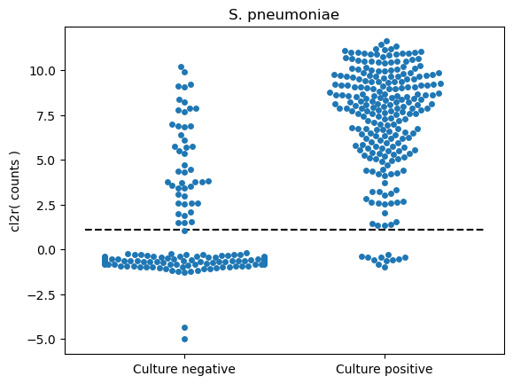
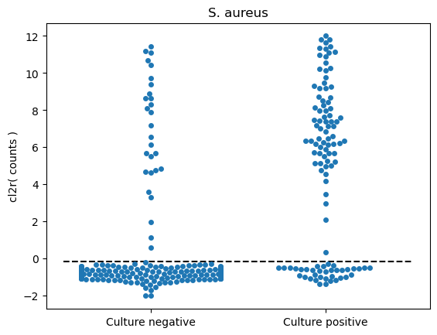
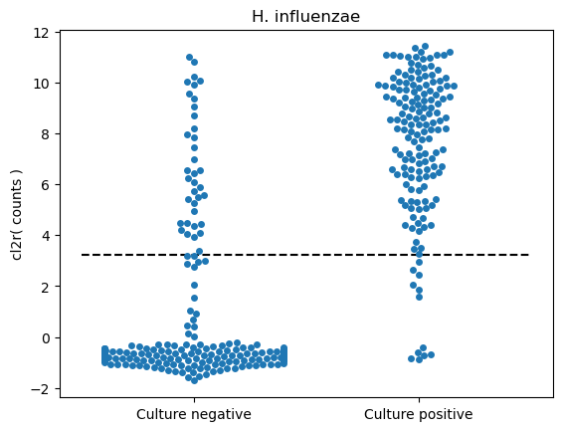
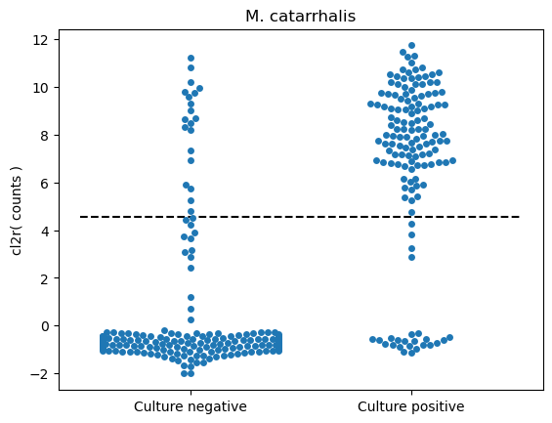

Supplementary Figure 2

Supplementary Figure 3: Streptococcus pneumoniae tree received by StrainPhlAn

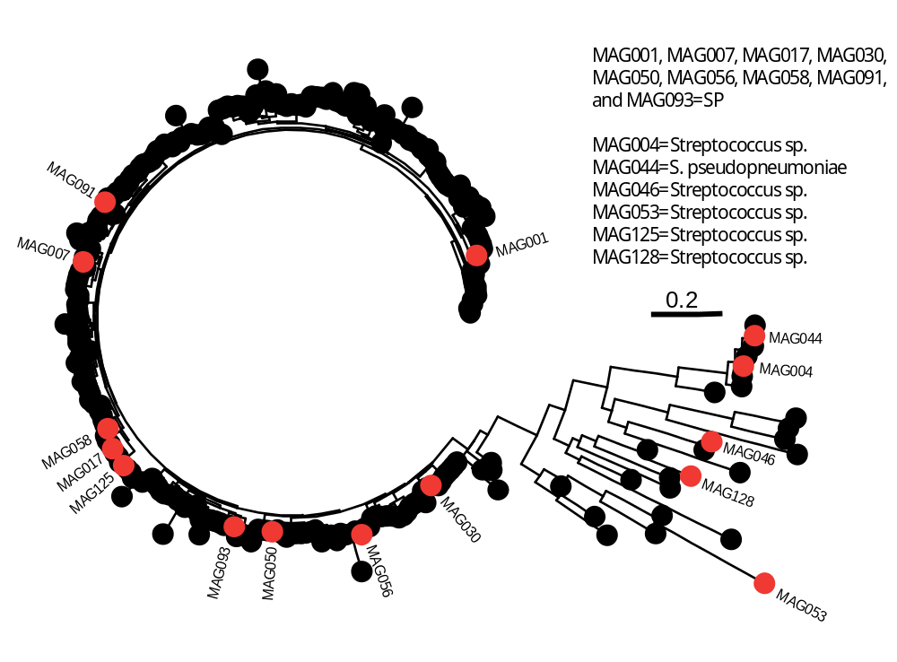

Supplementary Figure 4A and 4B

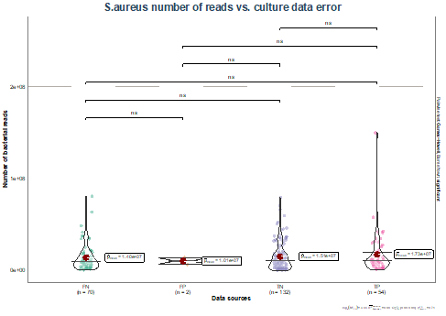

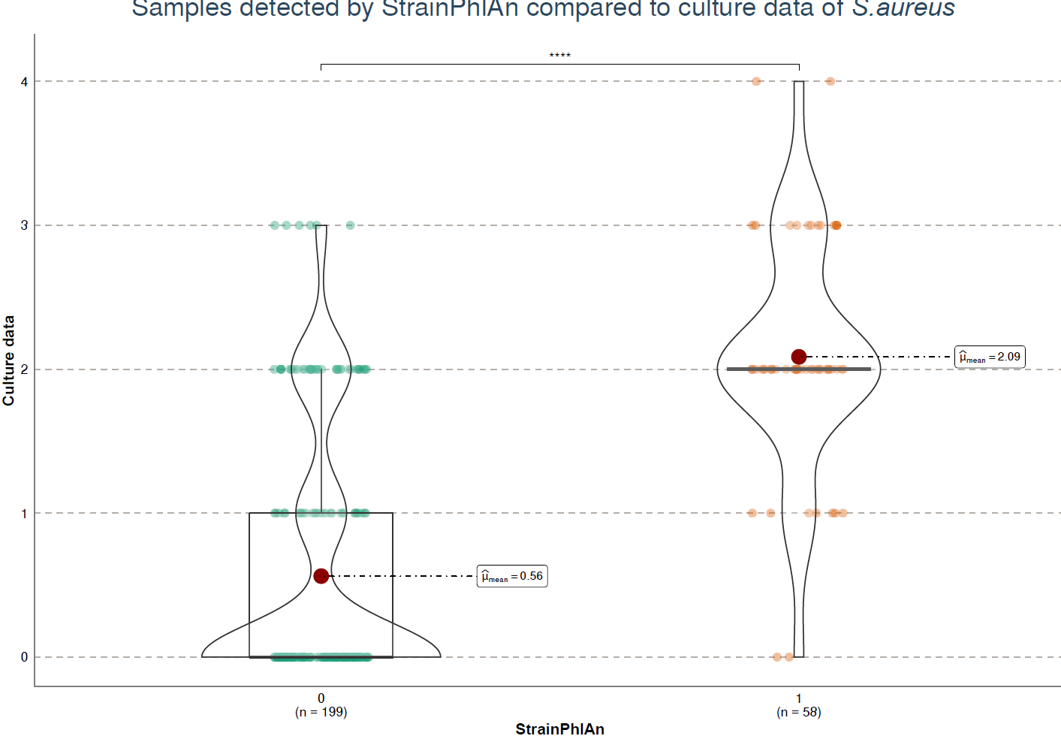

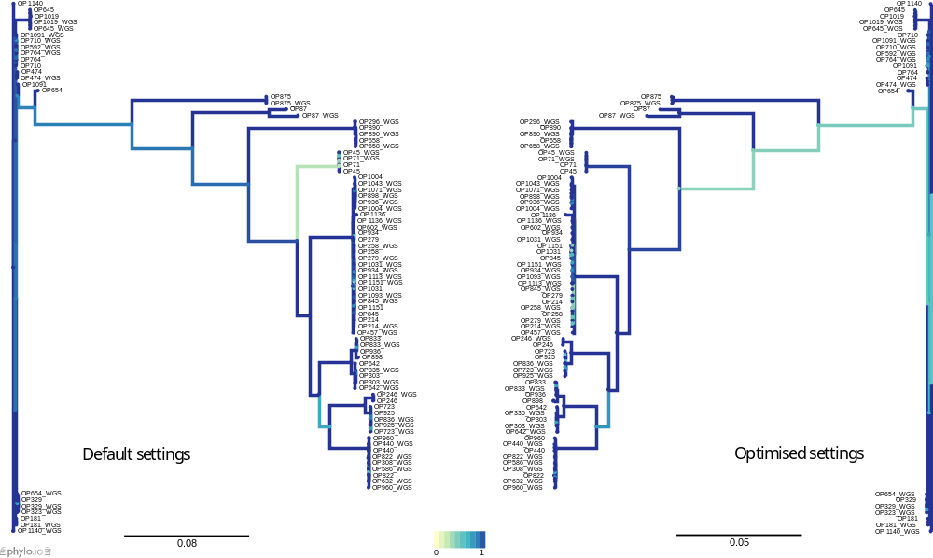
Supplementary figure 5

Supplementary figure 6: Pairwise single nucleotide variations (SNVs) for four different bacterial species of the NP
Values are shown for S. pneumoniae, M. catarrhalis, H. influenzae and S. aureus. Values represent samples from different children at different months (red), samples from same child (green; at 2 and 4 months) and from different children at the same age.

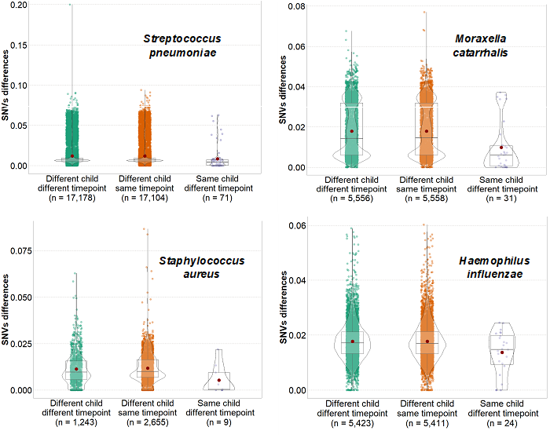

Supplementary figure 7
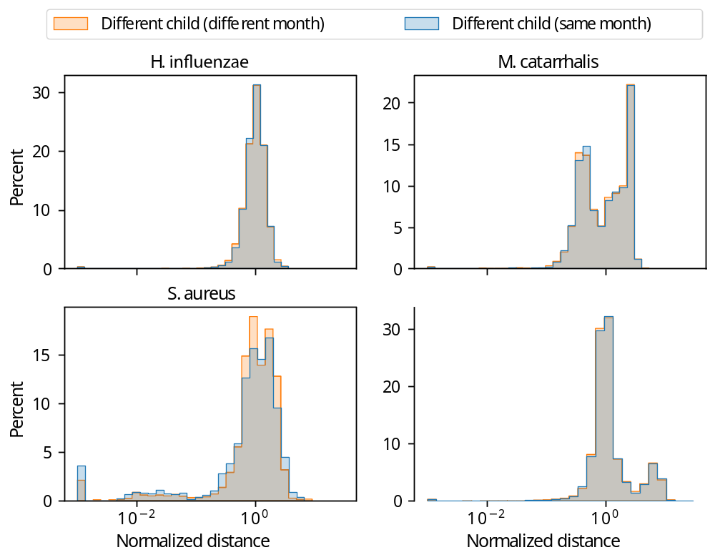

Supplementary figure 8

Supplementary figure 8

