Supplementary Information

An Atomically Thin Programmable and Photosensitive Monolayer Vanadium Disulfide Memtransistor
Mayukh Das^{1,#}, Akshay Wali ^{6,#}, Amit Kumar Patel ^{2#}, Suyash Rai², Anand B Puthirat³, Pulickel M Ajayan ³, Anchal Srivastava^{2*}, Saptarshi Das^{1,3 4,5,6,*}
¹Department of Engineering Science and Mechanics, Penn State University, PA 16802, USA
²Department of Physics, Institute of Science, Banaras Hindu University, Varanasi 221005 , India
³Department of Materials Science and Nano Engineering, Rice University, Houston, 77005, USA

⁴Materials Science and Engineering, Penn State University, PA 16802, USA
⁵ Department of Materials Characterization Laboratory, Penn State University, PA 16802, USA
⁶Department of Electrical Engineering, Penn State University, PA 16802, USA
# Equal Contribution
* Corresponding Author: anchal@bhu.ac.in, sud70@psu.edu

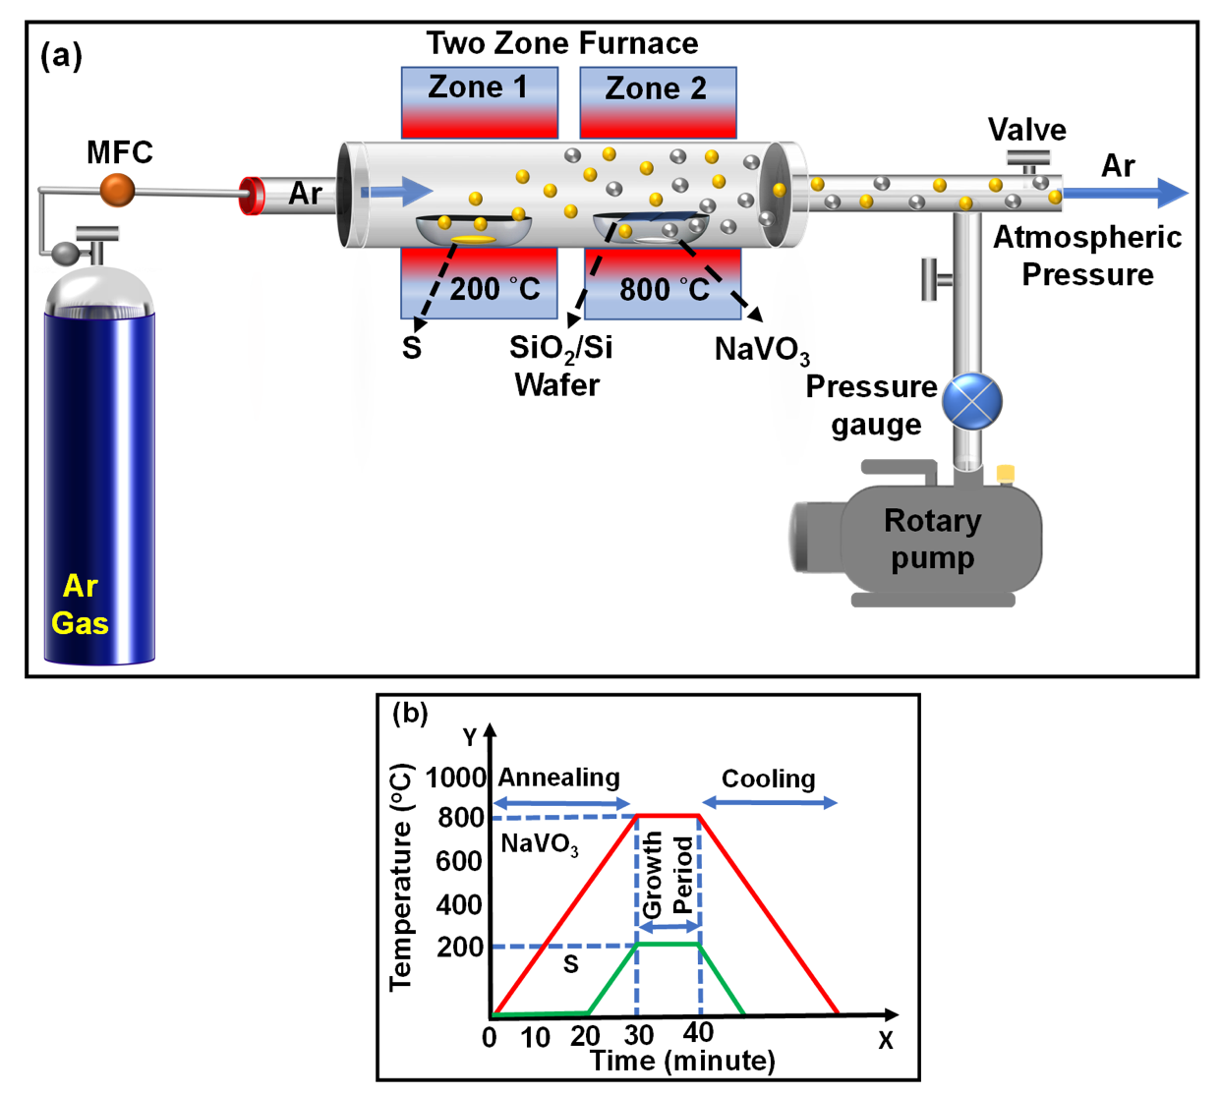
Supplementary Information S1. (a) Schematic illustration of the two zone APCVD synthesis process. (b) Optimized temperature profile of zone-1 and zone -2 for synthesis of monolayer VS₂ crystals.

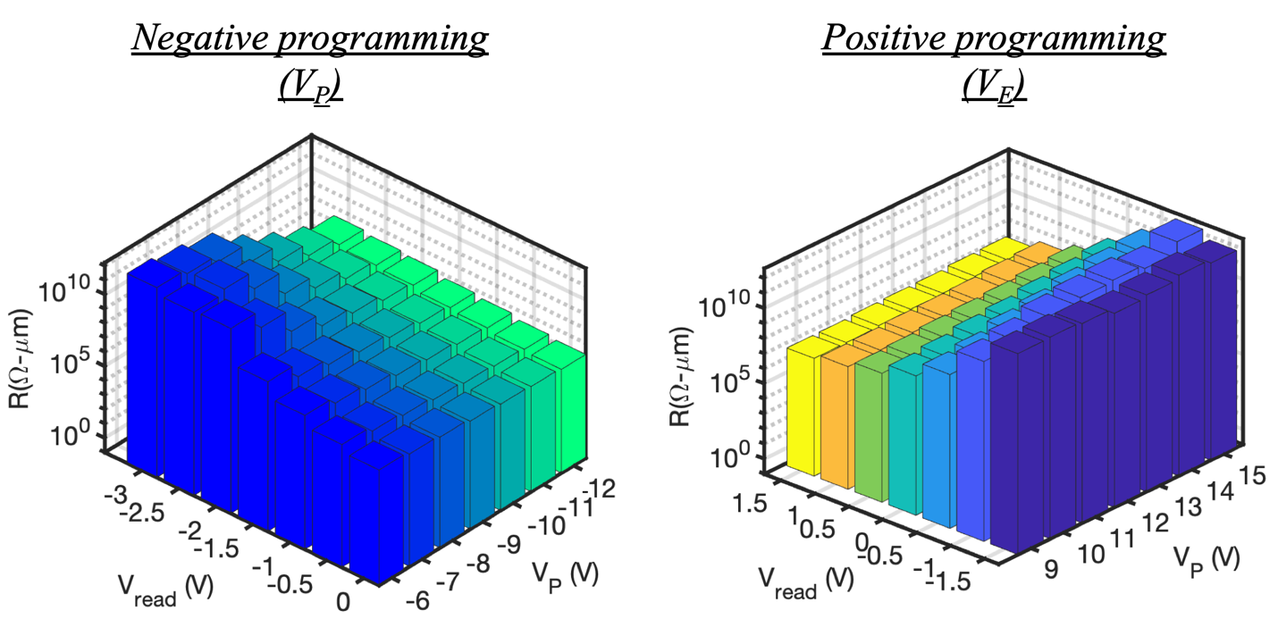
Supplementary Information S2: 3D bar plots of the extracted resistance values as a function of different $V_{BG}$ values for each applied $V_{P/E}$.

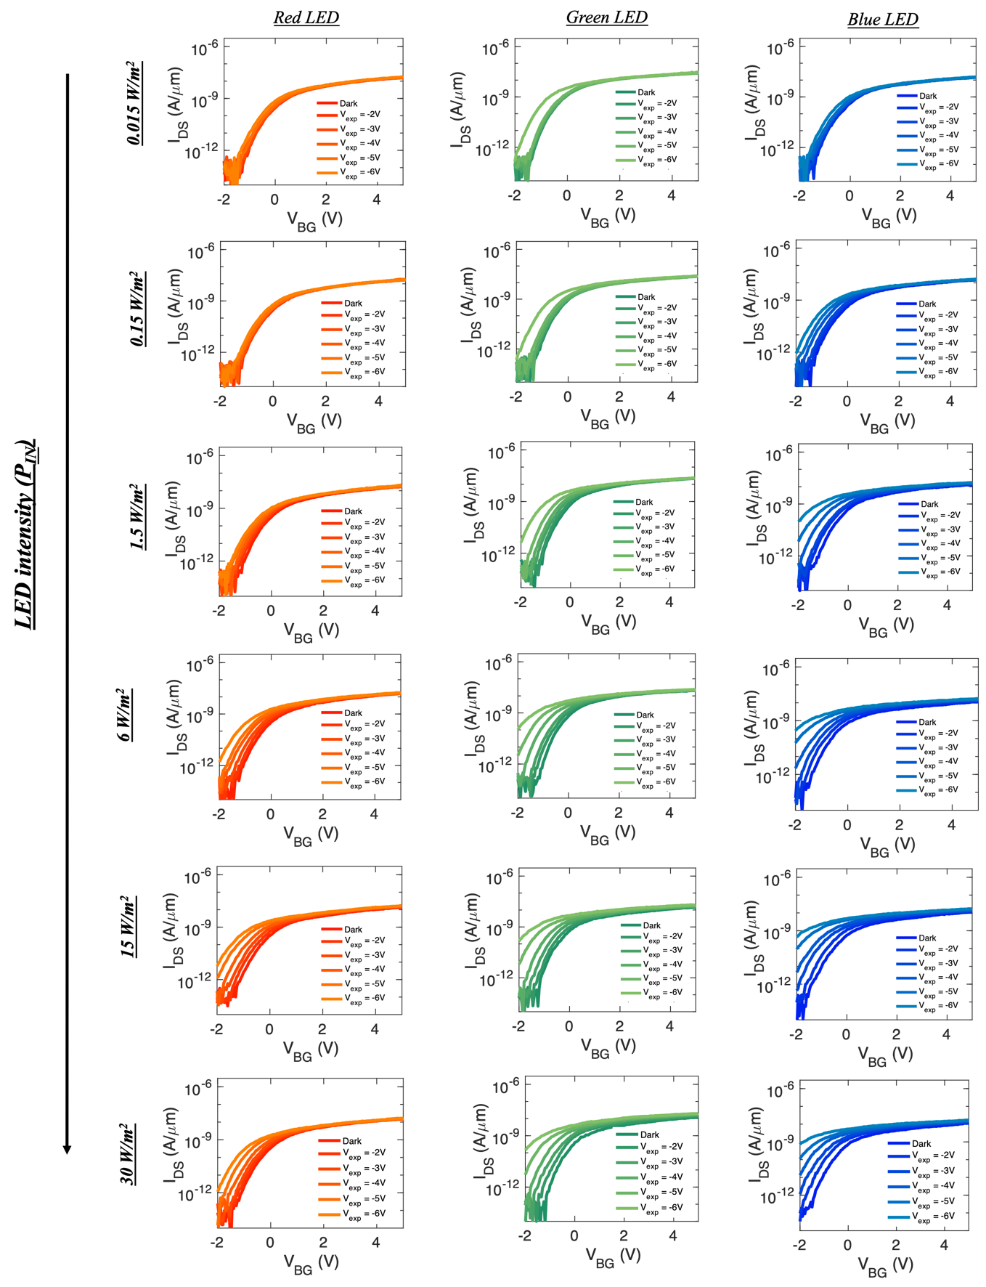
Supplementary Information S3: Transfer characteristics in logarithmic scale of a representative memtransistor for different $P_{in}$ intensities and $V_{exp}$ values for red, green and blue wavelengths

