Supporting Information for
Achieving energy transformation: Metal intensity for the development of China's photovoltaic roadmap towards 2060

Moisés Gómez, Guochang Xu, Yan Li, Junlin Liao, Xi Lu, Jinhui Li, Kebin He, Lili Liu, and Xianlai Zeng*
*E-mail: xlzeng@tsinghua.edu.cn (X. Zeng)

This PDF file includes:
Supporting text
Figures S1 to S3
Tables S1 to S4
SI References

Table S1. The cumulated annual solar PV capacity in China from 2000 to 2060 (GW).
Year | BLS | CNS | Year | BLS | CNS | Year | BLS | CNS
2000 | 0.03 | 0.03 | 2021 | 290.9 | 290.3 | 2041 | 2099.2 | 2334.5
2001 | 0.04 | 0.04 | 2022 | 332.5 | 331.5 | 2042 | 2201.3 | 2473.8
2002 | 0.06 | 0.06 | 2023 | 379.4 | 378 | 2043 | 2297.7 | 2608.5
2003 | 0.07 | 0.07 | 2024 | 431.8 | 430.2 | 2044 | 2387.8 | 2737.7
2004 | 0.08 | 0.08 | 2025 | 490.2 | 488.7 | 2045 | 2471.3 | 2860.3
2005 | 0.14 | 0.14 | 2026 | 554.9 | 553.9 | 2046 | 2548.2 | 2975.8
2006 | 0.16 | 0.16 | 2027 | 626.2 | 626.2 | 2047 | 2618.4 | 3083.5
2007 | 0.2 | 0.2 | 2028 | 704.1 | 706.1 | 2048 | 2682.1 | 3183.4
2008 | 0.25 | 0.25 | 2029 | 788.7 | 793.8 | 2049 | 2739.5 | 3275.2
2009 | 0.41 | 0.41 | 2030 | 879.9 | 889.5 | 2050 | 2791 | 3359.2
2010 | 1.02 | 1.02 | 2031 | 977.2 | 993.2 | 2051 | 2837 | 3435.4
2011 | 3.11 | 3.11 | 2032 | 1080.2 | 1104.7 | 2052 | 2877.9 | 3504.3
2012 | 6.72 | 6.72 | 2033 | 1188.2 | 1223.7 | 2053 | 2914.1 | 3566.2
2013 | 17.75 | 17.75 | 2034 | 1300.2 | 1349.5 | 2054 | 2946 | 3621.6
2014 | 28.39 | 28.39 | 2035 | 1415.2 | 1481.5 | 2055 | 2974.1 | 3671
2015 | 43.54 | 43.54 | 2036 | 1532 | 1618.5 | 2056 | 2998.8 | 3714.9
2016 | 77.79 | 77.79 | 2037 | 1649.3 | 1759.5 | 2057 | 3020.4 | 3753.8
2017 | 130.8 | 130.8 | 2038 | 1765.9 | 1903.1 | 2058 | 3039.2 | 3788.1
2018 | 175.02 | 175.02 | 2039 | 1880.5 | 2047.7 | 2059 | 3055.7 | 3818.3
2019 | 204.57 | 204.57 | 2040 | 1992 | 2192.1 | 2060 | 3070 | 3844.9
2020 | 254 | 254
Note: data for the year of 2000-2020 is from https://ourworldindata.org/grapher/installed-solar-pv-capacity?time=earliest..latest&country=CHN~OWID_WRL. Data for the year 2021-2060 is determined by a logistic growth.

Figure S1. Metal intensity to reach the PV roadmap by different scenarios and dominant sub-technologies: a) historical data 2000-2020, b) cumulated metal intensity in 2060, and c) zoom of the other metals from part b).
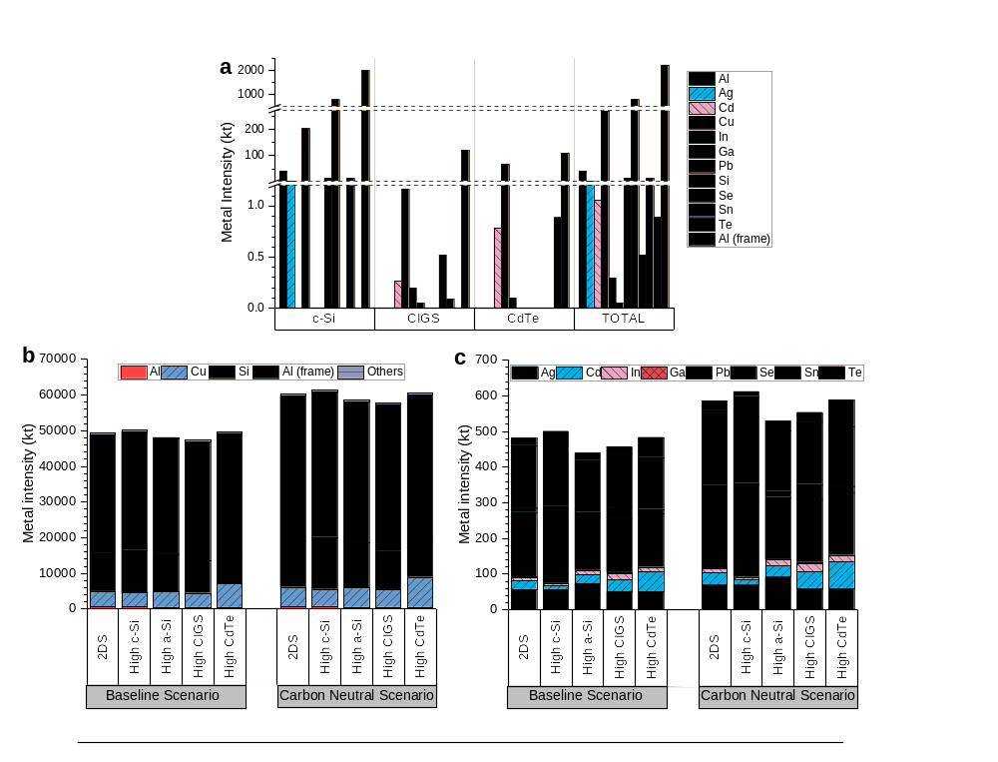

Figure S2. Metal intensity to reach the PV roadmap by different sub-technologies in the BSL-2DS, BSL-high a-Si, BSL-High CIGS, BSL-High CdTe, BSL-High c-Si, CNS-2DS, CNS-high a-Si, CNS-high CdTe, CNS-high CIGS, and CNS-high c-Si scenario.
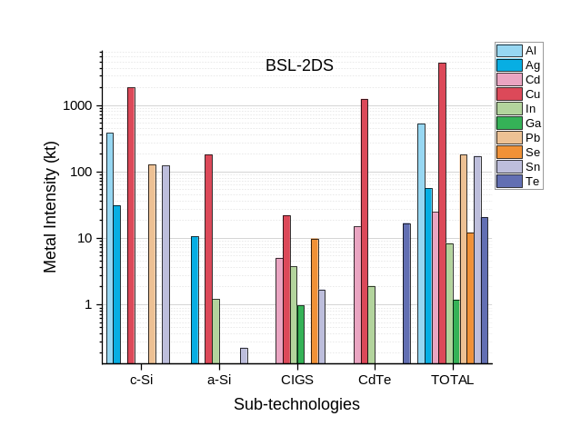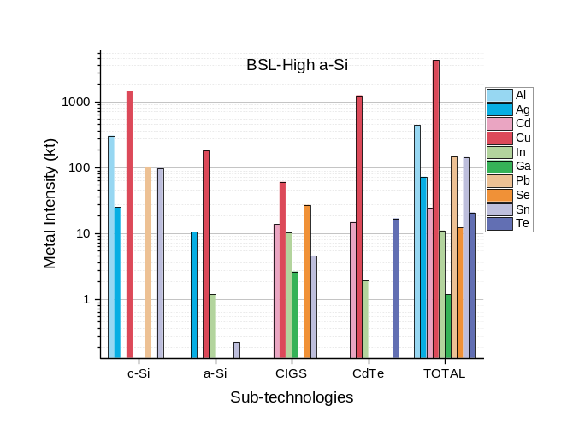
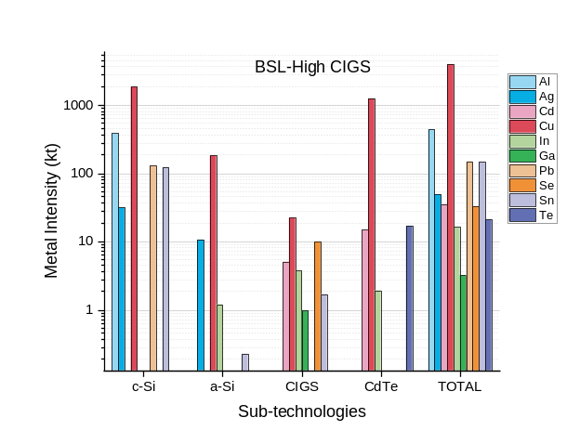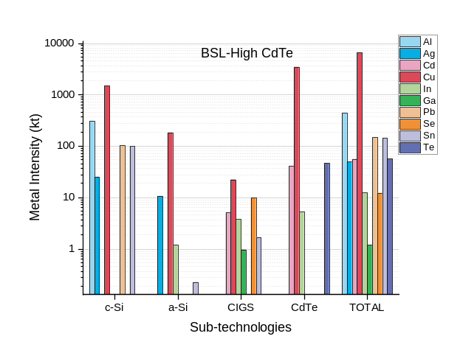
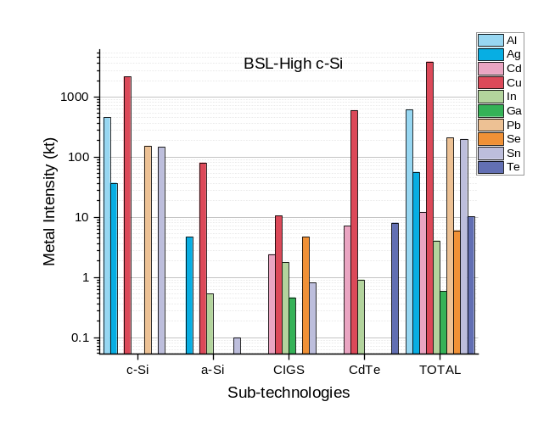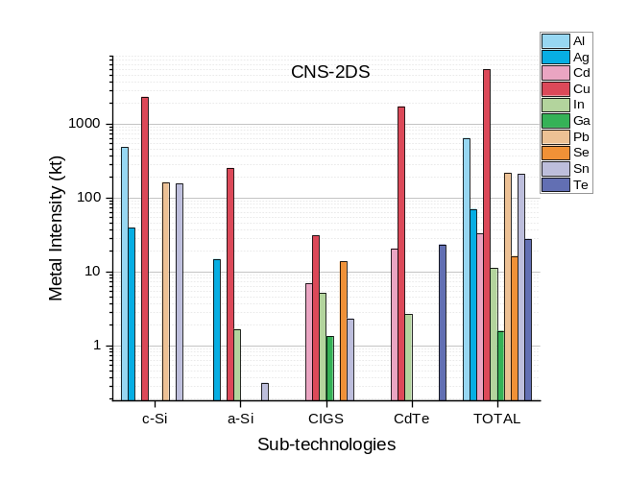

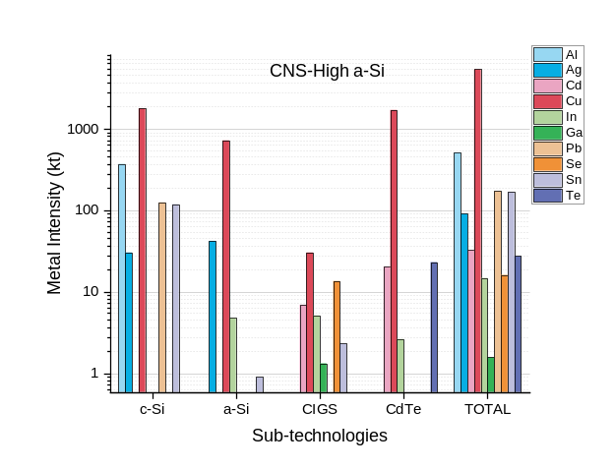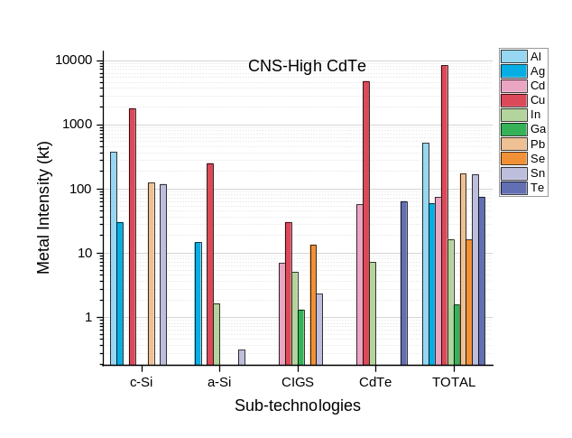
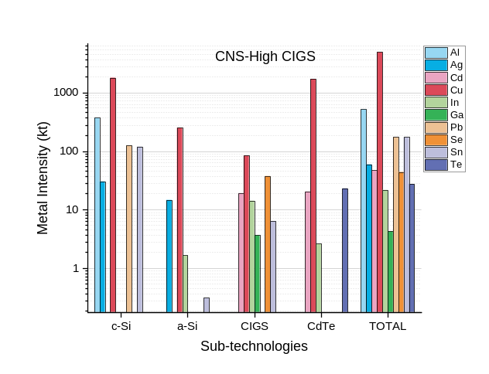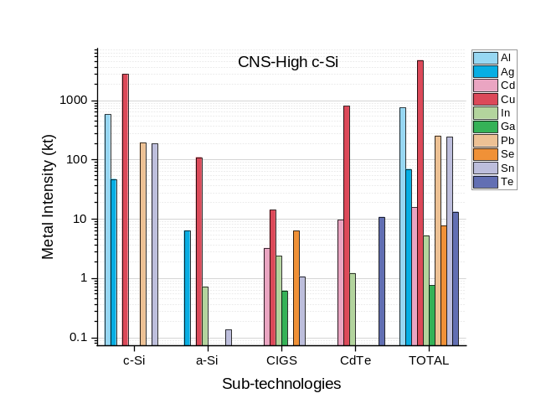

Figure S3. PV energy and technology roadmaps: a) cumulated installed PV capacity, b) 2-degree scenario (2DS), c) high c-Si scenario, d) high a-Si scenario, e) hight CIGS scenario, and g) high CdTe scenario.

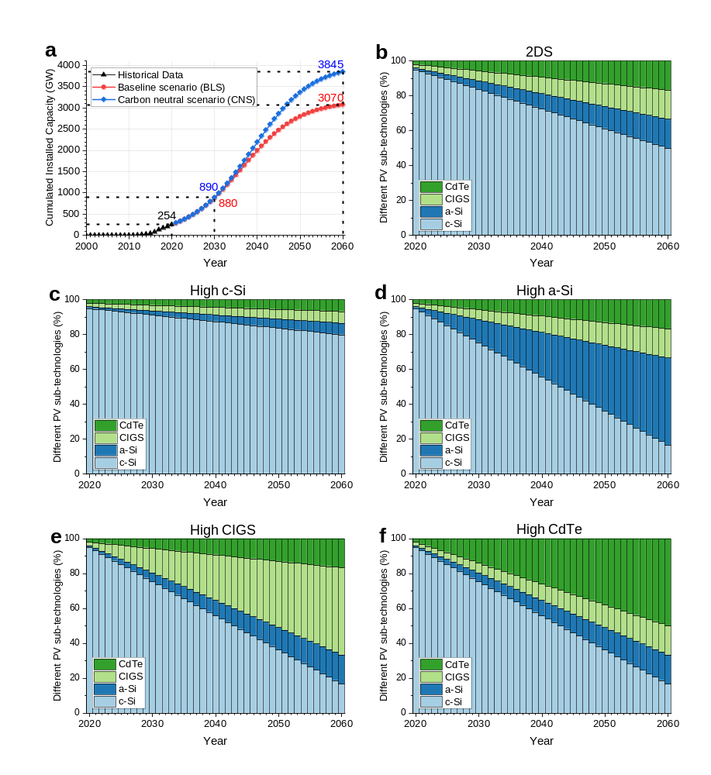

Table S2. PV cells and modules parameters.
Information | Values | Unit | References | Data from
Solar cell | 166x166 | mm² x mm²
Module power (~1.8 m²) | 415 | W | ¹ | Fig. 55
Module power (~2.2 m²) | 500 | W | ¹ | Fig. 56
Module sizes (residential installations) | 1.8 | m² | ¹ | Fig. 59
Module sizes (power plant installations) | 2.5 | m² | ¹ | Fig. 60
Module weight (residential installations) | 21 | kg | ¹ | Fig. 61
Module weight (power plant installations) | 30 | kg | ¹ | Fig. 62
Module Size | 2.2 | m² | Average values used
Module power (~2.15 m²) | 212.8 | W/m² | Average values used
Module weight | 25.5 | kg | Average values used

Table S3. Estimations of the energy cost associated with different metal productions, global and Chinese production, and reserves.
Metals & Metalloids | Symbol | Energy cost of production (GJ/t) | References | Price 2020 (US$/t)¹ | Global Production in 2020 (t)² | China Production in 2020 (t)² | Chinese Reserves (kt)³
Aluminium | Al | 212 | ² | 1,704 | 65,100,000 | 37,100,000 | 250,000⁴
Cadmium | Cd | 110 | ² | 2,290 | 24,000 | 10,000 | 13.2⁵
Copper (hydro) | Cu | 64 | ² | 6,221 | 20,600,000 | 1,720,000 | 26,000
Copper (pyro) | Cu | 33 | ² | 6,221 | 20,600,000 | 10,000,000 | 26,000
Gallium | Ga | 12,660 | ² | 596,000 | 327 | 3 | 0.5⁶
Gold | Au | 68,400 | ² | 57,035 | 3,030 | 365 | 2
Indium | In | 2,875 | ² | 158,000 | 960 | 540 | 3.4⁷
Lead | Pb | 20 | ² | 1,823 | 4,380,000 | 1,900,000 | 18,000
Silicon | Si | 1,250 | https://energyeducation.ca/encyclopedia/Silicon | 2,116 | 8,000,000 | 5,400,000 | - ⁸
Selenium | Se | - | - | 14,573 | 3,120 | 1,200 | 26
Silver | Ag | 1,582 | ² | 664,662 | 23,500 | 3,380 | 41
Steel | Alloy (Fe+C) | 19 | https://www.iea.org/reports/iron-and-steel | 482 | 1,790,000,000 | 1,060,000,000 | Not applicable
Tellurium | Te | - | - | 56,000 | 562 | 330 | 6.6
Tin | Sn | 207 | ² | 17,130 | 264,000 | 84,000 | 1,100
Zinc (electrolytic) | Zn | 48 | ² | 2,264 | 12,000,000 | 4,060,000 | 44,000
1: Prices were obtained from London Metal Exchange (LME) and the U.S. Geological Survey. Steel Price based on hot-rolled coil (HRC) steel benchmark.
2: Global and Chinese metal production were obtained from the U.S. Geological Survey (USGS).
3: Global reserves were obtained from the USGS annual reports of each element in 2021.
4: As a rule, 4 tons of dried bauxite is required to produce 2 tons of alumina, which, in turn, produces 1 ton of aluminium.
5: Cadmium reserves was estimates from the zinc reserves as typical cadmium content in zinc ores averages about 0.03%.
6: Most gallium is produced as a by-product of processing bauxite, and the remainder is produced from zinc-processing residues. The average gallium content of bauxite is 50 parts per million. However, less than 10% of the gallium in bauxite and zinc resources is potentially recoverable.
7: Indium reserves was calculated based on zinc reserves as 95% of the indium is produced as a by-product of zinc ores.
8: World and domestic resources for making silicon metal and alloys are abundant and adequate to supply world requirements for many decades.
Table S4. Metal and metalloid requirements for different cell technologies.
c-Si (PERC) |  | References | a-Si (SHJ) |  | References
Efficient (%) | 19.6-22.3 | ³ | Efficient (%) | 22.4 | ⁴
Material | [kg/MW] |  | Material | [kg/MW]
Al | 184 | ⁵ | Ag | 47 | ⁴
Ag | 15 | ⁶ | Cu | 804 | ⁵
Cu | 884 | ⁶ | In | 5.32 | ⁶
Pb | 62 | ⁵ | Si | 2,749 | ⁵
Si | 3,430 | ⁵ | Sn | 1 | ⁵
Sn | 59 | ⁵ | Al (frame) | 7,452 | ⁵
Al (frame) | 8,768 | ⁵
CIGS |  | References | CdTe |  | References
Efficient (%) | 15.7 | ⁵ | Efficient (%) | 18-22 | ³
Material | [kg/MW] |  | Material | [kg/MW]
Cd | 21 | ⁵ | Cd | 62 | ⁷
Cu | 92 | ⁵ | Cu | 5181 | ²
In | 15.5 | ¹ | In | 7.95 | ⁸
Ga | 4 | ⁷ | Te | 70 | ⁷
Se | 41 | ⁷ | Al (frame) | 8,571 | -
Sn | 7 | ⁵ | Frame was calculated as the average of the other frames |  | -
Al (frame) | 9,494 | ⁵ |  |  | -

SI References
1 International Technology Roadmap for Photovoltaic (ITRPV): Results 2020. 88 (2021).
2 Fizaine, F. & Court, V. Renewable electricity producing technologies and metal depletion: A sensitivity analysis using the EROI. Ecological Economics 110, 106-118, doi:https://doi.org/10.1016/j.ecolecon.2014.12.001 (2015).
3 Allouhi, A., Rehman, S., Buker, M. S. & Said, Z. Up-to-date literature review on Solar PV systems: Technology progress, market status and R&D. Journal of Cleaner Production 362, 132339, doi:https://doi.org/10.1016/j.jclepro.2022.132339 (2022).
4 Louwen, A., van Sark, W., Schropp, R. & Faaij, A. A cost roadmap for silicon heterojunction solar cells. Solar Energy Materials and Solar Cells 147, 295-314, doi:https://doi.org/10.1016/j.solmat.2015.12.026 (2016).
5 Gervais, E., Shammugam, S., Friedrich, L. & Schlegl, T. Raw material needs for the large-scale deployment of photovoltaics – Effects of innovation-driven roadmaps on material constraints until 2050. Renewable and Sustainable Energy Reviews 137, 110589, doi:https://doi.org/10.1016/j.rser.2020.110589 (2021).
6 Månberger, A. & Stenqvist, B. Global metal flows in the renewable energy transition: Exploring the effects of substitutes, technological mix and development. Energy Policy 119, 226-241, doi:https://doi.org/10.1016/j.enpol.2018.04.056 (2018).
7 Kavlak, G., McNerney, J., Jaffe, R. L. & Trancik, J. E. Metal production requirements for rapid photovoltaics deployment. Energy & Environmental Science 8, 1651-1659, doi:10.1039/C5EE00585J (2015).
8 Öhrlund, I. Future Metal Demand from Photovoltaic Cells and Wind Turbines ‐ Investigating the Potential Risk of Disabling a Shift to Renewable Energy Systems. (Science and Technology Options Assessment (STOA), European Parliament, 2011).

