Supplementary Information

Reconfigurable, non-volatile neuromorphic photovoltaics

Tangxin Li ^{1, 2, 6#}, Jinshui Miao ^{1, 6#*}, Xiao Fu ^{1, 2, 6#}, Bo Song ^{3#}, Bin Cai ³, Xiaohao Zhou ^{1, 6}, Peng Zhou ⁴, Xinran Wang ⁵, Deep Jariwala ^{2*}, Weida Hu ^{1, 6*}
¹ State Key Laboratory of Infrared Physics, Shanghai Institute of Technical Physics, Chinese Academy of Sciences, Shanghai, 200083, China
² Department of Electrical and Systems Engineering, University of Pennsylvania, Philadelphia PA 19104, United States
³ Institute of Intelligent Machines, HFIPS, Chinese Academy of Sciences, Hefei, China
⁴ School of Microelectronics, Fudan University, Shanghai, China
⁵ School of Electronic Science and Engineering, Nanjing University, Nanjing 210093, China
⁶ University of Chinese Academy of Sciences, Beijing, China

*Corresponding authors
E-mail: Jinshui Miao: jsmiao@mail.sitp.ac.cn, Deep Jariwala: dmj@seas.upenn.edu, Weida Hu: wdhu@mail.sitp.ac.cn

#These authors contributed equally to the work.

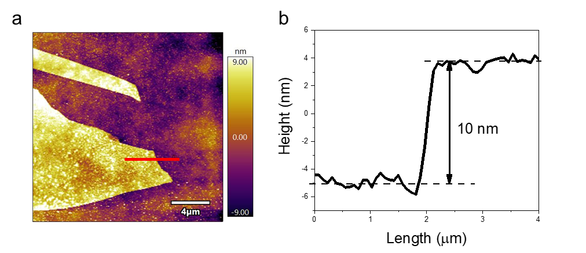

Figure S1. a, AFM topography image of MoS₂ flakes obtained by a mechanical exfoliation approach. b, Height profiles taken along the horizontal red lines in (a), AFM analysis of a MoS2 flake shows the thickness of the material was about 10nm.

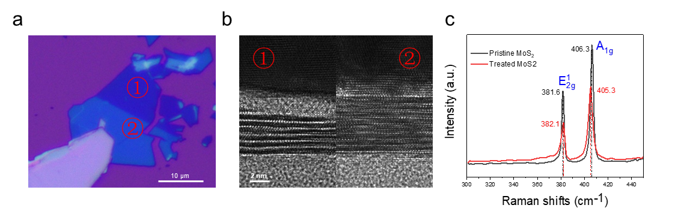

FigureS2. Optical microscopy (a) and transmission electron microscope (TEM) (b) images of MoS₂ flakes before (②) and after (①) plasma treatment. c, Raman spectrum of MoS₂ flakes before (②) and after (①) plasma treatment, measured using an excitation wavelength of 520 nm.

The thinning down of the MoS₂ after Ar plasma treatment shows different thickness/contrast compare to pristine MoS₂ which is confirmed by the optical/TEM images shown in Fig. S2a and S2b. Fig. S2c shows the two Raman features of the MoS₂, which correspond to $E_{2g}^{1}$ and $A_{1g}$ peak, before and after Ar plasma treatment. The red shift of $E_{2g}^{1}$ peak and the blue shift of $A_{1g}$ peak as well as the decreasing in intensities of these two peaks further confirm the thinning of the MoS₂ flake^{1,2}.

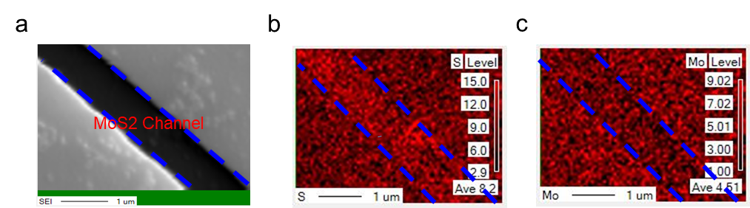

FigureS3. a, Scanning electron microscopy (SEM) image of the treatment Au/MoS2/Au device, the region between the blue line is MoS₂ Channel. Wavelength dispersive X-ray spectroscopy (WDS) of S-atom Level (b) and Mo-atom level (c) distribution below the Au electrode and MoS₂ Channel regions.

Energy dispersive spectroscopy (EDS) can hardly estimate the contents of S and Mo elements precisely which attribute to the spectral overlap between the S Kα (2.30 keV) and the Mo Lα (2.29 keV) X-ray emission lines. We carry out the WDS measurement to estimate the contents of S and Mo elements quantitatively^{3,4}. Obviously, the content of S is much higher than that of Mo for the pristine MoS2 channel as shown in Fig. S3b and S3c. The ratio of S/Mo is about 1.95 which is close to the stoichiometry of the S and Mo elements in pristine MoS2. On the contrary, the S signal below the electrodes is much weaker than the S signal in the channel With a ratio of S/Mo of about 1.42. The different contrast ratio of S/Mo between pristine MoS2 and plasma-treated MoS2 suggests that S vacancies appear under the electrode. This result is consistent with the experimental process, that MoS2 under the electrode was treated by plasma.

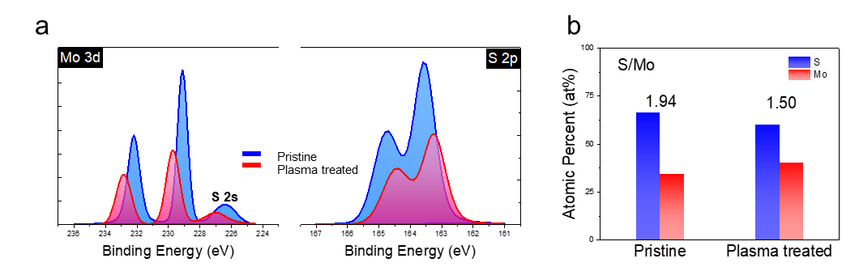

FigureS4. a, XPS survey spectra for the pristine and plasma treated MoS₂ samples. b, S and Mo atomic ratio for pristine and plasma treated MoS₂ samples.

XPS spectra of Mo 3d and S 2p for MoS2 film indicates the relative content of the elements. And by calculating the atomic percent of S/Mo, the S/Mo atomic ration of pristine MoS2 is 1.94 (nearly to theoretical value: 2). The treatment MoS2 atomic ratio is 1.5, that shows loss of sulfur atoms during plasma etching⁵.

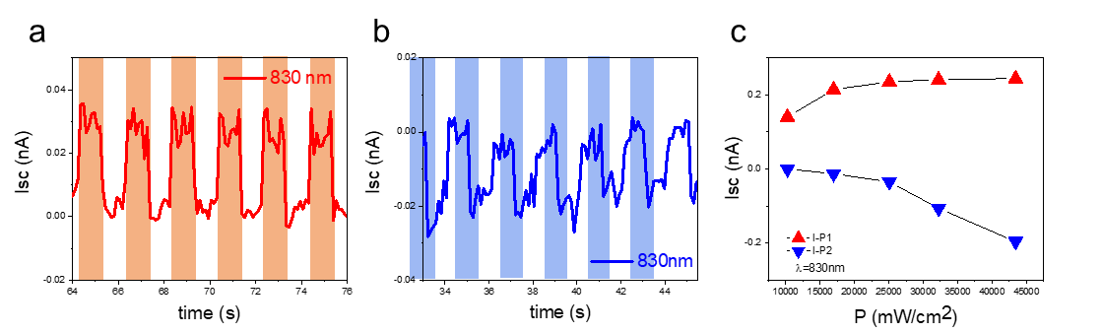

FigureS5. I-V curves for positive (a) and negative (b) short circuit current under 830 nm illumination. c, I-P curves for positive and negative photoresponse states at wavelength of 830 nm.

With the pulse voltage applying on the Au/MoS₂/Au device，it also could get the Isc changes from the positive values to negative values. The photocurrent is about 0.03nA or -0.03nA at 830nm light illumination and V_{ds}= 0V. For the result of I-P curve, the photocurrent is near saturation at large light intensity conditions because of the band edge absorption at 830nm. It demonstrates the possibility of achieving positive and negative photoresponse in the near infrared.

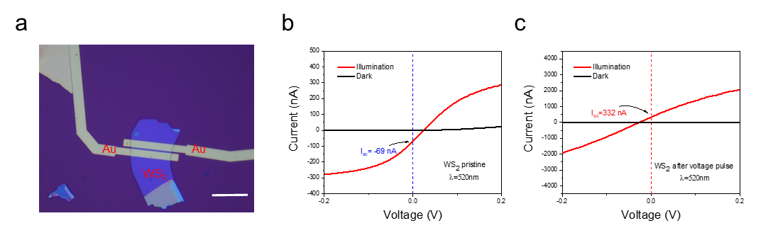

FigureS6. a, Optical microscopy of plasma treated WS2 device. b, Negative short circuit current (I_{sc}=-69 nA) shows in the I-V current characteristic with and without 520 nm illumination. c, I-V curves of WS2 device after negative pulse voltage with and without 520 nm illumination, short circuit current changes to 332 nA, scare bar 20 μm. For results, the WS₂ can also get the same phenomenon as MoS₂. First, short-circuit current of -69 nA obtained under illumination conditions for WS2 device. But, after -10V 100ms electric pulse, short-circuit current changed to 333 nA. Achieved negative to positive photocurrent conversion at 0 V.

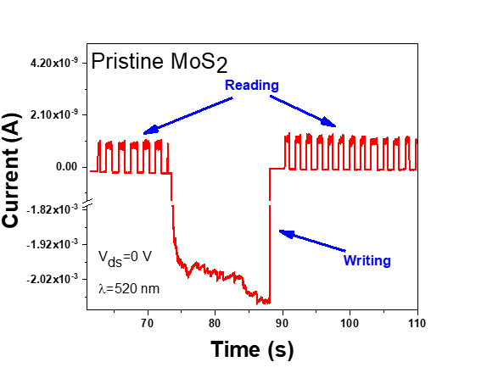

FigureS7. Photoresponse of pristine MoS₂ before and after applied 15V 10s writing voltage at Vds=0V, λ=520nm.

Compare to treatment MoS₂ devices, the photocurrent of pristine MoS₂ has not obvious changed with applying large voltage pulse at V_{ds} =0V. The sulfur vacancies are also exist to supply the electrons for n-type conductive semiconductor. The number of sulfur vacancies are not enough (as show in figureS4) for rewriting the photocurrent in metal/MoS₂ (pristine) /metal device.

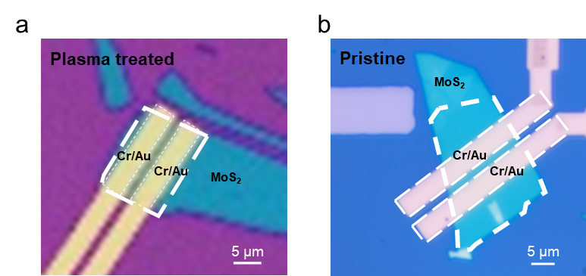

FigureS8. Optical microscopy images of plasma treated (a) and pristine MoS2 (b) devices for photocurrent mapping measurement. The thick white dashed line represents the area of the material and the thin dotted line is the area of the two electrodes.

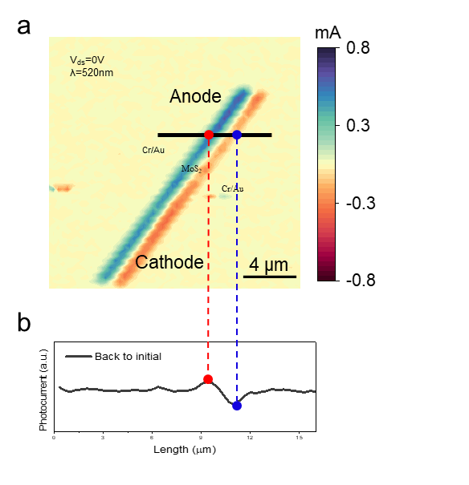
FigureS9. a, Photocurrent mapping obtained from plasma treated MoS₂ after applied 15V 15s writing voltage at Vds=0V, λ=520nm. b, The distribution of photocurrent is taken along the horizontal black lines, the red and blue dashed line show the position of photocurrent close to the electrodes.

For the photocurrent mapping result, in MoS₂ channel, the origin region close to anode shows the localized positive photocurrent and the blue region close to cathode represents the localized negative photocurrent. Magnitude of positive and negative photocurrent is nearly the same that means the collection of photocurrents in the metal and MoS₂ junction regions on both sides are similar.

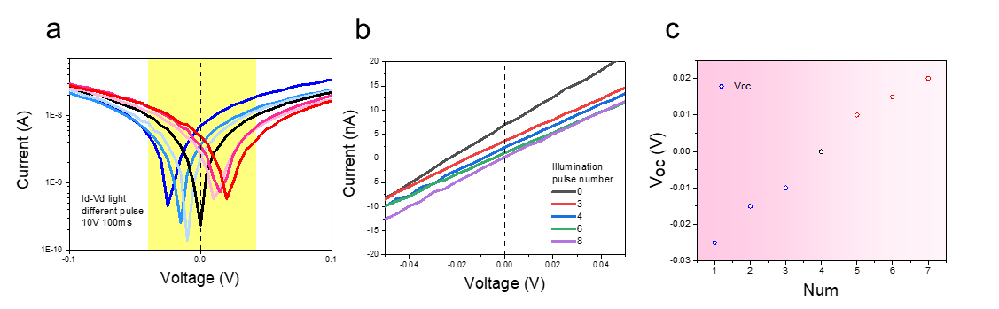

FigureS10. a, Output characteristic curves applied different number pulse for 10V 100ms under illumination, λ=520nm. b, I-V curves were extracted from the yellow region in (a) applied 0,3,4,6,8 voltage pulses. c, Open circuit voltage were extract from (a) under different number of voltage pulses. Also, by optimizing the number of pulse voltage, the 6 different short circuit current and open circuit voltage were obtained which changed from negative to positive.

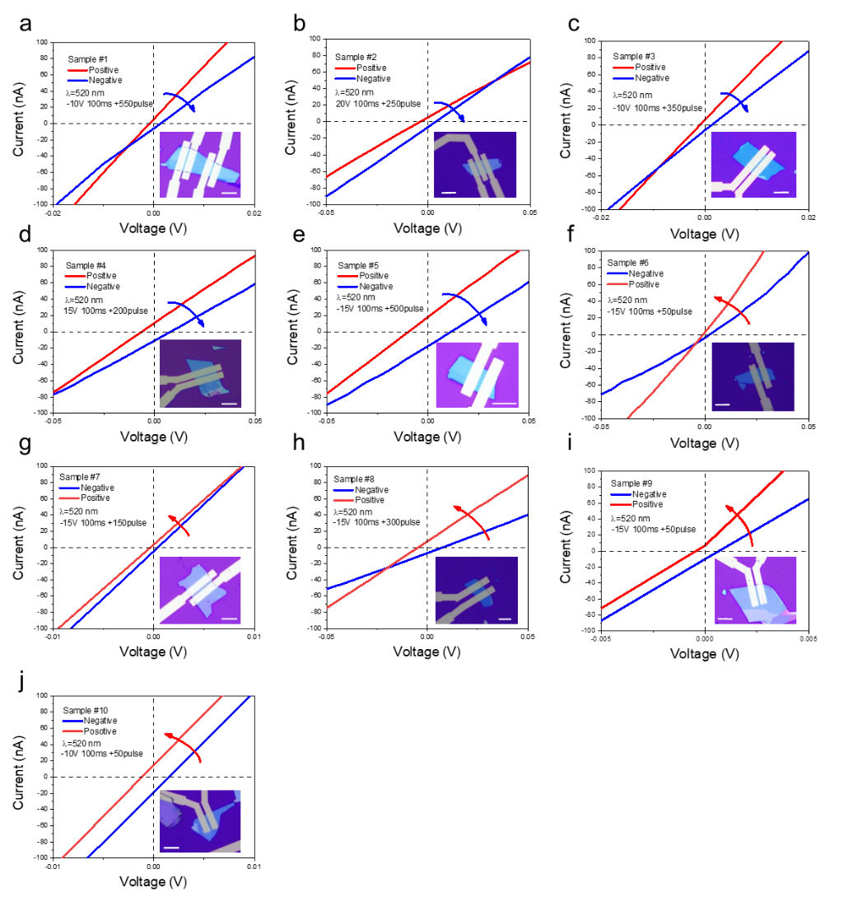

FigureS11. Output characteristic curves of 10 samples with different voltage pulses. (a)-(e), Variation of Short circuit current (I_{sc}) changes from positive to negative with applied negative pulse voltage. Scale bar, 8 μm. (f)-(j), Variation of Short circuit current (I_{sc}) changes from negative to positive with applied positive pulse voltage. Scale bar, 8 μm. Measurements were all under 520 nm light conditions.

Here, we chose 10 different devices to get our measurement results. The thickness of MoS2 films are from 10-60 nm, and the channel of devices is from 1-2 μm. To test the sample 1 to sample 5, with applied negative voltage pulse, the short circuit current changes from positive to negative. For sample 6 to sample 10, with applied positive voltage pulse, the short circuit current changes from negative to positive. For the treatment device, demonstrates good reconfigurable regulatory properties.


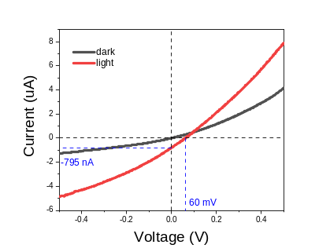
a
b

FigureS12. Output characteristic curves of large short-circuit current and open-circuit voltage. a, The optical image of measurement device. Scale bar, 4 μm. b, Id-Vd curve under dark and illumination conditions, λ=520 nm. The two-terminal M/S/M device performance I_{sc} for -795 nA and V_{oc} for 60 mV.

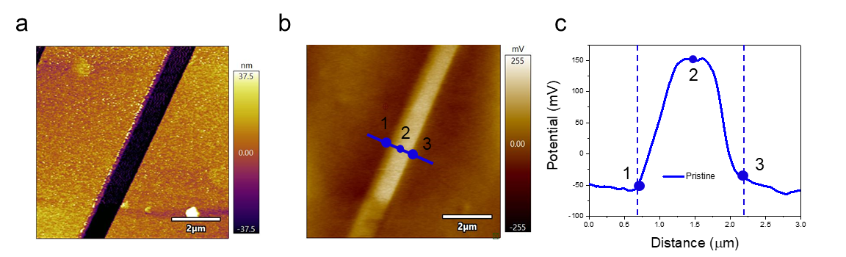

FigureS13. AFM and corresponding KPFM images measured from two different MoS₂ devices: (a) and (b), pristine MoS₂. The magnitude of the electric potential was extracted from the KPFM images, and the curves show the potential changed between the MoS₂ channel and Au electrode, blue line for pristine MoS₂ (c).And points 1,2,3 in (c) are KPFM images and potential curves one by one correspondence position.

From the potential curve of pristine MoS₂, the variation of potential is distribution between the interface of Au electrode and MoS₂. The potential is symmetrically distributed on both sides of the electrode, and there is no change of potential along the region of MoS₂ channel means distribution of electric field is equal to zero. Also, the electric field is strongest at the metal and semiconductor interface.

Table 1. Device parameters for TCAD simulations
Device parameters
Doping concentration (N_{C}) | 1e¹⁶ cm⁻³
Electron affinity (χ) | 4.3 eV
Band gap (E_{g}) | 1.2 eV
Channel length (L) | 2 μm
Schottky workfunction (W) | 5.1-4.98 eV (step0.01)

The device parameters for the simulation are detailed in Table 1. According to the experiment, by using the module called SDE in Sentaurus Workbench to design the structure. The 2 μm channel was built and two electrodes contact were constructed at the both side of the channel. Parameter file in SDE was revised for the MoS2 material. Also, the optoelectronic characterization of the device was performed in SDEVICE module. Two electrodes contact were set for the Schottky contact by defining the Schottky workfunction in the codes. And, in physics section, recombination and non-local tunneling model was taken consideration, T=300 K. In addition, the light section was also introduced in the device, and the wavelength, intensity, direction of light was important for the simulation. Finally, the electron and hole current got from the solution of the Poisson equation with different sweep voltage range. Simulation results were all got from the Svisual module. In the simulation, combined the result of KPFM results that the sulfur vacancies can change the Schottky barrier beside the two electrode contacts. So, we designed the variable Schottky workfunction in one side of the electrode contact to see the changes for short-circuit current of the devices. And the simulation results show the same trend as the experimental results as show in FigureS8.

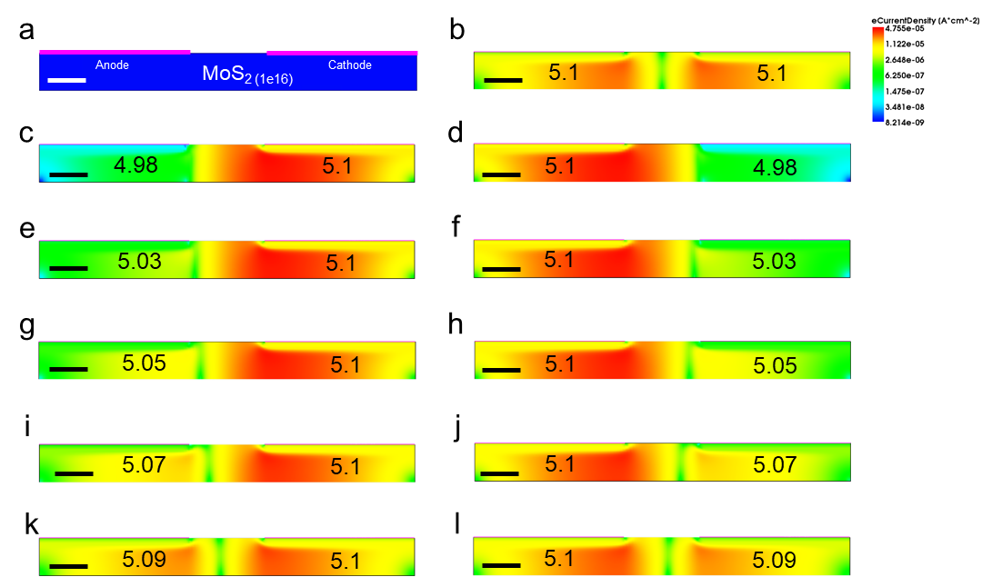

FigureS14. a, Structure of the metal/MoS2/metal device for TCAD simulation. Scale bar, 1 μm. b, Electron density distribution under symmetric Schottky workfunction distribution between anode and cathode under illumination at 0 V bias, λ=520 nm, V_{ds}=0 V. Scale bar, 1 μm. c-i, Electron density distribution under illumination at 0V bias with different anode and cathode Schottky workfunction, λ=520 nm, V_{ds}=0 V. Scale bar, 1 μm.

As for Schottky diode, the majority carrier dominated the device current. In our simulation, the MoS₂ was n-type material and electronic current was important for device. Because of the symmetric structure of metal/MoS₂/metal, the diffusion of minority carrier could be negligible. So, the performance of electronic current density was displayed in FigureS11. From the figureS11 b, the electronic current density was centro-symmetric distribution, and the short-circuit current show in Figure4 was nearly 0 A. When changed the Schottky workfunction at side of cathode with 0.01 eV step, the electronic current density was large distribution at high level Schottky workfunction side, also got the negative short-circuit current in I_{d}-V_{d} curve. And the density would be weakening when the gap between anode and cathode barrier became smaller as show in FigureS11 c, e, g, i, k. By adjusting the value of cathode, the positive short-circuit current was measured in the device. And the symmetrical results were shown in the figureS11 d, f, h, j, i.

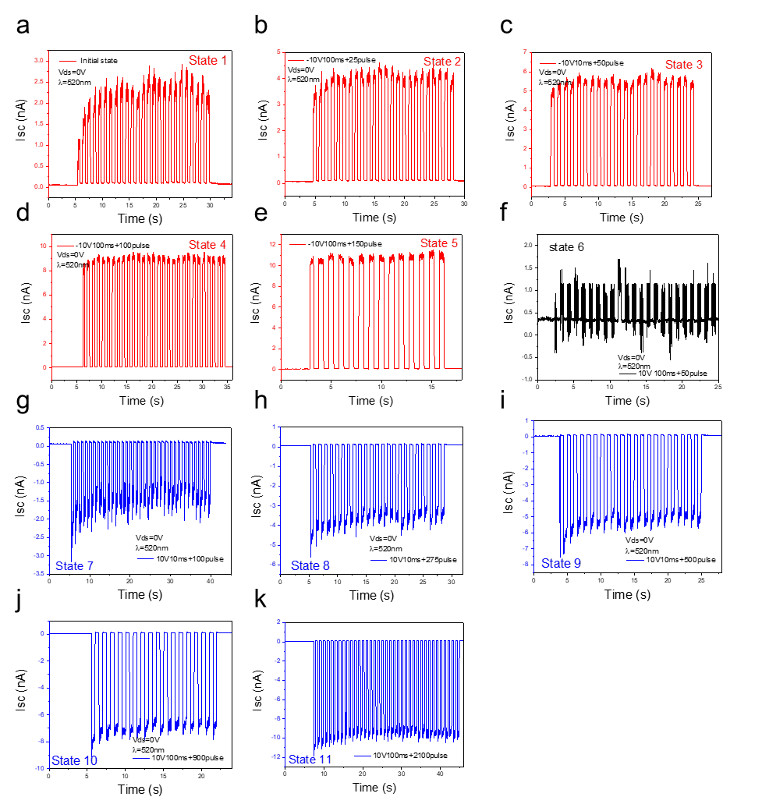

FigureS15. The 11 photoresponse states are measured at 520 nm and zero bias of Vds. a-e, Positive photoresponse states obtained for different number of negative pulse voltages (-10 V 100 ms). f, Nearly zero photoresponse state achieved from positive pulse voltage (10 V 100 ms +50 pulse). g-k, Negative photoresponse states for different number of positive pulse voltages (10 V 100 ms).

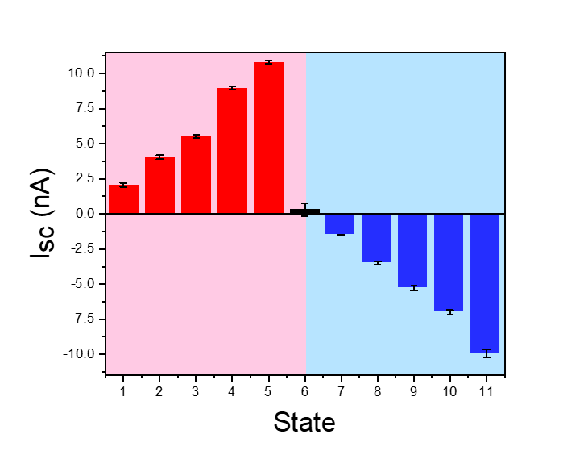
FigureS16. Histogram statistics of 11 photoresponse states from FigureS14.

By counting the magnitude of photocurrent from FigureS14, and taking its average value from FigureS12, the different values of photocurrent short circuit current are obtained, 2 nA, 4 nA, 5.5 nA, 9 nA, 11 nA, 0 nA,-1.5 nA, -3.5 nA, -5 nA, -7 nA, -10 nA. Consider the device area and the size of the spot, 11 photoresponse states are calculated from different I_{sc}, 6.3 mA/W, 12.0 mA/W, 16.5 mA/W, 27.0 mA/W, 33.0 mA/W, 0.0 mA/W, -4.5 mA/W, -10.5 mA/W, -15.9 mA/W, -21 mA/W, -29.7 mA/W. Large distinguishability of each photoresponse state and repeatable modulation can be achieved. And, these positive and negative states can be useful for neural network computing.
The Responsivity is related with the light intensity and photocurrent, and also calculated by the formula as show in equation (1):
$$R=\frac{I}{P} (1)$$
Considered the light spot area is larger than the device area, so the result should be normalization as show in equation (2):
$$R=\frac{I∙S_{light}}{P∙S_{device}} (2)$$
In experiment, the light spot diameter is 200 μm and the device area is 84 μm². Also the light intensity is 4.98 mW. All results for photoresponse are from equation (2) in FigureS14.

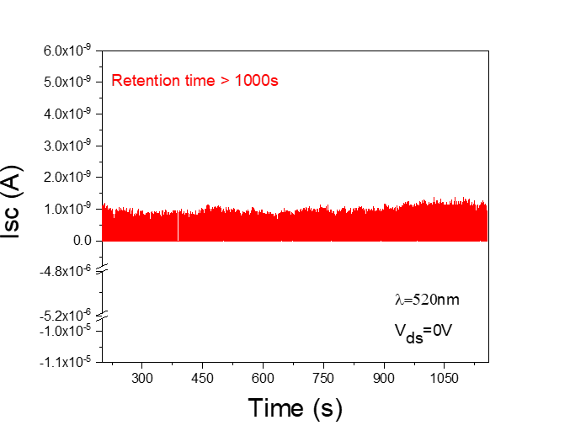

FigureS17. I-T characteristic of treated MoS2 device for short circuit current under 520 nm illumination. The retention time of photoresponse state is large than 1000s.

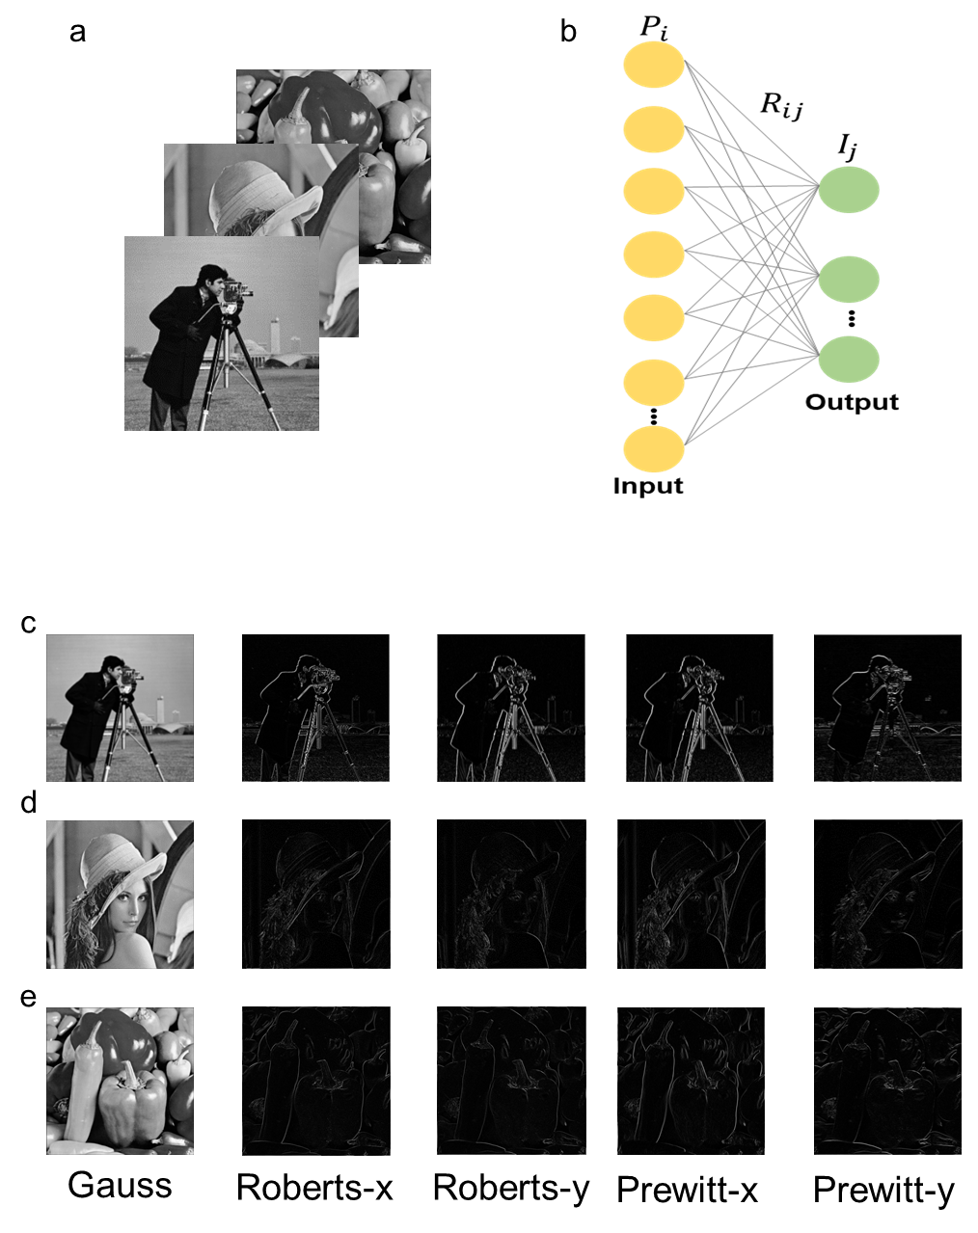

FigureS18. Use the photoresponse states for Image processing by 3 × 3 array.

The operation of Gaussian blur is emulated by a 3 × 3 array with setting the 9 devices to 3 different photoresponse sates, and the distribution of the photoresponse states of different devices is shown in the FigureS16. The three different gray pictures (Cameraman, Lena, Peppers) were used for image processing in FigureS16(a). For the neural network for image processing, the single layer perceptron was used and the formula of $I=\sum{P×R}$ was performance by matrix multiplication(MAC) as shoe in FigureS16(b). The gray value was reflect to different power intensities, and the weights in network were used multi-photoresponse states. The Experiment results emulated from the photoresponse states matrix of the Gaussian kernel matrix $\frac{1}{89.7}$ $\left[\begin{matrix}6.3 & 12.0 & 6.3 \\ 12.0 & 16.5 & 12.0 \\ 6.3 & 12.0 & 6.3\end{matrix}\right]$ with our 3 × 3 array. The operation of image preprocessing of the Roberts operator is emulated by 2×2 array with the individual device written to a specific photoresponse state, in which each cell contains 2 photo-memristors, different types of matrices ($\left[\begin{matrix}-1 & 0 \\ 0 & 1\end{matrix}\right]$ and $\left[\begin{matrix}0 & -1 \\ 1 & 0\end{matrix}\right]$) are used for edge detection along the X-axis and Y-axis directions. The operation of image processing of the Prewitt operator is emulated by 3×3 array with the individual device written to a specific photoresponse state, different types of matrices ($\left[\begin{matrix}-1 & 0 & 1 \\ -1 & 0 & 1 \\ -1 & 0 & 1\end{matrix}\right]$ and $\left[\begin{matrix}1 & 1 & 1 \\ 0 & 0 & 0 \\ -1 & -1 & -1\end{matrix}\right]$) are used for edge detection along the X-axis and Y-axis directions. In the Roberts and Prewitt operators, the “-1” was from the negative potoresponse state and the “1” was from the positive photoresponse state⁶. For results of three different gay picture with Gauss, Roberts-x, Roberts-y, Prewitt-x and Prewitt-y were show in FigureS16(c), FigureS16(d) and FigureS16(e). Using the experimental photoresponse states, both image processing methods can obtain better edge detection results.

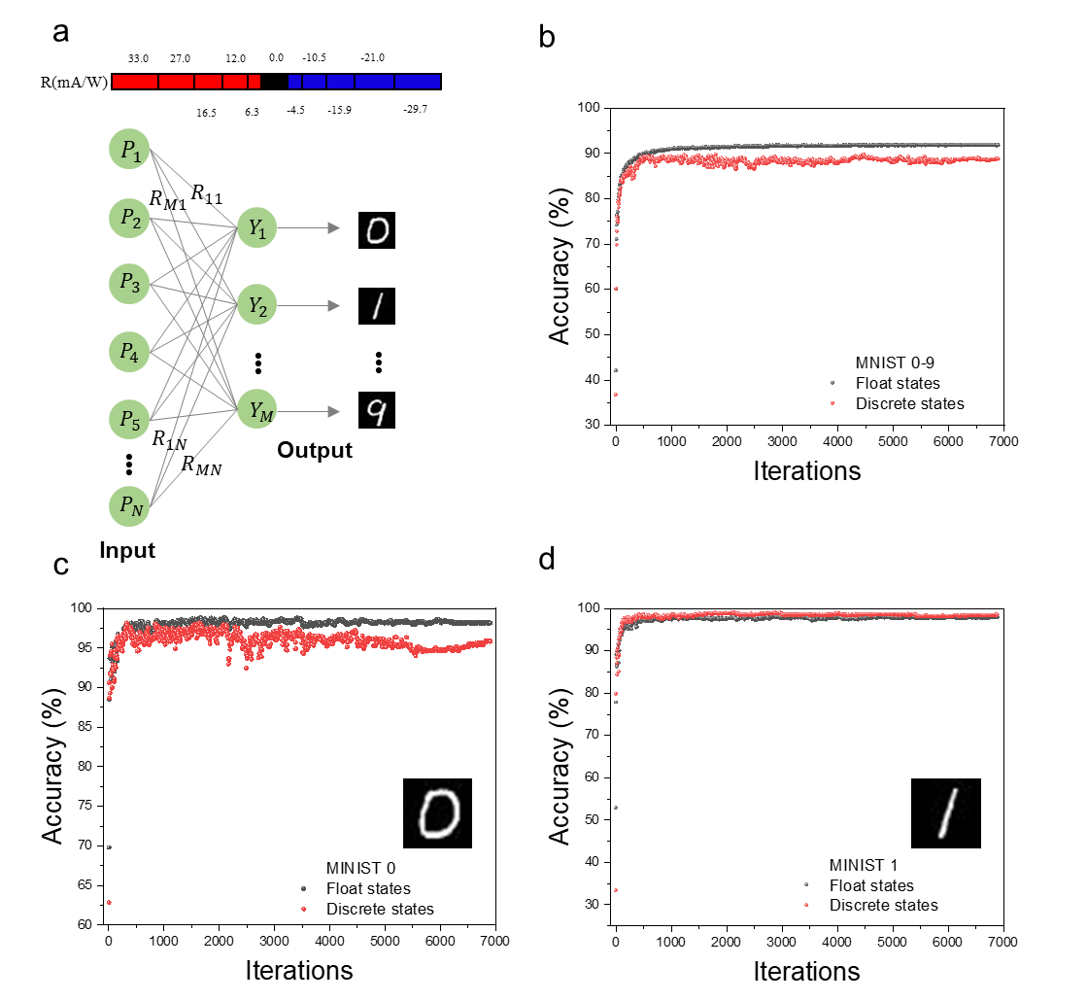
FigureS19, Use the photoresponse states for MINIST recognition. a, Dividing the continuous states into 11 photoresponse states, structure schematic diagram of single layer perceptron (SLP) also shows in (a). b, Recognition accuracy of MINIST 0-9 numbers with float states and discrete states. The recognition accuracy of number 0 (c) and 1 (d) with over 95%. Floating point weight is always used in computing for single layer perceptron.

The photo-responsivity matrix can also be programmed as a single layer perception neural network for image recognition. In this section, we trained a fully connected (FC) layer to recognizes images of handwriting numbers “0” to “9” from the MINIST data set. The weights in FC are first trained offline with 60000 images of the training set, delivering the recognition rate with 91% accuracy for the testing set. Then, by dividing the floating point weight into the 11 photoresponse states (one-by-one correspondence according to the scale). Compare to the recognition accuracy for single layer perceptron with floating point weight and 11 discrete states. Both of the total accuracy for 0-9 images are nearly to 90%. For image 0 and image 1, both the recognition accuracy are up to 95%. So, the 11 photoresponse states are also suitable for recognition task of single layer perceptron.

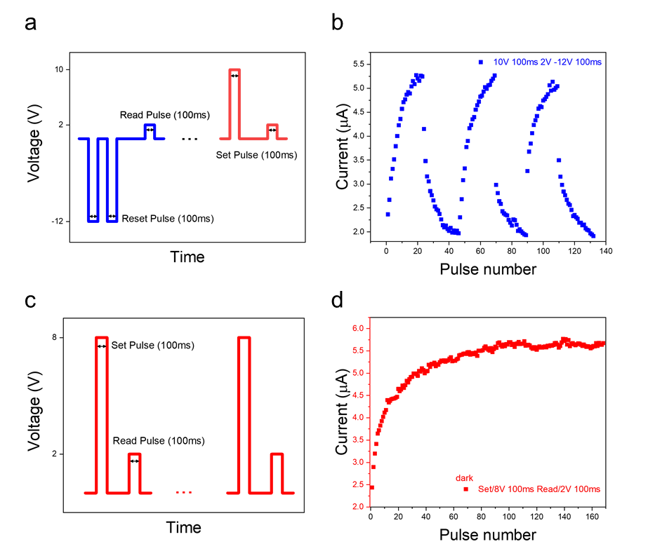
FigureS20. Conductance modulation due to pulsed voltage under the dark condition.
a, The magnitude of voltage and duration of time for set pulse (10V 100ms), reset pulse (-12V 100ms), read pulse (2V 100ms). b, Current measurement with changing set pulse and reset pulse numbers c, The magnitude of voltage and duration of time for set pulse (8V 100ms) and read pulse(2V 100ms). d, Current measurement with increasing the number of pulse numbers.

For the result, conductance the treatment metal/MoS₂/metal can also be tunable by applying the voltage pulse. During the set pulse and the reset pulse, a modulated conductance state was achieved. Also, when changed the amplitude of voltage pulse,168 different conductive states got from the treatment device.

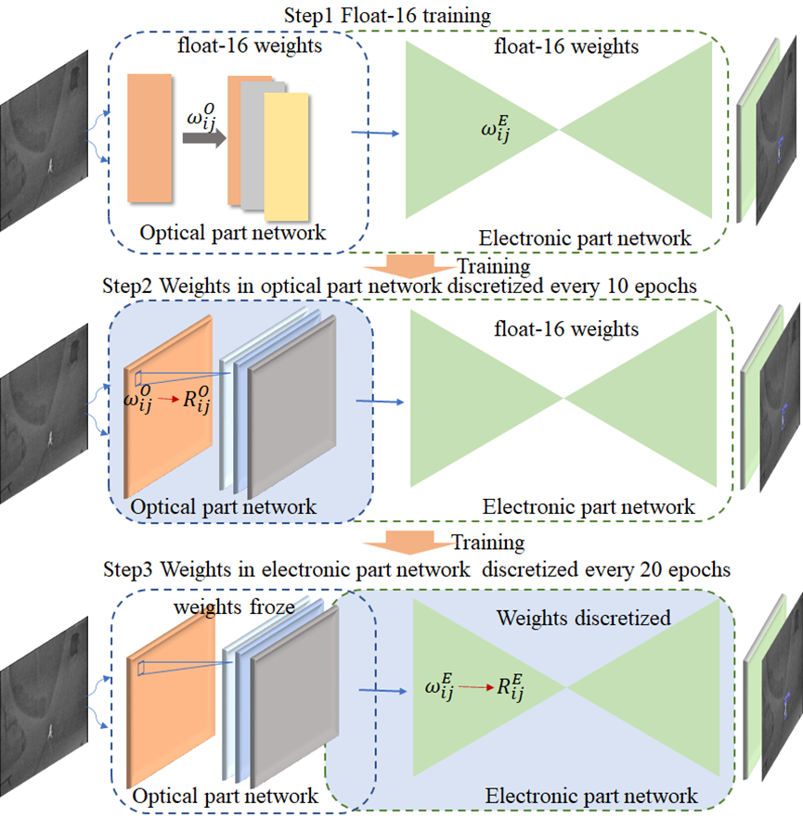

FigureS21. Training strategy for object detection by using optical and electronic states.

The training process of our object detection network is divided into three steps as show in Figure19. In the first step, the weights are trained and updated with float-16 datatype. In the second step, the weights in optical part network are discretized every 10 epochs. In the third step, the weights in optical part network are frozen and the weights in electronic part network are discretized every 20 epochs.

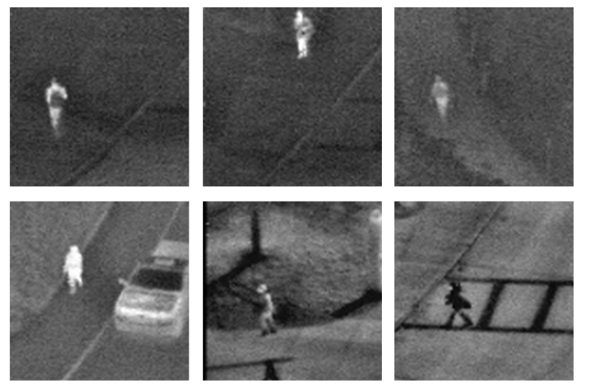

FigS22. The training and testing set.

The OSU Thermal Pedestrian Database⁷ is used for the evaluation of our method. The task of the database is to conduct person detection in thermal imagery. In our experiments, we randomly cropped patches with a size of 96×96 from the database, and each cropped patch only contains one person. The cropped patches are randomly split with 2131 images for training and 585 images for testing. The brightness of each pixel is encoded into the optical power.

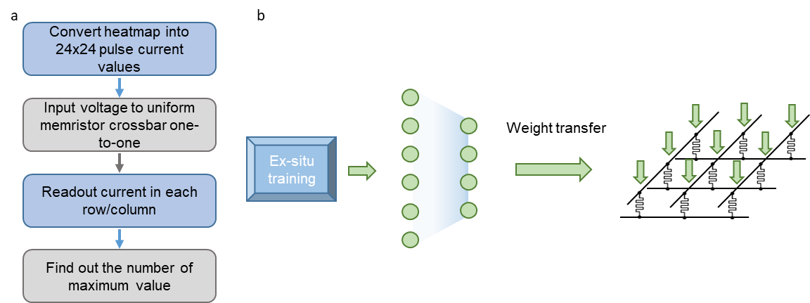

FigS23. a, Flowchart of the target locating method applied to the heatmap using memristor crossbar in Spice. b, Diagram of the experimental FC demonstration with Ex situ training and weight transfer.

Memristor has become an ideal candidate for in-sensor or near-sensor computing device due to their nonvolatility. By converting each pixel value of the heatmap into a voltage pulse amplitude in a specific range, and then inputting them into the memristor array, each memristor in the crossbar array corresponds to a pixel in the heatmap, thus 576 memristors are used, and the conductance of all memristors are uniform. According to Ohm's law and Kirchhoff law, summation calculation is operated simultaneously both in each row and each column. By calculating the sum of the current in each row, we compare 24 row current to find the maximum value, of which the row number directly indicates the Y axis value of the target point in the heatmap. In the same way, we obtain the X axis value of the target point by comparing 24 column current. Finally, we use the Operational Amplifiers transform the row and column current value to voltage value as show in the Figure. 4e.

References

1. Li, H., et al. From Bulk to Monolayer MoS2: Evolution of Raman Scattering. Adv. Funct. Mater. 22, 1385-1390 (2012).
2. Liu, Y., et al. Layer-by-Layer Thinning of MoS2 by Plasma. Acs Nano 7, 4202-4209 (2013).
3. Thomas, S., et al. Electrodeposition of MoS2 from Dichloromethane. J. Electrochem. Soc. 167, 106511 (2020).
4. Noori, Y. J., et al. Large-Area Electrodeposition of Few-Layer MoS2 on Graphene for 2D Material Heterostructures. ACS Appl. Mater. Interfaces 12, 49786-49794 (2020).
5. Zhu, H., et al. Remote Plasma Oxidation and Atomic Layer Etching of MoS2. ACS Appl. Mater. Interfaces 8, 19119-19126 (2016).
6. Cherri, A. K.&Karim, M. A. Optical symbolic substitution: edge detection using Prewitt, Sobel, and Roberts operators. Appl. Opt. 28, 4644-4648 (1989).
7. Davis, J. W.&Keck, M. A. A two-stage template approach to person detection in thermal imagery. In 2005 IEEE Workshop on Applications of Computer Vision (WACV) 364-369 (IEEE, 2005).

