Green and low-cost synthesis of N and P double doped porous carbon derived from Sonchus arvensis L for simultaneous electrochemical detection of ascorbic acid, dopamine and uric acid
Qiaoqian Sunª, Xiaolong Liangª, Zuohua Liu ^{ab}, Li Gongª, Yijiao Zhangª, Siwei Jinª, Hongchen Puª , Miao Yinª, Jinyin Yuª, Wanying Yanª, Huanbao Fa ^{ab*}, Wei Yin ^{abc*}
a School of Chemistry and Chemical Engineering, Chongqing University, Chongqing 400044, China
b National-Municipal Joint Engineering Laboratory for Chemical Process Intensification and Reaction, Chongqing University, Chongqing 400044, China
c Analytical and Testing Center of Chongqing University, Chongqing 400044, China
* Corresponding authors.
E-mail addresses: huanbaofa@cqu.edu.cn (H. Fa), yinweicqu@163.com (W. Yin)
Telephone: +86 13228612804 (H. Fa), +86 18580638261(W. Yin), +86 15922926287(H. Liu)
Fax: +86 023 65678951.
Declaration of competing interest: None.

S1.1 Chemicals and reagents
DA and UA were purchased from Huaxia reagent, and AA from Shanghai TITAN Technology Co., Ltd. HCl, ethanol, H₃PO₄, K₃[Fe(CN)₆], NaH₂PO₄·2H₂O and Na₂HPO₄·12H₂O (Chengdu Kelong ChemSical Reagent Factory) were of analytical grade. The normal human serum was from Beijing Soleibao Technology Co., Ltd. Ist. Distilled water was used throughout all experiments.

S1.2 Instruments and measurements
The morphologies of composites were examined using a scanning electron microscope (SEM, JSM-7500F, Hitachi, Japan) . The carbon materials were determined by X-ray photoelectron spectra (XPS, ESCALAB250Xi, Thermo Fisher Scientific). XRD patterns were measured using Spectris Pte. Ltd (PANalytical X’ Pert Powder). Raman spectroscopy was acquired on a Raman spectrometer (In Via, British Renishaw Company). Nitrogen sorption isotherms and the Brunauer-Emmett-Teller (BET) surface areas were determined by the full automatic multi station specific surface area and aperture analyzer (Max-II, macchikbaier company, Japan).
Cyclic voltammetry (CV) and differential pulse voltammetry (DPV) were used for electrochemical detection, which were completed on CHI660E Electrochemical Workstation. The three-electrode system was used, the GCE was used as the working electrode, Ag/AgCl as the reference electrode and Pt as the counter electrode. The conditions of CV determination were as follows: the mixed solution of 5.0 mM K₃[Fe(CN)₆] and 0.1 M KCl was used as electrolyte, the scanning range was set between -0.1 V and +0.6 V, and the scanning rate was 50 mV/s. DPV determination conditions: PBS buffer solution (pH=7.0) prepared with 0.1 M NaH₂PO₄·2H₂O and Na₂HPO₄·12H₂O solution was used as electrolyte, the scanning potential ranged from -0.2 V to 0.5 V, the pulse amplitude was 50 mV, the pulse duration was 0.2 s. The test frequency of electrochemical impedance spectroscopy (EIS) ranged from 100 kHz to 0.01 Hz with an amplitude of 5 mV. All experiments were carried out at room temperature.

S2 Optimization of experimental conditions
For best experimental results, the coating amount of SaL-800, pH value of PBS and enrichment time were optimized in the mixed solution of 500 μM AA, 50 μM DA and 50 μM UA. Fig. S2A shows the optimization diagram of the coating amount. When the coating amount from 2 μL increased to 6 μL, the currents of AA, DA and UA show an upward trend, while 6 μL-10 μL show a downward trend. The best coating amount was 6 μL. In Fig. S2B, in the range of 5-7, the currents of AA, DA and UA increase with the pH value, reach the highest point when the pH value is 7, and decreases with the increase of pH value over 7. Therefore, the optimal pH value was 7. When the enrichment time from 30 to 150 s (Fig. S2C), the currents of AA and UA increase, and decrease when enrichment time exceeds 90 s, while DA reaches the highest point at 60 s and changed little within 60-90 s. Overall, 90 s was selected as the best enrichment time in this experiment.
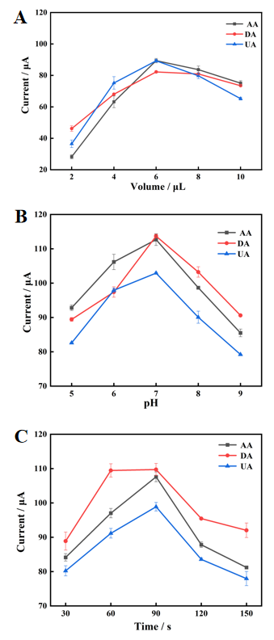

Fig. S2. The optimization of coating amount of SaL-800(A), pH value in PBS(B) and enrichment time (C)

