Supplementary Information
Altering the Spectroscopy, Electronic Structure, and Bonding of Organometallic Curium(III) Upon Coordination of 4,4′−bipyridine

Brian N. Long,¹ María J. Beltrán-Leíva,¹ Joseph M. Sperling,¹ Todd N. Poe,¹ Cristian Celis-Barros,*^{,1,2} Thomas E. Albrecht-Schönzart*^{,1,2}

¹Department of Chemistry and Biochemistry, Florida State University, 95 Chieftan Way, Tallahassee, Florida 32306
²Department of Chemistry and Nuclear Science & Engineering Center, Colorado School of Mines, Golden, Colorado 80401

*To whom correspondence should be addressed: talbrechtschoenzart@gmail.com, Ccelisbarros@mines.edu

Key Words: actinides, curium, cyclopentadienyl ligands, organoactinide, organometallic

Supplementary Information

Table of Contents

S1. Characterization Methods 3
S2. Synthesis Pictures 5
S3. Structural Details 10
S4. Solid-State Absorption and Photoluminescence 17
S5. Solution Phase Absorption Spectra 26
S6. Computational Details 33
S7. Additional Theoretical Results 35
S8. References 61

S1. Characterization Methods

Crystallographic Details
Crystals were collected in on a glass slide in Parabar 10312 oil, closed in a petri dish, and taped shut to prevent air exposure while transporting to a microscope. Single crystals were mounted on 75 μm MiTeGen loops and placed under a stream of N₂(g). Diffraction data was collected on a Bruker D8 Quest X-ray Diffractometer using a IμS X-ray source (Mo K_{α}; λ = 0.71073 Å). Unit cell determination and data collection of 1−Sm was completed at 120 K, while 1−Cm and 1−Gd were completed at 100 K. Centering, unit cell collection, and frame integrations were completed using APEXIII. Characterization and refinements were performed through SHELXTL utilizing the OLEX2 GUI. ^{1,2} Structural and crystallographic details can be found in Tables S1 - S6. Cif files for each crystal can be found under CCDC Deposition numbers: 1−Sm (2236796), 1−Gd (2236795), and 1−Cm (2236794).

Solid State Absorption Spectroscopy and Photoluminescence
In an argon atmosphere glovebox, single crystals were collected under Parabar 10312 oil on a glass slide, closed into a petri dish, and taped to prevent air exposure while transporting to the instrument. Photoluminescence and absorption spectra were performed using a CRAIC Technologies 20/20 PVTM Microspectrophotometer with a 100 W mercury light source and 75 W xenon lamp for photoluminescence and transmission, respectively. Data collection of 1−Cm was collected at room temperature (23 ℃) and −180 ℃. A Linkam LTS420 stage was used purged with N₂ for 5 minutes and cooled to −180 ℃ at a rate of 5 ℃/min. Absorption spectra were collected from 320 nm to 1,700 nm and photoluminescence was collected from 320 nm to 800 nm using excitation sources of 365 nm and 420 nm.

Solution Phase Absorption Spectroscopy
In an argon glovebox, samples were filtered in toluene and transferred to a Starna GL14-C screw cap cell. Absorption spectra were performed at room temperature on a Cary 6000i series UV/Vis/NIR spectrophotometer from 250 nm to 1700 nm with a pathlength of 0.4 cm. Spectra of 1−Sm and 1−Gd were measured again after being exposed to air for 24 hours while spectra of 1−Cm were collected each hour over a 48 hour period.

S2. Synthesis Pictures

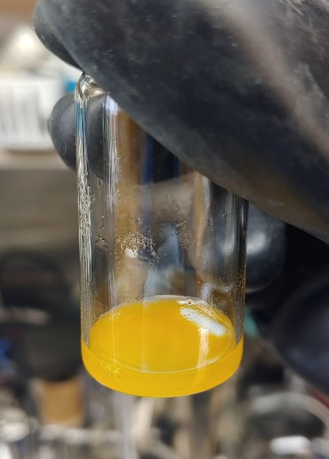
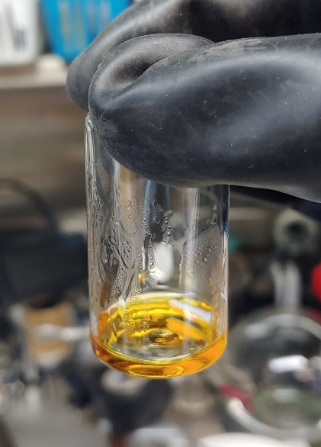
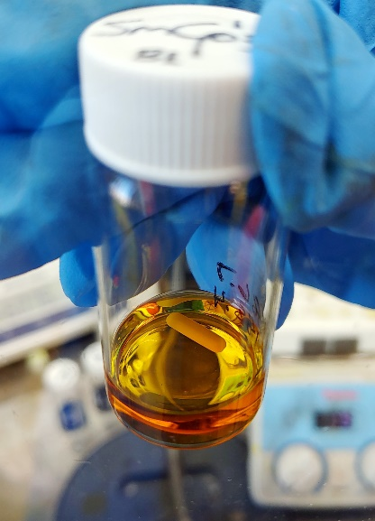
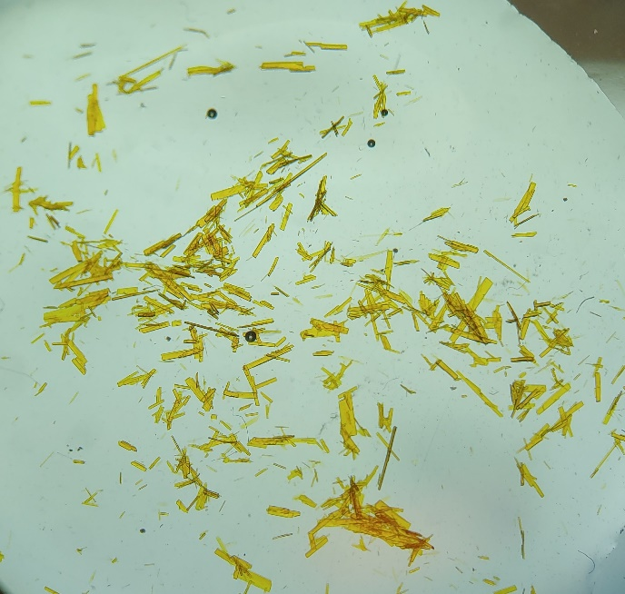
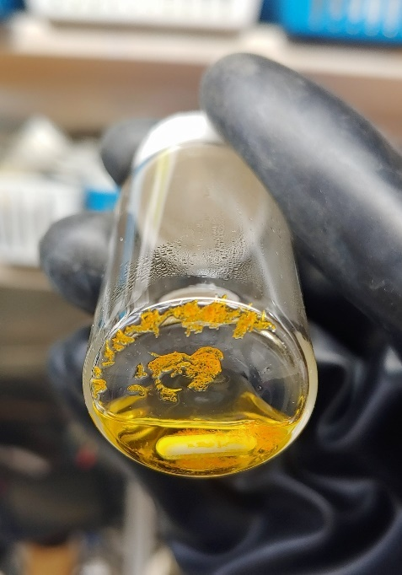
Figure S1. A. A sample of Cp′₃Sm in hexane. B. (Cp′₃Sm)₂(μ−4,4′−bpy) precipitate in toluene. C. Solution of (Cp′₃Sm)₂(μ−4,4′−bpy) at 120 °C. D. Crystals of (Cp′₃Sm)₂(μ−4,4′−bpy) grown by cooling to room temperature. E. Crystals used for single-crystal X-ray diffraction.
E
D
A
B
C

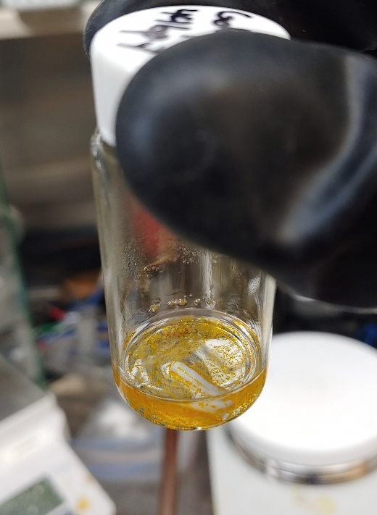
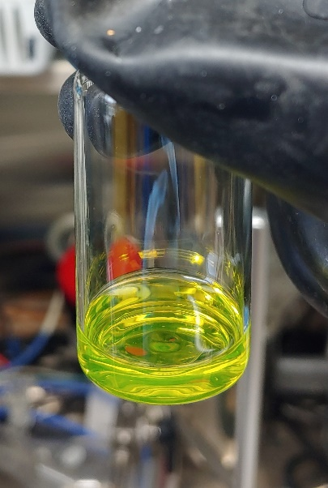
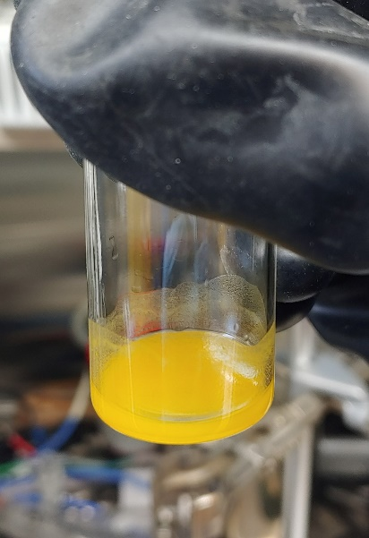
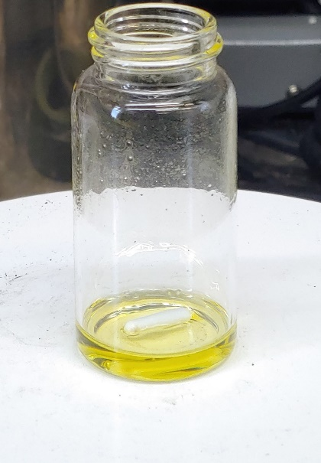
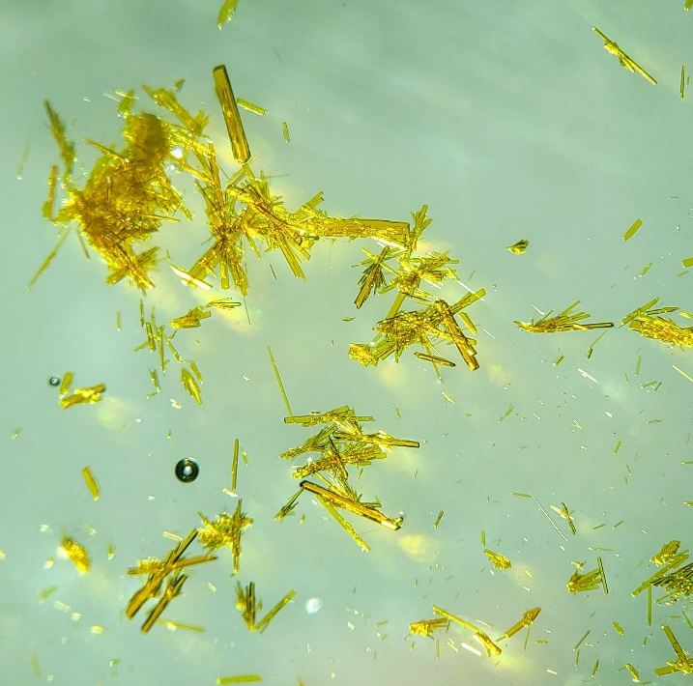
Figure S2. A. A solution of Cp′₃Gd in hexane. B. (Cp′₃Gd)₂(μ−4,4′−bpy) precipitate in toluene. C. Solution of (Cp′₃Gd)₂(μ−4,4′−bpy) heated to 120 °C. D. Crystals of (Cp′₃Sm)₂(μ−4,4′−bpy) grown by cooling to room temperature. E. Crystals used for single-crystal X-ray diffraction.
D
E
B
C
A

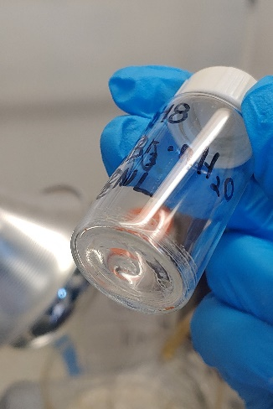
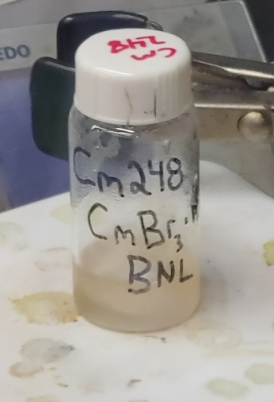
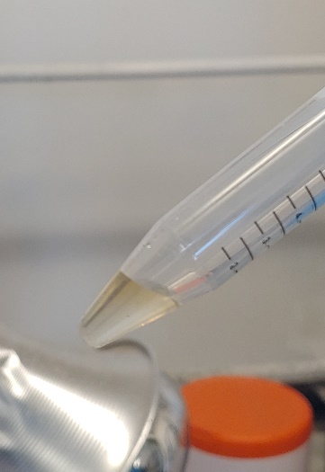
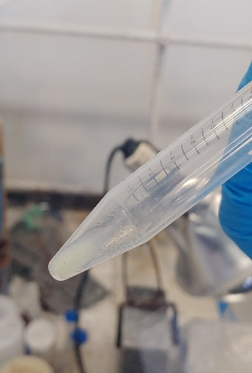
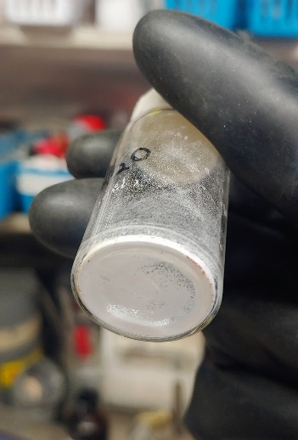
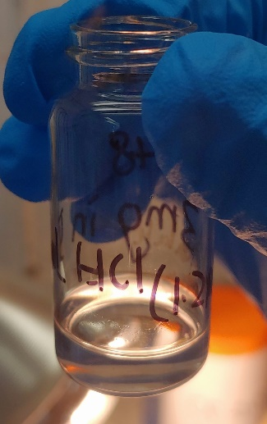
Figure S3. A. A stock solution of Cm³⁺ (3.3 mg) in HCl (2 M) B. The pellet of Cm(OH)₃ after rinsing with H₂O. C. Cm dissolved in HBr (8.77 M) D. Dried residue of CmBr₃(H₂O)_{n} after washing with OEt₂. E. Slurry of CmBr₃(DME)_{n} in DME and TMS−Br. F. Dried powder of CmBr₃(DME)_{n}.
D
E
F
B
C
A

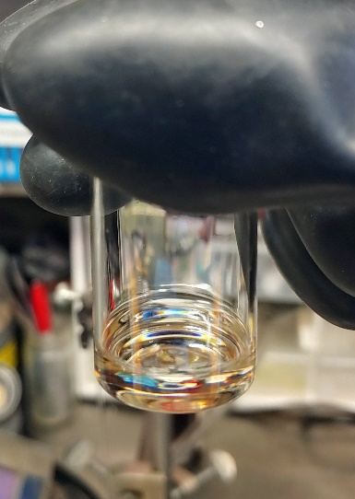
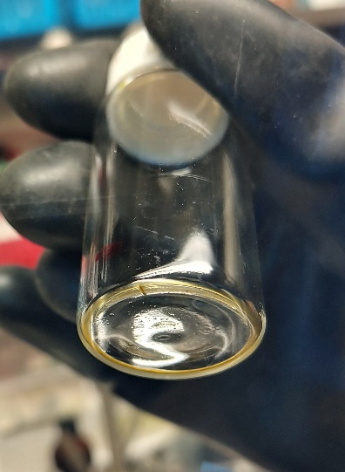
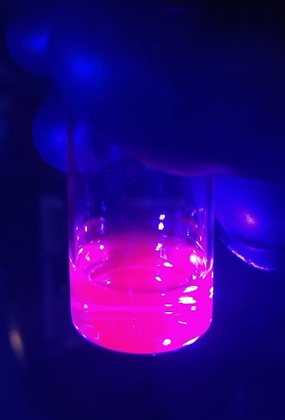
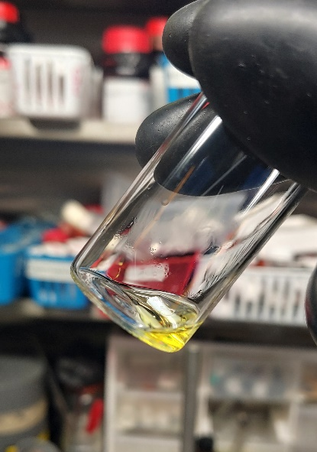
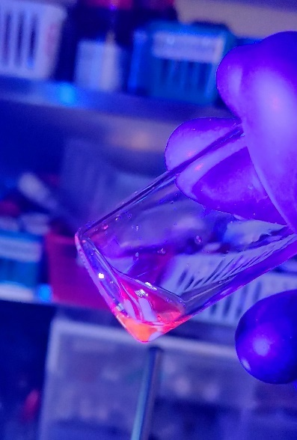
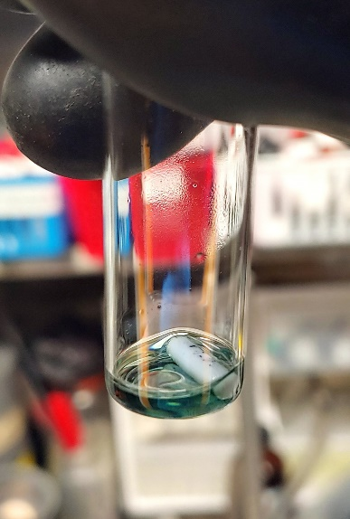
G
H
I
J
K
L

Figure S4. G. A putative solution Cp′₃Cm in hexane. H. The putative solution of Cp′₃Cm glowing under a blacklight. I. Dried Cp′₃Cm forming an oil and small crystal clusters. J. Solution of (Cp′₃Cm)₂(μ−4,4′−bpy) in toluene. K. Solution of (Cp′₃Cm)₂(μ−4,4′−bpy) glowing under a blacklight. L. After heating to 120 °C, the yellow solution of (Cp′₃Cm)₂(μ−4,4′−bpy) turned green upon slowly cooling to room temperature.

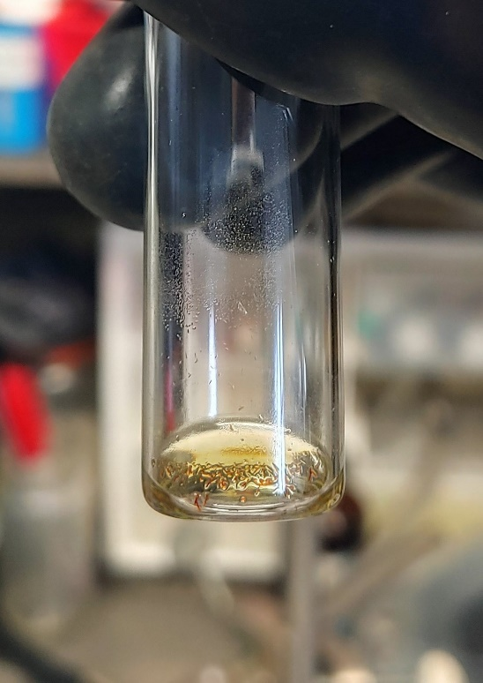
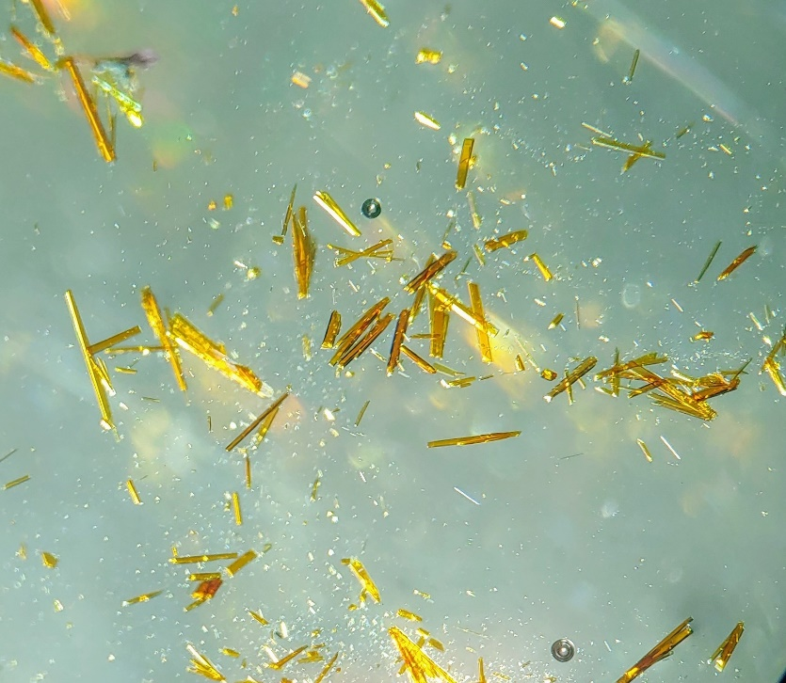
M
N

Figure S5. M. The solution turned yellow again overnight and crystals of (Cp′₃Cm)₂(μ−4,4′−bpy) suitable for single-crystal X-ray diffraction were grown at room temperature. N. A batch of crystals used for single-crystal X-ray diffraction.

S3. Structural Details

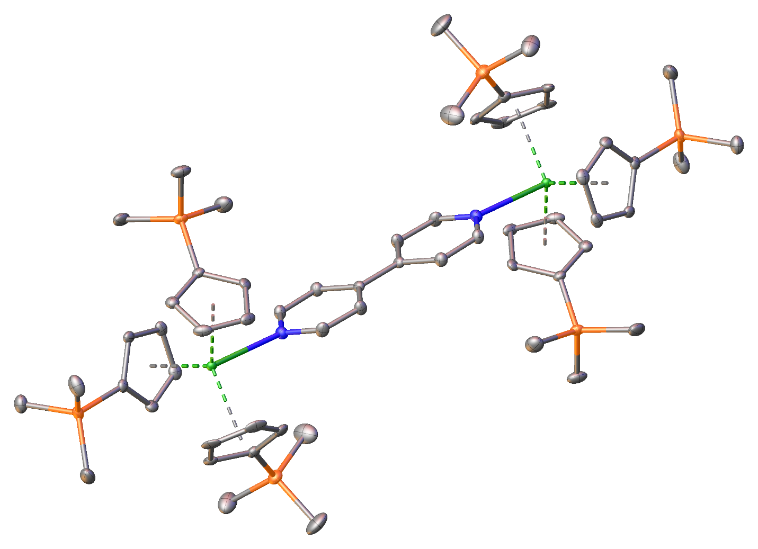

Figure S6. Crystal structure of (Cp′₃Sm)₂(μ−4,4′−bpy), 1−Sm. Green = Samarium, Blue = Nitrogen, Orange = Silicon, Gray = Carbon. Hydrogen has been omitted for clarity. Thermal ellipsoids are models at 50% probability.

Table S1: Crystal data and structure refinement for 1−Sm.
Deposition Number | 2236796
Empirical formula | C₅₈H₈₆Sm₂N₂Si₆
Formula weight (g/mol) | 1280.52
Temperature/K | 120
Crystal system | triclinic
Space group | P$\overline{1}$
a/Å | 9.4874(13)
b/Å | 11.3744(16)
c/Å | 14.808(2)
α/° | 99.424(3)
β/° | 101.419(3)
γ/° | 95.638(3)
Volume/Å³ | 1531.1(4)
Z | 1
ρ_{calc}g/cm³ | 1.389
μ/mm⁻¹ | 2.052
F(000) | 656.0
Crystal size/mm³ | 0.675 × 0.453 × 0.158
Radiation | MoK_{α} (λ = 0.71073 Å)
2Θ range for data collection/° | 4.712 to 55.23
Index ranges | −12 ≤ h ≤ 12, −14 ≤ k ≤ 14, −14 ≤ l ≤ 19
Reflections collected | 13642
Independent reflections | 7025 [R_{int} = 0.0347, R_{sigma} = 0.0550]
Data/restraints/parameters | 7025/0/316
Goodness-of-fit on F² | 1.042
Final R indexes [I ≥ 2σ (I)] | R₁ = 0.0333, wR₂ = 0.0757
Final R indexes [all data] | R₁ = 0.0412, wR₂ = 0.0789
Largest diff. peak/hole / e Å⁻³ | 1.19/−1.91

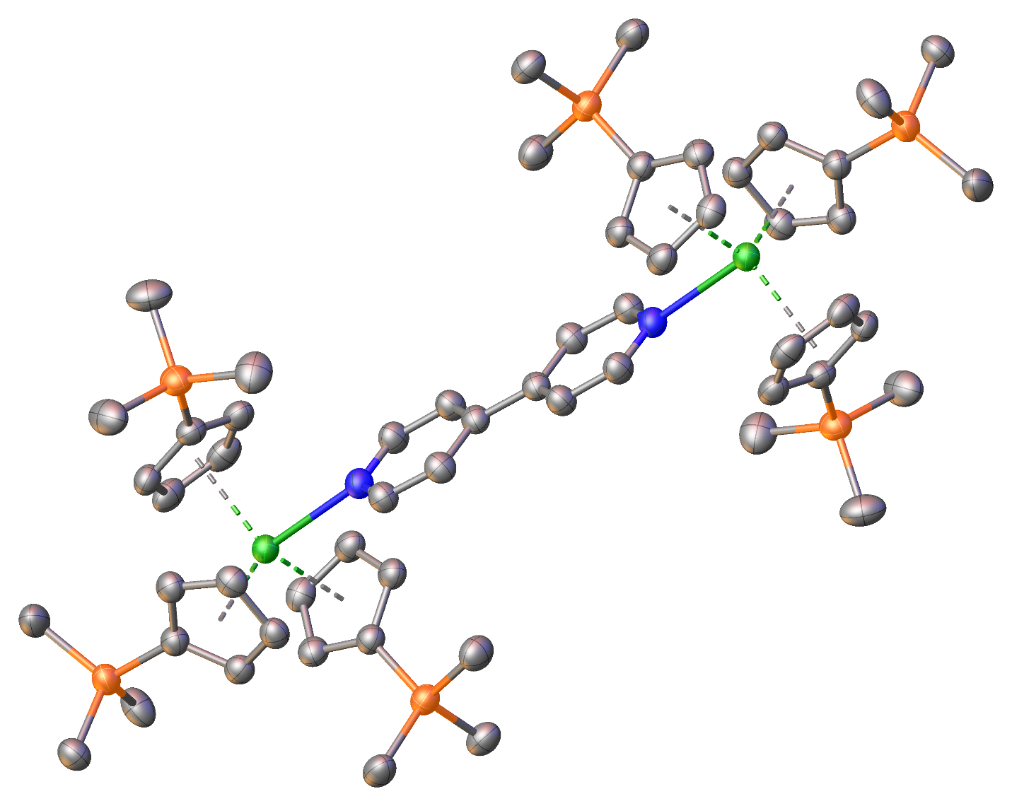
Figure S7. Crystal structure of (Cp′₃Gd)₂(μ−4,4′−bpy), 1−Gd. Green = Gadolinium, Blue = Nitrogen, Orange = Silicon, Gray = Carbon. Hydrogen has been omitted for clarity. Thermal ellipsoids are models at 50% probability.
Table S2: Crystal data and structure refinement for 1−Gd.
Deposition Number | 2236795
Empirical formula | C₅₈H₈₆Gd₂N₂Si₆
Formula weight (g/mol) | 1294.32
Temperature/K | 100
Crystal system | triclinic
Space group | P$\overline{1}$
a/Å | 9.4868(8)
b/Å | 11.3583(11)
c/Å | 14.7385(15)
α/° | 99.336(4)
β/° | 101.605(3)
γ/° | 95.620(3)
Volume/Å³ | 1521.0(3)
Z | 1
ρ_{calc}g/cm³ | 1.413
μ/mm⁻¹ | 2.316
F(000) | 660.0
Crystal size/mm³ | 0.487 × 0.169 × 0.115
Radiation | MoK_{α} (λ = 0.71073 Å)
2Θ range for data collection/° | 4.712 to 54.988
Index ranges | −10 ≤ h ≤ 12, −14 ≤ k ≤ 14, −19 ≤ l ≤ 18
Reflections collected | 33140
Independent reflections | 6966 [R_{int} = 0.0684, R_{sigma} = 0.0482]
Data/restraints/parameters | 6966/0/316
Goodness-of-fit on F² | 1.056
Final R indexes [I ≥ 2σ (I)] | R₁ = 0.0385, wR₂ = 0.0945
Final R indexes [all data] | R₁ = 0.0437, wR₂ = 0.0982
Largest diff. peak/hole / e Å⁻³ | 1.52/−0.52

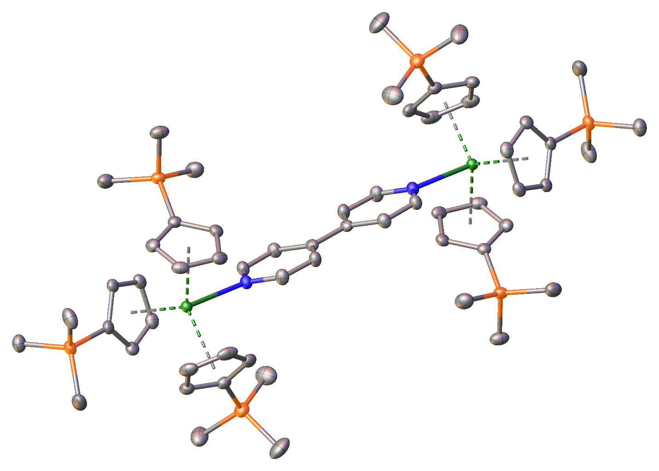
Figure S8. Crystal structure of (Cp′₃Cm)₂(μ−4,4′−bpy), 1−Cm. Green = Curium, Blue = Nitrogen, Orange = Silicon, Gray = Carbon. Hydrogen has been omitted for clarity. Thermal ellipsoids are models at 50% probability.
Table S3: Crystal data and structure refinement for 1−Cm.
Deposition Number | 2236794
Empirical formula | C₅₈H₈₆Cm₂N₂Si₆
Formula weight (g/mol) | 1475.85
Temperature/K | 100
Crystal system | triclinic
Space group | P$\overline{1}$
a/Å | 9.4771(3)
b/Å | 11.3592(4)
c/Å | 14.7868(6)
α/° | 99.2120(10)
β/° | 101.6140(10)
γ/° | 95.5520(10)
Volume/Å³ | 1525.38(10)
Z | 1
ρ_{calc}g/cm³ | 1.598
μ/mm⁻¹ | 2.807
F(000) | 724.0
Crystal size/mm³ | 0.387 × 0.156 × 0.087
Radiation | MoK_{α} (λ = 0.71073 Å)
2Θ range for data collection/° | 5.358 to 55.008
Index ranges | −12 ≤ h ≤ 11, −14 ≤ k ≤ 14, −19 ≤ l ≤ 19
Reflections collected | 47077
Independent reflections | 6992 [R_{int} = 0.0448, R_{sigma} = 0.0260]
Data/restraints/parameters | 6992/0/348
Goodness-of-fit on F² | 1.064
Final R indexes [I ≥ 2σ (I)] | R₁ = 0.0146, wR₂ = 0.0336
Final R indexes [all data] | R₁ = 0.0160, wR₂ = 0.0342
Largest diff. peak/hole / e Å⁻³ | 0.57/−0.51

Table S4. Structural data for 1−Sm, 1−Gd, and 1−Cm. Additional information for previously reported structures of Cp′₃Ce(py) (Ce), ³ (Cp′₃Nd)₂(μ−4,4′−bpy) (Nd), ⁴ (Cp′′₃Th)₂(μ−4,4′−bpy) (Th), ⁵ (Cp′₃U)₂(μ−4,4′−bpy) (U), ⁶ and (Cp′₃Am)₂(μ−4,4′−bpy) (Am) ⁴ is provided for further comparison.

Bond | Length (Å)
Compound | Ce | Nd | 1−Sm | 1−Gd | Th | U | Am | 1−Cm
M1−N1 | 2.704(4) | 2.6482(16) | 2.626(3) | 2.592(3) | 2.362(4) | 2.626(7) | 2.618(2) | 2.5962(16)
M1−Cent1 | 2.573(5) | 2.535(2) | 2.496(3) | 2.495(4) | 2.606(5) | 2.551(10) | 2.544(3) | 2.538(2)
M1−Cent2 | 2.574(5) | 2.561(2) | 2.537(3) | 2.477(4) | 2.578(5) | 2.521(10) | 2.521(3) | 2.498(2)
M1−Cent3 | 2.587(5) | 2.542(2) | 2.515(3) | 2.523(4) | 2.597(5) | 2.549(10) | 2.506(3) | 2.516(2)
M1−C1 | 2.843(5) | 2.8000(19) | 2.780(3) | 2.790(3) | 2.881(5) | 2.902(9) | 2.899(3) | 2.9029(19)
M1−C2 | 2.830(5) | 2.8338(19) | 2.808(3) | 2.742(3) | 2.912(5) | 2.799(9) | 2.818(3) | 2.835(2)
M1−C3 | 2.823(5) | 2.8093(19) | 2.775(3) | 2.715(4) | 2.923(5) | 2.759(9) | 2.739(3) | 2.757(2)
M1−C4 | 2.849(5) | 2.7751(18) | 2.740(3) | 2.788(4) | 2.831(5) | 2.774(9) | 2.768(3) | 2.728(2)
M1−C5 | 2.843(5) | 2.7722(18) | 2.748(3) | 2.808(4) | 2.800(5) | 2.865(9) | 2.844(3) | 2.815(2)
M1−C9 | 2.847(5) | 1.8660(19) | 2.890(3) | 2.754(4) | 2.815(4) | 2.798(9) | 2.813(3) | 2.7718(19)
M1−C10 | 2.863(5) | 2.8296(19) | 2.806(3) | 2.796(4) | 2.815(4) | 2.763(9) | 2.831(3) | 2.743(2)
M1−C11 | 2.851(5) | 2.7621(19) | 2.734(3) | 2.770(4) | 2.877(4) | 2.780(9) | 2.811(3) | 2.746(2)
M1−C12 | 2.816(5) | 2.7877(19) | 2.761(3) | 2.724(4) | 2.872(4) | 2.791(8) | 2.744(3) | 2.786(2)
M1−C13 | 2.825(5) | 2.860(2) | 2.841(3) | 2.719(4) | 2.843(4) | 2.840(9) | 2.763(3) | 2.816(2)
M1−C17 | 2.924(5) | 2.835(2) | 2.811(3) | 2.889(3) | 2.895(5) | 2.843(10) | 2.782(3) | 2.811(2)
M1−C18 | 2.853(5) | 2.7890(19) | 2.765(3) | 2.827(4) | 2.880(5) | 2.785(9) | 2.818(3) | 2.829(2)
M1−C19 | 2.797(5) | 2.761(2) | 2.747(3) | 2.738(4) | 2.893(5) | 2.775(9) | 2.794(3) | 2.807(2)
M1−C20 | 2.807(5) | 2.827(2) | 2.799(3) | 2.714(4) | 2.833(4) | 2.843(9) | 2.753(3) | 2.730(2)
M1−C21 | 2.868(5) | 2.847(2) | 2.822(3) | 2.797(4) | 2.813(4) | 2.851(9) | 2.751(3) | 2.756(2)
N1−M1−Cent1 | 101.697 | 103.383 | 103.553 | 101.116 | 101.091 | 93.752 | 93.655 | 93.761
N1−M1−Cent2 | 100.110 | 93.478 | 93.372 | 103.576 | 100.480 | 103.504 | 101.178 | 103.628
N1−M1−Cent3 | 96.424 | 101.405 | 101.186 | 93.684 | 102.385 | 101.178 | 103.503 | 101.236
Cent1−M1−Cent2 | 118.297 | 118.104 | 117.980 | 117.583 | 114.233 | 118.287 | 116.668 | 117.764
Cent2−M1−Cent3 | 119.515 | 116.520 | 116.692 | 117.626 | 118.438 | 117.228 | 117.408 | 117.416
Cent3−M1−Cent1 | 114.307 | 117.436 | 117.473 | 116.787 | 116.037 | 116.463 | 117.949 | 116.684
M1−Cent_{avg} | 2.578(5) | 2.546(2) | 2.516(3) | 2.498(4) | 2.594(5) | 2.540(10) | 2.524(3) | 2.517(2)
M1−C_{avg} | 2.843(5) | 2.813(2) | 2.788(3) | 2.771(4) | 2.859(5) | 2.811(10) | 2.795(3) | 2.789(2)
Cent−M1−Cent avg | 117.373 | 117.353 | 117.381 | 117.332 | 116.236 | 117.326 | 117.342 | 117.288

S4. Solid-State Absorption and Photoluminescence

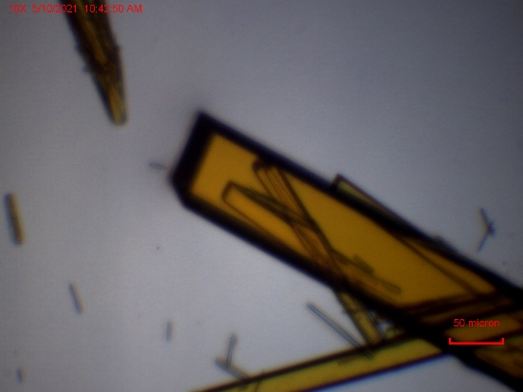
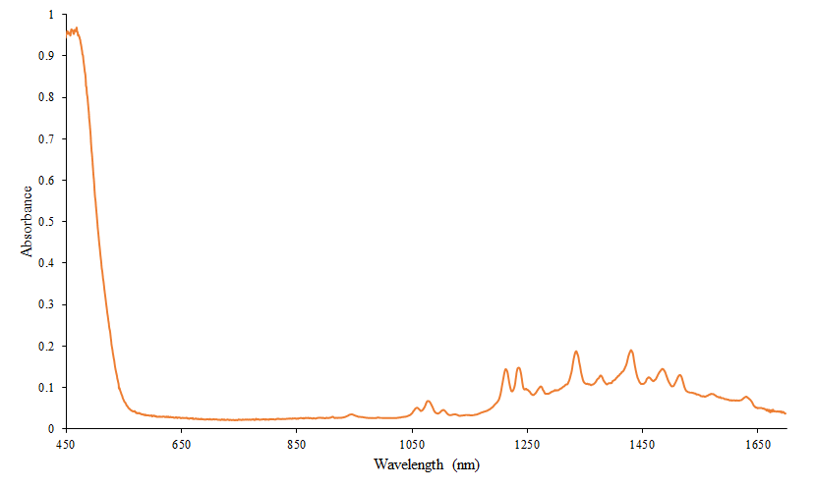
Figure S9. Solid-state absorption spectrum of 1−Sm, collected at room temperature. The crystal used is pictured in the top right.

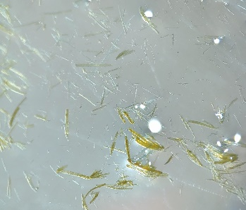
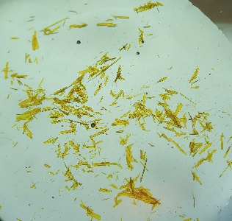
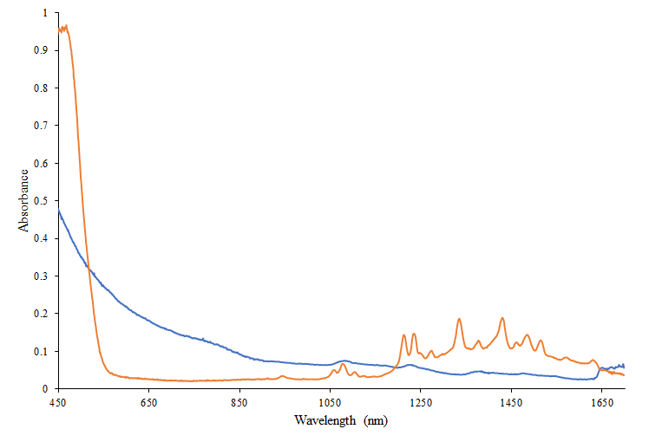
Figure S10. Solid-state absorption spectrum of 1−Sm collected using fresh crystals (orange) and after 24 hours of air exposure (blue). The crystal batches used are shown with the fresh batch on the left and after 24 hours of air exposure on the right.

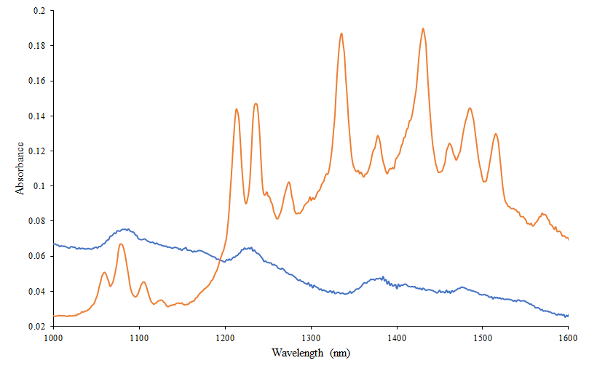
Figure S11. Solid-state absorption spectrum of 1−Sm before (orange) and after (blue) air exposure between 1000 nm and 1600 nm for enhanced clarity of f-f transitions.

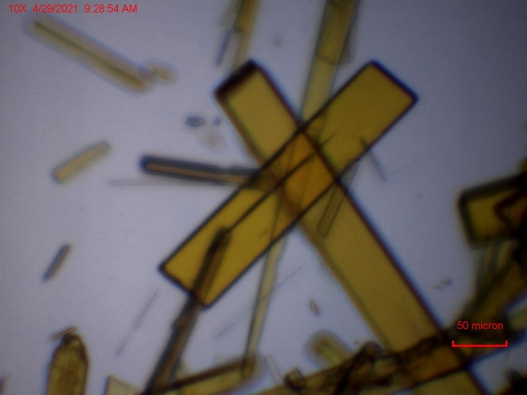
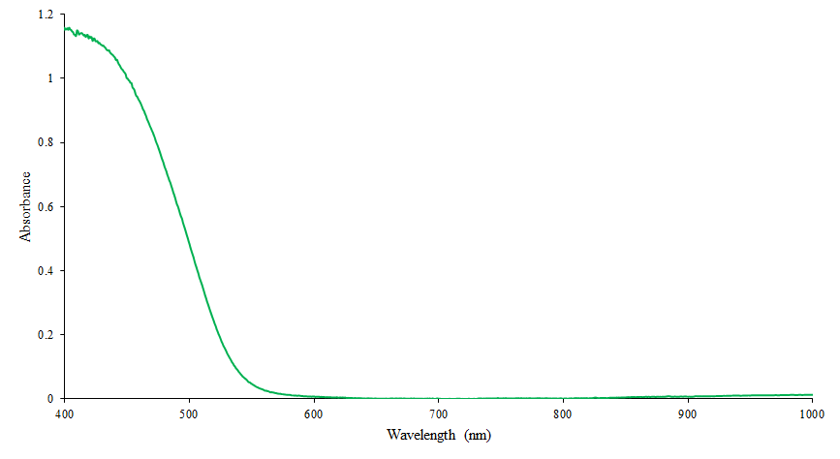
Figure S12. Solid-state absorption spectrum of 1−Gd, collected at room temperature. The crystal used is pictured in the top right.

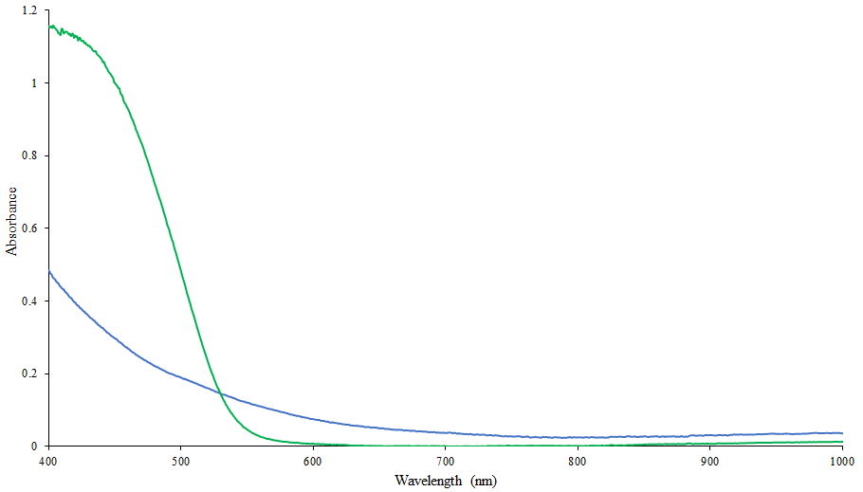
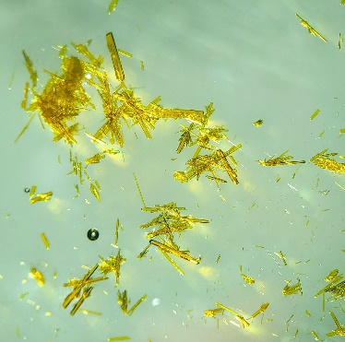
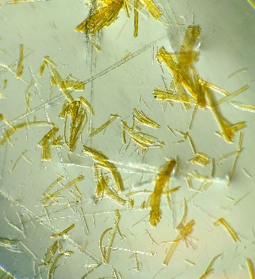
Figure S13. Solid-state absorption spectrum of 1−Gd collected using fresh crystals (green) and after 24 hours of air exposure (blue). The crystal batches used are pictured with the fresh crystals on the left and after 24 hours of air exposure on the right.

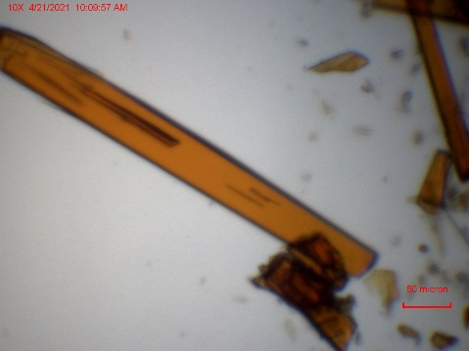
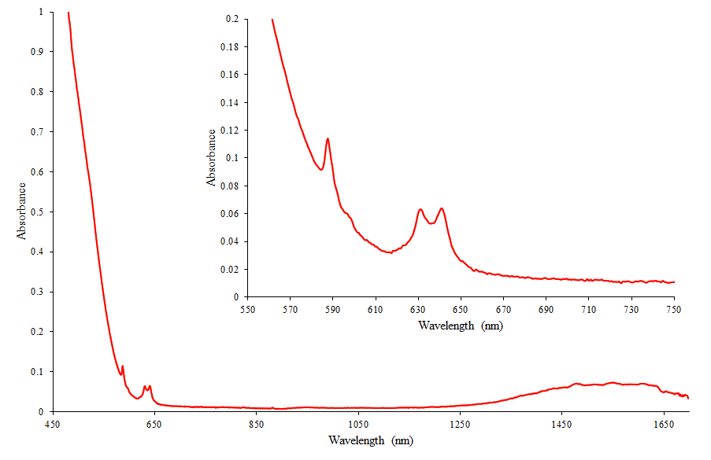
J = $\frac{5}{2}$
J = $\frac{7}{2}$
J = $\frac{7}{2}$
Figure S14. Solid-state absorption spectrum of 1−Cm, collected at room temperature. The crystal used is pictured in the top right.

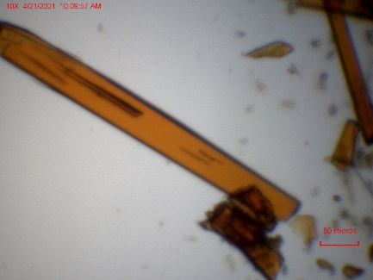
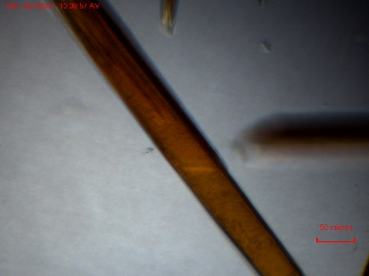
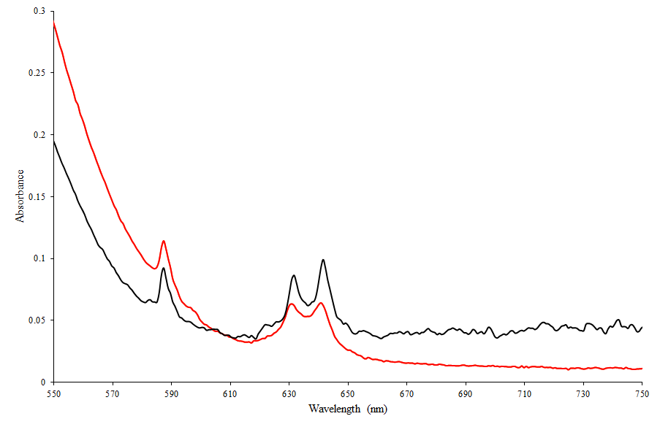

Figure S15. Solid-state absorption spectrum of 1−Cm, collected at room temperature (red) compared to −180 ℃ (black). The crystals used are pictured at room temperature (left) and at −180 ℃ (right).

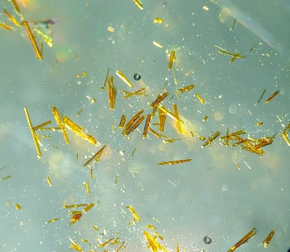
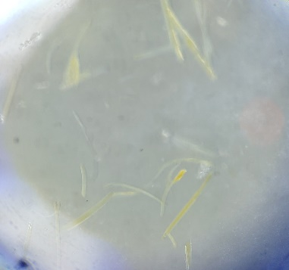
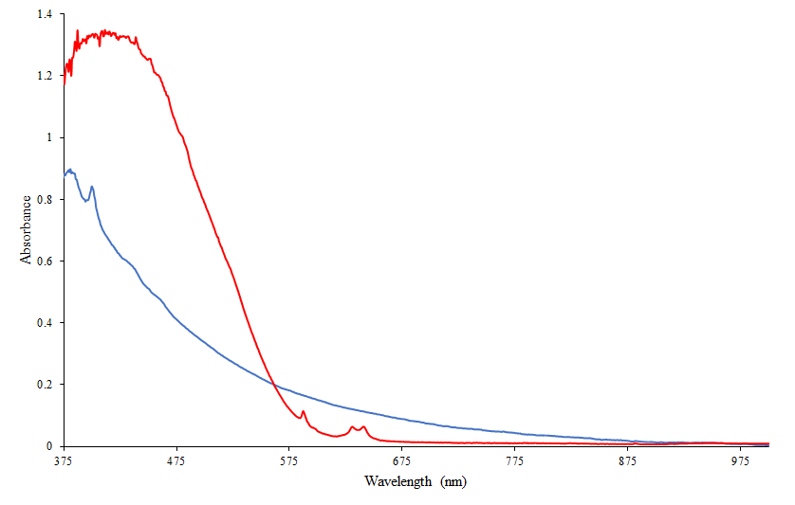
Figure S16. Solid-state absorption spectrum of 1−Cm collected using fresh crystals (red) and after 24 hours of air exposure (blue). The crystal batches used are pictured with the fresh crystals on the left and after 24 hours of air exposure on the right.

J = $7/2$ (${}_{ }^{6}{D_{7/2}}$ ${}_{ }^{8}{S_{7/2}}$)
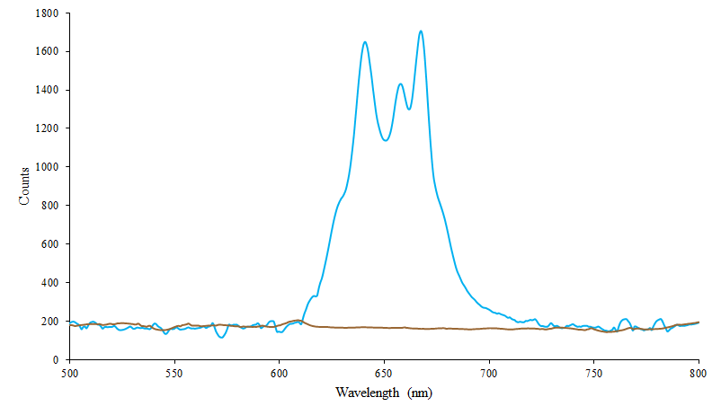
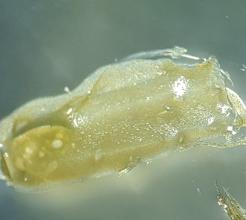

Figure S17. Photoluminescence of putative Cp′₃Cm excited at 420 nm. Emission spectra were collected before (blue) and after (brown) 24 hours of air exposure.

S5. Solution Phase Absorption Spectra

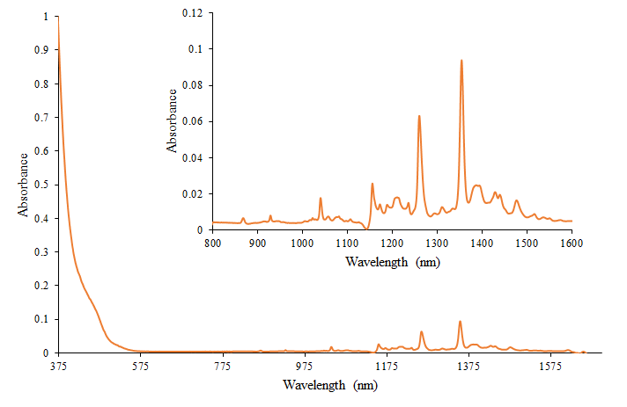
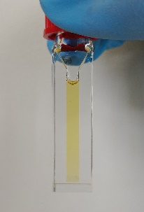

Figure S18. Solution phase absorption spectrum of 1−Sm. A zoomed spectrum is shown in the top right to enhance clarity of f-f transitions. The sample used is pictured above.

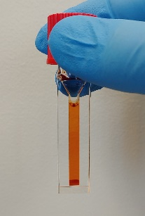
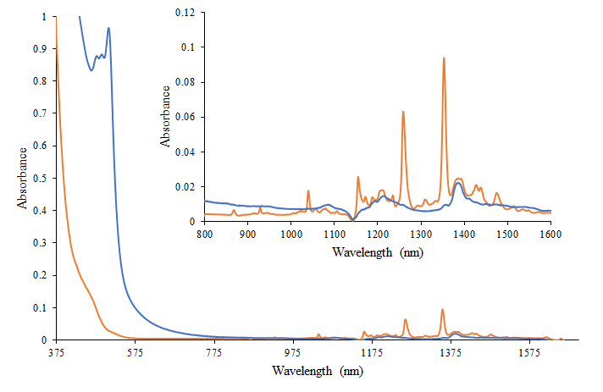
Figure S19. Solution phase absorption spectra of 1−Sm. Spectra were collected before (orange) and after (blue) 24 hours of air exposure. The sample used is pictured above before (left) and after (right) 24 hours of air exposure. A zoomed spectrum is provided to enhance clarity of the f-f transitions.

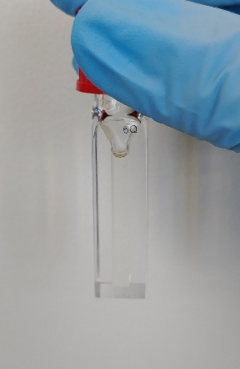
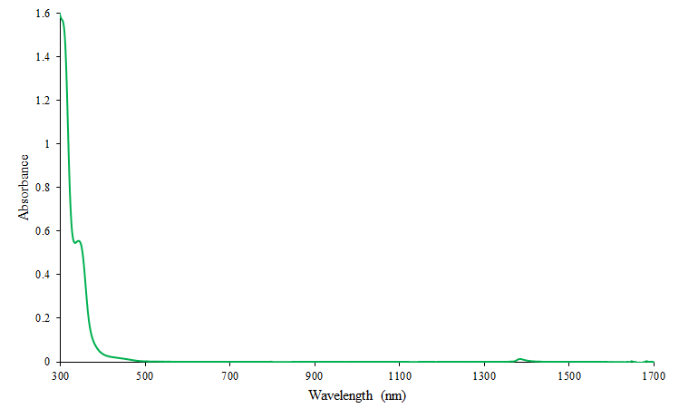
Figure S20. Solution phase absorption spectrum of 1−Gd. The sample used is pictured above.

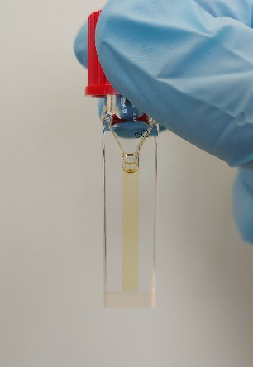
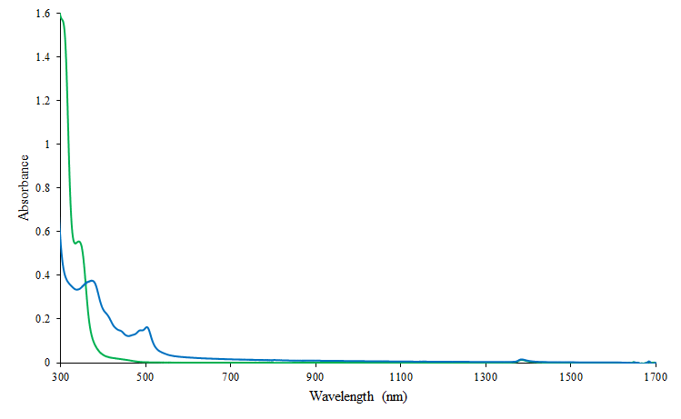
Figure S21. Solution phase absorption spectra of 1−Gd. Spectra were collected before (green) and after (blue) 24 hours of air exposure. The sample used is pictured above before (left) and after (right) 24 hours of air exposure.

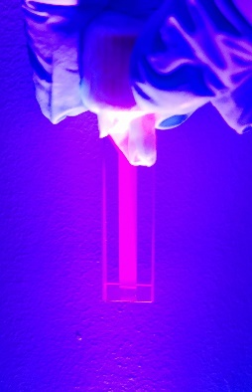
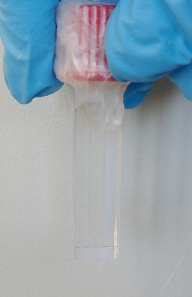
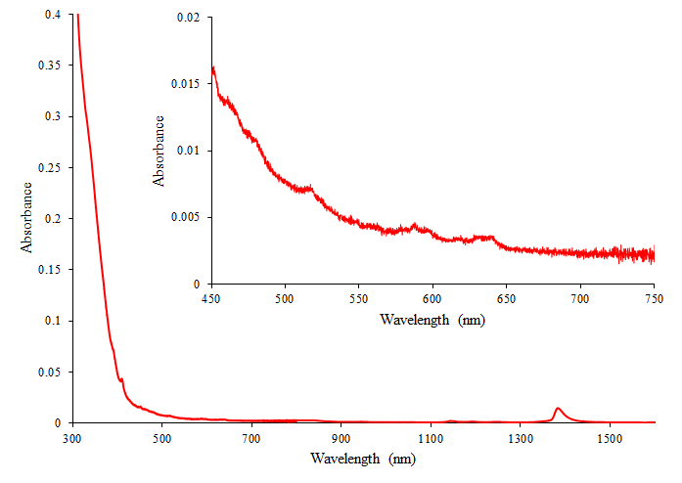
Figure S22. Solution phase absorption spectrum of 1−Cm. A zoomed spectrum is shown to view the very weak f-f transitions of Cm³⁺. The sample used is pictured in the top right and again under a blacklight.

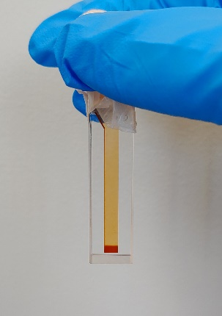
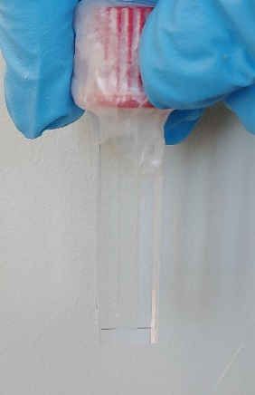
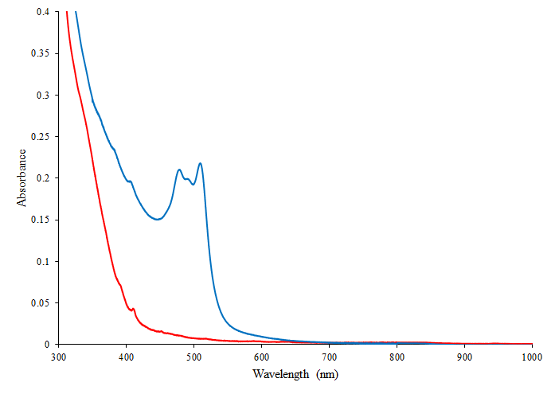
Figure S23. Solution phase absorption spectra of 1−Cm. Spectra were collected before (red) and after (blue) 24 hours of air exposure. The sample used is pictured above before (left) and after (right) 24 hours of air exposure.

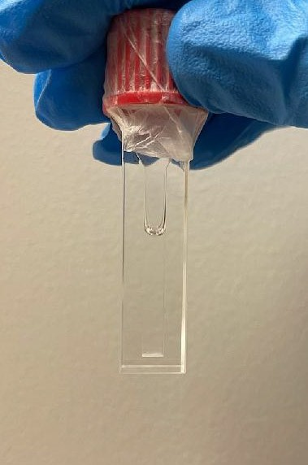
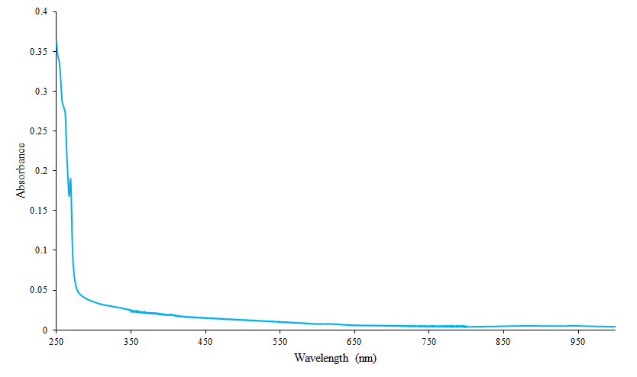

Figure S24. Solution phase absorption spectrum of a putative Cp′₃Cm solution.
S6. Computational Details

To get insight on the electronic structure, spectroscopic properties, and bonding in 1−Sm, 1−Gd, 1−Cm and Cp₃′Cm, the ab-initio complete active space self-consistent field (CASSCF) along time-dependent DFT (TDDFT) approximations were employed. ⁷ Details of each calculation are described below.

Theoretical Models and Geometry Optimizations
The structures of 1−Sm, 1−Gd, and 1−Cm were obtained from the crystallographic information file (CIF) and were used as input for the geometry optimizations. Since no crystallographic structures were obtained for Cp′₃Cm, a geometry optimization on a hypothetical system was carried out. All these calculations were performed in ADF2019⁸ using the generalized gradient approximation (GGA) Perdew-Burke-Ernzerhof (PBE) in conjunction with the Slater-type basis functions (STO) triple-zeta potential (TZP). ⁹ The scalar relativistic (SR) effects were incorporated via the zeroth-order relativistic approximation (ZORA). ¹⁰ Due to 1−Sm, 1−Gd, and 1−Cm are bimetallic systems, their size represents a limitation from the theoretical perspective. Therefore, a model consisting of one Cp′₃M unit (M = Sm, Gd, Cm) coordinated to pyridine was employed.

CASSCF Calculations
The starting wavefunctions were calculated at Hartree-Fock (HF) level of theory along with the all-electron ANO-RCC Gaussian-type basis sets contracted to TZP quality. ^{11,12} The second-order Douglas-Kroll-Hess (DKH2) Hamiltonian was employed to account for the scalar relativistic effects. ¹³ This resulting wavefunction was subjected to state-average (SA) CASSCF calculations to mostly recover the static correlation. Two active spaces were calculated: 1) n electrons in seven f orbitals, CAS(n, 7) with n = 5,7,7 for Sm, Gd and Cm, respectively 2) an extension of the first one that includes one bonding ligand orbital and two extra electrons, that is a CAS(n + 2, 8). A third active space including 6 extra electrons and 6 extra orbitals corresponding to the bonding and antibonding 6d_{z}², 6d_{xz} and 6d_{yz} orbitals was attempted, however it became impractical. To account for the dynamic correlation effects, the multiconfigurational pair-density functional theory (MC-pDFT) was employed using tPBE on-top functional. ¹⁴ The spin-orbit (SO) coupling was included by state interactions between the CASSCF wavefunctions using the restricted active space state interaction (RASSI) method. ¹⁵ All these calculations were performed in OpenMolcas. ¹⁶
Bonding Analyses
Natural Bond Orbital (NBO) analyses¹⁷ were performed with the NBO software implemented in the Amsterdam Density Functional (ADF) suite within AMS2019. ¹⁸ The fully optimized structures were used to calculate the Natural Localized Molecular Orbitals (NLMOs) of 1−Sm, 1−Gd, 1−Cm and Cp′₃Cm. The level of theory used was similar to those used for the geometry optimizations except that the functional used was the hybrid GGA PBE0. Given that the NBO formalism produces similar results independent of the basis set or whether the density comes from DFT or wavefunction-based calculations, we considered that calculating the whole experimental molecule would be best to be analyzed. Conversely, the topology of the electron density is considerably more sensitive to the origin of the molecular electron density, thus we used the CASSCF ground-state wavefunction to obtain the molecular electron density to be analyzed through QTAIM calculations with MultiWFN. ¹⁹

S7. Additional Computational Results
Table S5. Experimental and calculated average M–(Cp′ cent) distances (Å) and angles (degrees) in 1−Sm, 1−Gd and 1−Cm. The effect of coordinating the 4,4′–bipyridine is also observed in the calculated bond distances of Cp′₃M (M=Sm, Gd, Cm) systems shown in Table S6. As observed below, bond lengths in Cp′₃M are smaller than in 1−M due to the reduced coordination.
 | Experimental |  |  | Calculated
 | 1−Sm | 1−Gd | 1−Cm | 1−Sm | 1−Gd | 1−Cm
Avg M–(Cp′ cnt) | 2.516 | 2.498 | 2.517 | 2.546 | 2.516 | 2.541
M–N_{Bpy} | 2.626 | 2.592 | 2.596 | 2.729 | 2.660 | 2.670
Avg Cnt–M–Cnt | 117.4 | 117.3 | 117.3 | 117.8 | 117.6 | 117.5
Avg Cnt–M–N | 99.6 | 99.5 | 99.5 | 98.2 | 99.0 | 99.1

Table S6. Experimental and calculated average M – (Cp′ cent) distances (Å) in Cp′₃M (M = Sm, Gd, Cm). Cp′₃Sm and Cp′₃Gd systems were optimized for comparative purposes using the same level of theory described in the computational details.
 | Experimental |  |  | Calculated
 | Cp′₃Smª | Cp′₃Gd^{b} | Cp′₃Cm | Cp′₃Sm | Cp′₃Gd | Cp′₃Cm
Avg M–(Cp′ cnt) | 2.461 | 2.437 | - | 2.475 | 2.444 | 2.472
ª J. Am. Chem. Soc. 2015, 137, 1, 369–382 (²)
^{b} J. Am. Chem. Soc. 2013, 135, 26, 9857–9868 (³)

Table S7. Theoretical assignment of the experimental absorption bands observed in 1−Sm. The assignment was done based on the calculated position of the SO-pDFT states shown in Table S8.
Experimental Bands |  | Assignment
Wavelength (nm) | Wavenumber (cm⁻¹) | Assignment
1575 | 6349.2 | 5/2(⁶H) → 15/2 (⁶H)  5/2(⁶H) → 1/2 (⁶F)
1518 | 6587.6 | 5/2(⁶H) → 15/2 (⁶H)  5/2(⁶H) → 1/2 (⁶F)
1475 | 6779.7 | 5/2(⁶H) → 15/2 (⁶H)  5/2(⁶H) → 1/2 (⁶F)
1460 | 6849.3 | 5/2(⁶H) → 15/2 (⁶H)  5/2(⁶H) → 1/2 (⁶F)
1430 | 6993.0 | 5/2(⁶H) → 3/2 (⁶F)
1375 | 7272.7 | 5/2(⁶H) → 5/2 (⁶F)
1235 | 8097.2 | 5/2(⁶H) → 7/2 (⁶F)
1215 | 8230.5 | 5/2(⁶H) → 7/2 (⁶F)
1115 | 8968.6 | 5/2(⁶H) → 9/2 (⁶F)
1075 | 9302.3 | 5/2(⁶H) → 9/2 (⁶F)
1060 | 9434.0 | 5/2(⁶H) → 9/2 (⁶F)

Table S8. Assignment of the SO−pDFT states for 1−Sm in terms of the total angular momentum quantum number, J. The most predominant Russell-Saunders term is also indicated in the second column. The energies and wavelenghts correspond to the Kramers components of the different manifolds. Manifold |  | Position of SO-pDFT states
J | Spectroscopic Term | Energy (cm⁻¹) | Wavelength (nm)
5/2 | ⁶H
  0
  58.4725
  223.419
  -
  171020.6
  44759
7/2 | ⁶H
  728.9291
  1066.28
  1197.14
  1217.94
  13718.8
  9378.4
  8353.2
  8210.6
9/2 | ⁶H
  2175.682
  2302.326
  2408.72
  2434.236
  2450.924
  4596.3
  4343.4
  4151.6
  4108.1
  4080.1
11/2 | ⁶H
  3362.499
  3483.949
  3593.22
  3785.206
  3817.926
  3854.888
  2974.0
  2870.3
  2783.0
  2641.9
  2619.2
  2594.1
13/2 | ⁶H
  4884.269
  5043.233
  5203.371
  5278.985
  5338.677
  5340.178
  5354.613
  2047.4
  1982.9
  1921.8
  1894.3
  1873.1
  1872.6
  1867.5
15/2 + 1/2 | ⁶H + ⁶F
  6305.665
  6364.099
  6486.014
  6532.931
  6574.991
  6642.288
  6702.247
  6743.443
  6861.831
  1585.9
  1571.3
  1541.8
  1530.7
  1520.9
  1505.5
  1492.0
  1482.9
  1457.3
3/2 | ⁶F
  6876.426
  6995.769
  1454.2
  1429.4
5/2 | ⁶F
  7290.769
  7361.329
  7371.416
  1371.6
  1358.5
  1356.6
7/2 | ⁶F
  8206.31
  8215.612
  8216.662
  8292.328
  1218.6
  1217.2
  1217.0
  1205.9
9/2 | ⁶F
  9378.206
  9420.438
  9438.025
  9562.972
  9597.42
  1066.3
  1061.5
  1059.5
  1045.7
  1041.9
11/2 | ⁶F
  10836.26
  10852.76
  10893.39
  10980.48
  11095.79
  11150.84
  922.8
  921.4
  918.0
  910.7
  901.2
  896.8

Table S9. Theoretical assignment of predicted absorption bands in 1−Gd. The assignment was done based on the calculated position of the SO-pDFT states shown in Table S10.
Predicted Bands |  | Assignment
Wavelength (nm) | Wavenumber (cm⁻¹) | Assignment
334 | 29967 | 7/2(⁸S) → 7/2 (⁶D)
329 | 30360 | 7/2(⁸S) → 5/2 (⁶D)

Table S10. Assignment of the SO−pDFT states for 1−Gd in terms of the total angular momentum quantum number, J. The most predominant Russell-Saunders term is also indicated in the second column. The energies and wavelenghts correspond to the Kramers components of the different manifolds.
Manifold |  | Position of SO-pDFT states
J | Spectroscopic Term | Energy (cm⁻¹) | Wavelength (nm)
7/2 | ⁸S
  0
  2.2334
  6.7497
  13.6279
  -
  4477478.3
  1481547.3
  733788.8
7/2 | ⁶D
  29344
  29953.06
  29965.58
  30059.75
  340.8
  333.9
  333.7
  332.7
5/2 | ⁶D
  30345.8
  30360.33
  30372.94
  329.5
  329.4
  329.2

Table S11. Theoretical assignment of the experimental absorption bands observed in 1−Cm. The assignment was done based on the calculated position of the SO-pDFT states shown in Table S12.
Experimental Bands |  | Assignment
Wavelength (nm) | Wavenumber (cm⁻¹) | Assignment
630 | 15873 | 7/2(⁸S) → 7/2 (⁶D)
650 | 15384 | 7/2(⁸S) → 7/2 (⁶D)

Table S12. Assignment of the SO−pDFT states for 1−Cm in terms of the total angular momentum quantum number, J. The most predominant Russell-Saunders term is also indicated in the second column. The energies and wavelenghts correspond to the Kramers components of the different manifolds.
Manifold |  | Position of SO-pDFT states
J | Spectroscopic Term | Energy (cm⁻¹) | Wavelength (nm)
7/2 | ⁸S
  0
  40.2677
  187.123
  385.236
  -
  248338.0
  53440.8
  25958.1
7/2 | ⁶D
  15216.6
  15266.9
  15353.4
  16087.8
  657.2
  655.0
  651.3
  621.6
5/2 | ⁶D
  16650.1
  16657.7
  16735.9
  600.6
  600.3
  597.5

Table S13. Theoretical assignment of the experimental emission bands observed in Cp′₃Cm. The assignment was done based on the calculated position of the SO-pDFT states shown in Table S14.
Experimental Bands |  | Assignment
Wavelength (nm) | Wavenumber (cm⁻¹) | Assignment
645 | 15504 | 7/2 (⁶D) → 7/2(⁸S)
660 | 15152 | 7/2 (⁶D) → 7/2(⁸S)
670 | 14925 | 7/2 (⁶D) → 7/2(⁸S)

Table S14. Assignment of the SO−pDFT states for Cp′₃Cm in terms of the total angular momentum quantum number, J. The most predominant Russell-Saunders term is also indicated in the second column. The energies and wavelenghts correspond to the Kramers components of the different manifolds.
Manifold |  | Position of SO-pDFT states
J | Spectroscopic Term | Energy (cm⁻¹) | Wavelength (nm)
7/2 | ⁸S
  0
  25.333
  129.187
  351.218
  -
  394742.0
  77407.1
  28472.4
7/2 | ⁶D
  15121.4
  15408.3
  15448.1
  15698.7
  661.3
  649.0
  647.3
  637.0
5/2 | ⁶D
  16365.6
  16401.2
  16559.1
  611.0
  609.7
  603.9

 |  | NLMO Hybrid composition
 |  | α | β
M−Cp′(1) | 1−Sm | 14% Sm(0.25 5d; 0.75 4f) | 4% Sm(0.79 5d; 0.21 4f)
M−Cp′(1) |  | 85% C(1.00 2p) | 95% C(1.00 2p)
M−Cp′(1) | 1−Gd | 6% Gd(0.01 6s; 0.98 5d) | 6% Gd(0.70 5d; 0.29 4f)
M−Cp′(1) |  | 93% C(1.00 2p) | 93% C(1.00 2p)
M−Cp′(1) | 1−Cm | 9% Cm(0.01 7s; 0.99 6d) | 9% Cm(0.01 7s; 0.64 6d; 0.35 5f)
M−Cp′(1) |  | 90% C(0.02 2s; 0.98 2p) | 90% C(1.00 2p)
M−Cp′(1) | Cp′₃Cm | 9% Cm(0.02 7s; 0.98 6d) | 8% Cm(0.81 6d; 0.18 5f)
M−Cp′(1) |  | 90% C(0.01 2s; 0.99 2p) | 91% C(1.00 2p)
M−Cp′(2) | 1−Sm | 16% Sm(0.19 5d; 0.81 4f) | 4% Sm(0.85 5d; 0.14 4f)
M−Cp′(2) |  | 83% C(1.00 2p) | 94% C(1.00 2p)
M−Cp′(2) | 1−Gd | 4% Gd(0.01 6s; 0.98 5d) | 6% Gd(0.62 5d; 0.37 4f)
M−Cp′(2) |  | 94% C(1.00 2p) | 93% C(1.00 2p)
M−Cp′(2) | 1−Cm | 9% Cm(0.01 7s; 0.99 6d) | 9% Cm(0.01 7s; 0.54 6d; 0.45 5f)
M−Cp′(2) |  | 90% C(0.02 2s; 0.98 2p) | 90% C(1.00 2p)
M−Cp′(2) | Cp′₃Cm | 8% Cm(0.02 7s; 0.98 6d) | 8% Cm(0.82 6d; 0.17 5f)
M−Cp′(2) |  | 91% C(0.01 2s; 0.99 2p) | 90% C(0.01 2s; 0.99 2p)
M−Cp′(3) | 1−Sm | 10% Sm(0.35 5d; 0.65 4f) | 4% Sm(0.74 5d; 0.25 4f)
M−Cp′(3) |  | 88% C(1.00 2p) | 95% C(1.00 2p)
M−Cp′(3) | 1−Gd | 6% Gd(0.01 6s; 0.98 5d) | 6% Gd(0.79 5d; 0.20 4f)
M−Cp′(3) |  | 93% C(1.00 2p) | 93% C(1.00 2p)
M−Cp′(3) | 1−Cm | 9% Cm(0.01 7s; 0.99 6d) | 9% Cm(0.01 7s; 0.72 6d; 0.28 5f)
M−Cp′(3) |  | 90% C(0.02 2s; 0.98 2p) | 90% C(1.00 2p)
M−Cp′(3) | Cp′₃Cm | 9% Cm(0.01 7s; 0.99 6d) | 7% Cm(0.80 6d; 0.19 5f)
M−Cp′(3) |  | 90% C(0.01 2s; 0.99 2p) | 91% C(0.01 2s; 0.99 2p)
M−N | 1−Sm | 4% Sm(0.17 6s; 0.68 5d; 0.15 4f) | 4% Sm(0.19 6s; 0.73 5d; 0.08 4f)
M−N |  | 93% N(0.32 2s; 0.68 2p) | 93% N(0.32 2s; 0.68 2p)
M−N | 1−Gd | 4% Gd(0.20 6s; 0.80 5d) | 4% Gd(0.19 6s; 0.73 5d; 0.08 4f)
M−N |  | 92% N(0.31 2s; 0.69 2p) | 93% N(0.32 2s; 0.68 2p)
M−N | 1−Cm | 7% Cm(0.13 7s; 0.87 6d) | 6% Cm(0.11 7s; 0.72 6d; 0.16 5f)
M−N |  | 90% N(0.30 2s; 0.70 2p) | 90% N(0.30 2s; 0.70 2p)
Table S15. Selected Natural Localized Molecular Orbitals (NLMOs) and their hybrid compositions describing the metal-ligand bonds of 1−Sm, 1−Gd, 1−Cm, and Cp′₃Cm. NLMOs were obtained from PBE/STO-TZP calculations.
OPTIMIZED MOLECULAR GEOMETRIES

1−Sm
Sm 4.73061123 -2.64827356 3.23460013
Si 6.32535635 -3.97467007 6.92868079
Si 5.46783406 1.71748016 3.65914492
Si 1.88048446 -5.84812361 2.44997454
N 2.58751183 -1.59397196 1.91447343
C 4.83599384 -1.67571701 5.83810336
H 5.62082524 -0.95297599 6.04547444
C 3.53587486 -1.35620278 5.37143660
H 3.16545771 -0.35306530 5.16661526
C 4.23674051 -4.58891425 1.20455271
H 3.71680367 -4.30472419 0.29027430
C 4.68984839 -5.45576020 3.26576506
H 4.58017983 -5.93344087 4.23576223
C 3.61693761 -5.14045162 2.37013464
C 4.93915384 -3.08777958 6.02092169
C 1.55383840 -0.95953170 2.50035640
H 1.54823428 -0.95098625 3.58990569
C 3.65960257 -3.62171586 5.67165078
H 3.37371423 -4.66845425 5.73096225
C 2.80644318 -2.56965708 5.26726061
H 1.76568268 -2.68376220 4.96663824
C 0.53167318 -0.32917932 1.79855273
H -0.25448173 0.16076514 2.37140448
C 5.92041735 -5.09549452 2.67229726
H 6.91056485 -5.23076230 3.10689776
C 6.30444126 -1.47620526 1.24708588
H 6.28504236 -1.96485097 0.27527354
C 5.63953617 -4.57170528 1.38317315
H 6.37771499 -4.24585551 0.65455388
C 5.50950065 -0.37941290 1.64196932
H 4.77236554 0.12002161 1.01528940
C 5.86700375 0.01837363 2.96573243
C 0.53295146 -0.33061104 0.39508316
C 6.91088248 -0.87861888 3.37418966
H 7.44542333 -0.84124070 4.32192948
C 2.59231655 -1.59436932 0.56604548
H 3.43719222 -2.09595583 0.09150143
C 7.17805939 -1.78944106 2.32888931
H 7.93487617 -2.57280314 2.33576119
C 1.61207300 -0.99527739 -0.21404364
H 1.71161174 -1.05389461 -1.29704516
C 5.74114225 1.85009753 5.52357790
H 5.01138576 1.26869555 6.10411461
H 5.64958239 2.90306964 5.83231463
H 6.75041334 1.51498594 5.80770322
C 8.01700921 -3.39675309 6.31058630
H 8.16325316 -3.62470261 5.24433964
H 8.82284561 -3.89221468 6.87386272
H 8.14339774 -2.31161519 6.44288380
C 6.19039511 -3.56237198 8.76857895
H 6.27276188 -2.47825664 8.93708372
H 6.98549909 -4.05776197 9.34726117
H 5.22091824 -3.88858067 9.17370460
C 6.62187740 2.95745679 2.81603453
H 7.67475966 2.71734845 3.02688822
H 6.42987796 3.98328680 3.16699725
H 6.49106614 2.93956620 1.72383536
C 3.68530103 2.20714105 3.24626093
H 3.48594231 2.12399444 2.16712251
H 3.49692504 3.25183299 3.53745906
H 2.95383104 1.57675820 3.77249227
C 1.37023903 -6.23408378 4.22758993
H 2.10261670 -6.88977031 4.72211638
H 0.40383084 -6.76136193 4.23449532
H 1.26009752 -5.32580088 4.83706170
C 1.87194306 -7.46387598 1.46547441
H 2.15628556 -7.28813541 0.41721176
H 0.87639399 -7.93450834 1.47455648
H 2.59166916 -8.18127972 1.88719776
C 0.60721817 -4.68287054 1.67459018
H 0.50480912 -3.75082793 2.24881153
H -0.38001366 -5.16893308 1.63919125
H 0.88039169 -4.41628902 0.64224100
C 6.18825932 -5.84722154 6.71945056
H 5.18935419 -6.21408461 7.00014424
H 6.91730934 -6.35140539 7.37210919
H 6.39176104 -6.16554499 5.68706264
N -2.58751183 1.59397196 -1.91447343
C -1.55383840 0.95953170 -2.50035640
H -1.54823428 0.95098625 -3.58990569
C -0.53167318 0.32917932 -1.79855273
H 0.25448173 -0.16076514 -2.37140448
C -0.53295146 0.33061104 -0.39508316
C -2.59231655 1.59436932 -0.56604548
H -3.43719222 2.09595583 -0.09150143
C -1.61207300 0.99527739 0.21404364
H -1.71161174 1.05389461 1.29704516
Sm -4.73061123 2.64827356 -3.23460013
Si -6.32535635 3.97467007 -6.92868079
Si -5.46783406 -1.71748016 -3.65914492
Si -1.88048446 5.84812361 -2.44997454
C -4.83599384 1.67571701 -5.83810336
H -5.62082524 0.95297599 -6.04547444
C -3.53587486 1.35620278 -5.37143660
H -3.16545771 0.35306530 -5.16661526
C -4.23674051 4.58891425 -1.20455271
H -3.71680367 4.30472419 -0.29027430
C -4.68984839 5.45576020 -3.26576506
H -4.58017983 5.93344087 -4.23576223
C -3.61693761 5.14045162 -2.37013464
C -4.93915384 3.08777958 -6.02092169
C -3.65960257 3.62171586 -5.67165078
H -3.37371423 4.66845425 -5.73096225
C -2.80644318 2.56965708 -5.26726061
H -1.76568268 2.68376220 -4.96663824
C -5.92041735 5.09549452 -2.67229726
H -6.91056485 5.23076230 -3.10689776
C -6.30444126 1.47620526 -1.24708588
H -6.28504236 1.96485097 -0.27527354
C -5.63953617 4.57170528 -1.38317315
H -6.37771499 4.24585551 -0.65455388
C -5.50950065 0.37941290 -1.64196932
H -4.77236554 -0.12002161 -1.01528940
C -5.86700375 -0.01837363 -2.96573243
C -6.91088248 0.87861888 -3.37418966
H -7.44542333 0.84124070 -4.32192948
C -7.17805939 1.78944106 -2.32888931
H -7.93487617 2.57280314 -2.33576119
C -5.74114225 -1.85009753 -5.52357790
H -5.01138576 -1.26869555 -6.10411461
H -5.64958239 -2.90306964 -5.83231463
H -6.75041334 -1.51498594 -5.80770322
C -8.01700921 3.39675309 -6.31058630
H -8.16325316 3.62470261 -5.24433964
H -8.82284561 3.89221468 -6.87386272
H -8.14339774 2.31161519 -6.44288380
C -6.19039511 3.56237198 -8.76857895
H -6.27276188 2.47825664 -8.93708372
H -6.98549909 4.05776197 -9.34726117
H -5.22091824 3.88858067 -9.17370460
C -6.62187740 -2.95745679 -2.81603453
H -7.67475966 -2.71734845 -3.02688822
H -6.42987796 -3.98328680 -3.16699725
H -6.49106614 -2.93956620 -1.72383536
C -3.68530103 -2.20714105 -3.24626093
H -3.48594231 -2.12399444 -2.16712251
H -3.49692504 -3.25183299 -3.53745906
H -2.95383104 -1.57675820 -3.77249227
C -1.37023903 6.23408378 -4.22758993
H -2.10261670 6.88977031 -4.72211638
H -0.40383084 6.76136193 -4.23449532
H -1.26009752 5.32580088 -4.83706170
C -1.87194306 7.46387598 -1.46547441
H -2.15628556 7.28813541 -0.41721176
H -0.87639399 7.93450834 -1.47455648
H -2.59166916 8.18127972 -1.88719776
C -0.60721817 4.68287054 -1.67459018
H -0.50480912 3.75082793 -2.24881153
H 0.38001366 5.16893308 -1.63919125
H -0.88039169 4.41628902 -0.64224100
C -6.18825932 5.84722154 -6.71945056
H -5.18935419 6.21408461 -7.00014424
H -6.91730934 6.35140539 -7.37210919
H -6.39176104 6.16554499 -5.68706264

1−Gd
Gd 4.68423174 -2.60601055 3.20592232
Si 6.32216237 -3.94844103 6.86385807
Si 5.48443614 1.74104130 3.68413565
Si 1.86109583 -5.79108305 2.46232562
N 2.60692698 -1.55995552 1.91441443
C 4.83304773 -1.64628798 5.77661701
H 5.62637448 -0.92908091 5.96492429
C 1.56712522 -0.93528337 2.50072561
H 1.56258708 -0.92593570 3.58977393
C 3.53405387 -1.32224452 5.33018419
H 3.16492297 -0.31707685 5.13348182
C 3.64442739 -3.58955702 5.63567131
H 3.35589700 -4.63490392 5.69375140
C 5.86050795 0.03999131 2.98509384
C 4.66563245 -5.37578600 3.27007148
H 4.56318588 -5.83765388 4.24744968
C 4.93577729 -3.06326571 5.95147311
C 0.53792342 -0.31809553 1.79804013
H -0.25265925 0.16388217 2.37118011
C 3.59369248 -5.07386068 2.38048628
C 0.53722262 -0.32346904 0.39516901
C 4.21255191 -4.53396724 1.19917367
H 3.68707236 -4.26364432 0.28390451
C 6.88073521 -0.87897245 3.38248747
H 7.42284638 -0.86065121 4.32608251
C 6.25647668 -1.45920984 1.25471486
H 6.21948274 -1.94315143 0.28166367
C 5.48624289 -0.34818666 1.66080603
H 4.75790818 0.17140472 1.04001029
C 7.12266311 -1.79736613 2.33116807
H 7.86729556 -2.59155632 2.33256886
C 2.61158089 -1.56300964 0.56481609
H 3.46165949 -2.05483201 0.09085976
C 5.89536910 -5.00746107 2.67237980
H 6.88656643 -5.14000351 3.10443763
C 2.79430256 -2.53852035 5.23915425
H 1.74643449 -2.64828105 4.96181394
C 5.61049481 -4.51624531 1.37038595
H 6.34575941 -4.18753677 0.64090797
C 1.62322646 -0.97737177 -0.21392349
H 1.72225239 -1.03797328 -1.29669212
C 6.64511888 2.97314800 2.83657596
H 7.69679710 2.73452199 3.05555627
H 6.45191611 4.00331769 3.17491738
H 6.52036893 2.94316312 1.74369684
C 8.01789237 -3.36517081 6.26188430
H 8.16823157 -3.57772331 5.19300539
H 8.81834539 -3.87207361 6.82291729
H 8.14695171 -2.28251577 6.41157490
C 6.17110102 -3.53810700 8.70376995
H 6.24537832 -2.45331559 8.87286059
H 6.96544850 -4.02864570 9.28798266
H 5.20065709 -3.87067550 9.10179055
C 5.76748200 1.86633759 5.54849407
H 5.03113420 1.29411512 6.13032107
H 5.69497123 2.91973827 5.86115358
H 6.77221960 1.51255391 5.82664026
C 1.35706116 -6.20083968 4.23671341
H 2.09350380 -6.85819877 4.72305913
H 0.39337467 -6.73342781 4.23698298
H 1.24178951 -5.30045783 4.85711099
C 3.70517687 2.25382242 3.28036462
H 3.50126022 2.17730415 2.20133066
H 3.53672118 3.30152023 3.57386845
H 2.96453010 1.63587315 3.80872726
C 0.57434574 -4.62533247 1.70721983
H 0.47640112 -3.69660935 2.28782985
H -0.41216152 -5.11394138 1.68270629
H 0.83336680 -4.35390849 0.67226546
C 6.19630669 -5.82267683 6.65689341
H 5.19884409 -6.19619049 6.93419447
H 6.92605792 -6.31759579 7.31626945
H 6.40846814 -6.14453684 5.62721998
C 1.85679482 -7.39512929 1.45883410
H 2.13657931 -7.20685131 0.41133547
H 0.86406868 -7.87207554 1.46633792
H 2.58267420 -8.11195335 1.87129232
N -2.60692698 1.55995552 -1.91441443
C -1.56712522 0.93528337 -2.50072561
H -1.56258708 0.92593570 -3.58977393
C -0.53792342 0.31809553 -1.79804013
H 0.25265925 -0.16388217 -2.37118011
C -0.53722262 0.32346904 -0.39516901
C -2.61158089 1.56300964 -0.56481609
H -3.46165949 2.05483201 -0.09085976
C -1.62322646 0.97737177 0.21392349
H -1.72225239 1.03797328 1.29669212
Gd -4.68423174 2.60601055 -3.20592232
Si -6.32216237 3.94844103 -6.86385807
Si -5.48443614 -1.74104130 -3.68413565
Si -1.86109583 5.79108305 -2.46232562
C -4.83304773 1.64628798 -5.77661701
H -5.62637448 0.92908091 -5.96492429
C -3.53405387 1.32224452 -5.33018419
H -3.16492297 0.31707685 -5.13348182
C -3.64442739 3.58955702 -5.63567131
H -3.35589700 4.63490392 -5.69375140
C -5.86050795 -0.03999131 -2.98509384
C -4.66563245 5.37578600 -3.27007148
H -4.56318588 5.83765388 -4.24744968
C -4.93577729 3.06326571 -5.95147311
C -3.59369248 5.07386068 -2.38048628
C -4.21255191 4.53396724 -1.19917367
H -3.68707236 4.26364432 -0.28390451
C -6.88073521 0.87897245 -3.38248747
H -7.42284638 0.86065121 -4.32608251
C -6.25647668 1.45920984 -1.25471486
H -6.21948274 1.94315143 -0.28166367
C -5.48624289 0.34818666 -1.66080603
H -4.75790818 -0.17140472 -1.04001029
C -7.12266311 1.79736613 -2.33116807
H -7.86729556 2.59155632 -2.33256886
C -5.89536910 5.00746107 -2.67237980
H -6.88656643 5.14000351 -3.10443763
C -2.79430256 2.53852035 -5.23915425
H -1.74643449 2.64828105 -4.96181394
C -5.61049481 4.51624531 -1.37038595
H -6.34575941 4.18753677 -0.64090797
C -6.64511888 -2.97314800 -2.83657596
H -7.69679710 -2.73452199 -3.05555627
H -6.45191611 -4.00331769 -3.17491738
H -6.52036893 -2.94316312 -1.74369684
C -8.01789237 3.36517081 -6.26188430
H -8.16823157 3.57772331 -5.19300539
H -8.81834539 3.87207361 -6.82291729
H -8.14695171 2.28251577 -6.41157490
C -6.17110102 3.53810700 -8.70376995
H -6.24537832 2.45331559 -8.87286059
H -6.96544850 4.02864570 -9.28798266
H -5.20065709 3.87067550 -9.10179055
C -5.76748200 -1.86633759 -5.54849407
H -5.03113420 -1.29411512 -6.13032107
H -5.69497123 -2.91973827 -5.86115358
H -6.77221960 -1.51255391 -5.82664026
C -1.35706116 6.20083968 -4.23671341
H -2.09350380 6.85819877 -4.72305913
H -0.39337467 6.73342781 -4.23698298
H -1.24178951 5.30045783 -4.85711099
C -3.70517687 -2.25382242 -3.28036462
H -3.50126022 -2.17730415 -2.20133066
H -3.53672118 -3.30152023 -3.57386845
H -2.96453010 -1.63587315 -3.80872726
C -0.57434574 4.62533247 -1.70721983
H -0.47640112 3.69660935 -2.28782985
H 0.41216152 5.11394138 -1.68270629
H -0.83336680 4.35390849 -0.67226546
C -6.19630669 5.82267683 -6.65689341
H -5.19884409 6.19619049 -6.93419447
H -6.92605792 6.31759579 -7.31626945
H -6.40846814 6.14453684 -5.62721998
C -1.85679482 7.39512929 -1.45883410
H -2.13657931 7.20685131 -0.41133547
H -0.86406868 7.87207554 -1.46633792
H -2.58267420 8.11195335 -1.87129232
1−Cm
Cm 4.67998870 -2.60705668 3.22755830
Si 5.48801444 1.74725697 3.67346061
Si 6.29976785 -3.94544582 6.90707369
Si 1.85126548 -5.80269670 2.45722220
C 0.53602943 -0.32376693 0.39637193
N 2.59954379 -1.56125156 1.91975616
C 0.53556403 -0.31351013 1.79952855
H -0.25404328 0.17262672 2.37064718
C 1.61997530 -0.98321432 -0.21044199
H 1.71893832 -1.04787059 -1.29304014
C 1.56229763 -0.93091477 2.50504590
H 1.55855513 -0.91863100 3.59429874
C 2.60573401 -1.57049331 0.57036544
H 3.45412525 -2.06894475 0.09959383
C 4.81715001 -1.63840971 5.82050381
C 6.29231888 -1.46691891 1.26916694
C 7.14330523 -1.79847275 2.36023793
H 7.88613506 -2.59440090 2.37788488
C 5.87526614 0.04634290 2.98263947
C 3.51732646 -1.31165498 5.37563636
C 3.62273907 -3.58006234 5.68225094
C 6.88953464 -0.87027455 3.40143796
H 7.41918965 -0.84416911 4.35206778
C 5.51719843 -0.35233938 1.65635544
C 5.76126370 1.87872506 5.53832365
H 5.02846533 1.30031876 6.11811154
H 5.67599249 2.93177484 5.84835643
H 6.76832281 1.53708985 5.82263833
C 3.58843264 -5.09735943 2.38464298
C 4.22453458 -4.56557316 1.20913321
C 7.99467599 -3.36354960 6.30232717
H 8.79655342 -3.86551403 6.86549405
H 8.12190309 -2.28000850 6.44635509
H 8.14552642 -3.58090417 5.23465103
C 2.77461732 -2.52617010 5.28610076
C 6.16741741 -5.81823501 6.69421887
H 6.37518451 -6.13665454 5.66277253
H 5.16894518 -6.18829531 6.97218158
H 6.89582164 -6.32013724 7.34947260
C 4.91564391 -3.05581121 5.99767323
C 4.64772210 -5.39792780 3.29133114
H 4.52990641 -5.85402992 4.27001011
C 5.62080248 -4.55056123 1.39889755
C 5.88707707 -5.03863096 2.70635317
H 6.87246623 -5.17171709 3.15185062
C 3.70664041 2.24563791 3.26141458
H 3.50676378 2.16651475 2.18194932
H 3.52344626 3.29082695 3.55437757
H 2.97217438 1.61821015 3.78708382
C 6.64411665 2.98512028 2.82974098
H 7.69625393 2.74769272 3.04729979
H 6.44926962 4.01310885 3.17270510
H 6.51927199 2.96016093 1.73689459
C 1.33563019 -6.19484410 4.23186949
H 2.06432763 -6.85581108 4.72465899
H 0.36710948 -6.71821852 4.23359084
H 1.22793969 -5.28929205 4.84577063
C 1.84093596 -7.41329592 1.46475743
H 2.12319150 -7.23444478 0.41644929
H 0.84631713 -7.88577248 1.47410171
H 2.56279458 -8.13036831 1.88341314
C 0.57991916 -4.63116519 1.68577267
H 0.48109596 -3.70114060 2.26413547
H -0.40935592 -5.11273305 1.64892695
H 0.85378730 -4.36196562 0.65420038
C 6.15407801 -3.53972422 8.74799831
H 6.94622928 -4.03665809 9.32936163
H 5.18260165 -3.86782451 9.14671114
H 6.23506518 -2.45615733 8.92066711
H 5.61201451 -0.92267660 6.00968615
H 3.14845314 -0.30611165 5.17839685
H 1.72628928 -2.63267986 5.00811699
H 3.33249667 -4.62526736 5.74172739
H 6.26632110 -1.96224151 0.30125704
H 4.79593132 0.16248306 1.02292859
H 3.71147809 -4.29753885 0.28575575
H 6.36721108 -4.22757652 0.67733827
C -0.53602943 0.32376693 -0.39637193
N -2.59954379 1.56125156 -1.91975616
C -0.53556403 0.31351013 -1.79952855
H 0.25404328 -0.17262672 -2.37064718
C -1.61997530 0.98321432 0.21044199
H -1.71893832 1.04787059 1.29304014
C -1.56229763 0.93091477 -2.50504590
H -1.55855513 0.91863100 -3.59429874
C -2.60573401 1.57049331 -0.57036544
H -3.45412525 2.06894475 -0.09959383
Cm -4.67998870 2.60705668 -3.22755830
Si -5.48801444 -1.74725697 -3.67346061
Si -6.29976785 3.94544582 -6.90707369
Si -1.85126548 5.80269670 -2.45722220
C -4.81715001 1.63840971 -5.82050381
C -6.29231888 1.46691891 -1.26916694
C -7.14330523 1.79847275 -2.36023793
H -7.88613506 2.59440090 -2.37788488
C -5.87526614 -0.04634290 -2.98263947
C -3.51732646 1.31165498 -5.37563636
C -3.62273907 3.58006234 -5.68225094
C -6.88953464 0.87027455 -3.40143796
H -7.41918965 0.84416911 -4.35206778
C -5.51719843 0.35233938 -1.65635544
C -5.76126370 -1.87872506 -5.53832365
H -5.02846533 -1.30031876 -6.11811154
H -5.67599249 -2.93177484 -5.84835643
H -6.76832281 -1.53708985 -5.82263833
C -3.58843264 5.09735943 -2.38464298
C -4.22453458 4.56557316 -1.20913321
C -7.99467599 3.36354960 -6.30232717
H -8.79655342 3.86551403 -6.86549405
H -8.12190309 2.28000850 -6.44635509
H -8.14552642 3.58090417 -5.23465103
C -2.77461732 2.52617010 -5.28610076
C -6.16741741 5.81823501 -6.69421887
H -6.37518451 6.13665454 -5.66277253
H -5.16894518 6.18829531 -6.97218158
H -6.89582164 6.32013724 -7.34947260
C -4.91564391 3.05581121 -5.99767323
C -4.64772210 5.39792780 -3.29133114
H -4.52990641 5.85402992 -4.27001011
C -5.62080248 4.55056123 -1.39889755
C -5.88707707 5.03863096 -2.70635317
H -6.87246623 5.17171709 -3.15185062
C -3.70664041 -2.24563791 -3.26141458
H -3.50676378 -2.16651475 -2.18194932
H -3.52344626 -3.29082695 -3.55437757
H -2.97217438 -1.61821015 -3.78708382
C -6.64411665 -2.98512028 -2.82974098
H -7.69625393 -2.74769272 -3.04729979
H -6.44926962 -4.01310885 -3.17270510
H -6.51927199 -2.96016093 -1.73689459
C -1.33563019 6.19484410 -4.23186949
H -2.06432763 6.85581108 -4.72465899
H -0.36710948 6.71821852 -4.23359084
H -1.22793969 5.28929205 -4.84577063
C -1.84093596 7.41329592 -1.46475743
H -2.12319150 7.23444478 -0.41644929
H -0.84631713 7.88577248 -1.47410171
H -2.56279458 8.13036831 -1.88341314
C -0.57991916 4.63116519 -1.68577267
H -0.48109596 3.70114060 -2.26413547
H 0.40935592 5.11273305 -1.64892695
H -0.85378730 4.36196562 -0.65420038
C -6.15407801 3.53972422 -8.74799831
H -6.94622928 4.03665809 -9.32936163
H -5.18260165 3.86782451 -9.14671114
H -6.23506518 2.45615733 -8.92066711
H -5.61201451 0.92267660 -6.00968615
H -3.14845314 0.30611165 -5.17839685
H -1.72628928 2.63267986 -5.00811699
H -3.33249667 4.62526736 -5.74172739
H -6.26632110 1.96224151 -0.30125704
H -4.79593132 -0.16248306 -1.02292859
H -3.71147809 4.29753885 -0.28575575
H -6.36721108 4.22757652 -0.67733827
Cp′₃Cm
Cm 0.07652070 -0.21022934 -0.81449181
C -1.03211121 2.26298864 -0.21518458
C -0.16873689 2.49021130 -1.31857547
C 1.15625356 1.99506489 0.52478963
C 1.16724695 2.34746231 -0.86000621
C -0.23047724 1.93590323 0.90258125
C 2.64551915 -0.41237799 -1.81983894
C 2.66445466 -1.14234041 -0.60964935
C 1.37275792 -2.29110245 -2.11642254
C 1.86671527 -2.30977110 -0.79145029
C 1.82170658 -1.10051889 -2.77120419
C -1.94609965 -1.81219428 0.23029184
C -2.56166865 -0.55360954 -0.07352195
C -1.62198964 -2.40873490 -1.02836628
C -2.58329548 -0.37436678 -1.47675310
C -1.99103758 -1.52639167 -2.07142788
Si 2.61821648 2.10560918 1.70091536
Si 1.57996510 -0.66399029 -4.58494975
Si -1.81602081 -2.63748785 1.91571849
C 3.25912011 -0.27914336 -5.35821409
H 3.15366076 -0.02489552 -6.42411016
H 3.93406230 -1.14413377 -5.27799917
H 3.74586988 0.57128146 -4.85695348
H 3.18387518 0.51484052 -2.00332808
H 3.22489707 -0.88433951 0.28706427
H 1.70879947 -3.09838909 -0.05631700
H 0.74965725 -3.05779398 -2.57099432
H -2.11787626 2.31950230 -0.23423933
H -0.60573077 1.73108969 1.90579442
H -2.95904133 0.14782749 0.65814592
H -3.00307630 0.47652166 -2.01173189
H -0.47698323 2.77446744 -2.32460066
H 2.05778764 2.51201848 -1.46339794
C 4.23809541 2.11744025 0.72770499
H 4.38831580 1.19914984 0.14215758
H 5.09254169 2.21888890 1.41465842
H 4.27221546 2.97144621 0.03398662
C 0.46113486 0.85070459 -4.79585417
H 0.33540509 1.09190339 -5.86308837
H 0.88848044 1.73757051 -4.30387129
H -0.54371910 0.68094240 -4.37762233
C 0.79017625 -2.13397572 -5.46859263
H -0.19747208 -2.38171743 -5.05117667
H 1.42288269 -3.03081514 -5.39269762
H 0.65043841 -1.91063025 -6.53734923
H -1.16586926 -3.38759874 -1.15805612
H -1.88756335 -1.71355644 -3.13972692
C 2.62585436 0.70150197 2.96993715
H 1.68756647 0.67622157 3.54442874
H 3.44734936 0.84775606 3.68846749
H 2.76070829 -0.28757222 2.50830007
C 2.47629689 3.73656507 2.64816571
H 2.46136416 4.59199400 1.95633946
H 3.32346990 3.86992645 3.33907173
H 1.54881214 3.77055486 3.23933877
C -1.30379911 -4.44014129 1.68313156
H -2.03662005 -4.98509893 1.06964455
H -1.23546622 -4.94990889 2.65637658
H -0.32193449 -4.52811621 1.19377773
C -3.49392571 -2.55612752 2.77797927
H -3.81212384 -1.51552420 2.94144844
H -3.45578975 -3.05358500 3.75962286
H -4.26872603 -3.05133638 2.17418642
C -0.53420689 -1.76565301 3.00412202
H 0.47712605 -1.81752935 2.57053613
H -0.48436792 -2.23264668 4.00038149
S8. References
1 Dolomanov, O. V., Bourhis, L. J., Gildea, R. J., Howard, J. A. K. & Puschmann, H. OLEX2: a complete structure solution, refinement and analysis program. J. Appl. Crystallogr. 42, 339-341 (2009).
2 Sheldrick, G. M. SHELXT - Integrated space-group and crystal-structure determination. Acta Crystallogr. Sect. A. Found. Crystallogr. 71, 3-8 (2015).
3 Mehdoui, T., Berthet, J. C. & Ephritikhine, M. Lanthanide(III)/actinide(III) differentiation in coordination of azine molecules to tris(cyclopentadienyl) complexes of cerium and uranium. Dalton Trans. 4, 579-590 (2004).
4 Long, B. N. et al. Cyclopentadienyl Coordination Induces Unexpected Ionic Am−N Bonding in an Americium Bipyridyl Complex. Nat. Commun. 13, 1-7 (2021).
5 Formanuik, A. et al. Double Reduction of 4,4'−Bipyridine and Reductive Coupling of Pyridine by Two Thorium(III) Single-Electron Transfers. Chem. Eur. J. 23, 2290-2293 (2017).
6 Mehdoui, T., Berthet, J. C., Thuery, P. & Ephritikhine, M. CCDC 958634: Experimental Crystal Structure Determination. (2013).
7 Roos, B. O., Taylor, P. R. & Sigbahn, P. E. M. A Complete Active Space SCF Method (CASSCF) Using a Density Matrix Formulated Super-CI Approach. Chem. Phys. 48, 157-173 (1980).
8 (Amsterdam, The Netherlands).
9 Perdew, J. P., Burke, K. & Ernzerhof, M. Perdew, Burke, and Erznzerhof Reply. Phys. Rev. Lett. 80, 891 (1998).
10 Van Lenthe, E., Baerends, E. J. & Snijders, J. G. Relativistic Regular Two-Component Hamiltonians. J. Chem. Phys. 99, 4597-4610 (1993).
11 Roos, B. O., Lindh, R., Malmqvist, P. A., Veryazov, V. & Widmark, P.-O. Main Group Atoms and Dimers Studied with a New Relativistic ANO Basis Set. J. phys. Chem. A 108, 2851-2858 (2004).
12 Roos, B. O. et al. New Relativistic Atomic Natural Orbital Basis Sets for Lanthanide Atoms with Applications to the Ce Diatom and LuF₃. J. Phys. Chem. A 112, 11431-11435 (2008).
13 Hess, B. A. Relativistic Electronic-Structure Calculations Employing a Two-Component No-Pair Formalism with External-Field Projection Operators. Phys. Rev. A: At., Mol., Opt. Phys. 33, 3742 (1986).
14 Gagliardi, L. et al. Multiconfiguration Pair-Density Functional Theory: A New Way To Treat Strongly Correlated Systems. Acc. Chem. Res. 50, 66-73 (2017).
15 Malmqvist, P. A., Roos, B. O. & Schimmelpfennig, B. The Restricted Active Space (RAS) State Interaction Approach with Spin-Orbit Coupling. Chem. Phys. Lett. 357, 230-240 (2002).
16 Fdez. Galván, I. et al. OpenMolcas: From Source Code to Insight. J. Chem. Theory. Comput. 15, 5925-5964 (2019).
17 Glendening, E. D., Landis, C. R. & Weinhold, F. Natural Bond Orbital Methods. Wiley Interdiscip. Rev. Comput. Mol. Sci. 2, 1-42 (2012).
18 Velde, G. t. et al. Chemistry with ADF. J. Comput. Chem. 22, 931-967 (2001).
19 Lu, T. & Chen, F. Multiwfn: A Multifunctional Wavefuntion Analyzer. J. Comput. Chem. 33, 580-592 (2011).

