Supplementary Information

Reversible electric-field-induced phase transition in Ca-modified NaNbO₃ perovskites for energy storage applications

Seiyu Aso1, Hiroki Matsuo2,* and Yuji Noguchi3,*
1 Department of Computer Science and Electrical Engineering, Graduate school of Science and Technology, Kumamoto University, 2-39-1, Kurokami, Chuo-ku, Kumamoto 860-8555, Japan
2 International Research Organization for Advanced Science & Technology (IROAST), Kumamoto University, 2-39-1, Kurokami, Chuo-ku, Kumamoto 860-8555, Japan
3 Division of Information and Energy, Faculty of Advanced Science and Technology, Kumamoto University, 2-39-1, Kurokami, Chuo-ku, Kumamoto 860-8555, Japan

*Correspondence: matsuo_h@cs.kumamoto-u.ac.jp and yuji19700126@gmail.com

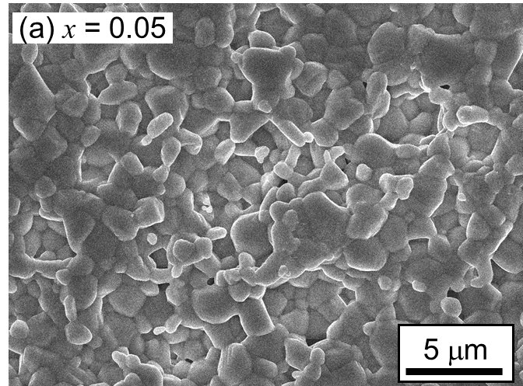 | 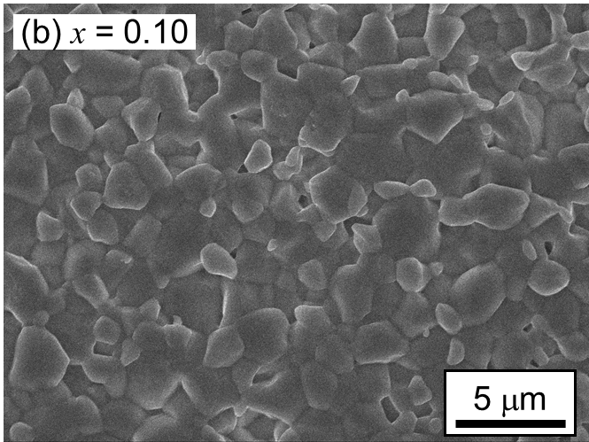
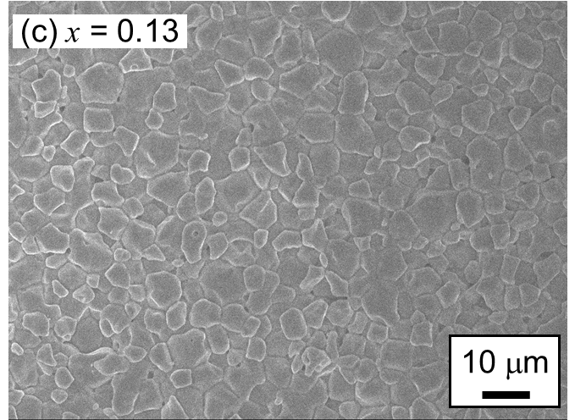 | 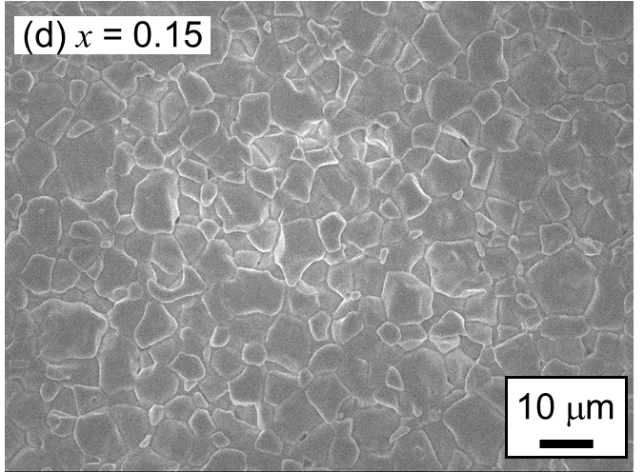
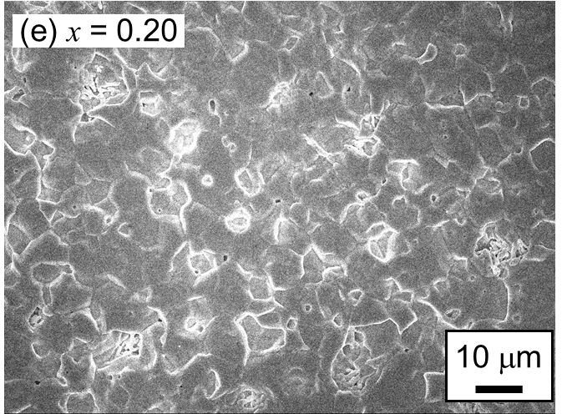
Figure S1. Cross sectional SEM images of Ca-NaNbO₃ ceramics with x of (a) 0.05, (b) 0.10, (c) 0.13, (d) 0.15, and (e) 0.20. Composition dependence of average grain size of the samples in Fig. 1(f) was obtained using these SEM images.

