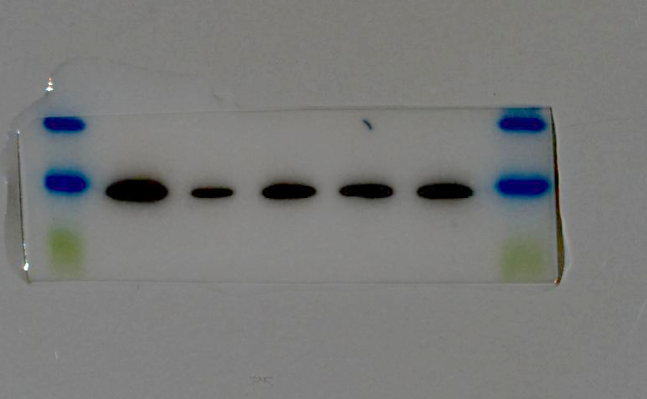
Figure 5
BMP2 30 kDa
HQDH
HQDM
HQDL

Db/db
Db/m
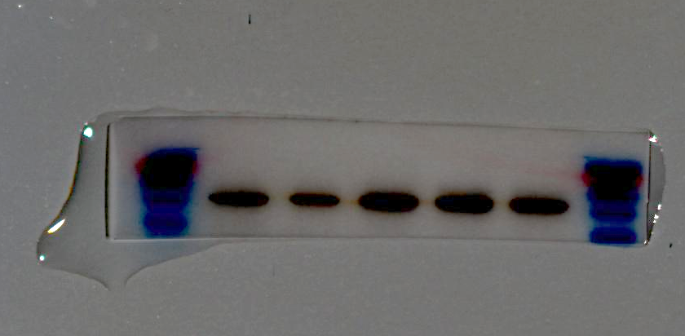
β-actin 42 kDa
HQDH
HQDM
HQDL
Db/db
Db/m
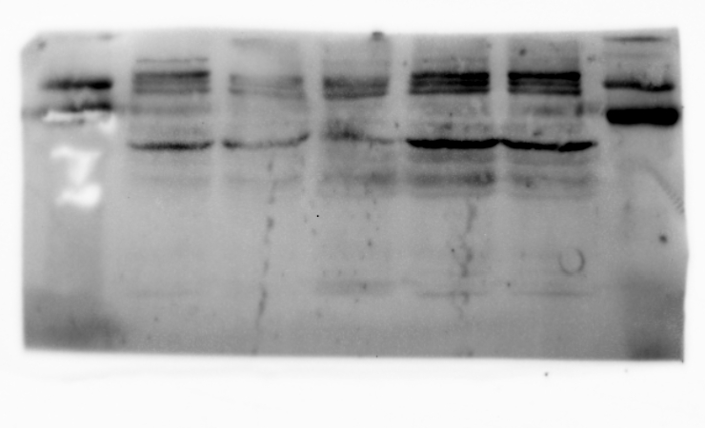
BMP7 49 kDa
HQDH
HQDM
HQDL
Db/db
Db/m
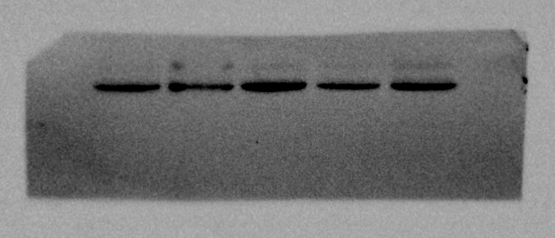
β-actin 42kDa kDac
HQDH
HQDM
HQDL
Db/db
Db/m
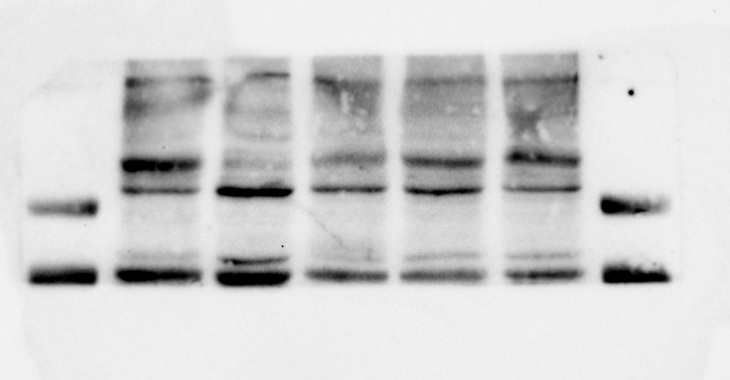
BMPR2 115kDa
HQDH
HQDM
HQDL
Db/db
Db/m
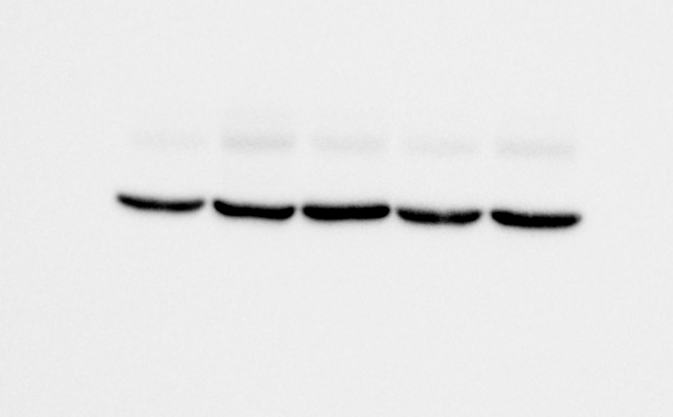
β-actin 42 kDa
HQDH
HQDM
HQDL
Db/db
Db/m

Figure 6

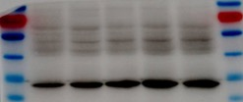
Phospho-smad1/5/9
60kDa
HQDH
HQDM
HQDL
Db/db
Db/m

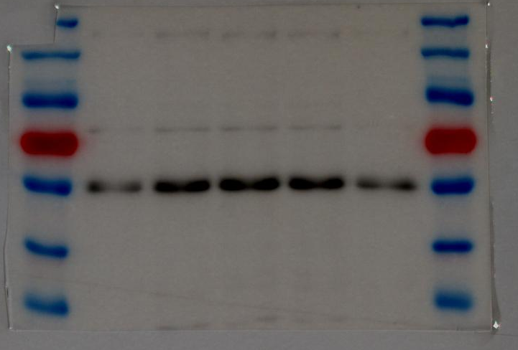
Db/db
HQDL
HQDM
HQDH
Db/m
smad1 60kDa

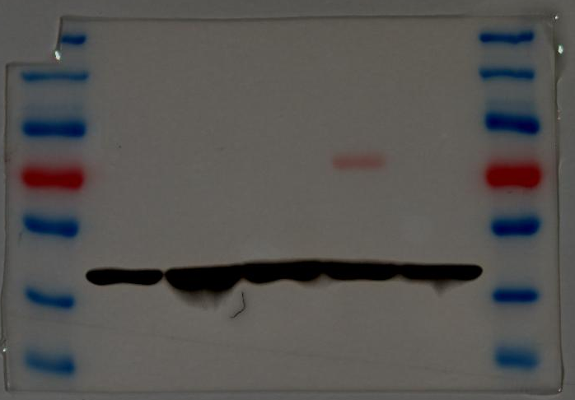
Db/db
HQDL
HQDM
HQDH
Db/m
β-actin 42 kDa

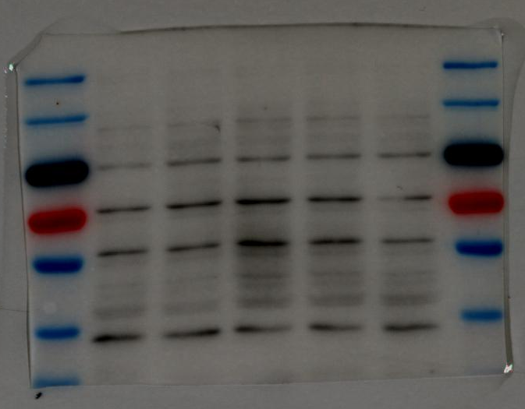
Db/db
Smad4 60kDa
HQDH
HQDM
HQDL
Db/m

Figure 7

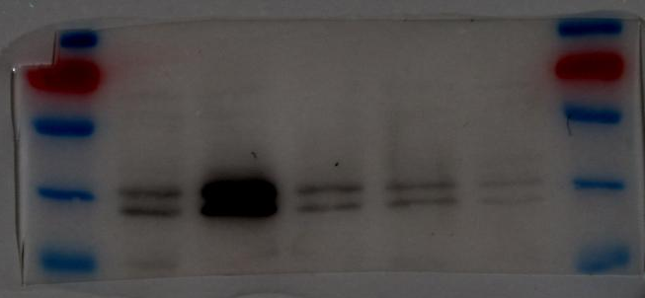
Db/mc
Phospho-ERK
44/42 kDa
HQDH
HQDM
HQDL
Db./db
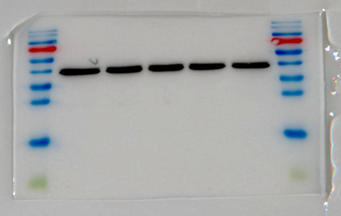
HQDH
HQDM
HQDLc
Db/dbc
Db/mc
ERK 44/42kDa的、 kDac
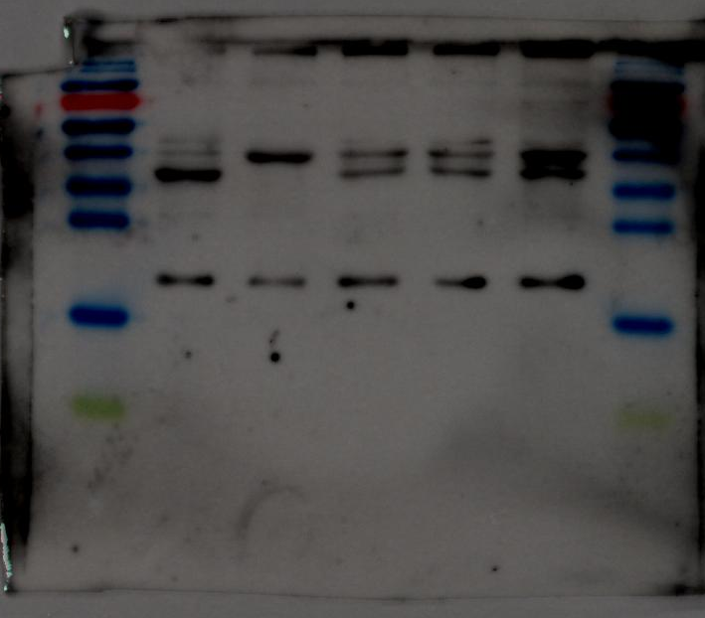
HQDH
HQDM
HQDL
Db/dbc
Db/mc
Active-rap1 24kDa
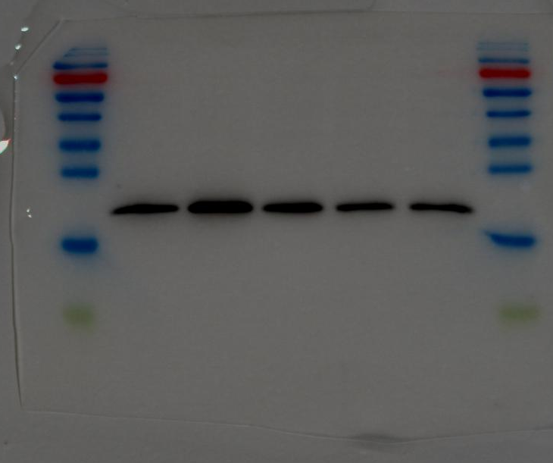
Db/mc
Dbdbc
HQDL
HQDM
HQDH
Total-rap1 24kDa

Figure 8
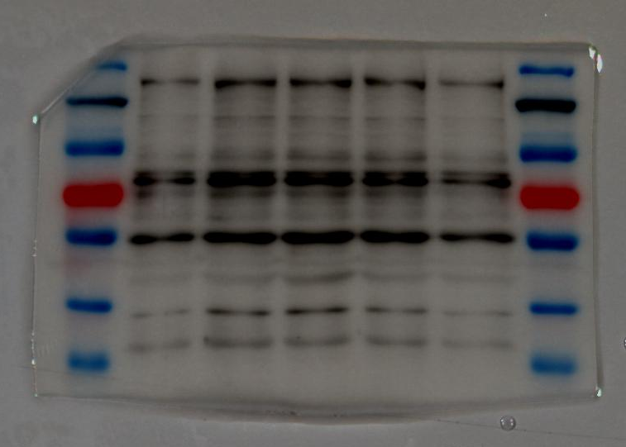
Cxcl 16 45 kDa
Db/mc
Dbdbc
HQDL
HQDM
HQDH

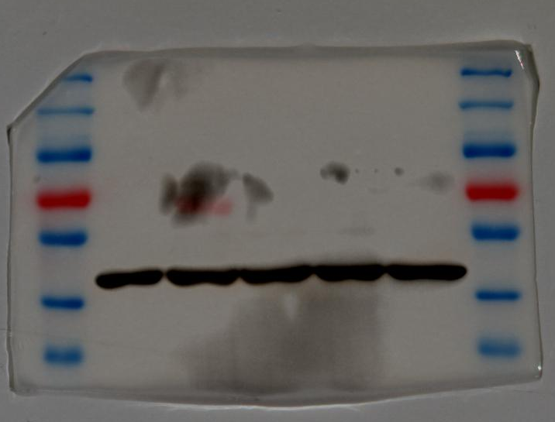
β-actin 42 kDa

Db/mc
Dbdbc
HQDL
HQDM
HQDH

