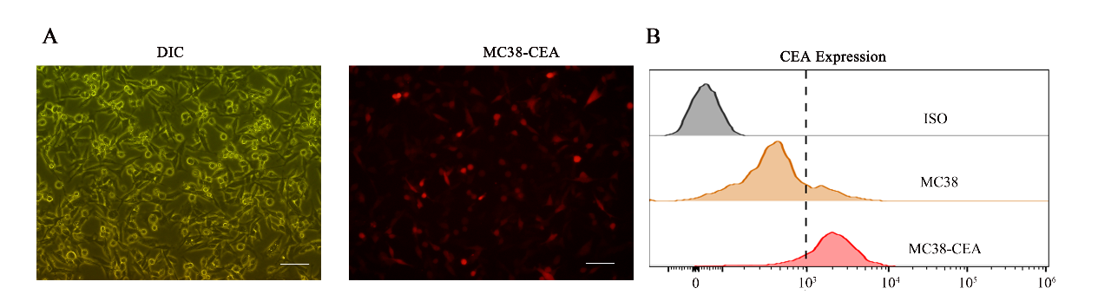
Figure S1. Preparation of the MC38 cell line stably expressing CEA
Representative fluorescent images showing expression of CEA (red) in MC38 cells by lentiviral infection; Scale bar: 50 μm. (B) Flow cytometric histograms representing CEA expression in MC38 cells for lentiviral infection. Control (blank), MC38 (yellow), MC38-CEA (red).
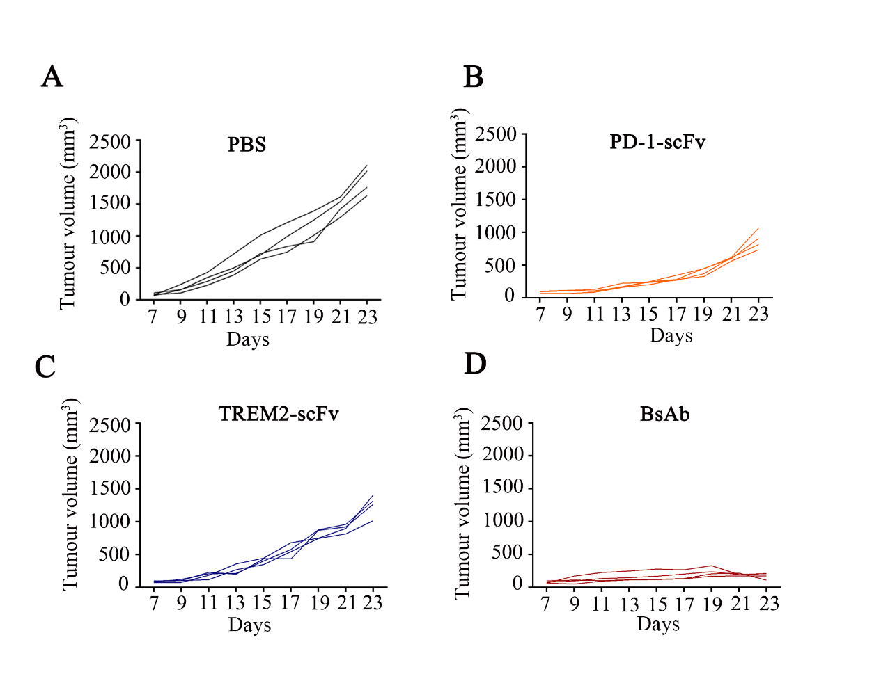

Figure S2. Anti-tumor function of PD1 scFv, TREM2 scFv, and BsAb.
(A-D) Growth curve of individual tumors in MC38-CEA tumor-bearing mice infused with PBS (A), PD-1 scFv (B), TREM2 scFv (C), or BsAb (D). n = 4 per group.

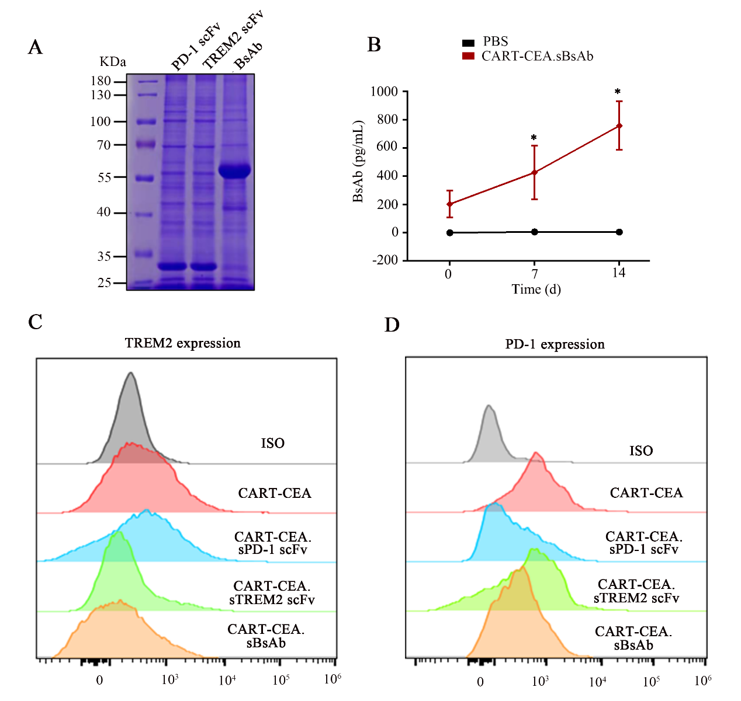
Figure S3. PD-1 scFv, TREM2 scFv, and BsAb are secreted by CAR-T cells and conjugated to specific targeted antigens.
(A) SDS-PAGE analysis of supernatants produced by genetically modified CAR-T cells secreting PD-1 scFv, TREM2 scFv, and BsAb subjected to purification and concentration using a nickel column. Detection of PD-1 scFv, TREM2 scFv, and BsAb expression in the concentrated supernatant by SDS-PAGE. (B) The concentration of BsAb in the supernatant increased with time. Mouse T cells transduced with CART-CEA.sBsAb supernatants were harvested at days 0, 7, and 14 for His-tag ELISA analysis. (C-D) Representative flow cytometry images showing PD-1 expression of mouse T cells (D) or TREM2 expression of BMDMs (C) incubated with 1 × 10⁵ CART-CEA.sPD-1 scFv, CART-CEA.sTREM2 scFv, and CART-CEA.sBsAb.

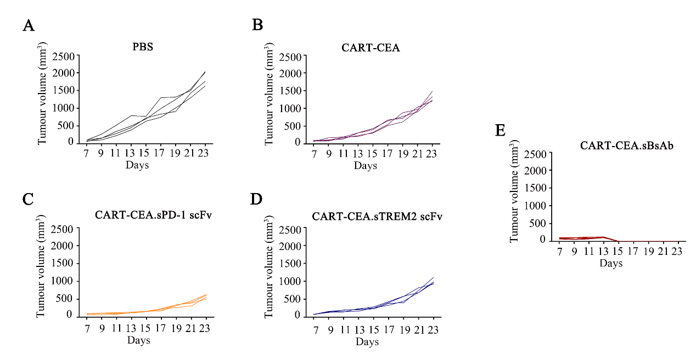
Figure S4. Anti-tumor function of the constructed CAR-T cells.
(A-E) Growth curve of individual tumors in MC38-CEA tumor-bearing mice infused with PBS (A), CART-CEA (B), CART-CEA.sPD-1 scFv (C), CART-CEA.sTREM2 scFv (D) or CAR-CEA.sBsAb (E); n = 4 per group.
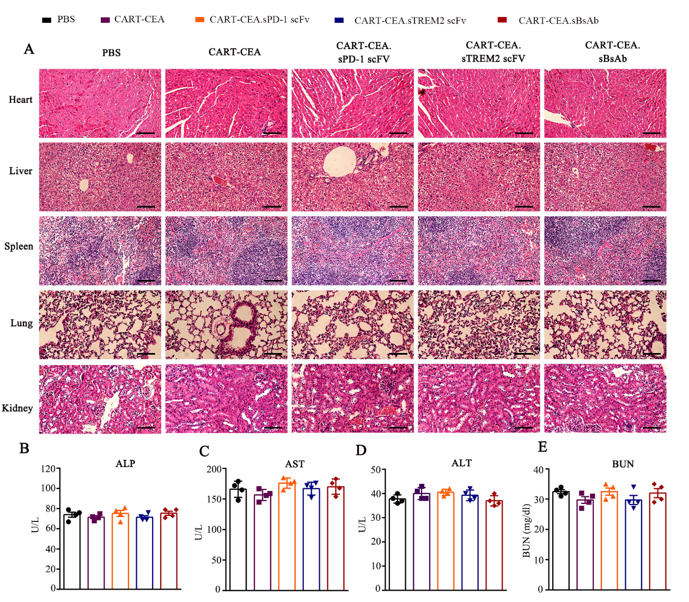
Figure S5. Biosafety evaluation of the constructed CAR-T cells.
- Histological evaluation of major organs, namely the heart, liver, spleen, lung, and kidney of mice by HE staining. Scale bars: 50 μm. (B-F) Hematological markers representing the liver (ALT, AST, ALP) and kidney (BUN) function in healthy C57BL/6J mice infused with PBS, CART-CEA, CART-CEA.sPD-1 scFv, CART-CEA.sTREM2 scFv, or CART-CEA.sBsAb. Serum was collected at the termination of animal experiments. CAR-T, chimeric antigen receptor-modified-T; HE, hematoxylin and eosin; ALT, alanine transaminase; AST, aspartate transaminase; BUN, blood urea nitrogen; PBS, phosphate buffered saline; CEA, carcinoembryonic antigen; PD-1, programmed death-1; TREM2, triggering-receptor-expressed on myeloid cells 2.

